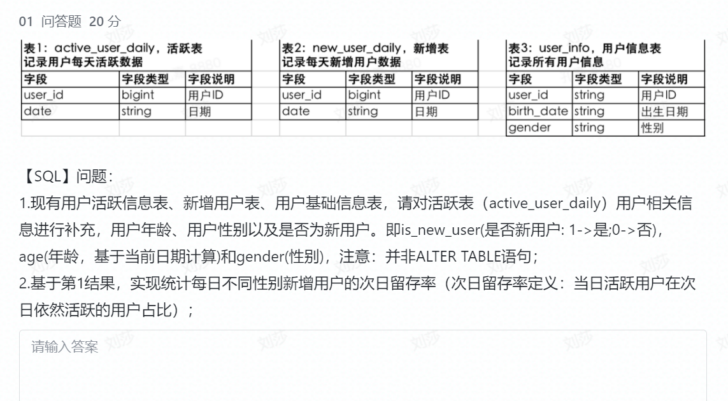

1.

Update active_user_daily a1

Set

age =(Select (date(birth_date)-date(curdate()) from user_info b1

Where b1.user_id=a1.user.id ) ) ),

is_new_user=(select  (case when a1.date =b2.curdate() then 1 else 0 end) from new_user_info b2 where b2.user_id=a1.user.id ),

Gender=(select gender from user_info b2 where b2.user_id=a1.user.id );

Update active_user_daily a1

Set

New_date=(select date from user_info b2 where b2.user_id=a1.user.id );

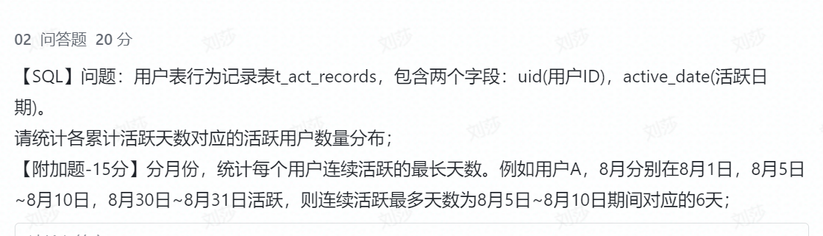

select 累计活跃天数，count（用户） 用户数量

from （Select uid 用户 ,Count ( distinc active_date) 累计活跃天数 from t_act_records group by uid ）

group by 累计活跃天数

;

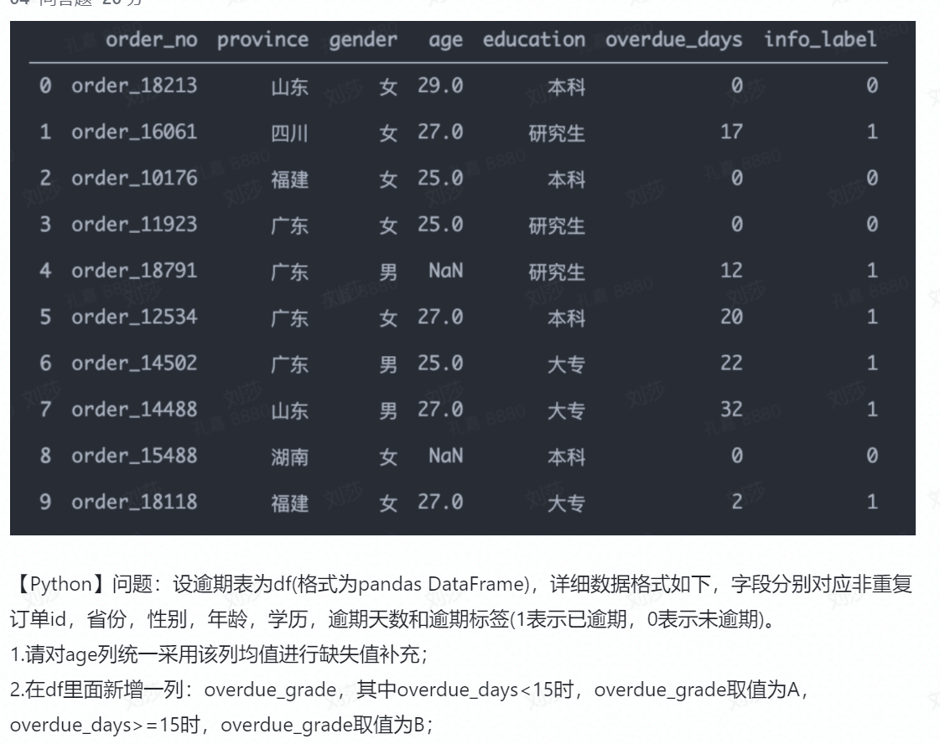

4.1

Import pandas as pd

df[“age”]=df[“age”].apply(lambda x: x if np.isnan(x)==False else df[“age”].mean())

4.2

df[“over_grade”]=df[“overdue_days”].apply(lamda x: A if x<15 else B)

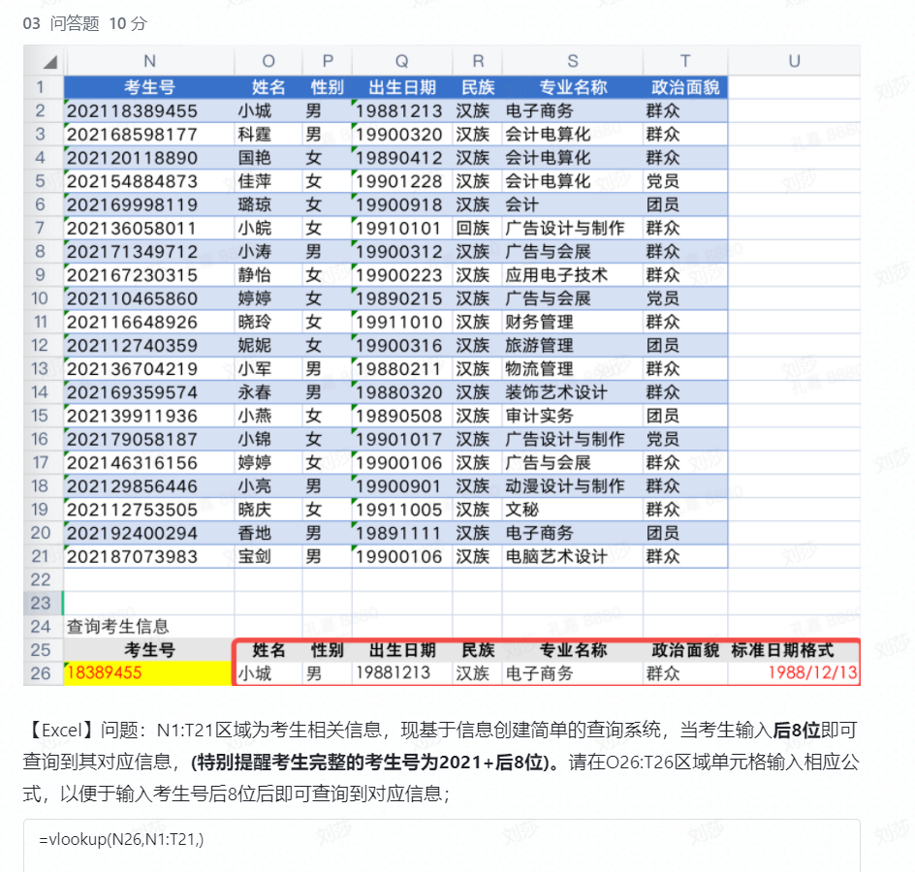

=Vlookup($N26,$N$2:$T$21,match(O$25,$O$1:$T$1,0),1)