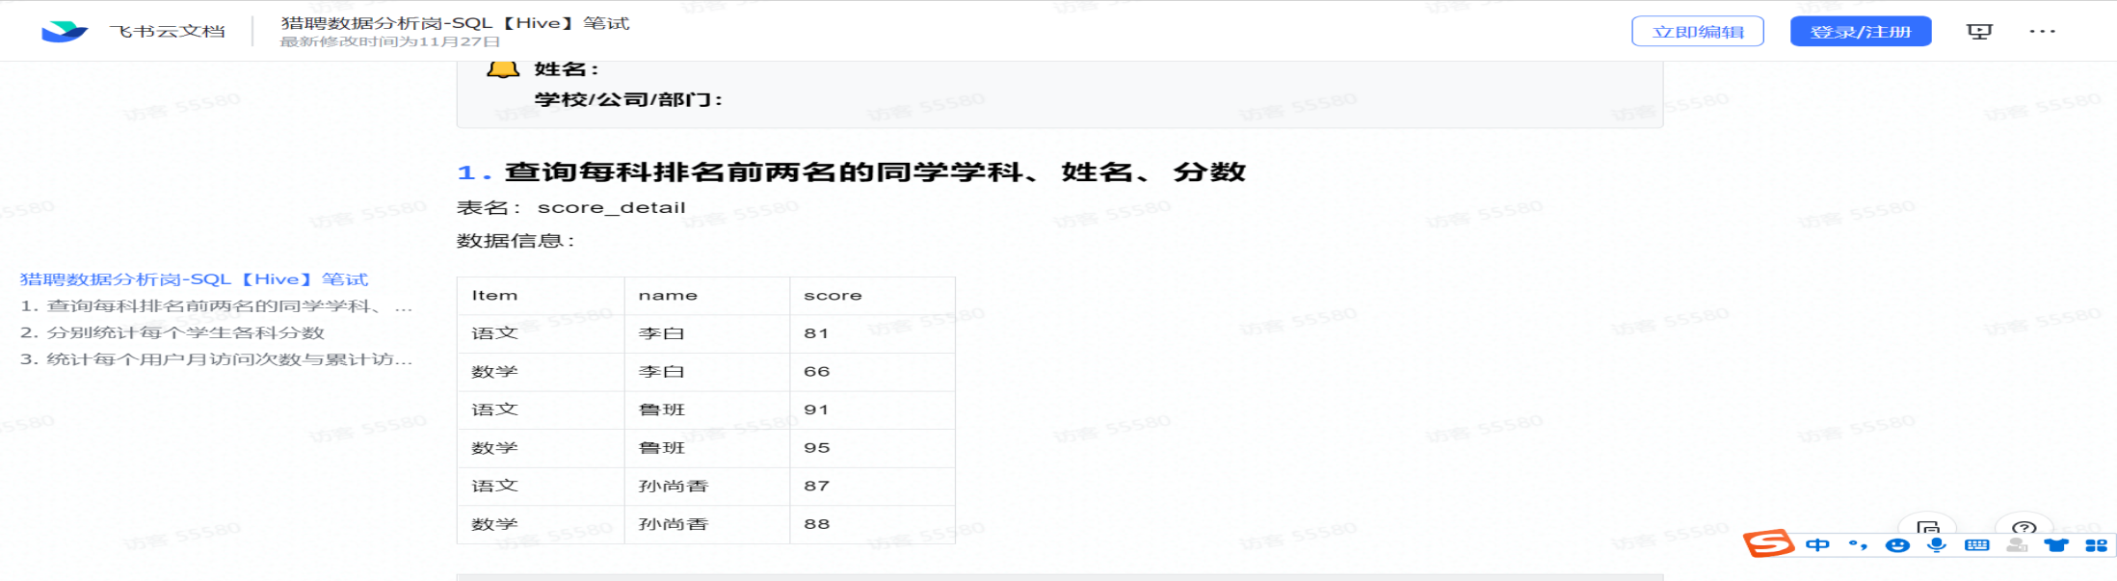

Select name,item,score,RN

from(

Select *,row_number() over (partition by item order by score desc) RN

From score_detail) as t1

Where RN=1 or RN=2;

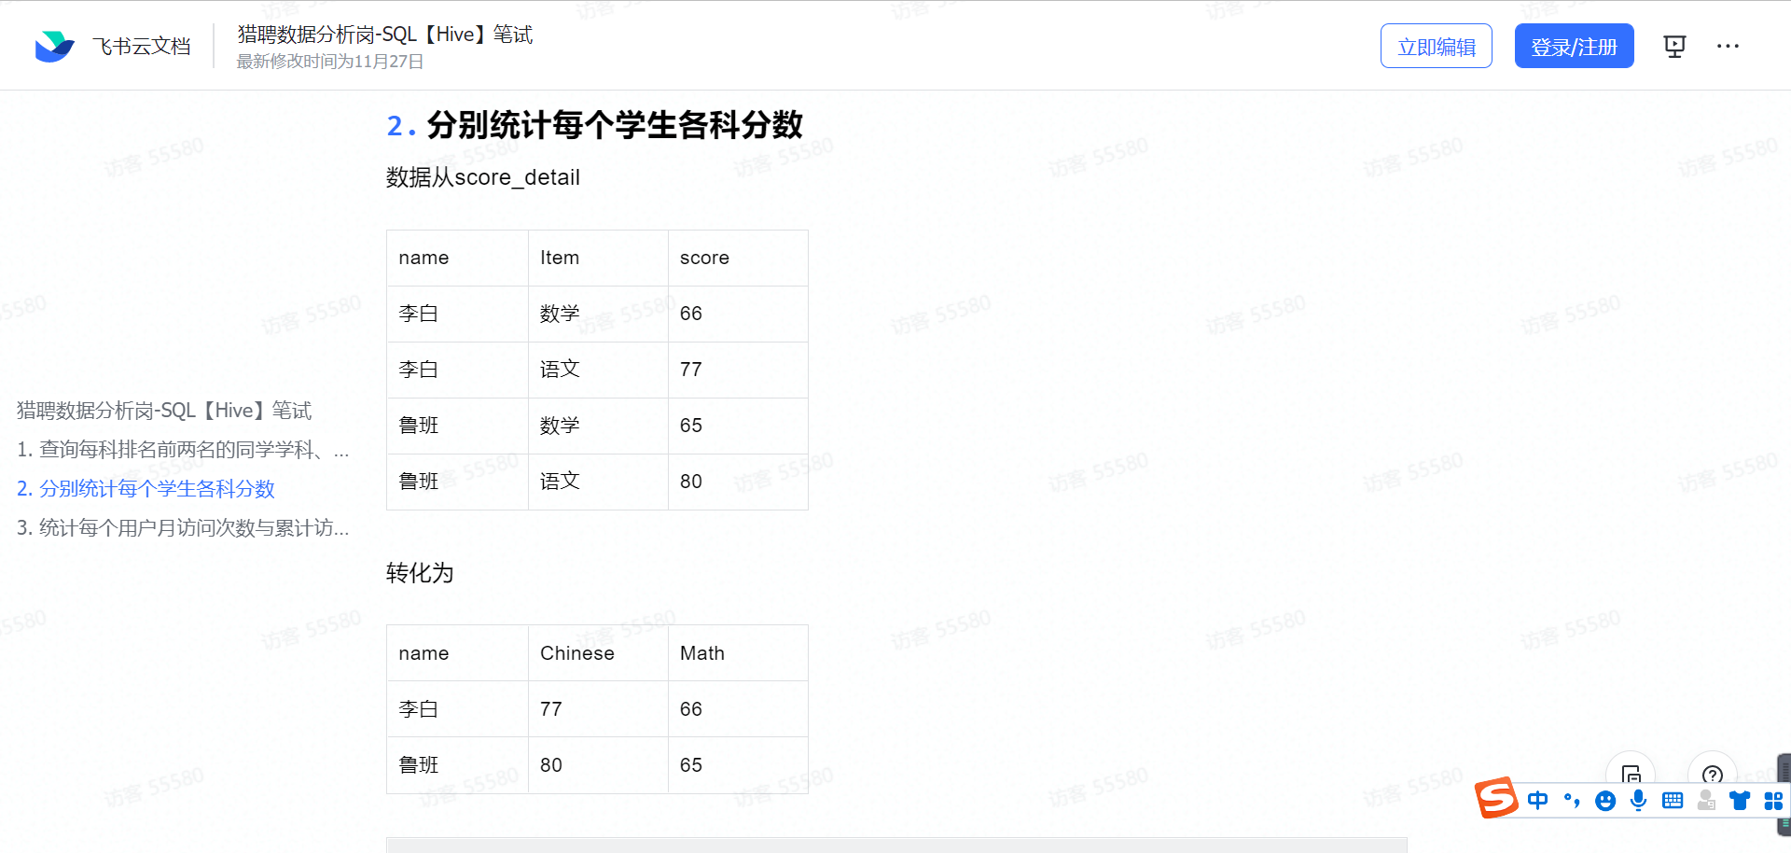

--第二题作答区域--

select name,

sum(case when item='语文' then score else 0 end) as 'Chinese',

sum(case when item='数学' then score else 0 end) as 'Math'

from score_detail

group by name;

数据准备

CREATE TABLE `action` (

`id` int(11) NOT NULL AUTO_INCREMENT,

`userid` char(5) COLLATE utf8_bin NOT NULL,

`visitdate` date DEFAULT NULL,

`visitcount` int(9) DEFAULT NULL,

PRIMARY KEY (`id`) USING BTREE

) ENGINE=InnoDB AUTO_INCREMENT=9 DEFAULT CHARSET=utf8 COLLATE=utf8_bin;

INSERT INTO `lls_test`.`count_user_visit`(`id`, `user_id`, `visit_date`, `visit_count`) VALUES (1, 'u01', '2017-01-21', 5);

INSERT INTO `lls_test`.`count_user_visit`(`id`, `user_id`, `visit_date`, `visit_count`) VALUES (2, 'u01', '2017-01-23', 6);

INSERT INTO `lls_test`.`count_user_visit`(`id`, `user_id`, `visit_date`, `visit_count`) VALUES (3, 'u02', '2017-01-23', 6);

INSERT INTO `lls_test`.`count_user_visit`(`id`, `user_id`, `visit_date`, `visit_count`) VALUES (4, 'u03', '2017-01-22', 8);

INSERT INTO `lls_test`.`count_user_visit`(`id`, `user_id`, `visit_date`, `visit_count`) VALUES (5, 'u04', '2017-01-20', 3);

INSERT INTO `lls_test`.`count_user_visit`(`id`, `user_id`, `visit_date`, `visit_count`) VALUES (6, 'u02', '2017-02-21', 8);

INSERT INTO `lls_test`.`count_user_visit`(`id`, `user_id`, `visit_date`, `visit_count`) VALUES (7, 'u01', '2017-02-22', 4);

INSERT INTO `lls_test`.`count_user_visit`(`id`, `user_id`, `visit_date`, `visit_count`) VALUES (8, 'u01', '2017-02-23', 5);

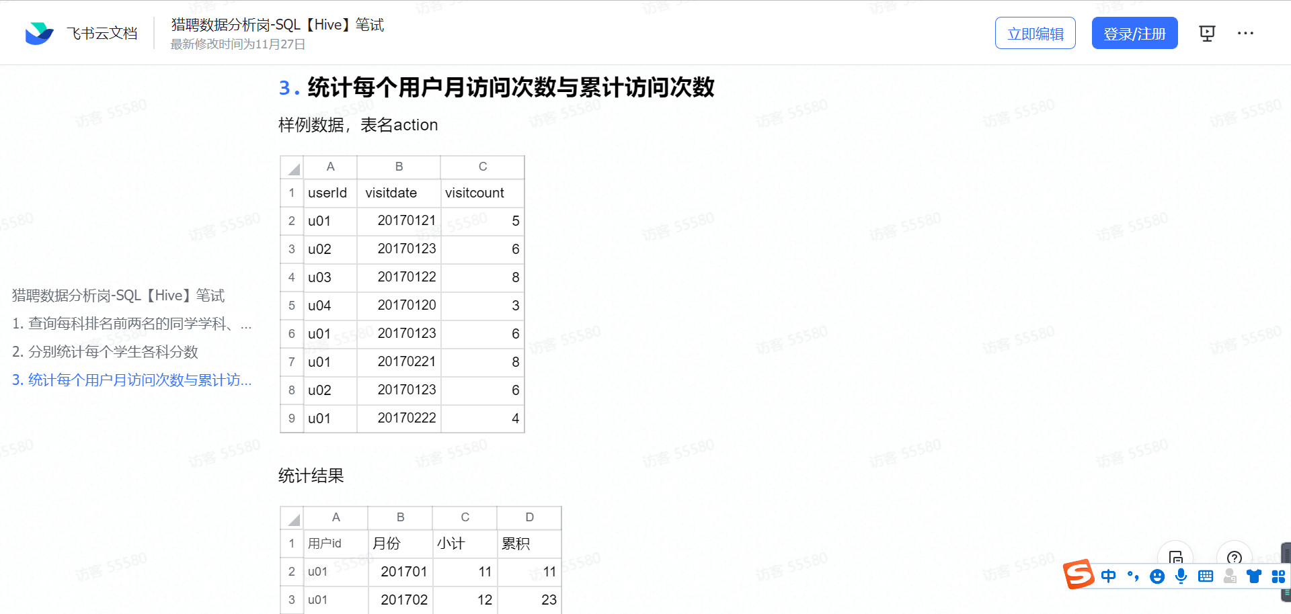

SELECT

a.userid 用户id,

a.yue 月份,

sum( visitcount ) 小计,

(

SELECT

SUM( b.小计 )

FROM

(

SELECT

a.id 用户id,

a.yue 月份,

SUM( vc ) 小计

FROM

( SELECT userid id, visitcount vc, DATE_FORMAT( visitdate, '%Y-%m' ) yue FROM action ) a

GROUP BY

a.id,

a.yue

) b

WHERE

b.月份<= a.yue

AND b.用户id = a.id

) 累积

FROM

( SELECT userid, visitcount, Date_format( visitdate, '%Y-%m' ) yue FROM action ) a

GROUP BY

a.userid,

a.yue;