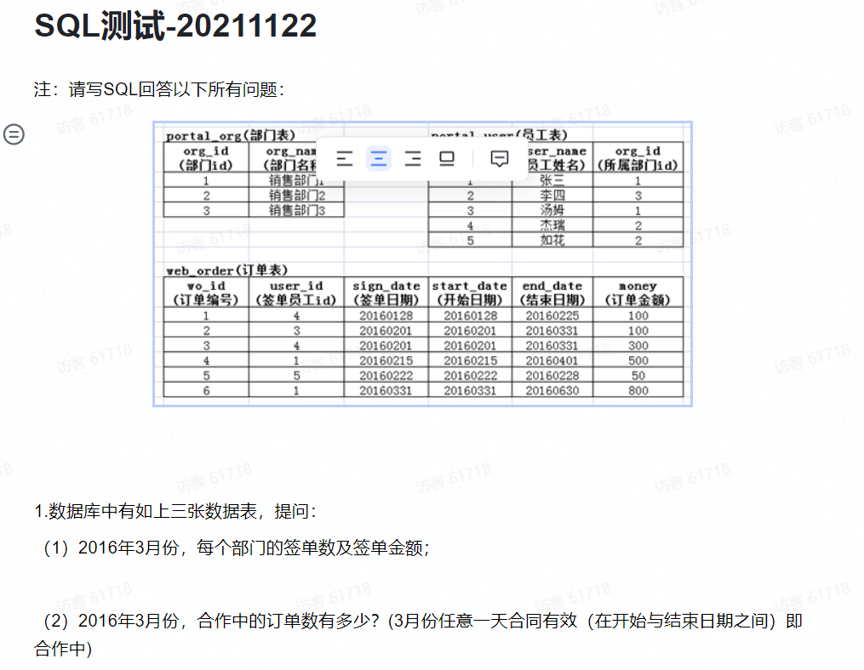

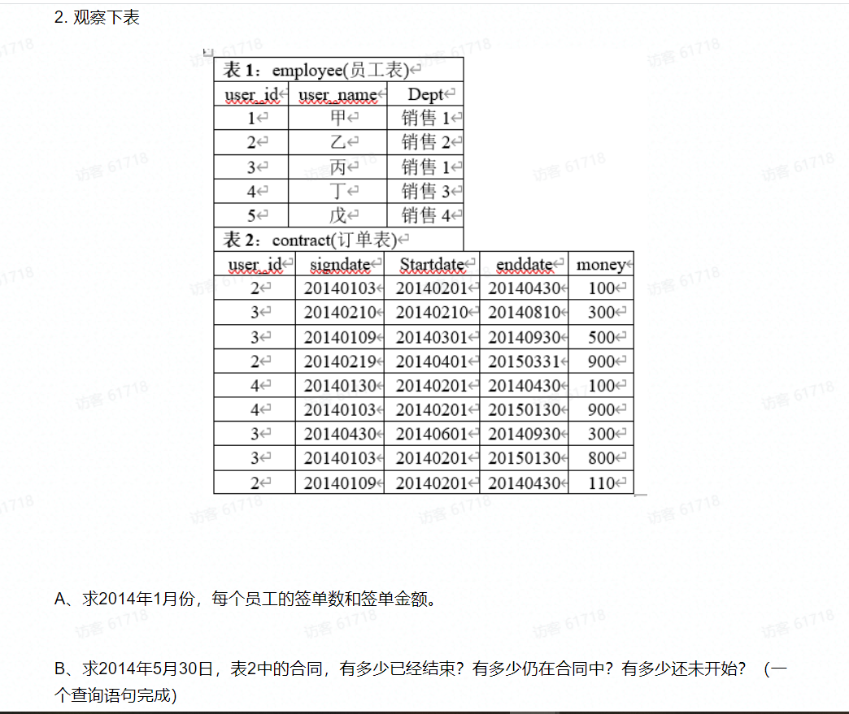

乔答案

1.(1)

Select po. org_name 部门名称, count(sign_date) 签单数 , sum(money) 签单金额

from web_order wo

left join portal_user pu on wo.user_id=pu.user_id

left join portal_org po on wo.org_id=po. org_id

Where sign_date between 20160301 and 20160331

Group by org_id;

1.(2)

Select count(*) 合作中的订单数

From portal_user pu

Inner join portal_org po on pu.org_id=po. org_id

Inner join web_order wo on pu.user_id=wo.user_id

Where start_date between 20160301 and 20160331

or end_date between 20160301 and 20160331;

2.(1)

Select count(*) 签单数,sum(money) 签单金额

From employee e

Inner join contract c on e.user_id=c.user_id

Where signdate between 20140101 and 20140131

Group by user_id;

2.(2)

select

sum(case when Startdate<=20140530 and enddate>=20140530 then 1 else 0 end) 正在进行数,

Sum(case when enddate<=20140530 then 1 else 0 end) 已经结束,

Sum (case when Startdate>20140530 then 1 else 0 end) 还未开始

from contract;

鸭子答案

第一题第一问

Select count(*) 签单数,sum(money) 签单金额

From portal_user a

Inner join portal_org b on a.org_id=b. org_id

Inner join web_order c on a.user_id=c.user_id

Where sign_date between 20160301 and 20160331

group by org_id;

第一题第二问

Select count(*) 合作订单数

From portal_user a

Inner join portal_org b on a.org_id=b. org_id

Inner join web_order c on a.user_id=c.user_id

Where start_date between 20160301 and 20160331

or end_date between 20160301 and 20160331

第二题第一问

Select count(*) 签单数,sum(money) 签单金额

From employee e

Inner join contract c on e.user_id=c.user_id

Where signdate between 20140101 and 20140131

Group by user_id

第二题第二问

select

(Select count(signdate) from contract where Startdate<=20140530 and enddate>=20140530) 正在进行数,

(Select count(signdate) from contract where enddate<=20140530 ) 已经结束,

(Select count(signtdate) from contract where Startdate>20140530) 还未开始

from contract;

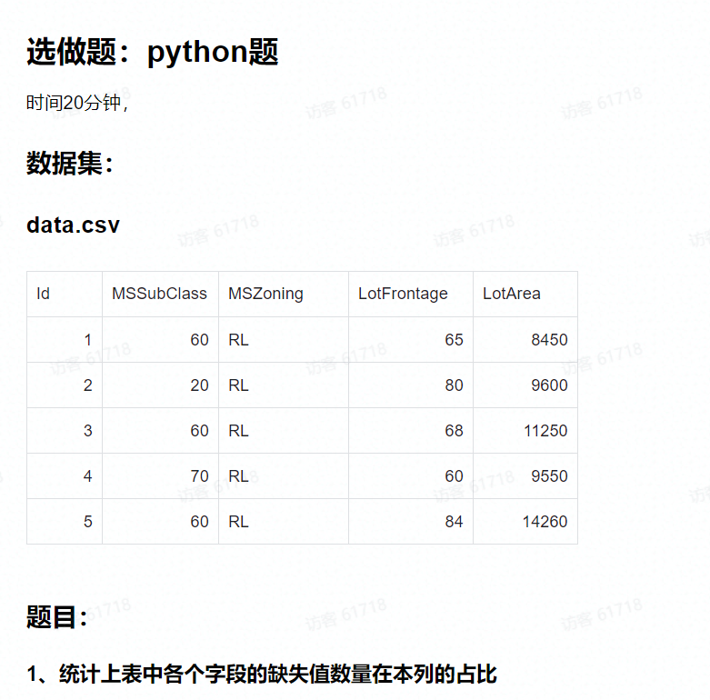

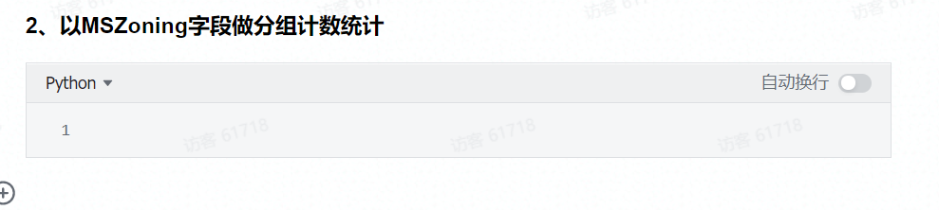

1

import pandas as pd

a=pd.read_csv(‘data.csv’)

def missing_percent(df):

     nan_percent = 100*(df.isnull().sum()/len(df))

     nan_percent = nan_percent[nan_percent > 0].sort_values()

     return nan_percent

 print(missing_percent(a))

2

grouped =a.groupby('MSZoning').aggregate(['count'])

grouped