**一、查找每个用户连续登陆的最大天数**

use girls

create table user_date(

uid int(20),

login_date date

);

insert into user_date

VALUES(201,'20170101')

,(201,'20170102')

,(202,'20170102')

,(202,'20170103')

,(203,'20170103')

,(201,'20170104')

,(202,'20170104')

,(201,'20170105')

,(202,'20170105')

,(201,'20170106')

,(203,'20170106')

,(203,'20170107');

（1）第一步：按照uid分组，login_date排序，增加一个新字段排名RN

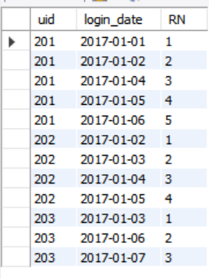select uid,login_date,

row_number() over (partition by uid order by login_date) RN

from user_date

（2）第二步：在第一步的基础上增加date_diff列，即login_date减去RN

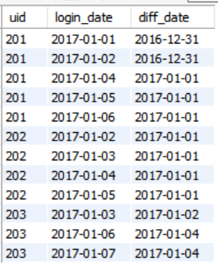

select uid,login_date,date_sub(login_date,interval RN day) as diff_date

from(

select uid,login_date,

row_number() over (partition by uid order by login_date) RN

from user_date) t1

（3）得到每个人在每一天的连续登陆天数

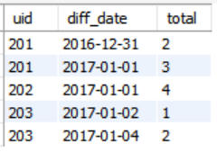

select uid,diff_date,count(1) as total

from(

select uid,login_date,date_sub(login_date,interval RN day) as diff_date

from(

select uid,login_date,

row_number() over (partition by uid order by login_date) RN

from user_date) t1

) t2

group by uid,diff_date

（4）取出最大值

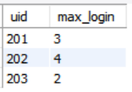

select uid,max(total) as max_login

from(

select uid,diff_date,count(1) as total

from(

select uid,login_date,date_sub(login_date,interval RN day) as diff_date

from(

select uid,login_date,

row_number() over (partition by uid order by login_date) RN

from user_date) t1

) t2

group by uid,diff_date

) t3

group by uid

二、

use girls;

create table student_test_info(

id int(20),

student_id int(20),

student_name varchar(20),

course_id int(20),

course_name varchar(20),

score int(20)

);

insert into student_test_info

values(1,201001,"张黛丝",101,"商务统计",73),

(2,201001,"张黛丝",104,"时间序列分析",67),

(3,201001,"张黛丝",105,"随机过程",52),

(4,201001,"李美妮",104,"时间序列分析",61),

(5,201001,"李美妮",102,"应用回归分析",63),

(6,201001,"孙纳德",101,"商务统计",87),

(7,201001,"孙纳德",107,"计量经济学",82);

(1).编写hive sql语句提取“不偏科的学生”名单。

其中“不偏科的学生”的定义是：该学生选的所有课程中，每一门课程的考试分数均高于该课程的平均分。查询的环境为原生hive2.0

Select student_name,course_name,score,avg_score

From(

Select course_id,avg(score) avg_score

From student_test_info

Group by course_id

) a

inner join student_test_info b on a.course_id=b.course_id

Where score>avg_score;

（2）选出每科排名前2名的同学名字

Select student_name,course_name,score,RN

from(

Select *,dense_rank() over (partition by course_id order by score desc) RN

From student_test_info) as t1

Where RN=1 or RN=2;