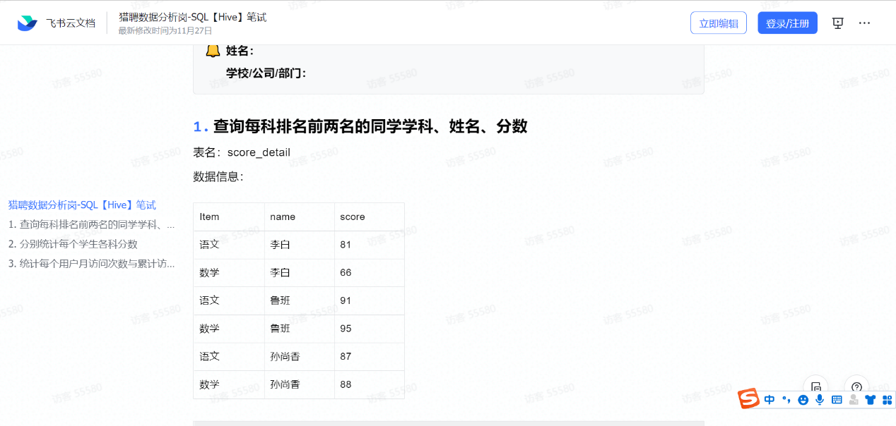

法1

Select name,item,score,RN

from(

Select *,row_number() over (partition by item order by score desc) RN

From score_detail) as t1

Where RN=1 or RN=2;

法2

select score_detail.*

from score_detail s1

where

(select count(1) from score_detail s2

where s2.course = s1.course and s2.score>s1.score)<2

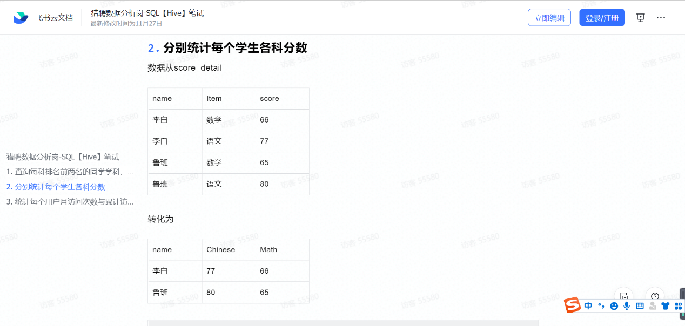

select name,

sum(case when item='语文' then score else 0 end) as 'Chinese',

sum(case when item='数学' then score else 0 end) as 'Math'

from score_detail

group by name;

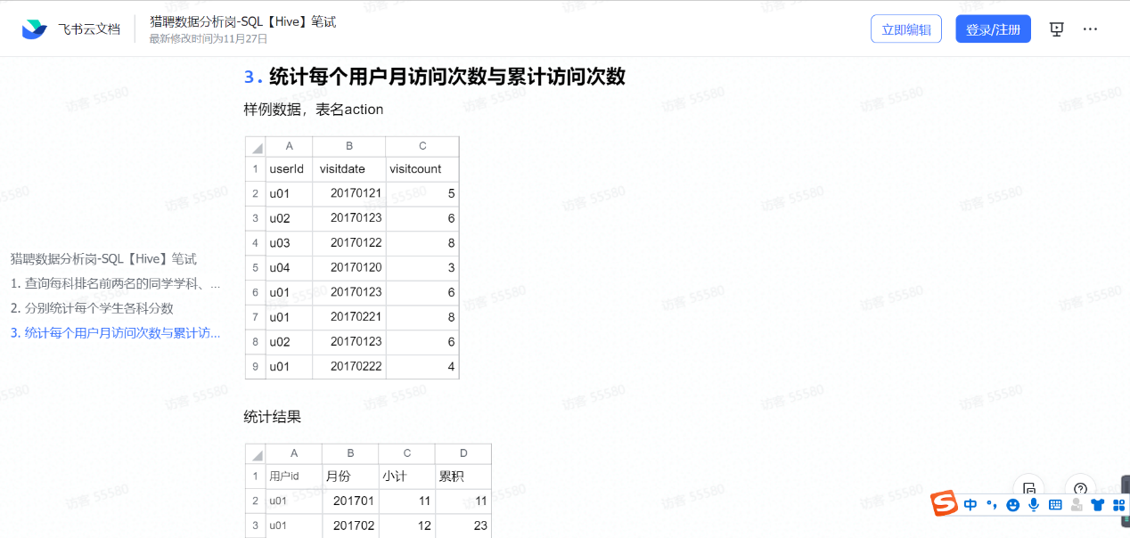

SELECT

a.userid 用户id,

a.yue 月份,

sum( visitcount ) 小计,

(

SELECT

SUM( b.小计 )

FROM

(

SELECT

a.id 用户id,

a.yue 月份,

SUM( vc ) 小计

FROM

( SELECT userid id, visitcount vc, DATE_FORMAT( visitdate, '%Y-%m' ) yue FROM action ) a

GROUP BY

a.id,

a.yue

) b

WHERE

b.yue<= a.yue

AND b.id = a.userid

) 累积

FROM

( SELECT userid, visitcount, Date_format( visitdate, '%Y-%m' ) yue FROM action ) a

GROUP BY

a.userid,

a.yue;