1.

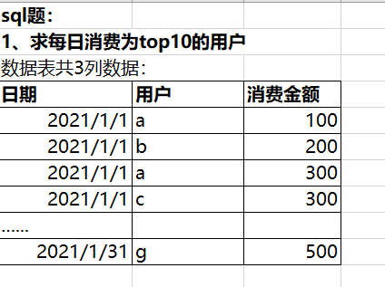

Select 日期，用户

from(

Select * ,row_number() over (partition by 日期order by 金额desc) rank

From(

Select sum(消费金额) 金额 , 用户，日期

From 表1

group by 用户,日期

)t2) t1

Where rank<=10;

2.

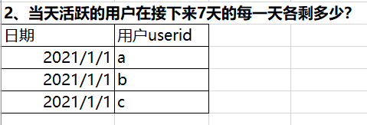

select

log_day '日期',

count(user_id_d0) '当日活跃数量',

count(user_id_d1) '次日留存',

count(user_id_d2) '2日留存',

count(user_id_d3) '3日留存',

count(user_id_d4) '4日留存',

count(user_id_d5) '5日留存',

count(user_id_d6) '6日留存',

count(user_id_d7) '7日留存',

from (

select

distinct 日期,

a.user_id_d0,

b.userid as user_id_d1,

c. userid as user_id_d2,

d. userid as user_id_d3

e. userid as user_id_d4,

f. userid as user_id_d5,

g. userid as user_id_d6,

h. userid as user_id_d7

from

(select

distinct date(日期), userid as user_id_d0

from 表2

group by userid

order by日期) a

left join 表2 b

on b.日期 =date_add(a.日期,interval 1 day) ,a.user_id_d0 = b.userid

left join 表2 c

on c.日期 =date_add(a.日期,interval 2 day) and a.user_id_d0 = c.user id

left join 表2 d

on d.日期 =date_add(a.日期,interval 3 day) and a.user_id_d0 = d.user id

left join 表2 e

on e.日期 =date_add(a.日期,interval 4 day) and a.user_id_d0 = e.user id

left join 表2 f

on f.日期 =date_add(a.日期,interval 5 day) and a.user_id_d0 = f.user id

left join 表2 g

on g.日期 =date_add(a.日期,interval 6 day)

and a.user_id_d0 = g.user id

left join 表2 h

on h.日期 =date_add(a.日期,interval 7 day)

and a.user_id_d0 = h.user id

)

group by 日期;

3.

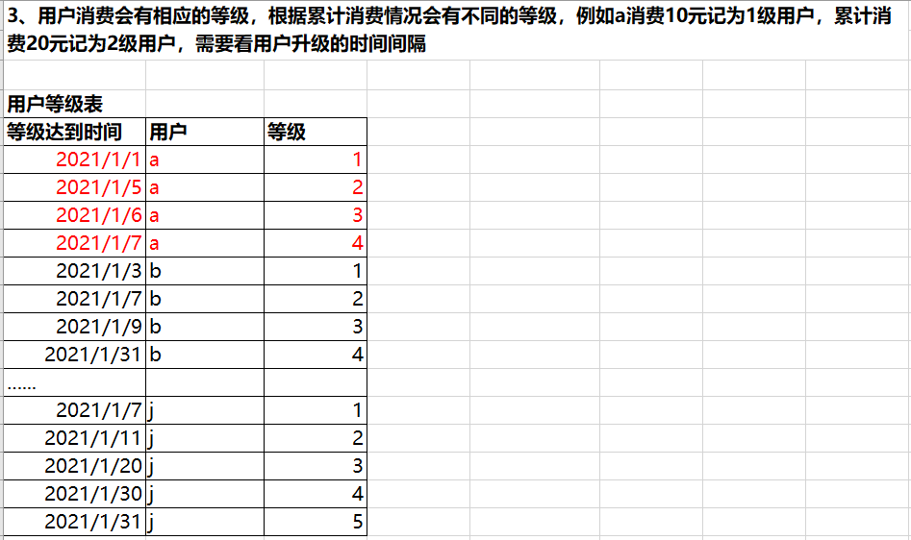

Select 用户,

Sum(case when 等级=1 then 升级间隔 else 0 end) as 等级一升级间隔,

Sum(case when 等级=2 then 升级间隔 else 0 end) as 等级二升级间隔,

Sum(case when 等级=3 then 升级间隔 else 0 end) as 等级三升级间隔,

Sum(case when 等级=4 then 升级间隔 else 0 end) as 等级四升级间隔,

Sum(case when 等级=5 then 升级间隔 else 0 end) as 等级五升级间隔

From (

Select b.用户, datediff(b.等级达到时间,a.等级达到时间) 升级间隔,b.等级

From 用户等级表 a

Inner join 用户等级表 b

On a.用户=b.用户 and b.等级=( a.等级) +1

)t

Group by用户;