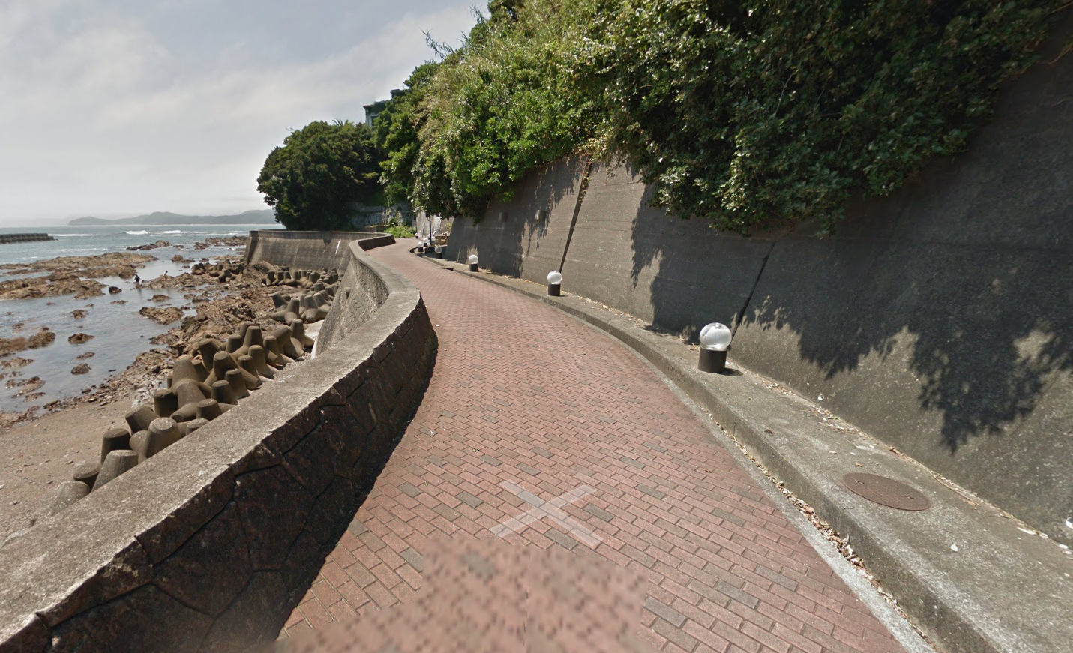
DragonBall
The Flag format :Securinets{lat_lon_place}
The solver :
Securinets{34.293_136.751_Bindama}
https://www.google.com/maps/place/Bindama+Road+Senyo+Parking+Lot/@34.2933377,136.7510119,2a,75y,297.31h,75.93t/data=!3m7!1e1!3m5!1sQCTOE2LVKNU4h3fYPOOxjg!2e0!6shttps:%2F%2Fstreetviewpixels-pa.googleapis.com%2Fv1%2Fthumbnail%3Fcb_client%3Dmaps_sv.tactile%26w%3D900%26h%3D600%26pitch%3D14.068224260421104%26panoid%3DQCTOE2LVKNU4h3fYPOOxjg%26yaw%3D297.3118702970571!7i13312!8i6656!4m6!3m5!1s0x6005ad0010462c2d:0x1084ecfdcd0c305f!8m2!3d34.2963195!4d136.7467196!16s%2Fg%2F11vm3szsyj?entry=ttu&g_ep=EgoyMDI2MDMxMC4wIKXMDSoASAFQAw%3D%3D

