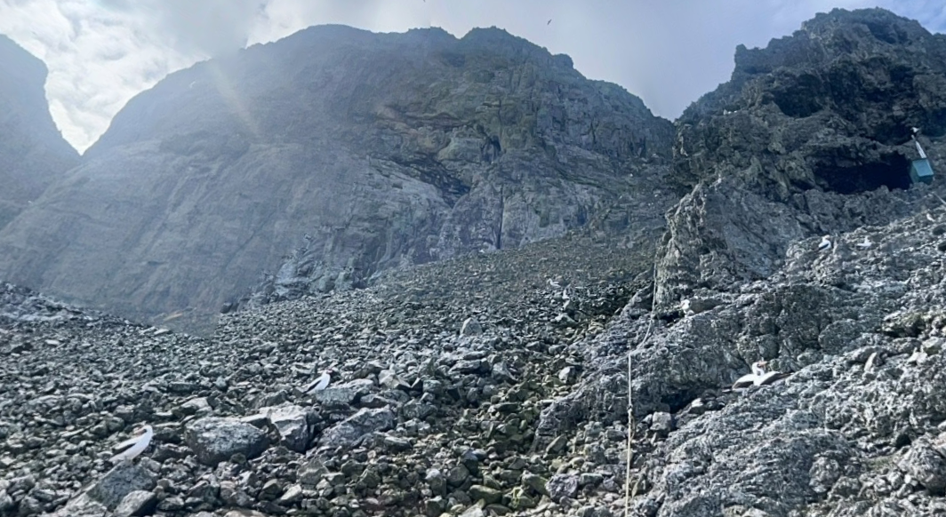
Name :Latino baby
During the early 19th century, two neighboring nations that had previously fought together for independence— fell into conflict over unpaid military debts, political interference, and disputed border territories, The tensions escalated into open war.
The two fleets eventually met in direct combat right at the waters of this place.
Find this place ;
Flag format : Securinets{placename_islandname_country_coords1_coords2}
Flag : Securinets{naturalnationalpark_malpelo_colombia_4.003_-81.606}
The solver :
The clue :this species Chaenopsidae is located around and in the center of that place
Ressources :
https://fr.wikipedia.org/wiki/%C3%8Ele_de_Malpelo
https://fr.wikipedia.org/wiki/Combat_de_Punta_Malpelo
https://earth.google.com/web/search/malpelo+park/@4.00353948,-81.60651974,2.6114444a,0d,60y,246.06273468h,120.34188443t,0r/data=CnsaTRJHCiUweDhmYzhkZGRkZGYyZTJmMWY6MHgzMjA2MTZjOTU2YTA4NTAyGfNf1np1BBBAIfZ698f7ZlTAKgxtYWxwZWxvIHBhcmsYASABIiYKJAlx_rtfvQsQQBFV0QHfz_YPQBkk2fCUeWZUwCEbVg1OOGdUwEICCAEiGgoWQ0lITTBvZ0tFSUNBZ0lEbS1lWFNWQRAFOgMKATBCAggASg0I____________ARAA
https://en.wikipedia.org/wiki/Chaenopsidae

