LAB – 4
Project Title: Adaptive-Software-Development-Lab
Project Scenario: Online Course Registration System (OCRS)

PHASE 1: UNDERSTANDING ADAPTIVE SOFTWARE DEVELOPMENT

Step 1: Study ASD Characteristics
- Mission-Focused Development
Mission-focused development means the team concentrates on achieving the main goal of the project instead of strictly following a fixed plan. The focus is on delivering value to users. This allows the team to adjust tasks and priorities if requirements change.
- Component-Based Development
In ASD, software is developed in small components or modules. Each component performs a specific function and can be developed independently. This approach makes the system flexible and allows easy modification or improvement.
- Time-Boxed Iterations
ASD uses fixed time periods called iterations to complete tasks. Each iteration has a limited duration, which encourages teams to deliver results quickly. Time-boxing helps maintain progress even when requirements change.
- Risk-Driven and Change-Tolerant Planning
ASD accepts that changes and risks are part of software development. Instead of avoiding them, teams plan in a way that allows easy adaptation. This helps the project respond effectively to new information and unexpected challenges.
- Continuous Learning
Continuous learning is an important part of ASD. After each iteration, the team reviews the results and learns from successes and mistakes. This learning helps improve future planning and development decisions.
Why Traditional Planning Fails in Uncertain Environments
Traditional planning assumes that all requirements are known at the beginning of the project. However, in real software projects, requirements often change due to new technology, user needs, or market conditions. When plans are fixed and rigid, teams cannot easily adapt to these changes. As a result, traditional planning may lead to delays, increased costs, or products that do not meet user expectations.

Step 2: Understand the SCL Cycle
- Speculate
In a real-world project like an online shopping application, the development team may assume that users prefer quick checkout and multiple payment options. Based on this assumption, they plan features such as guest checkout and digital payments.
- Collaborate
During development, developers, designers, testers, and stakeholders work together to discuss features and solve problems. For example, the development team collaborates with business managers to decide how the product search feature should work.
- Learn
After releasing a feature, the team collects feedback from users. For example, if users report difficulty in using the payment page, the team learns from this feedback and improves the design in the next iteration.

PHASE 2: SPECULATE PHASE USING TAIGA

Step 3: Create ASD Project in Taiga
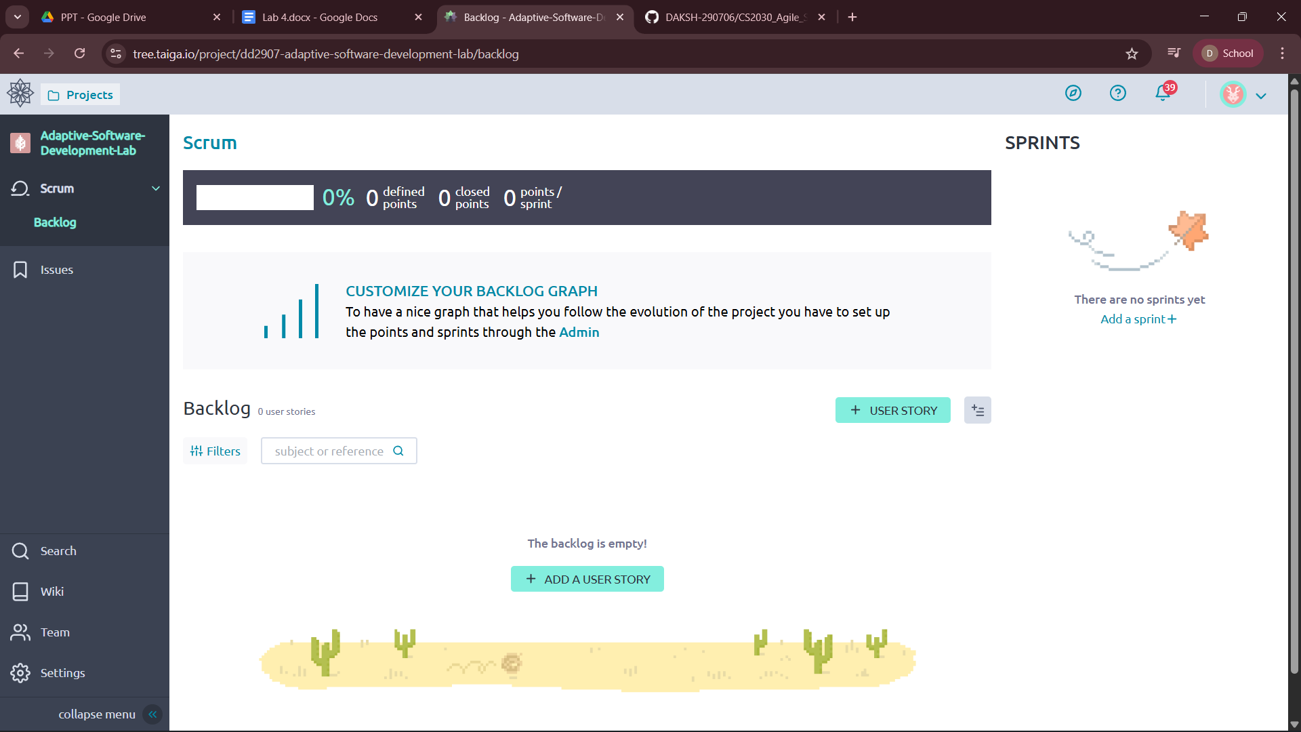

Step 4: Speculative Planning
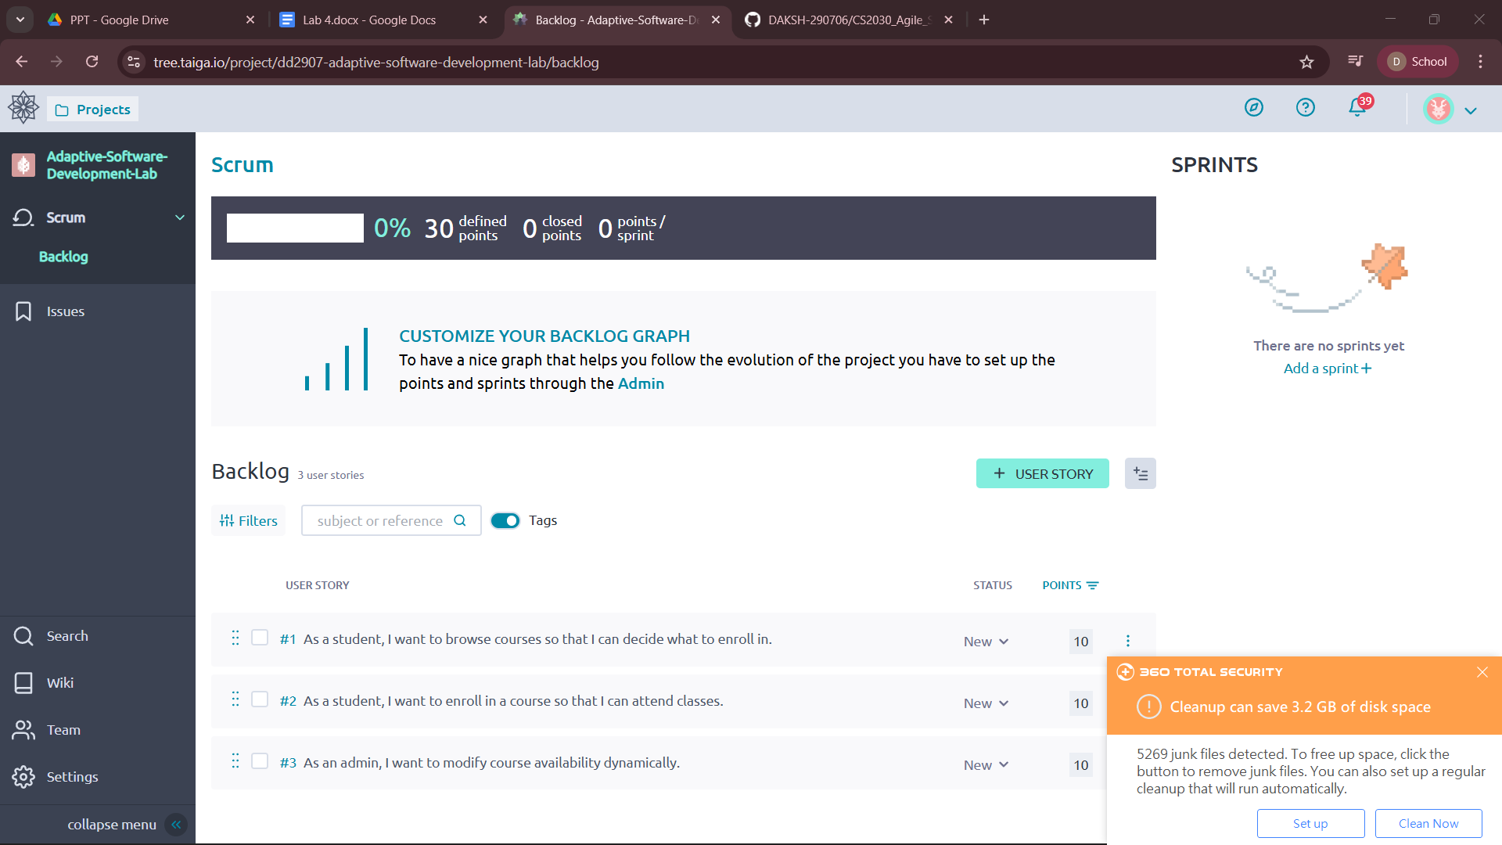

PHASE 3: COLLABORATE PHASE USING TAIGA

Step 5: Sprint Creation and Task Collaboration
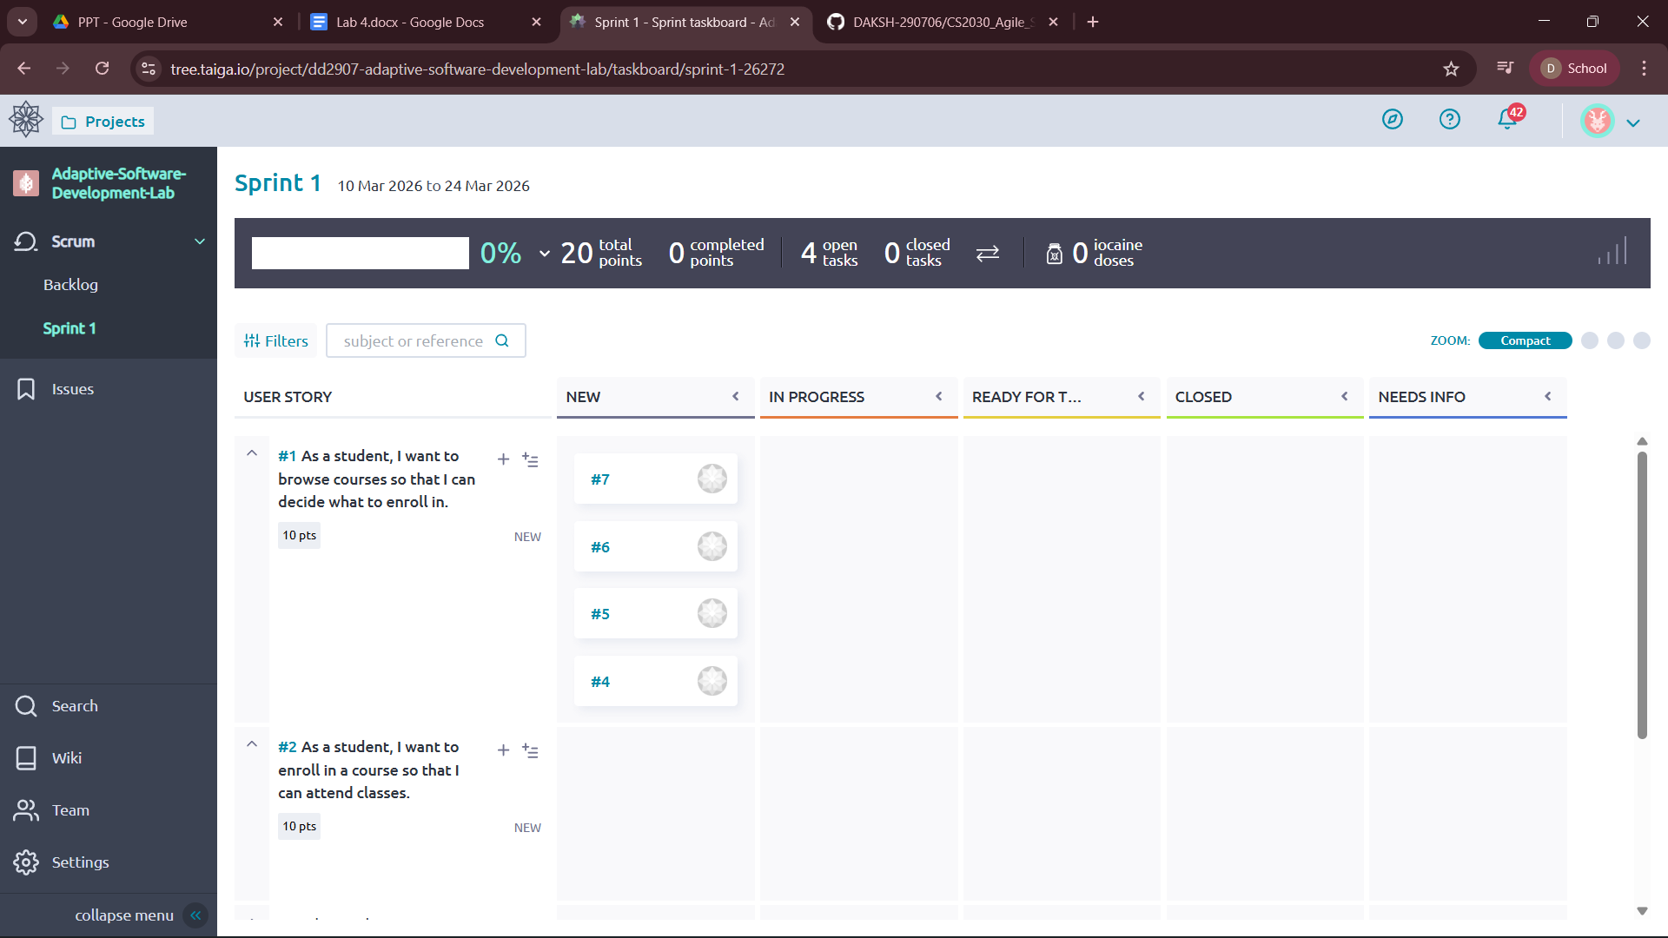

Step 6: Stakeholder Interaction Simulation
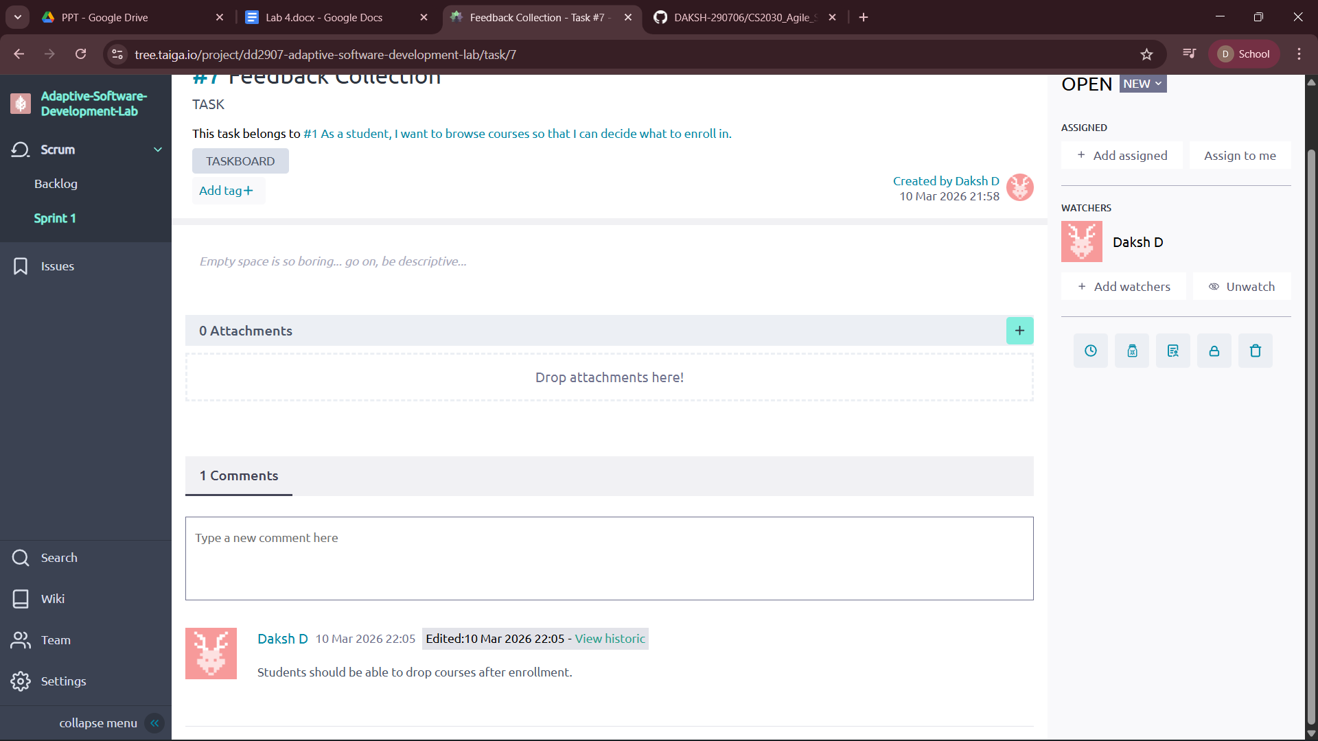

PHASE 4: LEARN PHASE & ADAPTATION

Step 7: Learning Review
1. Correct Assumptions
- Students want to browse courses before enrolling.
- Online course enrollment is an important feature.
- Admins need the ability to update course availability.
2. Wrong Assumptions
- Initially we assumed students would not need to cancel or drop courses.
- We also assumed payment would be the main concern, but flexibility in enrollment became more important.
3. New Information Discovered
- Students want the option to drop courses after enrollment.
- Users prefer easy navigation and filtering of courses.
- Feedback from stakeholders helped identify new requirements.

Step 8: Adaptation & Re-Speculation
Changes Made to Backlog
- Added a new user story: Drop Course after Enrollment.
- Increased priority of Course Enrollment and Browse Courses features.

Modified User Stories
- Updated Course Enrollment story to include drop option.
- Improved Browse Courses story by adding filtering features.

Plan for Next Iteration
- Implement Drop Course feature in the next sprint.
- Improve course search and filtering system.
- Collect more user feedback for further improvements.

