MERIDIAN TECHNOLOGIES
Board of Directors — Annual Strategic Review
CEO Opening Remarks | May 2026 | Catherine Park

We have a healthy enterprise, a profitable company, and a two-year window to decide what Meridian is — before the market decides for us.

Context (spoken: ~45 seconds)
This is my first annual board review as your CEO. I want to use this time honestly — not to recap a year you already know, but to name three problems that require board-level decisions, and to make one specific ask before we close. I will take ten minutes of questions after.
The Picture (spoken: ~30 seconds)
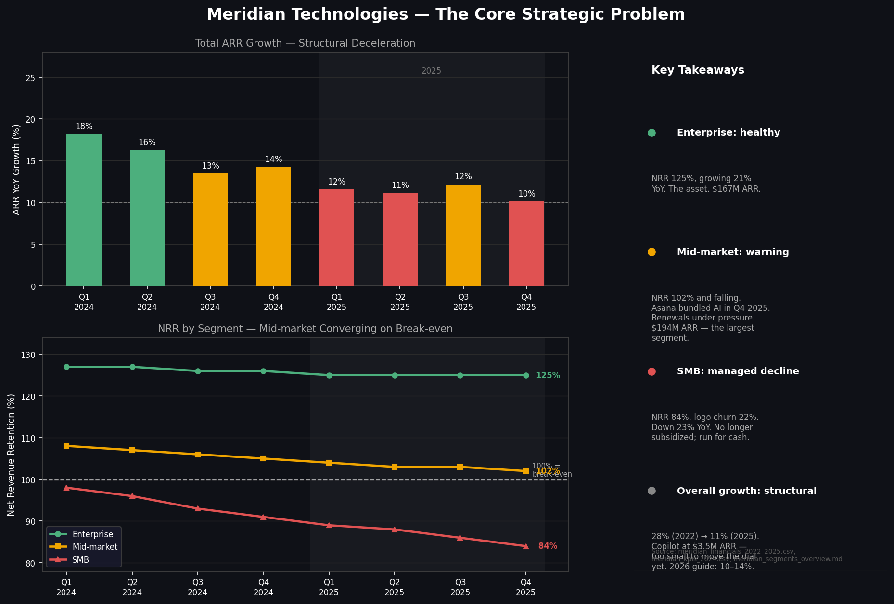
Figure 1. ARR growth deceleration (top) and NRR by segment (bottom), Q1 2024–Q4 2025. Sources: meridian_financials_2022_2025.csv, meridian_kpis_2024.csv, meridian_segments_overview.md.
This chart is the whole story. Enterprise is healthy and growing. SMB is in managed decline. Mid-market — our largest segment at 47% of ARR — is compressing toward break-even NRR. And across all three, total growth has decelerated from 28% in 2022 to 10% last quarter. That deceleration is structural. It is the reason this board meeting matters.

Issue 1 of 3 — Growth deceleration is structural; AI is the only re-acceleration lever, and it is unproven (spoken: ~75 seconds)
Full-year 2025 revenue was $400M, up 11% — the slowest growth this company has reported as a public. Our 2026 guide is 10–14%, below Street consensus at 15%. I said on our Q1 call that this deceleration is not transitory. I meant it.
The evidence:
- Revenue growth: 28% (2022) → 19% (2023) → 16% (2024) → 11% (2025). Four consecutive years of deceleration. (meridian_financials_2022_2025.csv)
- Sales efficiency: Magic number fell from 1.20 (Q1 2024) to 0.92 (Q4 2025) — we are spending more to acquire less ARR. (meridian_kpis_2024.csv)
- AI Copilot today: 710 paying seats, $3.5M ARR contribution on a $413M base. That is 0.85% of ARR. It is a promising signal, not yet a growth driver. (meridian_earnings_call_q4_2025.txt)
AI Copilot is real — 44% enterprise attach rate in Q4, ahead of our own target. But we cannot book re-acceleration on the basis of 710 seats. The board needs to pressure-test whether the Investor Day thesis on March 11 is credible, and what happens to our valuation if it is not.

Issue 2 of 3 — Mid-market is converging on break-even NRR; we do not control the competitive dynamic driving it (spoken: ~75 seconds)
Mid-market is $194M ARR — 47% of the company. It gets less board attention than SMB because the decline is slower. That is precisely why it is dangerous.
The evidence:
- NRR compression: Mid-market NRR fell from 115% (2022) to 102% (Q4 2025). Gross logo churn rose from 9.1% to 10.2% over the same period. (meridian_kpis_2024.csv)
- Competitive trigger: Asana bundled AI into its standard tier in Q4 2025. Every mid-market renewal now includes a demand for price holds, seat expansion at flat cost, or free AI Copilot. (meridian_earnings_call_q3_2025.txt)
- No checkbook fix: Unlike talent retention, this cannot be solved with capital. It requires a product response (AI parity) and/or a pricing model change — both of which take 12–18 months to show results.
If mid-market NRR crosses below 100%, we will have two of three segments in net contraction simultaneously. The 2026 resource management module and pricing refresh on the roadmap are the right moves — but the board should understand the exposure in the gap before they ship.

Issue 3 of 3 — Engineering capacity and Helio retention are the binding constraint on every strategy we just discussed (spoken: ~60 seconds)
We cannot execute the mid-market response, the Copilot roadmap, or the Investor Day commitments without the engineering team to build them. That team is under stress right now.
The evidence:
- Roadmap delivery: 8 of 12 product commitments in 2025 slipped or were deferred. CPO's own assessment: 'Engineering capacity is the binding constraint.' (meridian_product_roadmap_2025.md)
- Senior engineering attrition risk: 27% of senior engineers flagged below-market compensation in the October 2025 survey. People team estimates 15–25 senior engineers are at immediate flight risk. (meridian_employee_survey_2025.md)
- Helio cliff: The Helio retention agreements — the foundation of our agentic roadmap — carry a cash compensation cliff in 2026. CPO flagged this explicitly: 'If the team unwinds early… the roadmap is exposed.' (meridian_product_roadmap_2025.md)
This issue is solvable with capital. We have $463M in cash and no debt. A senior engineering compensation refresh costs $5–10M. The Helio cliff can be addressed proactively. What it requires is a board decision to act before the cliff, not after.

My One Ask (spoken: ~30 seconds)
I am asking the board to authorize a senior engineering and Helio retention package — up to $12M in incremental equity and cash — before the end of Q1 2026.
Every other issue on this agenda — growth re-acceleration, mid-market defense, Investor Day credibility — depends on the engineering team staying intact. This is the one action the board can take today that reduces risk across all three problems simultaneously. I have the People & Compensation Committee's support. I need full board authorization to move before the cliff hits.

The enterprise franchise Lenore built is the best asset in this category. Our job is to make sure we have the team to build the next chapter on top of it. I'll take questions.

Confidential — Meridian Technologies Board of Directors only | Prepared by: Office of the CEO | May 2026

