Stress Level Classification from User-Generated Text: A Comparative Study of Traditional Machine Learning, Deep Learning, and Transformer-Based Approaches
Dalia Nassar, Maryam Mahmoud, Rania Ossama, Yomna Medhat, Lina Ashraf
IDs: 231001310, 231000399, 231001334, 231000762, 231001820
CSCI417: Machine Intelligence — Dr. Sahar Selim
GitHub: https://github.com/DALIANASSAR13/STRESS--CLASSIFIER

Abstract
Mental health screening via social media has emerged as a critical area of research in computational psychology and Natural Language Processing (NLP). This study presents a comprehensive comparative evaluation of machine learning and deep learning architectures for text-based stress level classification into Low, Medium, and High categories. Addressing data scarcity and domain variance, we curate a robust, multi-source dataset comprising 21,436 samples integrating targeted YouTube scraped text, the Dreaddit dataset, and the GoEmotions dataset. We systematically evaluate six distinct methodologies: Logistic Regression, Support Vector Machines (SVM), One-Dimensional Convolutional Neural Networks (1D CNN), Long Short-Term Memory (LSTM) networks, DistilBERT, and the domain-specific MentalBERT. Our empirical results show that while traditional baselines achieve strong competitive accuracy (SVM: 80.4%), the 1D CNN offers an efficient approach for local n-gram feature extraction (accuracy: 76.0%, macro F1: 0.76). Ultimately, the domain-specific MentalBERT architecture achieves the highest overall performance (accuracy: 85.5%, macro F1: 0.85), establishing a clear benchmark for architectural trade-offs in automated mental health monitoring systems.
Index Terms—stress classification, NLP, mental health, transformer models, deep learning, MentalBERT, text classification.
I. INTRODUCTION
Psychological stress has emerged as one of the most pervasive mental health challenges of the twenty-first century. The World Health Organization (WHO, 2022) identifies stress-related disorders as a leading contributor to the global burden of disease, underscoring the urgent need for scalable, accurate, and non-invasive detection systems that can operate at a population level.
Conventional stress assessment methods — including structured clinical interviews, self-report instruments such as the Perceived Stress Scale, and wearable physiological monitoring — are resource-intensive, susceptible to social desirability bias, and fundamentally unsuited to large-scale deployment. The proliferation of digital communication through social media platforms has, however, created unprecedented opportunities for non-intrusive mental health analysis through Natural Language Processing (NLP).
User-generated text carries rich affective, cognitive, and behavioural signals that reliably reflect an individual's psychological state. This makes textual data a particularly tractable modality for automated stress level classification into clinically meaningful severity categories such as low, medium, and high stress.
This paper presents a systematic comparative evaluation of six model families — Logistic Regression, SVM, 1D CNN, LSTM, DistilBERT, and MentalBERT — on a novel multi-source three-class stress classification dataset, tracing the methodological evolution from traditional machine learning through deep sequential architectures to contemporary transformer-based models.
II. LITERATURE REVIEW
A. NLP for Mental Health Analysis
The relationship between linguistic expression and psychological state has been extensively documented in computational mental health research. Nijhawan et al. (2022) [9], in a large-scale study applying NLP and machine learning to social media data, demonstrated that deep contextual language models achieve classification accuracies of up to 94% in stress detection from Twitter posts. Complementing this, Inamdar et al. (2023) [4] analyzed Reddit posts from the Dreaddit benchmark and demonstrated that contextual embedding techniques such as BERT substantially outperform traditional feature representations.
B. Datasets and Benchmarks
The Dreaddit dataset [1] remains the most widely adopted resource in this area, comprising approximately 190,000 Reddit posts with 3,500 human-annotated segments for binary stress classification. The SMM4H 2022 Shared Task 8 [8] provided a standardized benchmark; the highest-performing submission achieved 79% F1 using BERTweet. Despite these contributions, nearly all benchmark datasets are designed for binary classification — fine-grained multi-class annotation schemes remain scarce [3].
C. Traditional Machine Learning
Support Vector Machines (SVM) occupy a foundational role in text classification. Muñoz et al. [3] demonstrated that SVM combined with TF-IDF features achieves F1 scores exceeding 80% on the Dreaddit benchmark. Logistic Regression (LR) constitutes another prominent baseline: Inamdar et al. [4] demonstrated that LR combined with ELMo contextual embeddings attains F1=0.76 on the same dataset. Both classifiers share a fundamental limitation: their linear structure prevents capturing non-linear contextual dependencies essential for fine-grained stress level discrimination.
D. Deep Learning Architectures
Long Short-Term Memory (LSTM) networks [Hochreiter & Schmidhuber, 1997] overcome the vanishing gradient problem through a gated memory cell architecture enabling selective retention of information across arbitrarily long sequences. Stogiannidis et al. [5] found that attention-augmented LSTMs using BERT contextual embeddings approach transformer-level performance — achieving up to 97% F1 — while training 2–3.5 times faster. One-Dimensional CNNs, pioneered for NLP by Kim (2014) [11], treat text sequences as temporal data where spatial filters capture localized linguistic patterns without manual feature engineering.
E. Transformer-Based Models
The Transformer architecture [Vaswani et al., 2017] [12] replaced sequential recurrent processing with parallel multi-head self-attention. BERT [Devlin et al., 2019] [13] introduced bidirectional encoder representations pre-trained via Masked Language Modeling; RoBERTa achieves F1 scores between 91% and 99% across mental health tasks [5]. DistilBERT retains 97% of BERT's language understanding while being 40% smaller and 60% faster. Ji et al. [6] introduced MentalBERT, pre-trained on over 13.6 million sentences from mental health Reddit communities, which consistently outperforms general-purpose BERT across multiple mental disorder detection benchmarks.
III. DATASET
A. Data Sources
This study uses a custom multi-source dataset constructed to support fine-grained three-class stress classification (low, medium, high) from English user-generated text. Three sources were merged to ensure linguistic diversity.
Dreaddit [1]: Reddit posts originally labeled binary (0/1). Labels were remapped: 0 → low, 1 → high. A total of 3,531 samples were retained.
GoEmotions [2]: A large Reddit emotion dataset (47,669 entries). A stratified sample of 4,766 entries (~10%) was drawn and mapped to stress severity levels.
YouTube Comments (scraped): Approximately 15,000 comments scraped from mental health-related videos and manually labeled into the three stress categories.
TABLE I
Dataset Sources and Composition
Source | Type | Original | Used
Dreaddit | Low / High | 3,531 | 3,531
GoEmotions | Multi-label | 47,669 | 4,766
YouTube | Low/Med/High | ~15,000 | ~15,000
Total | — | 21,436 | 20,965*
* After intensive preprocessing. Transformer pipeline retains 21,423 samples.
B. Class Distribution
After merging and cleaning, the dataset contains 21,436 samples: High = 7,883 (36.8%), Medium = 6,792 (31.7%), Low = 6,761 (31.5%). The imbalance ratio is 1.17, indicating near-balanced classes that do not require aggressive resampling.
IV. DATA PREPROCESSING
A. Intensive Pipeline (Traditional ML and Deep Learning)
Applied to produce df_preprocessed.csv (20,965 samples). Steps: (1) lowercasing; (2) removal of URLs, @mentions, #hashtags, numbers, punctuation, and non-ASCII characters/emojis via regex; (3) duplicate removal; (4) length filtering — texts under 10 or over 1,000 characters were removed; (5) lemmatization using NLTK WordNet Lemmatizer; (6) word tokenization via NLTK word_tokenize; (7) custom stopword removal; (8) label encoding (low=0, medium=1, high=2). Five auxiliary features were also extracted: word count, text length, average word length, punctuation count, and uppercase ratio.
B. Light Pipeline (Transformer-Based Models)
Applied to produce df_transformer_ready.csv (21,423 samples). Steps: (1) lowercasing; (2) URL removal; (3) whitespace normalization; (4) null and empty string removal; (5) duplicate removal. Punctuation, casing nuances, and informal language patterns were retained to preserve contextual signals. Sequences were truncated at 128 tokens (MentalBERT) and 64 tokens (DistilBERT) during tokenization.
V. METHODOLOGY
A. Feature Representation
Traditional ML models (SVM and Logistic Regression) use TF-IDF representations with a vocabulary of 5,000 features. LSTM and CNN models use randomly initialized word embeddings trained end-to-end. Transformer-based models (DistilBERT and MentalBERT) use subword tokenization and contextual embeddings derived from their respective pre-trained weights.
B. Models
Logistic Regression: A linear probabilistic classifier using TF-IDF features (5,000 terms), optimized with the lbfgs solver (max_iter=1000).
Support Vector Machine (SVM): An RBF-kernel SVM selected via Grid Search over 5-fold cross-validation (CV F1=0.789±0.014, C=1, no class weighting).
1D CNN: An Embedding layer (128-dim), a 1D Convolutional layer with 128 filters (kernel size=5), GlobalMaxPooling1D, Dense(64), Dropout, and Softmax output for 3-class prediction.
LSTM: An Embedding layer (vocab=5,000; dim=64; max_length=100), a single 64-unit LSTM layer, and a Dense Softmax output layer. Trained with Adam optimizer and categorical cross-entropy loss.
DistilBERT: The distilbert-base-uncased pre-trained checkpoint fine-tuned on the transformer pipeline dataset, sequences truncated at 64 tokens. Trained for 2 epochs.
MentalBERT: The mental/mental-bert-base-uncased checkpoint — pre-trained on 13.6M mental health Reddit sentences — fine-tuned on the transformer pipeline dataset, truncated at 128 tokens. Trained for 3 epochs with early stopping.
C. Training Setup
All models use an 80/20 train-test split with random_state=42. Class imbalance (ratio 1.17) was addressed using class weighting and data transformation where applicable. Traditional ML models were trained on the intensive-pipeline dataset (20,965 samples); transformer models on the light-pipeline dataset (21,423 samples). Each model was trained under consistent experimental settings to ensure a fair comparison.
D. Evaluation Metrics
Model performance is evaluated using accuracy, macro-averaged precision, recall, and F1-score, with per-class breakdowns and confusion matrices. The macro F1-score is emphasized as the primary evaluation metric to ensure balanced performance across all stress levels, given the clinical importance of correctly identifying each severity category.
VI. RESULTS
A. Summary of Performance
Table II presents the aggregate classification performance for all six models.
TABLE II
Overall Classification Performance — All Models
Model | Acc. | Macro F1 | F1-Low | F1-Med | F1-High | Type
Log. Reg. | 79.1% | 0.79 | 0.79 | 0.78 | 0.80 | Trad. ML
SVM | 80.4% | 0.80 | 0.79 | 0.80 | 0.82 | Trad. ML
CNN (1D) | 76.0% | 0.76 | 0.74 | 0.76 | 0.78 | Deep L.
LSTM | 69.1% | 0.67 | 0.58 | 0.66 | 0.79 | Deep L.
DistilBERT | 83.9% | 0.84 | 0.82 | 0.85 | 0.84 | Trans.
MentalBERT | 85.5% | 0.85 | 0.83 | 0.86 | 0.86 | Trans.

MentalBERT achieved the highest performance (accuracy: 85.5%, macro F1: 0.85), followed by DistilBERT (83.9%), SVM (80.4%), Logistic Regression (79.1%), CNN (76.0%), and LSTM (69.1%). Results confirm a clear hierarchy aligned with model expressiveness and the availability of pre-trained representations.
B. Logistic Regression
Logistic Regression achieved 79.1% accuracy with balanced per-class F1: low=0.79, medium=0.78, high=0.80. The confusion matrix (Fig. 1) shows 1,063/1,041/1,214 correct predictions for low/medium/high respectively. The most common error was between low and medium (159 low→medium; 124 medium→low), reflecting semantic overlap between adjacent severity levels.
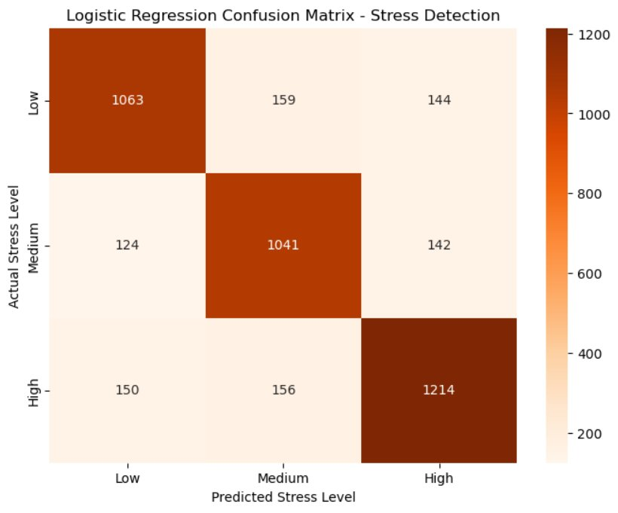
Fig. 1. Logistic Regression confusion matrix.
C. Support Vector Machine (SVM)
SVM achieved 80.4% accuracy (macro F1: 0.80). Grid Search identified an RBF kernel (C=1, no class weighting) as optimal over 5-fold cross-validation (CV F1=0.789±0.014). The confusion matrix (Fig. 2) shows 1,027/1,087/1,255 correct predictions. Low-stress misclassification was symmetric: 151 samples each predicted as medium and high.
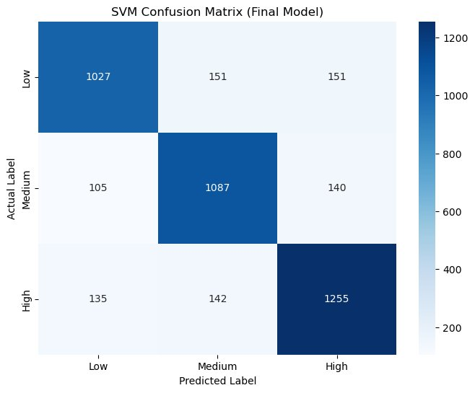
Fig. 2. SVM confusion matrix.
D. 1D Convolutional Neural Network (CNN)
The 1D CNN achieved 76.0% accuracy (macro F1: 0.76) with per-class F1 of 0.74/0.76/0.78. The confusion matrix (Fig. 3) reveals distributed errors: 180 high-stress samples were misclassified as low and 177 as medium, indicating difficulty distinguishing high stress when explicit crisis vocabulary is absent.
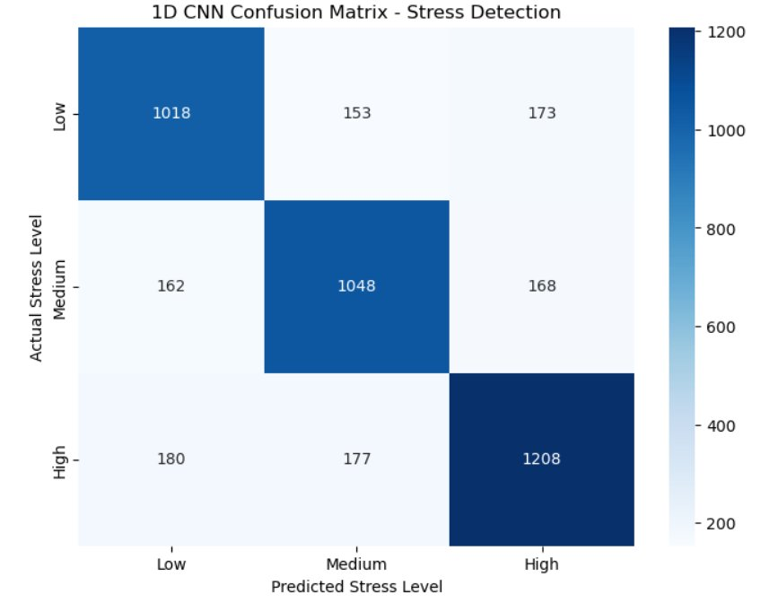
Fig. 3. CNN confusion matrix.
E. Long Short-Term Memory (LSTM)
LSTM produced the weakest results (accuracy: 69.1%, macro F1: 0.67). Per-class F1 revealed severe imbalance: low=0.58, medium=0.66, high=0.79. Only 583 of 1,357 low-stress samples (43%) were correctly classified, with 532 misclassified as medium. High-stress classification was comparatively reliable (1,355 correct). This pattern reflects the model's limited capacity when trained from scratch with a restricted architecture.
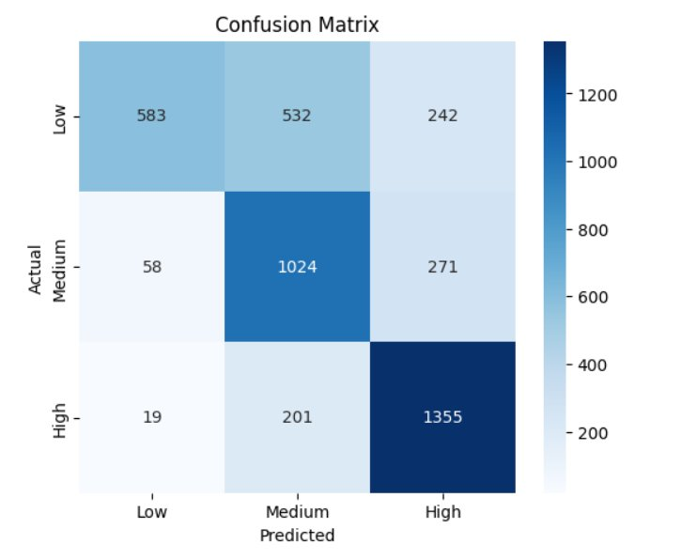
Fig. 4. LSTM confusion matrix.
F. DistilBERT
DistilBERT achieved 83.9% accuracy (macro F1: 0.84) with balanced per-class F1: low=0.82, medium=0.85, high=0.84. The confusion matrix (Fig. 5) shows 1,075/1,168/1,354 correct predictions. The primary error was low→high (174 samples), suggesting residual difficulty at the extremes of the stress spectrum. Validation loss stabilized at 0.427 (epoch 1) and 0.443 (epoch 2).
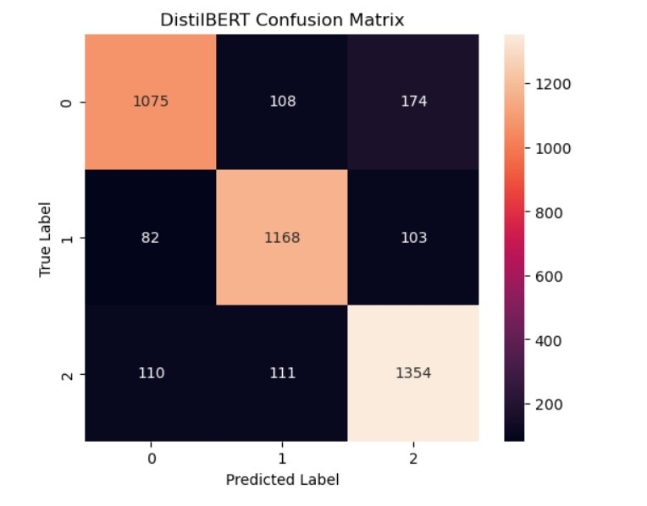
Fig. 5. DistilBERT confusion matrix.
G. MentalBERT
MentalBERT achieved the best results: accuracy=85.5%, macro F1=0.85, macro precision=0.856, macro recall=0.853. Per-class F1: low=0.83, medium=0.86, high=0.86. The confusion matrix (Fig. 6) shows 1,115/1,149/1,398 correct predictions. Training loss decreased from 0.441 to 0.176 over 3 epochs; macro F1 improved from 0.818 (epoch 1) to 0.854 (epoch 3).
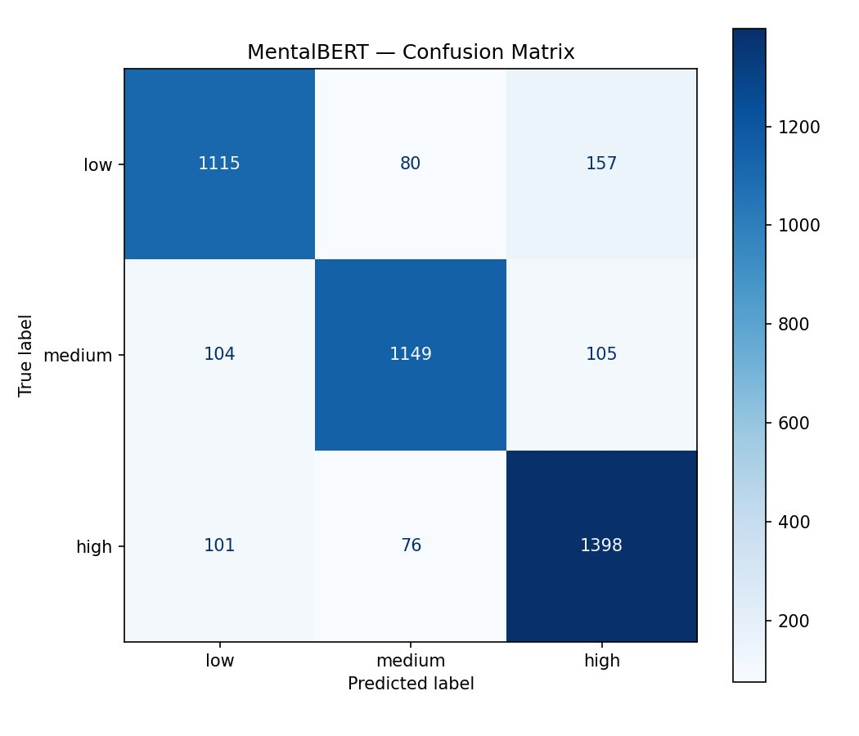
Fig. 6. MentalBERT confusion matrix.
H. Comparative Analysis
Across all models, the low-stress class was consistently the hardest to classify (LSTM F1=0.58; MentalBERT F1=0.83), while high stress was the most separable. Transformer models outperformed all others by 4–5 percentage points over the best traditional classifier (SVM: 80.4%). CNN and LSTM ranked below traditional classifiers — an unexpected result attributable to training from scratch without pre-trained embeddings on a dataset of moderate size.
VII. DISCUSSION
A. Overview of Comparative Results
The results reveal a clear three-tier performance hierarchy. Transformer-based models (MentalBERT: 85.5%, DistilBERT: 83.9%) led by 4–5 percentage points over the best traditional classifier (SVM: 80.4%), which in turn outperformed both deep learning models trained from scratch (CNN: 76.0%, LSTM: 69.1%). This ordering is consistent across both accuracy and macro F1.
B. Traditional Machine Learning: Competitive and Robust Baselines
SVM and Logistic Regression delivered strong and balanced results relative to their architectural simplicity. SVM achieved 80.4% accuracy with per-class F1 of 0.79, 0.80, and 0.82 for low, medium, and high respectively. Logistic Regression reached 79.1% with near-identical per-class F1. The gap between the two is marginal (1.3 percentage points), confirming that both models converge to similar decision surfaces on this dataset.
These findings are consistent with prior benchmarks. Muñoz et al. [3] reported SVM F1 exceeding 0.80 on the Dreaddit benchmark, and Inamdar et al. [4] demonstrated LR attaining F1=0.76 on the same dataset. The present results exceed those baselines under a harder three-class formulation. Despite their competitive performance, TF-IDF-based linear classifiers discard word order, negation, and contextual dependency — a structural ceiling on fine-grained severity discrimination.
C. Deep Learning Models: Underperformance Attributable to Training Constraints
The 1D CNN (76.0%) and LSTM (69.1%) ranked below both traditional classifiers — a result that runs counter to conventional expectations but has a principled explanation rooted in training conditions. Both models were trained from scratch without pre-trained embeddings. Stogiannidis et al. [5] demonstrated that attention-augmented LSTMs using BERT contextual embeddings approach transformer-level performance (up to 97% F1), compared to the 69.1% obtained here with randomly initialized embeddings. The CNN's 6.9 percentage-point advantage over the LSTM reflects its efficient extraction of local n-gram features.
D. Transformer-Based Models: Domain Adaptation as the Key Differentiator
DistilBERT and MentalBERT confirmed the state-of-the-art status of transformer architectures and produced the most balanced per-class performance. The accuracy gap between MentalBERT and DistilBERT is 1.6 percentage points (85.5% vs. 83.9%), which is modest in absolute terms but theoretically significant. Ji et al. [6] demonstrated that domain-specific pre-training on psychologically relevant discourse produces internal representations better calibrated to the informal, emotionally nuanced language of stress-related social media posts.
E. Multi-Class Classification Challenges and Class-Level Analysis
A consistent pattern across all six models is the differential difficulty of the three stress classes. High stress was the most separable (LSTM F1=0.79, MentalBERT F1=0.86), low stress was the most ambiguous (LSTM F1=0.58, MentalBERT F1=0.83), and medium stress occupied an intermediate position. High-stress posts tend to contain explicit emotional markers and strong affective valence. Low-stress posts are often lexically neutral, making them harder to identify by any feature-based approach.
VIII. LIMITATIONS
Dataset Size: The ~21K sample dataset is insufficient for training deep sequential models from scratch. CNN and LSTM underperformance is partly attributable to this constraint.
English-Only Scope: All data sources are English-language Reddit and YouTube text. Findings cannot be generalized to non-English populations or multilingual contexts.
Multi-Source Heterogeneity: The three sources use different annotation schemes, introducing potential label inconsistencies — especially for the medium stress class.
No Standard Multi-Class Benchmark: No widely adopted three-class stress benchmark exists, making direct comparison with prior work difficult. Most published F1-scores are for binary classification.
Training Constraints: DistilBERT was trained for only 2 epochs on CPU. LSTM was limited to a 5,000-token vocabulary and 100-token sequence length.
Ethical Considerations: All data is publicly available; named entities were anonymized. Deployment in real-world mental health monitoring would require ethical review, informed consent, and safeguards against misclassification-based harm.
IX. CONCLUSION
This study presented a comparative evaluation of six models for fine-grained, three-class psychological stress level detection from user-generated text. MentalBERT achieved the highest overall performance (accuracy: 85.5%, macro F1: 0.85), confirming that domain-specific pre-training on mental health discourse provides a consistent and meaningful advantage over general-purpose transformers and non-pre-trained architectures. DistilBERT (83.9%) followed closely, outperforming all non-transformer models by at least 3.5 percentage points.
Contrary to conventional expectations, traditional machine learning classifiers — SVM (80.4%) and Logistic Regression (79.1%) — outperformed both deep learning models trained from scratch, demonstrating that TF-IDF representations remain a robust and computationally efficient baseline when labeled data is of moderate scale. Future work should prioritize multilingual data expansion, incorporation of pre-trained embeddings into deep learning architectures, and the establishment of a standardized three-class stress benchmark.
. REFERENCES
[1] E. Turcan and K. McKeown, "Dreaddit: A Reddit Dataset for Stress Analysis in Social Media," in Proc. 9th Workshop Comput. Linguistics Mental Health, Hong Kong, 2019.
[2] D. Demszky et al., "GoEmotions: A Dataset for Fine-Grained Emotion Classification," in Proc. 58th Annu. Meeting Assoc. Comput. Linguistics, 2020.
[3] L. Muñoz, M. Martínez, and J. Villatoro-Tello, "Using TF-IDF and SVM for Stress Detection in Social Media," in Proc. IberEval Workshop, 2022.
[4] A. Inamdar, H. Bharadwaj, A. Chavan, and S. Kulkarni, "Mental Stress Detection Using NLP and Machine Learning on Reddit Posts," in Proc. Int. Conf. Artif. Intell. Mach. Learn., 2023.
[5] I. Stogiannidis, S. Vassos, P. Papadopoulos, and A. Mylonas, "A Comprehensive Benchmark Study for Multi-Class Mental Health Text Classification," IEEE Access, vol. 13, 2025.
[6] S. Ji, T. Zhang, L. Ansari, J. Fu, A. Tiwari, and E. Cambria, "MentalBERT: Publicly Available Pretrained Language Models for Mental Healthcare," in Proc. LREC, 2022.
[7] Z. Huang, C. Xiao, S. Zhao, J. Liu, and F. Wang, "MentalXLNet and MentalLongformer: Domain-Adapted Models for Long Mental Health Text," 2023.
[8] D. Weissenbacher et al., "Overview of the SMM4H 2022 Shared Tasks on Social Media Mining for Health," in Proc. Workshop SMM4H, 2022.
[9] T. Nijhawan, G. Sharma, M. Sharma, and P. Gulati, "Stress Detection Using NLP and Machine Learning Over Social Interactions," J. Big Data, vol. 9, no. 1, 2022.
[10] M. Tadesse, H. Lin, B. Xu, and L. Yang, "Detection of Suicide Ideation in Social Media Forums Using Deep Learning," Algorithms, vol. 13, no. 1, p. 7, 2019.
[11] Y. Kim, "Convolutional Neural Networks for Sentence Classification," in Proc. EMNLP, 2014.
[12] A. Vaswani et al., "Attention Is All You Need," in Advances in Neural Information Processing Systems, vol. 30, 2017.
[13] J. Devlin, M.-W. Chang, K. Lee, and K. Toutanova, "BERT: Pre-training of Deep Bidirectional Transformers for Language Understanding," in Proc. NAACL-HLT, 2019.

