9/7/2023

2201G3

APTECH north nazimabad

**VACCINATION MANAGEMENT SYSTEM**

**E-Project**

**VACCINATION MANAGEMENT SYSTEM**

**Group Members**

**AASHIR AAMIR BAIG  
Student 1398617**

**Submitted To**

[**eProjects@aglsm.com**](mailto:eProjects@aglsm.com)

**Project Instructor**

**Miss NEHA SHAH EJAZ**

**Curriculum Code**

**7062**

**MUHAMMAD SHAHEER**

**Student 1401788**

**MUHAMMAD UMAR**

**Student 1399562**



**Table of Contents**

E- project 1

Table of content 2

Group members 2

Acknowlegment 3

Introduction 3

Certificate 4

Problem Statement 5

Key Funcationality 6

Duration 7

Tasksheet 8

Hardware/ software Requirement 9

Work Flow 10

Screenshot 11

Conculsion 25

**ACKNOWLEDGEMENT**

We are thankful to Almighty, **ALLAH** that by His grace we have been successfully presenting ours **Vaccination project**in your hands. We have tried our best to take all relevant important topics in consideration so that this project may become comprehensive.

We would want to appreciate and thank all of those people who helped us during this journey of completing our project. Without everyone’s support, we could not have accomplished our work.

We express our sincere gratitude to our faculty “--**Miss Neha Shah Ejaz**--" and our coordinator “—**Miss Iqra Khan**—" for their amazing support and guidance, continuous encouragement and supervision throughout the course of the present work. It’s of no doubt that we have been very fortunate to work under such a supportive and cooperative teacher/coordinator

**CERTIFICATION**

1

Date: 26-6-2021

**THIS IS TO CERTIFY THAT,**

Aashir Aamir Baig, Muhmmad Shaheer & Muhammad Umer has been successfully design & developed “**Vaccination Management System"**

Authorized signature: **Ms. AATIKA LIAQUAT.**

**PROBLEMSTATEMENT:**

# Vaccination Management System

The main aim of developing this Bus managment android app is to provide the vehicle financial info by recording all users’ data and expenditure how much he/she spent. Here user should have user-id and password to verify his details every-time.

**MODULES:**

There are three modules in our Motor Vehicle Android Project:

**Admin**

* **All child details**
* **Date &amp; time of vaccination**
* **Report of vaccination**
* **Child, Vaccination (Date wise report)**
* **List of vaccine**
* **available or unavailable**
* **Request from parents**
* **Approve or Reject**
* **Add Hospital**
* **Update/Delete Hospital**
* **List of hospitals**
* **Booking Detail**

**Parent**

* **Register &amp; Login**
* **Details of child**
* **Vaccination Dates**
* **Book Hospital**
* **Request for hospital**
* **Report of vaccination taken**
* **My profile**

**Hospital**

* **Register &amp; Login**
* **Update Vaccine status**

**Hardware/ Software Requirements**

**Hardware**

* A minimum computer system that will help you access all the tools in the courses is a Pentium 166 or better
* 128 Megabytes of RAM or better

**Software**

Use software as per your requirement

* PHP
* MySQL
* PERL
* Apache

**TASK SHEET**

|  |  |  |  |  |  |
| --- | --- | --- | --- | --- | --- |
| **No.** | **Task** | **Actual Start Date** | **Actual Days** | **Team Mate Name** | **Status** |
| 1. | Case Study | 3th August 2023 | 1 | Aashir Aamir Baig  Muhammad Shaheer  Muhammad Umer | Completed |
| 2. | UI Designing | 5th August 2023 | 2 | Aashir Aamir Baig  Muhammad Minhaj | Completed |
| 3. | SCENARIO Making | 7th August 2023 | 1 | Aashir Aamir Baig  Muhammad Shaheer  Muhammad Umer | Completed |
| 4. | Material Searching | 8th August 2023 | 1 | Aashir Aamir Baig  Muhammad Shaheer  Muhammad Umer | Completed |
| 5. | Database Connectivity | 10th August 2023 | 2 | Muhammad Shaheer | Completed |
| 6. | Documentation | 15th August 2023 | 2 | Aashir Aamir Baig | Completed |

**WORKFLOW SUBMISSION CHECKLIST**

|  |  |  |  |
| --- | --- | --- | --- |
| **S.NO** | **LIST OF ITEMS** | **Remarks** | **COMMENTS** |
| 1. | Do All ACTIVITIES  Linked together | **Yes** | Throughout the Website |
| 2. | Database Connected | **Yes** | Using  SQL |
| 3. | Data fetched from all forms | **Yes** | Using Php |
| 4. | Admin Panel Working | **Yes** | No Comments |
| 5. | DOCUMENTATION Included | **Yes** | All 3-word documents. |
| 6. | Project Zip File | **Yes** | Created using WinRAR |

**SCREENSHOTS**

**Splash Screen**

**Home Page**

Our Home Page.

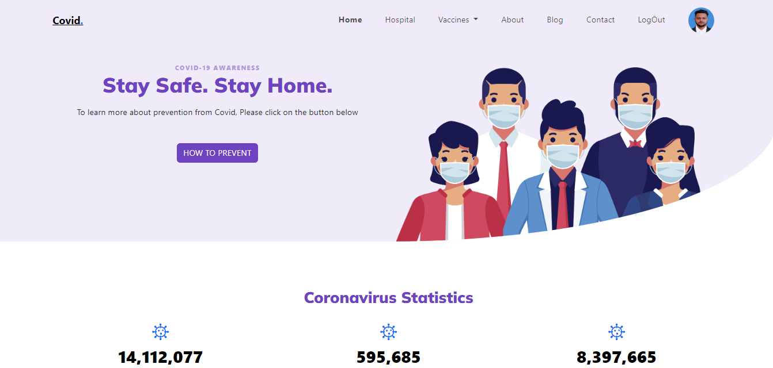

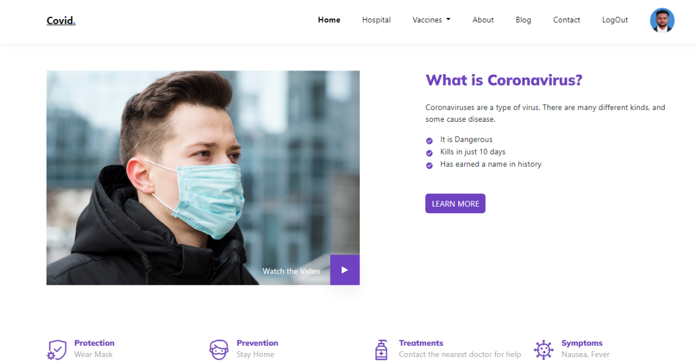

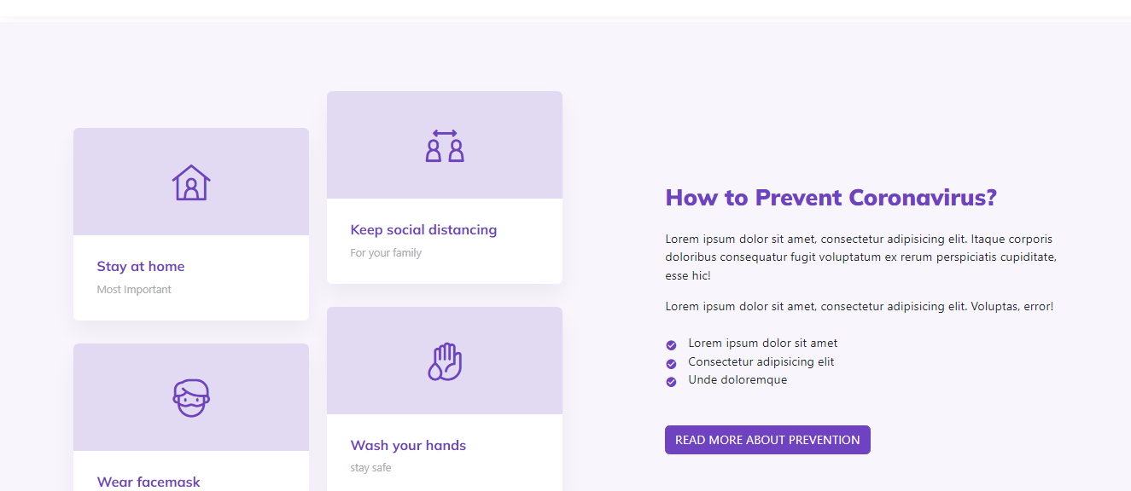

**Hospital**

From here we can see hospital

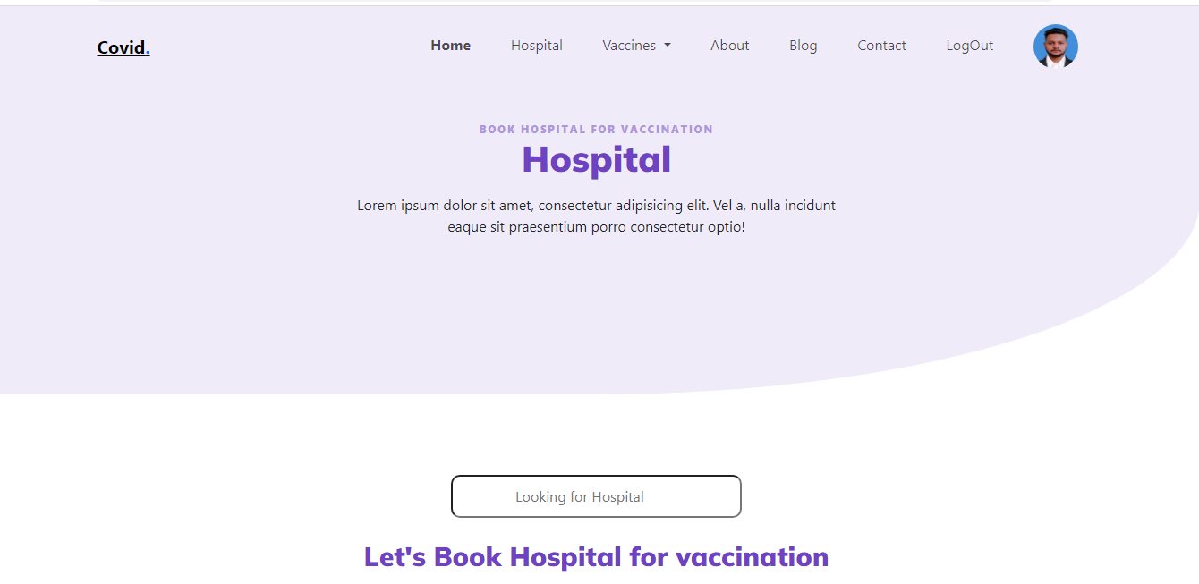

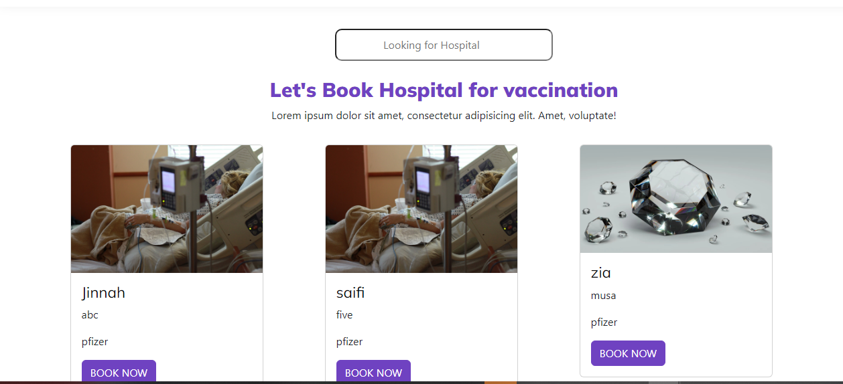

**Child information Form**

Parents will fill out form to get appointment

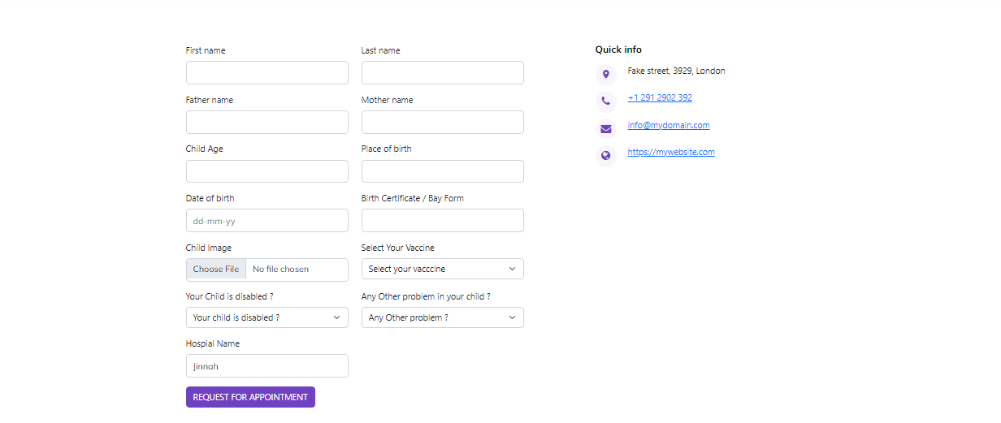

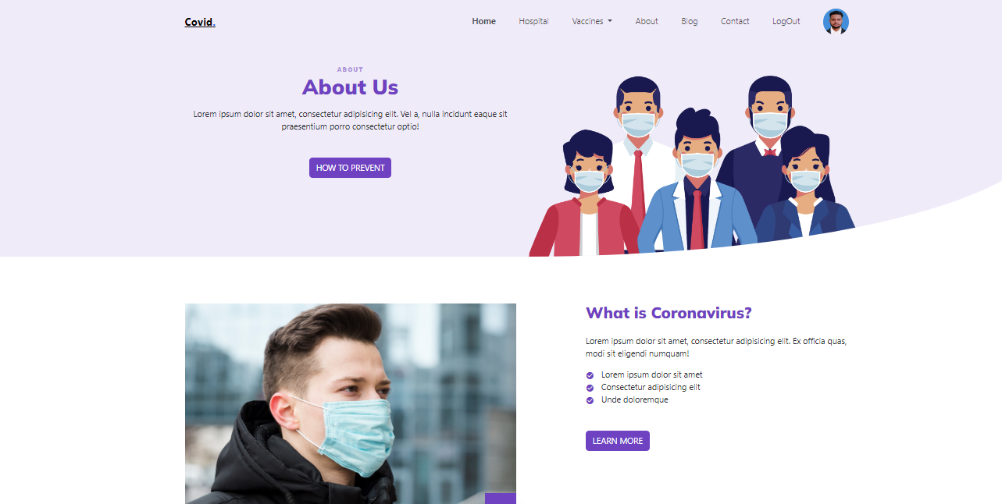**Vaccination**

**Contact Us**

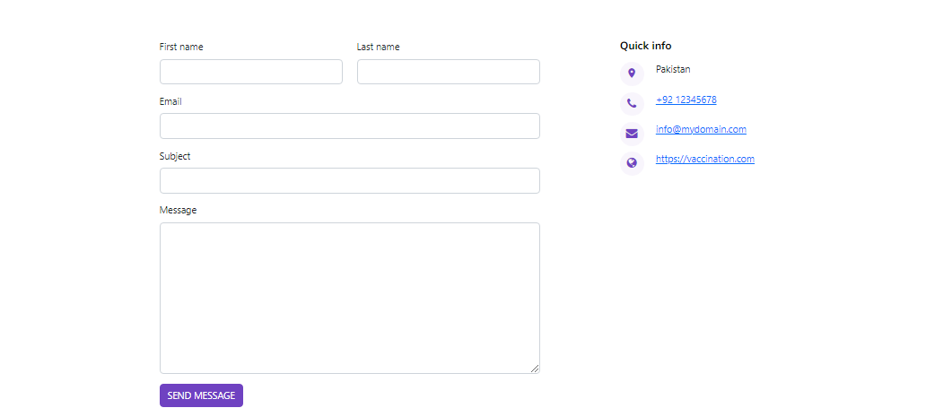

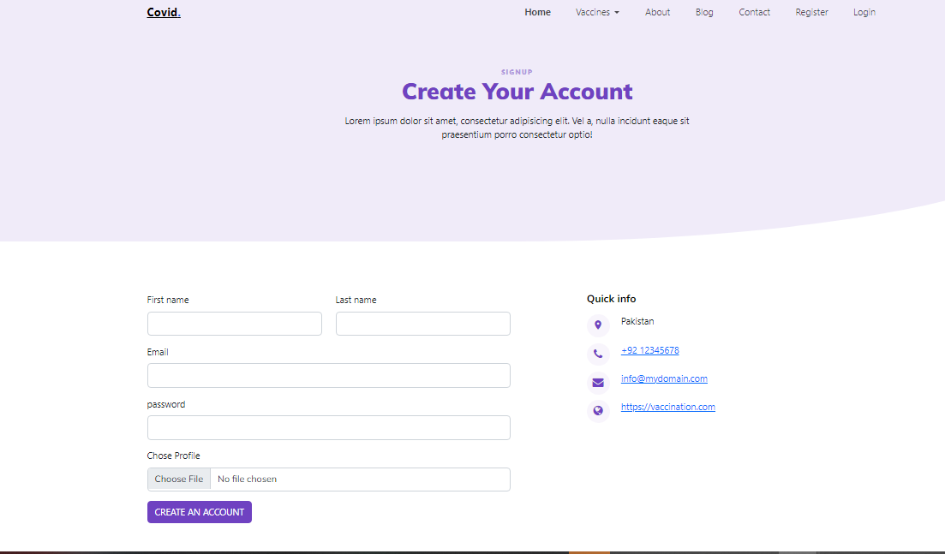**Registration Form**

**Admin Login Form**

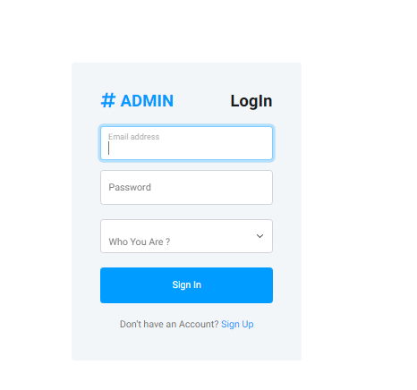

**Admin Child Details**

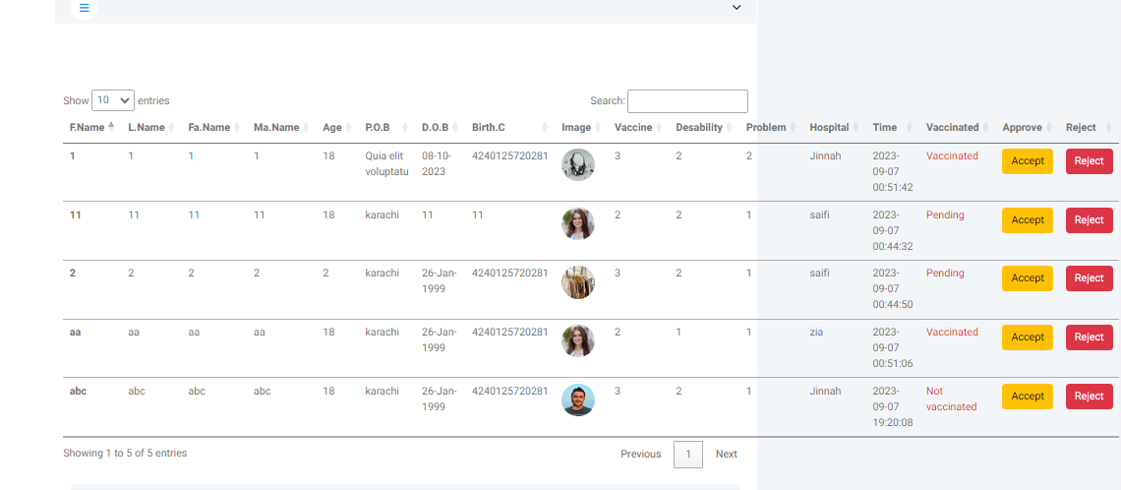

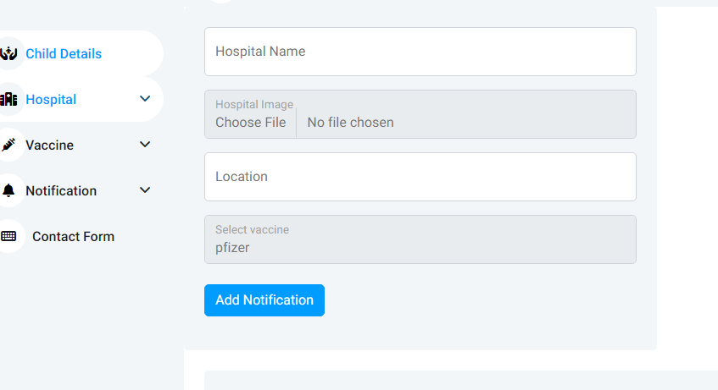**Add Hospital**

**Show Hospital**

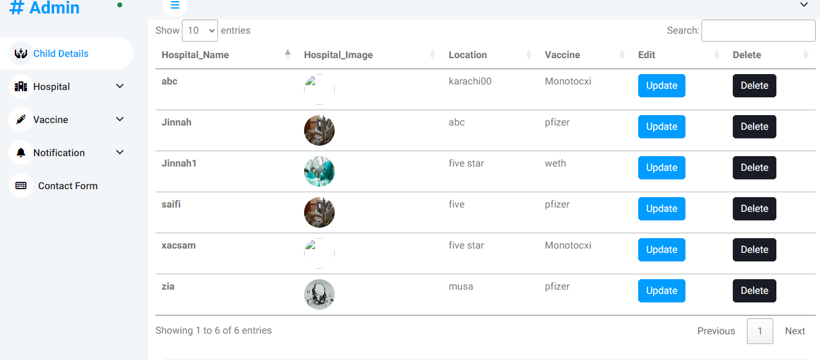

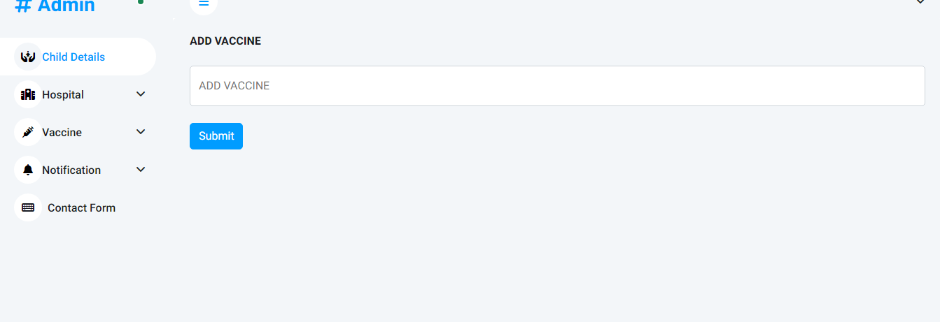**Add Vaccine**

**Update Vaccine**

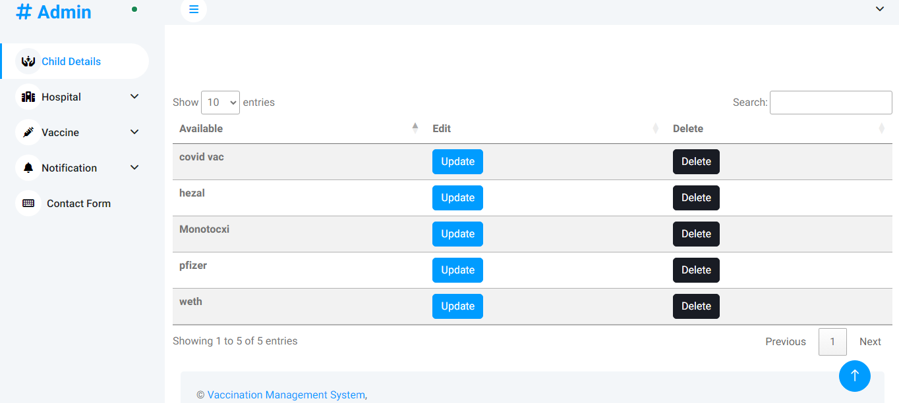

**Remarks**

It is very nice initiative that has made us work harder on our project and it has polished our skills.

**Problem Faced**

VACCINATION Website to be build to help parents vaccinate their Children

**Thank you**