- When i try to cancel a running a operation it tells me that sorry i cant do that and when i give it again it then cancels the process fix that please.
- And when i tell it to find the chair it moves in the wrong and says that it has seen a chair a going towards the goal although there is no such thing over there fix that (i think it is due to the issue of threshold detection)
- Add one more thing that when i tell it to move to the nearest person suppose there are two persons in its view so it should then go towards that i prefer suppose i tell it to go to the nearest one can it do the basically what iam asking that if there are two same object in its view suppose two same chairs or two person in a same frame then add an algorithm or a way to so that the robot is intelligent enough to distinguish between the two same objects.
- Also one more thing the patrolling is amazing but constantly moves to a gap the way ahead of it is clear but instead moving ahead it turns around move back through the ame path again and gradually comes to it again fix that also.
- One more thing suppose it detects a person which is standing behind an obstacle then there its path finding fails can you add something so that it remmebers the coordinates of that person and moves through different areas that gets him closer to thos cordinates find it path through the maze of obstacles to the person that would be amazing.
- Also if it cant find the it has been told then after searching for some time in that area it should stop and tell the operator sorry i cannot find any person in this area rather than by constantly moving around over there.
- One more thing is that it constantly confusing and give the wrong count of things i dont know why and when i tell it to go to the person and then to the chair it says person not found and finding another chair what does another chair means i mean what is finding another chair but why is it saying that finding another chair i didnt tell it to find another chair and one more thing if say find a certain object then that means that just find that object do not navigate to it should just say that i found a (name) object.
- I dont what is the reason but as soon as i give some commands after some time the slam map disfigures in to something i dont know what but when i give command i establish a goal at random point can we fix the slam mapping some how to give accurate mapping.
- Also add one more thing that if the operator tell it to move three blocks ahead or move back a little or move to the right or to the left or do any specific degree rotation then it should be able to do that also precisely.
- I dont know why but when i enter the dock and undock commands the rest of the commands dont work i mean the nav 2 dosent publish goals after that i think it is due to the i create 3 can we fix this?
- 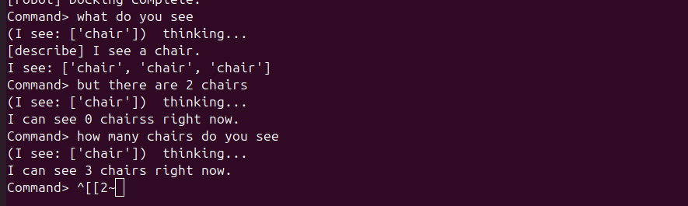fix this problem as well please i dont know how intelligent it is but based on this response it is dumped as fuck make the LLM such that it as able to reason with the operator rather acting like dumb idiot it should be atleast able to reason like LLM
- Also recheack the yolo_server.py if it needs any improvement.

