Checklist

nieuw OAI-PMH formaat toevoegen aan EASY

Geel gemarkeerde onderdelen aanpassen aan de actuele situatie:

* Systeem: evm, localhost, …
* beschikbare dataset
* gewenst formaat

Fedora configureren: <http://evm:8080/fedora/admin/>

Testen: klik op run in <http://evm:8080/fedora/objects/easy-dataset:1/methods>

Table of Contents

Fedora configuratie 1

Style sheet 2

easy-sdef METHODMAP 2

easy-sdep METHODMAP 2

DSINPUTSPEC 2

WSDL 3

Trouble shooting 3

http://evm:8080/fedora/objects/easy-dataset:1/methods 3

http://evm:8080/fedora/objects/easy-dataset:1/methods/easy-sdef:oai-item1/getOpenAIREplus 3

# Fedora configuratie

Datastream toevoegen aan object *easy-sde****p****:oai-item1*:  
ID: EMD_OAP.xsl   
Label: Stylesheet for transformation from EMD to OpenAIREplus-flavoured DataCite  
Content: XSL transformatie

Datastreams uitbreiden:  
[http://evm:8080/fedora/objects/easy-sde**f**:oai-item1/datastreams/METHODMAP/content](http://evm:8080/fedora/objects/easy-sdef:oai-item1/datastreams/METHODMAP/content)   
[http://evm:8080/fedora/objects/easy-sde**p**:oai-item1/datastreams/METHODMAP/content](http://evm:8080/fedora/objects/easy-sdep:oai-item1/datastreams/METHODMAP/content)  
[http://evm:8080/fedora/objects/easy-sde**p**:oai-item1/datastreams/DSINPUTSPEC/content](http://evm:8080/fedora/objects/easy-sdep:oai-item1/datastreams/DSINPUTSPEC/content)  
[http://evm:8080/fedora/objects/easy-sde**p**:oai-item1/datastreams/WSDL/content](http://evm:8080/fedora/objects/easy-sdep:oai-item1/datastreams/WSDL/content)

Objecten die moeten bestaan (maar geen inhoud hebben)

easy-model:EDM1DATASET (label: Content Model for EDM DATASET)

dans-model:recursive-item-v1 (label: Content Model for Recursive Item)

## Style sheet

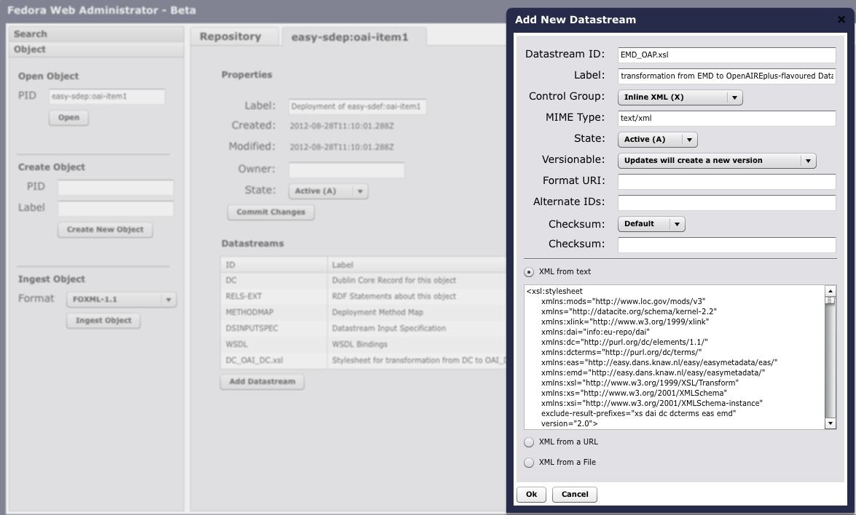

## easy-sdef METHODMAP

<fmm:Method

label=*"Get metadata formatted as OpenAIREplus-flavoured DataCite"*

operationName=*"getOpenAIREplus"*>

</fmm:Method>

## easy-sdep METHODMAP

<fmm:Method

operationLabel=*"Get metadata formatted as OpenAIREplus-flavoured DataCite"*

operationName=*"getOpenAIREplus"*

wsdlMsgName=*"getOpenAIREplusRequest"*

wsdlMsgOutput=*"dissemResponse"*>

<fmm:DatastreamInputParm

parmName=*"EMD"*

passBy=*"URL_REF"*

required=*"true"*></fmm:DatastreamInputParm>

<fmm:DatastreamInputParm

parmName=*"EMD_OAP.xsl"*

passBy=*"URL_REF"*

required=*"true"*></fmm:DatastreamInputParm>

<fmm:MethodReturnType

wsdlMsgName=*"dissemResponse"*

wsdlMsgTOMIME=*"text/xml"*></fmm:MethodReturnType>

</fmm:Method>

## DSINPUTSPEC

<fbs:DSInput

DSMax=*"1"*

DSMin=*"1"*

DSOrdinality=*"false"*

wsdlMsgPartName=*"EMD_OAP.xsl"*

pid=*"easy-sdep:oai-item1"*>

<fbs:DSInputLabel>XSL Stylesheet</fbs:DSInputLabel>

<fbs:DSMIME>text/xml</fbs:DSMIME>

<fbs:DSInputInstruction></fbs:DSInputInstruction>

</fbs:DSInput>

## WSDL

<wsdl:message name=*"getOpenAIREplusRequest"*>

<wsdl:part name=*"EMD"* type=*"this:inputType"*></wsdl:part>

<wsdl:part name=*"EMD_OAP.xsl"* type=*"this:inputType"*></wsdl:part>

</wsdl:message>

…

<wsdl:operation name=*"getOpenAIREplus"*>

<wsdl:input message=*"this:getOpenAIREplusRequest"*></wsdl:input>

<wsdl:output message=*"this:response"*></wsdl:output>

</wsdl:operation>

</wsdl:portType>

…

<wsdl:operation name=*"getOpenAIREplus"*>

<http:operation location=*"saxon/SaxonServlet?source=(EMD)&amp;style=(EMD_OAP.xsl)&amp;clear-stylesheet-cache=true"*></http:operation>

<wsdl:input>

<http:urlReplacement></http:urlReplacement>

</wsdl:input>

<wsdl:output>

<mime:content type=*"text/xml"*></mime:content>

</wsdl:output>

</wsdl:operation>

</wsdl:binding>

# Trouble shooting

## <http://evm:8080/fedora/objects/easy-dataset:1/methods>

Nieuwe formaat wordt niet getoond

sdef ontbreekt

## <http://evm:8080/fedora/objects/easy-dataset:1/methods/easy-sdef:oai-item1/getOpenAIREplus>

Caused by: …GeneralException: ServiceMapper returned error. The underlying error was a java.lang.NullPointerException. The message was "null" …ServiceMapper.parse(ServiceMapper.java:193)  
…ServiceMapper.getService(ServiceMapper.java:153)  
…ServiceMapper.getMethodDefBindings(ServiceMapper.java:124)

Foutje in WSDL, Request ontbrak in message name:

<wsdl:message name=*"getOpenAIREplusRequest"*>

…  
Caused by: … Error getting http://evm:8080/saxon/SaxonServlet?source= *http://evm:8080/fedora/get/easy-dataset:1/EMD/2013-11-22T12:58:03.891Z*&style=*http://evm:8080/fedora/get/easy-sdep:oai-item1/EMD_didl.xsl/2012-08-28T11:10:01.455Z*&clear-stylesheet-cache=false   
… Caused by: …ConnectTimeoutException: The host did not accept the connection within timeout of 20000 ms...

Gewraakte URL met curl op evm zelf uitgeprobeerd:

als evm vervangen wordt door localhost werkt het wel. Of de argumenten geëncodeerd zijn of niet maakt niet uit. Ook <http://localhost:8080/fedora/objects/easy-sdep:oai-item1/datastreams/EMD_OAP.xsl/content> als style argument blijkt ook te werken.

Het blijkt niet mogelijk om in de WSDL *evm* te vervangen door *localhost*

<wsdl:service name=*"N/A"*>

<wsdl:port binding=*"this:binding"* name=*"port"*>

<http:address location=*"http://evm:8080/"*></http:address>

</wsdl:port>

</wsdl:service>

Uiteindelijk bleek dat op de EVM de file /etc/hosts een verkeerd IP adres bevatte, zie ook de handleidingen:

* In smb://10.169.32.22/develop/centos-6.2-x86_64-server/evm-1.0.zip
* En smb://10.169.32.22/develop/centos-6.2-x86_64-server/evm-1.0-manual-addendum-VM-warefusion-4.doc