**ISAD251**

**APPLICATION DESIGN DOCUMENT**

# Daniel Skillman, 10602402

## Storyboards.

## Screenshots.

## Diagrams.

## Links.

# Storyboards

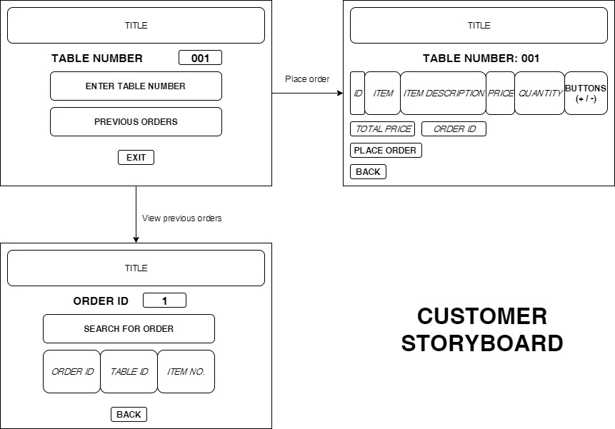

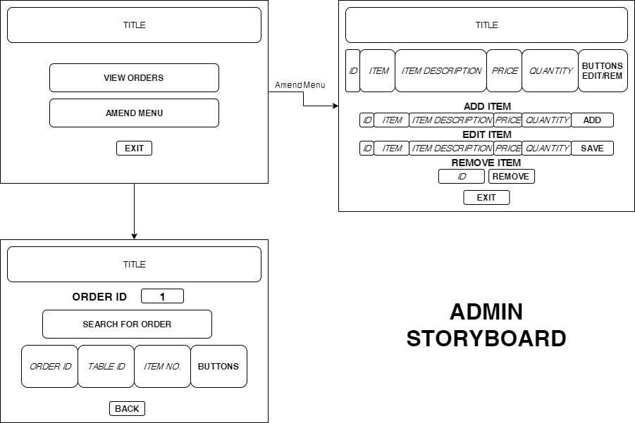

# Screenshots

1. 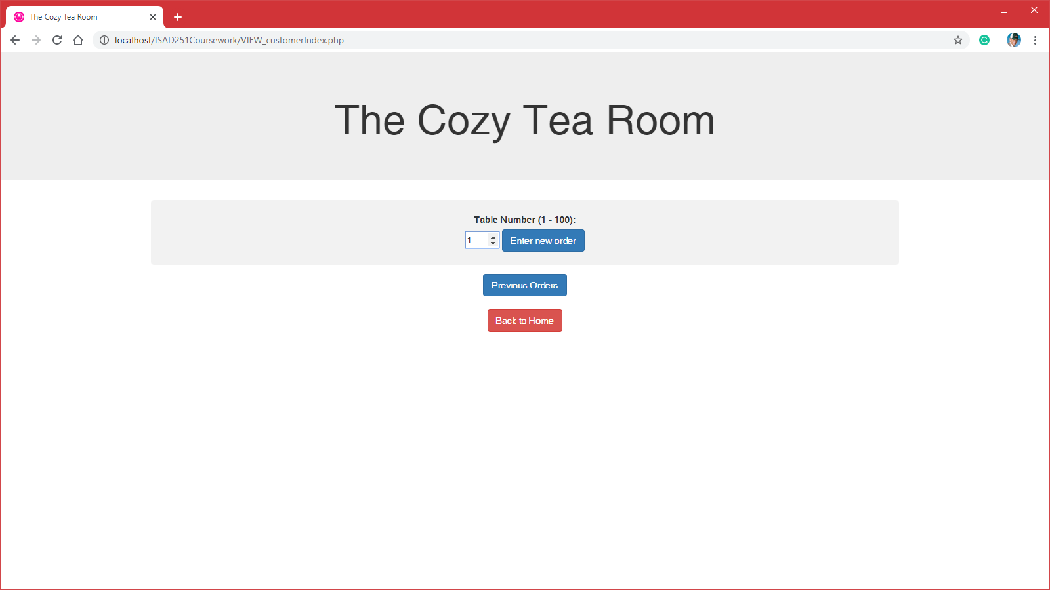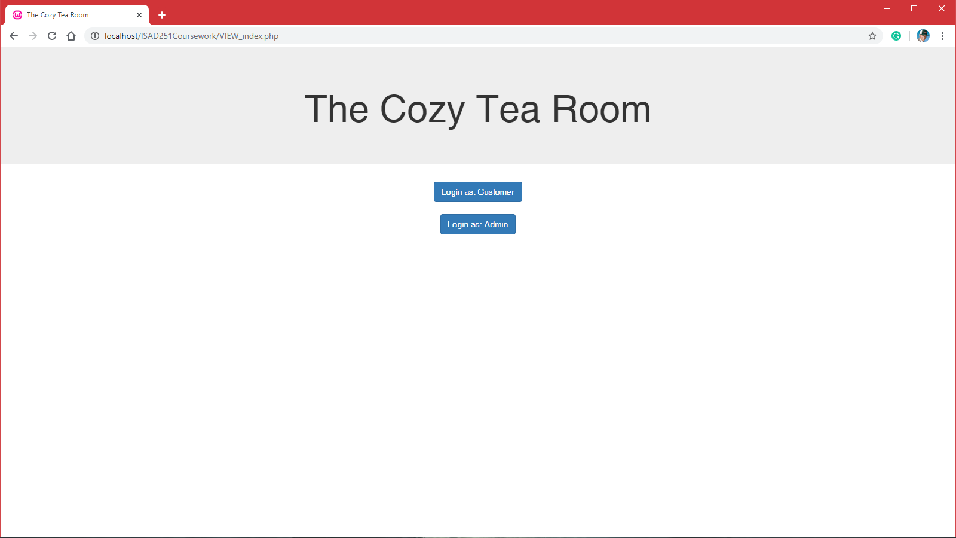The front-end portal. Here you can decide to use either customer or an admin as a login. This will change the application experience either way.
2. When selecting customer, the customer will be sent to the first entry point. Here a table number between one and one hundred can be selected. Or go to the previous orders menu.
3. A screenshot of a cell phone

   Description automatically generatedA screenshot of a cell phone

   Description automatically generatedAfter selecting a table number, the customer will be shown a menu with different items. They can add and take away items from their basket. The customer is shown their table number, order ID and total price as they make their selection.
4. When clicking proceed, the customers order will have been placed in the system. It shows an alert with a repeat of their information that is relevant (ORDER ID, TOTAL PRICE, AND TABLE NUMBER).
5. 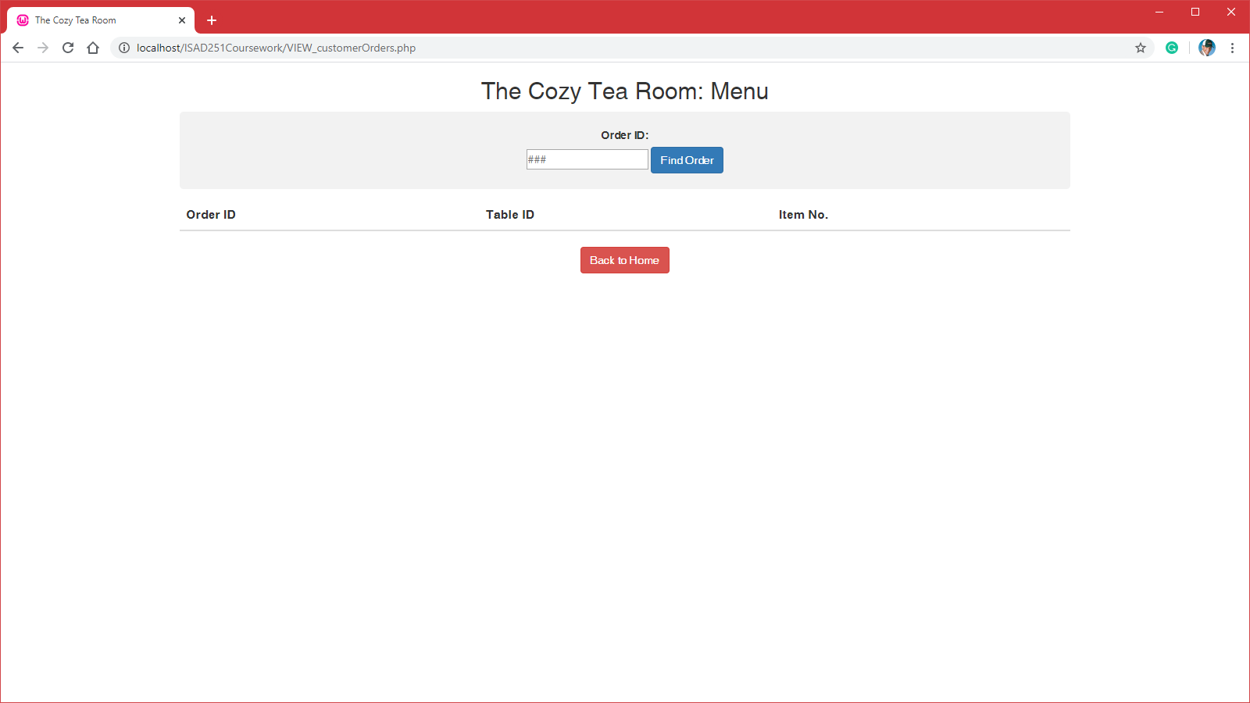After placing the order the customer is returned to the home portal where they can view their previous order.
6. When the customer types in their order ID, it will show the relevant details to their order. (Not functional).
7. 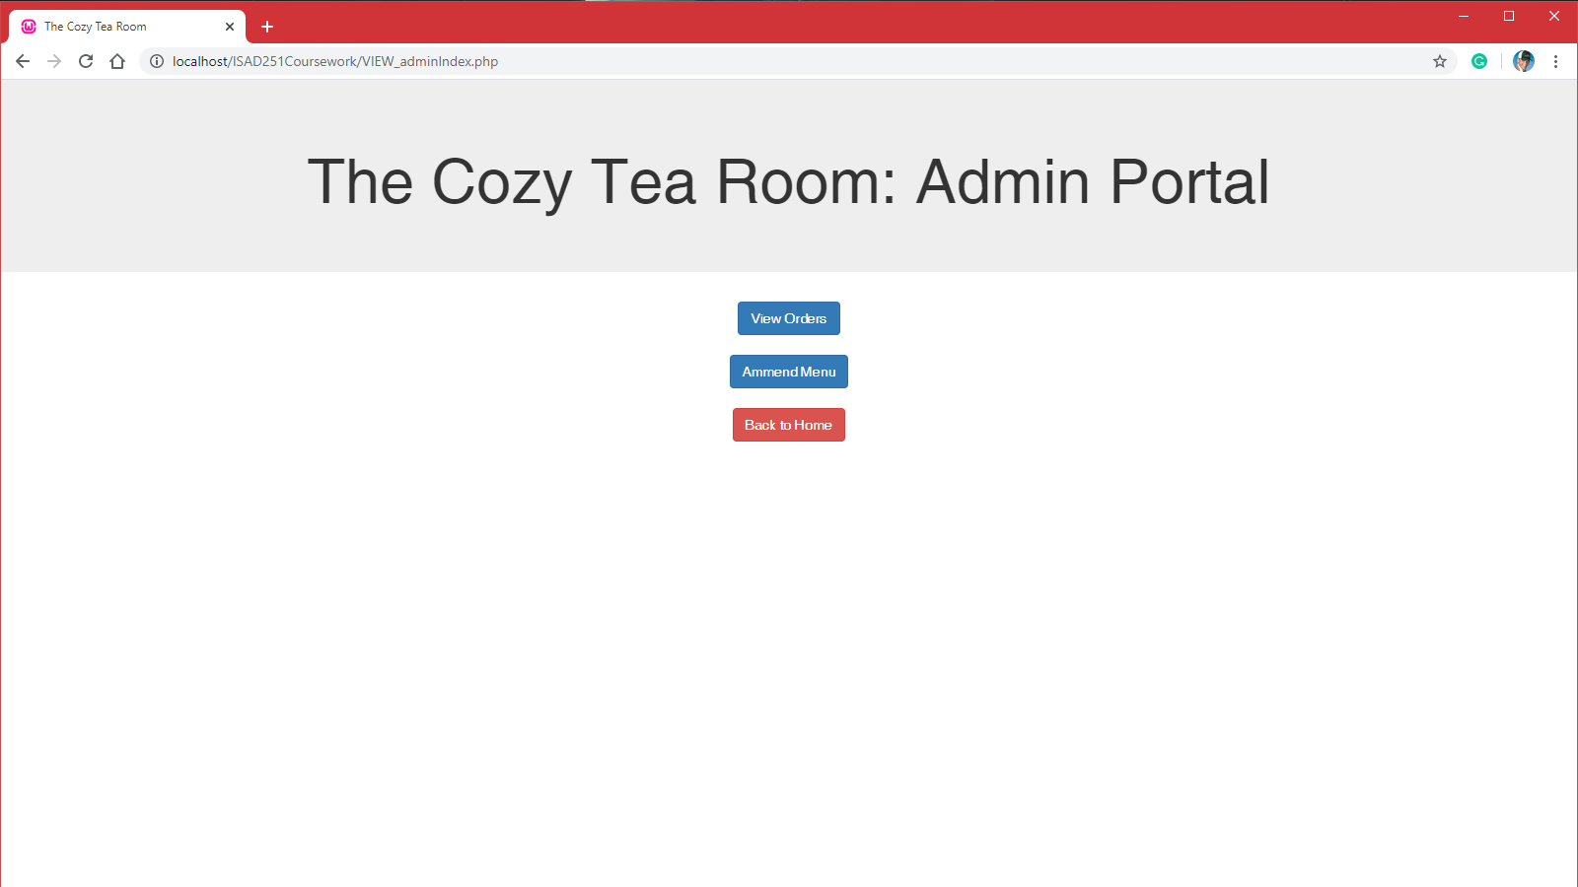Returning to the main portal, Admin is selected.
8. The admin is shown their portal. Where they can either view previous orders, or be shown the menu which they can make edits to.
9. 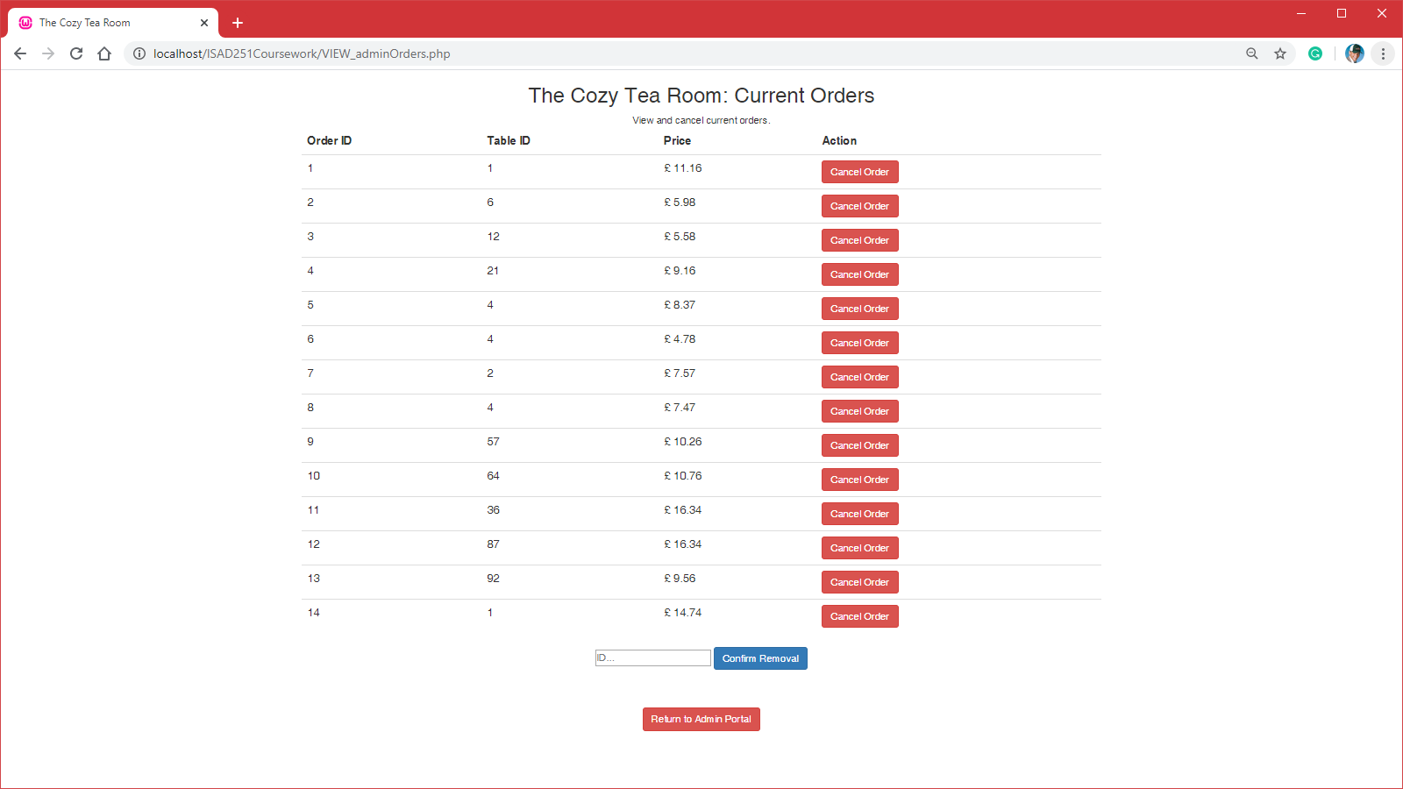This is what the admin is shown when viewing all current orders. Where they would have the option to cancel individual orders. (Not functional).
10. Returning from the orders screen takes the admin to the portal again.

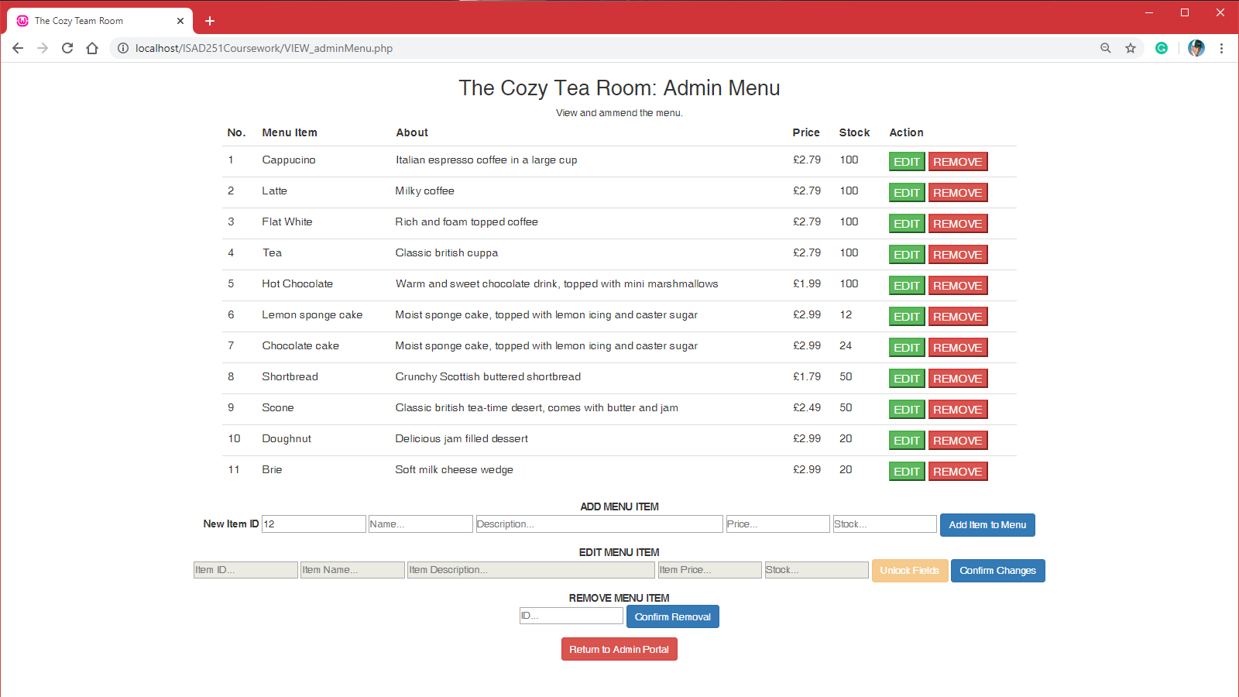

1. 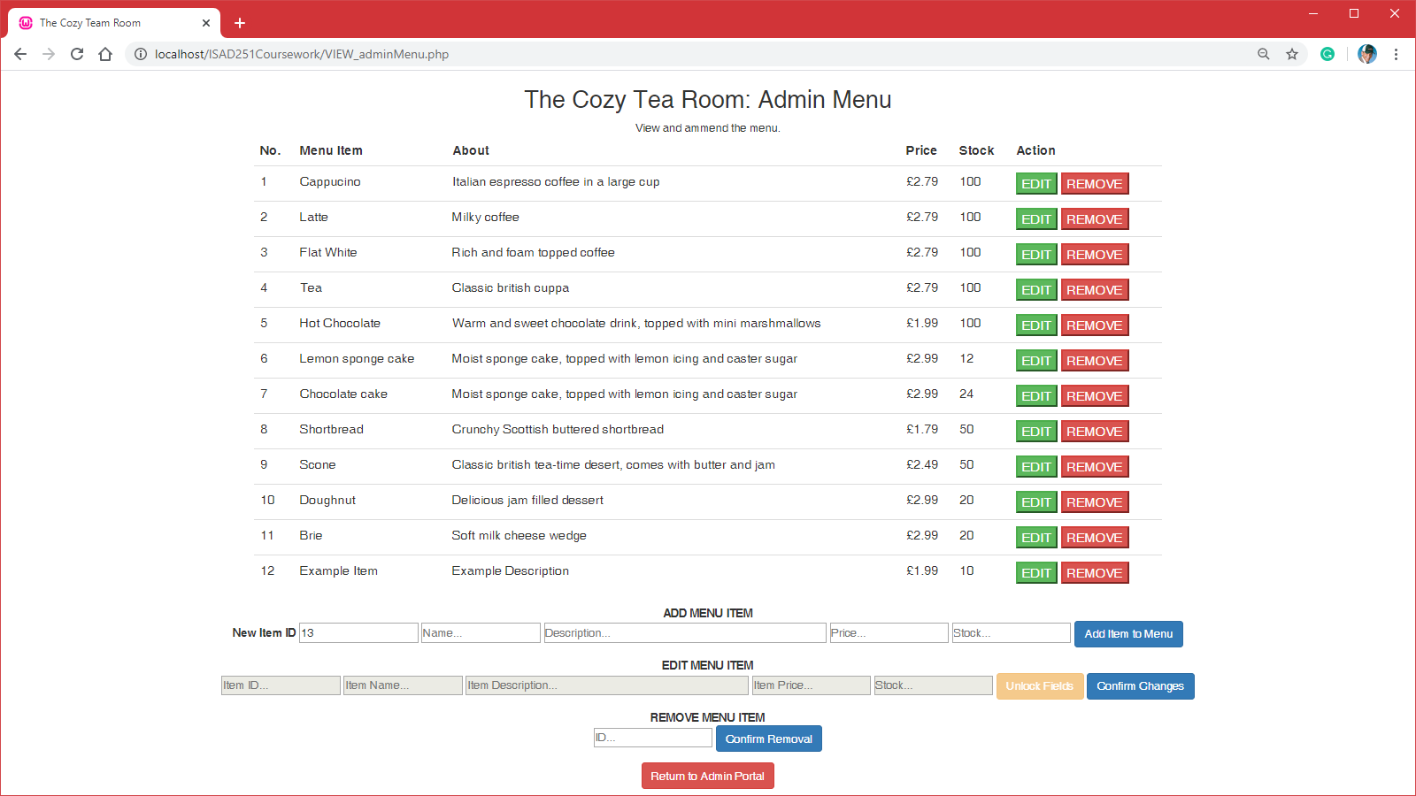From the portal the admin can view the menu, with capability to add, edit and remove items.

–

1. To add an item, the admin uses the dialogue boxes under the table.
2. 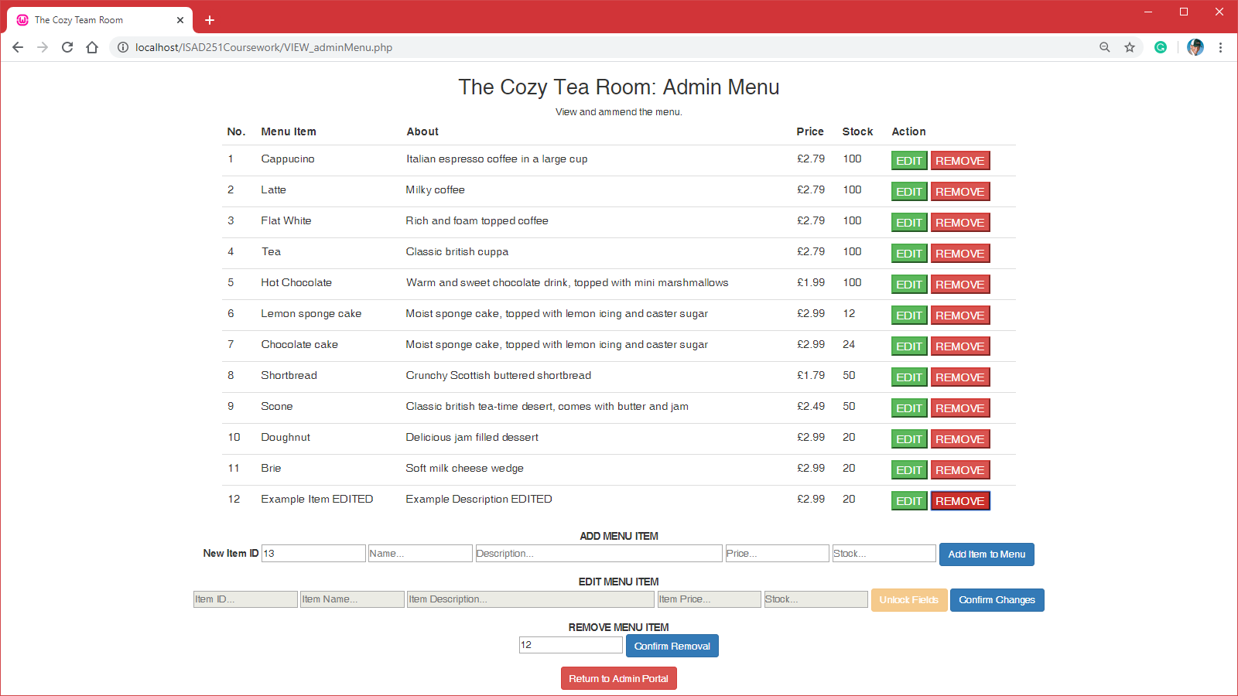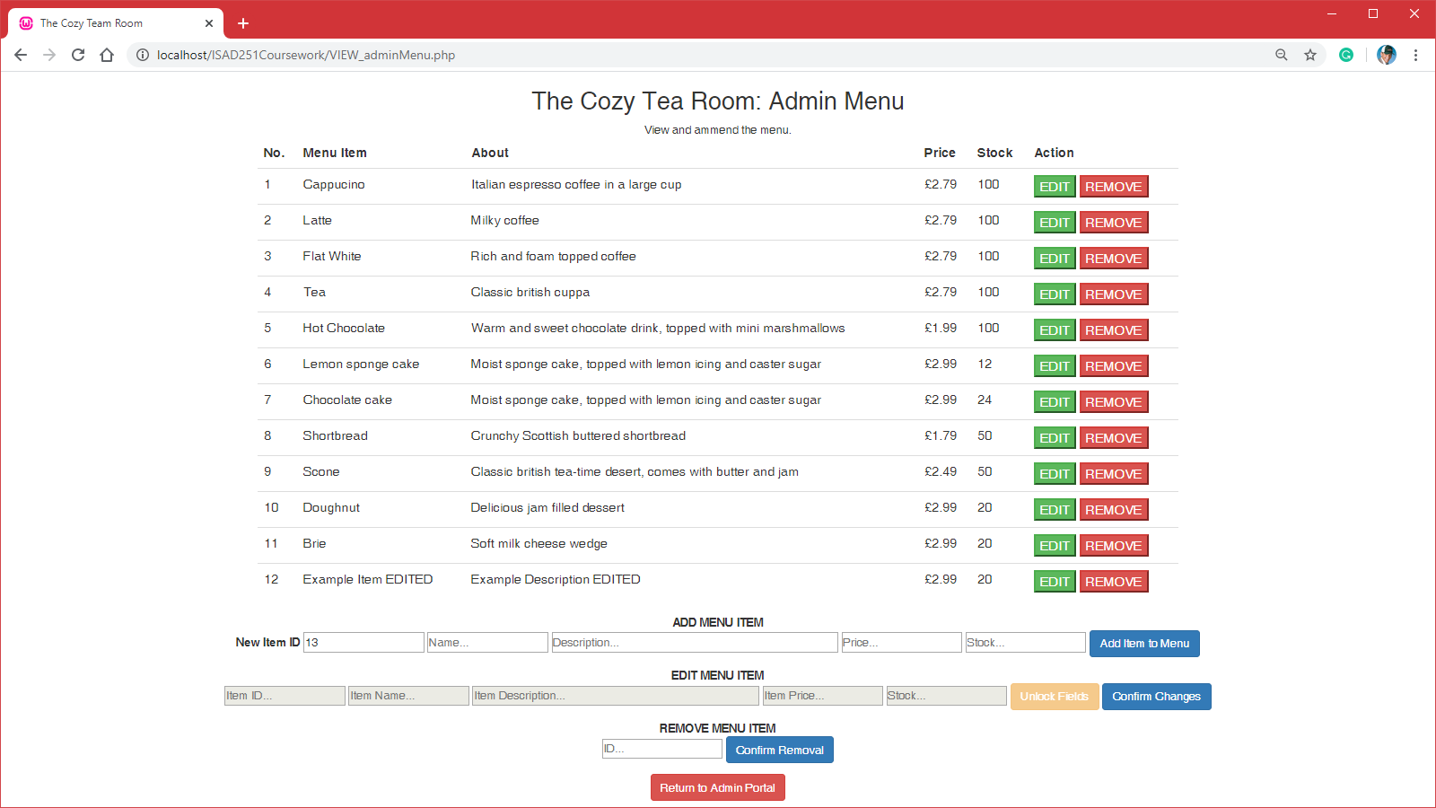When pressing one of the green edit buttons, the dialogue boxes can be opened by pressing the yellow button on the right side. This allows the boxes to be edited for sure. Finally the blue button on the right will save the data.
3. Finally when pressing the red buttons in the side, the lowest dialogue box will be filled with the item ID, this is a confirmation box before the row is dropped permanently.
4. The table is now back to it’s original state.

# Diagrams

**Customer UML Action Diagram**

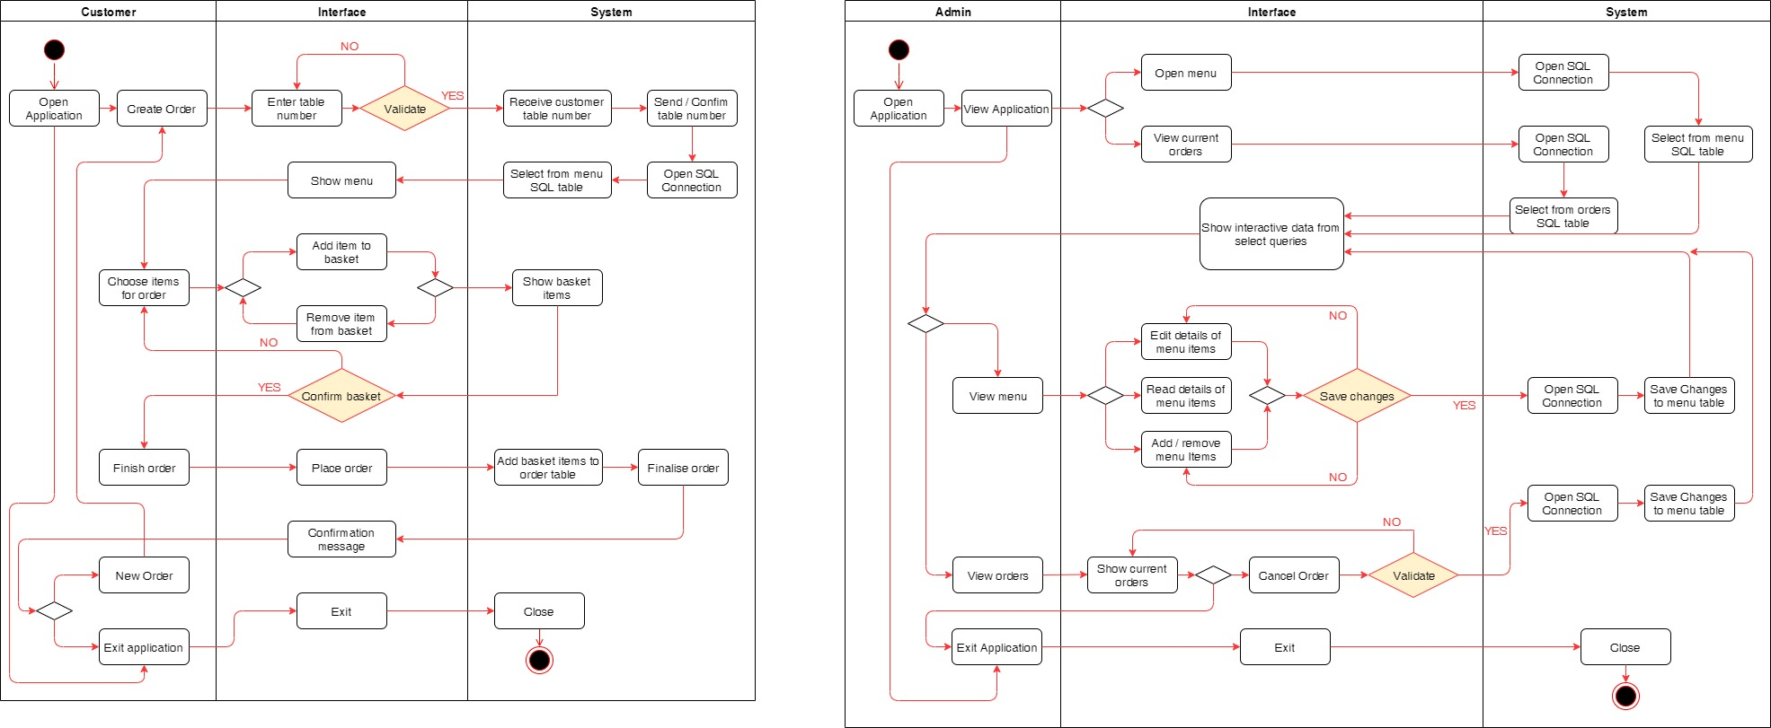

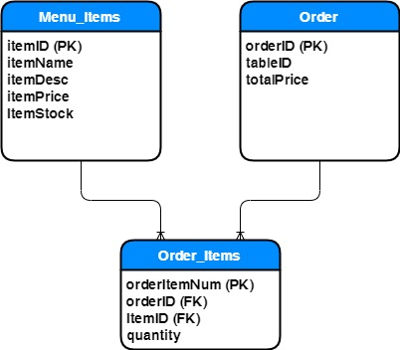**Admin UML Action Diagram**

**ERD Diagram**

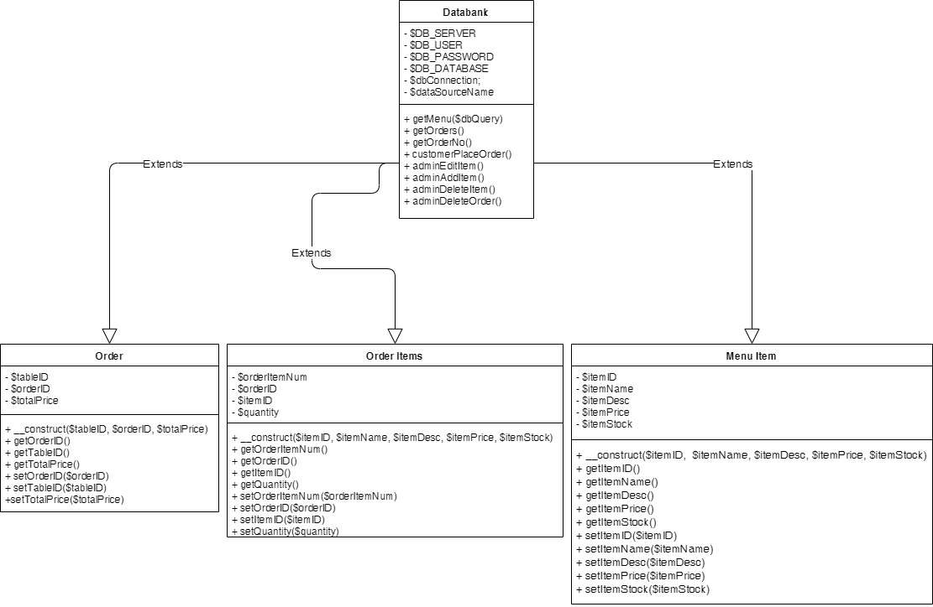**UML Class Diagram**

# Links

GITHUB: https://github.com/DANSKI423319/ISAD251Coursework.git