Lớp 11-TMDT
Tên: Đào Thị Lý
MSSV: 1150070027
BÀI THỰC HÀNH BUỔI 1
BÀI TẬP LAP 1
Bài tập 1:
Ban đầu ta tạo một Empty Views Activity chọn ngôn ngữ Java
Bước1: Vào activity_main.xml thêm code sau vào
<?xml version="1.0" encoding="utf-8"?>
<LinearLayout xmlns:android="http://schemas.android.com/apk/res/android"
android:orientation="vertical"
android:padding="16dp"
android:layout_width="match_parent"
android:layout_height="match_parent"
android:background="#FFFFFF">
<!-- Ô nhập số thứ nhất -->
<EditText
android:id="@+id/edtNumber1"
android:layout_width="match_parent"
android:layout_height="wrap_content"
android:hint="Nhập số thứ nhất"
android:inputType="numberDecimal"
android:backgroundTint="#6200EE"
android:layout_marginBottom="8dp"
android:textSize="16sp" />
<!-- Ô nhập số thứ hai -->
<EditText
android:id="@+id/edtNumber2"
android:layout_width="match_parent"
android:layout_height="wrap_content"
android:hint="Nhập số thứ hai"
android:inputType="numberDecimal"
android:backgroundTint="#6200EE"
android:layout_marginBottom="16dp"
android:textSize="16sp" />
<!-- Text hiển thị kết quả -->
<TextView
android:id="@+id/tvResult"
android:layout_width="match_parent"
android:layout_height="wrap_content"
android:text="Kết quả"
android:textColor="#808080"
android:gravity="center"
android:textSize="18sp"
android:layout_marginBottom="16dp" />
<!-- Hàng chứa các nút phép tính -->
<LinearLayout
android:orientation="horizontal"
android:layout_width="match_parent"
android:layout_height="wrap_content"
android:layout_gravity="center"
android:weightSum="5">
<Button
android:id="@+id/btnAdd"
android:layout_width="0dp"
android:layout_height="wrap_content"
android:layout_weight="1"
android:text="+"
android:backgroundTint="#6200EE"
android:textColor="#FFFFFF"
android:textSize="20sp" />
<Button
android:id="@+id/btnSub"
android:layout_width="0dp"
android:layout_height="wrap_content"
android:layout_weight="1"
android:text="-"
android:backgroundTint="#6200EE"
android:textColor="#FFFFFF"
android:textSize="20sp" />
<Button
android:id="@+id/btnMul"
android:layout_width="0dp"
android:layout_height="wrap_content"
android:layout_weight="1"
android:text="*"
android:backgroundTint="#6200EE"
android:textColor="#FFFFFF"
android:textSize="20sp" />
<Button
android:id="@+id/btnDiv"
android:layout_width="0dp"
android:layout_height="wrap_content"
android:layout_weight="1"
android:text="/"
android:backgroundTint="#6200EE"
android:textColor="#FFFFFF"
android:textSize="20sp" />
<Button
android:id="@+id/btnMod"
android:layout_width="0dp"
android:layout_height="wrap_content"
android:layout_weight="1"
android:text="%"
android:backgroundTint="#6200EE"
android:textColor="#FFFFFF"
android:textSize="20sp" />
</LinearLayout>
</LinearLayout>

Bước 2: Vào MainActivity.Java nhập code sau đây
package com.example.firstprogram;
import androidx.appcompat.app.AppCompatActivity;
import android.os.Bundle;
import android.view.View;
import android.widget.*;
public class MainActivity extends AppCompatActivity {
EditText edtNumber1, edtNumber2;
TextView tvResult;
Button btnAdd, btnSub, btnMul, btnDiv, btnMod;
@Override
protected void onCreate(Bundle savedInstanceState) {
super.onCreate(savedInstanceState);
setContentView(R.layout.activity_main);
initControl();
}
private void initControl() {
edtNumber1 = findViewById(R.id.edtNumber1);
edtNumber2 = findViewById(R.id.edtNumber2);
tvResult = findViewById(R.id.tvResult);
btnAdd = findViewById(R.id.btnAdd);
btnSub = findViewById(R.id.btnSub);
btnMul = findViewById(R.id.btnMul);
btnDiv = findViewById(R.id.btnDiv);
btnMod = findViewById(R.id.btnMod);
btnAdd.setOnClickListener(v -> calculate('+'));
btnSub.setOnClickListener(v -> calculate('-'));
btnMul.setOnClickListener(v -> calculate('*'));
btnDiv.setOnClickListener(v -> calculate('/'));
btnMod.setOnClickListener(v -> calculate('%'));
}
private void calculate(char op) {
String s1 = edtNumber1.getText().toString().trim();
String s2 = edtNumber2.getText().toString().trim();
if (s1.isEmpty() || s2.isEmpty()) {
tvResult.setText("⚠️ Nhập đủ hai số!");
return;
}
double n1 = Double.parseDouble(s1);
double n2 = Double.parseDouble(s2);
double result = 0;
switch (op) {
case '+': result = n1 + n2; break;
case '-': result = n1 - n2; break;
case '*': result = n1 * n2; break;
case '/':
if (n2 == 0) {
tvResult.setText("❌ Không thể chia cho 0!");
return;
}
result = n1 / n2;
break;
case '%': result = n1 % n2; break;
}
tvResult.setText("Kết quả: " + result);
}
}
Bước 3: vào AndroidManifest.xml nhập code sau đây vào
<manifest xmlns:android="http://schemas.android.com/apk/res/android"
package="com.example.firstprogram">
<application
android:allowBackup="true"
android:label="@string/app_name"
android:supportsRtl="true"
android:theme="@style/Theme.AppCompat.Light.NoActionBar">
<activity
android:name=".MainActivity"
android:exported="true">
<intent-filter>
<action android:name="android.intent.action.MAIN" />
<category android:name="android.intent.category.LAUNCHER" />
</intent-filter>
</activity>
</application>
</manifest>
- Sau khi làm đầy đủ các bước trên thì ta có kết quả như hình dưới đây :
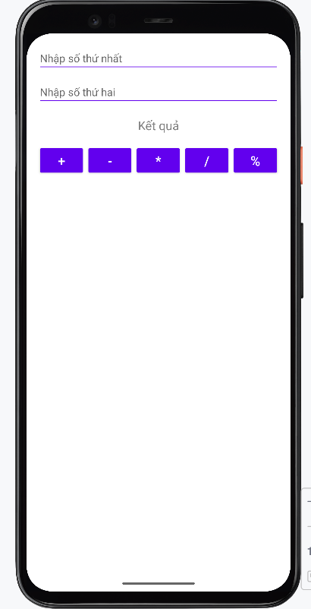

Bài tập 2:
Bước 1: Tạo giao diện activity_random_number.xml
res/layout/activity_main.xml
<?xml version="1.0" encoding="utf-8"?>
<LinearLayout xmlns:android="http://schemas.android.com/apk/res/android"
android:layout_width="match_parent"
android:layout_height="match_parent"
android:orientation="vertical"
android:gravity="center"
android:background="#FFFFFF"
android:padding="24dp">
<TextView
android:id="@+id/tvNumber"
android:layout_width="wrap_content"
android:layout_height="wrap_content"
android:text="00"
android:textSize="80sp"
android:textColor="#E53935"
android:textStyle="bold"
android:layout_marginBottom="40dp"
android:gravity="center" />
<Button
android:id="@+id/btnRandom"
android:layout_width="match_parent"
android:layout_height="wrap_content"
android:text="RANDOM NUMBER"
android:backgroundTint="#6200EE"
android:textColor="#FFFFFF"
android:textStyle="bold" />
</LinearLayout>
Bước 2 tạo RandomNumberActivity.Java nhập code sau đây
package com.example.firstprogram;
import androidx.appcompat.app.AppCompatActivity;
import android.os.Bundle;
import android.widget.Button;
import android.widget.TextView;
import java.util.Random;
public class RandomNumberActivity extends AppCompatActivity {
TextView tvNumber;
Button btnRandom;
Random random = new Random();
@Override
protected void onCreate(Bundle savedInstanceState) {
super.onCreate(savedInstanceState);
setContentView(R.layout.activity_random_number); // phải khớp với tên layout
tvNumber = findViewById(R.id.tvNumber);
btnRandom = findViewById(R.id.btnRandom);
btnRandom.setOnClickListener(v -> {
int number = random.nextInt(100); // random 0–99
tvNumber.setText(String.valueOf(number));
});
}
}
Bước 3: vào AndroidManifest.xml nhập code sau đây vào
<?xml version="1.0" encoding="utf-8"?>
<manifest xmlns:android="http://schemas.android.com/apk/res/android"
package="com.example.firstprogram">
<application
android:allowBackup="true"
android:icon="@mipmap/ic_launcher"
android:label="@string/app_name"
android:supportsRtl="true"
android:theme="@style/Theme.AppCompat.Light.NoActionBar">
<activity android:name=".DiceActivity" />
<activity android:name=".MainActivity" />
<activity
android:name=".RandomNumberActivity"
android:exported="true">
<intent-filter>
<action android:name="android.intent.action.MAIN" />
<category android:name="android.intent.category.LAUNCHER" />
</intent-filter>
</activity>
</application>
</manifest>
Bước 4: Thêm bg_gradient.xml trong res/drawable thêm code sau vào
<?xml version="1.0" encoding="utf-8"?>
<shape xmlns:android="http://schemas.android.com/apk/res/android"
android:shape="rectangle">
<gradient
android:type="linear"
android:angle="270"
android:startColor="#3F51B5"
android:endColor="#2196F3"
android:gradientRadius="400dp" />
</shape>
Bước 5: Thêm btn_primary.xml trong res/drawable thêm code sau vào
<?xml version="1.0" encoding="utf-8"?>
<shape xmlns:android="http://schemas.android.com/apk/res/android"
android:shape="rectangle">
<solid android:color="#FF4081" />
<corners android:radius="12dp" />
<padding
android:left="16dp"
android:top="10dp"
android:right="16dp"
android:bottom="10dp" />
</shape>
Sau khi xong ta có kết quả :
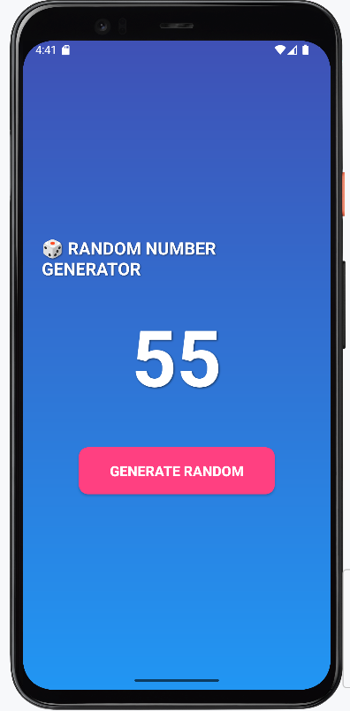
Phần 2 bài 2
Bước 1: Tạo một activity_dice.xml và nhập code sau đây vào
<?xml version="1.0" encoding="utf-8"?>
<LinearLayout xmlns:android="http://schemas.android.com/apk/res/android"
android:layout_width="match_parent"
android:layout_height="match_parent"
android:orientation="vertical"
android:gravity="center"
android:background="#FFFFFF"
android:padding="24dp">
<ImageView
android:id="@+id/imgDice"
android:layout_width="200dp"
android:layout_height="200dp"
android:src="@drawable/dice_1"
android:layout_marginBottom="40dp"
android:contentDescription="Dice" />
<Button
android:id="@+id/btnRollDice"
android:text="ĐỔ XÚC XẮC"
android:textColor="#FFFFFF"
android:textStyle="bold"
android:backgroundTint="#6200EE"
android:layout_width="match_parent"
android:layout_height="wrap_content" />
</LinearLayout>
Bước 2: Vào DiceActivity.Java nhập code sau đây vào
package com.example.firstprogram;
import androidx.appcompat.app.AppCompatActivity;
import android.os.Bundle;
import android.view.animation.Animation;
import android.view.animation.AnimationUtils;
import android.widget.Button;
import android.widget.ImageView;
import java.util.Random;
public class DiceActivity extends AppCompatActivity {
ImageView imgDice;
Button btnRollDice;
Random random = new Random();
@Override
protected void onCreate(Bundle savedInstanceState) {
super.onCreate(savedInstanceState);
setContentView(R.layout.activity_dice);
imgDice = findViewById(R.id.imgDice);
btnRollDice = findViewById(R.id.btnRollDice);
btnRollDice.setOnClickListener(v -> {
// Animation xoay xúc xắc
Animation rotate = AnimationUtils.loadAnimation(this, R.anim.rotate);
imgDice.startAnimation(rotate);
// Sinh mặt xúc xắc ngẫu nhiên
int number = random.nextInt(6) + 1;
int resId = getResources().getIdentifier(
"dice_" + number, "drawable", getPackageName());
imgDice.setImageResource(resId);
});
}
}
Bước 3: vào res/anim/rotate.xml nhập code sau đây vào
<?xml version="1.0" encoding="utf-8"?>
<rotate xmlns:android="http://schemas.android.com/apk/res/android"
android:fromDegrees="0"
android:toDegrees="720"
android:pivotX="50%"
android:pivotY="50%"
android:duration="600" />
Bước 4: Vào res/drawable thêm 6 ảnh của 6 mặt xúc xắc vào
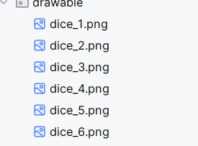

Bước 5: Vào AndroidManifest.xml nhập code sau đây vào
<?xml version="1.0" encoding="utf-8"?>
<manifest xmlns:android="http://schemas.android.com/apk/res/android"
package="com.example.firstprogram">
<application
android:allowBackup="true"
android:icon="@mipmap/ic_launcher"
android:label="@string/app_name"
android:supportsRtl="true"
android:theme="@style/Theme.AppCompat.Light.NoActionBar">
<activity android:name=".MainActivity" />
<activity android:name=".RandomNumberActivity" />
<activity
android:name=".DiceActivity"
android:exported="true">
<intent-filter>
<action android:name="android.intent.action.MAIN" />
<category android:name="android.intent.category.LAUNCHER" />
</intent-filter>
</activity>
</application>
</manifest>

Sau khi xong ta có kết quả sau đây:
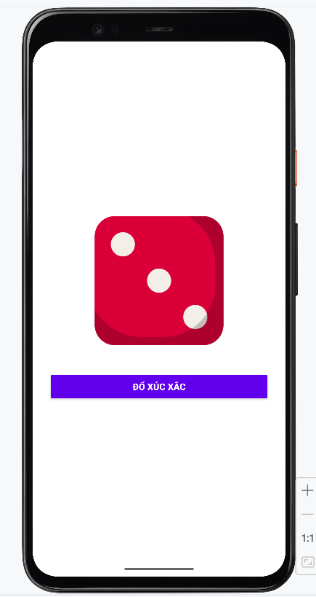

Bài 3:
Bước 1: Vào activity_nghegoi.xml ta nhập code sau đây vào
<?xml version="1.0" encoding="utf-8"?>
<ScrollView xmlns:android="http://schemas.android.com/apk/res/android"
android:layout_width="match_parent"
android:layout_height="match_parent"
android:fillViewport="true"
android:background="#FAFAFA">

<LinearLayout
android:layout_width="match_parent"
android:layout_height="wrap_content"
android:orientation="vertical"
android:padding="24dp">

<!-- 🟪 Header -->
<TextView
android:layout_width="match_parent"
android:layout_height="wrap_content"
android:text="ỨNG DỤNG GỌI ĐIỆN 💬 NHẮN TIN"
android:textSize="22sp"
android:textStyle="bold"
android:textColor="#FFFFFF"
android:gravity="center"
android:background="@drawable/header_bg_modern"
android:padding="20dp"
android:elevation="8dp"
android:layout_marginBottom="28dp" />

<!-- 📞 Nhập số điện thoại -->
<TextView
android:layout_width="match_parent"
android:layout_height="wrap_content"
android:text="📞 Số điện thoại"
android:textSize="16sp"
android:textStyle="bold"
android:textColor="#263238"
android:layout_marginBottom="8dp" />

<EditText
android:id="@+id/edtPhoneNumber"
android:layout_width="match_parent"
android:layout_height="wrap_content"
android:hint="Nhập số điện thoại..."
android:inputType="phone"
android:background="@drawable/edittext_background_soft"
android:padding="14dp"
android:textColor="#000000"
android:textColorHint="#9E9E9E"
android:layout_marginBottom="20dp" />

<!-- 💌 Nhập tin nhắn -->
<TextView
android:layout_width="match_parent"
android:layout_height="wrap_content"
android:text="💌 Nội dung tin nhắn"
android:textSize="16sp"
android:textStyle="bold"
android:textColor="#263238"
android:layout_marginBottom="8dp" />

<EditText
android:id="@+id/edtMessage"
android:layout_width="match_parent"
android:layout_height="150dp"
android:hint="Nhập nội dung tin nhắn..."
android:gravity="top"
android:inputType="textMultiLine"
android:background="@drawable/edittext_background_soft"
android:padding="14dp"
android:textColor="#000000"
android:textColorHint="#9E9E9E"
android:layout_marginBottom="30dp" />

<!-- ⚡ Nút thao tác -->
<LinearLayout
android:layout_width="match_parent"
android:layout_height="wrap_content"
android:orientation="horizontal"
android:gravity="center"
android:weightSum="2">

<Button
android:id="@+id/btnCall"
android:layout_width="0dp"
android:layout_height="wrap_content"
android:layout_weight="1"
android:text="📞 Gọi điện"
android:textAllCaps="false"
android:textColor="#FFFFFF"
android:textStyle="bold"
android:textSize="16sp"
android:background="@drawable/btn_green_gradient"
android:layout_marginEnd="8dp"
android:elevation="5dp" />

<Button
android:id="@+id/btnSendSMS"
android:layout_width="0dp"
android:layout_height="wrap_content"
android:layout_weight="1"
android:text="💬 Gửi SMS"
android:textAllCaps="false"
android:textColor="#FFFFFF"
android:textStyle="bold"
android:textSize="16sp"
android:background="@drawable/btn_orange_gradient"
android:layout_marginStart="8dp"
android:elevation="5dp" />
</LinearLayout>

</LinearLayout>
</ScrollView>
Bước 2: ta vào Nghegoi.Java ta nhập code sau đây vào
<?xml version="1.0" encoding="utf-8"?>
<ScrollView xmlns:android="http://schemas.android.com/apk/res/android"
android:layout_width="match_parent"
android:layout_height="match_parent"
android:fillViewport="true"
android:background="#F3F4F6">
<LinearLayout
android:layout_width="match_parent"
android:layout_height="wrap_content"
android:orientation="vertical"
android:padding="24dp">
<!-- 🟦 Header -->
<TextView
android:layout_width="match_parent"
android:layout_height="wrap_content"
android:text="ỨNG DỤNG GỌI ĐIỆN &amp; NHẮN TIN"
android:textSize="22sp"
android:textStyle="bold"
android:textColor="#1E88E5"
android:gravity="center"
android:background="@drawable/header_bg"
android:padding="16dp"
android:elevation="6dp"
android:layout_marginBottom="24dp" />
<!-- 🔢 Nhập số điện thoại -->
<TextView
android:layout_width="match_parent"
android:layout_height="wrap_content"
android:text="Số điện thoại"
android:textSize="16sp"
android:textStyle="bold"
android:textColor="#374151"
android:layout_marginBottom="8dp" />
<EditText
android:id="@+id/edtPhoneNumber"
android:layout_width="match_parent"
android:layout_height="wrap_content"
android:hint="Nhập số điện thoại..."
android:inputType="phone"
android:background="@drawable/edittext_background"
android:padding="14dp"
android:textColor="#111827"
android:textColorHint="#9CA3AF"
android:layout_marginBottom="20dp" />
<!-- 💬 Nhập tin nhắn -->
<TextView
android:layout_width="match_parent"
android:layout_height="wrap_content"
android:text="Tin nhắn"
android:textSize="16sp"
android:textStyle="bold"
android:textColor="#374151"
android:layout_marginBottom="8dp" />
<EditText
android:id="@+id/edtMessage"
android:layout_width="match_parent"
android:layout_height="150dp"
android:hint="Nhập nội dung tin nhắn..."
android:gravity="top"
android:inputType="textMultiLine"
android:background="@drawable/edittext_background"
android:padding="14dp"
android:textColor="#111827"
android:textColorHint="#9CA3AF"
android:layout_marginBottom="30dp" />
<!-- 🔘 Nút thao tác -->
<LinearLayout
android:layout_width="match_parent"
android:layout_height="wrap_content"
android:orientation="horizontal"
android:gravity="center"
android:weightSum="2">
<Button
android:id="@+id/btnCall"
android:layout_width="0dp"
android:layout_height="wrap_content"
android:layout_weight="1"
android:text="📱 Gọi điện"
android:textAllCaps="false"
android:textColor="#FFFFFF"
android:textStyle="bold"
android:backgroundTint="#43A047"
android:padding="14dp"
android:layout_marginEnd="8dp" />
<Button
android:id="@+id/btnSendSMS"
android:layout_width="0dp"
android:layout_height="wrap_content"
android:layout_weight="1"
android:text="💌 Gửi SMS"
android:textAllCaps="false"
android:textColor="#FFFFFF"
android:textStyle="bold"
android:backgroundTint="#FB8C00"
android:padding="14dp"
android:layout_marginStart="8dp" />
</LinearLayout>
</LinearLayout>
</ScrollView>
Bước 3: Tạo một edittext_background.xml
Res/drawable nhập code sau đây vào
<shape xmlns:android="http://schemas.android.com/apk/res/android"
android:shape="rectangle">
<solid android:color="#FFFFFF" />
<stroke android:width="1dp" android:color="#E5E7EB" />
<corners android:radius="12dp" />
<padding android:left="12dp" android:top="12dp" android:right="12dp" android:bottom="12dp" />
<shadowColor android:color="#33000000" />
</shape>
Bước 4: tạo một header_bg.xml nhập code sau đây vào
Res/drawable
<?xml version="1.0" encoding="utf-8"?>
<shape xmlns:android="http://schemas.android.com/apk/res/android"
android:shape="rectangle">
<solid android:color="#E3F2FD" />
<corners android:radius="10dp" />
</shape>
Bước 5: Vào AndroidManifest.xml nhập code sau đây vào
<?xml version="1.0" encoding="utf-8"?>
<manifest xmlns:android="http://schemas.android.com/apk/res/android"
package="com.example.firstprogram">
<uses-permission android:name="android.permission.CALL_PHONE" />
<uses-permission android:name="android.permission.SEND_SMS" />
<!-- ✅ Khai báo thiết bị có thể không có chức năng gọi/SMS -->
<uses-feature android:name="android.hardware.telephony" android:required="false" />
<application
android:allowBackup="true"
android:icon="@mipmap/ic_launcher"
android:label="@string/app_name"
android:supportsRtl="true"
android:theme="@style/Theme.AppCompat.Light.NoActionBar">
<activity
android:name=".DiceActivity"
android:exported="false" />
<activity android:name=".MainActivity" />
<activity android:name=".RandomNumberActivity" />
<activity
android:name=".Nghegoi"
android:exported="true">
<intent-filter>
<action android:name="android.intent.action.MAIN" />
<category android:name="android.intent.category.LAUNCHER" />
</intent-filter>
</activity>
</application>
</manifest>
Bước 6: Tạo một header_bg_modern.xml
<?xml version="1.0" encoding="utf-8"?>
<shape xmlns:android="http://schemas.android.com/apk/res/android"
android:shape="rectangle">

<gradient
android:type="linear"
android:angle="45"
android:startColor="#3F51B5"
android:endColor="#5C6BC0" />

<corners android:radius="10dp" />
</shape>
Bước 7: Tạo một edittext_background_soft.xml
<?xml version="1.0" encoding="utf-8"?>
<shape xmlns:android="http://schemas.android.com/apk/res/android"
android:shape="rectangle">

<solid android:color="#FFFFFF" />
<stroke android:width="1dp" android:color="#B0BEC5" />
<corners android:radius="10dp" />
</shape>
Bước 8: Tạo một btn_green_gradient.xml
<?xml version="1.0" encoding="utf-8"?>
<shape xmlns:android="http://schemas.android.com/apk/res/android"
android:shape="rectangle">

<gradient
android:startColor="#4CAF50"
android:endColor="#388E3C"
android:angle="90" />
<corners android:radius="12dp" />
</shape>
Bước 9: Tạo một btn_orange_gradient.xml
<?xml version="1.0" encoding="utf-8"?>
<shape xmlns:android="http://schemas.android.com/apk/res/android"
android:shape="rectangle">
<gradient
android:startColor="#FFB74D"
android:endColor="#F57C00"
android:angle="90" />
<corners android:radius="12dp" />
</shape>
- Sau khi xong ta có kết quả nghe gọi và nhắn tin như hình sau:
