Course Description | “How do we transition from writing single-use scripts to building robust, reusable, and scalable computational tools?"  This workshop is the second half of the Introduction to Python series. It builds directly on the concepts of Python I which included the grammar of the language (variables, loops, conditionals, regex) and now focuses on architecture: how to write code that is reusable, readable, testable, and maintainable. Students will move through a scaffolded arc from review of Python I → functions → recursion → modules → OOP

Course Learning Outcomes | By the end of this course, participants will be able to:  - Bundle decision-making logic into well-documented functions.  - Turn functions into modules and call them from notebooks.  - Implement recursive solutions and explain when recursion is appropriate.  - Compare and contrast procedural, functional, and object-oriented programming paradigms.  - Design and implement classes using OOP principles (encapsulation, inheritance, polymorphism).  - Leverage NumPy, Pandas, and SQLite3 to manipulate and query large datasets.  - Read and use third-party packages (BioPython, scikit-bio).  Recognize the progression from Python I string-based sequence analysis to library bioinformatics tools.

Course  Overview | Complete Python I (variables, loops, condition, regex) → Python II: M1: functions→ M2: recursion & modules  → M3: coding paradigms + OOP → M4: NumPy & Pandas → M5: SQLite & BioPython
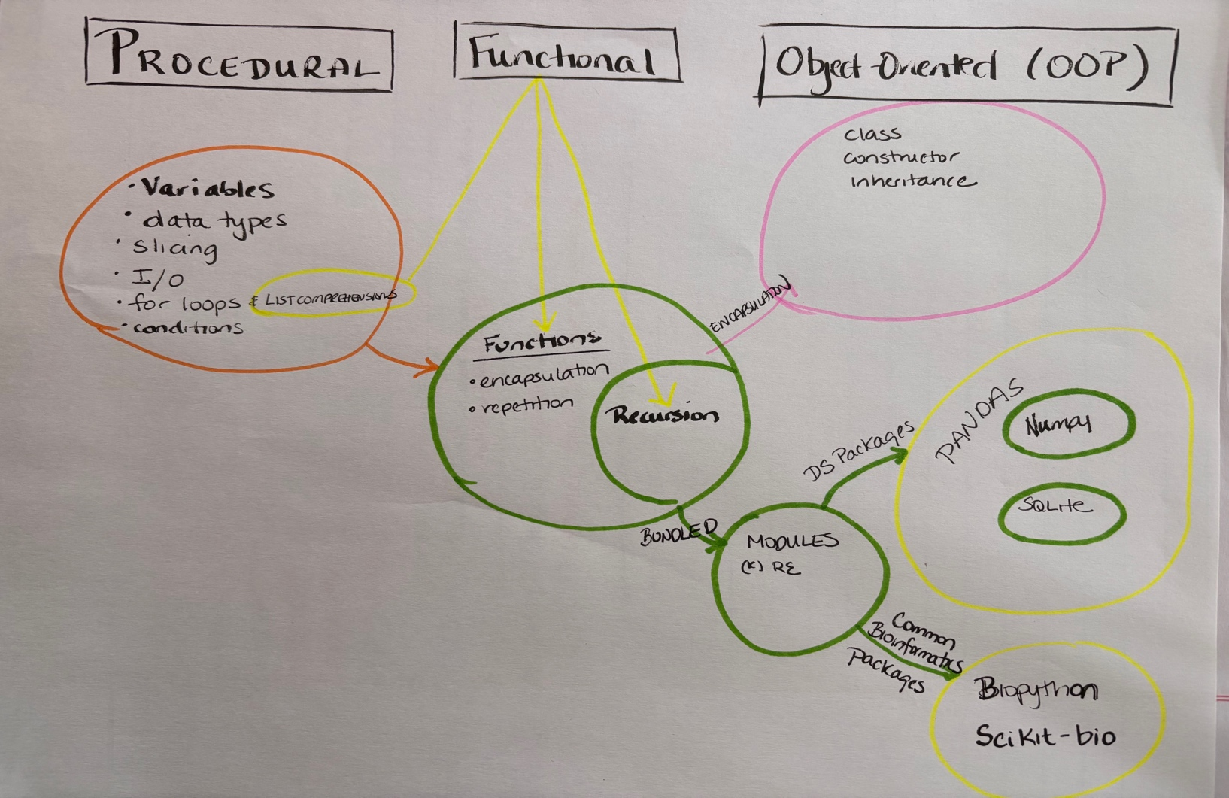

Schedule & Content
Module | Topic & Content | Learning Outcomes
MODULE 0 — Setup & Orientation
Q: What did Python I give us — and what can't it do yet?
A: Python I taught us the vocabulary and grammar of the language.
Python II is about learning architecture: how to write code other people (and future-you) can actually use!
0 | Pre- Check & Course Orientation  • Confirm Gmail account for Colab access  - We will use Colab for this course  • (Optional) VS Code  - see JAX Software Catalogue for details  • Complete entry survey  Motivation  • Quick tour of Assignments from Python I. We will review it. | Recognize:  • Python I concepts still in active use: loops, conditionals, dicts, file I/O, regex  • The difference between a script and a reusable tool  Implement:  • Identify 1–2 pieces of your Python I code that could be improved by wrapping in a function
MODULE 1 — From Scripts to Functions
Q: If everything in Python is an 'object', how do we communicate with them?
A: Fundamental syntax of manipulating objects, including variable assignment, the label we stick on a box in memory.

1A | Review of Python I Foundations  • Procedural evaluation and variable assignment  • Data types: primitives through complex (int, float, str, list, dict, tuple)  • Slicing and object methods  • File objects (open/close/read/write)  • for loops, while loops, conditions  • The concept of scope (preview: deep dive in 1B)  • When does code become hard to maintain? (motivates functions) | Recognize:  • Basic syntax, data types including num, floats, strings, tuples, dicts  • How scope differs inside vs. outside a block  Implement:  • Appropriate methods of data types, including slicing  • Opening, creating, reading, and writing to/from a file  • Problem decomposition into manageable parts  Resources:  • pythontutor.com as a visualization tool
Q: How do we stop repeating ourselves — and how do we teach our code to solve its own sub-problems?
A: Moving away from procedural code and learning to bundle decision-making into functions.
1B | Functions — Syntax, Scope & Design  • Why bundle logic? Reuse, readability, testability  • Function syntax: def, parameters, return, None  Scope rules  • Local vs. global scope  • Functions return to where they were called  • You have to actually call them  Good design habits  • One function, one job  • Docstrings and meaningful parameter names  • Functions can return None, and that's sometimes intentional | Recognize:  • The benefits of chunking / DRY (Don't Repeat Yourself)  • How to create your own functions  • Functions can return None  Implement:  • Rewrite Python I Module 4 ORF code bundled into a function  • Write a function with at least two parameters  Assignment for Certificate of Completion: See GitHub Course Site.
MODULE 2 — Recursion & Modules
Q: How do we write code that solves its own sub-problems automatically?
A: The joy of bundling. Students will learn the syntax of creating modules, external files containing functions that can be imported and called only when needed, reducing clutter and increasing reusability.
2A | Recursion  • Functions can call other functions  • Functions can call themselves — >recursion  Mental model  • Base case: when does it stop?  • General (recursive) case: how does it shrink toward the base?  • pythontutor.com as a visualization tool for the call stack  Classic examples  • Factorial, Fibonacci  • Traversing nested data structures  When to use recursion  • Tree-shaped problems, divide & conquer  • Trade-offs vs. iteration (readability, stack depth) | Recognize:  • Functions can call other functions  • Functions can call themselves  • Types of problems optimally solved via recursion  Implement:  • Access individual items in a nested tuple using a for loop  • Implement a recursive solution to the Fibonacci sequence
Q: How do we organize code so that we (and others) can easily reuse our best solutions in the future?
A: Bundling functions into external files that can be imported and called only when needed, reducing clutter and increasing reusability.
2B | Modules  • The joy of bundling: only load what you need  • Creating a .py file containing functions  • Importing your own module into a notebook  • Calling functions from within a module  Practical workflow  • Writing the module file alongside your notebook  • Relative vs. absolute imports  Connection to stdlib and pip packages  • You have already used import re, this is the same mechanism  • Preview: NumPy, Pandas, SQLite3 are modules too | Recognize:  • The benefits of modularization  • Syntax of modules  • How to call functions within modules  Implement:  • Bundle the ORFadviser function (Py-II M1) into a module and call it from a new cell  • Create and call your own custom module  Assignment for Certificate of Completion: See GitHub Course Site.
MODULE 3 — Programming Paradigms & Object-Oriented Programming
Q: Is there a 'right' way to solve a problem, or just different ways of thinking about it?
A: A tour and comparison of the different types of programming: procedural, recursive, functional programming, and object-oriented programming.
3A | A Tour of Programming Paradigms  1. Procedural (what we've been doing)  • Step-by-step instructions, top-to-bottom execution  2. Functional programming  • Functions as first-class objects  • Side effects and why avoiding them matters  • List comprehensions revisited (Py-I M3A) as functional style  • Higher-order functions: map, filter  • Lambda (anonymous) functions  3. Object-Oriented (preview of 3B)  • Encapsulation into objects  • Recommended resource: maryrosecook.com practical intro to FP | Recognize:  • Compare benefits and challenges of procedural, functional, and OO approaches  • Syntax of functional programming  • Define a side effect  • Importance of removing side-effects in functional programming  Implement:  • Translate a list comprehension into a for loop and vice versa  • Convert the AT-content loop (provided code) to use map/lambda
Q: Why reinvent the wheel when we can use powerful, pre-built engines to manipulate massive datasets instantly?
A: Leveraging the Python ecosystem: understanding OOP means you can read library documentation, understand what methods do, and extend existing classes.
3B | Object-Oriented Programming  • Objects have attributes (nouns) and methods (verbs)  • Bundled, encapsulated object  Core OOP mechanics  • class is the blueprint  • Constructor (__init__) and self  • Creating an instance of a class  OOP relationships  • Inheritance: child class inherits from parent  • Overriding attributes and methods  • Polymorphism: same method name, different behavior  Why this matters for bioinformatics  • BioPython Seq objects, Pandas DataFrames  • Understanding OOP helps you read library documentation | Recognize:  • class is the 'blueprint'  • What a constructor does  • How to create an instance of a class  Implement:  • Build a Platypus class that inherits from a Mammal superclass  • Override at least one attribute and one method to reflect platypus-specific traits  • Use a polymorphic method to differentiate Platypus from generic Mammal  Assignment for Certificate of Completion: See GitHub Course Site.
MODULE 4 — Scientific Libraries: NumPy & Pandas
Q: Why reinvent the wheel when we can use powerful, pre-built engines to manipulate massive datasets instantly?
A: Leveraging the Python ecosystem: NumPy provides the array object, the engine under Pandas, scikit-learn, and most scientific Python.
4A | NumPy  Why NumPy?  • Vectorization: operate on entire arrays, not element-by-element  • Memory efficiency vs. Python lists  The np.array object  • Creating arrays: from lists, zeros, ones, arange, linspace  • Array shape, dtype  Operations  • Slicing and subsetting (connects to Py-I string/list slicing)  • Boolean masking: applying conditions across the whole array  • Broadcasting: arithmetic across arrays of different shapes  • Axis-aware operations: np.mean(axis=0) vs axis=1 | Recognize:  • Why the array object in NumPy is considered so powerful and efficient  • Vectorization as an alternative to for loops  Implement:  • Different slicing & subsetting techniques on a 2D array  • Broadcasting arithmetic across an entire array  • Find row and column means; identify max-expression gene  Resources: Optional Practice!:  • 100 NumPy exercises (github.com/rougier/numpy-100)
4B | Pandas  Core data structures  • Series: a labeled 1D array  • DataFrame: a labeled 2D table (think: Excel with superpowers)  Getting data in  • From URL, from dict, from CSV file (compare to Py-I file I/O?)  • pd.read_csv  Exploring and manipulating  • Head, info, describe  • Slicing: iloc, loc, boolean conditions  • groupby for aggregation  • Merging / joining DataFrames  Visualization stack  • Basic plots with matplotlib (histogram, line, scatter) | Recognize:  • Series and DataFrame structures  • DataFrame methods and when to use them  Implement:  • Different slicing & subsetting techniques  • groupby to aggregate by category  • Plotting with Matplotlib  • Apply boolean conditions to filter rows  Resources:  • Cheatsheets  • pandastutor.com for visual intuition  Assignment for Certificate of Completion: See GitHub Course Site.
MODULE 5 — Databases, Querying & Bioinformatics Libraries
Q: How do we ask complex questions of massive, interconnected datasets without loading everything into memory?
A: Moving from flat files to relational databases and exploring the querying paradigm alongside familiar programming languages.
5A | SQLite3 — Relational Databases & SQL  Why relational databases?  • Flat files break at scale; what about linked but distinct tables  • Review: data.csv from Py-I → now imagine 1,000,000 rows  SQL query anatomy  • SELECT, FROM, WHERE, ORDER BY, LIMIT  • APPEND (INSERT), SORT, FILTER, JOIN, AGGREGATE  Using SQLite3 from Python  • import sqlite3 as sql  • Creating a connection object  • pd.read_sql_query —> bridge to Pandas  Similarities between Pandas and SQLite3  • Same question, different tools | Recognize:  • Structure of SQL queries  • Difference between a querying language and a programming language  • SELECT, APPEND, SORT, FILTER, JOIN, AGGREGATE  • Similarities between Pandas and SQLite3 functionality  Implement:  • Construct SQL queries against the JAX Desert ecology database  • Retrieve top-40 largest rodents sorted by weight desc; filter by species/sex; remove NULLs  Resources:  • Interactive: cudbg.github.io/sqltutor/
5B | Bioinformatics Libraries: BioPython & scikit-bio (time permitting)  Why this module matters for this audience  • Biologists at all levels encounter FASTA/GenBank data  • These libraries are the professional-grade version of the string parsing done in Py-I  BioPython  • The Seq object: a string with biological awareness  • SeqRecord: sequence + metadata (id, name, description)  • Parsing FASTA files with SeqIO  • Key methods: .complement(), .reverse_complement(), .translate()  scikit-bio  • Similar capabilities, pandas-integrated API  • Alignment objects | Recognize:  • The Seq object and how it differs from a plain Python string  • SeqRecord structure (id, name, description, seq)  Implement:  • Parse a FASTA file with SeqIO  • Use .reverse_complement() and .translate() on a Seq object  • Compare output of hand-rolled Py-I ORF code to BioPython result  Assignment for Certificate of Completion: See GitHub Course Site.

