JAX Biostatistics III
"How do we move from data to justified action in a world where we cannot run the experiment we actually want?"

Description and Goals of the Course:
This course extends the applied statistical foundation of Biostatistics I & II into territory that modern biological and health research increasingly demands but doesn’t typically include in an introductory applied statistics sequence: causal inference, qualitative methods, meta-analytic thinking, machine learning as an analytical tool, and data ethics. Randomization is at the core of experimental design, and is the ‘gold standard’, but we rarely have it in observational studies. This course introduces qualitative methods (how do we infer when we don’t have numbers?), causal analysis (the formal machinery of getting as close as possible to an experiment), meta-analysis (aggregating imperfect evidence), machine learning (prediction without mechanism), and ethics (the responsibility that accompanies making decisions on imperfect knowledge). Where Biostatistics I & II asked "what does this sample tell us?", Biostatistics III asks "what should we conclude, and how should we act?"

Learning Objectives
By the end of this course, students will be able to:
- Critically evaluate the assumptions underlying common inferential tests and recognize when those assumptions are violated
- Describe and apply core qualitative research methods, including thematic analysis using the Boyatzis framework
- Articulate the fundamental problem of causal inference and explain why randomization solves it
- Construct and interpret directed acyclic graphs (DAGs) to represent causal assumptions and identify appropriate adjustment sets
- Apply the back-door criterion to determine which variables to include or exclude from regression models
- Explain instrumental variables and Mendelian randomization as strategies for causal identification in observational data
- Evaluate meta-analyses critically, including publication bias, heterogeneity, and the file drawer problem
- Distinguish between machine learning as a predictive tool and statistical modeling as an inferential tool
- Identify and reason about ethical issues in data collection, analysis, and reporting, including algorithmic fairness, privacy, and reproducibility

(Potential) Data Set: https://gtexportal.org/home/ (Proposed via Claude, so I need to research how appropriate it is as I assemble hands-on activities and assignments).

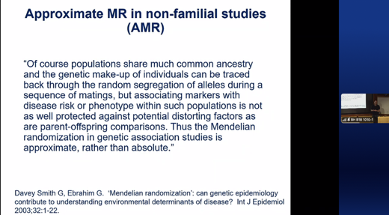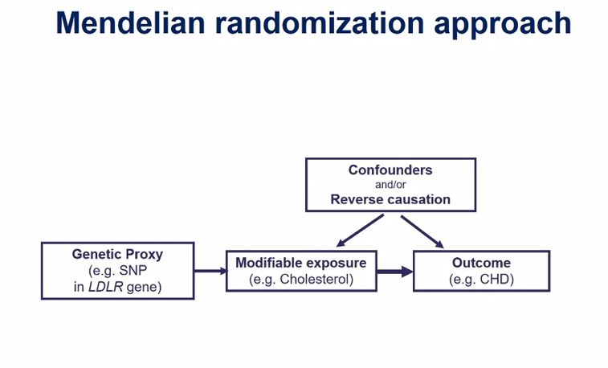
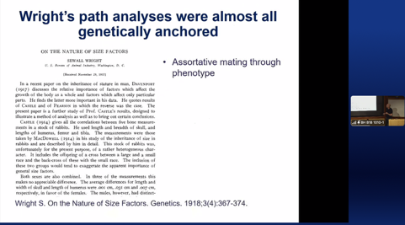

Day 1
Activity | Learning Objectives
Foundations Revisited & Research Design
Q: What do we actually know, and how do we know it?
A | Title: Hypothesis Testing Review  - Active walk-through of the hypothesis testing flowchart using real dataset decisions  - What happens when Assumptions are not met?
A1 | 5 ambiguous scenarios: identify which test would you run?
B | Title: Experimental Design  - Power analysis as a design decision.  - Pre-registration and its effects.  - Sensitivity and specificity revisited as design metrics, not just diagnostic ones.  - Link between design choices and later analysis validity.
B1 | Activities:  - Confusion matrix  - Power analysis calculation  - Improve the following study designs
C | Title: Why Design Fails: Bridge to Causal Thinking  - Confounding  - effect modification  - Simpson's paradox with worked examples.  - what do we do when we cannot randomize?
C1 | Activities:  - Explain Simpson’s paradox  - What do we do when we cannot randomize?
D | Title: Qualitative Methods I: Why & What  - Qualitative methods as legitimate epistemological alternatives.  - Overview of phenomenology, grounded theory, thematic analysis, content analysis.
D1 | Activities:  - reading: QuestionPro blog post (Part 1 resource).  - ?
E | Title: Qualitative Methods II: Recognizing Pattern Recognition  - Thematic analysis framework  - moving from raw data to code to theme to theory.  - In-class activity: code 3 short interview excerpts together. Resources: Boyatzis YouTube series Parts 2–6.
E1 | Activities:  - Code an interview and explain your choices
Wrap-Up | ?

Day 2
Activity | Learning Objectives
Causal Inference I: Framework & Randomization
Correlation tells you what happened. Causation tells you what to do.
A | Title: Why Causal Inference?  - 5 min McElreath interview  - The fundamental problem of causal inference  - Sewell wright and path analysis (as the progenitor to DAGs)  - Rubin causal mode  - Pearl  - Counterfactuals  - Logic of intervention  - Why correlation fails in medicine and biology (NNT measurement)
A1 | Counterfactual examples and questions
B | Title: Potential Outcomes Framework  - Formalize the notation  - Dissect “Average treatment effect” (ATE) versus “average treatment effect on the treated” (ATT)  - Worked example
B1 | Activities:  - Questions/drawings
C | Title: Randomization – why is works & when it doesn’t!  - Randomization as gold standard and its real limits  - Non-compliance, attrition, ethics, generalizability  - Intent-to-treat versus per-protocol analysis  - Bridge to observational methods
C1 | Activities:  - ?
D | Title: Observational studies – Threats & Tools  - Conceptual overview of Rubin Causal Model: Propensity scores, matching, stratification.  - These approaches are designed to make the observed data behave as if it came from a randomized experiment, so that the average of Y(1) − Y(0) across units can be estimated. Because only one of the two outcomes, Y(1) or Y(0) has actually happened so the difference is unobservable and you need to develop these tricks to estimate this difference.  - What question does each method answer?  - Key message: method should follow from the causal question, not the data structure.
D1 | Activities:  - ?
E | Title: Qualitative Methods III: Analysis in Practice  - Software tools: R packages (qdap, tidytext, quanteda) and GUI tools (NVivo, ATLAS.ti).  - Live 15-min-ish demo.  - Mixed-methods designs: when do you need both qualitative and quantitative approaches?
E1 | Activities:  - Question using one of the R packages
Wrap-Up | ?

Day 3
Activity | Learning Objectives
Causal Inference II: DAGS & Adjustment
Q: Drawing your assumptions before you analyze your data
A | Title: Introduction to DAGs  - Review: Rubin's model does not require you to draw a picture of how causes relate to one another. You define your treatment, your outcome, and your population, and you ask: what would the distribution of outcomes look like under a different assignment of treatments? The assumptions are encoded in mathematics, not in graphs. Pearl has do(T=1) calculus; Rubin has Y(1)/Y(0)  - In contrast, Pearl: how can a reasoning system represent and use knowledge about causal structure? It has emerged from Bayesian networks (which makes sense given Pearl’s contributions to Bayesian nets), and the vertices between nodes represent your belief about the data-generating process.  - What a DAG is and why it differs philosophically from a regression model.  - DAGs force transparency about your assumptions!  - Nodes, edges, and causal directionality.  - A DAG is a statement of your beliefs about the world.  - Do calculus: a formal language for computing the effect of interventions, written do(X = x), which is explicitly distinct from conditioning on X = x. The do-operator represents actually setting a variable to a value, cutting it from its causes and fixing it, which is what an intervention does and what observational conditioning does not. Pearl's three-layer causal hierarchy (association, intervention, counterfactual) is one of his most useful pedagogical contributions: most statistical methods live entirely on the first layer (what is the correlation?) and cannot by themselves answer questions on the second (what would happen if I did X?) or third (what would have happened if I had done X differently?).  - Based on McElreath Stat Rethinking lectures 5–7.
A1 | Activities:  ? See McElreath for ideas.
B | Title: Paths, d-separation & the rules  - Front-door, back-door, and collider paths.  - Rules of d-separation.  - Walkthrough of 5 canonical structures: chain, fork, collider, confounder, descendant.  - Students practice identifying open vs. closed paths.  - Resource: Heiss backdoor paths blog post.
B1 | Activities:  ?
C | Title: Using DAGs to determine adjustment sets  - Back-door criterion.  - Minimal adjustment sets.  - Live demo: dagitty.net.  - Critical warning: controlling for colliders opens bias rather than closing it - illustrated with worked examples.
C1 | Activities:  ?
D | Title: Mediation & Effect Modification  - Direct vs. indirect effects.  - Why controlling for a mediator is often wrong.  - Introduction to the four-way decomposition: total, direct, indirect, and reference interaction effects.
D1 | Activities:  - ?
E | Title: DAG workshop  - Students build their own DAGs for an assigned research scenario (e.g., neighborhood poverty and childhood asthma).  - Small groups present and critique each other's causal assumptions.
E1 | Activities:
Wrap-Up | ? focus on differences between Rubin & Pearl. There is overlap, but substantial differences that are nuanced.

Day 4
Activity | Learning Objectives
Causal Inference III, Meta-Analysis & Machine Learning
Q: Beyond your own data - aggregating, instrumenting, and learning
A | Title: Instrumental Variables & Mendelian Randomization  - IV logic: relevance, exclusion restriction, exogeneity.  - Mendelian randomization as nature's randomized trial.  - MR (Mendelian randomization) is vertical Pleiotropy  - Correlated pleiotropy which is a particular problem for MR  - Examples from GWAS studies.  - Limitations and testable vs. untestable assumptions.
A1 | Activities:
B | Title: Meta-Analysis I: Logic & Power  - What meta-analysis can and cannot answer.  - Fixed vs. random effects models.  - Heterogeneity and I².  - Power in meta-analysis: why five underpowered studies do not equal one powered study.
B1 | Activities:
C | Title: Meta-Analysis I: Bias, Replication & the File Drawer Problem  - Publication bias.  - Funnel plots.  - p-hacking.  - The replication crisis.  - Registered Reports as a structural solution.  - The file drawer problem (Rosenthal). Selective outcome reporting and fail-safe N.
C1 | Activities:
D | Title: Machine Learning I: Concepts for Biologists  - ML as a prediction tool vs. an inference tool; the distinction that matters for science.  - Supervised/unsupervised learning, bias-variance tradeoff, cross-validation, regularization.  - When does ML belong in a research pipeline?
D1 | Activities:  - ?
E | Title: Machine Learning II: Regulatory & Network Applications  - Regulatory network inference (ARACNE, GENIE3).  - Gene expression clustering and dimensionality reduction (PCA, UMAP).  - Critical note: correlation-based networks vs. causal networks —> return to DAGs
E1 | Activities:
Wrap-Up | ?

Day 5
Activity | Learning Objectives
Data Ethics
The statistician is never just a technician.
A | Title: Ethics I: Framing & Guiding Principles  - Why ethics is a statistical issue, not only a philosophical one.  - Belmont Principles: beneficence, non-maleficence, justice, respect for persons and how they manifest (and are expanded) in data decisions.  - Historical cases: Tuskegee, HeLa cells/ Pelvic Exams on unconscious women by medical students (2024 finally outlawed by directly tying Medicaid funding to it!), IBM/Holocaust data use, Cambridge Analytica.
A1 | 5
B | Title: Ethics II: Algorithmic fairness & equity in Data  - Disparate impact vs. disparate treatment.  - How training data encodes historical inequity.  - Fairness criteria (demographic parity, equalized odds, calibration) and why they are mathematically incompatible simultaneously.  - Cases: COMPAS recidivism, pulse oximeter bias.
B1 | Activities:
C | Title: Ethics III: Data Ownership, Privacy & Consent  - Biobank governance, re-identification risk, GDPR and HIPAA in research contexts.  - Community-based participatory research as a model.  - The difference between what is legal and what is ethical.
C1 | Activities:
D | Title: Ethics IV: Reproducibility as an ethical obligation  - Open data, pre-registration, FAIR principles.  - Selective reporting as a form of harm.  - The statistical consultant's responsibility. When should you refuse a project?
D1 | Activities:  ?
E | Title: Synthesis & Capstone Discussion  - Students present a 3-slide causal story for a research question of their choice:  - What is the DAG? What is the estimand? What could go wrong ethically?  - Closing discussion: statistics is how we make collective decisions; what kind do we want to make?
E1 | Activities:
Wrap-Up | ?

Required Resources & Reading List
All videos and blog posts listed below are freely available online. No textbook purchase is required. McElreath's Statistical Rethinking (2nd ed.) is recommended for students who wish to go deeper on causal inference and Bayesian methods; the lecture series associated with the 2024 course is fully open access and excellent!
Module | Type | Resource / URL
Day 1 – A | Instructor resource | Hypothesis testing flowchart
Day 1 – D | Blog post (pre-read) | QuestionPro: Introduction to Qualitative Data — questionpro.com/blog/qualitative-data/
Day 1 – E | Video series (pre-view) | Boyatzis: Thematic Analysis Intro — youtube.com/watch?v=7m0LVHK8a94
Day 1 – E | Video series (pre-view) | Boyatzis Parts 2–6 — youtube.com/watch?v=wbdN_sLWl88 and subsequent links
Day 1 – E | Video (in-class) | Qualitative coding walkthrough — youtube.com/watch?v=_uapR0qiN6s
Day 2 – A | Video (in-class excerpt) | McElreath interview on causal inference — youtube.com/watch?v=YvhuYONl1o0
Day 2 – A | Video lecture | Brady Neal: Introduction to Causal Inference — youtube.com/watch?v=Od6oAz1Op2k
Days 3–4 | Course materials (open access) | McElreath Statistical Rethinking 2024 — github.com/rmcelreath/stat_rethinking_2024
Day 3 – B/C | Blog post (in-class) | Heiss: Closing Backdoor Paths with DAGs — andrewheiss.com/blog/2020/02/25/closing-backdoors-dags/
Day 3 – C | Web tool | dagitty.net — browser-based DAG construction and adjustment set identification
Day 2 – E | Software (optional) | NVivo / ATLAS.ti (institutional license) or R: tidytext, quanteda, qdap packages

Recommended Further Reading
- Pearl, J., Glymour, M., & Jewell, N.P. (2016). Causal Inference in Statistics: A Primer. Wiley.
- McElreath, R. (2020). Statistical Rethinking: A Bayesian Course with Examples in R and Stan (2nd ed.). CRC Press.
- Hernán, M.A. & Robins, J.M. (2020). Causal Inference: What If. Chapman & Hall/CRC. [Free PDF at hsph.harvard.edu]
- Boyatzis, R.E. (1998). Transforming Qualitative Information: Thematic Analysis and Code Development. SAGE.
- D'Agostino McGowan, L. & Barrett, M. (2023). Causal Inference in R. [In development, open access]
- O'Neil, C. (2016). Weapons of Math Destruction. Crown. [Ethics — accessible general audience]
- Benjamin, R. (2019). Race After Technology. Polity. [Ethics — algorithmic bias]

