

dapp.pro

#### DAPP Arithmetic node

#### DAPP Arithmetic node

最新更新：2019年9月18

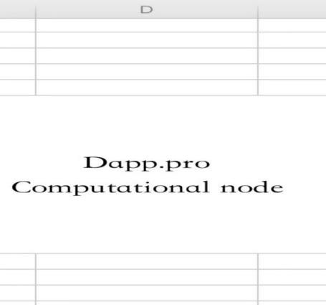

* 1. table of Contents
  2. CONTENT ABSTRACT 3
  3. 1 project background 5
  4. 1.1 Blockchain development process 5
  5. 1.2 User and market pain points 6
  6. 1.2.1 Inconvenient Digital Currency Management: 6
  7. 1.2.2 Trading and redemption threshold: 6
  8. 1.2.3 Insufficient blockchain performance and unreasonable design: 7
  9. 1.2.4 Blockchain development costs are high, the calculation power is wasted, and the connection to the real world is difficult: 8
  10. 1.2.5 "DAPP+" application scenario missing: 8
  11. 2. Product introduction 9
  12. 2.1 EOS Wallet 10
  13. 2.2 Hierarchical Certainty (HD Wallets) 11
  14. 2.3 Multi-chain currency one-stop management 12
  15. 2.4 Decentralized services and multiple security guarantees 13
  16. 2.5 multi-language support 13
  17. 2.6 Digital Currency Exchange and Trading 14
  18. 3 business model 15
  19. 3.1TOKEN Plan 15
  20. 3.2 “dapp.por” platform and side chain 19
  21. 3.3dapp.por Dapp Ecological Entrance 19
  22. 3.4dapp.por Premium DAPP Distribution Platform 24
  23. 4. Technical characteristics and innovation 26
  24. 4.1mortgage consensus mortgage consensus 26
  25. 4.4ThunderNode 30
  26. 4.5 Safer Random Number Scheme 30
  27. 5. Disclaimer 26
  28. .......risk tips 33

## CONTENT ABSTRACT

DAPP Arithmetic node

Overview:

Introducing dapp.pro and DAPP networks

Dapp.pro's mission is to promote large-scale application of distributed applications (dApps) by introducing a set of technology solutions: "DAPP Network", which makes development on the blockchain easier and more affordable. Start.

Despite the maturity and popularity of blockchain technology, it is still difficult to exploit its potential. One of the reasons for this disconnect is the lack of decentralized applications or dApps that provide key utilities and compelling experiences for mainstream users. "Killer-level app" refers to an application that naturally increases usage to a certain percentage of people (regularly used) - without having to have an in-depth understanding of the underlying technologies (such as the TCP/IP protocol behind the Internet). While consumer applications like CryptoKitties showcase current scaling challenges on platforms such as Ethereum, the dynamic developer and dApps ecosystem is still evolving. Today, the most popular dApp is in the game,

Online gambling and communication categories - but tomorrow, their features and coverage may be as broad as the Internet.

With the emergence of competitors in the Ethereum blockchain platform, new technical challenges and opportunities have emerged. Although the EOS blockchain may bring unlimited scale and speed, the RAM and CPU resources required to run on the EOS blockchain are not cheap, limited, and are expected to become more successful due to successful adoption - creating chicken and An egg-constrained ecosystem. A technical solution is needed to make it easy for dApp developers to externalize CPU and RAM from the EOS blockchain and take advantage of the functionality normally required in an accessible and affordable way.

Dapp.pro is proud to introduce the DAPP Network Native Node called "DAPP", a multi-purpose utility node designed to power the ecosystem of utilities, resources and services, specifically for user-centric dApp developer needs

The DAPP network paved the way for the emergence of new, decentralized applications - those applications that were previously unimaginable due to the systemic limitations of the prior art stack. By introducing a new collaboration and motivation ecosystem, it is likely that there will be a long tail of truly diverse, creative and useful dApps.

Dapp.pro introduced the first utility of the DAPP node - the DAPP.PRO/RAM system. DAPP.PRO/RAM is an alternative storage solution for developers developing EOS dApps that is compatible with existing RAM systems, decentralized and cost-effective to store and retrieve an unlimited amount of data.

Dapp.pro released the first key product supported by DAPP nodes to the community, providing tools for developers to build and create DAPP networks. With this vision in mind, dapp.pro has developed a roadmap that provides developers with continuous tools and services that can help dApp scalability. The development of the DAPP network aims to improve the convenience, speed and affordability of building scalable dApps on the blockchain today.

First, DAPP.PRO/RAM system

The EOS blockchain represents an important milestone in the development of the public blockchain. The market value is over $2,200,000,000 and approximately. 10,000 new accounts per week (as of January 14, 2019), with powerful processing capabilities to support the next wave of paradigm conversion dApp.pro

The first use of the DAPP.pro node was designed to enhance one of the core functions of the EOS blockchain, RAM (a resource for storing data).

In order to develop on EOS, dApp developers must own and use RAM. Currently, there are two main reasons for the limited use of RAM: its price exceeds 58 EOS / 1MB (as of February 14, 2019), and the supply has a ceiling, currently about 90GB (expected to January 31, 2019) Will increase to 129GB)), which severely limits the functionality of dApp developers and their applications.

The DAPP.PRO/RAM system ("DAPP.PRO/RAM") introduces three innovations for blockchain developers:

1. Reasonable storage space.

2. There may be an unlimited amount of storage.

3, chain integrity down chain processing

DAPP.PRO/RAM is another storage solution for developers building EOS dApps that are RAM-compatible, decentralized and designed to make it affordable and efficient to store and retrieve an unlimited amount of data. In addition, DAPP.PRO/RAM intends to eliminate the current correlation between memory (RAM) cost and smart contract size (requires storage) by using RAM as a cache.

Today, dApp developers are limited in their efforts to build EOS because they have difficulty paying for RAM and/or the RAM they need for their dApps far exceeds the current total supply. With the introduction

DAPP.PRO/RAM is a complement to RAM, and dApp developers will be able to contemplate new decentralized applications and user interactions that are prohibited by today's technology limitations.

II.DAPP.PRO/RAM system components

The DAPP.PRO/RAM system consists of the following main components:

DAPP.PRO node: The first use of the DAPP node allows you to interact with RAM as a cache. EOS contracts can only read and write data from the actual RAM. To provide additional capacity, DAPP.PRO/RAM introduces a mechanism that uses DAPP.PRO nodes to load data from DAPP.PRO/RAM into RAM in a decentralized and untrusted manner. The DAPP.PRO node will be used as an application access node for the DAPP.PRO/RAM system to access and use the system's read and write functions. The DAPP.PRO node does not grant other rights. The DAPP.PRO node can also be enabled on other blockchains and needs to be staked out by the dApp developer to enable it to use DAPP.PRO/RAM.

● DAPP.PRO node smart contract: manages the shares of the DAPP.PRO node required to access the DAPP.PRO/RAM system and enable its functions.

DAPP.PRO/RAM library: Any smart contract that uses DAPP.PRO/RAM instead of RAM includes the DAPP.PRO/RAM library, which enables the user contract to be the same as the RAM table (multiple index table). Reading and writing in the programming interface.

• dApp Service Provider (“DSP”): Anyone who operates a server running a DSP node (defined below). The DSP may provide a customized service package that includes: the amount of storage space used, the specifications of the server, and the amount of corresponding DAPP.PRO nodes ("DSP Service Packs") that must be owned to use each package.

• DSP node: The DAPP.PRO/RAM network consists of nodes operated by the dApp service provider. The DSP node acts as a redundant and untrusted store of data in the network. Each node provides an EOSIO API service to which the dApp submits its transaction ("TX") so that the contract can access the relevant data before performing the operation.

● User Contract: The standard code provided by the EOS dApp developer, including the dApps.DAPP.PRO/RAM library, so that DAPP.PRO/RAM can be used for compatibility and operation. The user contract interacts with the DAPP.PRO/RAM system as long as the user contract is equipped with a sufficient number of DAPP nodes to support the read/write requirements of the dApp.

IIIDAPP.PRO/.RAM system operation

A. Settings

In order to use the DAPP.PRO/RAM system, the dApp developer needs to do the following:

1) Integrate the DAPP.PRO/RAM library into the user contract, from which data is written to or read from the DAPP.PRO/RAM database.

2) Select the DSP service package that meets the initial dApp data storage and access requirements.

3) Obtain the applicable number of DAPP.PRO tokens to accommodate the required data storage and access requirements.

4) Obtain the DAPP token in the user contract through the DAPP.PRO/RAM library, assign the mortgage token to the specific DSP data store, and access the software package selected by the dApp developer.

5) You can use unused DAPP tokens to vote for DSPs that you think support and strengthen your community.

Similar to RAM, dApp developers need to monitor their DAPP.PRO/RAM usage (and the number of DAPP.PRO nodes collateralized) and change their selected DSP service packs as needed to avoid resource shortages (for example, service plans are too small) Service interruption due to insufficient service. The DAPP.PRO node has been staked out).

C. Processing TX with DAPP.PRO/RAM system

The process of executing TX on a user contract is as follows:

1) The client sends a standard TX to the user contract using DAPP.PRO/RAM. The TX is sent through the EOSIO API of the DSP node.

2) The DSP node detects all the data needed for TX, which is not found on RAM (because it has not been written yet), but exists on DAPP.PRO/RAM (see section 1 above):

a) DSP performs operations on locally synchronized EOS nodes

b) The user contract runs the transaction locally, and when it tries to access the required data, it throws an exception (assertion failure). If data is missing from RAM, this exception can be thought of as a way to signal the DSP to request its service.

c) The DSP catches the exception and parses the service request.

3) The DSP verifies that the dApp developer has enough DAPP nodes to stake out.

4) The DSP node relays the data and the proof of the encryption validity of the data to the user contract. This is called a "pre-request."

5) The user contract verifies the encryption certificate and loads the data into RAM.

6) The DSP sends the actual TX from the client to the user contract. At this point, all the necessary data is in RAM.

7) If the user contract requires modification of the data stored in DAPP.PRO/RAM, it will schedule an event using the new data captured by the DSP, which will cache it locally. Now, new data appears in the chain history.

8) The user contract calculates and stores the signature required for the password proof for use in the next reading, and also saves the data in RAM.

9) The user contract signals the DSP to clear the data from the RAM (using a transaction output (eg, console output field) to perform signal transmission).

10) The DSP sends an operation (clear) to the user contract, the user contract deletes the data from the RAM, while retaining the signature to verify the integrity of the next warm-up request. As mentioned above, there is no data loss because it is part of the chain history.

D. Cross-chain function of DAPP.PRO/RAM system

The DAPP.PRO/RAM system can also act as shared memory between chains. By passing DAPP.PRO/RAM data pointers (such as IPFS pointers) between chains, they will be available to DSPs in multiple chains. Thus, once IBC (inter-block communication) is available, the DAPP.PRO/RAM system will allow unlimited "IBC bandwidth" in addition to its core functionality.

IV.DAPP Service Provider (DSP)

Any individual or entity can become a DSP. The DSP remains completely autonomous in all aspects of its operation. Customized data packages are available for each DSP with pre-defined terms as determined by the DSP.

As defined in the "DAPP Node Distribution Mechanism" section below, the DSP is motivated by the expansion of the DAPP node.

A. DSP function

o Standard API endpoints for the EOS blockchain.

○ Warm-up: User contracts have a temporary cache (stored in standard RAM). Whenever an action is called, the DSP simulates the action and collects all the necessary data points needed for the action. The DSP then sends a warm-up request - a request containing data points and cryptographic signatures for those data points. After being verified by the user contract, this request will be temporarily loaded into the temporary RAM cache table.

○ Proof/data indexing of the selected data set: The actual DAPP.PRO/RAM data and proofs have been effectively stored in the chain history. In order to provide quick access to these elements when performing a "warm-up request", the DSP listens to block history in real time and stores the latest versions and certificates of different data points in accessible locations (eg IPFS, S3, disk, SQL).

○ DSP allows for many other custom external services, many of which will be created by the community, some of which are outlined in the roadmap section below.

V.DAPP network system model

• In order to gain access to DSP-promoted DAPP.PRO/RAM systems and services, dApp developers must mortgage DAPP nodes in user contracts. The number of DAPP nodes required in each user contract shall be the number of applicable DAPP nodes required to meet the read/write requirements of the dApp and shall match the selected DSP encapsulation requirements. Please note that dApp developers may need to invest more than the minimum amount to vote for a particular DSP.

• The dApp developer may maintain multiple DAPP nodes assigned to enable services from different DSPs. This is especially to ensure service redundancy in the case of potential DSP unavailability.

● The DAPP.PRO smart contract will continue to generate new DAPP.PRO coins with an annual allocation rate ranging from 1-5% ("inflation"), which will apply to the total supply of DAPP.PRO. DAPP node smart contract allocates inflation to DSP

It is proportional to the number of DAPP nodes that are staked out and assigned to the DSP. The stakeout amount is calculated in units of accumulated blocks, and is distributed on a cycle basis. Initially, the inflation rate was set at 1.71%. Thereafter, the community may update the inflation rate from time to time to an annual inflation rate between 1% and 3%.

• In order to receive an inflation DAPP node, the DSP must request a node from the DAPP Generator smart contact. After the first time the DAPP node is staked out into one of its service packs, the DSP can declare for the first time that the DAPP node is only one block. After the DSP claims the DAPP node, he will not be able to apply again until he has applied for at least 24 hours last time, and so on.



## 1 project background

## 1.1 Blockchain development process

## In 2008, Nakamoto published a paper entitled “Bitcoin: A Peer to Peer Electronic Cash System” in the Bitcoin Forum, which first proposed the concept of blockchain, and thus constructed the technical basis and bits of transaction information encryption transmission. Currency network. Since the establishment of the Bitcoin digital currency platform in 2009, the Bitcoin system has been running stably, and the process from distribution to transaction circulation has been automatically realized. At the same time, the blockchain is used as a basic support technology, and it has gradually been applied to more scenarios. A variety of digital currencies based on this concept have been born, such as Litecoin, Dogecoin, and Ripple.

## In 2015, with the concept of intelligent contract platform brought by the Ethereum open source project, the registration and transfer of various types of assets and contracts were realized, which facilitated the issuance and circulation of digital currency, greatly enriching the digital currency type. Especially since the beginning of 2017, through the ICO way, various tokens have emerged in an endless stream, bringing a new round of prosperity in the digital currency market.

## The emergence of EOS has brought new imagination to the blockchain. In just a few months since the main network was launched, the version has undergone dozens of upgrades, not only the stability has been greatly improved, but also the new functions are gradually realized. The node team is also actively involved in building the EOS ecosystem. What is even more exciting is that EOS has attracted more and more development teams. There are already hundreds of DApps running on the EOS main network. The transaction volume and circulation market value far exceed Ethereum, and the space for development is growing. The broader it is.

### User and market pain points

### 1.6.1 Inconvenient management of digital currency:

### Despite the rapid development of the digital currency market, there is still no good solution for the storage and management of digital currency. How to safely back up a digital currency wallet key or address private key is already in front of the user. The door is wide. Nowadays, in the face of more and more digital currency categories, when users make different asset allocations or diversify their investments, the management threshold is further enhanced, and the strategy to deal with them is to install different decentralized wallets for different types of digital currencies. Management; either simply placed in a centralized wallet or exchange, let the central agency manage it. The former brings great inconvenience to the user's use and management, and the latter has certain security risks (the central organization is attacked, or the business failure is not good, etc.) will bring asset losses. How to better balance security and convenience is the direction that service providers in this field have been working hard.

### 1.6.2 Trading and redemption threshold:

### At present, the trading and redemption of digital currency is mainly done through exchanges. This is a very high threshold for non-professional users. Registered exchanges require strict real-name authentication. Transaction of digital currency requires learning related processes and operational steps, recharge and withdrawal. There are usually certain restrictions; the exchange between digital currencies requires first exchange of digital currency for legal currency, and then for the purchase of another digital currency.

### Another way is a service provider like LocalBitcoins, which provides off-exchange digital currency transactions. Users who have buying and selling needs have their own quotes. You just need to see the right price, one-on-one transaction, just like using C2C mall. However, the shortcoming is that in order to ensure that the two parties do not default, the digital currency usually needs to be hosted on the platform during the transaction, which in turn leads to the risk that the platform may default, subjectively stealing money or objectively causing losses due to hacking and other reasons.

### 1.6.9 Insufficient blockchain performance and unreasonable design:

### In August 2017, Bitcoin experienced its first large-scale fork, which produced BCH. In the following months, people continued to fork the Bitcoin network. The Ethereum network is hard-forged into ETC and ETH because of DAO events. What is the reason here?

### 1. The performance of Bitcoin is seriously insufficient. BCH has hard-forked Bitcoin for the banner of Bitcoin expansion.

### 2, the computing power is more and more concentrated, the system should be decentralized as a control, free to manipulate the blockchain network, contrary to the original intention of the blockchain decentralization;

### 3, Ethereum's smart contract is a very big improvement in the blockchain, but this design concept has a huge problem, that is, the financial logic and business logic are coupled in a circle.

### 4. During the gradual development of the EOS main network, we found some deviations from expectations. As the most competitive third-generation public chain, you want to see more and richer applications running on EOS. Developers will use EOS as their preferred platform for application development, but because of the current EOS. The limitations of the resource model result in high usage costs, including creating more accounts for users and the higher cost of deploying operational DApps. The IBC, which is the key technology required for the millions of TPS to be realized in the white paper, has not been promoted. The main network has repeatedly experienced insufficient CPU computing resources, which has intensified the urgency of the demand for cross-chain communication. In addition, due to the Pipeline-dapp.pro consensus mechanism adopted by EOS, a transaction takes nearly three minutes to ensure that it cannot be changed. Although it is a big improvement compared to Bitcoin and Ethereum, it also brings the application scenario of EOS. There is a big limitation. Fast payment can only focus on small transfers. Large transfers must wait long enough to ensure that they cannot be changed. This limits the payment experience for users on the chain and under the chain.

**1.6.17 Blockchain development costs are high, the calculation power is wasted, and it is difficult to connect to the real world:**

**With the vigorous development of blockchain technology, blockchain technology will be used by enterprises from all walks of life in the future, and the high development cost of blockchain will make entrepreneurs discouraged; the mining mode of POW is eliminated due to fierce competition in computing power. The mining machine is thrown away as garbage, which is extremely wasteful, and the dapp.pro mechanism can not have the decentralization advantage of POW; the blockchain technology itself is difficult to know the real social data, such as the temperature, the stock price, the weather, etc. Data, although some miners can provide some commonly used data, but because of the variety of real-world data, miners can't provide the data that entrepreneurs want, and entrepreneurs can't do decentralized if they provide the data themselves. It is hard to be convinced, which makes it difficult to connect the blockchain to the real world.**

**1.6.18 "DAPP+" application scenario is missing:**

**For digital currency to develop longer, it must have a wider range of application scenarios. At present, with the deep research in the field of blockchain, especially for the exploration of the direction of smart contracts, there are gradually some product plans and real economic life combined, seeking cooperation and win-win at the demand side. However, the real landing and scale use is still scarce, and the service for the client is even more numerous. Whether it is bitcoin, Ethereum, or new tokens based on the smart contract platform, only with more interaction with the physical world can the value of DAPP itself be increased, thereby promoting the market prosperity of the digital currency and the physical world. Increased efficiency.**

2. Product introduction

“dapppro” coexists with decentralized multi-chain, DAPP ecological development as the core concept, will join hands with blockchain entrepreneurs to grow, help project value and explore the new future of blockchain economy.

With "dapp.pro" EOS Eco and HD Wallet Storage, you can provide users with unified management of multi-blockchain assets with the following features:

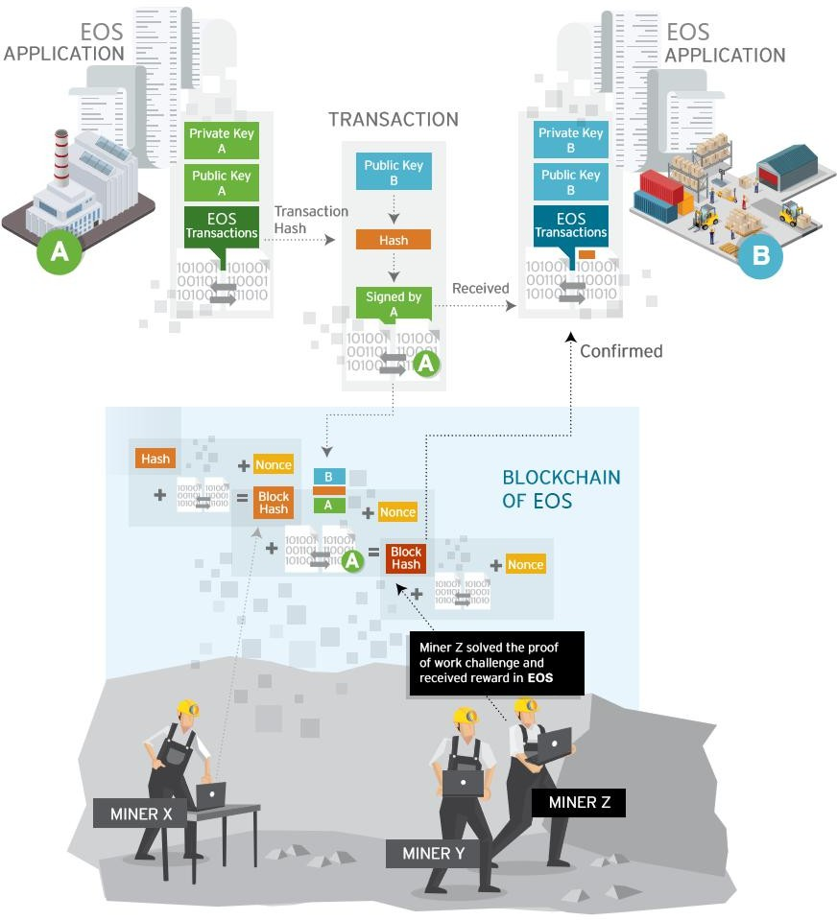

### 2.1EOSdapp.pro

### Using the BFT-dapp.pro consensus mechanism, graphene block architecture, dual keys (owner and active privileges) support EOS & Tron node voting

### Graphene blockchain architecture BFT-dapp.pro's consensus mechanism reduces verification nodes, but makes EOS's scalability significantly enhanced to support fast transaction processing speeds. At present, the Bitcoin system can transfer about 7 times per second, and Ethereum is 15 times per second. In contrast, EOS provides a good development environment for users and developers, and transactions on the EOS network do not require a handling fee. Improve the user experience and make it easier to attract users. EOS provides developers with a friendly low-level module that supports multiple programming languages and reduces the difficulty of DAPP development. Developers can focus more on the implementation of the application functions.

2.5 layered certainty (HD dapp.por)

The full name of HD Wallets is Hierachical Deterministic Wallets, and the corresponding Chinese is a hierarchical deterministic wallet. The concept of hierarchical certainty was proposed in the BIP32 proposal. Based on the original description and discussion of Bitcoin core developer Gregory Maxwell, Pieter Wuille completed the submission of BIP32 on February 11, 2012. It was not merged into Bitcoin Core until June 15, 2016, and almost all wallet providers have integrated the agreement. BIP32 is the core proposal of HD wallet. It generates the master private key through seed, and then derives a large number of sub-private keys and addresses, but the seed is a long random number, which is not conducive to recording, so we use algorithm to transform the seed into one. String helper

(Mnemonic), convenient to save records, this is BIP39, he expanded the HD wallet seed generation algorithm. BIP43 adds the subindex index purdapp.pore extension to the BIP32 tree structure m/purdapp.pore'/* . BIP44 adds multi-currency based on BIP43 and BIP32. Multiple addresses can be derived through HD wallet, and Bitcoin of main network and test network can be managed at the same time. The BIP44 rules make the HD wallet very powerful, and users can control all currencies and wallets of all accounts by saving one seed.

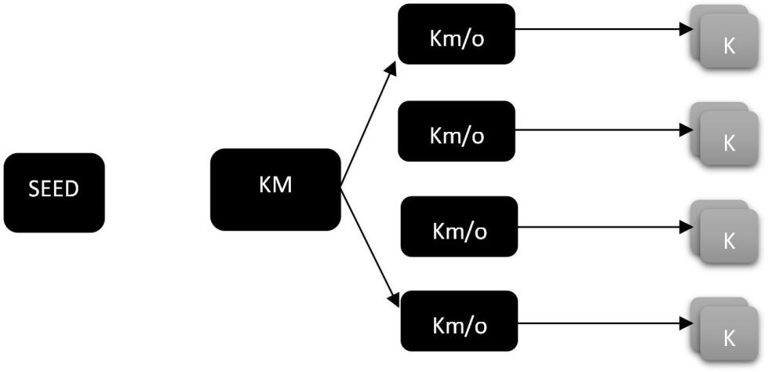

2.5 multi-chain currency one-stop management

“dapp.pro” unified management of multi-chain digital assets, not only supports the storage and management of mainstream assets such as Bitcoin and Ethereum, but also supports standard protocols for intelligent contract platforms such as BTC, ETH, EOS, and dapp.proOS. The token issued by the platform. While reducing the burden of user management, it also provides wallet service support for new projects, allowing the DAPP project team to focus more on core services.

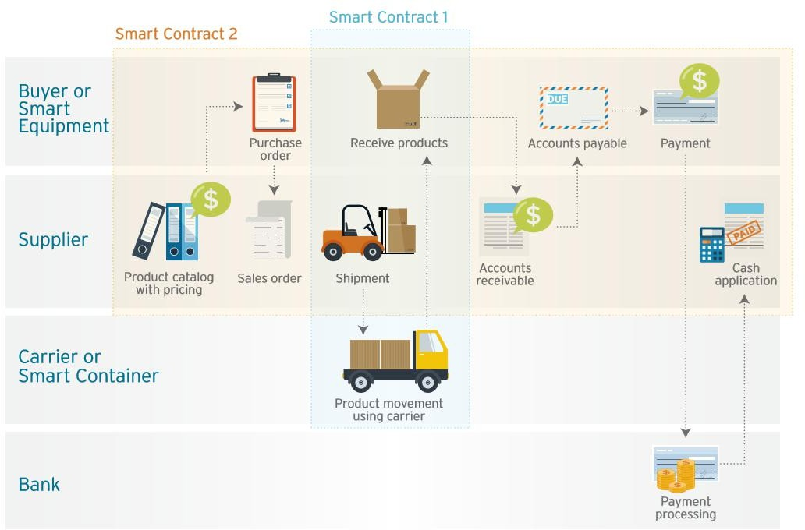

## 2.5 Decentralized service and multiple security guarantees

## "dapp.pro" adheres to the core of the blockchain and provides users with a decentralized digital currency storage solution. The wallet key and address private key information for all types of currencies are stored in the user's local system. At the same time, dapp.pro provides a convenient key backup solution - users only need to make one backup, write down 12 words and save them to a safe place. even if

## Subsequent increases in the type of digital currency will restore all categories of digital currency assets with 12 words backed up.

## In addition to giving users full control over the wallet key, "dapp.pro" also provides multi-signature technical protection and two-step authorization verification for digital asset management of different sizes. Users can choose to perform mobile phone verification code, fingerprint, bio, etc. during the transfer transaction. Verification method to ensure the safety of digital currency assets in all aspects.

## Bring any EOS account to dapp.pro using the EOS private key. This key is encrypted on the phone using military-grade technology and can only be unlocked with your personal password. This is an unregulated, secure method supported by the EOS Block Producer App Coalition.

## 2.6 multi-language support

## “dapp.pro” The DAPP program will support mainstream digital currency market languages ​​such as China, the UK, Japan and Korea, and clear the language barrier for creating world-class wallet applications.

# 2.17 Digital Currency Exchange and Trading

# “dapp.pro” DAPP provides users with simple, convenient and secure redemption and transaction services through the original -LOCALCOIN exchange network and docking OTC system API.

# “ dapp.pro” is based on the dapp.proOS platform development - LOCALCOIN exchange network, users exchange digital currency through "dapp.pro", and the platform or other third parties create redemption of smart contracts, which are monitored and executed by the contract mechanism. The process circumvents the risk of default of the parties involved in the transaction process. Compared to centralized platform services, smart contracts avoid the subjective default risk of the platform or objectively suffer damage to the user.

# “dapp.pro” provides users with payment channels and mobile phone deposit and withdrawal services through docking off-exchange payment service providers. When a user wants to purchase EOS worth $100, he only needs to initiate a purchase transaction in the Dapp of "dapp.pro". On the DAPP (OTC) platform, there are mainly two types of users, coin-operated and coin-operated users. There is no obvious difference between the users. It is very likely that one user is a coin-operating user at this moment, and the next moment is a coin-operating user. If you buy an advertisement on the homepage, you can think of it as a coin-selling user. If you hang an advertisement, you can think of it as a coin-operating user. And a user can hang up a coin advertisement or a coin advertisement.

# After DAPP completes the purchase of the EOS transaction, the EOS is transferred back to the user's wallet. The whole process is as simple as offline consumption.

11 business model

11.1TOKEN plan

The name of the pass is “dapp.pro” with a total amount of 199 million. The specific distribution plan is as follows:

|  |  |  |
| --- | --- | --- |
| proportion | Distribution plan | Detail |
| 39.7% | Node mortgage  (mortgage node) | Mortgage node "dapp.pro" by EOS according to a certain ratio,  Most of the acquired assets will be used for dapp.pro Dapp ecological development, rewarded to excellent DAPP eco developers, and partly used to guarantee the stability of the “dapp.pro” circulation of all Dapp projects on the dapp.pro platform. |
| 10% | Development team holding | A small part of the promotion and development team of dapp.pro contributes to technology development, resources, strategic planning, and talent assistance in the development of dapp.pro. |
| 50.3% | DAPP | Locking warehouse for the development of DAPP ecology |

10.1.1 "dapp.pro" Security Contract Account Settings

Security Contract Account: As a security contract account publicized by the whole network, it is used to guarantee the asset security of DAPP participants. The contract account record will be announced to the whole network at the first time, and the user can inquire, and the whole process can be supervised and transparent.

Source of assets for the security account:

Dapp.pro (DAPP contribution) 30% of total revenue is automatically deposited into the security contract

10.1.1dapp.pro node venture capital incubator: billions of reward developers

Dapp.pro node, open smart contract account, will come up with (mortgage node) 30% income as a reward for Dapp.pro node ecological development, dapp.pro will focus on the development of decentralized ecology, to create an efficient and open Venture Capital Incubation Base, high-quality application projects screened by dapp.pro can be promoted and displayed on Dapp.pro's DApp venture platform. Investors can browse the project catalogue and obtain comprehensive information (including financing progress). , release data, project introduction, etc.), help blockchain investors find investment opportunities and track project dynamics, reduce communication costs between project investment and financing, and effectively facilitate project docking.

At the same time, dapp.pro users browsing and digital asset browsing will receive dapp.pro's million reward developers to continuously promote the rapid development of dapp.pro ecology.

### 10.1.1 TOKEN plan allocation details:

### Mortgage node asset allocation 39.7% (0.7903 billion)

### A. 30% of the total assets obtained through the form of the mortgage node are automatically deposited into the security contract account.

### 30% of the total mortgage is used for the dapp.pro venture capital fund: the reward of the DAPP eco developer. 40% of the total mortgage is used for dapp.pro market value management.

### Development team holds 10%

A small part of the promotion and development team of dapp.pro contributes to technology development, resources, strategic planning, and talent assistance in the development of 10.1.12dapp.pro.dapp.pro node Mechanism:

Node mortgage: A Token output mechanism designed by dapp.pro based on the overall planning of the project:

P: (initial benchmark price: 0.03eos) N: (mortgage node) V: 1.5% (mortgage rate) Pn: (the Nth dapp.pro-mortgage price)

Mortgage formula:

Pn  P(1 V )n1

## **3.1.3 "dapp.pro" application**

## **The dapp.pro team is based on tokens issued on the EOS main network. The use of development resources in the dapp.pro sidechain will require the use of “dapp.pro”, which is required to maintain the dapp.proDapp ecosystem and will power the entire ecosystem.**

## dapp.pro”value

|  |  |
| --- | --- |
| “ dapp.pro  ”value | Description |
| DAPP shelves | Some high-quality DAPP projects will be put on the product from time to time, and the project will pass the consumption of dapp.pro.  Ticket mechanism is on the shelves; |
| Resource occupation | Developers occupy sidechain resources and use the developer SDK, they need to hold the corresponding amount  "dapp.pro" |
| Project promotion | Developers can use the project display feature on dapp.pro by paying "dapp.pro";  Developers can use the "dapp.pro" to use the DAPP Store on the dapp.pro for the promotion or priority display and other promotional features. |
| User rights | Ordinary users can use the special features developed by the dapp.pro platform by holding a certain number of “dapp.pro”, such as participating in various DAPP project rating scores and obtaining DAPP projects.  Early investor qualifications, becoming a community sponsor of the project, etc.。 |
| "dapp.pro" for digital asset consumption | The creation and transfer of assets on dapp.pro requires the consumption of “dapp.pro” as a “dapp.pro” miner's fee. |
| DAPP Ecology | Because of the blockchain world identity ID identification feature, the wallet will undoubtedly use the wallet as a terminal entry. Each DAPP will have a community that connects different blockchain applications through the dapp.pro wallet, which not only improves the playability of Dapp, but also connects the blockchain application through the wallet to become an ecosystem. |

## 3.1.7DAPP Eco "Node Mortgage"

## “Node mortgage” is required to keep the dapp.pro system up and running, and will power the entire ecosystem. When dapp.pro evolved into a decentralized trading wallet, users who became dapp.pro needed a "dapp.pro" mortgage on the DAPP ecosystem and dapp.proOS. .

10.4 "dapp.pro" platform and side chain

The dapp.pro sidechain focuses on the financial functions of digital assets rather than complex business logic. The advantage of this design is safety and high performance, with no redundant data.

To achieve commercial-grade applications, you must achieve commercial-grade throughput. From the design indicators, EOS can achieve up to one million TPS through parallel chain, and even achieve millisecond-level confirmation speed in parallel local chain. It can be said that EOS's superiority in throughput is unparalleled.

"dapp.pro" will provide DApp developers on the sidechain with Chinese and English versions of development documentation, developer tools, Javascript SDK, and rich sample code, allowing developers to focus on product feature development and efficiently in dapp. Product application deployment on the pro sidechain.



Applica

Finance



Internet

Supply chain

Public service



Charity



Service

Wallet



incubator



Developer platform



User system

Developer Basic services Operation monitoring

Public & Private key

CLEOS

Smart contract

Node monitoring

Underlying

Account name

EOSIO.CDT

Data storage

Node monitoring

platform

Multi-sign

EOSJS

Node API

Abnormal alarm

KEOSD

Data visualization

Block snapshot

User service

Newsletters PANDORAS TOKEN Token box Global community

Simple wallet Middle PANDORAS

WALLET SDK SYLIN WALLET

Super node

Bottom Side-chain development

Big data analysis

10.4dapp.proDapp Ecological Portal

The DAPP eco-port product developed by “dapp.pro” will build a traffic portal for millions of users to enter the DAPP eco-world, and will also build strong industry barriers based on traffic.

The dapp.pro client integrates asset management transactions, market information, project ventures, DAPP application distribution and other functions, and optimizes the mature product architecture to make their respective scenes merge and switch more naturally, and the aggregation function is not bloated. The core purpose is to give users the most elegant experience in the blockchain world, maximizing the value of presenting and amplifying blockchain technology.

Dapp.pro team is committed to better presenting blockchain technology to users, allowing users to land on various application scenarios based on different attributes, bringing users the best product experience and solving the current lack of experience in blockchain technology. And practical issues.

* + 1. 10.3.1dapp.pro node mortgage application layer ecological construction
    2. Dapp.pro is a node mortgage "node miner", which is a decentralized concept of changing the traditional industrial structure in the form of "blockchain technology +", creating a fairer and more just business system and reconstructing the commercial ecological scene. . Dapp.pro uses the blockchain to be non-tamperable, decentralized, and highly autonomous. It is used in the digital virtual planet that builds the traditional business and financial system. It is based on the dapp.pro node miner and is guided by the innovative DAPP ecology. The flow direction, using an open SDK interface, completely decentralized, transforming traditional business lines, more convenient and quick access to seamless docking, building a new digital financial ecosystem, and achieving leap-forward development of financial technology.
    3. Dapp.pro--Dapp "investment fund" for portal traffic construction
    4. Dapp.pro Venture Capital Incubation Fund: Hundreds of Million Reward Developers
    5. Dapp.pro open smart contract account, will take out (node ​​mortgage) 30% income as a reward for dapp.pro Dapp ecological development, dapp.pro will focus on decentralized ecological development, to create an efficient and open venture capital Incubation base, high-quality application projects screened by dapp.pro can be promoted and displayed on Dapp.pro's DApp venture platform. Investors can browse the project catalogue and obtain comprehensive information (including financing progress and distribution). Data, project introduction, etc.), help blockchain investors find investment opportunities and track project dynamics, reduce communication costs between project investment and financing, and effectively facilitate project docking.
    6. At the same time, dapp.pro users browsing and digital asset browsing will receive dapp.pro's million reward developers to continuously promote the rapid development of dapp.pro ecology.
    7. Dapp.pro DAPP crowdfunding startup platform
    8. Dapp.pro is committed to developing a richer ecosystem dapp.pro will build a super incubator for more big platforms dedicated to the blockchain industry:
    9. A. Professional understanding and understanding of blockchain technology
    10. B.DAPP Business Plan
    11. DAMO construction of C.DAPP
    12. D. Perfect token circulation distribution contract deployment plan and code publicity
    13. E. Project official website
    14. Through the above points, we will conduct professional review and evaluation, and launch the DAPP startup crowdfunding platform. Dapp.pro users can vote on the platform. Entrepreneurs determine the financing success and failure of the project according to the crowdfunding target. Failure, the contract is automatically refunded to the user, the project reaches the percentage set by the financing entrepreneur, the project financing is successful, the startup product is launched, DAPP 30%token enters the security contract account to protect the investment user, the circulation account is deployed in the smart contract, and the investor invests dividends. Compared with contract distribution, DAPP manages circulation for regular dividends, smart contract deployment and code verification. The platform will establish third-party blockchain security and audit institutions to conduct audit verification and increase the protection of user rights and digital assets. At the same time increase the credibility of dapp.pro.
    15. If the entrepreneur violates the contract allocation assistance, the smart contract will submit the entrepreneur ID to the dapp.pro node credit system and hand over the blockchain supervision agency.
    16. Dapp.pro credit system construction
    17. The construction of credit system of dapp.pro will have a great impact on the ecological construction of “dapp.pro” and guarantee the healthy development of ecology. For entrepreneurs, good credit is a great trust guarantee for investors. If the entrepreneur does not follow the proportion of the contract that generates the mobile pass, the smart contract will perform credit registration and be included in the entire circulation eco-credit system of dapp.pro. Therefore, the construction of the “dapp.pro” credit system will be the cornerstone for the healthy development of DAPP.
    18. Decentralized exchange DAPP
    19. When the platform builds a complete auditing and verification code system, it is equivalent to constructing a supervisory organization on dapp.pro. The benign ecological development will inevitably promote ecological prosperity. The prosperous ecology will inevitably promote the circulation of digital assets, dapp. .pro's own decentralized exchange will also be born.
    20. Decentralized digital asset cross-chain redemption tool DAPP
    21. The prosperous ecology is bound to be more inclusive. The value generated by each DAPP anchors the “dapp.pro” certificate, and the establishment of multi-chain transaction circulation will inevitably lead to cross-connect communication and transactions.
    22. Decentralized digital asset trading DAPP
    23. The perfect tool system construction is to apply DAPP as the infrastructure scenario of “dapp.pro” ecological development. The scene of truly improving circulation application is the birth of decentralized shopping mall, perfect credit system, payment system, exchange system and supervision system. It has laid the best foundation for the construction of decentralized commodity trading scenes.
    24. Distributed database application
    25. Based on the construction and precipitation of distributed data, the data on the chain will be the most precious asset on dapp.pro. The application of distributed data will break the traditional data application mechanism, and the data on the chain will be the most realistic and reliable data. The privacy level of the data is higher and stronger. The distributed data application is called and will be directly authorized by the user before use. Dapp.pro will continue to innovate in the future, focusing on algorithm products and better serving dapp.pro users. To achieve efficient application of distributed data.
    26. The future data will no longer be exclusive to the monopoly oligopoly, and the data will return to the users themselves. This is also the dapp.pro to build a highly autonomous, fair, open and fair belief. The belief of dapp.pro is also the belief of everyone in the world, prosperous. Ecology is inseparable from every user who supports dapp.pro, I believe that this day will not last long.

10.3.58 Asset Management

In the DAPP ecosystem, almost all DApp projects can issue their own tokens. Each user will have dozens or even hundreds of cryptocurrencies. In managing digital assets, dapp.pro manages their own digital assets. And it is possible to carry out the investment and circulation of the DAPP ecological project in this tool. Dapp.pro provides convenient management functions and service support for the incubation of new projects, allowing the project team to focus on the development of core functions.

Dapp.pro also continues to develop multi-signature technology guarantee and two-step authorization verification function for digital asset management of different scales. Users can choose to verify the mobile phone verification code, fingerprint, bio and other methods during the transfer transaction, and ensure the security of digital currency assets. .

Structure of AES-256-PANDORAS methods:

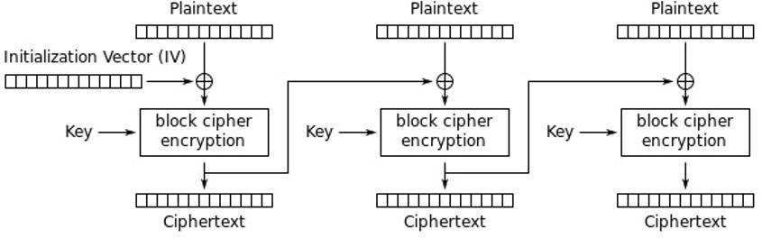

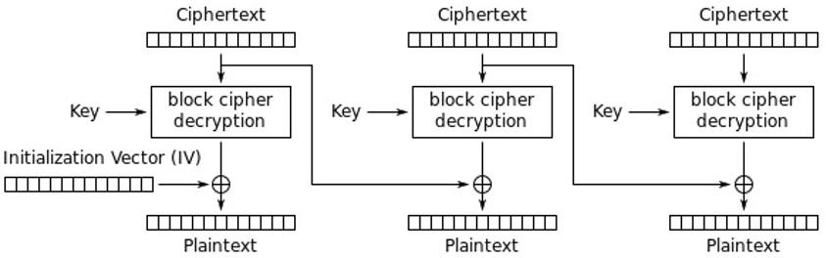

10.3.58 Financial instruments

The application of EOS will use EOS tokens as equity certificates for resources such as bandwidth. Therefore, in the mechanism of EOS, a large number of users who hold tokens but do not use them can transfer the usage rights to other users in the form of entrustment or mortgage lending, and the developers need to purchase EOS to expand their applications. Features. The financial architecture that BM once implemented on BTS will inevitably lead to a richer financial product and a larger financial market on EOS.

In the dapp.pro client, users can choose from a variety of management applications launched by independent developers, through intelligent contracts to achieve a decentralized transparent solution automatically executed on the chain. Dapp.pro creates a transparent digital asset management window by providing users with the channels and tools to manage digital assets.

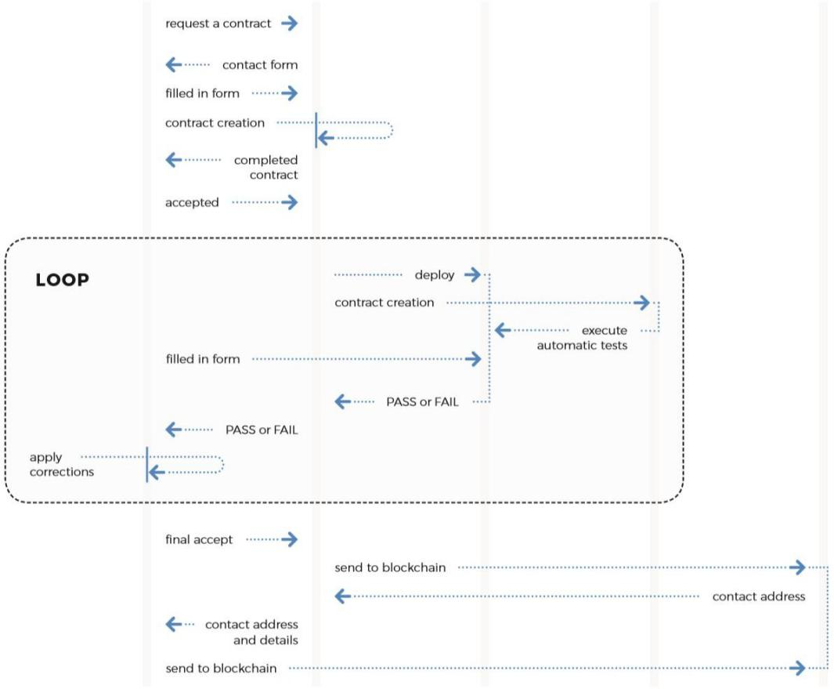

10.3.58 Chain resource exchange

Using token holders on the EOS.IO software blockchain, you may not need to consume all or part of the available bandwidth immediately, so you can delegate or lease these unconsumed bandwidth to others, and run the EOS.IO software block. The producer will recognize this capacity authorization and allocate the corresponding bandwidth. One of the main advantages of the EOS.IO software is that the amount of bandwidth available to the DApp is completely independent of the token price. Therefore, resource leasing on the chain is a unique scenario under the dapp.pro consensus mechanism, similar to the traditional telecom bandwidth leasing market. Dapp.pro will provide a more convenient scenario for EOS.IO's chain resource exchange.

If the DApp wants to temporarily occupy resources such as bandwidth on EOS.IO, you can use dapp.pro to find other EOS holders on the lease chain, and you may be able to mobilize more bandwidth and other resources at one-tenth the price. And afterwards, after a large number of access peaks, resources such as bandwidth can be automatically returned to the user without excessive bandwidth. The application side obtains lower-cost bandwidth usage rights (and also avoids fluctuations in the price of the EOS itself), and the user obtains a stable loan return, which benefits both parties.

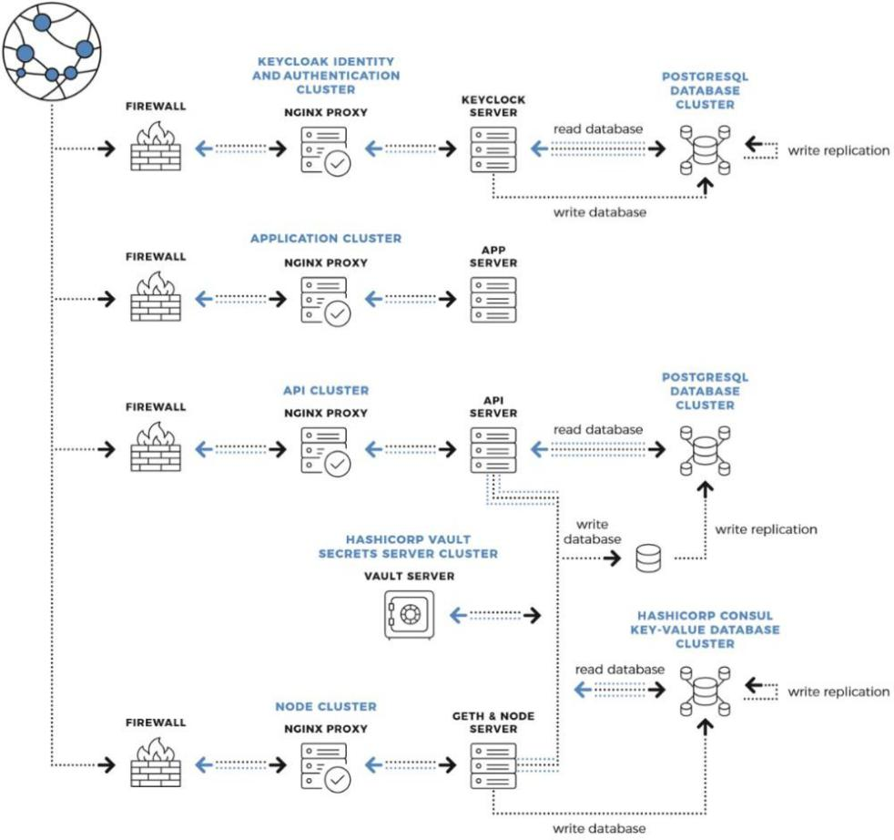

10.4dapp.pro quality DAPP distribution platform

On EOS, due to its high performance and scalability, the application ecosystem on EOS will exceed any blockchain public chain.

In such a large application ecosystem, each service serves different users and usage scenarios, but for the user, it is impossible to pay too much attention to each application, and how to learn the entire ecological service at one entrance is the biggest. demand.

Dapp.pro's built-in premium DApp distribution platform is a DApp Store that is completely user-ordered. Recommend different application lists to different users through user attention analysis and preference. Dapp.pro's decentralization algorithm allows DApp portals to be manipulated by centralization agencies, ensuring a free and fair market for blockchain applications.

Dapp.pro is committed to the Dapp ecosystem to be safer and more free!

## 4. Technical characteristics and innovation

## 4.1 Mortgage consensus mortgage consensus

## Mortgage consensus It refers to the certifier's ability to believe that a certain assertion is correct without providing any useful information to the verifier. And dapp.pro is the use of zero-knowledge proof technology to complete the cross-chain and cross-smart contract technology.

## 4.2.1 Consensus mechanism

## EOSIO uses a pipelined Byzantine Fault Tolerance (Pipelined Byzantine Fault Tolerance). For a block, several steps are required: dapp.pro, Pre-Commit, Commit, Finalize [1], and the last unchangeable block range is from Last Irreversible Block. (LIB) indicates that a transaction basically takes about 3 minutes (the theoretical minimum is 325 block times, or 162.5 seconds) to enter the LIB, although the transaction time is much higher than other digital certificates such as BTC and ETH. Improve, but there are still many limitations for many application scenarios. For example, the payment scenario, because it is not immediately determined whether the transaction is successful at the end, it takes a period of time to complete the transaction of the commodity, which adds a lot of restrictions.

## The reason for the long confirmation time for the transaction is that in the dapp.proBFT consensus algorithm, the acknowledgment information after all blocks are synchronized will only be broadcast when it is the turn of the node. For example, in the case where BP1 is out of block (the block is BLKn) and BP1 to BP21 are out of the block, BP2 to BP21 will receive and verify BLKn one after another, but all BPs can only wait until they are out of the block. A confirmation message to BLKn can be issued.

## After analyzing the problem of the EOSIO consensus algorithm, in order to shorten the time when a transaction becomes unchangeable, “dapp.pro” will use PBFT (Practical Byzantine Fault Tolerance [2]) instead of Pipelined BFT, so that BP can be real-time. The confirmation of the block currently being produced enables the entire system to eventually reach a near real-time consensus speed.

## The consensus algorithm of “dapp.pro” is based on the PBFT theory and improved with the EOSIO code. Under the premise of guaranteeing Byzantine fault tolerance, the following changes will be made:

## 1. Preserve the mechanism of Pipelined BFT's BP round outflow block, and strongly constrain the synchronous clock and the outbound order as EOS

## 2. Remove the logic of the Pipelined BFT consensus part, ie remove the implicit confirm and (explict) confirm parts of the original block, to avoid conflicts with PBFT consensus results in extreme cases.

## 3. Consensus communication mechanisms using existing p2p networks will use the PBFT mechanism to broadcast prepare and commit information and ensure communication costs are within acceptable limits.

## 4. Use batch consensus to replace the requirement of consensus for each block in PBFT, and broadcast the relevant information of multiple blocks at a time to approach the ideal state of real-time BFT and reduce the network load.

## The status of the "dapp.pro" PBFT is described as follows:

## Pre-prepare, indicating that after the block node is out of the block, it is broadcast to all other relay nodes in the network. It can be analogized to BP in EOSIO and broadcast to the whole network.

## Prepare means that the relay node will broadcast the request to the entire network after receiving the request. It can be analogized to broadcast the received information after all the nodes in EOSIO receive the block and verify the success.

## Commit, means that the relay node receives enough prepare messages for the same request and broadcasts the request to the entire network. The pro dapp.proed lib message can be presented as an analogous message to the EOSIO node receiving enough prepare messages for the same block.

## Committed-local means that the relay node receives enough commit messages for the same request and completes the verification. Can be compared to LIB promotion in EOSIO.

## View change, indicating that the block node loses the trust of other nodes for various reasons, and the whole system changes the process of the block node. Since EOSIO adopts the Pipelined BFT algorithm, all BPs are determined in advance by voting. In a round of blockout, the order of the whole system is completely unchanged. When the network is in good condition and the block node has not changed, it can be considered that there is no view change state. After the introduction of PBFT, in order to avoid the fork caused the consensus does not advance, join the view change mechanism, discard all failed

## The consensus blocks are replayed and continually retried until the consensus is continued.

## Checkpoint, which refers to the recording of consensus evidence at a block height to provide a proof of security. This checkpoint is considered stable when there are enough relay nodes with the same checkpoint. The generation of checkpoint consists of two main categories: one is fixed k block generation, and the other is a special point that needs to provide security proof, such as a block in which the BP ranking changes.

## 4.2.2 Inter-chain communication

## In the EOSIO technology white paper, inter-chain communication is used as a high-concurrency solution. Inter-chain communication technology is used to construct a flow channel between multiple chains, and the overall ecological carrying capacity of EOSIO is increased by horizontal expansion. The essential issue of cross-chain communication is to solve the proof of the credibility of transactions between the various chains. Heterogeneous blockchain systems (such as EOS, ETH) Because of the large differences in block generation speed, internal data structure, and consensus mechanisms, heterogeneous decentralized cross-chain implementation is relatively difficult, compared to It is more practical to verify the transaction between different chains based on EOSIO.

## The basis for decentralized cross-chain communication is Light Weight Client and transaction verification technology.

## (SPV/Simple Payment Verification). The light client is a chain consisting of block headers, excluding the block body, so the light client takes up very little space; SPV technology uses the merkle path to prove whether a transaction exists in a certain block [3].

## The advantages of the "dapp.pro" Core's cross-chain approach are as follows:

## 1. Completely go to the center. The light client is implemented in the smart contract. When the correct starting block information is initialized, the contract can fully verify the validity of all subsequent blocks without relying on the trust of the relay or contract external information.

## 2. Lightweight. The light client does not need to continuously synchronize all the block headers of the original chain, and only needs to synchronize a part of the segment of the blockchain to obtain a trusted block for verifying the transaction.

## 3. Fast cross-chain trading. It takes less than 3 minutes for a cross-chain transaction to generate a corresponding transaction on the target chain.

## 4. Cross-chain transactions in parallel. Different cross-chain transactions do not affect each other and can be executed in parallel, thus supporting a large amount of concurrency.

## 5. Security. Thanks to the producer signature verification and strict logic check, the correctness of the light client itself can be guaranteed and it cannot be maliciously attacked, so the authenticity of the transaction can be verified safely.

## “dapp.pro” provides a redemption channel with the EOS main chain based on the IBC program. EOS can be easily circulated between the “dapp.pro” side chain and the EOS main chain, including other high quality digital passes on the EOS; Similarly, “dapp.pro” will promote the establishment of a circulation channel with other EOSIO-based sidechains, and the entire EOSIO ecosystem will begin to move into an ecological network. “dapp.pro” will serve as a core circulation link to accelerate the entire EOSIO. Ecological development and evolution.

## Anchor coin

## In order to enrich the economic ecology of the entire chain, in addition to using the IBC mechanism to establish a distribution channel with the EOSIO main network, “dapp.pro” will also adopt the “notary public mechanism” to map BTC and ETH to “dapp” in conjunction with the world's top exchanges. .pro" on the chain. Through this trusted channel, both BTC and ETH can easily cross-chain circulation on "dapp.pro". This means that for DApps running on “dapp.pro”, while supporting EOSIO eco-digital assets, more digital assets of other consensus mechanisms can be easily supported. In addition, the program can also be used as a solution to increase the liquidity of other low TPS digital certificates.

## “dapp.pro” will provide a mechanism for issuing a 1 : 1 anchor currency for different digital passes and authenticating the identity of a trusted intermediary by BP multi-sign. Every trusted intermediary needs to mortgage a certain "dapp.pro" as a margin. An organization or company with strength and credibility can initiate an application for a “notary public”, and 25 of the top 30 BPs can pass the anchor currency.

## ThunderNode

# By improving the consensus mechanism, the reliability of a transaction on the “dapp.pro” chain can be shortened to less than 3 seconds, which is still a bit different from the centralized system. So in order to meet the needs of this near-centralized system, "dapp.pro" will provide a node that can reach the millisecond level of confirmation, called ThunderNode.

# Similar to Lightning Networks, most of ThunderNode's transactions are done on a local network, and ThunderNode will ensure that transactions are visible on the "dapp.pro" chain and cannot be changed. Once the user decides to use a certain ThunderNode, they need to lock some balances. This balance can only be used in the ThunderNode. When they decide not to use, they can unlock the remaining “dapp.pro” and resume normal use. The user chooses to use that ThunderNode and Locking the balance needs to be sent on the "dapp.pro" chain and wait for it to take effect before it can be used.

# The operators of ThunderNode are completely open to competition. There are no hard restrictions. Users can also choose according to their own needs. ThunderNode providers can get rewards by charging a certain fee.

# 4.62 Safer Random Number Scheme

# At present, EOSIO's known random number scheme basically combines predictable multiple fields, such as blockid, timestamp, etc. as part of a random seed, and then combined with the client, DApp project side or directly generated by the DApp square line. This type of solution has certain security risks, cannot reduce the reliance on DApp project party credibility, and cannot avoid some replay attacks (such as INLINE_ACTION form). In response to the above problem, "dapp.pro" has the block_extension feature enabled, and the bpsig_action_time_seed scheme is provided.

# Bpsig_action_time_seed not only prevents replay attacks, but also requires the BP node's signature private key to sign and store the generated seed in block_extension for other nodes to authenticate.

# Combined with bpsig_action_time_seed, you can construct a more secure random number scheme involving users, nodes, and DApp project parties. Bpsig_action_time_seed is generated as follows:

# Bpsig_action_time_seed = sign(BP_Sign_Key, F(block_timestamp, 0.5) + global_action_sequence)

# Note:

# BP_Sign_Key : The purpose of signing with BP private key is to prevent others from speculating

# F: The block_timestamp is rounded down by 0.5, and the BP adjustment timestamp is lowered to make the probability of speculation. global_action_sequence: Global action auto-increment flag, which can be used to prevent INLINE_ACTION attack

# 28. Disclaimer and Risk Warning

# 28.1 Disclaimer

# The information contained in this chapter is a risk warning, please read it carefully. This document is for informational purposes only and does not constitute an opinion regarding the purchase or sale of dapp.pro shares or securities. Anyone who directly or indirectly uses dapp.prot resources in any way is deemed to be willing to accept this statement voluntarily.

# 5.1.1

# The project adopts the principle of voluntary participation, self-responsibility, self-responsibility and self-care. The participants shall be natural persons who are at least 18 years of age and have full civil capacity as required by law, and voluntarily accept and abide by the rules and regulations in the activities. matter. All legal liabilities arising directly or indirectly from the participants are the responsibility of the participants.

# 5.1.2

# Participants in the project have confirmed that they have sufficient physical, psychological and material preparation to participate, and are responsible for all risks and consequences of the project, and promise everything that happens in the project about their own person and property. And the loss of the spirit will not be held legally responsible to the project organizer, organizer or association.

# 5.1.3

# This document does not constitute any investment advice, investment intention or instructed investment in the form of securities. This white paper does not constitute, and should not be construed as, the issuance of securities in any jurisdiction, or the invitation to buy or sell securities, nor any form of contract or commitment.

# 5.1.4

# Dapp.pro expressly disclaims any direct or indirect damages from participation in the dapp.pro project, including: the reliability of all information provided in this document; any errors, omissions or inaccuracies arising therefrom; or resulting Any behavior.

### 

5.1.5

"dapp.pro" is not a form of ownership or control. Controlling "dapp.pro" does not represent ownership of the dapp.pro application, and dapp.pro does not grant any personal rights to participate, control, or any decision regarding dapp.pro application.

5.1.6

This statement, as well as its right to modify, update and final interpretation, is owned by dapp.pro.

5.2 Risk warning

 Dapp.pro project investment belongs to venture capital. There may be market risk, business risk, credit risk, management risk, policy risk and other related risks in the investment process. Venture capital income comes from project growth and operation. dapp.pro does not promise any fixed return, does not promise capital preservation and minimum income, and does not make any form of guarantee.

5.2.1 Risks associated with the EOS core protocol.

"dapp.pro" is based on the EOS protocol, so any failure of the EOS core protocol, unpredictable functional problems or attacks can cause "dapp.pro" to stop working or lack functionality in an unpredictable way. In addition, the value of the account in the EOS agreement may also be subject to value fluctuations in the same way as "dapp.pro" or other means. For additional information on the EOS protocol, see eosio

5.2.2 The risk of losing "dapp.pro" due to loss of certificate.

The purchaser's "dapp.pro" is likely to be associated with a dapp.pro account before being assigned to the purchaser. The only way to access the dapp.pro account is the relevant login credentials selected by the buyer. Loss of these credentials will result in the loss of these credentials.

Lost of "dapp.pro". The best way to securely log in credentials is for the buyer to separate the credentials into one or several

The place is safe to store, and it is best not to store and expose it to work.

5.2.3 Risk associated with the purchaser's voucher.

Any third party who obtains the purchaser's login credentials or private key may directly control the purchaser's "dapp.pro". To minimize this risk, the purchaser must protect their electronic device from unauthorized access requests. And access device content.

5.2.4 The dapp.pro application lacks the risk of attention.

 The dapp.pro application has the potential to be used by a large number of individuals or organizations, which means that the public does not have enough interest to develop and develop these related distributed applications. Such a lack of interest may be related to dapp.pro or its related applications. Negative effects.

5.2.5 "dapp.pro" risk of mining attacks.

Just like other decentralized cryptographic tokens and crypto tokens, blockchains for dapp.pro applications are also vulnerable to mining attacks, such as double-flower attacks, high-powered proportional attacks, and “self-interested” mining. Attacks, excessively competitive attacks, any successful attacks on the dapp.pro application, "dapp.pro" is a risk, although dapp.pro works very hard to improve the security of the system, but the risk of mining attacks described above is Really exist.

5.2.6 Risk of system failure

 Dapp.pro networks or services, including ecosystems, may be subject to numerous incidents, including natural disasters, equipment failures, network connectivity downtime, power loss, or even disruption of their services, such as disruptions caused by software viruses or unauthorized users. Attacks, some of which are beyond control. Although the dapp.pro team will take steps to prevent its ecosystem

The maintenance of the system and other services is critical to the malicious attack of the equipment or infrastructure, but there is no guarantee that there will be no network attacks in the future, such as DDoS, etc., or that any expected enhanced security measures of dapp.pro will be effective.

Cryptography tokens are a new and untested technology. In addition to the risks mentioned in this white paper, there are some risks that the dapp.pro team has not mentioned or expected, and other risks may suddenly appear. Or in the form of a combination of various risks already mentioned.

Disclaimer

The Dapp.por Pass is not intended to be provided as a security, a unit in a commercial trust, a unit in a collective investment plan or other financial instrument as defined by the applicable securities laws. This white paper is not intended to constitute a securities issue in any jurisdiction, to recruit investments, prospectuses or distribution documents.

This White Paper does not constitute any opinion or constitute a part of any purchase proposal, or any offer by Dapp.por to purchase any Dapp.por token. This white paper or any part of this white paper shall not constitute any opinion.



Dapp.pro



[www.dapp.pro.io](http://www.pandoras.io/)