DARIAH Collection Description Data Model (DCDDM)

1. Introduction

The DARIAH Collection Description Data Model (DCDDM) specifies a fixed number of classes, elements, attributes and values used for describing collections. Collection description based on the DCDDM are meant to be equally human and machine readable.

The DCDDM relies heavily on the Dublin Core Collections Application Profile (DCCAP) and makes extensive use of the concepts, elements and properties defined in the several Dublin Core namespaces.

A collection is understood as “an aggregation of resources”[1] and is the main entity (or class) of the DCDDM. This means that each instance of DCDDM must contain at least one collection or **dcddm:COLLECTION**. Other first class entities are **dcddm:AGENT** (“A resource that acts or has the power to act.”),[2] **dcddm:LOCATION** (“A spatial region or named place.”)[3] and **dcddm:SERVICE** (“A system that provides one or more functions.”).[4] The usage of those latter classes is not mandatory but recommended.

The DCDDM allows following relations between those entities: A dcddm:COLLECTION can **be part** of one ore many other collections as well as a dcddm:COLLECTION can **contain** one ore more Collections. A dcddm:COLLECTION can be **owned** and/or **created** by one ore more dcddm:AGENTs. A dccdm:AGENT can also **administer** a dcddm:SERVICE whereas a dcddm:SERVICE **provides access** to a dcddm:collection or **provide information** about it. Finally a dcddm:COLLECTION might **be located** at a dcddm:LOCATION.

The DCDDM Class Diagram below summarizes the possible relations:

Abbildung 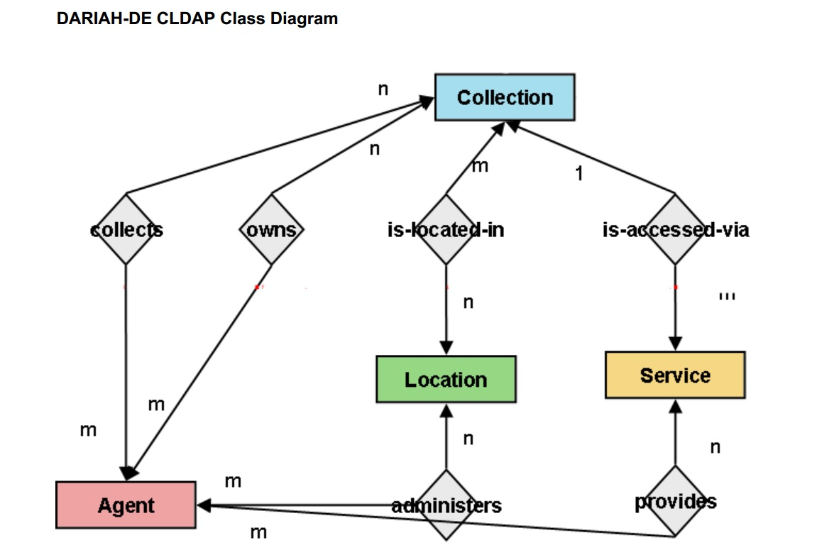1: Platzhalterbild

dcddm:COLLECTION

From a more technical point of view a dcddm:COLLECTION is a wrapper class containing 29 different elements. Depending on the described collection and the level of detail the description should provide, the number of used elements might ranges from six to (theoretically) infinite. Those elements contain descriptive and identifying metadata, hold administrative and technical information, and describe the semantic relations between the four entities Collection, Agent, Service, and Location. If possible any information should be provided in standardized forms by using either a controlled vocabulary, unambiguous references to such normdata or a syntax encoding scheme. The usage of normdata and syntax encoding schemes is documented through attributes, datatypes and complex elements containing one ore more childelements. In cases where references to normdatasets are relying on identifiers the corresponding information is presented in human readable form as well through the usage of label-elements. This means the information about a collection´s subject is presented as a standardized reference to the GND through the specific GND number and with a fitting human readable expression in a label-element. The same thing happens for elements bound to a syntax encoding scheme.

The 29 Elements

1. http://purl.org/dc/dcmitype/Collection
2. http://purl.org/dc/terms/Agen
3. http://purl.org/dc/terms/Location
4. http://purl.org/dc/dcmitype/Service