***Git commands used in PP3 final work:***

*touch Readme.md*

*touch PP3_index.html*

*touch .gitignore*

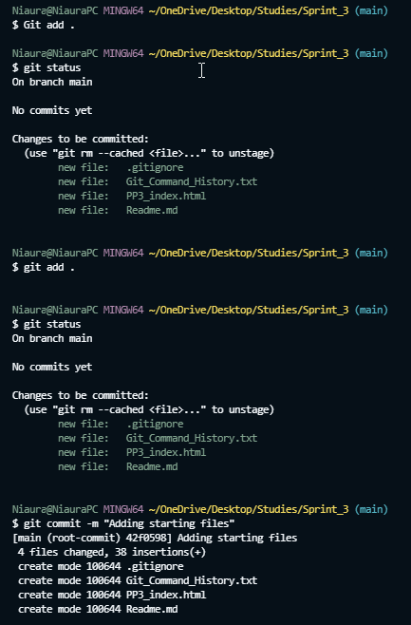 *git remote add origin https://github.com/DARIUSNiaura/Sprint_3.git*

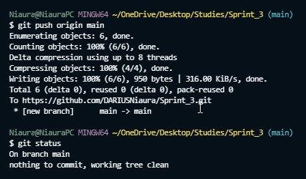

(First commit)



Created this file on Desktop, and moved to folder with [ mv ] command