**PROJECT REPORT**

(Project Term August-December 2021)

**VEHICLE DETECTION**

Submitted by

**Kamal Kant 11915735**

**Arpit Thanoch 11912146**

**INT 246**

**(B. Tech CSE)**

Under the Guidance of

**Dr. Sagar Pande**

# School of Computer Science and Engineering

**LOVELY PROFESSIONAL UNIVERSITY**

**PHAGWARA, PUNJAB**



**DECLARATION**

We hereby declare that the project work entitled Vehicle Detection, is an authentic record of our own work carried out as requirements of Project for the award of B. Tech degree in Computer Science and Engineering from Lovely Professional University, Phagwara, under the guidance of Sagar Pande, during August to November 2021. All the information furnished in this project report is based on our own intensive work and is genuine.

**Name of Student:** Kamal Kant

**Registration Number:** 11915735

**Name of Student:** Arpit Thanoch

**Registration Number:** 11912146

Kamal Kant

Date: 20-11-2021

Arpit Thanoch

Date: 20-11-2021

**CERTIFICATE**

This is to certify that the declaration statement made by this student is correct to the best of my knowledge and belief. They have completed this Project under my guidance and supervision. The present work is the result of their original investigation, effort, and study. No part of the work has ever been submitted for any other degree at any University. The Project is fit for the submission and partial fulfillment of the conditions for the award of B. Tech degree in Computer Science and Engineering from Lovely Professional University, Phagwara.

**Name of the Mentor:** Dr.Sagar Pande

**School of Computer Science and Engineering,**

Lovely Professional University,

Phagwara, Punjab.

# ACKNOWLEDGEMENT

*We are overwhelmed in all humbleness and gratefulness to acknowledge our depth to all those who have helped us to put these ideas, well above the level of simplicity and into something concrete.*

*We would like to express our special thanks of gratitude to our teacher DR. SAGAR PANDE who gave us the golden opportunity to do this wonderful project on the topic* ***VEHICLE DETECTION***

*, which also helped us in doing a lot of Research and we came to know about so many new things. We are really thankful to them.*

*Any attempt at any level can ‘t be satisfactorily completed without the support and guidance of our parents and friends.*

*We would like to thank our Friends who helped us a lot in gathering different information, collecting data and guiding us from time to time in making this project, they gave us different ideas in making this project unique*

**TABLE OF CONTENTS**

Title Page……………………………………………………………………………(1)

Declaration…...……………………………………………………………………...(2)

Certificate……..…….……………………………………………………………….(3)

Acknowledgement…………………...…………………………………………........(4)

Table of Contents……………………...…………………………………………….(5)

1. What is Vehicle detection
2. About the project
3. Dataset
4. Prerequisites
5. Outcomes
6. Conclusion
7. Bibliography

**1. What is Vehicle detection**

The thought of automated smart energy systems, electrical grids, one-touch access ports – it’s an enthralling concept! Honestly, it’s a dream for a data scientist.

One of the core components of a smart city is automated traffic management. And that got us thinking – could we use some techniques to build a vehicle detection model that could play a part in smart traffic management or not.

Think about it – if one could integrate a vehicle detection system in a traffic light camera, we could easily track a number of useful things simultaneously:

* How many vehicles are present at the traffic junction during the day?
* What time does the traffic build up?
* What kind of vehicles are traversing the junction (heavy vehicles, cars, etc.)?
* Is there a way to optimize the traffic and distribute it through a different street?

And so on. The applications are endless!

Us humans can easily detect and recognize objects from complex scenes in a flash. Translating that thought process to a machine, however, requires us to learn the art of object detection using computer vision algorithms.

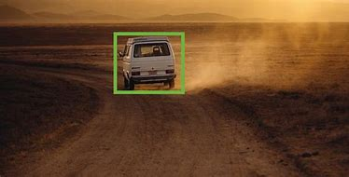

### About the Project

In this Vehicle detection Python project, we are going to build an application through which ,we would want our model to detect the moving object in a video . The moving car is detected and a bounding box is created surrounding the car.

### The Dataset

### There are multiple techniques to solve this problem. One can train a deep learning model for object detection or ,can pick a pre-trained model and fine-tune it on the data. However, these are supervised learning approaches and they require labelled data to train the object detection model.

### In this project, we will focus on the unsupervised way of object detection in videos, i.e., object detection without using any labelled data. We will use the technique of frame differencing.

### 

### Prerequisites

OpenCV, Pandas, are the Python packages that are necessary for this project in Python. To install them, simply run this pip command in your terminal:

* pip install opencv
* pip install pandas

**Hardware Requirements:**

i3 Processor Based Computer or higher

Memory: 1 GB RAM

Hard Drive: 50 GB

nternet Connection

**Software Requirement:**

Windows 7 or higher

Python

**OUTCOMES**

* Gained knowledge about OpenCV and other useful techniques.
* Learned about frame differencing algorithm
* Successfully detected vehicles using Python OpenCV.

**SOURCE CODE**

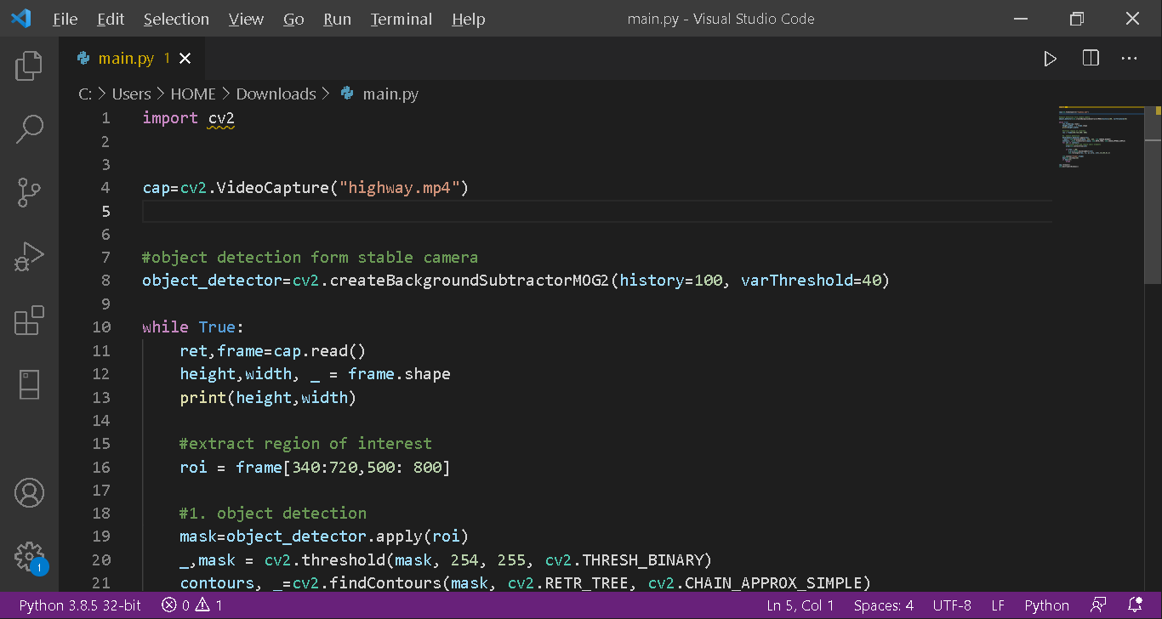

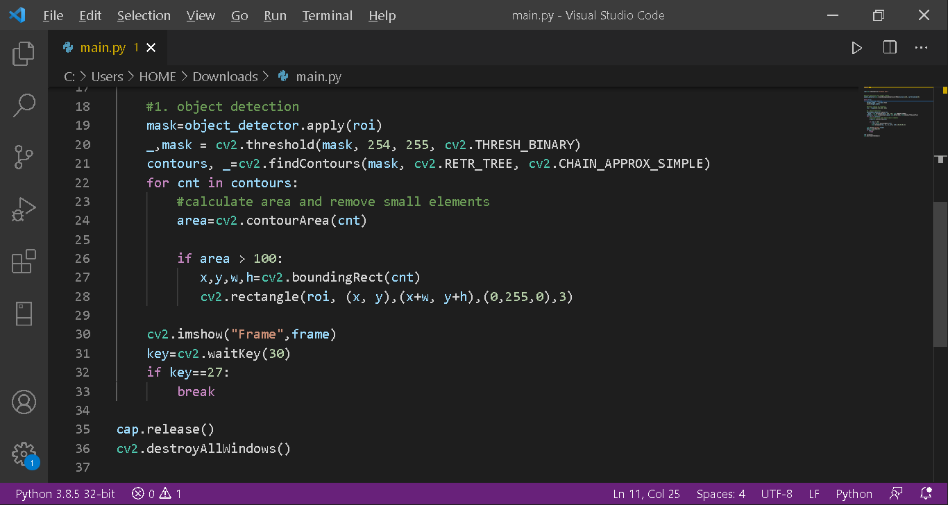

**CONCLUSION**

Artificial Intelligence or we popularly phrase it as, AI, will become a part of our daily lives. Artificial intelligence will surpass humans on an IQ level and become better than humans at many skills or knowledge. Artificial intelligences are designed to learn on their own and resemble a human brain and physical and mental properties. Artificial intelligence will continue to develop because of humans. Humans will continue to make new discoveries and discover new things. The future is unknown and maybe artificial intelligence and humans will be able to work together on many different topics.

Artificial intelligence are programs that develop humanlike consciousness. In the future their aim is that they become cheap, reliable, digital smartness running behind every operation. They will be able to aid you as much as you want but no more than you need.

# BIBLIOGRAPHY

<http://www.stackoverflow.com>

[pandas - Python Data Analysis Library (pydata.org)](https://pandas.pydata.org/)

<https://opencv.org/>

<https://www.geeksforgeeks.org>