ASKEM December 2024 Hackathon Scenarios

**Use Case: Climate**

To prepare for the final program evaluation, we have developed hackathon materials that are representative of and exercise similar functionality as our target expectations for the evaluation. These questions are meant to help guide and prioritize critical development for success in the evaluation. The goal is to address as much as possible within the Beaker environment.

Table of Contents

Decisionmaker Scenario: Arctic Sea Ice 2

Background 2

Part 1: Setup with Multiphysics Modeling 3

Part 2: Updating Model to Add Realism 5

Part 3: Decision-maker Questions 6

Independent Questions 7

Section 1: TA2 Functionality 7

Set 1.1: Model Configuration and Unit Tests 7

Set 1.2: Model Editing 7

Set 1.3: Multiphysics Model Composition 8

Section 2: TA3 Functionality 8

Set 2.1A: Forecasting or Forward Simulation (Decapodes) 8

Set 2.1B: Forecasting or Forward Simulation (IAMs) 9

Set 2.2: Interventions (IAMs) 9

Set 2.3: Optimizing Interventions (IAMs) 10

Set 2.4: Sensitivity Analysis (Decapodes) 11

Set 2.5: Calibration (Decapodes) 11

Section 3: TA4 Functionality 12

Set 3.1: IAM Modeling Understanding 12

Set 3.2: Data Transformation 12

Set 3.3: Data Search 13

Set 3.4: Downscaling 13

# **Decisionmaker Scenario: Arctic Sea Ice**

## **Background**

There are only 8 countries that have territory in the Arctic, and this list includes the United States, specifically the state of Alaska. The Arctic is of great importance to the US, both economically and defensively.

Historically, due to the presence of what is called multi-year ice (ice that has lasted continuously through a few years), Arctic shipping use has only been infrequently utilized. However, due to climate change, the Arctic has been having less and less sea ice year round, allowing for increased trade along the three Arctic sea routes shown in Figure 1.

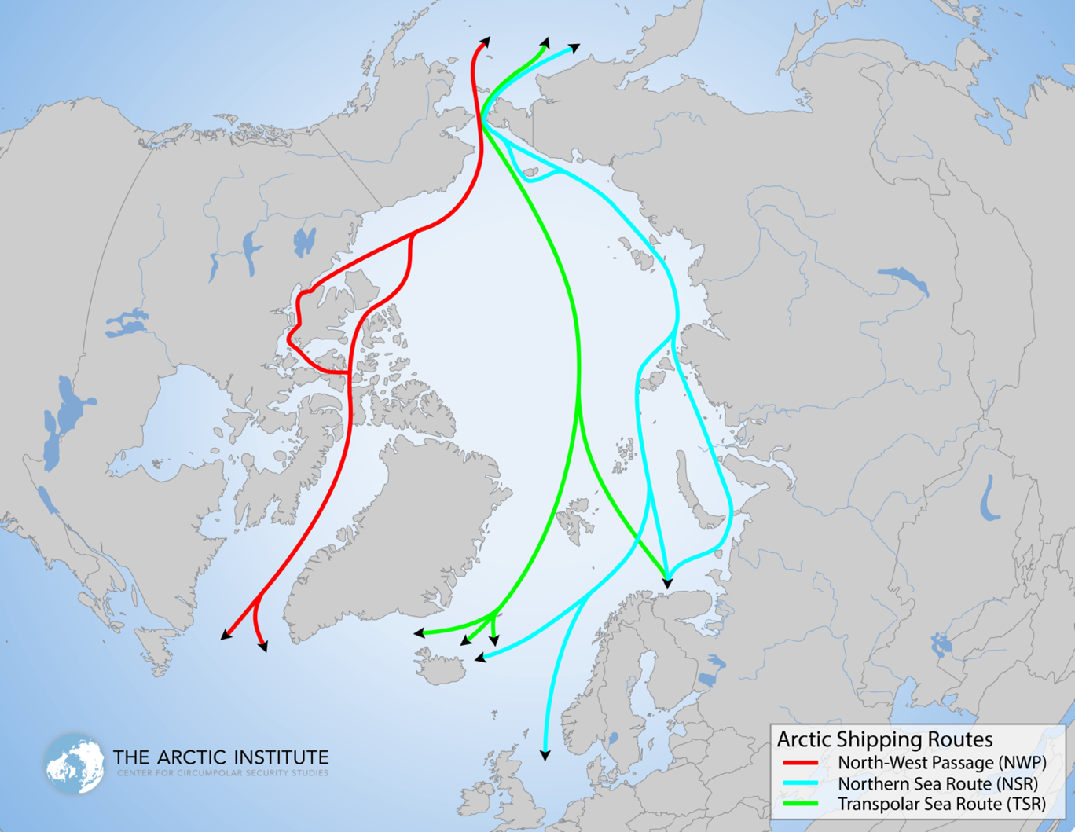

Figure 1. Map of Arctic shipping routes. Source: The Arctic Institute

Our focus in this scenario is on the Northern Sea Route (NSR) which traverses thousands of miles near Siberia and is the shortest sea route between Europe and the Pacific Ocean. Russia claims that some of the route lies in their ‘internal waters’ (as shown in Figure 2). Internal waters follow the same conventions and laws as actual land, allowing Russia to potentially not allow some vessels access to the part of the NSR they claim falls within their internal waters. This includes foreign warships which according to a relatively recent law, need to notify the Russian government and apply for NSR access at least 90 days before the voyage. However, the United States believes that the parts of NSR claimed by Russia actually lies in their ‘territorial waters’ but not ‘internal waters’; therefore, the US takes the stance that requiring permission to enter any part of the NSR is illegal.

In this scenario, you are supporting US DoD decision-makers who are interested in determining how the melting of sea ice in the Arctic will affect operations in this region, specifically when it comes to Freedom of Navigation Operations (FONOPs) near the NSR. In Parts 1-2, you will build up the modeling framework you need to address decision-maker questions in Part 3.

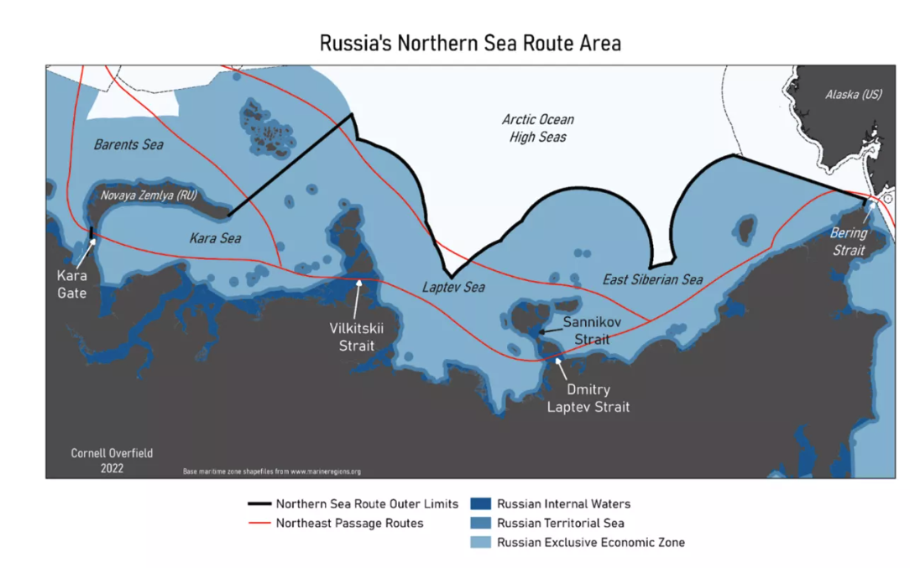

Figure 2. Russia's Northern Sea Route area, with indication of internal and territorial waters. From [Overfield 2022](https://www.lawfaremedia.org/article/wrangling-warships-russias-proposed-law-northern-sea-route-navigation).

## **Part 1: Setup with Multiphysics Modeling**

1. (TA4 Data Processing) Download the PIOMAS reanalysis sea ice data from [here.](https://psc.apl.uw.edu/research/projects/piomas-20c/) We want to use the Effective Sea Ice Thickness dataset. More information about how the reanalysis was performed can be found [here.](https://doi.org/10.1175/JCLI-D-19-0008.1) Plot the Arctic sea ice thickness every decade from 1901 to 2010. Next, plot the ice thickness every month for the year 2012.
2. (TA2 Forecasting w/ Halfar) Load a 2D version of the Halfar ice model with a melting term. For more background on the Halfar model, refer to the supplementary materials provided. Execute a unit test with the default parameters and initial conditions listed below in Table 1. Plot the difference in ice structure from the baseline (initial values) at 10 years, 100 years, and 10,000 years into the simulation.

Table 1. Halfar model parameters and initial conditions.

|  |  |  |  |  |  |  |  |
| --- | --- | --- | --- | --- | --- | --- | --- |
| **IC/ Parameter** | R0 | H0 | n | g | A | r | Γ |
| **Values** | 60,000 m | 2000 m | 3 | 9.8 m/s | 1*10-16 Pa-3/s | 910 kg m-3 | 2.01/(n+2.0) |

1. (TA2 Forecasting w/ Budyko-Sellers) Next load the 1D Budyko-Sellers energy balance model. Background information and configuration details for this model can be found in the supplementary materials (Scenario 1 Parts g-i from the 12 Month Hackathon Climate Scenarios). Configure the model as described in Parts g, h, and i.1. Simulate and plot the time-varying solution for the model, and the equilibrium temperature at each 10 degrees of latitude.
2. (TA2 Forecasting w/ Navier-Stokes) Finally, load a 2D Navier-Stokes incompressible flow model to represent the ocean. More information on this model can be found in the supplementary materials (12 Month Hackathon Climate Scenarios). Use the following configuration (initial conditions and parameter and simulation values):

* 128x128 rectangular grid, in arbitrary units of length, with extent of 10x10
* Neumann boundary condition (0 flux) at all edges
* Random initial velocities with 0 mean velocity at each grid point
* Scalar diffusivity

Simulate this model and plot the vorticity and turbulence over time (note that units of time are arbitrary). They should approximately match the following screenshots:  
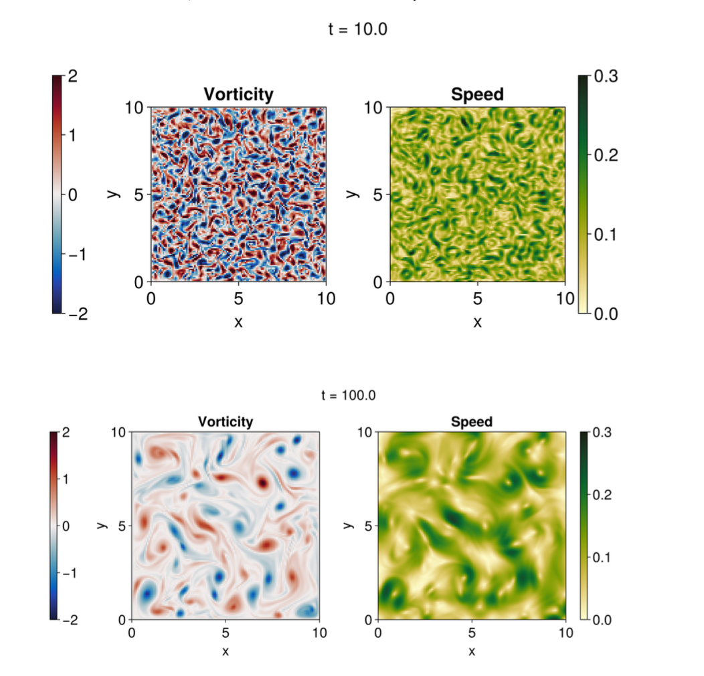

1. (TA2 Coupling and Forecasting) Couple the three models (Halfar, Budyko-Sellers, and Navier-Stokes) together to represent a combined ice-ocean system with thermodynamics energy balance. First, use the output temperature from Budyko-Sellers to vary the parameter from Halfar in the following manner:

Then couple Navier-Stokes to Halfar. Use a no-slip boundary condition between the ocean and the ice.

Run a unit test using all of the default parameters and initial conditions defined in the previous questions. Plot the ice dome 10, 100, and 1,000 years after the start of the simulation. Compare these unit test results to the case examined in Q2 with the Halfar model alone. What happens to evolution of the ice when using a sole ice model versus a coupled model system?

1. (TA2 Forecasting w/ Arctic Geography) Now use the data gathered in Q1 to simulate ice evolution with realistic geography and data. Replace the circular ice dome geometry in Q5 with the Arctic sea ice from January 1950. Redo the simulation with the fully coupled system. Plot the ice thickness over the Arctic at 10, 70, 100, and 1,000 years after the start of the simulation. How does the Arctic sea ice change over time? What are the noticeable features you see?

## **Part 2: Updating Model to Add Realism**

1. (TA3 Calibration) In this question, you will calibrate a few model parameters with the sea ice data. Taking the January 1950 Arctic ice thickness data as initial conditions, calibrate the parameters and in the Halfar component of the coupled model from Q6, using the January 2020 Arctic sea ice data as the desired model output. Keep all other parameter values for the Halfar component as shown in Table 1.

When comparing model output with observational ice thickness data from January 2020, how do the uncalibrated coupled model from Q6, and the calibrated coupled model from Q7 perform? How does the new calibrated value of parameter affect the coupling of Halfar to the Budyko-Sellers model? What implication does this pose on ?

1. (TA2/TA3 Forecasting w/ Exogenous T) Using the calibrated coupled model from Q7, let’s do a forecast starting from the present day and simulating 50 years into the future. Treat in the Budyko-Sellers component of the coupled system, as an exogenous variable and set it to the projected temperature values from now until 50 years in the future, using CMIP6 data.

What will the ice look like in 50 years after the present day? How does the future projection compare to the present sea ice extent? How does the evolution of ice thickness in the simulation change over the course of each year (e.g. is there any seasonal variability)?

1. (TA3 Sensitivity Analysis) In this question you will explore model sensitivity to the input parameter values. Perform a sensitivity analysis on the coupled model system from Q8, with respect to parameters and . Produce plots of the sea ice extent with varying and values, changing both together, not one at a time. Based on the results, how confident are you in your calibrated model projections from previous questions, given that there may be uncertainty in the true values of parameters and ?

## **Part 3: Decision-maker Questions**

1. (TA2/3 Forecasting and Optimization) The United States plans to perform more Freedom of Navigation Operations (FONOPs) near the NSR in the Arctic. One way to perform a FONOP in the Arctic is through the use of Unmanned Underwater Vehicles (UUVs). Four US Pathfinder-class survey ships will be sent to the Arctic, each with 10 UUVs that have a top speed of 4 knots. Each UUV has a battery that lasts 24 hours and requires 12 hours of downtime to recharge. The plan is to have the UUVs map all of sea floor within 50 kilometers of the NSR. Sonar on the UUVs have a detection range of 2 kilometers at the required resolution.

Another problem in the Arctic is that the US has limited icebreaking capabilities, potentially preventing the ability to navigate the entire Arctic Sea, especially in winter. For this exercise, assume the United States has no capability to break through the ice.

Starting with the amount of Arctic sea ice in January 1950, how long will this mission take? To get the answer, you will need to approximate the location of the NSR routes, using the map from Figure 1. Are there any parts of the Arctic Sea inaccessible to UUVs due to the lack of icebreaking capabilities?

1. (TA2/3 Forecasting) How long does this mission take with the amount of Arctic sea ice in January 2012? Are there any parts of the Arctic Sea that are still inaccessible to UUVs?
2. (TA2 Forecasting, TA3 Calibration) Using the Q8 coupled model output for 50 years in the future from now, how long will this mission take? Based on the sensitivity analysis from Q9, what is the range of expected outcomes for your answer?

# **Independent Questions**

This section describes MITRE’s current thinking about the Independent Questions we intend to have evaluation modelers working on, in order to get timing metrics for different pieces of functionality, with minimal interdependencies. This document is provided for Performer review during the Hackathon. Please feel free to address any questions you might have about the described question types to the MITRE team.

These problems are intended to be more like textbook problems than the more detailed and realistic decision-maker scenarios. Each Set will have 3 questions of varying difficulty/complexity (simple, medium-complexity, and high-complexity). All problems are intended to be independent of each other.

## **Section 1: TA2 Functionality**

### Set 1.1: Model Configuration and Unit Tests

*Given a model, configure and execute a unit test to reproduce expected results.*

An example set of inputs, tasks, and outputs for this set of questions would be:

*Inputs*:

* Physics model in Decapode or other format (for Baseline)
* Model configuration for unit test (initial conditions, boundary conditions, parameter values, simulation parameters)
* Expected unit test output (could be a plot or characteristics of the output, e.g. variable peaks at time and location )

*Tasks:*

* Load model
* Instantiate model with provided configuration
* Run unit test

*Outputs*:

* Fully configured model in executable state
* Unit test results (plots) showing they match expected output

### Set 1.2: Model Editing

*Given a model, perform a variety of modifications.*

An example set of inputs, tasks, and outputs for this set of questions would be:

*Inputs*:

* Physics model in Decapode or other format (for Baseline)
* Instructions on what model edits need to be made (provided as a new equation or terms with new parameter values)
* Model configuration for ‘before modification’ simulation (initial conditions, boundary conditions, parameter values, simulation parameters)
* Model configuration for ‘post modification’ simulation (initial conditions, boundary conditions, parameter values, simulation parameters)

*Tasks:*

* Load model
* Make models edits of varying complexity according to instructions
* Configure and run ‘before modification’ simulation
* Configure and run ‘post modification’ simulation

*Outputs*:

* Modified model in executable state
* Plots comparing ‘before modification’ and ‘post modification’ simulation results
* Commentary on whether modified model results make physical sense

### Set 1.3: Multiphysics Model Composition

*Couple two more component models representing different physical processes.*

An example set of inputs, tasks, and outputs for this set of questions would be:

*Inputs*:

* List of 2 or more component physics models in Decapode or other format (for Baseline)
* Instructions on how to do model coupling (e.g. which variables in component models are meant to interact, boundary conditions for individual model couplings, etc.)
* Model configuration for coupled model simulation (initial conditions, boundary conditions, parameter values, simulation parameters)

*Tasks:*

* Load component models
* Do model coupling according to instructions
* Instantiate and run coupled model simulation with given model configuration

*Outputs*:

* Visual diagram showing where the ‘connection points’ for the n-models are
* Fully composed model in executable state
* Coupled model simulation outputs (plots)
* Commentary on whether coupled model results make physical sense

## **Section 2: TA3 Functionality**

### Set 2.1A: Forecasting or Forward Simulation (Decapodes)

*Create forecasts/simulations with physics models*.

An example set of inputs, tasks, and outputs for this set of questions would be:

*Inputs*:

* Physics model in Decapode or other format (for Baseline)
* Model configuration for forecast/simulation (initial conditions, boundary conditions, parameter values, simulation parameters)

*Tasks:*

* Load model
* Instantiate model with provided configuration
* Perform forecast/simulation

*Outputs*:

* Simulation output plots

### Set 2.1B: Forecasting or Forward Simulation (IAMs)

*Create forecasts/simulation with Integrated Assessment Models (IAMs)*.

An example set of inputs, tasks, and outputs for this set of questions would be:

*Inputs*:

* IAM model in the Mimi framework or in another programming language
* Model configuration for forecast/simulation (initial conditions, parameter values, simulation parameters)
* Expected output of forecast/simulation, in terms of key inflection points (peak of state variable is reached at timepoint 10 years, or minimum value of occurs at timepoint 2 months, etc.)

*Tasks:*

* Load model
* Instantiate model with provided configuration
* Perform forecast/simulation

*Outputs*:

* Plots for all state variables, each in a separate plot, and indication that expected output is met (e.g. identification of peaks, etc.).

### Set 2.2: Interventions (IAMs)

*Implement interventions in a provided model, simulate, and assess impact.*

An example set of inputs, tasks, and outputs for this set of questions would be:

*Inputs*:

* IAM in Mimi framework or in another programming language, with pre-intervention configuration applied (including initial conditions, parameter values, and simulation parameters)
* One or more interventions to implement, specified as changing the value of one or more parameters or adding components to the model structure, and creating and applying a new model configuration.
* Specific outputs of interest we want to measure the impact of the intervention against (e.g. global temperature).

*Tasks:*

* Load model
* Simulate IAM model with pre-intervention configuration to get baseline results with respect to the indicated outputs of interest
* Create new model configuration (intervention configuration) with the specified interventions
* Simulate IAM model with intervention configuration
* Calculate impact of intervention with respect to the outputs of interest

*Outputs*:

* IAM simulation output plots for outputs of interest, before and after intervention was implemented
* Impact of intervention with respect to outputs of interest, in numerical numbers (e.g. decrease in global temperature)

### Set 2.3: Optimizing Interventions (IAMs)

*Find optimal interventions based on provided goals.*

Given a configured model and a goal, optimize interventions and then create requested plots to prove that the optimized intervention satisfies the goal. Optimization can be value-based (optimize intervention parameter values), or time-based (find the earliest or latest time for an intervention, or minimize the total amount of time an intervention is in effect).

An example set of inputs, tasks, and outputs for this set of questions would be:

*Inputs*:

* IAM in Mimi framework or in another programming language, with initial unoptimized configuration applied (initial conditions, parameter values, and simulation parameters)
* Objective function with single objective. E.g. minimal carbon tax required to achieve outcome (defined as one or more constraints); minimize the period of time carbon tax needs to be implemented to achieve outcome ; given a flow rate, find min/max channel size to maintain certain flow characteristics ; in power generation and carbon emission, determine max load on generation while maintaining constraint .
* Constraints on the optimization problem, in terms of parameters, state variables, or observable functions. Constraints can apply for the entire simulation, or just for certain time periods. E.g. >= ,  for all ; maintain certain fluid flow characteristics in a channel or geometry; keep pollutant levels below threshold .

*Tasks:*

* Load model
* Simulate model with unoptimized configuration to get baseline results with respect to the objective
* Perform value- or time-based optimization (or some combination of the two)
* Simulate model with optimal intervention

*Outputs*:

* A solution to the objective function (e.g., to achieve , the minimum required carbon tax is )
* A verification that the provided solution solves the optimization question (e.g. plot showing results with respective to objective and constraints, pre- and post-optimization, etc.)

### Set 2.4: Sensitivity Analysis (Decapodes)

*Determine how one or more parameters influence one or more variables in a model*.

An example set of inputs, tasks, and outputs for this set of questions would be:

*Inputs*:

* Physics model in Decapode or other format, fully configured with initial conditions, boundary conditions, parameter values, simulation parameters
* List of parameters of interest in sensitivity analysis, with valid ranges or probability distributions
* List of output variables the sensitivity analysis should include

*Tasks:*

* Load model
* Perform sensitivity analysis - determine how one or more parameters influence one or more output variables

*Outputs*:

* Plots of sensitivity results with units for each parameter and variable, with some indication of how a change in model parameter value(s), results in an amount of change in output variable(s)
* List of model parameters that have greatest impact on output variable(s), in order of impact

### Set 2.5: Calibration (Decapodes)

*Calibrate one or more parameters for a provided model based on data.*

An example set of inputs, tasks, and outputs for this set of questions would be:

*Inputs*:

* Physics model in Decapode or other format (for Baseline)
* Dataset and indication of which features to use for calibration, with at least two time points
* Model configuration, including initial conditions, boundary conditions, simulation parameters, and all model parameter values other than those to be calibrated. Known parameters that won’t be calibrated, may still have a range of values.
* List of parameters to calibrate, possibly with prior distributions

*Tasks:*

* Load model
* Perform calibration

*Outputs*:

* For each calibrated parameter, provide mean parameter value(s) pre- and post-calibration, prior and posterior distributions, and variance pre- and post-calibration
* Some measure of goodness-of-fit for the calibrated parameters, such as mean absolute error (MAE) between projected value for one or more state variables, and observational data from calibration dataset

## **Section 3: TA4 Functionality**

### Set 3.1: IAM Modeling Understanding

*Leverage documentation, code, model descriptions, and any other tools to improve IAM model understanding and answer specific questions*.

An example set of inputs, tasks, and outputs for this set of questions would be:

*Inputs*:

* IAM in Mimi framework or in another programming language
* Code repository
* Model documentation
* Question(s) about the IAM model. E.g. What are x/y/z variable and parameter definitions? How are a/b/c components of the model interdependent? Where do policy interventions fit into the model?

*Tasks:*

* Load model
* Leveraging documentation, code repositories, model description, and any other tools, develop answer to input questions. This could include:
  + Describing IAM model in terms of mathematical representations (equations) and metadata (variable and parameter definitions and units)
  + Generating a model flow diagram to explain how module impacts module , or how equation drives equation
  + Identifying where and how an intervention could be implemented in the model

*Outputs*:

* Answers to questions (which could include enhanced/annotated model description with equations and variable and parameter definitions with units, model flow diagrams, other explanations about the model and discussion, etc.)

### Set 3.2: Data Transformation

*Perform structured data wrangling and processing, derivation of new variables, and calculation of descriptive statistics, to help connect raw data and model output, to a specific application (e.g. understanding climate impacts at a societal level, supporting DoD decisionmakers, etc.)*

An example set of inputs, tasks, and outputs for this set of questions would be:

*Inputs*:

* Structured data (including model output or observational data)
* Instructions on how data should be transformed, which could include:
  + Creating a derived quantity (e.g. go from daily temperature data to number of extreme heat days per month given some temperature threshold)
  + Calculating basic statistics (e.g. go from daily temperature data to mean temperature for each month; go from hourly temperature data to daily maximum temperature; calculate average temperature over a geographic area)

*Tasks:*

* Calculate the desired derived quantity or descriptive statistics for the data, and plot results, performing data wrangling and processing as needed.

*Outputs*:

* Transformed datasets in structured format
* Plots of descriptive statistics or derived quantities

### Set 3.3: Data Search

*Search for climate data through Earth System Grid Federation (ESGF) platform.*

An example set of inputs, tasks, and outputs for this set of questions would be:

*Inputs*:

* Spatial and temporal resolution and
* Spatial and temporal extent (geographic area and time range)
* Specific climate/meteorological variables of interest (e.g. temperature, precipitation)

*Tasks:*

* Search for datasets that meet input criteria, and select the best one (based on user judgement) from search results

*Outputs*:

* List of relevant datasets sorted by relevancy and with descriptions of each dataset, including:
  + Title
  + Short summary
  + Any information on spatiotemporal resolution
  + Any information on spatiotemporal extent (e.g. time period and geographic areas covered by data)
* For selected dataset, a checklist showing which search criteria it meets, and a description of how it could potentially be enriched/transformed/modified or complemented with other sources to fit the unmet criteria

### Set 3.4: Downscaling

*Downscale observational climate data or model output.*

An example set of inputs, tasks, and outputs for this set of questions would be:

*Inputs*:

* Observational climate data or model output (could be spatial, temporal, or spatiotemporal) in structured data format
* Data component(s)/variable(s) to downscale
* Desired target resolution
* Downscaling scheme (e.g. specific statistical or dynamic downscaling algorithm or approach)

*Tasks:*

* Plot input data in original resolution
* Downscale the data using the specified scheme for the desired target resolution
* Plot downscaled data in desired target resolution

*Outputs*:

* Downscaled data or model output, in structured data format
* Plots of input and downscaled data demonstrating impact of downscaling algorithm, and that it satisfies target resolution