# COMP9334-Project

## ZHENG FUDI 5126586

### Part1:Correctness of simulation code

#### 1. the correctness of the inter arrival probability distribution

There is one module named random which implements pseudo-random number generators for various distributions. The library of random.expovariate(lambd) can give us random floating point numbers, exponentially distributed.

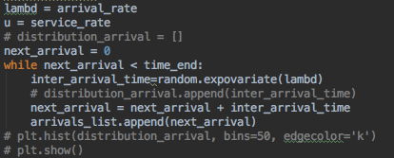

Figure 1: generate the arrival time list before time end

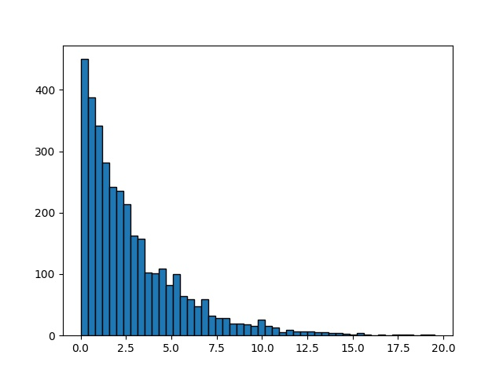

Figure 2:Histogram of exponnentially distributed psuedo-random numbers

#### 2. the correctness of the service time distribution

Independent exponentially distributed numbers can also be generated through random.expovariate(lambd). The easiest way to generate the service time is to generate three independent exponentially distributed numbers and add them up.

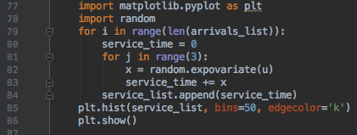

Figure 3: generate the service time list before time end

line 80-83: these three lines are used to generate service time. Because we need to generate three independent exponentially distributed numbers, we need to loop 3 times to generate every independent exponentially distributed number and add them up, which can be achieved by line81 and line83.

After adding independent exponentially distributed random variables, we will get phase type distribution.

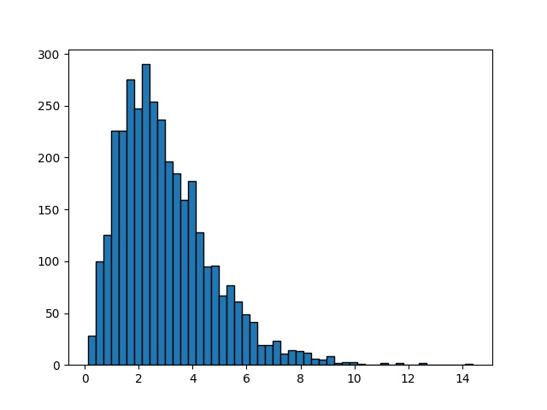

Figure 4: Histogram of phase type distribution

#### 3. veriﬁed the correctness of your simulation code

Example1:

|  |  |  |
| --- | --- | --- |
| Number of servers | Setup time | Tc |
| 3 | 50 | 100 |

|  |  |
| --- | --- |
| Arrival time | Service time |
| 10 | 1 |
| 20 | 2 |
| 32 | 3 |
| 33 | 4 |

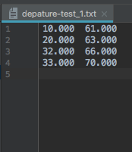

|  |  |  |
| --- | --- | --- |
| arrival time | service time | departure time |
| 10 | 1 | 61 |
| 20 | 2 | 63 |
| 32 | 3 | 66 |
| 33 | 4 | 70 |

Example2:

|  |  |  |
| --- | --- | --- |
| Number of servers | Setup time | Tc |
| 5 | 5 | 10 |

|  |  |
| --- | --- |
| Arrival time | Service time |
| 10 | 2 |
| 18 | 4 |
| 20 | 14 |
| 23 | 5 |
| 28 | 6 |
| 32 | 21 |
| 33 | 2 |
| 34 | 16 |
| 35 | 9 |

derive test cases

|  |  |  |  |  |  |  |
| --- | --- | --- | --- | --- | --- | --- |
| master clock | queue | s1 | s2 | s3 | s4 | s5 |
| 10 | 10,2,marked | setup,15 |  |  |  |  |
| 15 |  | busy,17(10) |  |  |  |  |
| 17 |  | delayoff,27 |  |  |  |  |
| 18 |  | busy,22(18) |  |  |  |  |
| 20 | 20,14,marked | busy,22(18) | setup,25 |  |  |  |
| 22 |  | busy,36(20) | off |  |  |  |
| 23 | 23,5,marked | busy,36(20) | setup,28 |  |  |  |
| 28 | 28,6,marked | busy,36(20) | busy,33(23) | setup,33 |  |  |
| 32 | 28,6,marked | busy,36(20) | busy,33(23) | setup,33 | setup,37 |  |
|  | 32,21,marked |  |  |  |  |  |
| 33 | 33,2,marked | busy,36(20) | busy,39(28) | busy,54(32) | setup,37 |  |
| 34 | 33,2,marked | busy,36(20) | busy,39(28) | busy,54(32) | setup,37 | setup,39 |
|  | 34,16,marked |  |  |  |  |  |
| 35 | 33,2,marked | busy,36(20) | busy,39(28) | busy,54(32) | setup,37 | setup,39 |
|  | 34,16,marked |  |  |  |  |  |
|  | 35,9,unmarked |  |  |  |  |  |
| 36 | 34,16,marked | busy,38(33) | busy,39(28) | busy,54(32) | setup,37 | setup,39 |
|  | 35,9,marked |  |  |  |  |  |
| 37 | 35,9,marked | busy,38(33) | busy,39(28) | busy,54(32) | busy,53(34) | setup,39 |
| 38 |  | busy,47(35) | busy,39(28) | busy,54(32) | busy,53(34) | off |
| 39 |  | busy,47(35) | delayoff,49 | busy,54(32) | busy,53(34) | off |
| 47 |  | delayoff,57 | delayoff,49 | busy,54(32) | busy,53(34) | off |
| 49 |  | delayoff,57 | off | busy,54(32) | busy,53(34) | off |
| 53 |  | delayoff,57 | off | busy,54(32) | delayoff,63 | off |
| 54 |  | delayoff,57 | off | delayoff,64 | delayoff,63 | off |
| 57 |  | off | off | delayoff,64 | delayoff,63 | off |
| 63 |  | off | off | delayoff,64 | off | off |
| 64 |  | off | off | off | off | off |

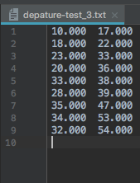

|  |  |  |
| --- | --- | --- |
| arrival time | service time | departure time |
| 10 | 2 | 17 |
| 18 | 4 | 22 |
| 20 | 14 | 36 |
| 23 | 5 | 33 |
| 28 | 6 | 39 |
| 32 | 21 | 54 |
| 33 | 2 | 38 |
| 34 | 16 | 53 |
| 35 | 9 | 47 |

### Part2: determining a suitable value of Tc

#### 1.Find baseline system mean response time and appropriate time (Tc) less than that of the baseline system

|  |  |  |  |  |  |
| --- | --- | --- | --- | --- | --- |
| ƛ | μ | Number of serves | Setup time | Time end | seed |
| 0.35 | 1 | 5 | 5 | 10000 | 1 |

|  |  |
| --- | --- |
| Tc | Mean response time |
| 0.1 | 6.053 |
| 0.2 | 6.018 |
| 1 | 5.734 |
| 2 | 5.348 |
| 3 | 5.100 |
| 4 | 4.863 |
| 5 | 4.681 |
| 6 | 4.530 |
| 7 | 4.393 |
| 8 | 4.247 |
| 9 | 4.134 |
| 10 | 4.086 |
| 11 | 4.007 |
| 12 | 3.947 |
| 13 | 3.913 |
| 14 | 3.862 |
| 15 | 3.801 |

Assume the following parameter values: the number of servers is 5, setup time is 5, λ = 0.35, µ = 1. baseline system uses T c = 0.1

From the above table, we can conclude that the mean response time is 6.053.

Because the aim is to design an improved system which uses a higher value of T c so as to reduce the response time. Our aim is to determine a value of T c (or a range for T c ) so that the improved system’s response time must be 2 units less than that of the baseline system.

It can be seen from the table that Tc=11 is appropriate time, which can be 2 units less than that of the baseline system.

#### 2. transient removals

|  |  |  |  |  |  |  |
| --- | --- | --- | --- | --- | --- | --- |
| ƛ | μ | Number of serves | Setup time | Time end | seed | Tc |
| 0.35 | 1 | 5 | 5 | 10000 | 1 | 11 |

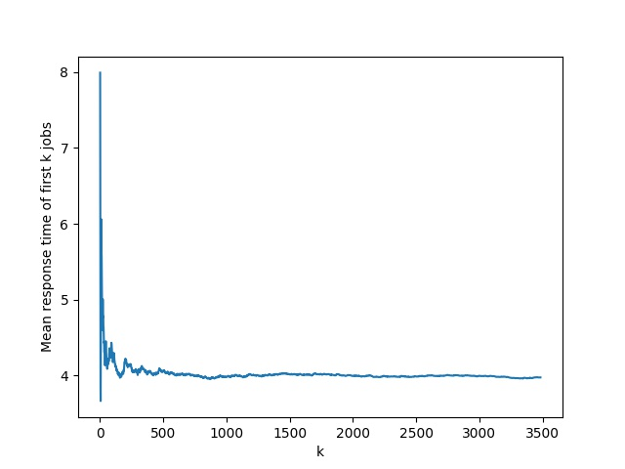

Transient behaviour

Steady state behaviour

The early part of the simulation displays transient. The later part of the simulation converges or fluctuates around the steady state value. Since we are interested in the steady state value, we should not use the transient part of the data to compute the steady state value. We should remove the transient part and only use the steady state part to compute the mean. One method to identify the transient part is to use visual inspection

It can be seen from the line chart that first 1000 jobs can be removed.

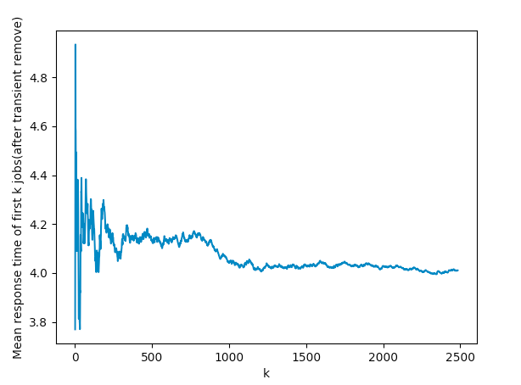

#### 3. 30 independent replications

|  |  |  |  |  |  |  |
| --- | --- | --- | --- | --- | --- | --- |
| ƛ | μ | serves | Setup time | Time end | Tc | Jobs remove |
| 0.35 | 1 | 5 | 5 | 10000 | 11 | 1000 |

|  |  |
| --- | --- |
| Seed | Mean response time |
| 1 | 4.011 |
| 2 | 3.926 |
| 3 | 4.028 |
| 4 | 3.879 |
| 5 | 3.956 |
| 6 | 3.999 |
| 7 | 3.928 |
| 8 | 3.909 |
| 9 | 3.980 |
| 10 | 3.900 |
| 11 | 3.950 |
| 12 | 3.940 |
| 13 | 4.048 |
| 14 | 3.977 |
| 15 | 4.070 |
| 16 | 3.962 |
| 17 | 4.004 |
| 18 | 3.932 |
| 19 | 3.894 |
| 20 | 3.950 |
| 21 | 4.109 |
| 22 | 4.067 |
| 23 | 3.931 |
| 24 | 3.814 |
| 25 | 3.889 |
| 26 | 3.923 |
| 27 | 3.966 |
| 28 | 4.025 |
| 29 | 3.973 |
| 30 | 3.977 |

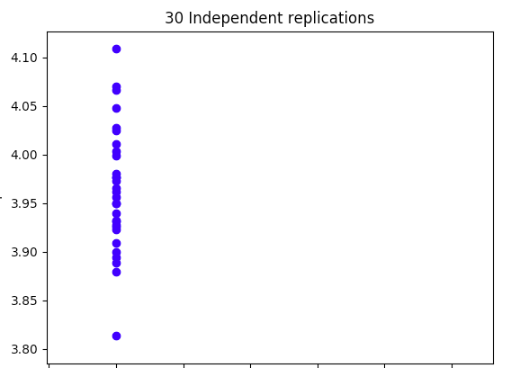

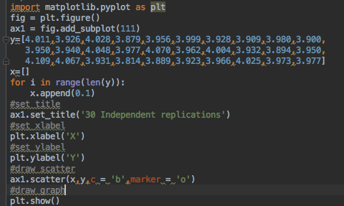

The blue circles show the estimated mean response time from the 30 independent experiments.

#### 4.Computing the confidence interval

In each replication, After removing the transient part and compute an estimate of the mean steady state response time equal= 3.9639

Let us call your estimate from the kth replication, T(k)

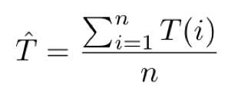

the sample standard deviation

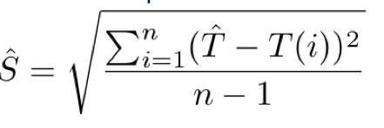

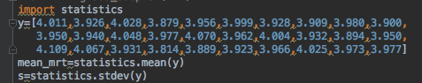

statistics.mean(*data*)

Return the sample arithmetic mean of *data* which can be a sequence or iterator.

The arithmetic mean is the sum of the data divided by the number of data points. It is commonly called “the average”, although it is only one of many different mathematical averages. It is a measure of the central location of the data.

statistics.stdev(*data*, *xbar=None*)

Return the sample standard deviation (the square root of the sample variance). See [variance()](https://docs.python.org/3/library/statistics.html#statistics.variance)for arguments and other details

T=3.9639(the sample arithmetic mean)

S=0.06389557752760522(the sample standard deviation)

There is a probability (1- $α$) that the mean response time that you want to estimate lies in the interval

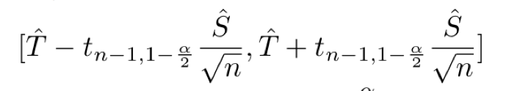

• The sample mean of (n = ) 30 replications =3.964

• The sample standard deviation of 30 replications is 0.0639

• If we want to compute the 95% confidence interval, $α$ = 0.05

• Since we did 30 independent experiments and want 95% confidence interval, we use

t(29,0975).

From the t-distribution table, the value of 2.0452, the 95% confidence interval is

[3.964-2.0452*(0.0639/ $√30$),3.964+2.0452*(0.0639/ $√30$)]=[3.940,3.988]





|  |  |  |  |  |  |  |
| --- | --- | --- | --- | --- | --- | --- |
| ƛ | μ | serves | Setup time | Time end | Tc | Jobs remove |
| 0.35 | 1 | 5 | 5 | 10000 | 11 | 1000 |

There is a 95% probability that the true mean response time that we want to estimate is in the interval [3.940,3.988] under the conditions from the above table.