Course Recommender System in a Liberal Arts Context

Raphaël Morsomme
University College Maastricht
Zwingelput 4
6211 KH Maastricht
(+32496486716)
raphael.morsomme@maastrichtuniversity.nl
Sofia Vazquez Alferez
University College Maastricht
Zwingelput 4
6211 KH Maastricht
(+31625246406)
sofia.vazquezalferez@maastrichtuniversity.nl

ABSTRACT
This paper describes a direct application of topic modelling and sequential rule mining to provide transparent course recommendations to students of the Liberal Arts and Sciences Bachelor from University College Maastricht, based on their academic interests and performance in previous courses. The system is developed to complement academic advising and help students make well informed decisions. We find that course recommendations based on a topic modeling of course descriptions are useful and that sequence mining provides a rough method to control for prerequisites.
Keywords
Education, recommendation system, warning, topic model, grade prediction.

INTRODUCTION
The Bachelor in Liberal Arts offered at the University College Maastricht, the Netherlands, is an honors program characterized by an open curriculum. The program allows students to design their curriculum in a fairly free fashion: more than 75% of the educational credits are free, the college offers more than 150 courses covering a wide range of topics from artificial intelligence, to conflict resolution and to pop songs, and students can take up to one year’s worth of courses at other departments of Maastricht University. This freedom allows students to tailor their curriculum to their own interests, but the large number of courses available makes the selection of courses overwhelming (REF). Firstly, the number of courses offered at the 12 departments of the university is too large for students to have an overview of which ones match their academic interests. Secondly, since each student of the Liberal Arts program has a unique curriculum, it can be difficult for a student to determine if she/he has covered the necessary prerequisites for a particular course or if the course’s level is too advanced given her/his academic background. A system that identifies courses matching a student’s academic interests and warns them if they are not ready yet for a particular course would therefore be extremely beneficial for the student of the liberal arts program. It increased their information position, thereby improving self-advising, and, used as an agenda-setting tool, it also improve academic advising.
Our course recommender system achieves both goals: courses suggestions and warnings. To receive course suggestions, the student enters her/his academic interest. The system returns 10 courses that match the indicated interests and are thus potentially interesting for the student. In practice, the student selects key words that represent her/his academic interests from a predetermined list and the course recommender system uses a topic model fitted with the Latent Dirichlet Allocation algorithm (Blei, 2003) to identify the 10 courses whose content best matches the topics corresponding to the selected key words (see figure X). To receive warnings, students provide their transcript and indicate which courses they are considering for the following term. The system issues a warning for the courses that it identifies as too advanced given the current academic background of the student. In practice, the student enters her/his student ID with which the system accesses her/his past academic performance. From it, the system identifies the skills acquired by the student and, using a lasso-regularized linear regression model fitted to each individual course (Tibshirani, 1996), it estimates the grade that the student will obtain in the selected courses and issues a warning when the predicted grade is a fail (see figure X).
For such data-driven system, opaqueness can be an impediment to an effective use (Castelvecchi, 2016). If the system is opaque, students and academic advisors are more likely to see it as a black box and not take its recommendations seriously. To tackle this issue, we have made the system as transparent as possible: a course suggestion mentions which of the selected key words led to it and a list of potential preparatory coursework is attached to each warning.
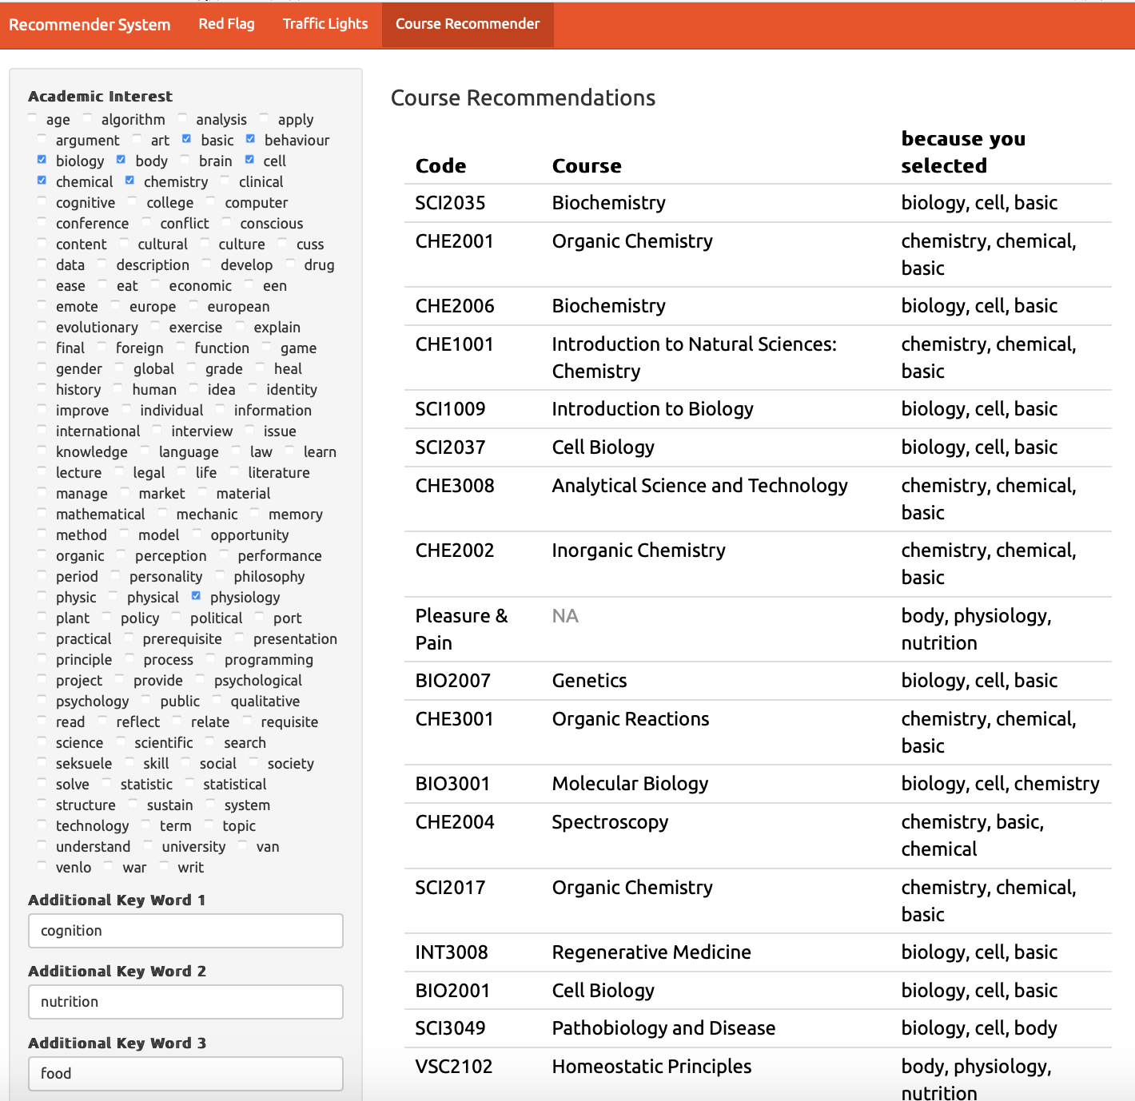
Figure X. Course suggestions in practice (TODO: UPDATE)
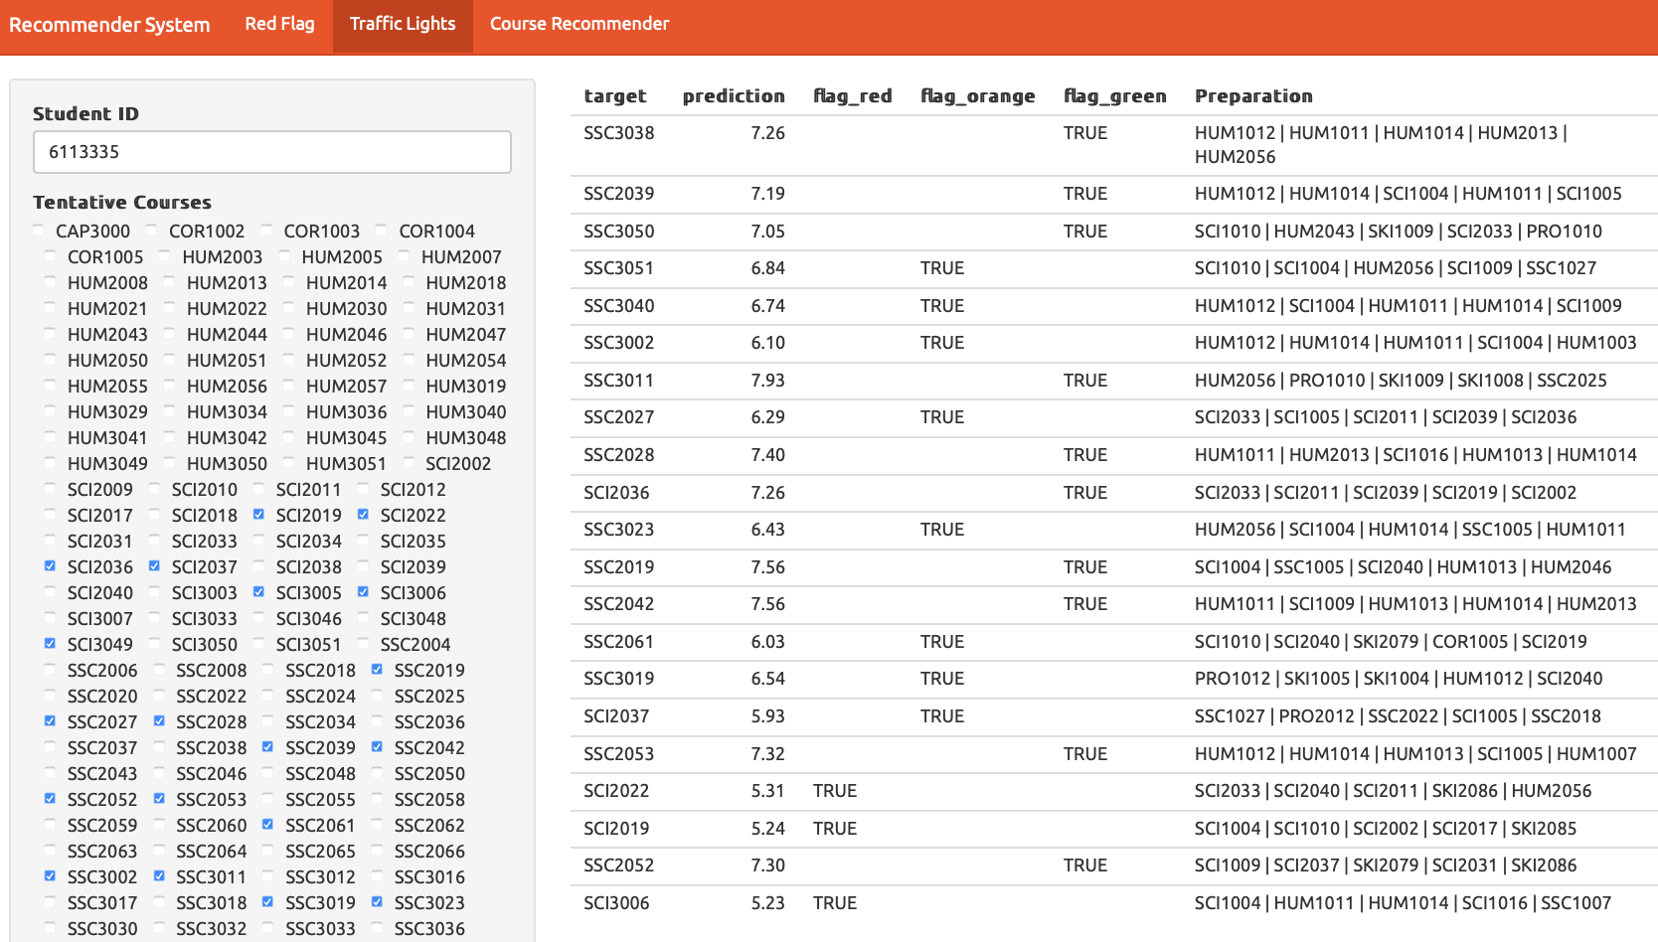
Figure X. Warning in practice (TODO: UPDATE FIGURE)

Literature Review
Identifying courses that are both of interest to the (university) students and of an appropriate level is a task that has recently gained attention in the literature. Gulzar, Leema and Deepak (2018) proposed a recommender system that uses information retrieval techniques to select courses based on student interests. Their system uses key words to search the space of possible courses but tries to improve the quality of the query by finding synonyms and generating N-grams so that the search returns a higher number of courses. Then, an Ontological Model is used to expand the search even further and retrieve courses that are related in the Ontological Model to the previously extracted courses. In this context, an Ontological Model is a knowledge model that represents relationships between concepts of a previously specified domain, such as ‘Computer Science’ (Gulzar, Leema, 2016). The system is considered to be content based because it is the contents of the courses that are matched to the concepts of the ontological model or the key words of the query. In this manner, the recommender system allows the interest of the students to be matched to the contents of the course. However, the system suffers from several drawbacks: first, the domains (e.g. Computer Science or Medicine) from which the ontological models are built must be defined a-priori (Gulzar, Leema, 2016). Second, the recommender system is dependent on a well-built database that is not always available at interested institutions.
Bydžovská (2016), developed a recommender system that takes into account a student’s past performance and interest profile to make course recommendations. Students interests are defined in a narrow sense, that is, a course is considered of interest if a student has taken the course or marked it as a favorite in the university system. Course recommendations based on interest are then made through a collaborative filtering approach: the suggested courses were the most selected courses by other students in the same field of study, or those that were taken by the n-most similar students that had already graduated. To detect risk of failure, Bydžovská (2016) predicted grades of students using classification and regression, or nearest neighbor depending on the course, binned the predicted grades into excellent, good, or bad and then issued warnings accordingly. The main innovation of the system, was that it proceeded to include social behavior and consider courses taught by a favorite teacher or taken by friends of students into the recommendations. Although the system attempts to handle both interest and appropriateness of level for a course, it suffers from a three major disadvantages: firstly, it does not provide the kind of transparent recommendation that would allow students to reflect on their course selection because the content of the course is not explicitly taken into account. Secondly, it does not give students suggestions of how to address their deficiencies. Thirdly, it does allow for a change in student interests, which is particularly important in a liberal arts context where students go through a broad exploratory phase before specializing.
Bakhshinategh, Spanakis et. al, (2017) addressed the issue of recommending courses that helps students overcome their deficiencies whilst accounting for changes over time. They view a study program as a path to obtain graduating attributes (skills, qualities, understandings) and rank the impact that each course has on promoting those graduating attributes for a student who took the course. The ranking is done through self-assessment by students after taking the course. The recommender system then uses collaborative filtering to find courses that score highest on promoting a targeted graduating attribute for a student who wishes to develop it further. Thus, if a student lacks “analytical skills”, the system identifies courses that improve these skills so that a student comes closer to the level of “analytical skills” that is required for graduation. This system can be used to find preparatory courses for other courses by shifting from graduating attributes to attributes required to succeed in a course. The main disadvantage is that the impact of each course is found through self-assessment rather than in a data driven way.
Jang, Pardos and Wei (2019) take a different approach to find preparatory courses by using Recurrent Neural Networks to develop a goal-based course recommender. A student specifies a course that they wish to take, along with the grade they desire to achieve and the system uses their personal course enrollment history and grades to find personalized preparatory courses. Although this approach finds preparatory courses in a data-driven way, it does so at the expense of transparency, which makes a student’s reflective decision making process more difficult and provides no direct insight to academic advising on how to improve the curriculum.

[INSERT LINK TO OUR WORK FITS HERE]
- we extend Bydžovská (2016) ‘s use of student interest by using a topic model.

Data
We use two types of data: student data and course data.
The student data consists of anonymized course enrollment information. We use the transcripts of the 2,526 students of the liberal arts program between 2008 and 2019 with a total of 79,245 course enrollments. We exclude course enrollments with a missing grade, indicating that the student either dropped the course or fail the attendance requirement. In the latter case, an observation corresponding to the resit is present in the data set. Figure X presents the student data. Each row contains an anonymized student ID, a course ID, a year and semester, and the obtained grade.
The course data consists of the 2018-2019 course catalogues of five departments of Maastricht University: European Studies, University College Maastricht, University College Venlo, Psychology and Science Program. These course catalogues contains a one-page description of 490 courses. Figure X presents the textual data in the tidy format with one row per document-term (Wickham, 2014). We follow common data cleaning procedure in text mining (Meyer, Hornik, & Feinerer, 2008): we tokenize the individual terms, stem them with the Hunspell dictionary and remove common stop words, numbers between 1 and 1,000, and terms that occur less than three times in the data set.
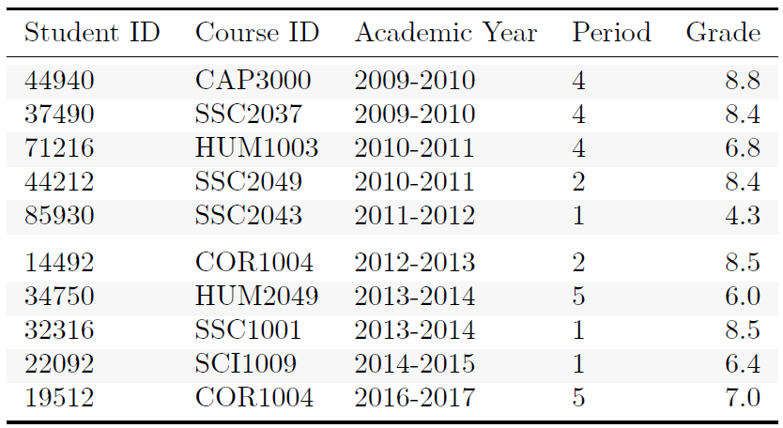
Figure X. Example of student data.
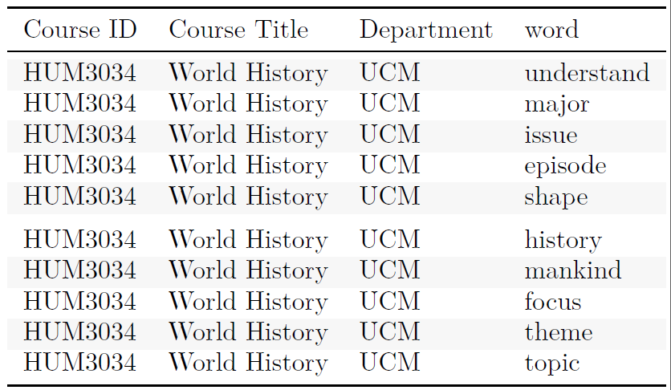
Figure X. Example of course data.

Methodology

Overview
Figure X presents a flowchart of our course recommender system. At the heart the system is a topic model fitted on the course data with the Latent Dirichlet Allocation algorithm. The topic model is used for three purposes. First, we use it together with the student data to estimate the topic expertise of each student, i.e. how much they know about a particular topic. We then fit a predictive model for each course that takes as input the student’s academic performance and topic expertise to estimate her/his grade. The system issues a warning if the student selects a course for which the predictive model predicts a fail grade. Second, we us the topic model to suggest to the student courses whose content match her/his academic interest. The student’s academic interests are estimated through the key words that she/he enters into the app and the courses that she/he has taken. The system returns the 10 courses whose topic distribution (as estimated by the topic model) has the shortest KL distance to the academic interests of the student. Third, we use the topic model together with the predictive models to provide a list of preparatory courses accompanying each warning. The list of preparatory courses consists of the 5 courses whose topic distribution has the shortest KL distance to the coefficient estimates of the topic expertise variables in the the predictive model.
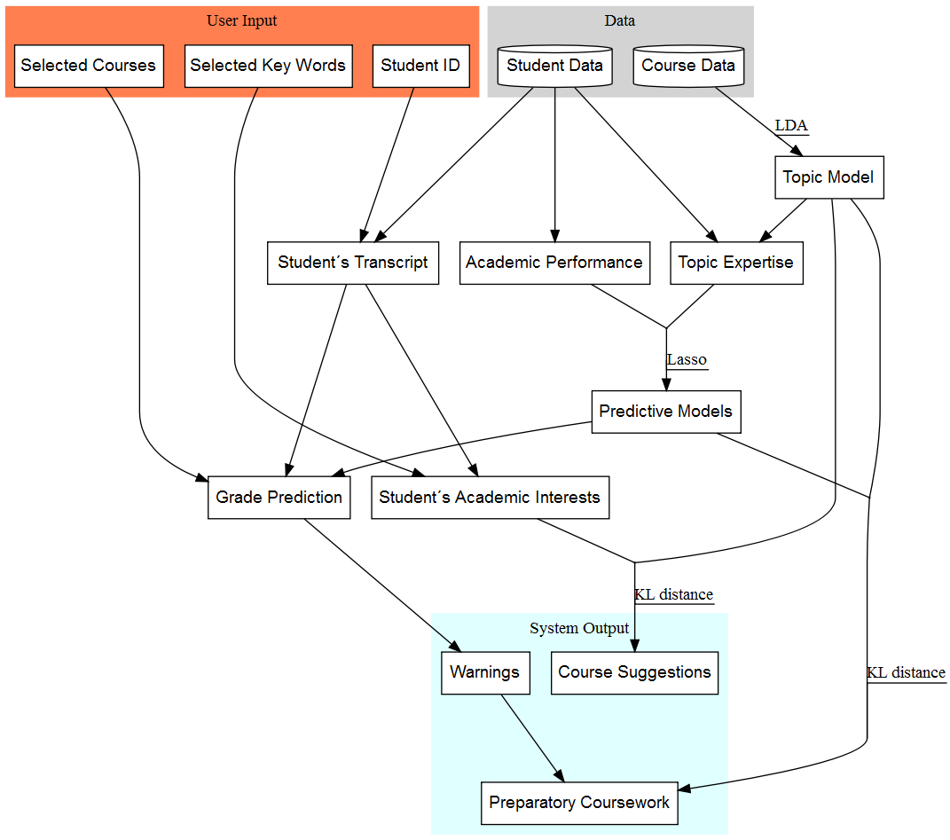
Figure X. Flowchart

Topic Model
a topic is a mixture of terms. a document is a mixture of topics.
a topic can be present in differnet document & a term in differnet topics e.g. XXXX.
Topic model fitted on the course data with the Latent Dirichlet Allocation algorithm. Given a number of topics and a corpus of documents, the algorithm estimates a topic model that consists of a term distribution per topic (figure X) and a topic distribution per course (figure X).
---
model selection: maximum likelihood ~ n topics.

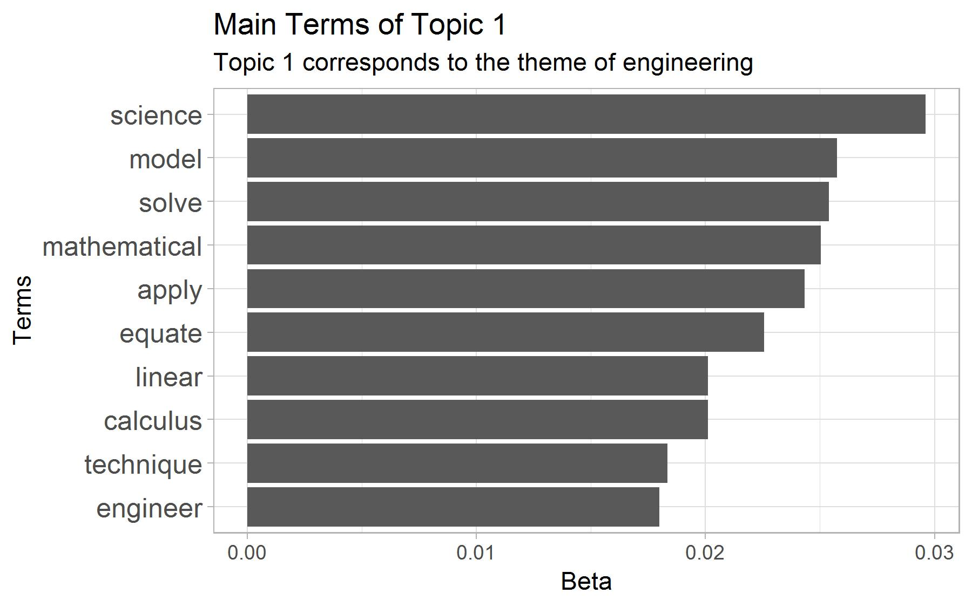
Figure X. Term Distribution in a Topic.

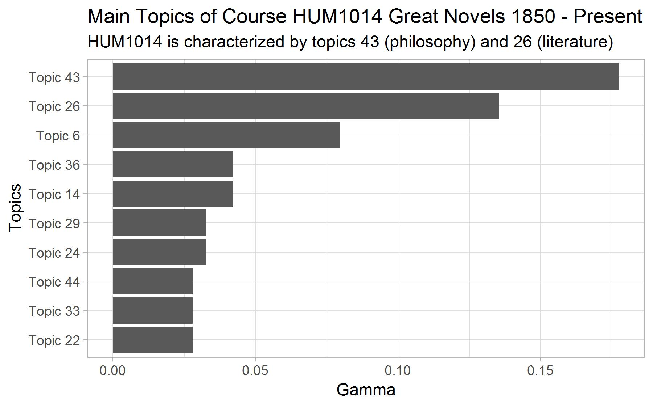
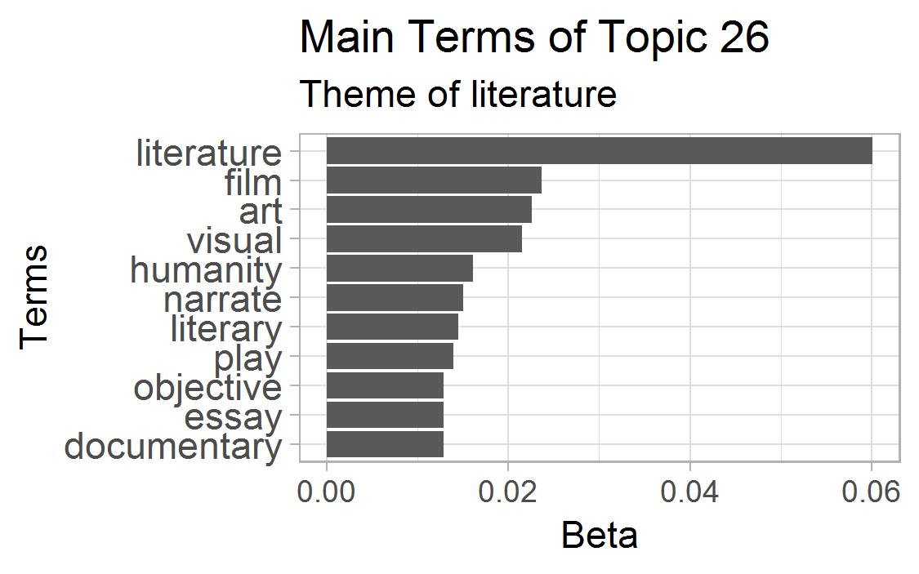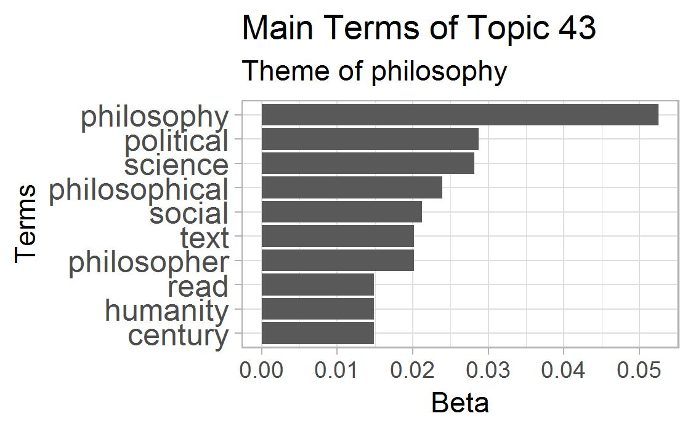
Figure X. Topic Distribution in a Course.

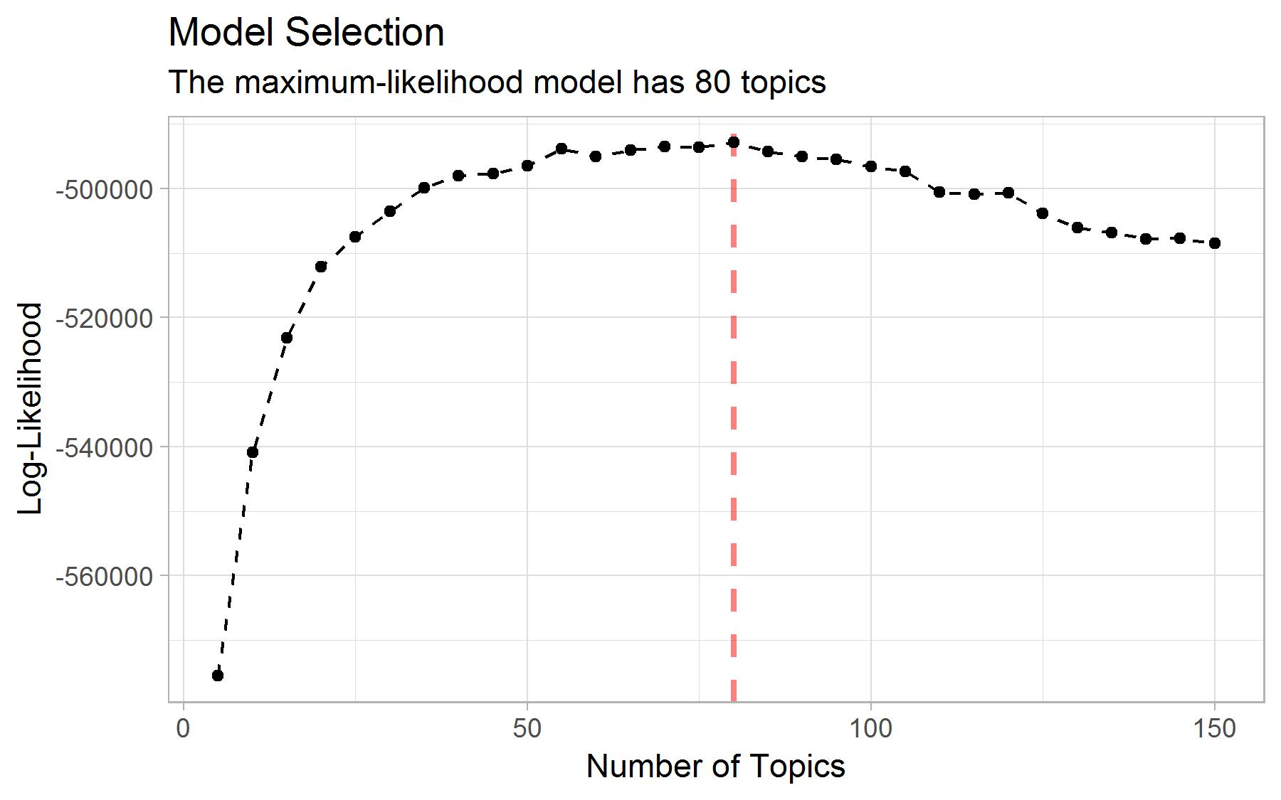
Figure X. Model Selection based on log-likelihood.

Warnings
We fit a predictive model for grade for each of the 132 courses currently offered at the college that have had more than 20 student enrollments since 2008. The model is a lasso-regularized multivariate linear regression model (Tibshirani, 1996). The set of predictors consists of students’ past academic performance and their level of topic expertise at the start of the course. Students’ past academic performance consists of 6 variables corresponding to their general GPA and their concentration-specific GPA. Students’ topic expertise consists of a set of 35 variables (one per topic of the topic model) which indicate how much knowledge of the topic the student has acquired through his curriculum. Topic expertise can be regarded as an approximation of the skills acquired by the student. Concretely, a topic expertise variable corresponds to the sum of the topic’s importance in the courses taken by the student (as estimated by the topic model) weighted by her/his grades. The assumption is that a student who obtains 10/10 in a course has acquired all the topic-related knowledge present in the course while a student who obtains 5/10 has only acquired half of it. Figure X presents a toy example of the contribution of individual courses towards a student’s topic expertise.
Since the number of predictors is large, we regularize the model to avoid overfitting. We use the lasso penalty to shrink the coefficient estimates (Tibshirani, 1996). For each model, we use 10-fold cross-validation to find the lasso tuning parameter λ that minimizes the mean absolute prediction error (Hastie et al., 2009). Figure X presents the distribution of the cross-validation mean absolute prediction error among the 132 prediction models. The model for the course PRO2004 Academic Debate has the smallest prediction error (0.38 grade point) and that for the course SCI3006 Mathematical Modelling the largest (1.74 grade point). The mean cross-validation error weighted by the number of student enrolled in the course is 0.77, the median is 0.77 and the standard deviation is 0.28.

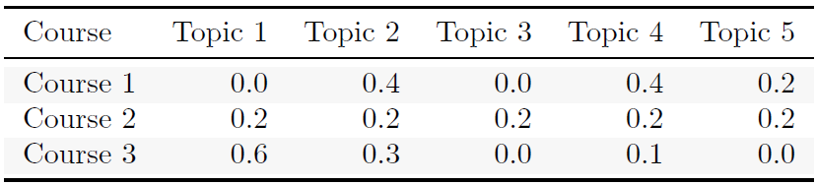
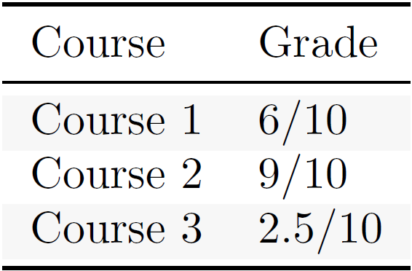
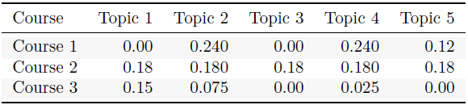
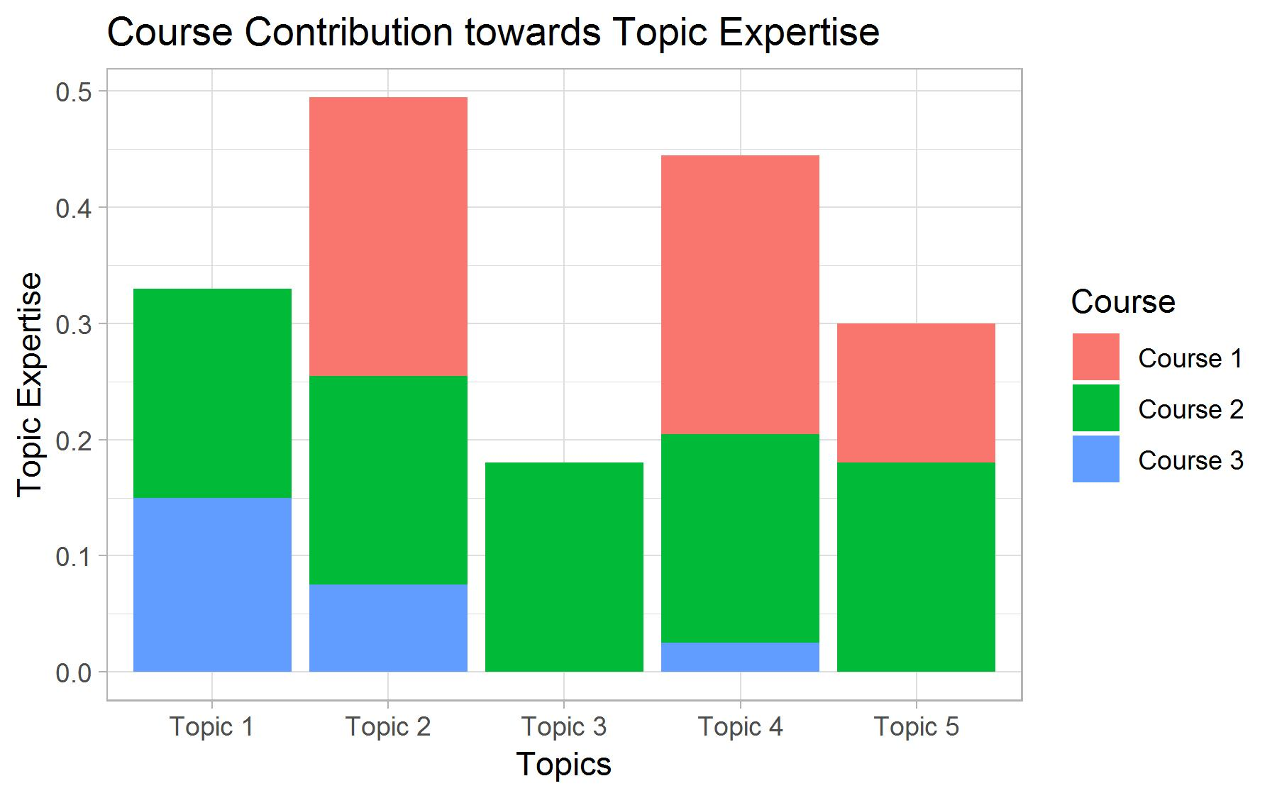
Figure X: Toy example of topic expertise with 3 courses and 5 topics. The upper table presents the distribution of topic per course (gamma coefficients from a topic model). The middle table indicates the grades obtained by a student in these courses. The bottom table and the barplot indicate the contribution of each course to the topic expertise profile of the student after taking these courses. The topic expertise variables are then used as predictor in the predictive model.

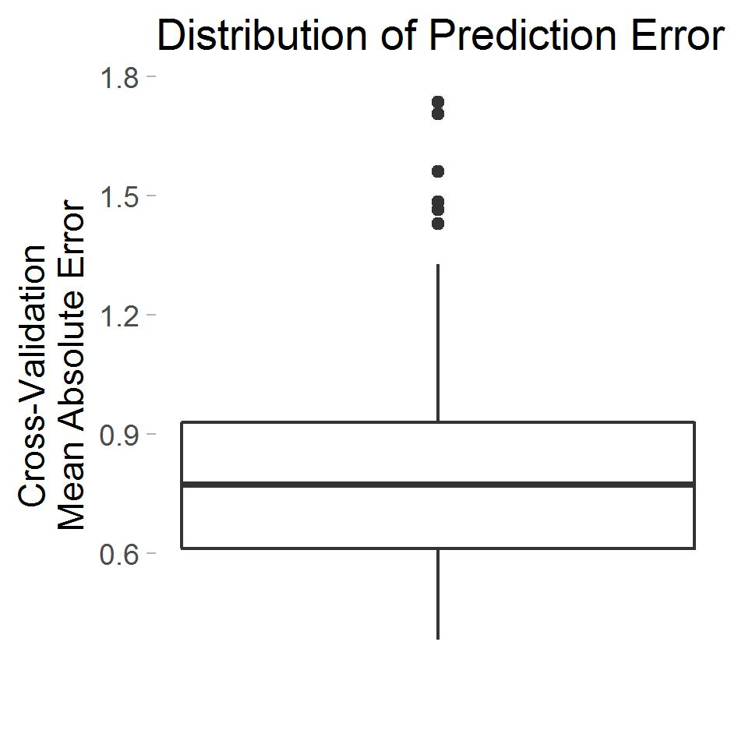
Figure X: Distribution of the cross-validation prediction error among the 148 predictive models.

To receive a warning, the user enters her/his student ID and a list a courses that she/he is considering taking the coming term into the system. The system then uses the student ID to extract the student’s transcript, from which the past academic performance of the student and her/his topic expertise can be established. The predictive models of the selected courses then uses these variables to predict

Rule-based Warnings
We investigated an alternative approach for warnings based on association rules. We used the CSPADE algorithm (REF) to identify sequences in the students transcripts of the type <fail course A> => <fail course B> and <not take course A> => <fail course B> and considered rules with a support superior to 10 students, a confidence superior to 0.4 and a lift superior to 1.1. Warnings were issued when a student indicate that they considered taking a course for which one the selected rules indicates that she/he is likely to fail it.
Although this approach is very transparent, which motivated its initial adoption, it turned out to be unsuitable to our case. First, given the small size of our sample and the fact that relatively few students fail courses at the college, only 21 rules met the criteria. Second, this approach ignores the fact that skills can be acquired in several courses.
To tackle the first issue, we considered a relaxed version of the rules that substitutes a <fail course A> with a <obtain less than 6.5 in course A>. This increased the number of rules meeting the criteria to 185. Yet, the second issue remained and led us to consider a regressive predicting model that uses topic expertise as a proxy for skills that a necessary to perform well in a course.

Preparatory Coursework
In order to be transparent and help student design their curriculum, each warning is accompanied by a list of preparatory course work.
To provide warnings we mine the student data using the CSPADE algorithm. Given a set of sequences, the CSPADE algorithm identifies all subsequences with a support superior to a given threshold. Since we are working with a relatively small number of observations (around 2,526 student, each taking around 40 courses), we restrict the search to two item sequences, i.e. rules with a single antecedent and a single consequent. Each item is a dyad composed of a course and grade (<course, grade>). We also identify sequences whose antecedent is a course that has not been taken (see Figure 3, second red flag). The obtained subsequences can be conceptualized as association rules whose left-hand side is anterior to the right-hand side. We only consider sequences whose right-hand side corresponds to a low performance i.e. a grade of 7 or lower (using a stricter threshold i.e. a failing grade of 5.4 produces rules with extremely low support) and have a count superior to 20 students, a confidence superior to 0.4 and lift superior to 1.1.
To provide red flags, we ask the student to enter the courses s(he) intends to take the following semester. We then, select all rules that have one of the prospective courses as a consequent and check whether the student’s transcript contains any of the <course, grade> dyads that appear as antecedents in the selected rules. If this is the case, we issue a red flag for the course that matches the consequent; otherwise, no warning is given. In order to make the red flags transparent, we provide a numerical summary of the subsequence on which the red flag is based.
We are currently working on an alternative approach to red flags based on the competences acquired by students throughout their curriculum. We are also working on providing a list of courses that a student faced with a red flag could follow as a preparation to the course flagged by the system.

Course Recommendation
To provide Course Recommendations, we identify the courses whose content best match the academic interests of the students. First, we identify the topics covered by a course with the help of a topic model fit on the course data with a Latent Dirichlet Allocation (LDA) algorithm. A topic model allows the probabilistic modeling of term frequency occurrences in documents by providing a probability distributions of topics per document (i.e. per course), and of words per topic. We fit topic models on the most recent course catalogue and on the course manuals. In the future, we hope to be able to fit a topic model on the academic literature of each course to obtain a more detailed representation of course content. We vary three parameters of the algorithm – number of topics, alpha and beta – and select the model with the best log-likelihood (Figure 1). At the time of this writing, we are still evaluating the optimal value of the latter two parameters; yet, the current topic model already gives very good recommendations. In the future, we may also consider two alternative metrics: perplexity and coherence.
Second, we map the key words introduced by the students into the system to the topics identified by the topic model. This way, we establish a topic profile of the student which consists of a numeric vector indicating the importance of each topic for the student. At the moment, student topic profiles are established only via the key words they enter in the system, but we are working on building a more complete profile by allow students to indicate courses and academic literature whose content particularly match their interests. Finally, we rank the courses based on their match with the topic profile of the student and recommend the top n courses.
To make these recommendations transparent, we include the key words that led to a course being recommended.

RESULTS
This is work in progress, yet the results are promising. Course recommendations were particularly satisfactory. The recommended courses follow logically from the selected key words; an opinion that was corroborated by faculty members, academic advisors and current students of the liberal arts program. An example of the outcome can be seen in Figure 2.
Results for red flags were less satisfactory. Given the relatively small number of students, the large number of course and the flexibility of the program, sequences tends to have a low support and to be particularly sensitive to variance. Moreover, in its current form, the system does not permit to over-ride red flags; that is, even if there is ample evidence that a student is able to perform well in a course, if (s)he matches a single sequence, then a red flag is issued. Figure 3 provides an example of red flags.

Future Work
Augment course data: use manuals, then literature
STM
improve suggested preparatory coursework
In the light of these results, we would like to continue improving both pillars of the course recommender system. First, we would like to include course information from the other departments. This way, the system could recommend courses to the students which they had never considered because they ignored they existence and did not know that their content suit their academic interest. We also want to elaborate a more complete topic profile of student by taking into account courses or journal articles that the student found particularly interesting. Second, given the limited success of red flags based only on performance in past courses, we would like take into account the competences that the students acquire during their curriculum. One such approach is to consider the topics that the student has covered in past courses (obtained from a topic model).

ACKNOWLEDGMENTS
Our thanks to the University College Maastricht, the Institute of Data Science, Maastricht University, and the Department of Data Science and Knowledge Engineering, Maastricht University, in particular to Evgueni Smirnov, and Peter Vermeer for supporting this project with their expertise.

REFERENCES
- Bakhshinategh, B., Spanakis, G., Zaïane, O. R., & ElAtia, S. (2017). A Course Recommender System based on Graduating Attributes. In CSEDU (1) (pp. 347-354).
- Blei, D. M., Ng, A. Y., & Jordan, M. I. (2003). Latent dirichlet allocation. Journal of machine Learning research, 3(Jan), 993-1022.
- Bydžovská, H. (2016). A Comparative Analysis of Techniques for Predicting Student Performance. International Educational Data Mining Society.
- Gulzar, Z., Leema, A. A., & Deepak, G. (2018). PCRS: Personalized course recommender system based on hybrid approach. Procedia Computer Science, 125, 518-524.
- Gulzar, Z., & Leema, A. A. (2016). An ontology based approach for exploring knowledge in networking domain. In 2016 International Conference on Inventive Computation Technologies (ICICT) (Vol. 1, pp. 1-6). IEEE.
- Hastie, T., Tibshirani, R., & Friedman, J. (2009). The elements of statistical learning: data mining, inference, and prediction, Springer Series in Statistics.
- Hornik, K., & Grün, B. (2011). topicmodels: An R package for fitting topic models. Journal of Statistical Software, 40(13), 1-30.
- Meyer, D., Hornik, K., & Feinerer, I. (2008). Text mining infrastructure in R. Journal of statistical software, 25(5), 1-54. URL http://www.jstatsoft.org/v25/i05/.
- Tibshirani, R. (1996). Regression shrinkage and selection via the lasso. Journal of the Royal Statistical Society: Series B (Methodological), 58(1), 267-288.
- Wickham, H. (2014). Tidy data. Journal of Statistical Software, 59(10), 1-23. doi:10.18637/jss.v059.i10.

Courses offered at the college are divided into 5 concentrations: humanities, natural sciences, social science, skills and projects

