**MINOR PROJECT**

**System Requirements Specification Report**

**on**

**TITLE: PolyDoc Multi-lingual Document**

**Understanding System.**

**BACHELOR OF COMPUTER APPLICATION (BCA)**



**KLE TECHNOLOGICAL UNIVERSITY**



by

|  |  |
| --- | --- |
| **NAME** | **USN** |
| Darshan Janganure | 01FE23BCA071 |
| Pooja Madiwalar | 01FE23BCA074 |
| Sayeda Iram | 01FE23BCA111 |
| Mohemmed Yaseen | 01FE23BCA118 |

**Under the guidance of**

Prof.Shivayogi V Hublikar





**KLE TECHNOLOGICAL UNIVERSITY**

**Earlier Known as**

B. V. Bhoomaraddi College of Engineering

**Vidyanagar Hubballi-580031**

**2025-2026**

Table of Contents

1. Introduction 3

1.1 Purpose 3

1.2 Scope 3

1.3 Definitions, Acronyms, Abbreviations 4

1.4 References 4

1.5 Overview 5

2. Overall Description 5

2.1 Product Perspective 5

2.2 Product Functions 6

2.3 User Characteristics 6

2.4 Constraints 7

2.5 Assumptions and Dependencies 7

3 Specific Requirements 8

3.1 Functional Requirements 8

3.2 Non-Functional Requirements 11

3.3 External Interface Requirements 13

3.3.1 User Interfaces 13

3.3.2 Hardware Interfaces 14

3.3.3 Software Interfaces 14

3.3.4 Communication Interfaces 15

4 System Models 16

4.1 Use Case Diagrams 17

4.2 Data Flow Diagrams (DFD) 17

4.3 Entity-Relationship Diagrams (ERD) 20

5 Other Requirements 21

5.1 Safety Requirements 21

5.2 Legal/Regulatory Compliance 22

5.3 Backup & Recovery 23

5.4 Audit and Logging 24

# Introduction

## Purpose

The purpose of this Software Requirements Specification (SRS) is to define the functional and non-functional requirements for **PolyDoc**, a multi-lingual document understanding and system. This system is being developed to address the growing need for intelligent document processing that can handle multiple languages (particularly Indian languages like Hindi and Kannada), extract meaningful information from various document formats, and provide AI-powered analysis capabilities.

## Scope

**PolyDoc** is a comprehensive document processing system that provides the following capabilities:

**What the system will do:**

* + - Process multi-format documents (PDF, DOCX, TXT, Images)
    - Extract text using advanced OCR technology with multi-language support
    - Preserve original document layouts during processing
    - Provide AI-powered document summarization
    - Enable real-time chat interface with documents
    - Implement vector-based semantic search
    - Support Hindi, Kannada, and English language processing
    - Offer document management capabilities (upload, view, delete)

**System Benefits:**

* + - Reduces manual document processing time by 80%
    - Supports underrepresented languages (Hindi, Kannada)
    - Preserves document formatting and layout integrity
    - Provides intelligent document insights through AI
    - Enables efficient document search and retrieval
    - Offers free and open-source AI model integration

**Goals:**

* + - Create an accessible multi-lingual document processing platform
    - Demonstrate advanced NLP capabilities for Indian languages
    - Provide a user-friendly web interface for document interaction

## Definitions, Acronyms, Abbreviations

|  |  |
| --- | --- |
| Term | Definition |
| API | Application Programming Interface |
| AI | Artificial Intelligence |
| DFD | Data Flow Diagram |
| ERD | Entity-Relationship Diagram |
| FastAPI | Modern Python web framework for building APIs |
| GenAI | Generative Artificial Intelligence |
| GPU | Graphics Processing Unit |
| ML | Machine Learning |
| MongoDB | NoSQL document database |
| NLP | Natural Language Processing |
| OCR | Optical Character Recognition |
| PDF | Portable Document Format |
| PolyDoc | Multi-lingual Document Understanding System |
| REST | Representational State Transfer |
| SRS | Software Requirements Specification |
| UI | User Interface |
| UML | Unified Modelling Language |
| Vector DB | Vector Database for semantic search |

## References

* + - **IEEE Standard 830-1998** – IEEE Recommended Practice for Software Requirements Specifications
    - **FastAPI Documentation** – <https://fastapi.tiangolo.com/>
    - **MongoDB Documentation** – <https://docs.mongodb.com/>
    - **Transformers Library** – Hugging Face Transformers Documentation
    - **OCR Research Papers** – Multi-lingual OCR techniques and implementations
    - **React Documentation** – <https://reactjs.org/docs/>
    - **Vite Build Tool** – <https://vitejs.dev/guide/>
    - **Python 3.9+ Documentation** – <https://docs.python.org/3/>

## Overview

This SRS document is organized into five main sections:

* **Section 1 (Introduction)** provides the purpose, scope, definitions, and overview of the document.
* **Section 2 (Overall Description)** describes the product perspective, functions, user characteristics, constraints, and dependencies.
* **Section 3 (Specific Requirements)** details functional and non-functional requirements with interface specifications.
* **Section 4 (System Models)** presents UML diagrams including use cases, data flow, and entity-relationship diagrams.
* **Section 5 (Other Requirements)** covers safety, legal compliance, backup, and audit requirements.

# Overall Description

## Product Perspective

**PolyDoc** is designed as a standalone web-based application with clearly defined system relationships, dependencies, and boundaries.

**Relation to Existing Systems:** PolyDoc operates as an independent system, functioning as a self-contained document processing platform. It is accessible through standard web browsers without the need for additional plugins and integrates with the host operating system’s file system to enable document upload and download. For data storage, PolyDoc connects with MongoDB to manage documents and associated metadata.

**System Dependencies:** The frontend of the system is built using React with Vite, while the backend relies on the Python FastAPI framework to provide REST API services. Document storage and user data are maintained in MongoDB. For natural language processing tasks, PolyDoc utilizes Hugging Face Transformers. Multi-language OCR engines support text extraction from diverse documents, and a vector database is employed to enable semantic search and document similarity comparisons.

**System Boundaries:** Input is provided in the form of various document formats through the web interface, while output includes processed text, summaries, chat responses, and search results. The system interacts externally with file systems and web browsers, and internally it performs document processing using AI and ML models

## Product Functions

**Major System Functions**

**Document Upload and Processing** support multiple file formats including PDF, DOCX, TXT, and images. It provides multi-language OCR capabilities with support for Hindi and Kannada, ensures layout preservation during text extraction, and includes automatic language detection.

**AI-Powered Document Analysis** enables intelligent document summarization, key information extraction, content categorization, and semantic understanding of documents.

**Interactive Document Chat** offers a real-time question-answering interface with context-aware responses based on document content. It supports multi-turn conversations and generates language-specific responses.

**Vector-Based Search** provides semantic document search, content similarity matching, advanced query processing, and multilingual search capabilities.

**Document Management** ensures secure document storage, file organization and categorization, document metadata management, and version control with history tracking.

**User Interface** features a responsive web interface, an intuitive document upload workflow, real-time processing status updates.

## User Characteristics

**Primary User Types**

**Academic Researchers** typically include graduate students, professors, and research scholars with intermediate to advanced computer literacy. Their usage pattern involves processing research papers, theses, and other academic documents. They often require multi-lingual document analysis in English, Hindi, and Kannada.

**Business Professionals** include corporate employees, consultants, and analysts with basic to intermediate computer literacy. They primarily use the system for processing business documents, reports, and presentations. Their language needs are mainly English, with occasional support for regional languages.

**Students** consist of undergraduate and graduate learners with basic to intermediate computer literacy. They use the system for study materials, assignment processing, and research support. Their requirements often involve multi-lingual educational content processing.

**Government Officials** include public sector employees and administrators with basic computer literacy. Their primary usage pattern is the processing of official documents and multilingual form analysis.

## Constraints

**Technical Constraints**

**Performance Constraints** specify that the system requires a minimum of 8GB RAM for AI model execution and at least 10GB of free disk space for model caching. GPU acceleration is preferred but not mandatory. Each document processed must not exceed a maximum file size of 10MB.

**Platform Constraints** define that the application is web-based and requires support from modern browsers. The backend runs on Python 3.9+ while the frontend build process depends on Node.js 18+. Windows 10/11 is the primary target operating system for compatibility.

**Resource Constraints** include an AI model loading time of 2 to 5 minutes during the first startup, with memory usage reaching up to 4GB during heavy processing. Network bandwidth is required for the initial download of AI models, which ranges from 2 to 3GB.

**Budget Constraints** emphasize development using free and open-source technologies, avoiding licensing fees for core AI models. Cloud deployment costs may apply if hosting is used, while minimal hardware requirements are expected for deployment.

**Regulatory Constraints** require compliance with data privacy and document content security standards. The system must also ensure open-source license compatibility and avoid any commercial restrictions on AI model usage.

## Assumptions and Dependencies

**Assumptions**

The **user environment** assumes that users have access to modern web browsers such as Chrome, Firefox, Safari, or Edge, along with a stable internet connection for the initial setup and model downloads. It is also assumed that users possess basic computer literacy, sufficient for file upload and navigation.

The **technical environment** assumes that the host system meets the minimum hardware requirements, while the Python and Node.js ecosystems remain stable. Additionally, it is expected that the MongoDB database will be consistently available and reliable.

The **business environment** assumes the continued availability of open-source AI models and user acceptance of the processing time required for AI operations. It is also based on the expectation of a growing demand for multi-lingual document processing.

**Dependencies**

The system has several external dependencies. **External libraries and frameworks** include the Hugging Face Transformers library for AI models, the FastAPI framework for backend services, React and Vite for frontend development, and the MongoDB database system.

**AI model dependencies** involve the availability of pre-trained language models for Hindi and Kannada, reliable OCR models for accurate text extraction, sentence transformer models for vector embeddings, and summarization models that deliver consistent performance.

**System dependencies** include the operating system’s file handling capabilities, a reliable web server deployment environment, strong database connectivity and performance, and stable network access for external model downloads.

# Specific Requirements

## Functional Requirements

|  |  |  |
| --- | --- | --- |
| FR ID |  | Requirement Description |
| FR1: Document Upload and Validation | | |
| FR1.1 |  | The system SHALL accept document uploads in PDF, DOCX, TXT, and common image formats (PNG, JPG) |
| FR1.2 |  | The system SHALL validate file size limits (maximum 10MB per document) |
| FR1.3 |  | The system SHALL verify file format integrity before processing |
| FR1.4 |  | The system SHALL provide real-time upload progress indicators |
| FR1.5 |  | The system SHALL generate unique identifiers for each uploaded document |
| FR2: Multi-lanuage OCR Processing | | |
| FR2.1 |  | The system SHALL extract text from image-based documents using OCR |
| FR2.2 |  | The system SHALL support Hindi, Kannada, and English text recognition |
| FR2.3 |  | The system SHALL preserve original document layout during text extraction |
| FR2.4 |  | The system SHALL automatically detect document language |
| FR2.5 |  | The system SHALL maintain text formatting and structure information |
| FR3: AI-Powered Document Analysis | | |
| FR3.1 |  | The system SHALL generate intelligent summaries of processed documents |
| FR3.2 |  | The system SHALL extract key information and topics from document content |
| FR3.3 |  | The system SHALL provide content categorization based on document type |
| FR3.4 |  | The system SHALL support multi-language summarization capabilities |
| FR3.5 |  | The system SHALL maintain summary quality metrics and confidence scores |
| FR4: Interactive Chat Interface | | |
| FR4.1 |  | The system SHALL provide a chat interface for document-based question answering |
| FR4.2 |  | The system SHALL maintain conversation context across multiple queries |
| FR4.3 |  | The system SHALL generate responses based on document content |
| FR4.4 |  | The system SHALL support multi-language query processing |
| FR4.5 |  | The system SHALL provide source attribution for chat responses |
| FR6: Document Management | | |
| FR6.1 |  | The system SHALL store processed documents with metadata |
| FR6.2 |  | The system SHALL provide document listing with filtering capabilities |
| FR6.3 |  | The system SHALL support document deletion and archival |
| FR6.4 |  | The system SHALL maintain document access history and statistics |
| FR6.5 |  | The system SHALL provide document export capabilities |
| FR7: User Session Management | | |
| FR7.1 |  | The system SHALL maintain user session state across browser refreshes |
| FR7.2 |  | The system SHALL provide session timeout management |
| FR7.3 |  | The system SHALL support concurrent user sessions |
| FR7.4 |  | The system SHALL maintain user preferences and settings |
| FR7.5 |  | The system SHALL provide session activity logging |
| FR8: System Configuration | | |
| FR8.1 |  | The system SHALL provide configurable processing parameters |
| FR8.2 |  | The system SHALL support AI model switching and updates |
| FR8.3 |  | The system SHALL provide system health monitoring capabilities |
| FR8.4 |  | The system SHALL support backup and restore operations |
| FR8.5 |  | The system SHALL provide system performance metrics |

## Non-Functional Requirements

|  |  |
| --- | --- |
| NFR ID | Requirement Description |
| NFR1: Performance Requirements | |
| NFR1.1 | Document upload response time SHALL be less than 30 seconds for files up to 10MB |
| NFR1.2 | OCR processing time SHALL not exceed 2 minutes per document |
| NFR1.3 | AI model loading time SHALL be less than 5 minutes on system startup |
| NFR1.4 | Chat response time SHALL be less than 15 seconds for typical queries |
| NFR1.5 | Search query response time SHALL be less than 5 seconds |
| NFR1.6 | System SHALL support concurrent processing of up to 10 documents |
| NFR2: Reliability Requirements | |
| NFR2.1 | System uptime SHALL be 99% during operational hours |
| NFR2.2 | Document processing success rate SHALL be 95% or higher |
| NFR2.3 | System SHALL gracefully handle processing failures with error recovery |
| NFR2.4 | Data integrity SHALL be maintained across system restarts |
| NFR2.5 | System SHALL provide automatic backup mechanisms |
| NFR2.6 | Critical errors SHALL be logged with appropriate detail for debugging |
| NFR3: Usability Requirements | |
| NFR3.1 | User interface SHALL be intuitive requiring minimal training |
| NFR3.2 | System SHALL provide clear error messages and user guidance |
| NFR3.3 | Interface SHALL be responsive across desktop and tablet devices |
| NFR3.4 | System SHALL support accessibility standards (WCAG 2.1 Level AA) |
| NFR3.5 | Processing status SHALL be clearly communicated to users |
| NFR3.6 | Help documentation SHALL be integrated within the application |
| NFR4: Security Requirements | |
| NFR4.1 | Uploaded documents SHALL be stored securely with access controls |
| NFR4.2 | System SHALL prevent unauthorized access to user documents |
| NFR4.3 | Data transmission SHALL use secure communication protocols (HTTPS) |
| NFR4.4 | User sessions SHALL implement proper authentication and authorization |
| NFR4.5 | Sensitive data SHALL be encrypted at rest and in transit |
| NFR4.6 | System SHALL implement input validation to prevent malicious uploads |
| NFR5: Scalability Requirements | |
| NFR5.1 | System architecture SHALL support horizontal scaling |
| NFR5.2 | Database design SHALL accommodate growing document volumes |
| NFR5.3 | AI model management SHALL support model updates without system downtime |
| NFR5.4 | System SHALL handle increased user load through load balancing |
| NFR5.5 | Storage capacity SHALL be expandable without data migration |
| NFR5.6 | Processing queue SHALL manage multiple concurrent document requests |
| NFR6: Compatibility Requirements | |
| NFR6.1 | System SHALL be compatible with major web browsers (Chrome, Firefox, Safari, Edge) |
| NFR6.2 | Backend SHALL run on Windows, Linux, and macOS environments |
| NFR6.3 | System SHALL maintain backward compatibility with older document formats |
| NFR6.4 | API SHALL follow REST principles for third-party integration |
| NFR6.5 | System SHALL support standard document encoding formats |
| NFR6.6 | Database schema SHALL be version-controlled for future updates |

## External Interface Requirements

### User Interfaces

|  |  |
| --- | --- |
| UI ID | Requirement Description |
| UI1: Main Dashboard Interface | |
| UI1.1 | Clean, modern web interface with responsive design |
| UI1.2 | Navigation menu with clear sections: Upload, Documents, Chat. |
| UI1.3 | Real-time system status indicators and processing queues |
| UI1.4 | Multi-language interface support (English, Hindi, Kannada) |
| UI2: Document Upload Interface | |
| UI2.1 | Drag-and-drop file upload area with progress indicators |
| UI2.2 | File format validation with clear error messaging |
| UI2.3 | Upload queue management with batch processing capabilities |
| UI2.4 | Preview functionality for supported document types |
| UI3: Document Processing Interface | |
| UI3.1 | Real-time processing status with detailed progress information |
| UI3.2 | Processing results display with extracted text preview |
| UI3.3 | Document metadata display (language, size, processing time) |
| UI3.4 | Options for reprocessing or downloading results |
| UI4: Chat Interface | |
| UI4.1 | Conversational chat interface with message history |
| UI4.2 | Document context selector for targeted queries |
| UI4.3 | Response formatting with source attribution |
| UI4.4 | Multi-language input and response support |

### Hardware Interfaces

|  |  |
| --- | --- |
| HW ID | Requirement Description |
| HW1: Server Hardware Interface | |
| HW1.1 | Minimum 8GB RAM for AI model execution |
| HW1.2 | 10GB+ storage for model caching and document storage |
| HW1.3 | Multi-core CPU support for concurrent processing |
| HW1.4 | Optional GPU acceleration for enhanced AI performance |
| HW2: Client Hardware Interface | |
| HW2.1 | Standard web browser with JavaScript support |
| HW2.2 | Minimum 2GB RAM for smooth browser operation |
| HW2.3 | Stable internet connection for file uploads and API communication |
| HW2.4 | Display resolution support from mobile to desktop sizes |

### Software Interfaces

|  |  |
| --- | --- |
| SW ID | Requirement Description |
| SW1: Database Interface (MongoDB) | |
| SW1.1 | Document storage with GridFS for large file handling |
| SW1.2 | Metadata indexing for efficient search and retrieval |
| SW1.3 | User session and preference storage |
| SW1.4 | System configuration and settings management |
| SW2: AI Model Interface | |
| SW2.1 | HuggingFace Transformers library integration |
| SW2.2 | Model loading and caching mechanisms |
| SW2.3 | GPU/CPU computation backend switching |
| SW2.4 | Model versioning and update management |
| SW3: OCR Engine Interface | |
| SW3.1 | Multi-language OCR service integration |
| SW3.2 | Image preprocessing and enhancement |
| SW3.3 | Text extraction with layout preservation |
| SW3.4 | Confidence scoring and quality metrics |
| SW4: File System Interface | |
| SW4.1 | Temporary file storage for processing pipeline |
| SW4.2 | Secure document archival and retrieval |
| SW4.3 | Log file management and rotation |
| SW4.4 | Configuration file reading and validation |

### Communication Interfaces

|  |  |
| --- | --- |
| COM ID | Requirement Description |
| COM1: REST API Interface | |
| COM1.1 | RESTful API endpoints following OpenAI 3.0 specification |
| COM1.2 | JSON-based request/response format |
| COM1.3 | HTTP status codes for proper error handling |
| COM1.4 | API versioning for backward compatibility |
| COM2: WebSocket Interface | |
| COM2.1 | Real-time status updates during document processing |
| COM2.2 | Live chat functionality with immediate response delivery |
| COM2.3 | Processing progress notifications |
| COM2.4 | System health and status broadcasting |
| COM3: File Transfer Interface | |
| COM3.1 | Secure file upload with multipart/form-data encoding |
| COM3.2 | File download with proper MIME type handling |
| COM3.3 | Resume capability for large file transfers |
| COM3.4 | Upload progress tracking and cancellation support |

# System Models

## Use Case Diagrams

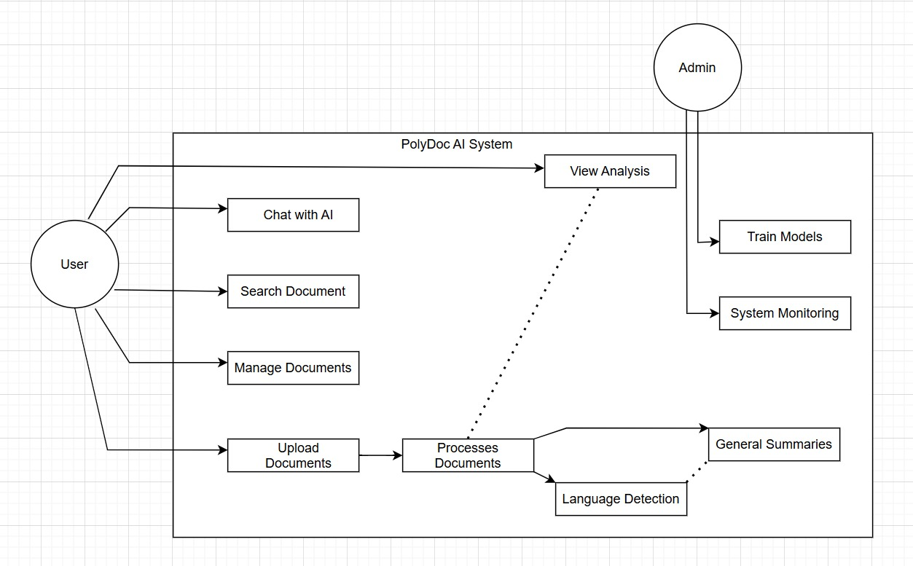

USE CASE DIAGRAM

## Data Flow Diagrams (DFD)

**Level 0 DFD (Context Diagram)**

DFD-ZERO-LEVEL

**Level 1 DFD (System Decomposition)**

DFD-LEVEL-ONE

## Entity-Relationship Diagrams (ERD)

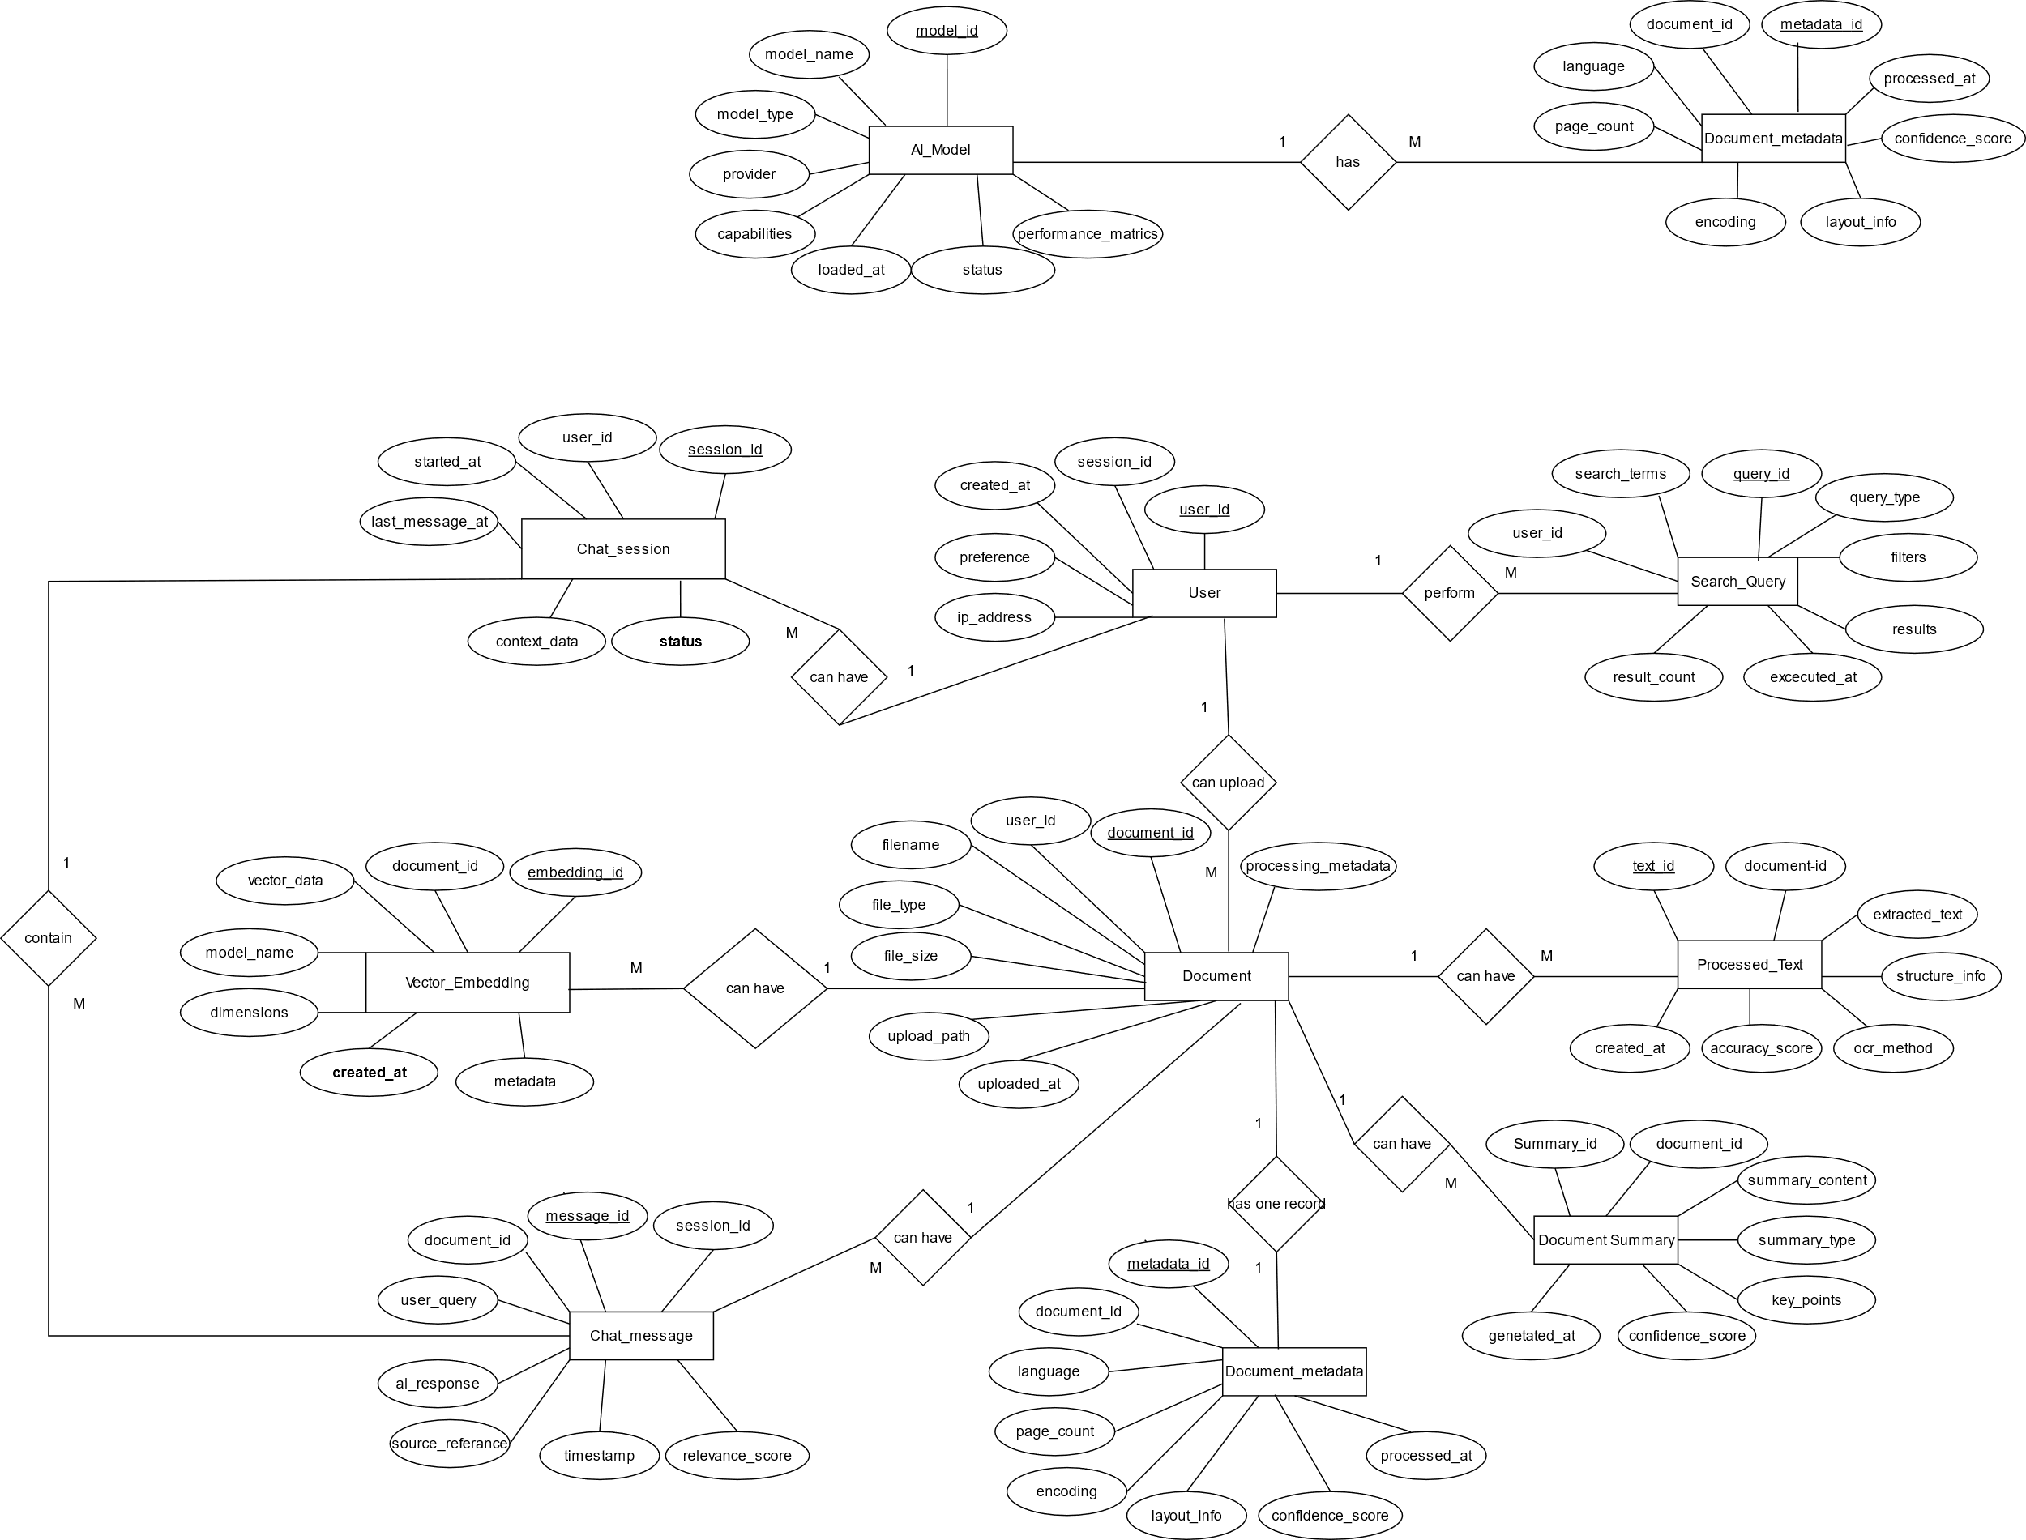

# Other Requirements

## 5.1 Safety Requirements

|  |  |
| --- | --- |
| SR ID | Requirement Description |
| SR1: Data Safety | |
| SR1.1 | The system SHALL implement automatic data backup mechanisms to prevent document loss |
| SR1.2 | The system SHALL provide data validation to ensure document integrity during processing |
| SR1.3 | The system SHALL implement graceful error handling to prevent system crashes during document processing |
| SR1.4 | The system SHALL provide rollback mechanisms for failed processing operations |
| SR1.5 | The system SHALL isolate user documents to prevent cross-user data contamination |
| SR2: System Safety | |
| SR2.1 | The system SHALL implement resource monitoring to prevent system overload |
| SR2.2 | The system SHALL provide circuit breakers for external service dependencies |
| SR2.3 | The system SHALL implement proper exception handling for AI model failures |
| SR2.4 | The system SHALL provide system health checks and automatic recovery mechanisms |
| SR2.5 | The system SHALL implement safe shutdown procedures for maintenance operations |
| SR3: User Safety | |
| SR3.1 | The system SHALL validate all user inputs to prevent malicious content processing |
| SR3.2 | The system SHALL implement rate limiting to prevent system abuse |
| SR3.3 | The system SHALL provide clear warnings for potentially sensitive document content |
| SR3.4 | The system SHALL implement secure file handling to prevent malware execution |
| SR3.5 | The system SHALL provide user data anonymization options |

## Legal/Regulatory Compliance

|  |  |
| --- | --- |
| LR ID | Requirement Description |
| LR1: Data Protection Compliance | |
| LR1.1 | The system SHALL comply with applicable data protection regulations (GDPR, CCPA) |
| LR1.2 | The system SHALL provide user consent mechanisms for data processing |
| LR1.3 | The system SHALL implement data retention policies with automatic deletion |
| LR1.4 | The system SHALL provide user rights implementation (access, rectification, erasure) |
| LR1.5 | The system SHALL maintain data processing audit trails |
| LR2: Intellectual Property Compliance | |
| LR2.1 | The system SHALL respect copyright limitations on processed documents |
| LR2.2 | The system SHALL provide proper attribution for AI model usage |
| LR2.3 | The system SHALL comply with open-source license requirements |
| LR2.4 | The system SHALL implement content filtering for copyrighted material |
| LR2.5 | The system SHALL provide legal disclaimers for AI-generated content |
| LR3: Accessibility Compliance | |
| LR3.1 | The system SHALL comply with Web Content Accessibility Guidelines (WCAG 2.1) |
| LR3.2 | The system SHALL provide alternative text for visual elements |
| LR3.3 | The system SHALL support keyboard navigation for all functions |
| LR3.4 | The system SHALL provide screen reader compatibility |
| LR3.5 | The system SHALL implement proper colour contrast and font sizing options |

## Backup & Recovery

|  |  |
| --- | --- |
| BR ID | Requirement Description |
| BR1: Data Backup Requirements | |
| BR1.1 | The system SHALL perform automated daily backups of all user documents and metadata |
| BR1.2 | The system SHALL maintain multiple backup versions with configurable retention periods |
| BR1.3 | The system SHALL implement incremental backup strategies to optimize storage usage |
| BR1.4 | The system SHALL provide backup integrity verification mechanisms |
| BR1.5 | The system SHALL support both local and cloud backup storage options |
| BR2: System Recovery Requirements | |
| BR2.1 | The system SHALL provide point-in-time recovery capabilities for data restoration |
| BR2.2 | The system SHALL implement disaster recovery procedures with documented RTO/RPO targets |
| BR2.3 | The system SHALL provide system configuration backup and restoration |
| BR2.4 | The system SHALL support partial recovery for individual user documents |
| BR2.5 | The system SHALL maintain recovery testing procedures and documentation |
| BR3: Business Continuity | |
| BR3.1 | The system SHALL provide high availability architecture with minimal downtime |
| BR3.2 | The system SHALL implement failover mechanisms for critical system components |
| BR3.3 | The system SHALL provide data synchronization across backup systems |
| BR3.4 | The system SHALL maintain service degradation procedures during partial failures |
| BR3.5 | The system SHALL provide communication protocols for system outage notifications |

## Audit and Logging

|  |  |
| --- | --- |
| AL ID | Requirement Description |
| AL1: System Audit Requirements | |
| AL1.1 | The system SHALL maintain comprehensive audit logs for all user actions |
| AL1.2 | The system SHALL log all document processing activities with timestamps and user identification |
| AL1.3 | The system SHALL implement tamper-proof logging mechanisms |
| AL1.4 | The system SHALL provide audit trail search and filtering capabilities |
| AL1.5 | The system SHALL maintain audit log retention policies compliant with regulations |
| AL2: Security Logging | |
| AL2.1 | The system SHALL log all authentication attempts and failures |
| AL2.2 | The system SHALL monitor and log suspicious user activities |
| AL2.3 | The system SHALL implement real-time security event alerting |
| AL2.4 | The system SHALL log system configuration changes and administrative actions |
| AL2.5 | The system SHALL provide security incident response logging capabilities |
| AL3: Performance and System Monitoring | |
| AL3.1 | The system SHALL log system performance metrics including response times and resource usage |
| AL3.2 | The system SHALL monitor AI model performance and accuracy metrics |
| AL3.3 | The system SHALL implement application error logging with detailed stack traces |
| AL3.4 | The system SHALL provide system capacity monitoring and alerting |
| AL3.5 | The system SHALL maintain operational dashboards for system health monitoring |
| AL4: Compliance Logging | |
| AL4.1 | The system SHALL maintain data access logs for compliance reporting |
| AL4.2 | The system SHALL log data processing activities for regulatory audit purposes |
| AL4.3 | The system SHALL implement log export capabilities in standard formats |
| AL4.4 | The system SHALL provide automated compliance reporting features |
| AL4.5 | The system SHALL maintain log archival procedures for long-term storage |