**Introduction to TreeAge**

Wednesday, September 14, 2022

Beate Sander

# Decision Analytic Software

TreeAge Pro Healthcare 2021(Full Functionality Student Research or Academic License)

Manual: <http://files.treeage.com/treeagepro/21.1.0/20210111/TP2021.1.0-HC-Manual.pdf>

# Installing TreeAge

Instructions should be in your software documentation.

# Getting Started - Basic Commands

Read manual, Chapters 2 and 6.

## Short overview of important commands and tree programming

(some may differ between Mac and PC)

***Adding branches*** - double click on any node (with no branches attached) - two branches with attached nodes will appear

***Node Names -*** enter in rectangle ABOVE branch

***Probabilities*** ***(or expressions) -*** enter in rectangle BELOW branch.

***Changing node types*** (among decision, chance, terminal, boolean, markov nodes) - right mouse button, then “change type; or hit CONTROL T; or select “Change Node Type” button in menu bar.

***Tree navigation*** (moving down the branches etc.) - simplest way is to use arrow keys or “Tree Explorer” Menu on the left.

***Assigning values to terminal nodes*** (PAYOFFS, in TreeAge speak) - change a node to a terminal node, the “PAYOFF” screen will pop up, enter the value for the outcome in PAYOFF #1 (there are 9 possible payoffs)

(Default setting for CEA: payoff 1 – cost, payoff 2 – effectiveness)

***Expanding or contracting the tree -*** options under Subtree menu; CONTROL J AND CONTROL/SHIFT J are quick ways to expand/compress the tree so that more or less of the tree is visible; zoom options are available in the menu on the right.

***Calculating the expected value*** (folding back or rolling back the tree) -

CONROL R (for ROLLBACK), or hit the “BEACHBALL” button, or select Roll Back under the Analysis menu.

***Sensitivity Analysis*** – hit F5; or hit the “SENS” button; or select Sensitivity Analysis under the Analysis menu.

***Printing/Saving*** - hit the “PRINT”/ “SAVE” button; or select print/save under the File menu.

Note: save tree frequently, e.g., after each major change

***Exporting tree files*** to word processors or graphics programs - select Save Image under the File menu. Tree file will be saved as png or other image file format that can subsequently be imported into other programs.

These commands should be all you need to build a (simple) tree.

# Building a Tree

Scenario- 70 yr old man with 3 vessel coronary artery disease (CAD). Medical therapy or surgery?

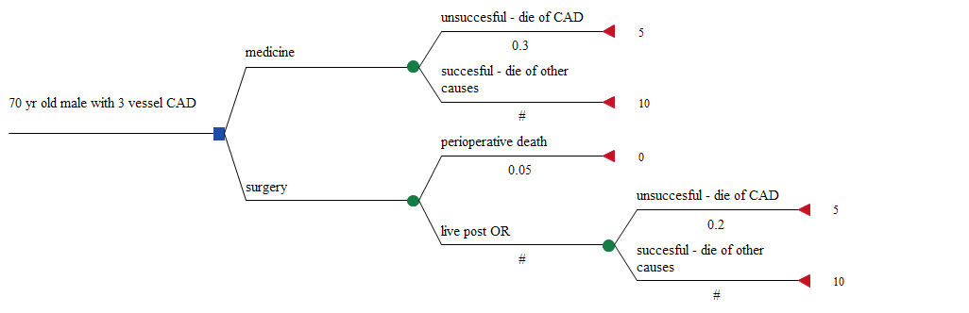

This is an example of a tree built using NUMERIC values for probabilities and “payoffs”.

The tree can be “rolled back” to yield an expected value- surgery is slightly preferred with an expected value of 8.55 life years, compared with 8.50 life years for medicine.

Limited options, though, for sensitivity analysis.

# Building a Tree with Variables

Much greater flexibility is possible if numeric quantities in the tree are defined as variables or expressions.

Key concept: variables may be globally or locally defined. The default condition is for a variable to take on a GLOBAL value, i.e. one that applies by default to all parts of the tree. That is, unless a different, LOCAL, definition is applied.

Global values live at the root node, and apply to everything to their right, i.e. the whole tree. LOCAL definitions apply only to parts of the tree to their right (downstream), but supersede GLOBAL ones.

Steps for using variables:

1. Declare name — Based on its intended function in your model, decide on a clear name for the variable.
2. Define, assign — Define the variable at a node, often the root (GLOBAL), by assigning it a value (or a formula).
3. Use — Anywhere the corresponding value is used in the tree (e.g., payoffs or probabilities).

TreeAge Pro offers multiple methods for each step.

Simplest way to CREATE a variable is to enter it in the appropriate location (e.g. beneath a node name). As you attempt to leave, a box will pop up and ask you if you wish to CREATE the variable. Hit the “CREATE VARIABLE” button, and you’ll be prompted to DEFINE the variable.

Another way to CREATE a variable is to right-click at the decision node (root) then choose “DEFINE VARIABLE” -> “NEW VARIABLE”.

To USE the variable you have just created, type in the variable name in the appropriate location (e.g. beneath a node name). Alternatively, point the mouse beneath the appropriate node name, click the three dots (…), which will show all the variables you have defined in the tree. Select the one you want to use at that node.

Our previous tree, now with variables:

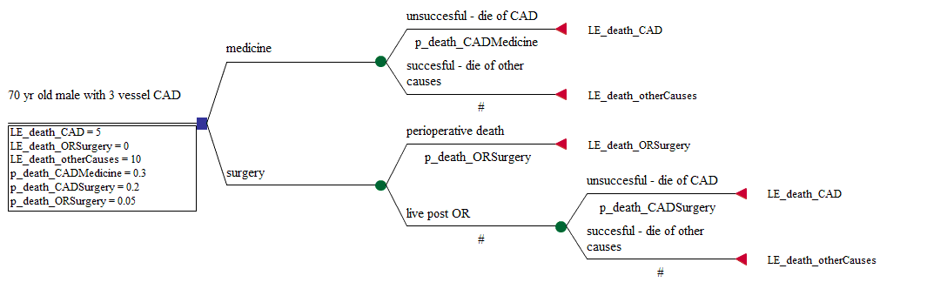

Now, among other things, sensitivity analysis is possible.

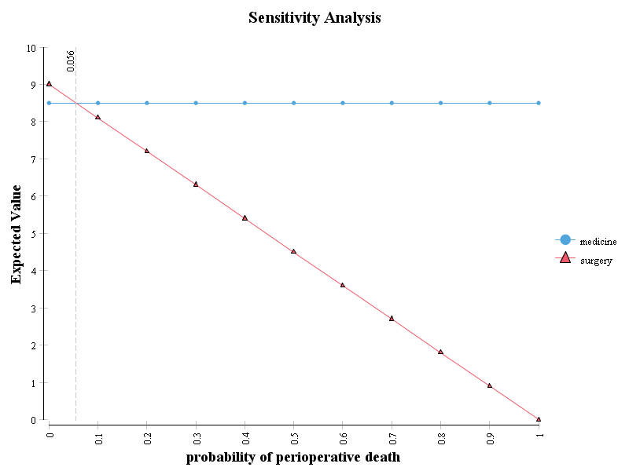

In the tree above, all variables are globally defined. In the tree you will build for this course, this will almost certainly not be the case.

Let’s assume that mean CAD severity in patients who are bypassed is less than in patients who receive medical therapy.

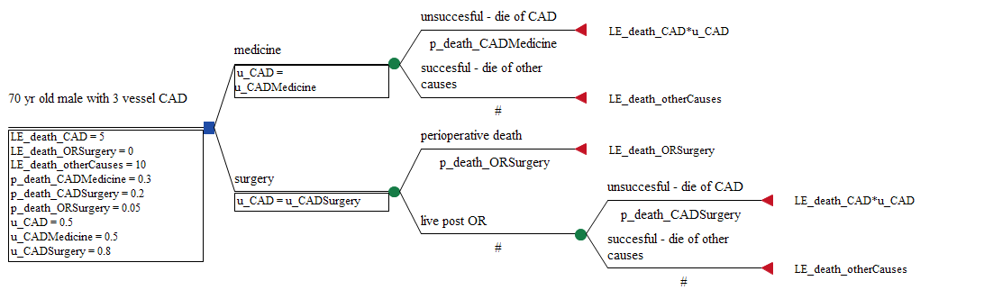

Note: In this tree, outcomes are modelled as QALYs, not LE. The utility of CAD is multiplied by life expectancy to provide an estimate of quality-adjusted life expectancy.

We’ve provided both LOCAL and GLOBAL definitions of the utility of CAD (via the “working variable” u_CAD) to reflect the fact that CAD severity is different between the two groups.

We could do this using other ways too:

-separate variables for surgical and medical angina

-create a function, expressing the relationship between surgical and medical angina. (This is probably a good idea anyway).

The advantages of LOCAL and GLOBAL definitions are best seen in the use of subtrees to model recurrent events.

# Using Subtrees

Building larger trees is much easier when subtrees are used to model outcomes that occur in multiple locations. Subtrees are an effective way of ensuring that your tree has symmetry, and that key elements are linked. It’s also a much more compact and manageable way of thinking about and representing large tree structures. For example, compare the two trees below: both use subtrees, but in the second the full tree is visible. There’s just a whole lot less to think about if you have a “standardized” or generic set of outcomes.

Subtrees can be CLONES or just regular subtrees. The difference is that, with CLONES, changes in the CLONE MASTER, i.e., the original subtree, will be reflected in all locations where clones are attached. Regular subtrees can be edited without changing anything in other subtrees.

As an example, our CAD tree, now modelled with a clone:

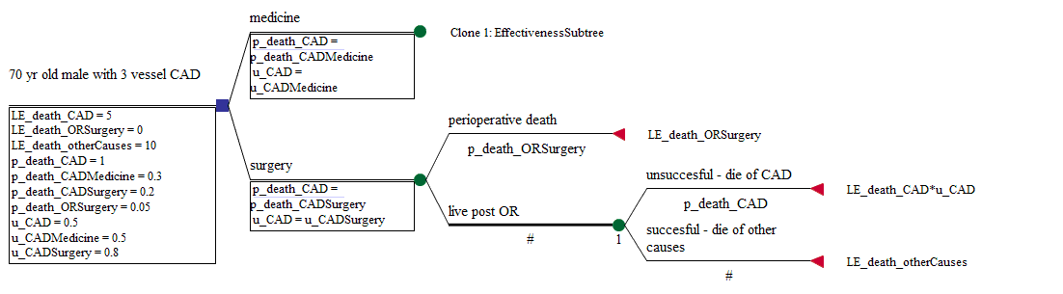

# Additional Concepts

1. Probabilistic sensitivity analysis
2. Constructing Markov models
3. Entering dual outcomes
4. Rolling back cost-effectiveness trees