Cost-Effectiveness and Decision Modeling in R

Model Calibration Exercise

|  |  |
| --- | --- |
|  |  |
| Fernando Alarid-Escudero, PhD1  Eva A. Enns, MS, PhD1  M.G. Myriam Hunink, MD, PhD2,3  Hawre J. Jalal, MD, PhD4  Eline M. Krijkamp, MSc2  Petros Pechlivanoglou, PhD5 |  |

Acknowledgements and attribution

Citations:

1. Jalal H, Pechlivanoglou P, Krijkamp E, Alarid-Escudero F, Enns E, Hunink MG. An Overview of R in Health Decision Sciences. Med Decis Making. 2017; 37(3): 735-746.
2. Krijkamp EM, Alarid-Escudero F, Enns EA, Jalal HJ, Hunink MGM, Pechlivanoglou P. Microsimulation modeling for health decision sciences using R: a tutorial. *Med Decis Making*. 2018; 38(3): 400-422.

In collaboration of:

1 University of Minnesota School of Public Health, Minneapolis, MN, USA

2 Erasmus MC, Rotterdam, The Netherlands

3 Harvard T.H. Chan School of Public Health, Boston, USA

4 University of Pittsburgh Graduate School of Public Health, Pittsburgh, PA, USA

5 The Hospital for Sick Children, Toronto and University of Toronto, Toronto ON, Canada

C:\Users\478030\Downloads\logo-nihes.png



**© Copyright 2017, THE HOSPITAL FOR SICK CHILDREN AND THE COLLABORATING INSTITUTIONS. All rights reserved in Canada, the United States and worldwide. Copyright, trademarks, trade names and any and all associated intellectual property are exclusively owned by THE HOSPITAL FOR SICK CHILDREN and the collaborating institutions and may not be used, reproduced, modified, distributed or adapted in any way without written permission.**

### Exercise: Calibration of the Sick-Sicker Model

NEED TO MODIFY.

HAVE A SEPARATE OVERVIEW OF THE SICK-SICKER MODEL (E.G. NOT IN THIS DOCUMENT)

As you may recall, the Sick-Sicker model simulates the progression of a cohort of healthy 25-year-olds at risk of developing a hypothetical disease with two stages of illness: a Sick state (S1) and a Sicker state (S2). Individuals in S1 have increased mortality, increased healthcare costs, and decreased quality of life relative to those in the Healthy state. Individuals in S2 have even greater increases in mortality, costs, and quality of life reductions. The state transition diagram is provided in the Figure below.

Previously, you were provided with a full set of input parameters for this model. However, “in reality” some of those input parameters can’t feasibly be estimated directly from individual-level data and need to be estimated through calibration. This is because while we can identify those who are afflicted with the illness through obvious symptoms, we can’t easily distinguish those in the S1 state from the those in the S2 state. Thus, we can’t directly estimate state-specific mortality hazard ratios, nor do we know the transition probability of progressing from S1 to S2. We do have some idea of the plausible ranges for these unknown parameters; these ranges are listed in Table 1. All other parameters are known and are also listed in Table 1.

There are three calibration targets to be used in this example: (1) observed survival of a cohort over time; (2) disease prevalence in a cohort over time; and (3) among sick patients (S1+S2), the proportion who are in the S1 state at three points in time. The first two targets came from an observational study of a typical cohort of individuals. The third target was obtained by subjecting ill patients to an invasive procedure which can determine disease stage, but can’t be used routinely due to its invasiveness. The calibration target values are provided in the data file “SickSickerTargets.RData”, which contains a list with three data frames: Surv, Prev, and PropSick.

The tasks below will guide you through the process of calibrating the Sick-Sicker model to estimate values for the unknown input parameters.

## Tasks

1. Adapt the function of the Sick-Sicker Markov model R code in “Markov_Sick-Sicker - SA - Function.R” so that the model returns model outputs that correspond to the calibration targets. Make this model into a function that can be called in the calibration process.
2. Load the calibration targets and plot them over time.
3. Implement a random search of the unknown parameters using Latin hypercube sampling. Plot a histogram of the sampled parameter values.
4. Run the Sick-Sicker Markov model for each of the sample parameter sets and store the relevant model outputs.
5. Calculate the fit of each model output to the calibration targets using a normal likelihood goodness-of-fit and identify the best-fitting parameter set.
6. Plot the model outputs corresponding to the best-fitting parameter set against each calibration target. Visually, is the model well-calibrated to the targets?

#### Table: Input parameters

|  |  |  |
| --- | --- | --- |
| **Parameters** | **Variable Name in R** | **Value** |
| Time horizon | n.t | 30 years |
| Cycle length |  | 1 year |
| Names of health states (*n*) | v.n | Healthy, Sick, Sicker, Dead |
| Annual discount rate | d.r | 3% |
| Annual transition probabilities |  |  |
| Disease onset (Η to S1) | p.HS1 | 0.15 |
| Recovery (S1 to Η) | p.S1H | 0.5 |
| .....Disease progression (S1 to S2) | p.S1S2 | To be calibrated; range: 0.01 - 0.50 |
| Annual probability of death |  |  |
| Healthy to Dead | p.HD | 0.005 |
| *Hazard ratio of death in S1 vs healthy | hr.S1 | To be calibrated;  range: 1.0 - 4.5 |
| *Hazard ratio of death in S2 vs healthy | hr.S2 | To be calibrated;  range: 5 - 15 |
| Annual costs |  |  |
| Healthy individuals | c.H | $2000 |
| Sick individuals in S1 | c.S1 | $4000 |
| Sick individuals in S2 | c.S2 | $15000 |
| Additional annual treatment cost per sick individual (S1 and S2) | c.Trt | $12000 |
| Utility weights |  |  |
| Healthy individuals | u.H | 1.00 |
| Sick individuals in S1 | u.S1 | 0.75 |
| Sick individuals in S2 | u.S2 | 0.50 |
| Intervention effect |  |  |
| Utility for treated individuals in S1 | u.Trt | 0.95 |

*Note: To calculate the probability of dying from S1 and S2, use the hazard ratios provided. To do so, first convert the probability of dying from healthy, p.HD, to a rate; then multiply this rate by the appropriate hazard ratio; finally, convert this rate back to a probability. Recall that you can convert between rates and probabilities using the following formulas: $r=-log⁡(1-p)$ and $p=1-e^{(-rt)}$

#### Figure: Schematic representation of the Sick-Sicker model

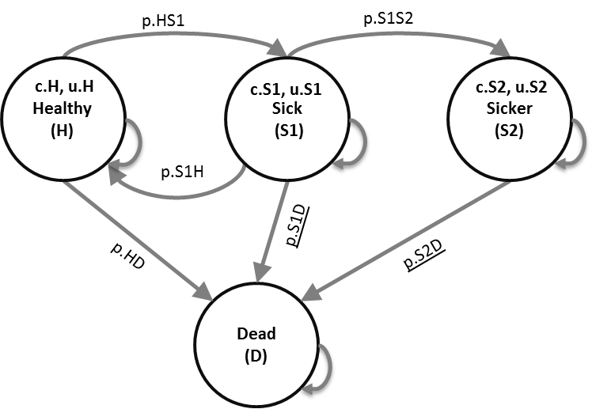

**Results**