**Title – Bank Management System**

**By-- Darvesh Bansal (22122018) & Smriti Paul (22122048)**

**INTRODUCTION:**

A Bank Management System is a software application that helps in managing the daily operations of a bank. In this project I tried to show the working of a banking account system and cover the basic functionality of a Bank Account Management System. The main aim of the project is to develop software for Bank Management System. This project is developed using Java language. The content management system deals with data entry, validation confirm and updating whiles the interactive system deals with administration and users.

**AIM OF THIS PROJECT:**

The main aim of designing and developing this Internet Banking System Java primarily based project is to provide secure and efficient net banking facilities to banking customers over the internet. This project gives real life understanding of Online Banking System and activities performed by various roles in supply chain.

**HOW TO RUN THE PROJECT:**

**Description of this Project**:

We have build up a java project of bank management system. This functionality of bank management system includes:

**\* A Login Page**

**\* Three signup Page**

**\* Deposit**

**\* Withdrawal**

**\* Producing a mini bank statement to track the transaction**

**\* Changing pin**

**\* Fast cash**

**LOGIN PAGE** includes two textfield (ACCOUNT NO, PIN) and three button (SIGN IN, SIGN UP, CLEAR). This page is connected to mysql-connector-jar-8.0.31

Here in the account no textfield we will enter the account no and in pin space we will enter the pin no which are already in the database in login table. The login table includes form no, Account no, pin no. Now the user will press the sign in button and it will get connected to main_class.

**SIGN_UP PAGE ONE** includes eight textfield (NAME, FATHER'S NAME, DATE OF BIRTH, GENDER, EMAIL ADDRESS, MARITAL STATUS, ADDRESS, CITY, PIN CODE, STATE), five radio button for gender and marital status (Married, Unmarried, Others).

Here in Name textfield user will enter his/her name. Then next Father’s name, Date of birth, gender, email address, marital status, address, city pin code and state just as we need to fill our form for opening a new account. Process is same as Offline Process. User need to put entire detailed to open a new bank account.

**SIGN_UP PAGE Two** includes five drop down box (RELIGION, CATEGORY, INCOME, EDUCATIONAL, OCCUPATION) two textfield (PAN NUMBER, AADHAR NUMBER) and four radio button for (SENIOR CITIZEN , EXISTING ACCOUNT)

Here in this signup form it will ask other details from the user like religion(Hindu, Sikh, Christian, Muslim, other) , In category it includes (General , OBC, SC , ST , Other) , In income it will show options like (if income is < 1,50,000 , <2,50,000, 5,00,000 , Upto 10,00,000 or above 10,00,000) and there is also a option to select occupation it gives option like ( Salaried , Self-Employed , Business , Student , Retired , Other ) . User will filled those details. After that it will ask if they have any existing bank account or not.

**SIGN_UP PAGE** **Three** includes Account details (ACCOUNT TYPE, CARD NUMBER, SERVICES REQUIRED)

In account type user will ask what type of account user want to choose like saving account, Fixed Deposit Account, Current account or Recurring Deposit Account. And Automatically from this page it will generate the card number and Pin. It will ask for the services user need like A T M card , Internet banking , Mobile Banking , Cheque Book and also if they want E-statement this will be services provide by bank

**Main_Class** includes Deposit, Cash Withdrawal, Mini Statement, Balance Enquiry, Pin Change, Fast Cash. By clicking the deposit class user will deposit some money into the account. Also can withdraw some money from the bank account by entering amount. if the amount is greater than the money user had deposit then it will show a error message i.e. “Insufficient Balance”. Also can change the pin. From Fast Cash option user can withdraw money without entering the amount. User can claim for the balance how much money the account holds after withdrawing or depositing. User can also get mini statement for the account (how much money is getting debited and credited)

Here are the screenshots (How the Project is running):

1.

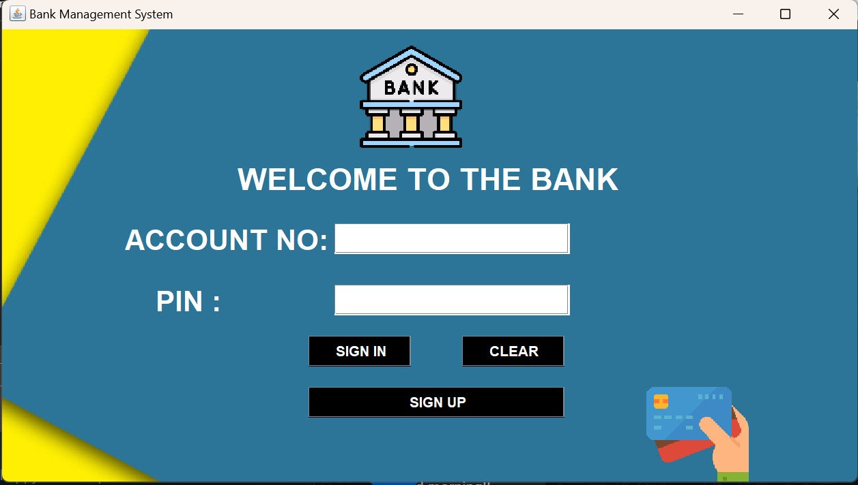

2.

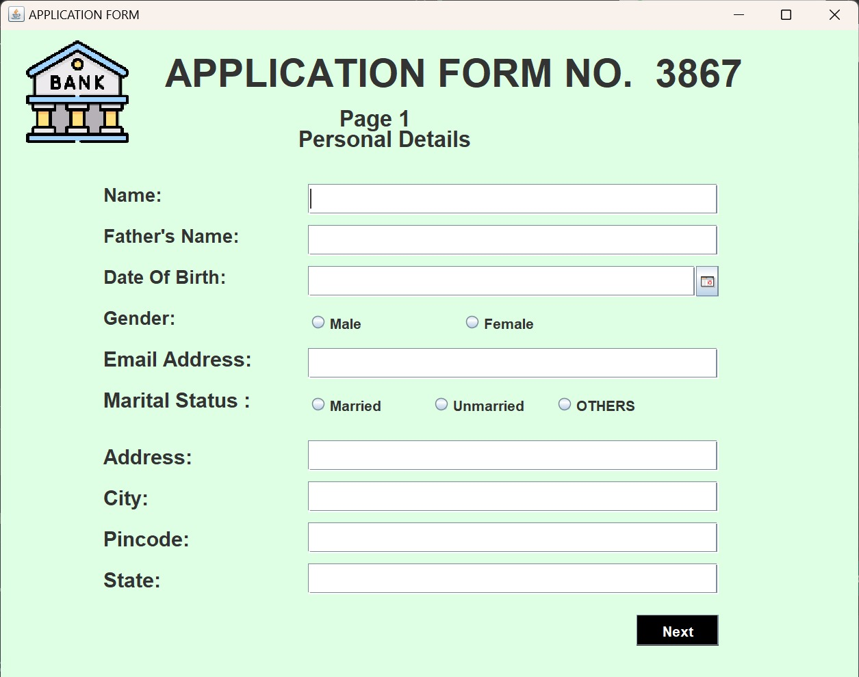

3.

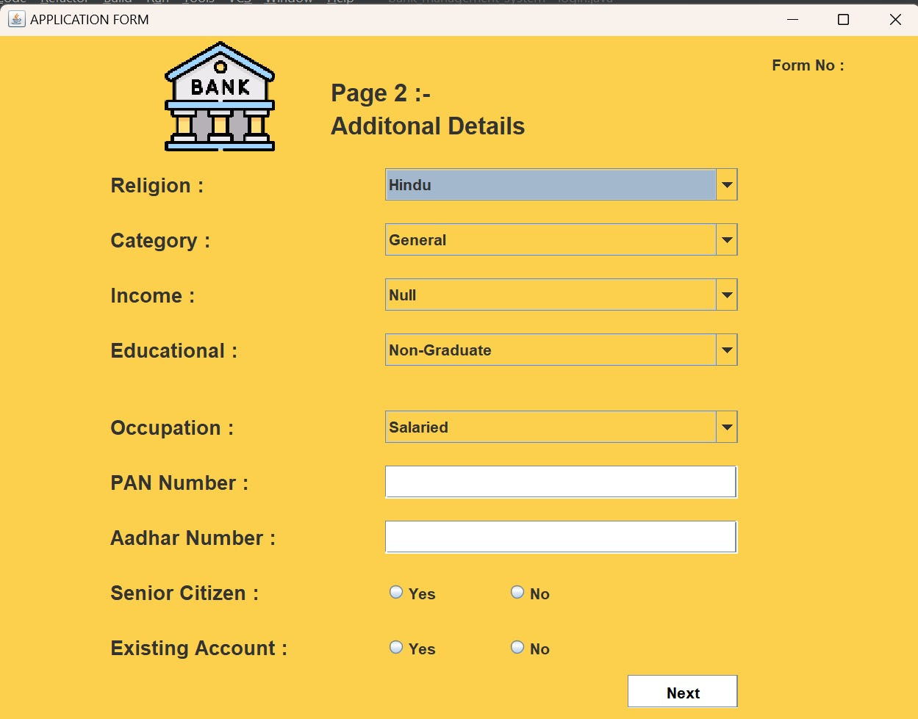

4.

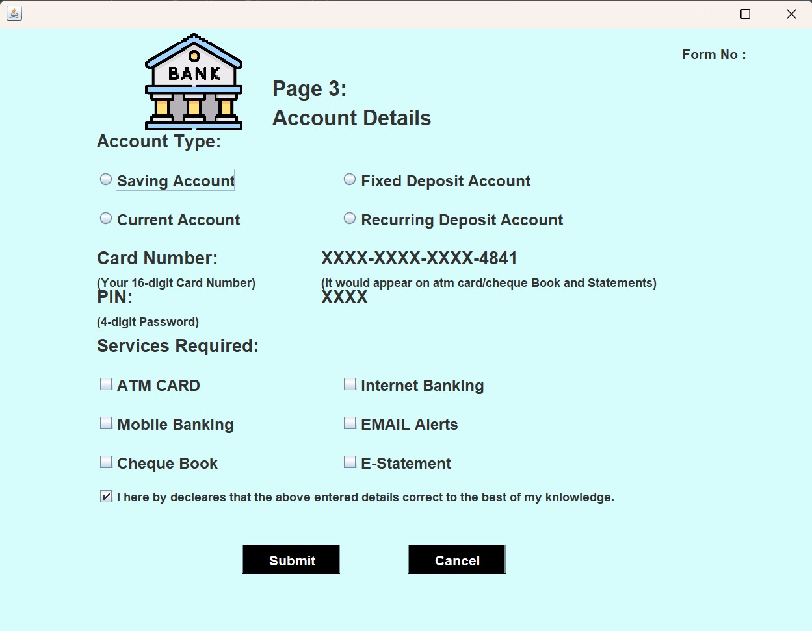

5.

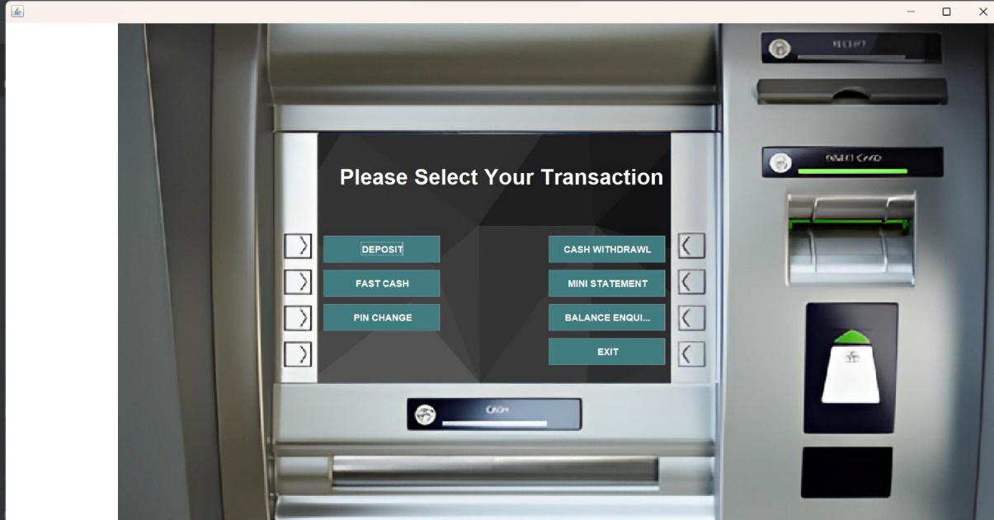

Now user can perform the transaction.

**Database:**

We have connected thus project to my sql server that’s why some tables are created

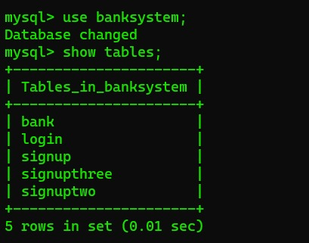

This are the Table in the database,

Giving an overview about the Tables,

Table: Bank

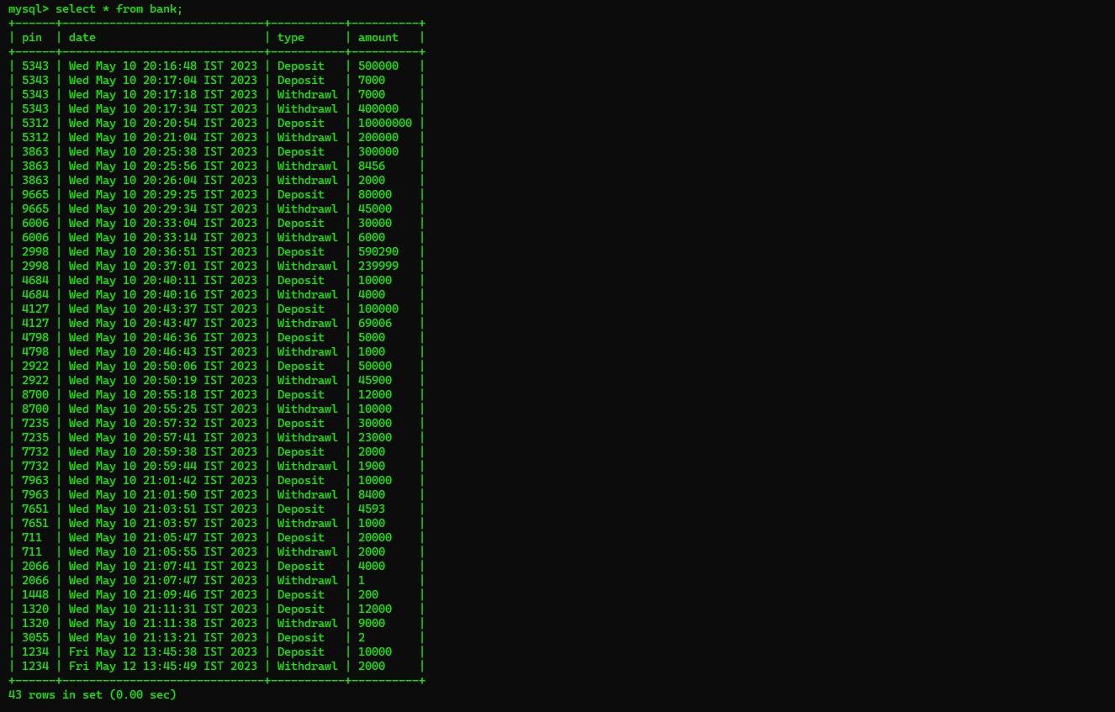

Table: Login

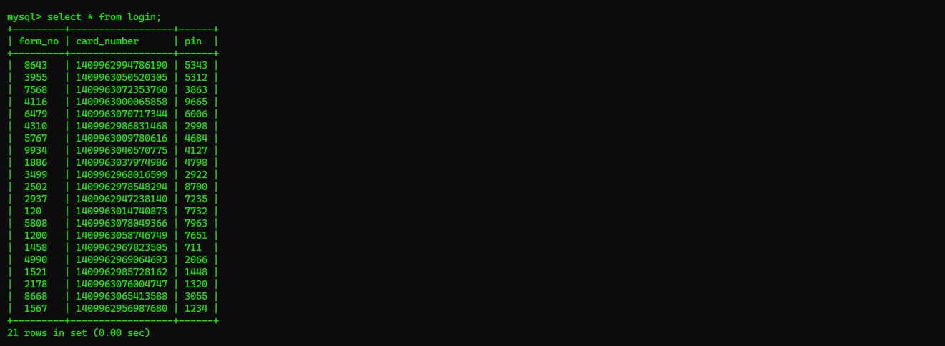

Table: signup

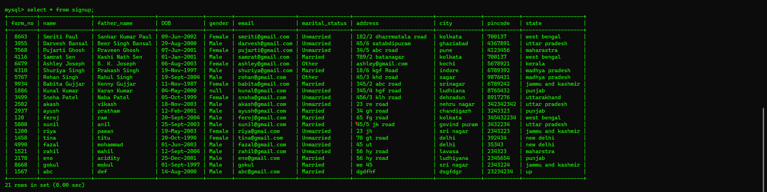

Table: signuptwo



Table: signupthree

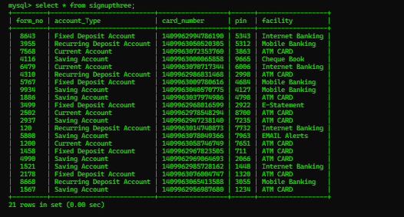

**Exploratory Data Analysis:**

Here We have Performed **EDA (Exploratory Data Analysis)** on the data we have got from the user

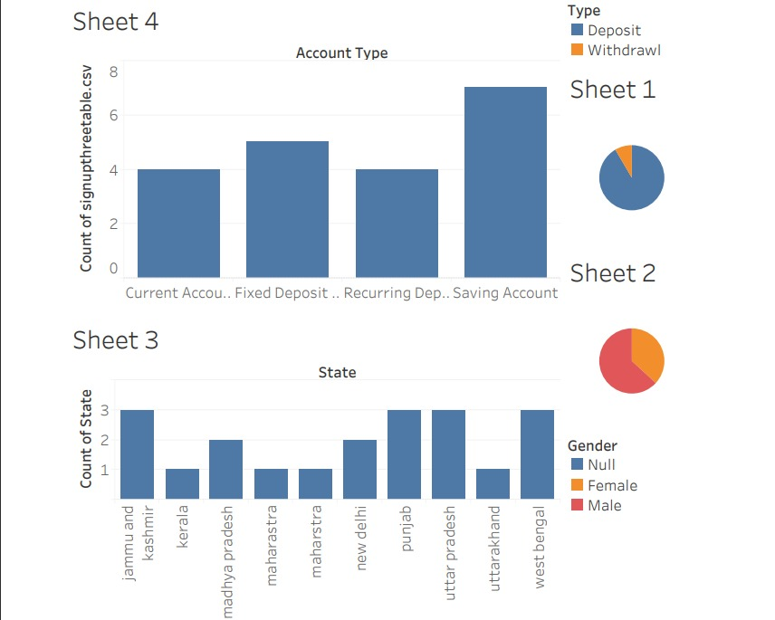

From the above Page we can **conclude** that

In Sheet 2 we can see male female user ration and in this bank mostly Male user are there. In Sheet 1 we are getting ratio of Type like deposit and Withdrawal. Mostly deposit money is greater than the withdrawal money. Here in Sheet 3 we have created a bar graph to see count of the people from different state. And in Sheet 4 we ca n see count of the Account Type like 4 people created current account, 4 user created Recurring account, 7 people created saving account and 5 user created Fixed deposit account.