Bangalore Restaurant Data Analysis
Output Explanation Report
Based on the submitted Jupyter Notebook
1. Project Overview
This project analyzes Bangalore restaurant data using Python, MySQL, Pandas, and Matplotlib. The analysis focuses on restaurant locations, cuisines, ratings, votes, menu items, online ordering, table booking, and the relationship between ratings and votes.
The workflow covers data loading, MySQL database setup, database structure checks, data-quality validation, SQL-based business analysis, and visualization of selected results.
2. Dataset and Database Overview
The notebook uses six related tables. The recorded row counts are:
Table | Rows | Purpose
restaurants | 100 | Restaurant-level information including rating, votes, cost, services, and location ID
location | 20 | Area, pincode, latitude, and longitude
cuisines | 15 | Cuisine master list
restaurant_cuisines | 210 | Restaurant-to-cuisine relationships
menu | 626 | Menu items, categories, prices, and vegetarian flag
reviews | 1,000 | Restaurant reviews, dates, ratings, and review text
3. Database Structure
The main relationships connect restaurants to locations, menu items, reviews, and cuisines. The restaurant_cuisines table links restaurants and cuisines, allowing multiple tables to be combined using SQL JOINs.

4. Data Quality Checks
No missing restaurant ratings were found.
The corrected duplicate-ID check found no duplicate restaurant IDs.
The corrected LEFT JOIN location check found no unmatched restaurant location IDs.
No invalid review ratings outside the expected range were found.
No negative or NULL restaurant cost values were found.

5. Output - Business Analysis
The following table summarizes the business questions, their outputs, and what the results show.
Analysis | Output | Interpretation
5.1 Total Number of Restaurants | 100 | The dataset contains 100 restaurants.
5.2 Number of Restaurants by Location | Jayanagar: 14; Whitefield: 9; Hebbal: 7; Brigade Road, BTM Layout, and JP Nagar: 6 each. | Restaurant coverage differs across locations.
5.3 Most Popular Cuisines | Andhra: 20 restaurants in the top-cuisine analysis. | Andhra is the most represented cuisine.
5.4 Restaurants Offering Online Ordering | 83 restaurants | Online ordering is available at most restaurants in the dataset.
5.5 Average Rating of Restaurants | 3.97 | The overall average restaurant rating is just under 4.
5.6 Average Cost for Two People | 657 | The average approximate cost for two people is 657.
5.7 Restaurant Ratings | Ratings range from 2.5 to 4.9. | Most ratings are concentrated in the mid-to-high range.
5.8 Number of Restaurants for Each Cuisine | Andhra: 20; Thai, Desserts, and Bengali: 17 each. | Cuisine representation varies across the dataset.
5.9 Top 10 Restaurants by Rating | Six restaurants have 4.9; the remaining top-10 values are 4.8 or 4.7. | The highest-rated group is concentrated near the top of the rating scale.
5.10 Top 10 Restaurants by Votes | The Diner: 2,479; Namma Corner: 2,457; Basil Restaurant: 2,427. | The leading restaurants have substantially more votes than lower-vote restaurants.
5.11 Total Restaurants in Each Area | Jayanagar: 14; Whitefield: 9; Hebbal: 7. | The area counts confirm uneven restaurant distribution.
5.12 Top 10 Restaurants by Average Rating | Top values: 4.9, followed by 4.8 and 4.7. | The highest restaurant ratings are clustered near the top of the scale.
5.13 Cuisine with Highest Number of Restaurants | Andhra: 20. | Andhra has the highest restaurant count among cuisines.
5.14 Restaurants with Multiple Cuisines | The displayed qualifying restaurants have 3 cuisines each. | Many restaurants in this analysis offer multiple cuisine categories.
5.15 Top 10 Cuisines by Average Rating | Chinese: 4.15; Cafe: 4.09; Italian: 4.07. | Chinese has the highest average rating in the displayed top-10 comparison.
5.16 Total Menu Items for Each Restaurant | Urban Tadka: 12; Grand Table: 12. | These two restaurants have the largest menu counts in the top-10 result.
5.17 Highest Rated Areas | Whitefield, JP Nagar, Hebbal, and Indiranagar have a 4.9 maximum rating. | Each listed area contains at least one restaurant rated 4.9.
5.18 Restaurants with High Rating, High Votes, and Multiple Cuisines | Bangalore Bowl: 4.9 rating and 2,222 votes. | This restaurant meets the selected conditions of high rating, high votes, and multiple cuisines.
5.19 Restaurant Votes and Ratings | 100 restaurant-level rating-vote pairs. | These paired values are used for the rating-versus-votes visualization.

6.1 Number of Restaurants by Location
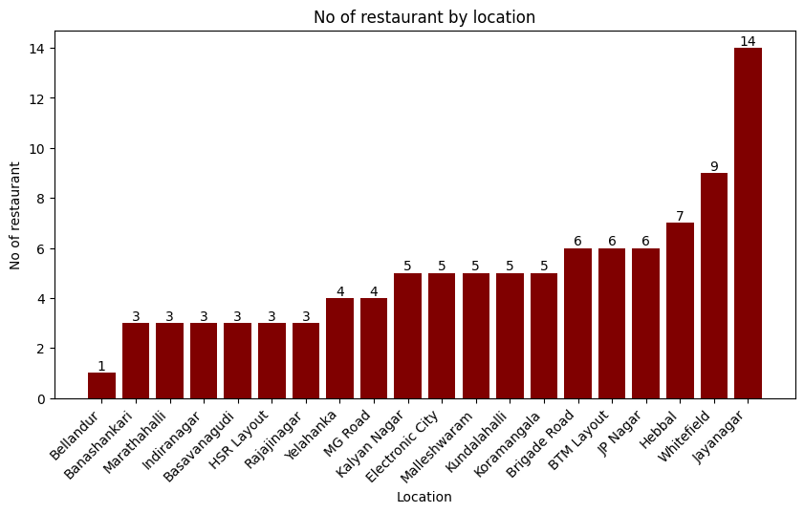
6.1 Number of Restaurants by Location
Explanation: The bar chart compares restaurant counts across the locations. Jayanagar has the highest count with 14 restaurants, followed by Whitefield with 9, while Bellandur has 1 restaurant.

6.2 Top 10 Cuisines by Number of Restaurants
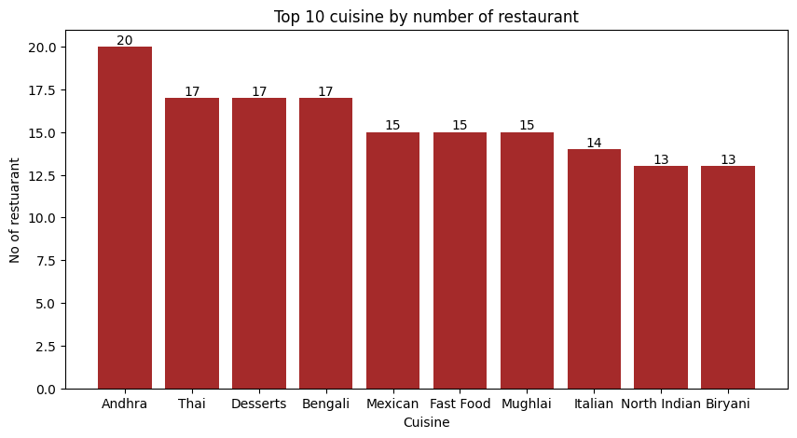
6.2 Top 10 Cuisines by Number of Restaurants
Explanation: The chart shows the ten cuisines offered by the largest number of restaurants. Andhra leads with 20 restaurants, while Thai, Desserts, and Bengali each have 17.

6.3 Top 10 Cuisines by Average Rating
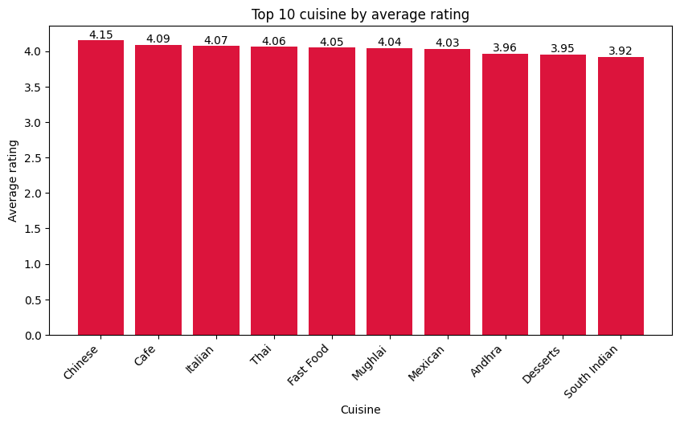
6.3 Top 10 Cuisines by Average Rating
Explanation: The chart compares average ratings for the selected top ten cuisines. Chinese has the highest displayed average at 4.15, followed by Cafe at 4.09 and Italian at 4.07.

6.4 Top 10 Restaurants by Votes
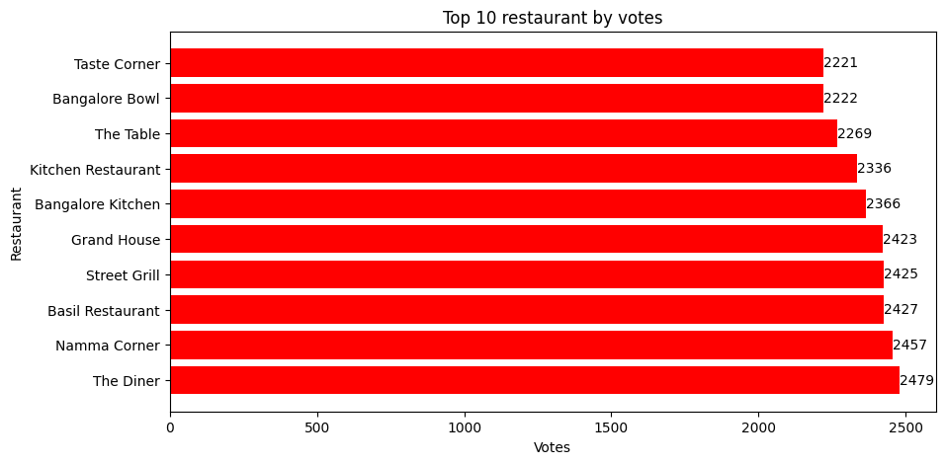
6.4 Top 10 Restaurants by Votes
Explanation: The horizontal bar chart shows the highest-vote restaurants. The Diner has 2,479 votes, followed by Namma Corner with 2,457 and Basil Restaurant with 2,427.

6.5 Top 10 Restaurants by Number of Menu Items
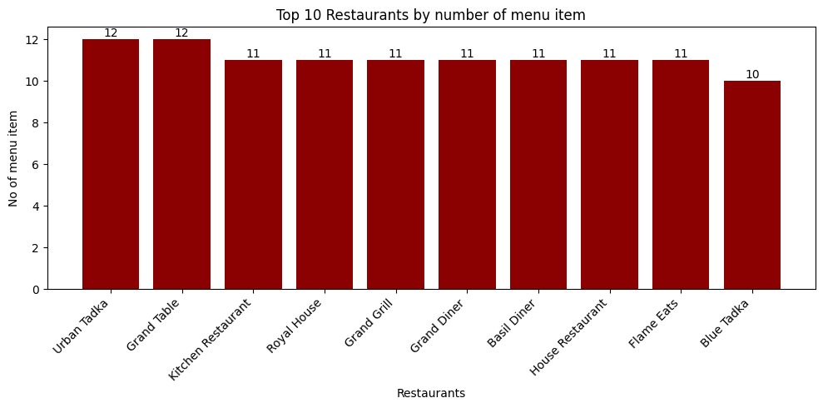
6.5 Top 10 Restaurants by Number of Menu Items
Explanation: The chart compares the top restaurants by menu count. Urban Tadka and Grand Table have 12 menu items each, while several other restaurants have 11.

6.6 Distribution of Restaurant Ratings
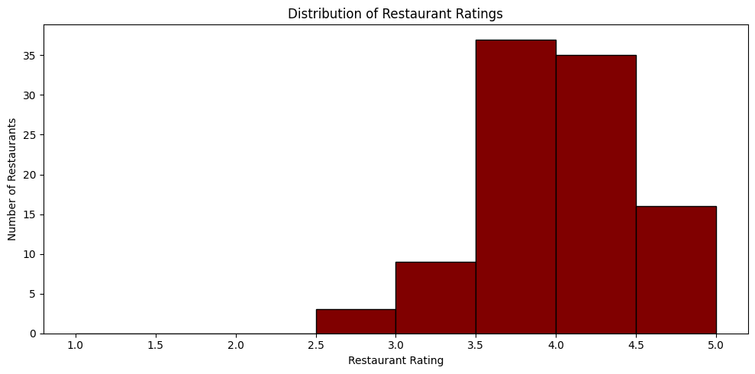
6.6 Distribution of Restaurant Ratings
Explanation: The histogram groups the 100 restaurant ratings into ranges. Most ratings fall in the mid-to-high range, especially around 3.5 to 4.5.

6.7 Restaurant Rating vs Votes
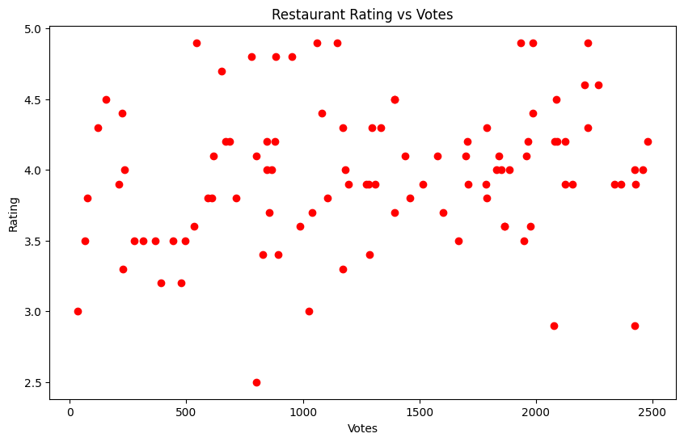
6.7 Restaurant Rating vs Votes
Explanation: The scatter plot places votes on the x-axis and rating on the y-axis, with one point per restaurant. The points span several rating and vote levels, so the chart does not show a simple one-to-one relationship.

7. Overall Insights
The dataset contains 100 restaurants across 20 locations, with Jayanagar having the largest count at 14.
Andhra is the most represented cuisine in the restaurant-count analysis, while Chinese has the highest average rating among the displayed top-ten cuisines.
The overall average restaurant rating is 3.97, and most restaurant ratings are concentrated between approximately 3.5 and 4.5.
Online ordering is more common than table booking in the dataset: 83 restaurants offer online ordering, while 25 offer table booking.
The Diner has the highest vote count in the top-vote analysis, while Urban Tadka and Grand Table have the largest menu counts among the top-ten restaurants.
The rating-versus-votes scatter plot shows that restaurants with many votes can have different rating levels rather than a simple linear pattern.
8. Recommendations
Use location-level restaurant counts to identify areas with higher or lower restaurant presence for further analysis.
Compare cuisine popularity and average ratings together when evaluating cuisine patterns.
Treat online ordering and table booking as separate service indicators because their adoption levels differ.
Future analysis could examine menu categories, menu prices, vegetarian availability, and review text in greater detail.
9. Conclusion
This project demonstrates the use of Python and MySQL to load, validate, analyze, and visualize restaurant data. SQL was used for joins, filtering, grouping, and aggregation, while Python and Matplotlib were used to turn query results into visualizations. The analysis highlights differences in location coverage, cuisine representation, ratings, votes, menu size, and restaurant services.
10. Scope and Limitations
The analysis is based on the fields available in the restaurant, location, cuisine, menu, and review tables. The project does not contain detailed customer-level order transactions, so customer spending, order frequency, and customer-level purchasing behavior are outside the current scope.

