ASSIGNMENT – 1
MODULE – 1 – OVERVIEW OF IT INDUSTRY
LAB EXERCISE

Q.1. Write a simple “Hello World” program in two different programming language of your
choice. Compare the structure and syntax.
Ans: ~ C programming : include<stdio.h>
int main()
{
printf(“Hello World”);
return 0;
}
~ Python programming : print(“Hello World”)

Q.2. Research and create a diagram of how data is transmitted through client to server
Over internet?
Ans: The following diagram shows how the data is transmitted through client to server
Over the internet ~
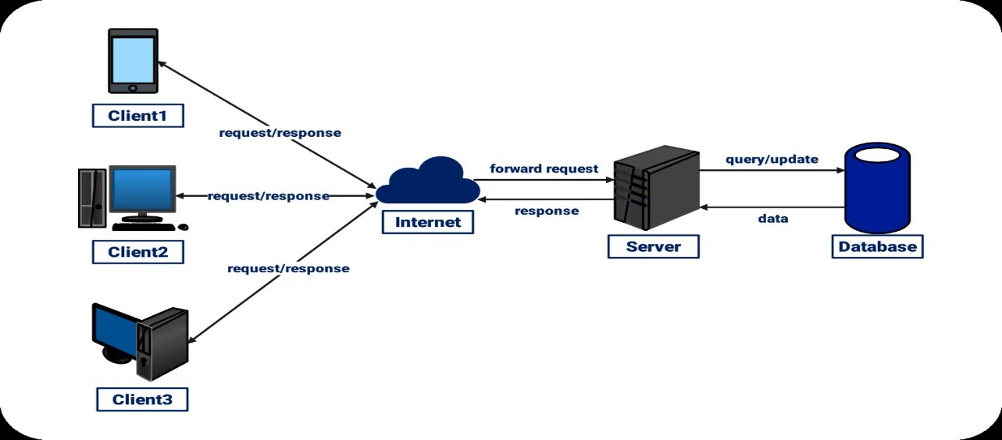
Q.3. Design a simple HTTP client-server communication in any language?
Ans: Didn’t understood this question and I don’t know the answer for this question.

Q.4. Research different types of internet connections (e.g., broadband, fiber, satellite)
and list their pros and cons?
Ans: The different types of internet connections are:
- BROADBAND
- FIBER CABLES
- SATELLITE
- MOBILE INTERNET (3G / 4G / 5G)
- HOTSPOT / WIFI – INTERNET

The pros and cons of these types of connection are listed below:

PROS:
- Wireless broadband doesn’t need cables and is easy to deploy.
- Wireless broadband are the good options in areas without wired infrastructures.
- Mobile internet is portable as we can carry our mobile anywhere.
- No fixed line is required.
- 5G offers a very high speed of internet.
- Fiber optic cables are highly reliable.
- Fiber optic cables are very much faster (up to 1 Gbps or higher).

CONS:
- Expensive installation cost.
- Data packages may be very costly.
- Coverage varies by location.
- Weather can disturb signal.
- Expensive equipment and setup costs for satellite connections.
- Mobile hotspots have limited range.
- Can be insecure if not protected.
- Speed depends on underlying conditions.
Q.5. Simulate HTTP and FTP requests using command line tools (e.g., curl)?
Ans: I don’t know that.

Q.6. Identify and explain three common application security vulnerabilities. Suggest
possible solutions?
Ans: Three common application security vulnerabilities and their possible solutions
Are listed below:
- SQL INJECTION - SQL INJECTION occurs when attackers insert some malicious SQL commands into the input fields (like login forms) to manipulate
Or access the databases.
- CROSS-SITE-SCRIPTING (XSS) - XSS happens when attackers inject malicious JavaScript into web pages viewed by other users.
This script can steal cookies, session data, or redirect users to malicious pages.
- Cross-Site Request Forgery (CSRF) - CSRF tricks a victim (usually logged-in) into performing unwanted actions on a website, such as changing passwords or transferring money, without realizing it.

Possible solutions for this kind of vulnerabilities are listed pointwise below:
- Use prepared statements / parameterized queries.
- Validate and sanitize all user input.
- Implement Content Security Policy (CSP).
- Encode/escape output before displaying user data.
- Validate and filter user inputs.
- Use frameworks that automatically escape HTML (e.g., React, Angular).
- Use CSRF tokens in forms and API requests.
- Set cookies with Same Site and Http Only attributes.

Q.7. Identify and classify 5 applications you use daily as either system software or
application software?
Ans: The 5 application or system software that I use daily are listed below.
- WINDOWS OPERATING SYSTEM: SYSTEM SOFTWARE
- It is used to boot my system.
- Provides the basic platform for running applications.

- BRAVE / GOOGLE CHROME / MICROSOFT EDGE: SYSTEM SOFTWARE
- Use to browse the internet.
- Access the services.

- WHATSAPP / MESSENGER: APPLICATION SOFTWARE
- Used to connect with people.
- Used to communicate via call and video calls.

- VISUAL STUDIO CODE: APPLICATION SOFTWARE
- Used to write codes.
- Used to execute queries and implement codes.

- INSTAGRAM: APPLICATION SOFTWARE
- Used for entertainment purpose.
- Used for communication.

Q.8. Design a basic three-tier software architecture diagram for a web application?
Ans: I don’t know that.

Q.9. Explore different types of software environments (development, testing, production).
Set up a basic environment in a virtual machine?
Ans: The different types of software environments (development, testing, and
Production) -
- DEVELOPMENT ENVIRONMENT
- Purpose – used by developer to write, build debug code.
- Contains IDEs (Vs Code)
- Debuggers and compilers
- Local databases or mock services
- Example tool VS Code, Git, Docker Desktop, Localhost servers

- TESTING ENVIRONMENT

- Purpose - Used by testers (QA) to verify functionality, performance, and security.
- Mirrors production but with test data
- Contains automated test tools
- Stable and controlled
- Examples: Selenium, JMeter, Postman, CI/CD pipeline testing servers

- PRODUCTION ENVIRONMENT

- Purpose: The live environment where end users access the application.
- High security
- High performance and reliability
- Real user data
- Strict change control (maintenance windows, approvals).
- Load balancers, web servers (Nginx/Apache), DB servers.

Q.10. Write and upload your first source code file to GitHub?
Ans: Already done that.

Q.11. Create a GitHub repository and document how to commit and push code changes?
Ans: Already done that.

Q.12. Create a student account on GitHub and collaborate on a small project with a
Classmate?
Ans: Project is not assigned till yet.

Q.13. Create a list of software you use regularly and classify them into the following
categories: system, application, and utility software?
Ans: The list of software that I use daily are listed below:
- VS CODE – APPLICATION SOFTWARE
- WINDOWS OS – SYSTEM SOFTWARE
- GOOGLE CHROME – SYSTEM SOFTWARE
- INSTAGRAM – APPLICATION SOFTWARE
- FACEBOOK – APPLICATION SOFTWARE
- WHATSAPP – APPLICATION SOFTWARE
- MS WORD – APPLICATION SOFTWARE
- AVAST – UTILITY SOFTWARE
- MCAFEE – UTILITY SOFTWARE

Q.14. Follow a GIT tutorial to practice cloning, branching, and merging repositories.
Ans: Done.

Q.15. Write a report on the various types of application software and how they improve
Productivity?
Ans: Report on the Various Types of Application Software and Their Role in Improving
Productivity:
- Introduction - Application software refers to programs designed to perform specific
tasks for users. These tasks may include word processing, data analysis, communication, media creation, and business operations. Unlike system software, which manages hardware and system functions, application software focuses on helping users complete meaningful work efficiently. This report explores different types of application software and explains how each contributes to increased productivity.

2. Types of Application Software
2.1 Word Processing Software
Examples: Microsoft Word, Google Docs, LibreOffice Writer
Purpose: Used for creating, editing, and formatting text documents.
Productivity Benefit:
- Provides templates and grammar tools
- Allows collaboration through real-time editing
- Helps produce high-quality documents quickly

2.2 Spreadsheet Software
Examples: Microsoft Excel, Google Sheets
Purpose: Used for calculations, data storage, analysis, and visualization.
Productivity Benefit:
- Automates complex calculations using formulas
- Visualizes data with charts and graphs
- Enhances decision-making with data analysis tools

Q.16. Create a flowchart representing the Software Development Life Cycle (SDLC)?
Ans:
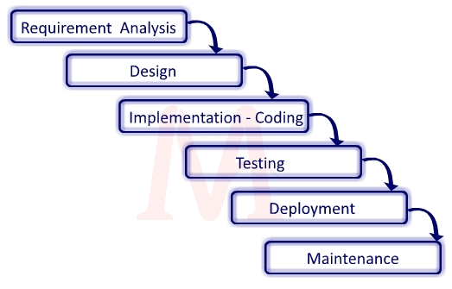
Fig – SOFTWARE DEVELOPMENT LIFE CYCLE
Q.17. Write a requirement specification for a simple library management system.
Ans: Some of the requirement specification for a simple library management
System are –
- Functional Requirements:
- Book Management
- Member Management
- Book / Issue Return
- Reporting
- Authentication

- Non – Functional Requirements:

- Performance requirement
- Usability requirements
- Reliability requirements
- Security requirements
- Maintainability requirements

Q.18. Perform a functional analysis for an online shopping system?
Ans: Functional Analysis of an Online Shopping System
1. Introduction
A functional analysis identifies what the online shopping system must do to meet user needs. It breaks the system into major functions, sub-functions, actors, and interactions.

2. System Actors
- Customer – Browses products, places orders, makes payments.
- Admin – Manages products, categories, orders, and users.
- Delivery Staff (optional) – Handles order delivery updates.
- Payment Gateway – Processes online payments securely.

3. Major System Functions
3.1 User Management
Functions:
- User registration
- User login & authentication
- Profile management
- Password reset
Inputs: Name, email, phone, password
Outputs: User account created/updated

3.2 Product Catalog Management
Customer Functions:
- Browse products by category
- Search products
- View product details (price, description, images, reviews)
Admin Functions:
- Add, edit, delete products
- Manage product stock
- Manage product categories
Inputs: Item details, search keywords
Outputs: Product listings, product details

3.3 Shopping Cart Management
Functions:
- Add items to cart
- Remove items from cart
- Update quantity of items
- View cart summary
Inputs: Product ID, quantity
Outputs: Updated cart, total price

3.4 Order Processing
Functions:
- Convert cart to order
- Enter delivery details
- Select payment method (COD / Online)
- Generate order summary
Inputs: Cart details, address, payment method
Outputs: Order confirmation, order ID

3.5 Payment Processing
Functions:
- Redirect to payment gateway
- Validate payment
- Handle successful/failed payment responses
Inputs: Payment details
Outputs: Payment success/failure notification

3.6 Delivery & Tracking
Functions:
- Update order status (Packed, Shipped, Delivered)
- Provide tracking information to customers
- Send delivery notifications
Inputs: Order ID, status updates
Outputs: Tracking updates, SMS/email notifications

3.7 Reviews & Ratings (Optional)
Functions:
- Add reviews and ratings
- Display customer reviews
Inputs: Rating, comments
Outputs: Updated product review list

3.8 Admin Panel Functions
Functions:
- Manage users
- Manage inventory
- View sales reports
- View and update order status

Q.19. Design a basic system architecture for a food delivery app.
Ans: FOOD DELEVERY APP:
Designing a food delivery application involves creating a robust system that connects users, restaurants, and delivery drivers seamlessly. The system must address user needs, ensure operational efficiency for restaurants, and provide real-time delivery tracking. Below is an overview of the key components and considerations for designing such a system.
Core Features and Functionalities
The application should include the following functionalities:
- User Registration and Authentication: Secure user accounts with login and registration features.
- Restaurant and Menu Management: Allow restaurants to manage menus, update availability, and set prices.
- Order Placement and Customization: Enable users to browse menus, customize orders, and place them with ease.
- Real-Time Order Tracking: Provide users with live updates on order status, estimated delivery time, and driver location.
- Secure Payment Processing: Integrate multiple payment options, including cards, wallets, and cash on delivery.
- Feedback and Rating System: Allow users to rate restaurants and delivery drivers to improve service quality.
- Delivery Management: Assign orders to drivers efficiently and optimize delivery routes.
System Architecture
The system architecture should follow a modular design to ensure scalability and maintainability:
- Frontend: Use technologies like React.js for a responsive and user-friendly interface.
- Backend: Implement Node.js and Express.js for handling API requests and business logic.
- Database: Use MongoDB for storing user data, restaurant details, orders, and reviews.
- APIs: Develop RESTful APIs to manage communication between the frontend and backend.
- Real-Time Updates: Use Web Sockets or similar technologies for live order tracking.
Data Flow and Relationships
The system's data flow can be visualized using an Entity-Relationship (ER) model and Data Flow Diagram (DFD):
- Entities: Users, Restaurants, Menu Items, Orders, Delivery Drivers, and Reviews.
- Relationships: Users can place multiple orders. Restaurants can offer multiple menu items. Orders can involve multiple menu items and are assigned to one delivery driver. Users can provide multiple reviews for restaurants.
- Processes: Order Management: From placement to delivery. User Management: Registration, login, and profile updates. Restaurant Management: Menu updates and order processing. Delivery Management: Assigning and tracking deliveries.
Non-Functional Requirements
The application must meet the following non-functional requirements:
- Performance: Ensure fast response times and efficient handling of high traffic.
- Security: Protect user data with encryption and secure payment gateways.
- Scalability: Design the system to handle growth in users, restaurants, and orders.
- Reliability: Minimize downtime and ensure consistent service availability.
- Usability: Provide an intuitive interface for users, restaurants, and delivery drivers.

Q.20. Develop test cases for a simple calculator program?
Ans: TEST CASES FOR SIMPLE CALCULATOR PROGRAM:
Assumptions: The calculator supports –
- Addition
- Subtraction
- Multiplication
- Division

TEST CASES:

Sn. | Description | Input | Expected output
TC-1 | Add two positive integers. | 5 + 3 | 8
TC-2 | Add positive & negative number | 5 + ( -3 ) | 2
TC-3 | Add decimal numbers | 2.5 + 2.5 | 5

Sn | Description | Input | Excepted Output
TC-1 | Subtract two positive numbers | 5 - 3 | 2
TC-2 | Subtract negative number | 10 - (- 3) | 13
TC-3 | Decimal subtraction | 5.5 – 2.2 | 3.3

Sn | Description | Input | Output
TC-1 | Multiply two numbers | 5 * 2 | 10
TC-2 | Multiply negative numbers | -5 * 3 | - 15
TC-3 | Decimal values | 5.5 * 5.5 | 30.25

Sn | Description | Input | Expected output
TC-1 | Dividing two numbers | 10 / 2 | 5
TC-2 | Dividing resulting in decimals | 5 / 2 | 2.5
TC-3 | Dividing positive by negative | 12 / -4 | -3

Q. 21. Create a DFD for a hospital management system.
Ans. Data Flow Diagram for a Hospital Management System:
PHARMACIST
PATIENT

Registration Request

Payment

HOSPITAL MANAGEMENT SYSTEM
DOCTOR
appointment
LAB TECHNICIAN
payment patient Records
MANAGEMENT
Pharmacist

payment receipt
payment records

Appointment
Confirmation

FIG – DATA FLOW DIAGRAM OF HMS

Q. 22. Draw a flowchart representing the logic of a basic online registration system?
Ans. Flow chart is a pictorial representation of how the problem is solved step by step
By using different geometrical shapes.

Display Error Message
END
Valid
Details
Complete Registration
Enter Registration Details
START

NO

YES

FIG – Flowchart Of Basic Online Registration System

