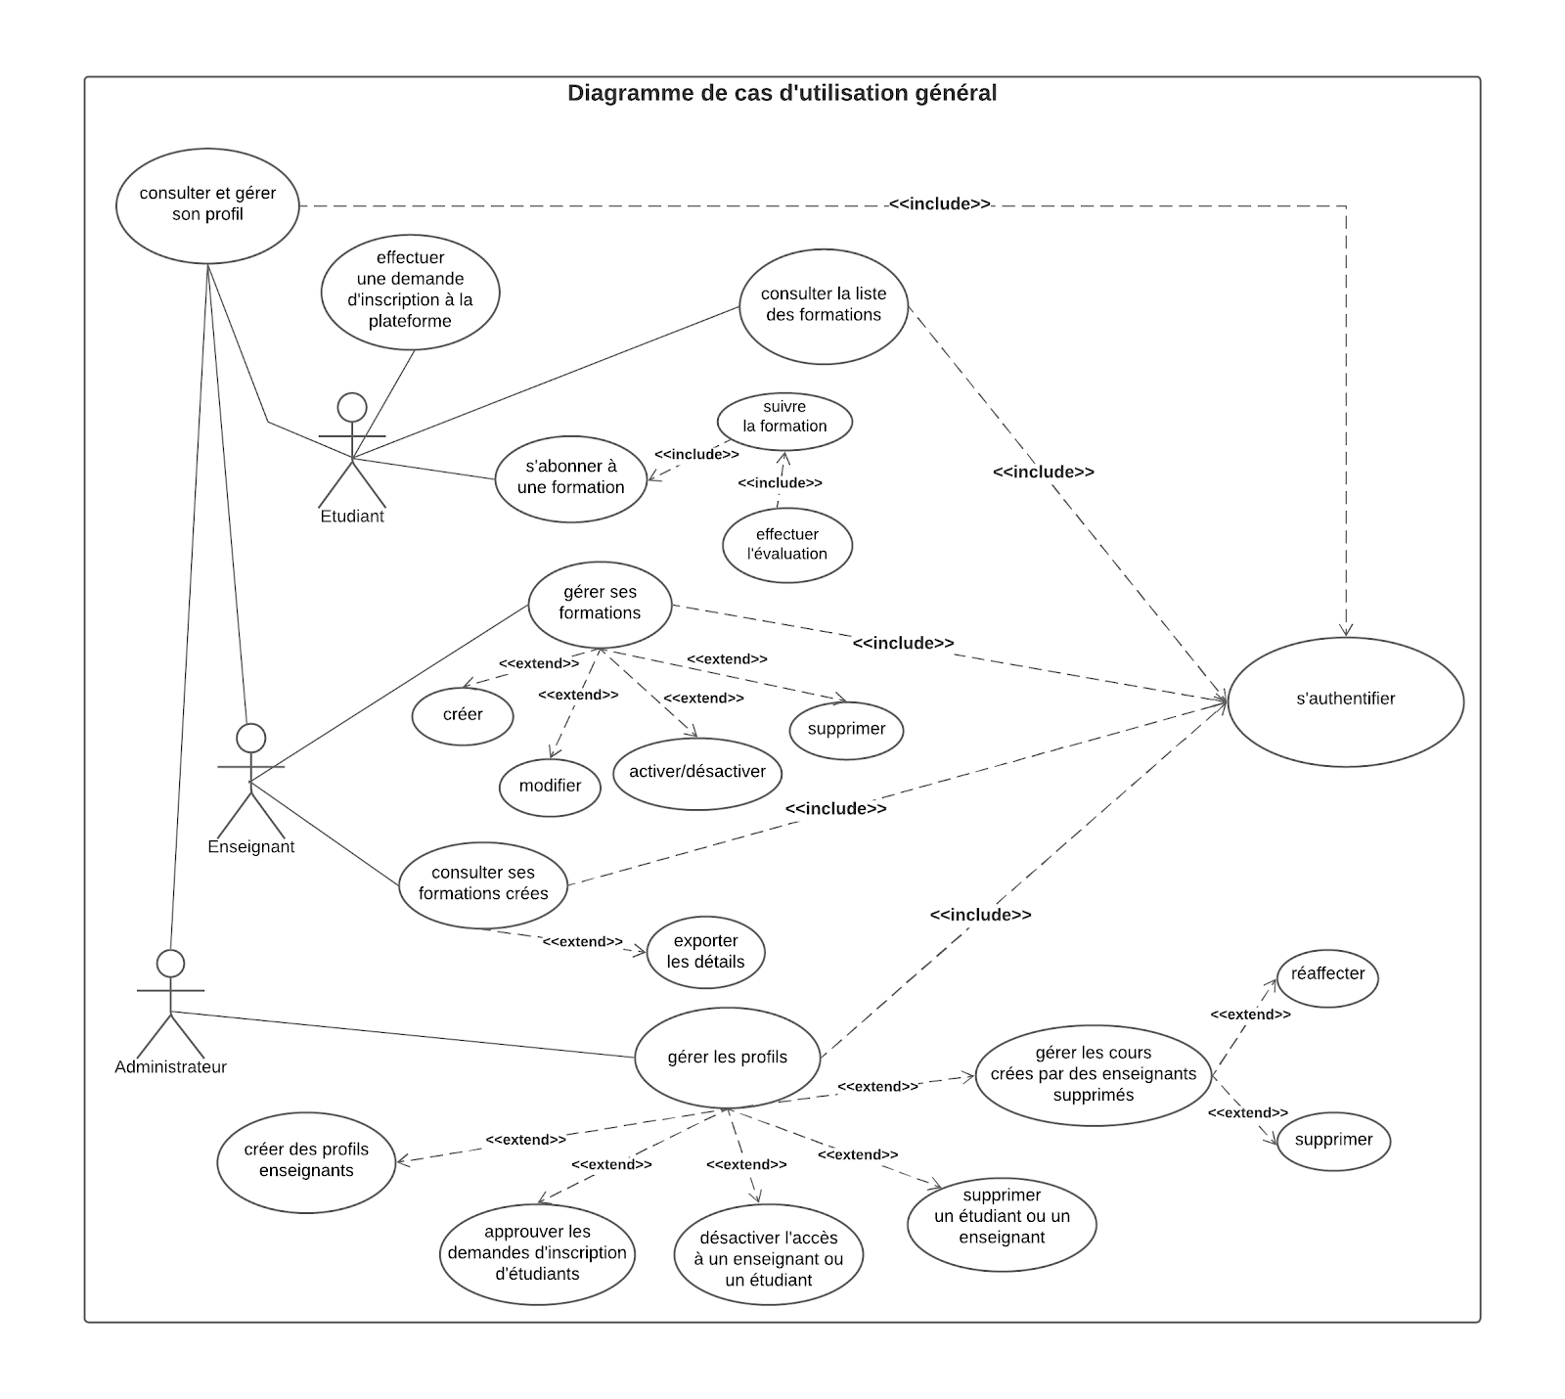

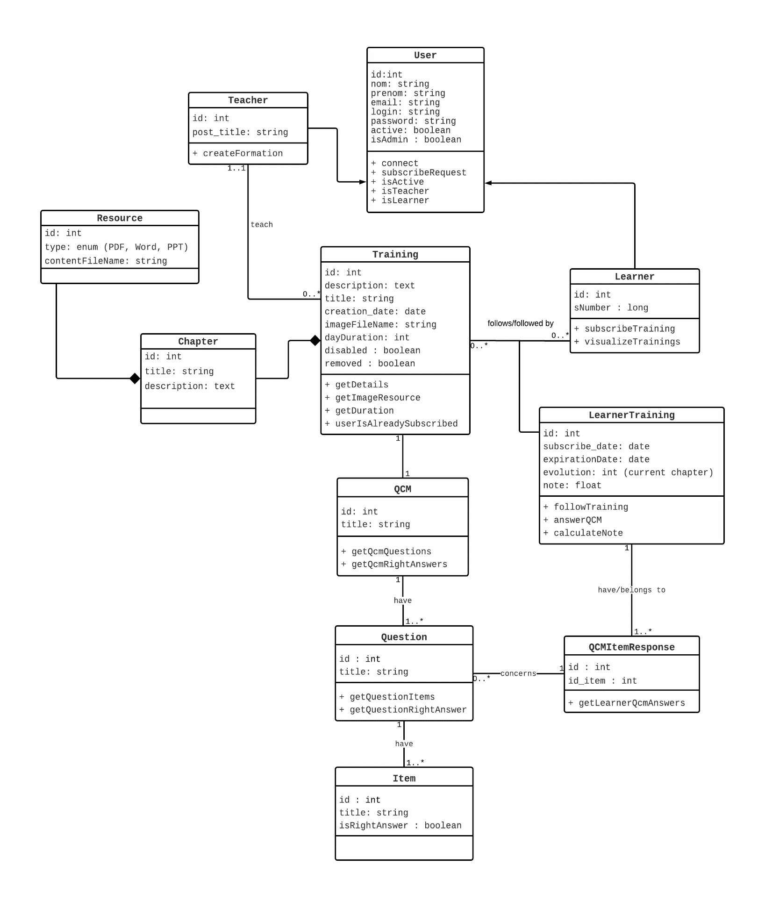

* **User** (id, name, lastName, email, login, password)
* **Teacher** (id, #id_user)
* **Learner** (id, #id_user)
* **Training** (id, title, description, creationDate, imageFileName, dayDuration, #id_Teacher)
* **Chapter** (id, title, description, #id_training)
* **Resource** (id, type, contentFileName, #id_chapter)
* **Learner_Training** (id, subscribeDate, expirationDate, evolution, note, #id_learner, #id_training)
* **Qcm** (id, title, #id_training)
* **Question** (id, title, id_qcm)
* **Item** (id, title, isRightAnswer, #id_question)
* **Qcm_item_response** (id, id_item, #id_question, #id_learner_training)

