# Introduction

DASH conformance software performs the task of validating at least the DADH MPD and also the segments pointed to by that MPD, as shown in Figure 1 [1]. If there is any conformance issue found, it is reported back. This document provides the software architecture, functionality, and basic usage of the conformance software.

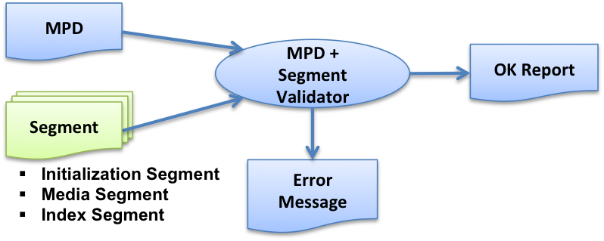

Figure 1: Role of conformance software [1]

Figure 2 shows a relatively detailed process flow.

1. Based on the provided MPD location, its is loaded.
2. XML validation and schema validation is done based on the MPD and the MPD schema, the latter pointed to by the MPD.
3. Schematron rules are validated.
4. If segment conformance testing is required, the MPD information is used to access/fetch the segments.
5. ISO BMFF rules are validated.
6. DASH specific rules are validated:
   1. General DASH rules (e.g. for sidx, ssix boxes etc).
   2. MPD information specific rules, e.g.
      1. Profile specific checks,
      2. Encrypted content specific checks etc.
7. Cross-representation checks are made (e.g. segment and subsegment alignment).

Each of the processing green blocks may generate conformance error messages that are provided to the user. Only if none of the blocks generate any error, the content is conforming to the specific DASH profile.



Figure 2: Detailed flow of DASH conformance testing

# Realization architecture

Figure 3 shows the functional block diagram of how the DASH conformance software has been realized. In Figure 4, more detailed functional diagram of the conformance software tool is provided.

* The conformance software resides on the “Test Server”.
* The “Tester” is a web-client, e.g. Google Chrome browser that access the conformance software on the Test Server.
* The Tested provides the MPD (either as an uploaded file, or points to the MPD location on the web) to the conformance software.
* Based on this information, the conformance software accesses the DASH content.
* Conformance testing is done on the Test Sever.
* The report of the conformance testing is provided back to the Tester.



DASH Content (3)

Test Server (2)

Tester (1)

1. Test Request (MPD)

2. Request content

3. Run Conformance tests

4. Results

Figure 3: Functional block diagram of realization architecture

### Test Server

Linux/Windows based Web server

Frontend code: https://github.com/Dash-Industry-Forum/Conformance-Software

Backend code: <https://github.com/Dash-Industry-Forum/Conformance-and-reference-source>

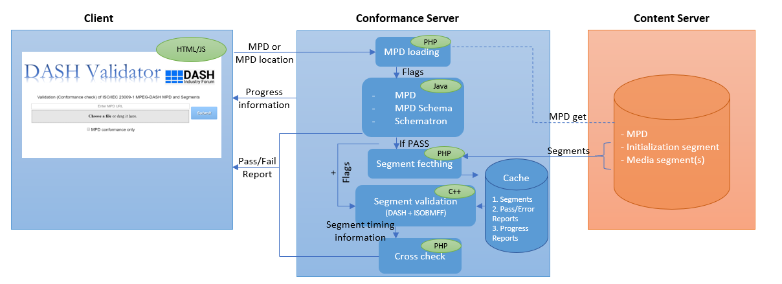

Figure 4: Functional diagram of DASH conformance software tool

The overall and detailed functional diagram for the conformance software tool can be seen in Figure 4.

1. Client accesses the conformance software web interface from a preferred web browser and either uploads the MPD or inputs the MPD URL. Thereafter, the client waits for the information regarding the progress and results.
2. Conformance software loads the uploaded MPD or fetches it from the provided MPD URL.
3. MPD, MPD schema and schematron validation is performed. Error file is generated for client/side reporting.
4. Unless otherwise stated, initialization segment and media segments are fetched from the content server and stored in a local cache.
5. Corresponding MPD information specific flags along with the segments are passed to the segment validation software binary executable, in which ISO-BMFF validation, general MPEG DASH segment rules and MPD information specific segment rules are performed. Error file and information files are generated for client-side reporting.
6. Information files generated by the segment validation software is then used for cross representation validation checks. Error file is generated for client-side reporting.
7. If no errors are found in any of the abovementioned processes, then the provided MPD and the segments are validated to be conformant to the MPEG DASH standard.

# Web-user interface

The web-based user interface for interaction with the conformance software is shown in Figure 5.

Results

MPD URL or file selected

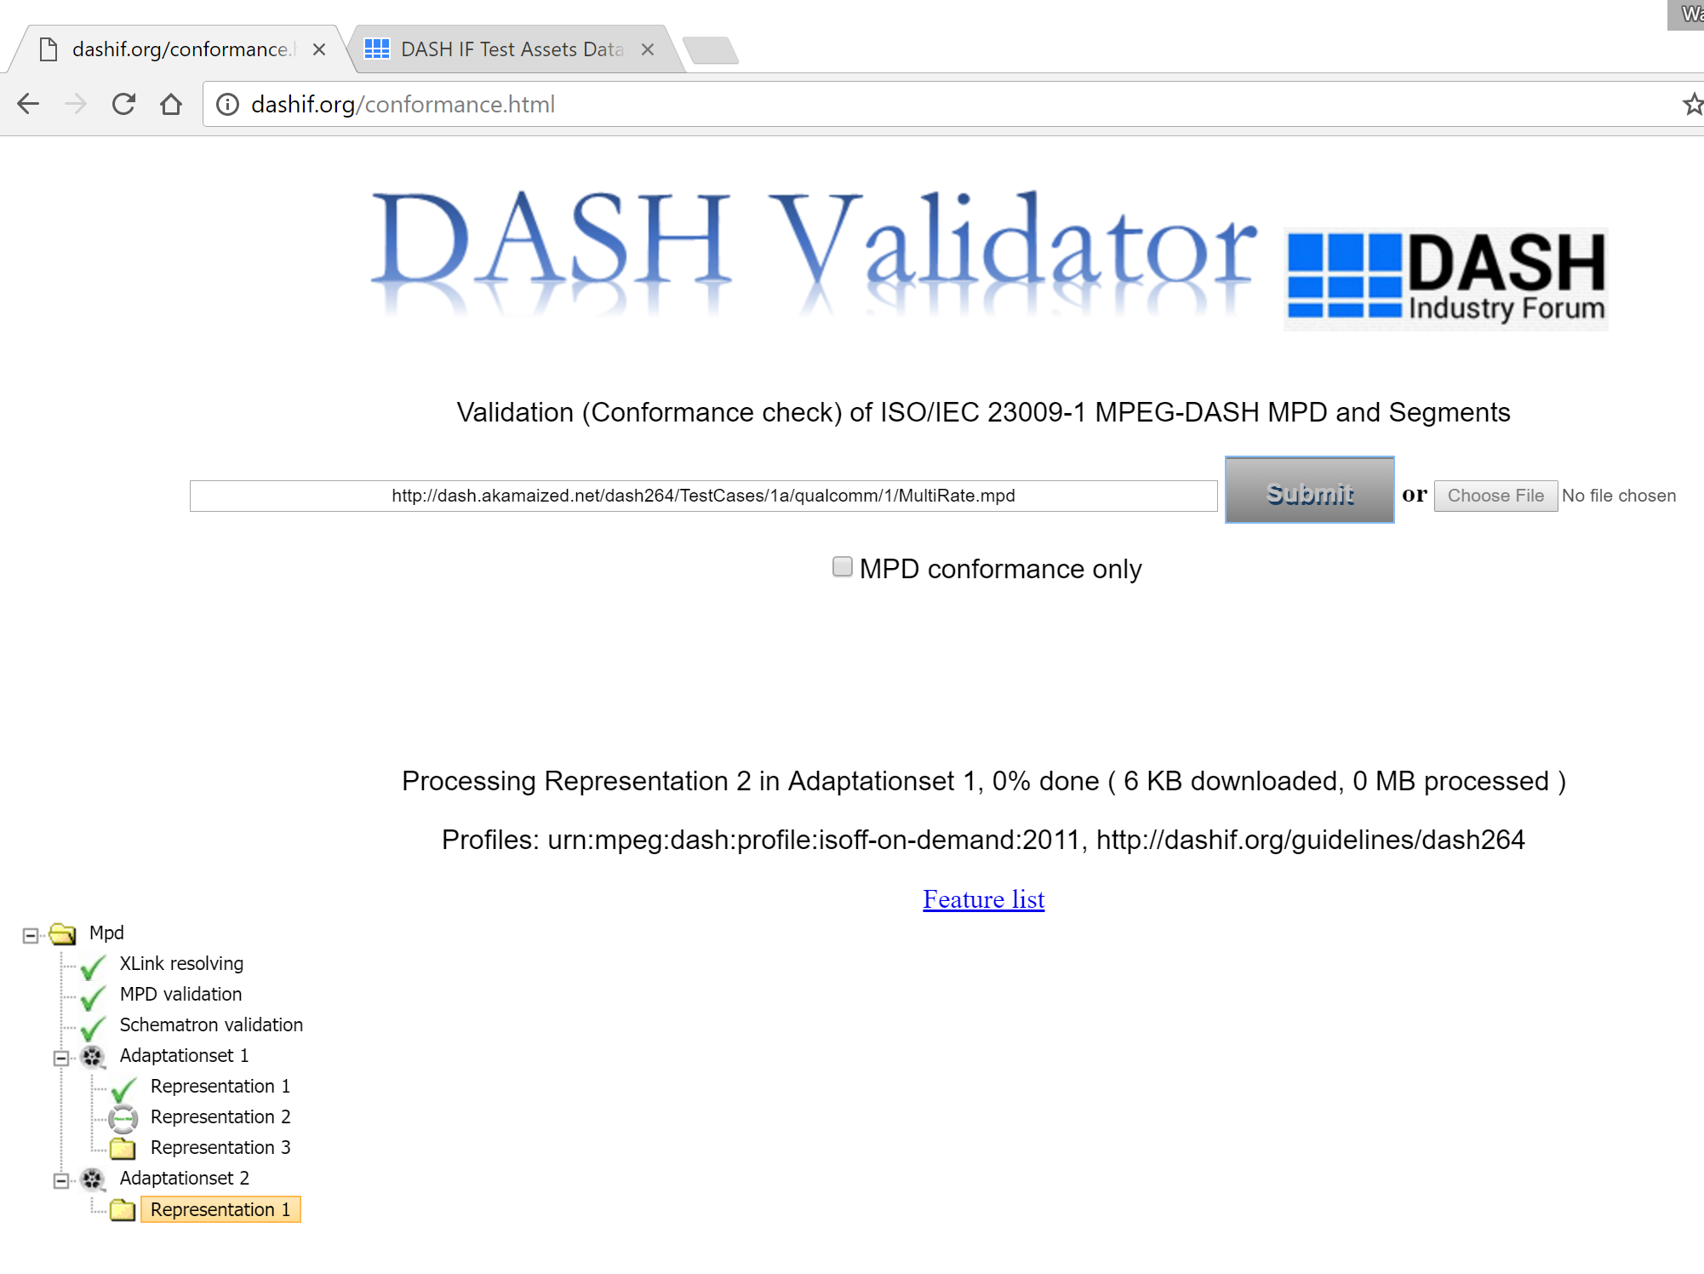

MPD URL or file selected

Results

Figure 5: Web user interface of the conformance software.

# References

[1] ISO/IEC 23009-2, “Information technology — Dynamic adaptive streaming over HTTP (DASH) — Part 2: Conformance and reference software”