# Usage of the Conformance-Software

There are three ways to access the conformance service.

## Web-user interface

Accessible at <http://vm1.dashif.org/conformance/current/webfe/conformancetest.php> (alias: <http://dashif.org/conformance.html> ).

**MPD URL or file selected**

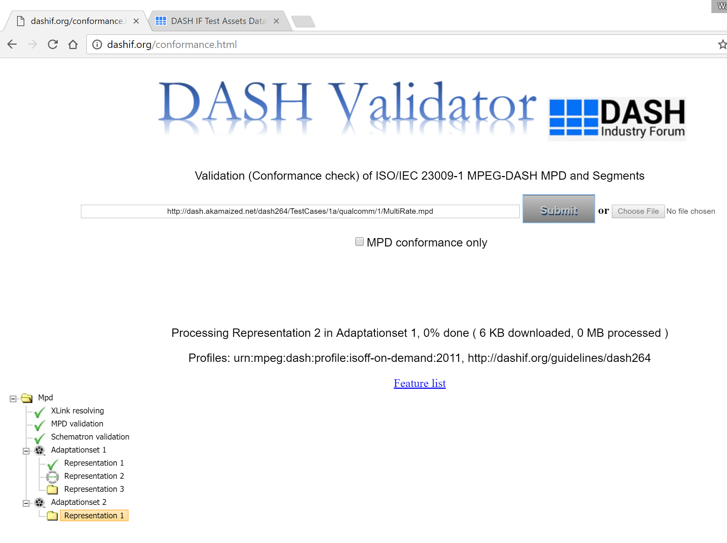

**Results**

You can provide a local test MPD by uploading, or offer an URL to the MPD file, then click "submit". Another possibility is passing the URL by appending an argument ?mpdurl=MPDlocation to the link.

eg. <http://vm1.dashif.org/conformance/current/webfe/conformancetest.php?mpdurl=http://dash.akamaized.net/dash264/TestCases/1a/qualcomm/1/MultiRate.mpd>

## Command-line

It's very convenient with wget or curl. For test vectors on a server, the format is:

wget --post-data 'urlcode=["MPDlocation","mpdvalidator",0]' -q http://vm1.dashif.org/conformance/current/webfe/process.php -O Output

OR

curl -d 'urlcode=["MPDlocation","mpdvalidator",0]' http://vm1.dashif.org/conformance/current/webfe/process.php

* MPDlocation is the URL of the test MPD file.
* Pass 1 instead of 0 to run MPD conformance test only.
* Output is the file name where you want to save the conformance result. If you want to display it directly in the console, then simply replace it with -. Curl output the result to display by default.

An example is: wget --post-data 'urlcode=["http://dash.edgesuite.net/dash264/TestCases/1a/qualcomm/1/MultiRate.mpd","mpdvalidator",0]' -q http://vm1.dashif.org/conformance/current/webfe/process.php -O -

If you want to test a local MPD file, please use the following format:

curl -F 'afile=@file_location' -F 'urlcode=["upload","mpdvalidator",1]' http://vm1.dashif.org/conformance/current/webfe/process.php

* file_location is the local path of your MPD file.
* The software only does a MPD conformance test no matter if you pass 1 or 0 here.

For example: curl -F 'afile=@/home/xxx/MultiRate.mpd' -F 'urlcode=["upload","mpdvalidator",1]' http://vm1.dashif.org/conformance/current/webfe/process.php

The temporary result folder is located in http://vm1.dashif.org/conformance/current/webfe/temp/. Usually it has a name starting with "id" and followed by random numbers. It's also possible to specify a name by e.g. -F 'foldername='NAME'' or -F 'foldername=NAME', which have the same effect. However, it's highly discouraged unless you have a special usage. The reason is that if two folders have the same name, then the new results would overwrite the old ones. Especially when you use some simple words, the results might be wrong if other users are using the same name as you do! So please be very careful when using this option!

We also restrict the format of the name you choose. Only name without "/" is accepted, which means that relative path is not allowed. If you for e.g. passed foldername ../xx or yy/xx to our server, the final name would both be xx, which would be located directly in the folder "temp".

For more details, please refer to Conformance Results:- https://github.com/Dash-Industry-Forum/Conformance-Software/wiki/Conformance-Results.

## Integration in a Web-service

A Simple test page is provided as an example to execute conformance test with just a few lines of JavaScript code. This sample page redirects to the result folder when the conformance is finished (please make sure to allow the pop-ups from the test page). The URL is <http://vm1.dashif.org/conformance/current/webfe/SimpleTest.html>.

# Functional Block Diagram

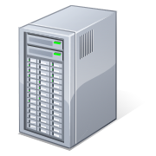

DASH Content (3)

Test Server (2)

Tester (1)

1. Test Request (MPD)

2. Request content

3. Run Conformance tests

4. Results

### Tester

Google Chrome browser

### Test Server

Linux/Windows based Web server

Frontend code: https://github.com/Dash-Industry-Forum/Conformance-Software

Backend code: https://github.com/Dash-Industry-Forum/Conformance-and-reference-source

### Note on Test Server sessions

Each run of the Conformance-Software creates separate sessions on the Test Server. The session folders are erased to save resources on the server based on timeouts. The session folders which are older than 30 minutes are deleted when a new test begins (This includes sessions started or completed before 30 minutes).