**DASISH QDDT – user guide**

*This document provides a user guide for the DASISH QDDT (Questionnaire Design and Development Tool).*

Last updated: 5 January 2015



Data Service Infrastructure for the Social Sciences and Humanities

## About the tool

The QDDT is a system for developing and documenting the full questionnaire development process of cross-national survey programmes, from the first concepts and questions to the final questionnaires. The tool is currently under development. Some of the uses/goals are:

* Improving both quality and transparency
* Internal (producer) users can use the tool to document the question design process
* External (consumer) users can use it to understand how each item and concept was developed
* Once the design for a questionnaire module has been completed, the information can be made available for download and transfer
* The information is permanently stored in the database for future reuse and reference
* QDDT is planned as the ‘mother tool’ in a chain of interoperable tools for the survey lifecycle

## Login page:

The QDDT is a web application and is accessed through a web browser. Log in with provided username and password.

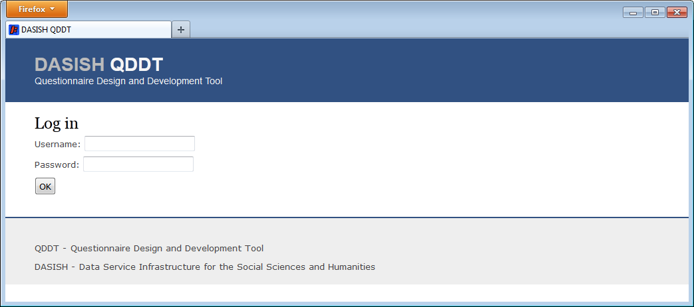

Figure 1 Log in page

## Home page:

Logging in will take you to your home page.

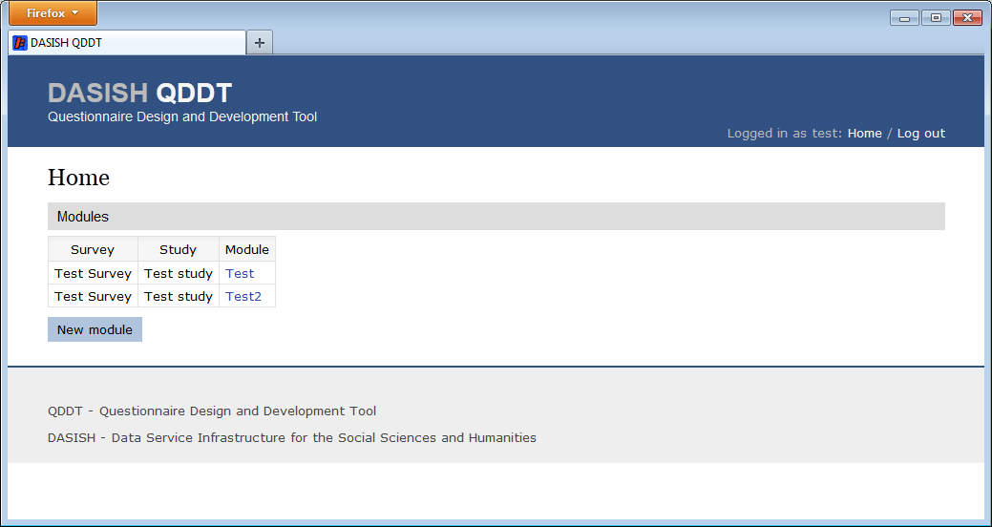

Figure Home page

Notice the ‘Home’ and ‘Log out’ links on the top banner to the right. Use those links to get back to the home page or to log out.

The home page shows all modules in that you have access to.

Click on the module you want to update or click the ‘New module’ button to create a new module.

## New module

If you click on the ‘New module’ button you will get up a form for registering a new module.

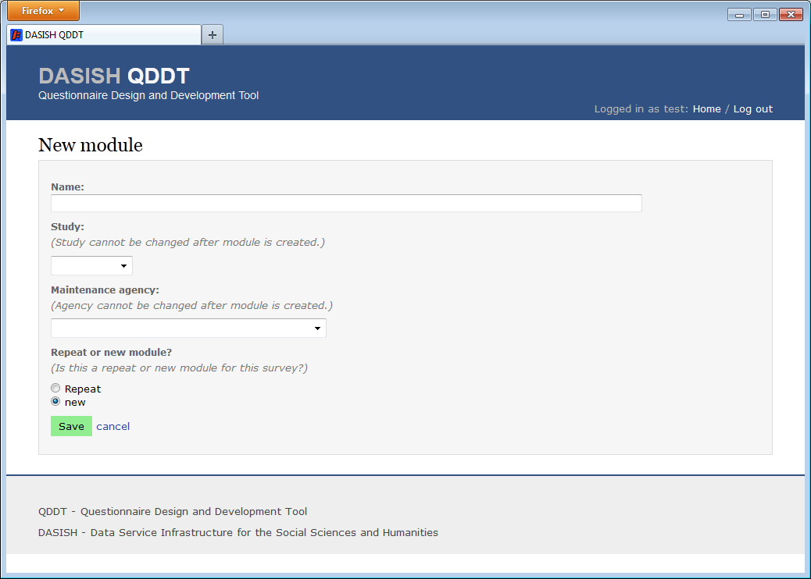

Figure 3 New module

**Note on saving:**

**Please note that to save your changes (to the database) you must click on the green buttons. The tool will (currently) not auto-save your changes. (Red buttons will remove or delete from the database.)**

**Any other buttons (blue buttons) or links (blue text) do not update the database. These buttons and links are for navigation purposes and will take you to another page in the tool or show you another view. Thus it is important that you save any changes that you will like to keep by clicking the green button before you ‘navigate away’ from the current view.**

## Module page:

When you create a new module or click on an existing module from the home page – you will get to the module page for the selected module.

Under the heading ‘Module development history’ you will find all revisions or iterations of the module. That is, all versions internal or public.

Click the green button to create the first iteration.

Now a new revision should have been created, and the green button disappears. There will always be only one version in development. And that version is only visible to the actor that created it or an actor with administration privileges.

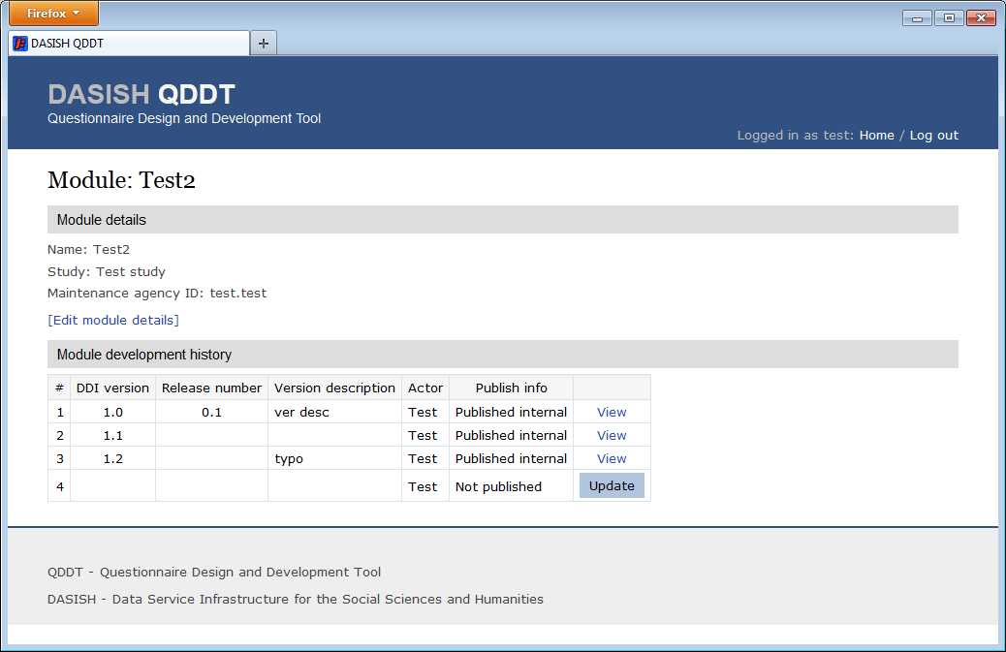

Figure 4 Module page, showing a module with four versions

## Update module version

To update the module, click on the ‘update’ button.

That will lead you to another page with a tabbed pane.

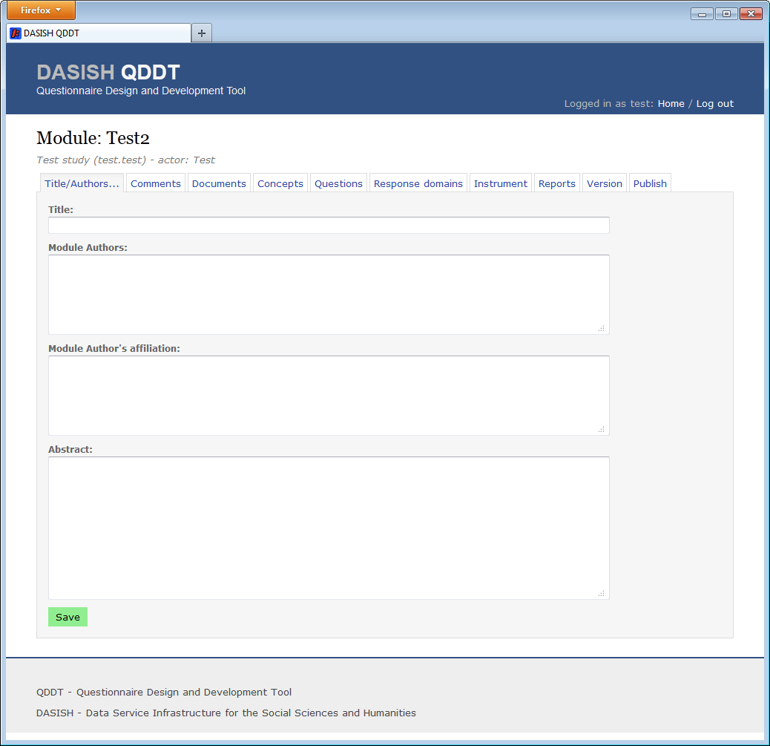

Figure 5 Update module

## Title/authors tab

Tab for updating the title, authors, and abstract of the module.

## Comments tab

Here you can add general comments that apply to the module as a whole.

## Documents tab

At this tab you can upload documents that describe the module in more detail.

## Concept tab

At this tab, you will first need to create a ‘Concept list’ before you can create concepts. Here you can name the concept hierarchy and provide a version description.

After you have created the concept list, you can add a new concept by clicking the green button labeled ‘Add new concept’ that will appear below the concept list form.

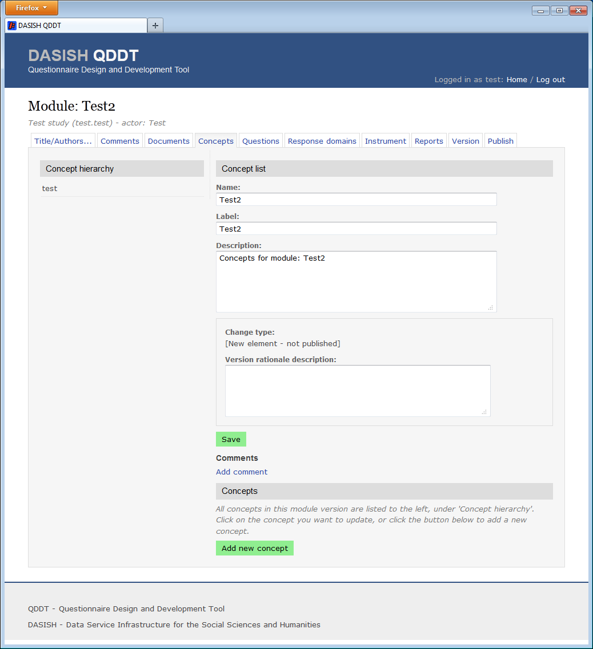

Figure 6 Concept tab – concept list

The new concept is created immediately and the navigation to the left shows the new concept as ‘(name missing)’. The new concept is also selected so you can update it right away.

You add a sub-concept by clicking on the button ‘Add new sub-concept’ when you have selected a concept.

You can add comments to the concept list, i.e. the concept hierarchy as a whole, or to individual concepts.

You can also associate this concept with a question by clicking the ‘Add question’ button.

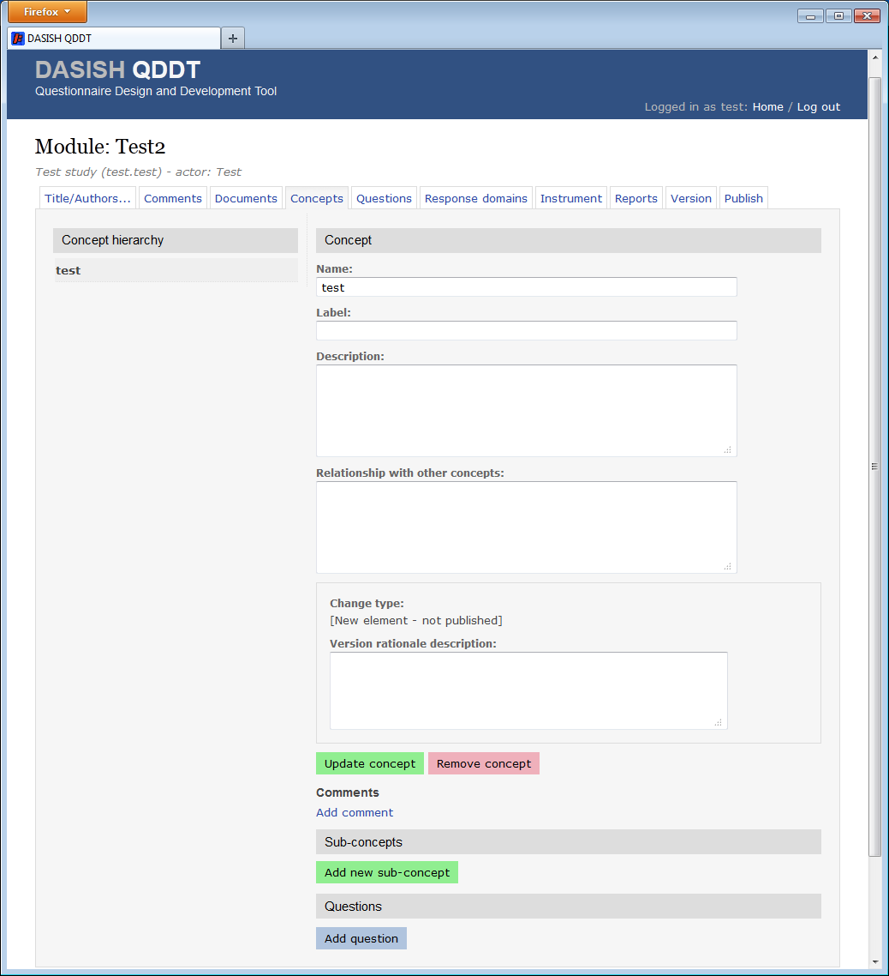

Figure 7 Concept tab - update concept

## Questions tab

At this tab you create questions. As for concepts you will (currently) first have to create a ‘Question Scheme’, or question list, before you create the individual question. The purpose of the question list, and concept list, is to group together the questions (and concepts for concept list). When doing this we can version the question list as a whole.

To create a question click the button ‘Add new question’. To update a question click the ‘Update question’ button for the question you want to update.

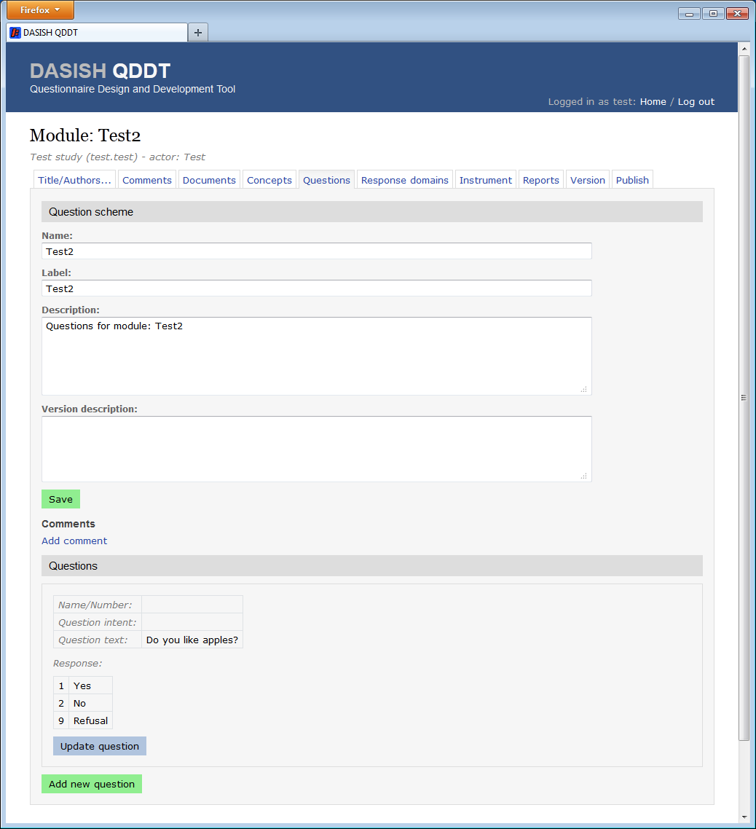

Figure 8 Questions tab

When editing a question, you can add a response domain, by clicking the ‘Add response domain’ or ‘Change response domain’ button.

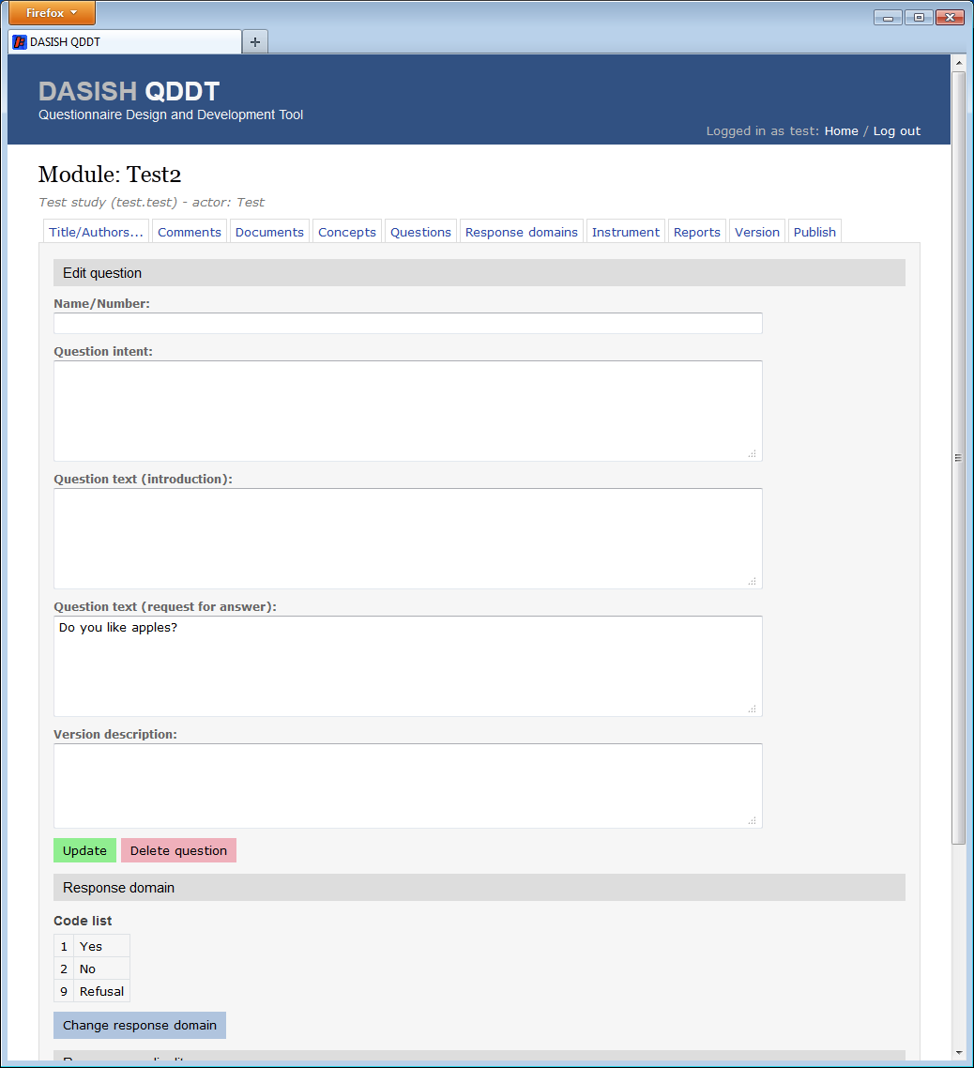

Figure 9 Edit question

## Response domains tab

At this tab you create the response domains. Currently the tool supports only code lists. A code list is created by first creating categories, and then codes based on categories, and finally the code list.

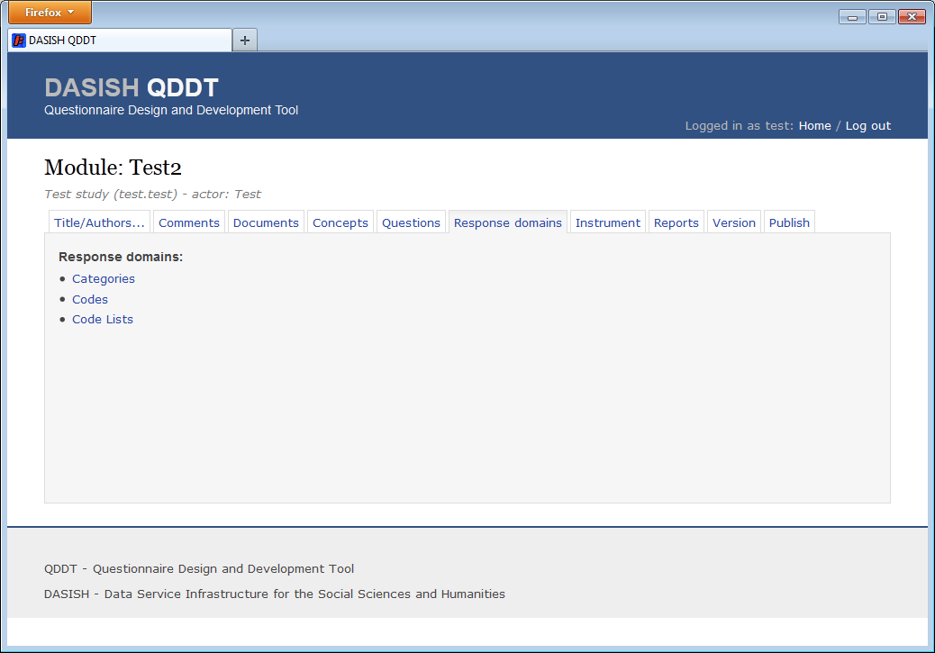

Figure 10 Response domains tab

There are three kinds of code lists: ‘Valid code list’, ‘Missing code list’, and ‘Code list’ (with both valid and missing codes). To create a code list with both valid and missing code, you will have to first create a ‘valid code list’, and then a ‘missing code list’. Then you can create a new code list consisting of the valid and missing code list you just created.

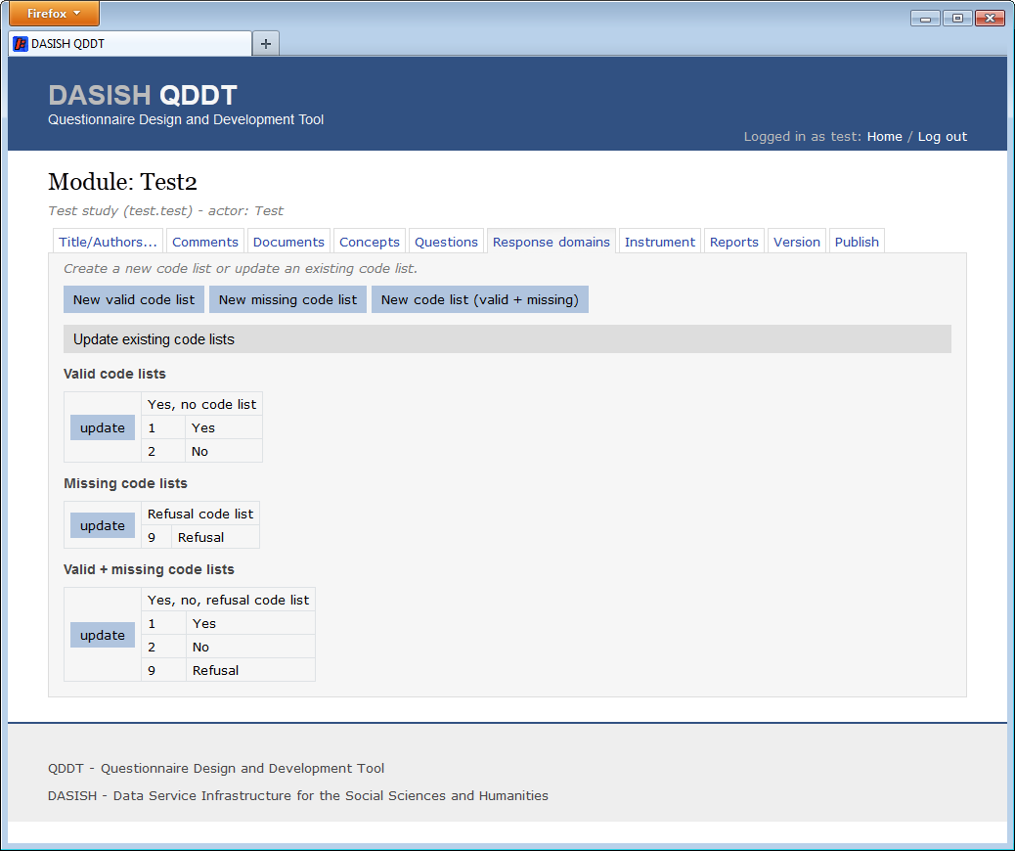

Figure Code lists

## Instrument tab

This is the tab where you actually create the questionnaire, i.e. choose the question order and control flow.

This is currently not implemented.

## Reports tab

This tab will let you create outputs and reports, also not implemented.

## Version info tab

Here you can provide version information to this module version.

## Publish tab

At this tab you publish the changes you have made for other to see, either internally (to a closed set of user) or externally (to everyone who has access to the tool).

When you publish your changes, you are actually publishing the module version you are working on. And this version will be stored permanently. The module version will appear in the ‘Module development history’ list.

You should publish/create new version when you wish to preserve a module state. That is, for example, when you would like to store a particular iteration of the development of the module.

Also you should publish/create new version when you want to use or reference any elements (concepts, questions …) created in the module.