## DWAN Wired-Marker manual

**1 DWAN Wired-Marker client as a part of DWAN framework**

1.1 What is it?

The DWAN (DASISH Web-ANnotator) client is a Firefox extension that enables a user to create free-text annotations on fragments of webpage content. Moreover, the user can share his annotation with other users by granting *read*, *write* or *all* permissions. The DWAN client has been developed on the basis of the existing *Wired Marker* web-annotation (Firefox Plugin) software, by adjusting it for collaborative annotating needs. The DWAN Wired-Marker version is implemented by adding program modules allowing sending and receiving requests to the common server database where the annotations of all users are stored.

The database and the server software that implements access to the database, constitute the back-end with which the DWAN Wired-Marker client communicates. The DWAN Wired-Marker instances, and also other DWAN compatible clients, have access to the database via a uniform service interface available over HTTP. In order to communicate with the back-end, clients must satisfy certain requirements: first of all, they should be able to send and receive requests in XML format according to the DWAN Schema; then, such requests should also satisfy DWAN’s API patterns.

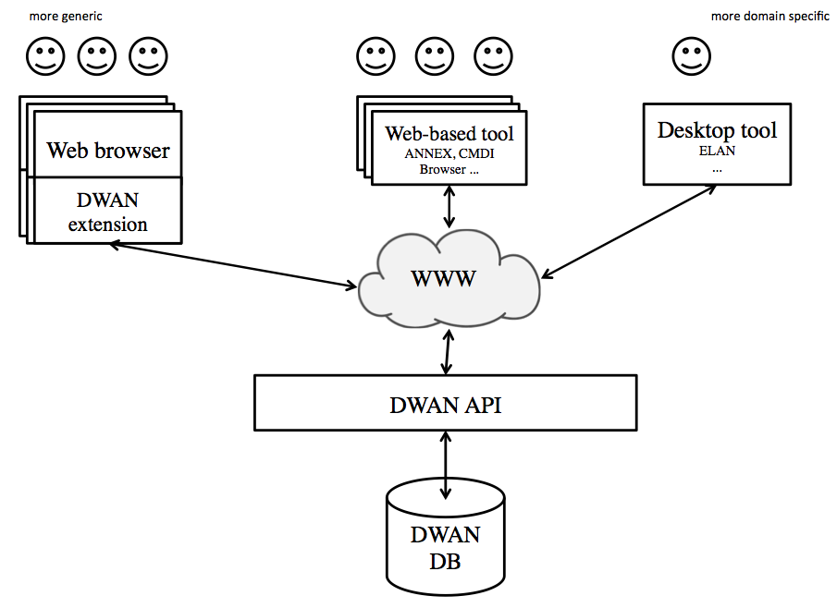

Figure 1. The DWAN Framework in more detail

1.2 Why use it?

The DWAN back-end and the DWAN compatible clients constitute the DWAN framework that is a solution for collaborative annotation. An important feature of the DWAN framework is that created content and sources can be stored in a shared database. In its turn, the DWAN Wired-Marker client allows a user to send and retrieve cached copies of the annotated resources.

1.3 Who is it for?

Individuals as well as groups of researchers from different institutions, countries or backgrounds can all benefit from using DWAN framework. Research Institutes or groups of researchers can develop their own clients for their particular use and purposes and as such they will have access to the shared DWAN Database.

**2 Download and Installation**

The DWAN client can be installed or downloaded from the github repository, <https://github.com/DASISH/dwan-client-wiredmarker/releases>. One can install it by navigating to this web page using the Firefox web browser, clicking on green button “dasishwebannotator.xpi” and following the simple standard instructions issued by the browser, like “allow” to install software from the site.

A second option is to start up a Firefox, drag and drop the xpi-file onto the Firefox window and yet another option is to: 1) download the xpi file in some directory of the user’s computer; 2) run the Firefox add-on manager; 3) follow “Install add-on from File” procedure by clicking the corresponding menu (see Figure 2).

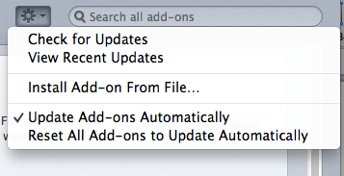

Figure 2. Firefox menu to start installation of the DWAN client from file

After installation is completed, “DWAN/Dasish Web Annotator” is added to the Firefox menu and once activated, the DWAN menu will appear on the left sidebar.

**3 Using DWAN**

3.1 Account management and logging-in

In order to use DWAN one needs to login into the back-end. DWAN offers two ways of authentication: (A) using a federated login e.g. *Shibboleth* and (B) with a local DWAN account that you can create yourself by filling in a form on the DWAN server-generated web page where you provide your login, e-mail address and password. Below both authentication procedures are described in more detail.

1. If your institution is part of the DWAN supported trust federation[1] and listed within the Discovery Service list of home organizations (see Figure 3**.**) you login with your institution credentials. Choose from the list of home organizations, select, and log in.
2. If your institution is not listed on the home organization list, you can create a user account following the following steps:
   1. Go to *https://myserver/ds/webannotator-basic*. [2]
   2. click on *Register as a non-Shibboleth user*
   3. fill in the user registration form and submit it

d. go to DASISH Web Annotator > Settings > Server > write this link: *https://myserver/ds/webannotator-basic* in the *User Specified* box and close.

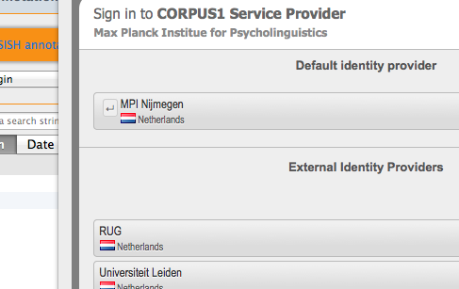

Figure 3. Authentication using Federated Identity

3.2 Viewing annotations

Annotations created on other client instances or by other users are all listed in the **Incoming** folder, in the left side box. The DASISH website is the default webpage. Navigate to the page you are interested in. Click the “reload” icon in the browser bar. If the page has been already annotated, a full list of annotations will appear on the bottom-left side of the browser window. The list can be ordered by annotations’ title or date. Please note, it is not possible to see the author of the annotations.

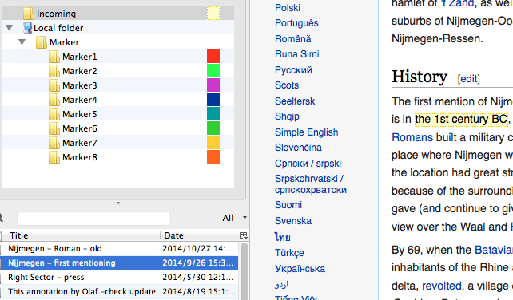To see annotations from the other users, click on the annotation you want to see in the full list. It will appear on the webpage marked by light yellow color, see Figure 4.

Figure 4. Viewing annotations of other users

To view own annotations, navigate to the **Marker** folder and click on the color used to make the annotation you are interested in. You will see the list of all annotations marked by this color. Select the one you need, see Figure 5 for an example.

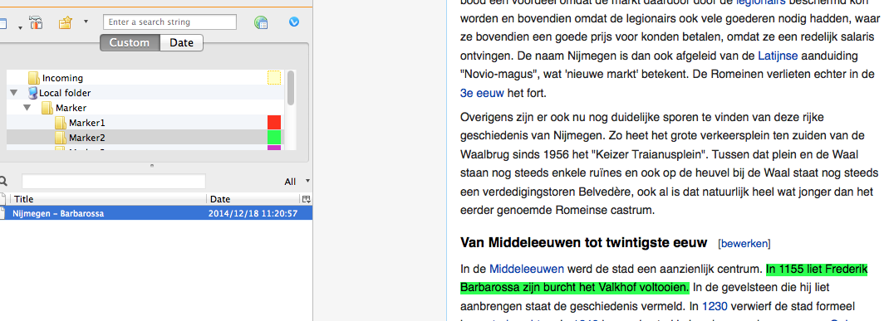If an annotation does not appear after clicking on it and also after refreshing the page, it means that the DWAN client cannot resolve the annotated fragment. The most probable reason for this is that the webpage has been changed since it was annotated.

Figure 5. Annotations viewable in the Marker folder

However, in DWAN a user can see the annotations even if the webpage has changed. This is done by requesting cached representations of the corresponding annotated pages. To do this, point the mouse to the annotation in question and right-click. In the pop-up menu select "*Cached representations*" and click "*open remote cache*" in the sub-menu. You will be able to get the cached representation of the page, which almost always looks like the original page. You will find the annotation you are interested in.

3.3 Annotating documents and editing annotations.

To annotate a web-document, navigate to the corresponding webpage and select a text fragment with the mouse. After right click select “Marker”-folder in the menu. Next, select the color you would like to use to mark the text fragment, see Figure 6.

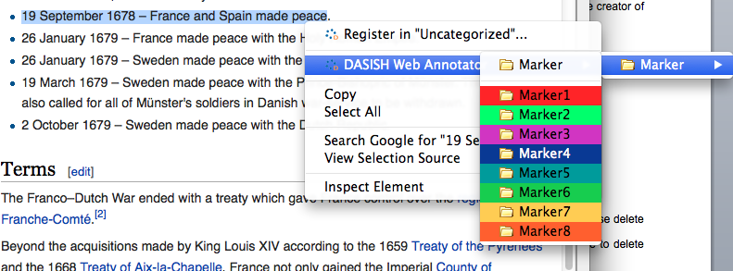

Figure 6. Selecting a marker

Following this, a pop-up text-box with two fields appears. One can assign a distinctive title to the annotation in the *Title* field and write a clear short description in the *Annotation* field, see e.g. Figure 7. To save the work, click “ok”. This then (finally) creates the annotation. It is shown on the web page now.

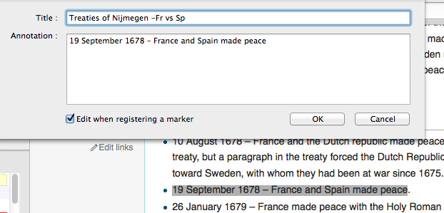

Figure 7. Creating an annotation

To annotate an image, click on the image you want to annotate, right click, select Dasish web Annotator and choose the marker colour you would like to use from the Marker folder. Annotate as you would normally annotate a text. The annotation will appear in the list of annotations as a normal annotation but it will have the symbol of a picture to distinguish it from text annotations.

To update the annotation, pick it up in the list, right click it and select “Properties” in the menu. The form for editing will appear, and by selecting tabs “Brief Overview” or “Annotation” one can edit the title and the text body. See Figure 8. Note, that only the creator of annotation or a user with *write* access can update the annotation.

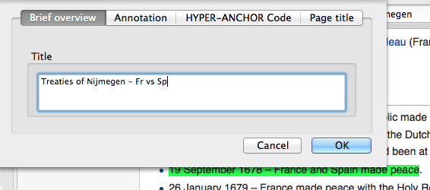

Figure 8. Editing annotation

You can delete your own annotation of an annotation to which you are assigned *all* access mode.To delete an annotation, first find the annotation you would like to delete in the corresponding folder, then right click on it and select ”Delete”.

3.4 Managing access rights for annotations.

When the user creates an annotation, all registered users except the creator (“owner”) get *read* access. The owner has *all* access, and users with *write* access can edit the annotation. Only the owner of an annotation or a user with *all* access can change the rights of other users and delete the annotation.

To change the access rights of an annotation right click it and select “Permissions”. Fill in the pop-up form, see Figure 9.

*Public access* defines minimal access rights for each logged-in user. For instance, if it is set to *read* then each logged-in user is able to read the annotation. Rights for a particular user are defined as maximum of public access and his individually set rights. For instance, the user with the e-mail [xxx.yyy@mpi.nl](mailto:xxx.yyy@mpi.nl) on the Figure 9 has *write* access.

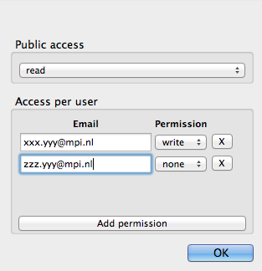

Figure 9. Changing access rights for a selected annotation

**4 DWAN TROUBLESHOOTING**

Advanced users and developers can examine the relationship between the Back-end and the Front-end directly by installing Firebug or Tamper Data, which are two other Firefox add-ons. This can be useful in situations where DWAN does not seem to work properly.

Because of the updates of the DWAN client, Firefox and operating systems, sometimes it is necessary to reinstall the client after a new release. Normally, it is necessary first to de-install the current version of the DWAN client following standard Firefox procedure of the add-on manager. Follow Tools > Add-ons in the browser menu to start the add-on manager. Within the add-on manager choose to de-install a selected extension, e.g. the DWAN client. Now, the second step: the new version of the DWAN client can be installed as it is described in the beginning of this manual.

However, sometimes the newly installed version would not work. In this case one should inform the administrator and the DWAN developers. Still to be able to work, create a new Firefox profile. Within this new profile you will download and start the new version of the DWAN client as usual. How to make a new profile and start it, is explained in detail at <https://support.mozilla.org/en-US/kb/profile-manager-create-and-remove-firefox-profiles>.

Alternatively, on MAC OS one can create a profile via Terminal window by using the command *mkdir -p ~/Library/Application\ Support/Firefox/Profiles/nameofprofile.* The instance of the Firefox with the given profile can by launched by the command

*/Applications/Firefox.app/Contents/MacOS/firefox -profile ~/Library/Application\_Support/Firefox/Profiles/nameofprofile -no-remote*.

To create and use a new Firefox profile in Windows you can use the Firefox Profile Manager that allows you to create a new profile while retaining your original one. If Firefox is open, close it completely by choosing “File -> Exit”. Go to the Windows Start Menu and select “Run”. Enter firefox.exe –P and click OK. Click the “Create Profile” button on the “Firefox – Choose User Profile” window that comes up. Click “Next >” in the “Create Profile Wizard” window that comes up. Type in a new name in the “Enter new profile name” box and click “Finish”. Clear the “Don’t ask at startup” box so that it is unchecked and click the “Start Firefox” box. Firefox will then start with a new profile.

**5 GLOSSARY**

**Annotation**: Annotations can loosely be described as all sorts of comments attached to text, images or other types of data.

**API**: “In [computer programming](http://en.wikipedia.org/wiki/Computer_programming), an **application programming interface** (**API**) is a set of routines, protocols, and tools for building software applications. An API expresses a [software component](http://en.wikipedia.org/wiki/Software_component) in terms of its operations, inputs, outputs, and underlying types. An API defines functionalities that are independent of their respective implementations, which allows definitions and implementations to vary without compromising each other. “ (Wiki).

**Cache**: In computing a cache is a component that stores data so that future requests for such data can be served.

**DASISH**: Data Service Infrastructure for the Social Sciences and Humanities. This European funded project brings together all 5 ESFRI research infrastructure initiatives in the social sciences and humanities (SSH), CLARIN, DARIAH, CESSDA, ESS and SHARE, and aims to provide solutions to a number of common relevant issues.

**Firefox**: Mozilla Firefox, also known as Firefox, is a free, open source web browser developed for Windows, OS X and Linux with a mobile version for Android.

**Firefox Add-On**: Add-Ons are installable enhancements to Mozilla Firefox that allow adding or augmenting application features.

**Firefox Profile**: All the changes that one makes in Firefox are stored in a special folder, called *profile*. One’s profile is stored in a separate place from the Firefox programma so that, if something ever goes wrong with Firefox, their information will still be there.

**Identity Provider**: An Identity Provider (IP or IdP) is responsible for providing identifiers for users looking to interact with a particular system and asserting to such a system that such an identifier presented by a user is known to the provider.

**REST**: REST stands for Representational state transfer and is an abstraction of the architecture of the World Wide Web. The REST architectural style is also applied to the development of web services.

**RESTful**: A web service can be characterised as RESTful if they conform to the REST architectural constraints. RESTful web services are built to work best on the Web.

**Shibboleth**: is a free and open source federated identity solution that connects users to applications both within and among organisations.

**Wired-Marker**: is a Firefox Add-On used to highlight and annotate web pages.

**XPI (Cross-Platform Installer Module)**: is a technology used by Mozilla for installing Mozilla extensions. An XPI Installer Module is a ZIP file that contains an install script or a manifest at the root of the file, and a number of data files.

1. Currently the DWAN back-end is connected to the CLARIN trust federation and allows access to all home organizations using CLARIN services as are also all eduGAIN connected home organizations.
2. For example, the current DWAN annotation service is located at <https://corpus1.mpi.nl/ds/webannotator-basic/>