

Data Service Infrastructure for the Social Sciences and Humanities

EC FP7

Grant Agreement Number: 283646

**Deliverable Report**

Deliverable: D5.6

Deliverable Name: DASISH Web Annotation (DWAN) framework

Deadline: M36

Nature:

Responsible: Daan Broeder, MPG-TLA

Work Package Leader: Daan Broeder, MPG-TLA

Contributing Partners and Editors: Valentina Ascuitti (KCL), Daan Broeder (MPG-TLA), Stuart Dunn (KCL), Twan Goosen (MPG-TLA), Indrek Jentson (University of Tartu), Kees-Jan van de Looi (MPG-TLA), Olof Olsson (UGOT), Stephanie Roth (UGOT), Olha Shkaravska (MPG-TLA), Menzo Windhower (MPG-TLA).

Table of Contents

2. Executive Summary 1

3. Introduction to the DWAN framework 2

3.1 Motivation 2

3.2 User scenarios 2

3.3 Requirements 4

4. Annotation Tools 4

4.1 State of the art on September 2012 4

4.2 Developments after September 2012. 9

5. DASISH Web Annotator (DWAN) 9

5.1 Framework architecture 9

5.2 DWAN’s Model and its connection to Open Annotation Model 10

5.3 DWAN Backend 14

Architecture 14

Database and Database Access Objects 14

REST Application Programming Interface 15

5.4 DWAN frontend(s) 21

Wired-Marker based frontend 21

Frontend for ELAN 23

Frontend for ANNEX 24

5.5 Testing Procedure 25

6. Social Sciences and Humanities: Results and Outlook 25

6.1 List of annotation tools used by the HSS community 26

6.2 Functionality mapping 38

6.3 Potential front-ends for DWAN in Social Sciences and Humanities. 43

7. APPENDIX 50

7.1 Schema 50

7.2 Wired-Marker-based DWAN frontend. Manual 56

# Executive Summary

The availability of digital archives and other research data via the Internet creates new chances for collaboration. Indeed, equipped with special software, researchers from different institution, countries and fields can work together via the network. Such collaboration can take the form of annotating the data and sharing these annotations using an annotation infrastructure. As stated in the task 5.6 description, *researchers need to be able to store the results of collaborative intellectual work either as an annotation of a single fragment or in the form of typed relations between a number of fragments.*

The aim of this document is to give a specification of a framework for annotating web-documents developed according to task 5.6 plan. By an annotation we mean a remark over a fragment(s) of a document(s).

From the technical point of view the proposed framework consists of one *backend*, constituted of the server software and the database, and possibly multiple *frontends* (clients). Developed within DASISH project the DWAN tool is an instance of the DWAN framework. It consists of the backend part and the client, which is a significantly adjusted version of the *Wired Marker* Firefox extension. The core of the backend is a database where annotations and information about corresponding annotated target documents are stored together with the targets’ cached representations. Archiving cached representations in the database is relevant when annotated documents are dynamically changed pages like news sites or wiki-pages under construction.

A client in the DWAN framework exchanges data with the server by sending REST requests and getting responses. Client-request bodies and server's responses have a form of XML files. The client is able to accept and send XML structures that obey a pre-defined XML schema. The schema mirrors a data model that has been designed to represent the main data structures, which are involved in constructing annotations.

# Introduction to the DWAN framework

## Motivation

In the last decades, we have witnessed large amounts of data moving to digital archives. These archives have been connected to the Internet, spreading the content through the research community. The availability of such data creates new chances for collaboration. To bring this collaborative environment to a next, higher level, the requirement is to develop a set of tools that allows groups of researchers from different institutions, countries, or backgrounds to work together. Such collaboration can take the form of annotating the data, and sharing these annotations using an annotation infrastructure.

By an annotation we mean a remark over a fragment(s) of a document(s). For instance it can be a text note containing the short English translation of a certain sentence in a target document, which is in Catalan. Annotatable documents include, for instance, web-pages or web-documents generated by linguistic software, e.g. EAF-files, created by [ELAN](http://tla.mpi.nl/tools/tla-tools/elan/).

## User scenarios

Consider examples of user scenarios that can be successfully run on the DWAN tool in its current state. It is assumed that before getting acquainted with these scenarios, the reader either has certain minimal experience with Wired Marker or at least has read DWAN *Manual,* which can be found in the Appendix at the end of this document.

The term *principal*, which we use below, in general denotes either a user or a group of users. At present, user and principal are synonyms for DWAN tool.

1*) Getting an annotation whose web-page page has been updated*.

The principal logs in, sees the list of annotations, chooses the one (s)he wants to see on the corresponding web-page. (S)he clicks on the annotation in the list, tries a few times to reload the page, but the annotation does not appear. The front-end cannot resolve the annotated fragment, possibly because the page has been updated and the fragment has changed its position or has disappeared completely. The principal requests the front-end to retrieve the remote cache and gets the cached representation of the page together with the other annotations done on this page by the moment of making the annotation under consideration.  Indeed, it can be seen that the page has been updated.

This use case was a part of the DWAN demo during LREC 2014. The wiki-page of "Right Sector" was used. “Right Sector” is a block of right and extreme-right groups in Ukraine. Due to highly unstable situation in the country this page is updated very often.  The reader can get the annotations on this wiki-page and their cached representations if (s)he has the Wired-Marker-based DWAN frontend installed.

2) *Changing users’ access mode for a particular annotation*.

The Wired-Marker-based DWAN client is implemented in the way that when a principal posts an annotation then all DWAN's registered principals automatically get the right to *read* the annotation. This excludes possibility to alter it. On principal’s request, the backend can issue one of two HTML forms for changing access modes, which can be *read*, *write* or *none*. Filling up and submitting the first form allows changing the access to a particular annotation of a particular principal. The second form is used to change public access mode at once, that is all registered principals get *write* access. Only owner of the annotation can change its access modes. Of course, all the changes are invertible.

Updating access modes is implemented through backend’s HTML forms because changing access rights is not implemented in Wired Marker, and adding this feature to DWAN frontend would be quite time consuming.[[1]](#footnote-1)

3) *Creating specific principal’s folder*.

Initially the Wired-Marker-based DWAN client generates the set of pre-defined folders (colored “marker”) for the logged-in principal. Annotations are sorted by the corresponding colors. If the initial collection of markers does not suffice the principal can create her own subfolder by choosing a new marker from a richer set of colors. For instance, she creates a purple marker-subfolder, where she collects all the annotations about the family of Picasso, from various web-pages.

The color information is sent to the server when an annotation is posted. Unfortunately, sorting annotations by colors is visible only by the creator of the annotations and only on that client instance where these annotations have been created.  For the time being a client cannot interpret color information that it gets from the server and all “the others” annotations are collected in a folder called *incoming* and have light-yellow color. [[2]](#footnote-2)

4) *An annotation on an annotation*.

A principal makes an annotation and then the same or other principal annotates this annotation. This feature can be used e.g. in remote discussions. It is technically possible since in DWAN annotation framework one can annotate any document accessible via the Internet. DWAN annotations are such documents.[[3]](#footnote-3)

## Requirements

In the DWAN framework it is assumed that possibly multiple clients communicate with a single backend consisting of the database and the server software which implements access to the database. A client is developed specifically for a particular sort(s) of web-documents, whereas the backend is not specific and treats requests of all clients in the same way. The core of the backend is the database where annotations and information about annotated targets are stored together with cached representations of the targets. A cached representation is a copy, e.g. a screenshot, of a target document. Storing cached representations allows to retrieve the copy of an annotated document when the actual web-document under the target’s URI has been updated so that locating the annotation in it becomes difficult or even impossible. It may happen when the corresponding fragment has been significantly changed or disappeared.

A client and a server exchange data via sending REST requests and responses. A client accepts and sends XML files that obey DWAN XML schema, which is a part of the server-side software. It mirrors a data model that has been designed to represent the main data classes, which are involved in constructing annotations, and relations between these classes.

# Annotation Tools

## State of the art on September 2012

Before development of DWAN began, more than 40 available annotation tools had been investigated to see if they could be (and to which extend) used as a starting point for the DWAN client. Selection had been based on four criteria: tool’s functionality compliance with task 5.6 requirements, if it is open software, if it can be adjusted to communicate with the backend, and platform-independency. The Table 1 represents the results of the investigation.

Table 1. Annotation tools available by Autumn 2012

|  |  |  |  |  |  |
| --- | --- | --- | --- | --- | --- |
| Tool | state | Open software | Backend access | Platform (browsers) | Functionality |
| A.nnotate | active | commercial |  |  | Annotating PDF, Word and other document formats on-line |
| AnnotationEdit | active | Commercial |  |  | Annotating video, audio |
| Annotator | active | Open source   Java Script | yes |  | Library and plug-in adding annotation functionality to any web-page, but one needs to alter its html by running script there |
| Annotea, Amaya | Last release jan 2012 | Open source | yes | Different distributions Linux, Windows, MacOS | Written in C, annotating html-web documents |
| Awesome Highlighter. | Not active ??  Web-page broken |  |  | Firefox bookmarklet, or add-on,  or by using the tool ‘s website | Highlighting and clipping chunks of text on web-documents |
| Blerp | Not active ??  Web-page broken |  |  | IE PlugIn, Firefox addOn | Support conversation on top  of the web-page |
| BounceApp | active | Free app | yes | Via their web-page http://www.bounceapp.com/ | Collaborative via sending “screenshots” in e.g. Facebook, Twitter and Notable |
| The Commentor | active | Commercial with the base plan free (3 collaborators) |  | Web-site, you need an account | Collaboration on visual media projects |
| CritLink | Last executable from 2000 |  | yes | Unix | Annotating web-documents in local networks and on the internet. Different colour means different sorts of comment: support (green, +), issue (red, -), bcomment (bule, #), query (orange, ?) |
| Crocodoc | active | Commercial with free Standard edition | yes |  | Annotated PDF, word, Pwerpoint documents are saved on Crocodoc servers |
| DIIGO | active | Commercial  with free base account | yes | Firefox, Safari, IE | Annotating web-pages, saved to Diigo library, Diigo account is needed |
| DrawHere | active | ??, one needs  an account |  | Firefox, IE bookmarklet | Drawing on web-pages, shareable |
| ThirdVoice | Discounted in 2001 |  |  | Browser Plug-in | Commenting web-sites, anyone could write anything; a lot of criticism from the web-page owners |
| Wired Marker | active | Creative commons | yes | FireFox extension | Highlighting and putting text notes on the fragments of web-documents |
| Fleck | Tool of 2006, Inactive? their site does not exist any more |  |  |  |  |
| http://delicious.com/ | active | Need an account | no | Bookmarklet |  |
| http://evernote.com/ | active | Need an account,   premium is commercial | no | Server, storage of the documents | With “skitch” : annotating pdf and images, not web-pages |
| http://webmarginalia.net/ | active | Open source Java Script | yes | Firefox, Safari, Chrome, IE,  For Moodle and Open Journal system | Highlighting html |
| http://www.yandell-lab.org/software/mwas.html | active | Need an account | no |  | Annotating genomes |
| TrailFire | Last mentioned in 2007 |  |  | Firefox, IE | Annotating (notes) webpages, categrozing annotated web-pages, sharing |
| REddIT | active | Need an account | no | server | Social networking  and  news website |
| ReframeIT | obviously not available any more, only light-weight demo on website, add-ons outdated, integration info missing on official website |  |  |  |  |
| Scrible | under development: free public beta version available | premium, paid edition under development, not yet available, license:  no modifications allowed |  |  |  |
| SharedCopy | State uncertain. According to http://en.wikipedia.org/wiki/Web\_annotation: Development has stopped. Observe: copyright date of official website: 2012 |  |  |  |  |
| ShiftSpace | Development has stopped. |  |  |  |  |
| Skim | active | BDS license |  | OS X | PDF reader and node taker |
| WebNotes | active | platinum /pro/lite version/, account is needed,  modification under permission |  |  | Adding notes to PDF and web-pages |
| JKN | new? |  |  |  | <http://info.jkn.com/firefox.htm>, Light version with available features: web page annotation, organize and search notes, share notes via email, twitter, and permalink or any other similar url found from annotation evaluation lists - they didn't work at all! |
| Keeppy |  |  |  | Server | <http://www.keeppy.com/>, a social network, relevant for our purposes |
| Loomp | new? | No license information, short technical information and easy access for downloading is missing. |  |  | One Click Annotator, a WYSIWYG Web editor for enriching content with RDFa annotations, <http://loomp.org/index.php/home.html>, |
| MarkITUp | new? | MIT/GPL licence, based on former jTagEditor, |  | needs jQuery 1.4.2 Javascript library | Toolbox. Will never be WYSIWYG editor. <http://markitup.jaysalvat.com/home/>, |
| NotateIT | new? | not open sources |  | only for Windows, seems not to be compliant with other platforms | <http://www.notateit.com/> |
| WebKlipper | new? | commercial |  |  |  |

As one can see, there were not that many open-software tools with suitable functionality available. Moreover, not many of them were well-documented. At the end the decision was made to select *Wired Marker* as a starting point for DASISH web-annotator client.

*Wired-Marker* is a Creative-Common licensed Firefox plugin, with the possibility to change the code under the agreement with its creators. It is platform independent since Firefox is one of the most popular browsers installable at Linux, OS X and Windows. The access to the backend database can be adjusted.

*Wired-Marker’s* functionality, though limited, still goes in line with DASISH purposes: a text fragment of an arbitrary web-document can be marked by a selected colour and a text remark (an annotation body) can be put on it. It was possible to extend the code so that the extension could communicate with the server to retrieve an annotation from the database or send a created annotation to the backend.

Another tool, called *PundIt* can do more than Wired-Marker, but unfortunately by the time when DASISH task 5.6 team had to make a decision, it was not yet available and it got Open Source license after development of DWAN had already started.

## Developments after September 2012.

*PundIt* allows to annotate images and their fragments. Moreover the tool allows to collect annotations into notebooks. In fact, Notebooks can be viewed as a generalised version of colours (markers) of *Wired Marker*. A notebook can be read exactly in the form intended by its creator.

*PundIt* has a feature, which in some cases may be considered as an inconvenience. While creating an annotation, a user must think in terms of a triple *Object-Predicate-Subject*, for instance “Karl Marx” (subject) “talks about” (predicate) “Kapital” (object). “Karl Marx” denote not only a piece of text but it is rather a wider notion, an *item*. Under this *item* one can collect texts, images or their fragments representing Karl Marks on the web-pages.

*ReframeIt* has appeared as a Firefox add-on for commenting web-pages and sharing it via Facebook, Twitter, Blogger, FriendFeed, Wordpress, RSS, HTML, e-mails.

# DASISH Web Annotator (DWAN)

## Framework architecture

The DWAN design assumes multiple clients working together with a single backend consisting of a database and a Representational State Transfer (REST) web service implemented in Java. It allows annotating any web-accessible content, linking data, creating relations, or providing feedback. Its novelty is that the created content and target annotated documents can be stored in a digital archive (in the database), which guarantees their sustainability and persistence. The digital storage for annotations and related resources is provided by TLA-MPI[[4]](#footnote-4).

DWAN is also especially meant to cater for specific linguistic tools that through their use of linguistic data formats can annotate specific linguistic items such as lexical items, annotation tags etc.



Figure 1. The DWAN Framework

## DWAN’s Model and its connection to Open Annotation Model

The class *Annotation* is the core of the model (see Figure 2). The relations *Annotation - Target*, *Target - Source*, *Target - Cached Representation* closely follow the *Open Annotation* (OA) standard. An annotation, i.e. an inhabitant of the class *Annotation*, is a structure that contains necessary information about user's annotation. In particular it contains the annotation's identifier, the reference to the owner and the time of creation. An owner is either the principal who has created the annotation or a principal to whom the ownership has been assigned.[[5]](#footnote-5)

Besides the owner, an annotation has *readers* and *writers*. As one can expect, a reader is a user that can read the annotation, and a writer can also add changes to it. Thus, a registered principal can be related to an annotation by means of one of three access modes: *reader*, *writer, none*.

An annotation can have one or more *targets*. A target (i.e. an inhabitant of the "Target" class) contains the reference to the web-document (a *source*) and the precise description of the document's fragment, which is actually annotated. Moreover, a target may refer to one or more cached representations of (the relevant parts of) the target document with the precise descriptions of the annotated fragments for each representation.

The semantics of an annotation is given in its body. In the implementation a body is an arbitrary text or an XML text. In both cases a precise MIME-type must be given by a client. For instance, a body can be a plain text, which describes a relation (like contradiction) between two fragments of some web-document. In this case the body should contain references to the targets that represent these two fragments and the document. Annotations can be gathered in notebooks.

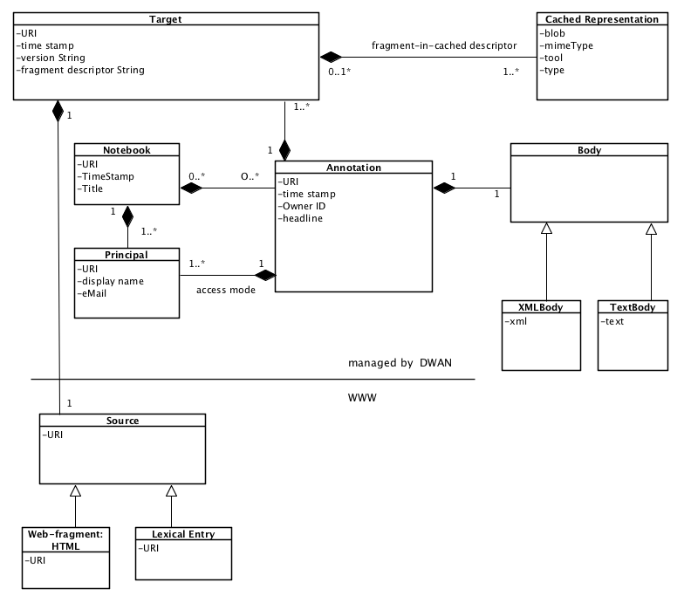

Figure 2. A simplified class diagram representing the DWAN model.

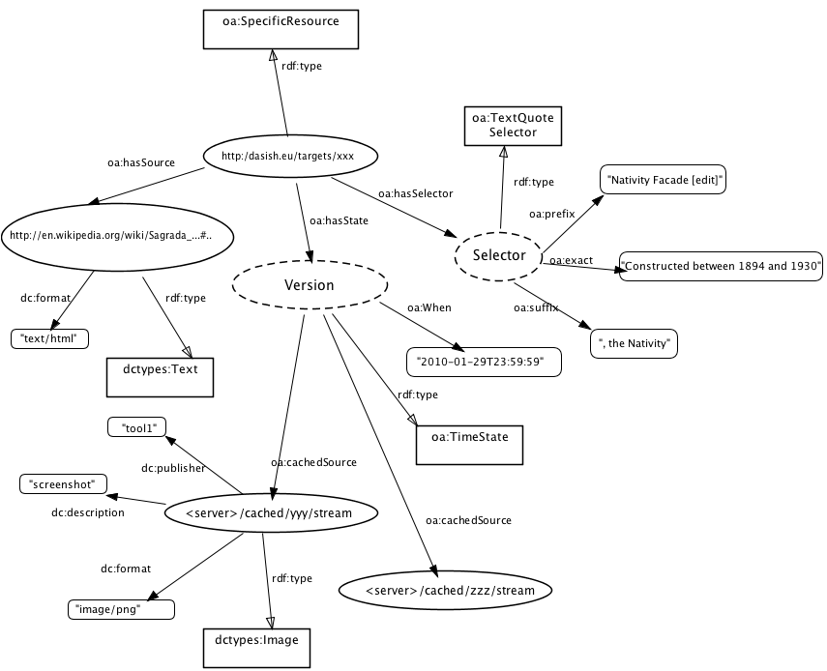

Figure 3. The DWAN target expressed using Open-Annotation vocabulary

DWAN model has been designed with *Open Annotation* in mind, and therefore the mapping between DWAN-model components and open-annotation concepts is build in a natural way. The targets of DWAN model correspond to the instances of the open annotation class oa:SpecificResource, see Figure 3. Multiple target sources are represented as instances of oa:Composite. Each of oa:item of the composite is either an instance of oa:SpecificResource or oa:Composite.

A cached representation of an annotated target source is referred via the target’s state, see the figure above. The properties oa:hasState and oa:cachedSource are used. The metadata of the cached representation are presented via dc-properties and dctypes: mimeType is presented as ​dc:format, tool is presented as ​dc:publisher, type is presented as ​dc:description; note that ​dc:type cannot be used here because its value must (recommended) be from the DCMI Type Vocabulary[[6]](#footnote-6); therefore, e.g. "screenshot" would not be a good value here. Moreover, a cached representation must have one of the dctypes as rdf:type, and it must be compliant with dc:format value. For instance, if dc:format is "image/png" then the corresponding rdf:type must be dctypes:Image.

A principal is an agent, and for agents *Open Annotation* recommends to use foaf namespace, see ​<http://xmlns.com/foaf/spec/>. This data model is designed for social networks, and in principle suits DASISH schema for a user and permission lists. There is one little technical inconvenience: foaf agents do not have a property which can be used to define permission types (reader, writer) directly. For now, permissions are represented via property foaf:topic\_interest. For an example, see Figure 4.

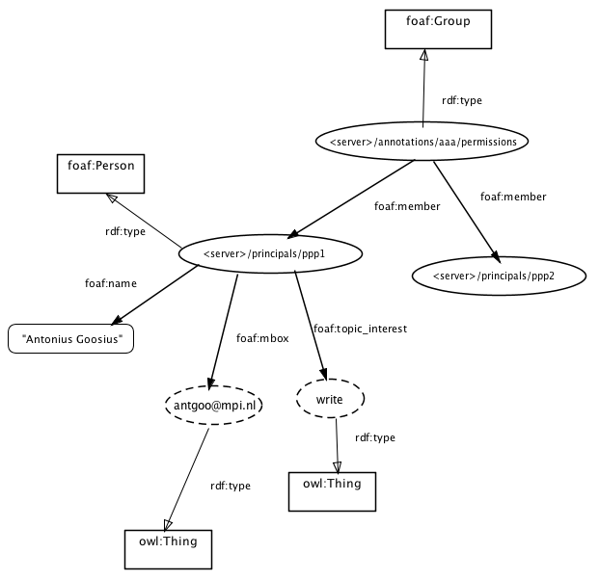

Figure 4. Example of an OA representation. Principal.

An annotation body in DASISH can be any correct xml or a text. A generic way to present such bodies in *Open Annotation* is to consider a body, which (typically) has attributes and elements, as instances of oa:Composite. Any element and any attribute of the body becomes an oa:item of the body. If an element has sub-elements, it is an instance of oa:Composite as well, etc. An attribute or an element with now sub-elements has one of the dc:types and one of the dc:formats, and possibly additional relevant properties, such as cnt:chars for text values.

## DWAN Backend

### Architecture

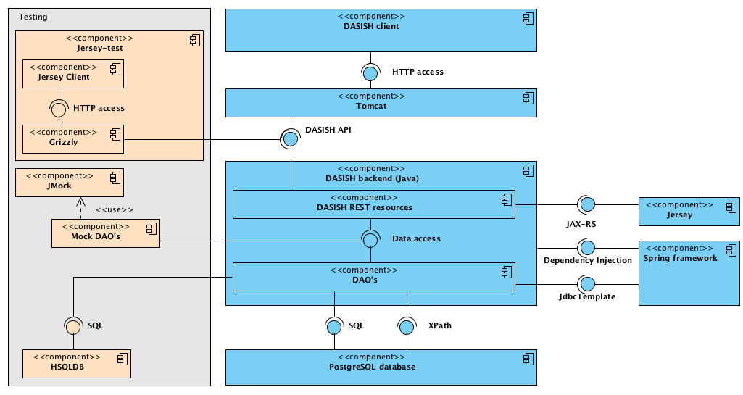

Figure 5. The DWAN-backend architecture

### Database and Database Access Objects

A PostgreSQL relational database provides storage for all the core resources: annotations, targets, cached representations, principals and notebooks. The database contains five main tables; each of them stores a corresponding type of resource. A column in a table represents an attribute in the corresponding resource class. For instance, any resource class has an attribute *id* (an identifier of type *xml:id*). This identifier is a part of the URI through which a client accesses an instance of the resource. URI has the form <service-uri>/<resource/<id>, e.g. *https:/dasish.mpi.nl/api/annotations/e3c834f0-34c4-11e3-aa6e-0800200c9a66*. Each of five resource tables has its column *external id*, that keeps public identifiers. From the programming point of view an external identifier is a UUID string generated by the server when a resource, e.g. an annotation, is added to the database.

Annotation bodies are stored in the table *annotation* in the column *body*.

Furthermore, there is a number of join tables representing the relations between the resources, which are described as relations between the resource classes. These relations induce a hierarchy between the resources. Indeed, any of the relations can be abstracted to "refers" so that we have that a *principal* refers to an *annotation* or a *notebook*, an *annotation* refers to a *target* and a *target* refers to a *cached representation*. As one can see, cached representations have the lowest position in this hierarchy. This hierarchy induces a "cascading" mechanism of adding and deleting resources in the database. For instance, removal of an annotation from the database triggers the removal of its targets, except for the ones to which other annotations still refer. In turn, removal of the targets triggers removal of all the corresponding cached representations unless some other targets refer to a cached representation under consideration.

*Database Access Objects* (DAO's) are used to programmatically access the data in the database. The DAO mechanism allows to form and call SQL database commands like SELECT, UPDATE, INSERT, and DELETE from Java methods. Methods for basic manipulations over resources (retrieving, updating, adding and deleting) are defined in the corresponding DAO java interface. For instance, the AnnotationDao.java interface lists the signatures of all necessary basic operations over the table *annotation* and the join tables *annotation-targets* and *annotations-principals-permissions*. By a basic operation we mean an operation which demands a single SQL statement. The interfaces are implemented using *SpringDAO[[7]](#footnote-7)*, which utilises a JDBC[[8]](#footnote-8) connection to access the data store. For instance, the *add annotation* method is implemented in JdbcAnnotationDao.java class as a single java method. As one expects, this method forms and calls an INSERT command for the table *annotation*.

Due to the presence of join tables there must be a mechanism that takes care of correctly sequencing basic operations. For instance, consider a complete procedure of deleting an annotation. The annotation's internal database identifier occurs in three join tables *annotations-targets*, *annotations-principals-permissions*, *notebooks-annotations*. If the annotation record is deleted from the table *annotations* before the corresponding rows in the join tables are removed, then the join tables have references to the non-existing annotation (via its internal identifier), and the database will signal an integrity error. To prevent such errors we have introduced a java class *DBDispatcher.java* which calls the methods from the DAO implementations in the correct order. Moreover it triggers cascading of the operations when necessary. For instance, complete deletion of an annotation amounts to purging the join tables first, then deleting the corresponding record in the *annotation* table, and then triggering removal of the annotation's unused targets.

Auxiliary resource-info classes generated by JAXB for the corresponding xml types *TargetInfo*, *AnnotationInfo*, *NotebookInfo* contain references to the corresponding resource plus the most important information about the resource.

### REST Application Programming Interface

The server and a client communicate with each other by means of a REST Application Programming Interface (API). A REST API is a collection of requests which the server must recognise and respond to in an appropriate way. Requests are made by means of a URL starting with the server's location specified by the type of requested resource and its identifier when applicable.

Requests of method type GET are used to retrieve information about resources stored in the database. For these GET requests the URL generally contains the identifier of a requested resource (as a *path request parameter*). For instance, it can be the identifier of an annotation or the identifier of a cached representation. Passing a principal identifier as a parameter is not required, because the active principal is known from the session via an identification procedure (e.g. *Shibboleth*). A PUT (resp. DELETE) request is used to update (resp. delete) the resource of which the identifier is given as a request parameter. Only the *owner* has DELETE rights. POST is performed when a client wants to create a new annotation. Most information necessary to fulfil a PUT or POST request is not given as a request parameter, but given serialized in the request body. For instance, to submit an annotation a client needs to fill in the request body with the XML-element corresponding to class *Annotation*. All the information necessary to create an annotation should be placed in the corresponding nodes of the XML-element.

If a POST (PUT) request is sent then in the case of success the server returns the serialized information about the added (resp. updated) resource together with a standard HTTP response code. If an annotation is posted or updated the server returns an xml document of type *envelope*, which contains a serialization of the resource together with the list of actions which client should perform to complete the request in a sound way. For instance, if an annotation is posted so that for one of its targets there is no cached representation in the database the list of action contains reminder to post a cached representation for the corresponding target id.

In the case of failure of the request the corresponding error status (with the detailed message when necessary) is returned, e. g. 401 *Unauthorized access* if the principal is not logged in (except for the log-in service).

Before describing the requests in more detail we give the list of used notations in Table 2.

Table 2. Notations

| **notation** | **meaning** |
| --- | --- |
| *aid* | annotation identifier |
| *cid* | cached-representation identifier |
| *datetime* | date and time, including time zone,  as defined in <http://www.w3.org/TR/xmlschema-2/#dateTime> |
| *nid* | notebook identifier |
| *prefix* | the prefix of a namespace |
| *tid* | target identifier |
| *text* | some text |
| *prid* | principal's id |
| *URI* | URI, as defined in <http://tools.ietf.org/html/rfc3986> |
| *Principal* | a user (person) or a group of users |

In the tables below all the requests are listed and the corresponding server responses are described.

**Principal realm**

Table 3. API for resource *Principal*

| **Resource** | **Description** | **Return (xml) type** |
| --- | --- | --- |
| GET api/authentication/login | Redirects to the login page, if the principal is not logged-in, or messages otherwise. | String message |
| GET api/authentication/principal | Returns logged-in principal. | Principal |
| GET api/principals/*prid* | Returns principal with the given prid. | Principal |
| GET api/principals/*prid*/current | Returns *true* if the *prid* is logged-in; *false* otherwise. | CurrenPrincipalInfo |
| GET api/principals/info?email=*user@mail.com* | Returns the principal with the given e-mail address. | Principal |
| GET api/principals/admin | Returns the string with the name and the e-mail of DWAN admin. | String |

**Annotations**

**api/annotations**

Table 4. API for resource *Annotation*. Part A.

| **Resource** | **Description** | **Return (xml) type** |
| --- | --- | --- |
| GET api/annotations?  link=*URI*& text=*text*&  access=[[*read, write*]]&  ns=*prefix:ns*&owner=prid&  after=*datetime1*&  before=*datetime2* | Returns the annotations filtered by the request parameters list of info-s of the annotations to which the logged-in principal has *read* (resp. *write*) access. Their links contain *uri*, their bodies contain *text*. Moreover, these annotations are created between *datetime1* and *datetime2*. If the parameter *link* is omitted, then considers all annotated objects to which the principal has *read*/*write* access. The default *datetime1*is 01 Jan 1970, 00:00. The default *datetime2* is today. | AnnotationInfoList |
| POST api/annotations | Adds a new annotation by picking up its XML-serialization from the request body. | Envelope AnnotationResponseBody |

**api/annotations/aid**

The table below describes requests in which the logged-in principal has authorized access to *aid*. *Authorized access* means that the principal has *read* access for GET-methods and *write* access for PUT body methods. Any logged-in principal can POST an annotation. To change permissions of the annotation the principal must be the *owner* of the annotation. If the principal tries to perform a request for which (s)he does not have privileges, the status 403 *Forbidden* is returned.

Table 5. API for resource *Annotation*. Part B.

| **Resource** | **Description** | **Return (xml) type** |
| --- | --- | --- |
| GET api/annotations/*aid* | Returns the annotation that has this *aid*. | Annotation |
| GET api/annotations/*aid*/targets | Returns the list of the *tid*-s of all the targets of *aid*. | ReferenceList |
| DELETE api/annotations/*aid* | Removes *aid* from the database, together with all its targets to which no other annotation refers | String messaging how many rows have been deleted (should ne 0 or 1) |
| PUT api/annotations/*aid* | Updates the annotation with *aid*. For instance, it is used when *prid* wants to correct typos in the annotation body and change annotated fragments. (See PUT api/annotations/*aid*/body for correcting body only.) The serialized representation of the updated annotation is given in the request body. | Envelope AnnotationResponseBody |
| PUT api/annotations/*aid*/body | Updates the body of the annotation *aid*. Used e.g. for correcting typos in the text part. | Envelope AnnotationResponseBody |
| GET api/annotations/*aid*/permissions | List of permissions for the *aid*. In user is not included in the list his access is defined by *public* attribute. | PermissionList |
| PUT api/annotations/*aid*/permissions | Updates the permission list. New permission list is given serialized in the request body. | Envelope PermissionResponseBody |
| PUT api/annotations/*aid*/permissions/*prid* | Updates the access mode for the annotation *aid* and principal *prid*. New access mode is given in the body of the request. | String messaging how many rows have been updated/added  (should be 0 or 1). |

**Targets**

A target represents a specific fragment of a specific version of an annotatable source. An instance of the *Target* and *TargetInfo* type has a string attribute *version*, which is to be filled by a client when an annotation is posted (or updated) and sent to the server. An *Annotation* type contains target-info elements that keep information about the annotation targets.

**api/targets**

Table 6. API for resource *Target*

| **Resource** | **Description** | **Return (xml) type** |
| --- | --- | --- |
| GET api/targets/*tid* | Returns the target with a given id. | Target |
| GET api/targets/*tid*/versions | Returns the lists of the URIs of all the sibling-versions of the *tid*, that is targets related to the same source (the same link). | ReferenceList |
| POST api/targets/*tid*/fragment/ *fragmentdescriptorstring*/cached | It is a 2-part POST, with the request body consisting of serialised *CachedRepresentationInfo* instance, and a single file representing the chacher representation itself: HTML document, image, etc. multiple files must be archived. | CachedRepresentationInfo |
| DELETE api/targets/*tid*/cached/*cid* | Removes connection *tid*-*cid*s. The cached representation is removed from the database as well, unless there are more references to this representation. | String messaging how many rows in the junction table have been removed,  should be 0 or 1 |

**api/cached**

It is possible to store the cached representation not only of the fragment precisely corresponding to annotation's target but of a larger fragment and even of the entire annotatable document. For instance, the DWAN client sends to the server the entire DOM of the annotated page, when an annotation is created. The relation between the target and its cached representation should be completed by a fragment descriptor pointing to the position of the annotated fragment in the cached representation. For instance, for a screenshot it may be an (x,y) -position of a left-upper corner of the annotated fragment and the size of a rectangle.

Table 7. API for resource *Cached Representation*

| **Resource** | **Description** | **Return (xml )type** |
| --- | --- | --- |
| GET api/cached/*cid*/metadata | Returns the meta-information of *cid* if it exists. | CachedRepresentationInfo |
| GET api/cached/*cid*/stream | Returns the file (stream), which is the cached representation with *cid* if it exists. | Stream, it is up to the client to interpret it correctly |
| GET api/cached/*cid*/content | Returns the image file, which is the cached representation with *cid* if it exists. | Image |

**Notebooks[[9]](#footnote-9)**

**api/notebooks**

Table 8. API for resource *Notebook*

| **Resource** | **Description** | **Return (xml) type** |
| --- | --- | --- |
| GET api/notebooks | Returns notebook-infos for the notebooks accessible to the logged-in principal. | NotebookInfoList |
| GET api/notebooks/owned | Returns the list of all notebook references owned by the logged-in principal. | ReferenceList |
| GET api/notebooks/*nid*/readers | Returns the list of *prid*-s who allowed to read the annotations from the notebook. | ReferenceList |
| GET api/notebooks/*nid*/writers | Returns the list of *prid* that can add annotations to the notebook. | ReferenceList |
| GET api/notebooks/*nid*/metadata | Returns all metadata about a specified notebook *nid*. | Notebook |
| GET api/notebooks/*nid*? maximumAnnotations=  *limit*& startAnnotation=*offset*&  orderby=*orderby*&  orderingMode=[[1,0]] | Returns the list of all annotations aid-s contained within a Notebook with related metadata. Parameters: *nid*, optional *maximumAnnotations* specifies the maximum number of annotations to retrieve (default -1, all annotations), optional *startAnnotation* specifies the starting point from which the annotations will be retrieved (default: -1, start from the first annotation), optional *orderby*, specifies the RDF property used to order the annotations (default: dc:created ), optional *orderingMode* specifies if the results should be sorted using a descending order *desc*=1 or an ascending order *desc*=0 (default: 0 ) | ReferenceList |
| PUT /notebooks/*nid* | Modifies metadata of *nid*. The new notebook’s name must be sent in request’s body. | Envelope NotebookResponseBody |
| PUT /notebooks/*nid*/*aid* | Adds an annotation aid to the list of annotations of *nid.* | Envelope NotebookResponseBody |
| POST api/notebooks/ | Creates a new notebook. Returns the *nid* of the created Notebook in response’s payload. | Envelope NotebookResponseBody |
| DELETE api/notebooks/*nid* | Deletes *nid*. Annotations stay, they just lose connection to *nid .* | https status, no xml |
| POST api/notebooks/*nid* | Creates a new annotation in *nid*. The content of an annotation is given in the request body. In fact this is a short cut of two actions: POST api/annotations and PUT /notebooks/nid?annotation=*aid*. | Envelope NotebookResponseBody |

## DWAN frontend(s)

### Wired-Marker based frontend

The original *Wired Marker* is freeware developed in Japan as part of the Integrated Database Project sponsored by the Ministry of Education, Culture, Sports, Science and Technology (development code name *ScrapParty*) for supporting the construction of databases. Tool’s concept and design belong to BITS Co., Ltd.[[10]](#footnote-10) and Prof. Okubo[[11]](#footnote-11).

Wired-Marker is licensed under a Creative Common license. This includes a “No-Derivative works” condition, which means that the modified code cannot be distributed. According to the special agreement between BITS Co., Ltd and MPI this condition has been waived.

Wired-Marker as well as its derivative DWAN client, is a Firefox extension that can be used with Firefox versions greater than 2.0.0. One can download the DWAN client as an xpi-file from the DASISH GitHub repository at <https://github.com/DASISH/dwan-client-wiredmarker/releases>. More detailed description on how to install the extension can be found in the Manual at the end of this document. After installation is completed, *DASISH web-annotator* is added to the Firefox menu.

The source code is written in JavaScript and contains XUL files as well. XUL stands for **X**ML **U**ser Interface **L**anguage, which is a [user interface markup language](http://en.wikipedia.org/wiki/User_interface_markup_language) developed by [Mozilla](http://en.wikipedia.org/wiki/Mozilla). XUL is implemented as an [XML](http://en.wikipedia.org/wiki/XML) dialect; it allows for [graphical user interfaces](http://en.wikipedia.org/wiki/Graphical_user_interface) to be written in a similar manner to [Web pages](http://en.wikipedia.org/wiki/Web_page). One of the possibilities to develop Firefox add-ons such as Wired-Marker is to use FoxBeans plug-in in Netbeans IDE. Then one will work with the NetBeans project of type Mozilla Addon.

From the user’s point of view original Wired-Marker is a highlighter that allows marking fragments of a web-document by different colors. An annotated fragment can be a text fragment or the whole image. This feature is present in the DWAN client as well. On top of that, an annotated fragment is preserved not only in the local client’s database within the extension but also sent by the DWAN client as an XML file to the backend database where it is stored. DASISH developers have implemented synchronization of the local and the backed-database.

The fragment is represented by the XPointer link that consists of the link to the page and the fragment descriptor defining the location of the fragment in an original document. The information about the colour is represented as a CSS-property in the fragment as well.

Another user can view that annotation in his/her DWAN client simply by reloading the annotated page. An annotation made by other instances of DWAN client is listed in the directory of *incoming* annotations on the left-hand side of the browser window. The corresponding annotated fragment appears as a light-yellow colored fragment.

The original colors, set up by other instances of the client, are not displayed, but they are saved on the database and transferred by the server on GET request of the client. Upgrading the DWAN client so that it will interpret the color correctly, is left to the future work.[[12]](#footnote-12)

Annotations in the *incoming* folder always come from the backend database and are generated by another instance of the DWAN client. Annotations generated by “this” client are distributed across the subfolders (*markers*) of the local folder according to their colors.

In order to access the database and therefore use DWAN and its sets of functionality (e.g. view and post annotations), one needs to log-in. DWAN offers two ways of authentication, via *Shibbolleth* or via Spring basic-authentication. If user’s institution is listed as a Shibboleth Identity Provider, (s)he can use her/his institution credentials by choosing the institution from the list of Identity Providers. Otherwise, the user can create an account by filling up and submitting the registration form referred to at the page <https://lux17.mpi.nl/ds/webannotator-basic/>. After that the user must set up server for working with basic authentication. For this one goes to DASISH Web Annotator>Settings>Server and sets the link <https://lux17.mpi.nl/ds/webannotator-basic> in the *User Specified* box .

When a user creates an annotation, the client sends it to the server together with a cached representation of the annotated page (on the moment of annotation). A cached representation can be requested by the user later, for instance if the client cannot deliver the annotation because the page has been changed and the fragment cannot be resolved. Consult the manual for more detail. The cached representation is sent as a serialized DOM for the html document. For images only links are sent. The next step would be to zip the HTML, images, CSS and JavaScript for the cached representation. This is done in Wired-Marker, but not posted to the backend for now.

It is possible to annotate an image, but not its fragment. The mouse pointer must be on the image, and the rest of steps are the same as for annotating text. The title and the annotation body are assigned automatically, with the annotation body getting the name of the image file. The title and the body can be edited later.

To edit an annotation one selects it in the list on the left-hand side of the browser window. Next, selecting *Properties* triggers a pop-up form. Altering its corresponding fields and tabs allows editing the annotation body and its title.

In the original Wired-Maker it is not possible to assign and reassign *read*, *write* and *none* access rights for a particular user given a particular annotation. However, the DWAN framework assumes changing access rights. When an annotation is created by the DWAN client all registered users except the creator (*owner*) get *read* access. The owner has *write* access and can change the rights of other users. Additional HTML forms are produced by backend server upon the request from the client, filling which allows the owner to reassign the rights for a particular user and an annotation, or change the public access mode for a given annotation.

Working on the turning of Wired-Marker into a DWAN client, the DASISH team has figured out that four of Wired-Marker’s drawbacks cannot be fixed in reasonable amount of time. First, it does not allow multiple-target annotations that means that a text note can be put exactly on one fragment. For instance one cannot annotate simultaneously two text fragments, by making a remark that they contradict each other. The second drawback is already mentioned: an annotation read from the database loses its original colour while interpreted by the client[[13]](#footnote-13). Third, fragments of images cannot be annotated by Wired-Marker, but only the whole image. Fourth, adding notebooks would demand significant refactoring of the original code. In a sense, coloured directories of local folder can be seen as notebooks.

At the end of this section we sum up the features that have been added to (or changed in) Wired-Marker to adjust it to DASISH requirements:

* design: customization of existing visual features (e.g. sidebar, top menu, right-click menus, add-ons manager view), customization of visual features for extended functionality (login/logout button, extended *Settings* menu for backend configuration);
* functionality: GET, PUT (update), POST, DELETE annotations; POST and GET for cached representations; authentication (login/logout);
* miscellaneous: rewrite of chrome.manifest for development in extension proxy file environment; extension code updates to ensure support by current Firefox versions (Wired-Marker only supports Firefox versions 2.0 – 10.\*, <http://www.wired-marker.org/en/index.html>); hyperanchor (<http://www.hyper-anchor.org/en/technical_format.html>) mapping to xpointer (used on POST/GET) (<http://www.w3.org/TR/xptr-framework>/, [http://www.w3.org/standards/techs/xpointer#w3c\_all](http://www.w3.org/standards/techs/xpointer" \l "w3c_all))
* getting updated annotation bodies[[14]](#footnote-14).

### Frontend for ELAN

The ELAN frontend for the DWAN backend is being prepared in the context of the COLTIME project. ELAN is an annotation program for media files. Comments in ELAN-speak are called Annotations in DWAN-speak.  Since ELAN already had the notion of *annotations*, in this section we use the word *comment* for DASISH annotations to avoid confusion.

Users can make ELAN annotations on "tracks" parallel to their media, called "Tiers". These annotations refer to time-wise fragments of the media. However, there was no specific support to comment on the ELAN annotations themselves. For instance, several researchers might want to coordinate their work, or review each other's work. Sometimes the tier system of ELAN would be used creatively for this purpose. This however has several drawbacks. For example, annotations on a single tier can't overlap each other time-wise. Multiple comments referring to the same period become cumbersome.

On the other hand, the DWAN backend is an ideal vehicle to store these comments: it is based on comments which refer to some URL, or even more specifically to some fragment of the URL by means of a fragment identifier.

To use this principle, ELAN adds a unique resource identifier to the files it processes, an URN such as urn:nl-mpi-tools-elan-eaf:59d08e6a-5cd9-4aed-8aa4-7074c270e635. This is necessary because ELAN operates on files local to a user's computer, and therefore they have no universally accessible URL.

On the other hand, once an ELAN file is imported into the TLA archive, it will have a stable URL assigned and the online viewer (ANNEX) can use that.

To refer to subsections of the media, fragment identifiers have been introduced. They can refer to a specific time period (#t=1.000/2.000), named tier (#tier=Gebruik) or even to a specific annotation (#anno=a1, using its internal ID).

Currently, there are no cached representations, since it is unclear what form they should take and how to present them to the user. Without a presentation, there is no point in creating them.

### Frontend for ANNEX

ANNEX is an open source online visualizer for time-aligned annotation files, primarily targeted at the EAF (ELAN Annotation Format) format. It powers an ELAN like web-interface, where users can visualize and browse trough the annotations of a time-aligned annotation file in the same fashion as in ELAN, while using a standard (Flash enabled) web-browser.

As with the ELAN frontend for the DWAN backend, ANNEX interaction with the DWAN is being developed under the scope of the COLTIME project.

Given that ANNEX deals with the same type of concepts as ELAN, it follows that also in ANNEX’s context, DWAN annotations are also referred as *comments*.

Primarily being a visualization tool for archived materials, ANNEX currently does not offer any creation or modification functionalities over time-aligned annotation files. This leverages the need for extra functionality allowing users to create comments on the existing annotations.

For this purpose the DWAN backend stands out as an ideal server-side engine to store, search and retrieve such comments. Furthermore, given its web application nature, in the case of ANNEX’s the gap between the desired functionality and the one already offered by the DWAN backend, is rather smaller than for ELAN’s case, since ANNEX’s already relies on URLs and part identifiers to fetch its own data, specifically ANNEX’s URLs accept time period (‘time=’ and ‘duration=’) and tier specification (‘tier=’) parameters. This consequently eliminates the need for the EAF URN described in the ELAN section of this document.

## Testing Procedure

The Software Test Plan (STP) is designed to prescribe the scope, approach, resources, and schedule of all testing activities. The detailed plan, which can be found at <https://github.com/DASISH/dwan-testing>, identifies the items to be tested, the features to be tested, the types of testing to be performed, the personnel responsible for testing, the resources and schedule required to complete testing, and the risks associated with the plan.

Testing is performed at several points in the life cycle as the product is constructed. Testing is a very “dependent'” activity. As a result, test planning is a continuing activity performed throughout the system development life cycle.

The scope of DWAN testing activity includes: server API for DWAN release 1.0 server side software, DWAN release 1.0 client side software for Firefox browser, DWAN User Manual. The scope of this testing activity does not include: DWAN release 1.0 server side software, DWAN development documentation Requirements.

Testing consists of several phases, each phase may or may not include testing of anyone or more of the following aspects of the DWAN software (listed alphabetically): availability, content, functionality, performance, reliability, scalability, security, usability.

The API for the server side software is tested separately with several Python scripts. The client side software is tested manually by following some basic test scenarios.

Testing is performed on the client side with operating system Windows 7, Windows 8, Mac OS X or Linux. For testing of the browser plugin the latest Mozilla Firefox version (29 or later) is used. For the testing of the server API the Python programming environment with the unit testing framework and the package Requests 2.3.0 https://pypi.python.org/pypi/requests/) is used.

All discovered software anomalies during the testing are registered in the project issue management pages under the GitHub <https://github.com/DASISH/dwanclientwiredmarker> and https://github.com/DASISH/dwanbackend.

In general, testing will only stop if the DWAN server becomes unavailable. If testing is

suspended due to the DWAN server becoming unavailable, testing will be resumed once access to the DWAN server is reestablished. Certain individual test cases may be suspended, skipped or reduced if prerequisite tests have previously failed e.g. usability testing may be skipped if a significant number of navigational tests fail.

# Social Sciences and Humanities: Results and Outlook

Annotation is an activity which runs throughout all scholarly work in all disciplines. The purpose of this section is to set out a definition of annotation to give context to the Dasish Web ANnotation framework (DWAN) annotation tool, to explore how annotation works in the broader context of scholarly communication in the humanities and Social Sciences (HSS), and to set out a series of scenarios which users in these domains are likely to encounter when faced with tasks requiring annotation and related activities.

Wikipedia (<http://en.wikipedia.org/wiki/Annotation>) defines annotation as: “[M]etadata (e.g. a comment, explanation, presentational markup) attached to text, image, or other data. Often annotations refer to a specific part of the original data”. Here, annotation may be defined as the linking of a piece of data to a larger set of information in a parent-child relationship, where the child derives from, expands on, elucidates or expresses opinion on the parent. It may refer to all of the parent or only a defined part of it, but a relationship must be expressed and made explicit. Annotations may be made by a human or a machine, and taken up for a variety of purposes, including establishing ‘ground truth’ for machine learning, the enhancement (or critiquing) of published sources by adding another perspective, for drawing out formal information on a primary text by providing formal meta-information about the text (such as the editorial material accompanying the primary apparatus criticus of an edition of a text) or for personal/private research purposes.

This review will comprise of three main elements: a list of software annotation tools drawn from the Tools e-Registry for E-Social science, Arts and Humanities (TERESAH) registry, which is the primary output of DASISH Work Package 2; a mapping of these tools’ functionality and, where it can be determined, their usages to the typology proposed by Dunn and Hedges (2012)[[15]](#footnote-15) in their report on crowd-sourcing in cultural heritage and the humanities; and a set of user scenarios based on this analysis.

## List of annotation tools used by the HSS community

The following list of tools has been generated from a simple search using the keyword annot\* in the Tools e-Registry for E-Social science, Arts and Humanities (TERESAH) registry, currently under development for WP2.

**A.nnotate.com**

Source : http://dirt.projectbamboo.org/resources/annotatecom

A.nnotate.com allows you to annotate documents and images online. You may also collaborate on documents and index files. A.nnotate.com supports PDF and MS Office file formats, and runs on all common web browsers.

**ANNIS**

ANNIS2 is an open source, versatile web browser-based search and visualization architecture for complex multilevel linguistic corpora with diverse types of annotation. ANNIS, which stands for ANNotation of Information Structure, has been designed to provide access to the data of the SFB 632 ("Information Structure: The Linguistic Means for Structuring Utterances, Sentences and Texts"). Since information structure interacts with linguistic phenomena on many levels, ANNIS2 addresses the SFB's need to concurrently annotate, query and visualize data from such varied areas as syntax, semantics, morphology, prosody, referentiality, lexis and more. For projects working with spoken language, support for audio / video annotations is also required.

In the SFB, a number of different projects collect and annotate data according to the common SFB Annotation Standard. This data, which is annotated using both automatic taggers/parsers and a small set of manual annotation tools (EXMARaLDA, ELAN, annotate/Synpathy, MMAX, RSTTool), is mapped onto the encoding standard of the SFB, PAULA (Potsdamer Austauschformat für Linguistische Annotation / Potsdam Interchange Format for Linguistic Annotation), a stand-off multilevel XML format, which serves as the basis for further processing. ANNIS2 provides the means for visualizing and retrieving this data. The diagram below illustrates the data flow from multiple annotation tools into the merged XML format and the ANNIS application.

**Advene**

The cross-platform Advene application allows users to easily create comments and analyses of video documents, through the definition of time-aligned annotations and their mobilisation into automatically-generated or user-written comment views (HTML documents). Annotations can also be used to modify the rendition of the audiovisual document, thus providing virtual montage, captioning, navigation... capabilities. Users can exchange their comments/analyses in the form of Advene packages, independently from the video itself.

The Advene framework provides models and tools allowing to design and reuse annotations schemas; annotate video streams according to these schemas; generate and create Stream-Time Based (mainly video-centred) or User-Time Based (mainly text-centred) visualisations of the annotations. Schemas (annotation- and relation-types), annotations and relations, queries and views can be clustered and shared in units called packages. Hypervideo documents are generated when needed, both from packages (for annotation and view description) and DVDs (audiovisual streams).

**Annotation Graph Toolkit (AGTK)**

Annotation Graphs are a formal framework for representing linguistic annotations of time series data. (Note: last updated 2007).

**Annotator**

Annotator is an open source JavaScript library that developers can include on their pages (along with jQuery) to allow users to annotate content. Annotations can be stored in AnnotateIt.

**Annotator\'s Workbench**

Source : http://dirt.projectbamboo.org/resources/annotators-workbench

The Annotator's Workbench is a software tool that enables users to create a collection from a set of existing video files, segment that collection, create annotations and assign vocabulary terms to the segments, and control access. This tool is part of the Ethnographic Video for Institution and Analysis (EVIA) Digital Archive Project at Indiana University and the University of Michigan.

**Annotorious**

Source : http://dirt.projectbamboo.org/resources/annotorious

A Web-based image annotation tool, built specifically for integration with existing Web pages or portal environments. Annotorious is also available as a plugin to the Annotator Web annotation system by the Open Knowledge Foundation.

**Annozilla (Annotea on Mozilla)**

Source : http://dirt.projectbamboo.org/resources/annozilla-annotea-mozilla

Annozilla allows you to view and create annotations associated with a web page. To use Annozilla you need to install the packages and get set up with an account with the W3C test server.

**Anvil**

Source : http://dirt.projectbamboo.org/resources/anvil

ANVIL is a free video annotation tool. It offers multi-layered annotation based on a user-defined coding scheme.

**Atlas.ti**

Source : http://dirt.projectbamboo.org/resources/atlasti

The purpose of ATLAS.ti is to help researchers uncover and systematically analyze complex phenomena hidden in text and multimedia data. The program provides tools that let the user locate, code, and annotate findings in primary data material, to weigh and evaluate their importance, and to visualize complex relations between them.

**Bibliopedia**

Source : http://dirt.projectbamboo.org/resources/bibliopedia

Bibliopedia is an open source, semantic wiki research platform designed to crawl scholarly resources including JSTOR, the Library of Congress, the Arts and Humanities Citation Index, and similar data sources, extract metadata about works cited, convert that data into a semantic web format, aggregate the different repositories, then display the results on a wiki-style website for the scholarly community to verify, add to, annotate, elaborate, and discuss. We envisage Bibliopedia as an open, research-enabling platform designed to unify the many disparate, closed silos of scholarly information available today, and that remain difficult and time-consuming to use. Our first goal was to extract and transform bibliographic data into a linked data format consistent with semantic web requirements, and to create large volumes of cross-references among texts, making digitized scholarly texts exponentially more useful to researchers and to machine analysis. The primary innovations Bibliopedia achieves are: 1) the aggregation and cross-referencing of separate silos of scholarly data; 2) the transformation of that information into a format consistent with the semantic web; and 3) crowd-sourcing the verification and elaboration of that data. Mapping and cross-referencing large-scale, high-volume scholarship also means that unexpected connections can be found and brought to light, along with less-known original works that might otherwise remain unread. Moreover, formatting scholarly references for the semantic web will make this data available to a far broader community and enable unexpected innovations. Bibliopedia will generate custom bibliographies and visualizations based on search results, facilitating a wide variety of scholarly inquiry and discovery. Most importantly, Bibliopedia is designed for ease of use, so as to substantially broaden participation to attract the largest possible range of humanities scholars as its user base, in particular scholars who do not normally use digital tools.

Bibliopedia provides a RESTful API, SPARQL queries, linked data, Zotero-compatibility, and many other features. Built with Drupal 7, available on github, and served from the cloud for scalability, portability, and reliability, Bibliopedia is open to interested academics and libraries who would like to see what their metadata looks like on the semantic web.

**Bookends**

Source : http://dirt.projectbamboo.org/resources/bookends

Bookends is reference management software that allows you to collect, annotate, and cite publications. Bookends performs Internet searches to retrieve references and associated web pages, or find and import references from other locations.

**brat rapid annotation tool**

Source : http://dirt.projectbamboo.org/resources/brat-rapid-annotation-tool

This online tool can be used for a wide variety of annotation tasks, including visualization and collaboration.

brat is designed in particular for structured annotation, where the notes are not freeform text but have a fixed form that can be automatically processed and "interpreted" by a computer. brat also supports the annotation of n-ary associations that can link together any number of other annotations participating in specific roles. brat also implements a number of features relying on natural language processing techniques to support human annotation efforts.

Other applications include entity mention detection, event extraction, coreference resolution, chunking, dependency syntax, meta-knowledge, and corpora annotation.

iAnnotate

Source : http://dirt.projectbamboo.org/resources/iannotate

Full-featured app for reading, annotating, organizing, and sending PDFs. Offers ability to annotate PDFs with pen, highlighter, audio recordings, and photos. For iPad or Android.

**CLAWS Tagger**

Source : http://www.arts-humanities.net/tools/claws\_tagger

A software tool for performing Parts-of-Speech (POS) tagging - the classification of words into one or more categories based upon its definition, relationship with other words, or other context - on a body of text. CLAWS (Constituent Likelihood Automatic Word-tagging System) uses several methods to identify parts of speech, most notably a system called Hidden Markov models (HMMs) which involve counting cases and making a table of the probabilities of certain sequences of words. For example, if an article and verb appear together, the next word is more likely to be a preposition, article, or noun, rather than another verb.

**GATE**

Source : http://dirt.projectbamboo.org/resources/gate

GATE (General Architecture for Text Engineering) is a sophisticated framework that allows manual and automatic annotation as well as the processing of all kinds of language resources. GATE has a broad community of users and developers, and comes with diverse plugins for specific linguistic tasks.

**Fleck**

Source : http://dirt.projectbamboo.org/resources/fleck

Fleck is a browser extension that allows you to collect bookmarks and annotate web pages.

FromThePage

BambooDirt

Source : http://dirt.projectbamboo.org/resources/fromthepage

FromThePage is free software that allows volunteers to transcribe handwritten documents on-line. It's easy to index and annotate subjects within a text using a simple, wiki-like mark-up. Users can discuss difficult writing or obscure words within a page to refine their transcription. The resulting text is hosted on the web, making documents easy to read and search.

**Greenshot**

Source : http://dirt.projectbamboo.org/resources/greenshot

Windows tool for annotating, editing, and sharing screen shots and images.

**HyperImage**

Source : http://dirt.projectbamboo.org/resources/hyperimage

The HyperImage platform supports the linking of (audio)-visual objects, texts and mixed-media documents. References between images in total, regions of images, annotations regarding the images, and other media, are achieved by means of hyperlinks.

**Juxta**

Source : http://dirt.projectbamboo.org/resources/juxta

Juxta is an open-source cross-platform tool for comparing and collating multiple witnesses to a single textual work. The software allows users to set any of the witnesses as the base text, to add or remove witness texts, to switch the base text at will, and to annotate Juxta-revealed comparisons and save the results.

Juxta comes with several kinds of analytic visualizations. The primary collation gives a split frame comparison of a base text with a witness text, along with a display of the digital images from which the base text is derived. Juxta displays a heat map of all textual variants and allows the user to locate — at the level of any textual unit — all witness variations from the base text. A histogram of Juxta collations is particularly useful for long documents. This visualization displays the density of all variation from the base text and serves as a useful finding aid for specific variants. Juxta can also output a lemmatized schedule (in HTML format) of the textual variants in any set of comparisons.

**LitBlitz Literature Notes Manager**

Source : http://dirt.projectbamboo.org/resources/litblitz-literature-notes-manager

Overview

LitBlitz is free web-based beta software that aims to improve how students and researchers manage their notes for literature reviews, assignment research and more. With LitBlitz, you can:

- Avoid hours of printing, highlighting, organizing and typing

- Save money involved in printing 100s to 1000s of pages

- Highlight and write notes without shuffling a stack of papers

- Organise your notes into digital notebooks in real-time

- Easily transfer notes to your draft review/assignment

LitBlitz v1.0 is currently available as a Google Chrome extension.

How LitBlitz Is Different

LitBlitz was designed from the ground-up to solve problems other annotation and notetaking services haven't looked at or have solved poorly. It's is different from popular notetaking and archiving softwarelike Evernote in that it allows users to:

(1) Take text and image snippets from their document/webpage sources rather than forcing the user to archive entire documents

(2) Write "Own Notes" (personal insights) related to snippets to enable rapid draft writing and context building

(3) Manage these snippets in themed digital notebooks for fast, easy reference

Note from founder: We are very open to improving through suggestions from librarians, academics and Ed Tech professionals - feel free to contact us via our website litblitz.net

**MMax2**

Source : http://www.arts-humanities.net/tools/mmax2

MMax2 is a text annotation tool for creating and visualizing annotations. It has advanced and customizable methods for information and relation visualization.

**MapHub**

Source : http://dirt.projectbamboo.org/resources/maphub

Maphub in an online application for exploring and annotating digitized, high-resolution historic maps. All user-contributed annotations are shared via the Maphub Open Annotation API.

**Mediathread**

Source : http://dirt.projectbamboo.org/resources/mediathread

Mediathread is an open-source platform for exploration, analysis, and organization of web-based multimedia content. It interoperates with a variety of image and video collections (such as YouTube, Flickr, library databases, and course libraries), enabling users to lift items out of these collections and into a scholarly analysis environment. In Mediathread, items can then be clipped, annotated, organized, and embedded into compositions and other written analysis.

**Melita**

Source : http://www.arts-humanities.net/tools/melita

Melita is a text annotation tool that uses Adaptive Information Extraction to identify text of relevance to user-defined scenarios. In the initial stages of use the user trains the tool to annotate sections of text, which are recorded as a set of rules. The rules may be revised and refined over time to improve accuracy and subsequently applied to similar texts. The application is now discontinued and has been replaced by AKTive Media.

**NB**

Source : http://dirt.projectbamboo.org/resources/nb

NB is designed for faculty and students to collaboratively annotate PDFs in an online environment. The faculty member can upload course material (e.g. readings), and make it available to their students. Students can then create public and private annotations on those PDFs. NB includes a feature for faculty and (optionally) students to download the resulting fully-annotated PDFs.

**NewRadial (INKE)**

Source : http://dirt.projectbamboo.org/resources/newradial-inke

NewRadial is an interactive visualization environment that uses an adapter system to display and combine content from remotely-served or locally situated databases. Although initially designed for use with image-based databases, NewRadial’s capabilities have been extended to handle the manipulation and annotation, in a visual field, of text-based databases. This adaptive ability makes it ideal for use with literary works, and—given its web-based functionality--ideal for collecting, associating and displaying independent databases together in the same visual field for use by a particular knowledge community.

The NewRadial prototype encourages three types of work:

1. A simple search, sorting and manipulation of database objects in a visual field for the purposes of early scholarly inquiry and curiosity-based research

2. Initial, raw and in-process commentary on connections and associations between database objects. Within the database’s visual field, scholars can add comments on such correlations, thus starting conversations, discussions and debates relating to such ideas. These discussions are hosted and archived by the NewRadial server.

3. Larger edition projects in which a community is able to centralize and sort specific selections from a larger database. NewRadial can be used to construct these curated environments, browse such environments, and (if desired) encourage secondary scholarship to proliferate in and around such projects.

Source code: http://sourceforge.net/projects/newradial-inke/

**NoodleTools**

Source : http://dirt.projectbamboo.org/resources/noodletools

MLA, APA, Chicago / Turabian and most-common Bluebook forms as an integrated citing and note-taking platform for individual or group projects. Prompts for analysis of source types and is unique in offering teaching support and personal help on any citation. Instructor / librarian view allows teacher to comment on work-in-progress providing just-in-time feedback in-context. Archives copies of web pages and pdfs which can be annotated. Dashboard provides long-term access to a portfolio of work.

**NoteBook**

Source : http://dirt.projectbamboo.org/resources/notebook

NoteBook is an application that offers a notebook-like interface for organizing digital information. Technical features include the ability to take notes and edit, add sticky notes, copy/paste information, diagram and sketch, annotate, import/export files, and more.

**Pliny**

Source : http://dirt.projectbamboo.org/resources/pliny

Pliny is a note-taking and annotation tool. It may be used with both digital (web pages, images, PDF files) and non-digital (books, printed articles) materials. Pliny is a desktop application that runs on your computer, and manages annotations and notes that you gather as you are reading.

**Project Pad**

Source : http://dirt.projectbamboo.org/resources/project-pad

Project Pad is web-based system for media annotation and collaboration for teaching and learning and scholarly applications. Project Pad provides tools for browsing and working with audio, video, and images from digital repositories. The user may organize and annotate excerpts within their own "online notebook

**Projects**

Source : http://dirt.projectbamboo.org/resources/projects

Projects allows researchers to organise and manage all their research outputs in a safe, simple and structured way. It’s designed to help academics, at any stage of their career, keep track and stay on top of all their results. It’s a light, useful and slick application that integrates into a researcher’s existing workflow to help them work more efficiently and ensure they have more time for making discoveries.

**Pundit**

Source : http://dirt.projectbamboo.org/resources/pundit

Pundit is a semantic annotation and augmentation tool. It enables users to create structured data while annotating web pages.

Annotations span from simple comments to semantic links to web of data entities (as Freebase.com and Dbpedia.org), to fine granular cross-references and citations. Pundit can be configured to include customcontrolled vocabularies. In other words, annotations can refer to precise entities and concepts as well as express precise relations among entities and contents. Read more on semantically structured annotations

Pundit is designed to enable groups of users to share their annotations and collaboratively create structured knowledge.

**QDA Miner - Qualitative Data Analysis Software for Qualitative Research**

Source : http://dirt.projectbamboo.org/resources/qda-miner-qualitative-data-analysis-software-qualitative-research

QDA Miner is an easy-to-use mixed-methods qualitative data analysis software package for coding, annotating, retrieving and analyzing small and large collections of documents and images. QDA Miner may be used to analyze interview or focus-group transcripts, legal documents, journal articles, even entire books, as well as drawing, photographs, paintings, and other types of visual documents. Its seamless integration with SimStat, a statistical data analysis tool, and WordStat, a content analysis and text-mining module, gives you unprecedented flexibility for analyzing text and relating its content to structured information, including numerical and categorical data.

For more information, visit http://provalisresearch.com/products/qualitative-data-analysis-software/

**Qigga**

Source : http://dirt.projectbamboo.org/resources/qigga

Qiqqa is a research management software that allows you to organize large numbers of papers; find new papers to read and new information about papers you already have; review materials and create annotation reports. Qiqqa has several PDF tools that also allow you to convert from PDFs to text, and use a clipboard function to cut and paste text into your document.

**Rehersal Assistant**

Source : http://dirt.projectbamboo.org/resources/rehersal-assistant

Rehearsal Assistant is an open source voice/audio recorder. You may organize recordings, record reminders and lists, and annotate events.

**Sente**

Source : http://dirt.projectbamboo.org/resources/sente

Sente is an academic reference management software that allows you to build a research library online; annotate and take notes on PDFs; add references from EBSCOHost and JSTOR; and share materials with students or colleagues.

**SharedCopy**

Source : http://dirt.projectbamboo.org/resources/sharedcopy

SharedCopy allows you to annotate and collaborate on web pages. SharedCopy works with Twitter, Basecamp, etc and also has APIs that enable it to integrate with other online services.

**Skim**

Source : http://dirt.projectbamboo.org/resources/skim

Skim is a PDF reader and note-taking software, with different colors of highlighting, annotation, sticky notes, numerous export formats and searching and filtering notes.

**Skitch**

Source : http://dirt.projectbamboo.org/resources/skitch

Skitch allows you to annotate, edit and share screen shots and images. Skitch has been acquired by Evernote Corp.

**Springpad**

Source : http://dirt.projectbamboo.org/resources/springpad-0

Springpad allows you to create, organize and share annotations and notes. You may bookmark web pages, search online products, use tags to better organize your information, create your own digital cork-board, and share your information by making your pages "public."

**Thinkport Annotator**

Source : http://dirt.projectbamboo.org/resources/thinkport-annotator

The Annotator allows you to analyze any block of text created by other authors. You may use virtualmarkers to highlight important passages, questions, thoughts, or add comments.

**Trailfire**

Source : http://dirt.projectbamboo.org/resources/trailfire

Trailfire allows you to create "trails" -- or guides -- that link together web sites, add notes, and find content via other people's trails.

**UAM CorpusTool**

Source : http://dirt.projectbamboo.org/resources/uam-corpustool

The UAM CorpusTool may be used for annotating a corpus as part of a linguistic study. The tool also allows to search for annotation forms and compare them to one another. It provides a graphical schema editor and saves annotations in a stand-off XML format.

**UVic Image Markup Tool**

Source : http://dirt.projectbamboo.org/resources/uvic-image-markup-tool

The Image Markup Tool allows you to "describe and annotate images, and store the resulting data in TEI XML files," all within a "simple enough interface that it can be used by people with little or no experience in editing XML code." Designed to be Windows-only, but can be successfully run on Linux using Wine.

Features:

Supports "a wide variety of image formats"

Saves markup information in conformant TEI P5 XML files

Create simple web output to display the annotated image in an interactive format

Simple, graphical interface lets you see the image and the fields for entering your markup notes

Annotations are visually represented on the image

View and hide different pieces of annotation as you work to see overlap or remove visual clutter

Allows knowledgeable TEI users to add additional TEI markup tags to their annotations

Allows access and manipulation of standard schema used, as well as creation of additional schema

Can handle multiple images in one file

Advantages:

Does for images all the wonderful things that XML markup does for text

Program checks XML for well-formedness and provides some basic assistance in automatically correcting ill-formed XML

Menu command for creating zip packages (containing image file, XML markup file, and associated schema files) provides an easy solution for moving projects

This tool also allows you to easily create thumbnails of a whole image or one annotated part of an image--one less task to perform in a separate image editing tool

Disadvantages:

Editing done to Image Markup's XML files in an external editor may not be preserved: Image Markup Tool "will not guarantee to preserve XML code which is added to one of its files in an external editor (although it will try)"

Web output provides only a starting place for web display, and is not a one-stop shop for a finished web product

Tips:

Although the program documentation states that little or no user experience with XML markup is needed, it would be advisable to have, at the minimum, some familiarity with the basic concepts of markup (an introductory understanding of HTML, for instance).

If you are interested in manipulating schemas, they are presented as ODD files (rather than schemas) which are then used to generate the schemas

**VARD**

Source : http://dirt.projectbamboo.org/resources/vard

VARD 2 is an interactive piece of software produced in Java designed to assist users of historical corpora in dealing with spelling variation, particularly in Early Modern English texts. The tool is intended to be a pre-processor to other corpus linguistic methods such as keyword analysis, collocations and annotation (e.g. POS and semantic tagging), the aim being to improve the accuracy of these tools

The VARD 2 software uses techniques derived from modern spell checkers to find candidate modern form replacements for spelling variants found within historical texts. The user can choose to process texts manually, selecting a candidate replacement offered by the system; automatically, allowing the system to use the best candidate replacement found; or semi-automatically, training the tool on a sample of the corpora.

The tool is designed specifically for Early Modern English spelling variation, but it can be used to deal with possibly any form of spelling variation, in any language, by plugging in your own dictionary and spelling rules.

Various related publications are available detailing the tool and its uses. And a full userguide is available.

Versioning Machine

Source : http://dirt.projectbamboo.org/resources/versioning-machine

"The Versioning Machine is a framework and an interface for displaying multiple versions of text encoded according to the Text Encoding Initiative (TEI) Guidelines... While the VM provides for features typically found in critical editions, such as annotation and introductory material, it also takes advantage of the opportunities afforded by electronic publication to allow for the comparison diplomatic versions of witnesses, and the ability to easily compare an image of the manuscript with a diplomatic version"

**Vertov**

Source : http://dirt.projectbamboo.org/resources/vertov

Vertov is a free media annotating plug-in for the research tool Zotero. Vertov allows you to cut audio and video files into clips, annotate the clips, and integrate annotations with other research sources and notes stored in Zotero. You must first download and install Firefox and Zotero before using Vertov.

**VideoANT**

Source : http://dirt.projectbamboo.org/resources/videoant

VideoANT is an online environment that synchronizes web based video with timeline based annotations.

VoodooPad

BambooDirt

Source : http://dirt.projectbamboo.org/resources/voodoopad

VoodooPad is an annotation and organization tool. You may drag and drop folders, PDF files, applications, and URLs into VoodooPad, while maintaining the links. VoodooPad provides full screen editing, the ability to export your pages as HTML documents, and search capabilities.

**Virtual Lightbox for Museums and Archives**

Source : http://dirt.projectbamboo.org/resources/virtual-lightbox-museums-and-archives

"The Virtual Lightbox for Museums and Archives (VLMA) is an educational tool for collecting and reusing in a structured fashion the online contents of museums and archives with visual components. With VLMA, you can browse and search collections, construct personal collections, export these collections to xml or Impress presentation format, annotate them, and share your collections with other VLMA users."

**WebLicht**

Source : http://dirt.projectbamboo.org/resources/weblicht

WebLicht is a service-oriented architecture (SOA) for creating annotated text corpora. Development started in October 2008 as part of CLARIN-D's predecessor project D-SPIN, and further development and enhancement of WebLicht is an important goal of CLARIN-D, aiming to make WebLicht a fully-functional virtual research environment.

WebLicht employs chains of RESTful web services. Each web service encapsulates a certain linguistic tool. For example, users can access as a web service the query component of a corpus, a format converter, a tokenizer, a tagger, or a parser. Translation between the input format specific to some tool and the WebLicht information interchange format TCF (see below) is performed by a web service wrapper. Each web service adds at least one layer of annotation encompassing the work of the tool encapsulated by that service. The output of a chain of WebLicht services is an automatically analyzed corpus in the form of an XML document.

To do this, each WebLicht service must be able to use a common interchange format that all the other services can also process. CLARIN-D's Text Corpus Format (TCF), serves this purpose. It is broadly compatible with existing related interchange formats like Negra, Paula, or TüBa-D/Z, and format-specific converters allow interchange between them.

WebLicht can be accessed only with a valid DFN-AAI/Shibboleth-based account or a local Tübingen account.

**Wmatrix**

Source : http://dirt.projectbamboo.org/resources/wmatrix

Wmatrix is web-based software for corpus analysis and comparison. It provides a web interface to the USAS and CLAWS corpus annotation tools, and standard corpus linguistic methodologies such as frequency lists and concordances. It also extends the keywords method to key grammatical categories and key semantic domains.

**Word Hoard**

Source : http://dirt.projectbamboo.org/resources/word-hoard

"In the WordHoard environment, texts are annotated or tagged by morphological, lexical, prosodic, and narratological criteria. They are mediated through a 'digital page' or user interface that lets scholarly but non-technical users explore the greatly increased query potential of textual data kept in such a form."

**WordFreak**

Source : http://dirt.projectbamboo.org/resources/wordfreak

"WordFreak is a java-based linguistic annotation tool designed to support human, and automatic annotation of linguistic data as well as employ active-learning for human correction of automatically annotated data." (text taken from http://wordfreak.sourceforge.net/)

**Zotero**

Source : http://dirt.projectbamboo.org/resources/zotero

Zotero allows users to bookmark and save content (PDFs, images, audio and video files, snapshots of web pages, etc.) by automatically pulling in metadata stored on websites. Users can then search, tag and annotate any entry in their library.

Zotero is primarily available as a Firefox plug-in, but is now also available in a stand-alone version with connectors to other browsers.

Zotero also allows students to automatically create Works Cited pages by drawing on the sources used in a document.

## Functionality mapping

Tools that can be used with DWAN backend are listed in Table 9 and their usage is explained in more detail in potential use cases described below in section 6.3. The functionality of each tool has been mapped to some categorisation proposed in the AHRC report on crowd-sourcing in cultural heritage and the humanities written by Dunn and Hedges (2012)[[16]](#footnote-16). In such report task types were identified as the following: mechanical, configurational, editorial, synthetic, investigative, and creative. Most annotation tools can go under the Configurational or Editorial task types; a task is an activity that a user undertakes in order to create, process or modify a digital asset (i.e. geospatial, text, numerical or statistical information, sound, image, video, ephemera and intangible cultural heritage). The *Configurational* type covers tasks that involve identifying structural patterns or ‘configurations’ in information, rather than processing individual pieces of information. Some such tasks will require a predisposition for working with quantitative data. The *Editorial* type involves modifying or improving an existing asset.

A process is a sequence of tasks through which an output is produced by operating on an asset. Moreover, a tool is considered informal if it has pre-defined entities which can be added as annotations and formal if it does not.

Table 9. Tools that can be used as DWAN frontends

|  |  |  |  |  |  |  |
| --- | --- | --- | --- | --- | --- | --- |
| Name | task type | task sub-type | process type | asset type | formal/ informal | collaborative platform |
| Bookends | Configurational; editorial | bibliographic annotation | Contextualization | text | informal | N |
| LitBlitz Literature Notes Manager | Editorial | bibliographic annotation | Commenting, critical responses and stating preferenes | text | informal | N |
| NoodleTools | Configurational | bibliographic annotation | Commenting, critical responses and stating preferenes | text | informal | Y |
| Projects | Configurational | bibliographic annotation | Contextualization | text | informal | N |
| Qigga | Configurational | bibliographic annotation | Contextualization | text | informal | N |
| Sente | Configurational | bibliographic annotation | Cataloguing | text | informal | N |
| Greenshot | Editorial | image annotation | Commenting, critical responses and stating preferenes | images | informal | N |
| HyperImage | Editorial | image annotation | Linking | images | informal | N |
| NewRadial (INKE) | Configurational | image annotation | Linking | text; image | informal | N |
| Skitch | Configurational | image annotation | Commenting, critical responses and stating preferenes | text; image | informal | N |
| UVic Image Markup Tool | Editorial | image annotation | Commenting, critical responses and stating preferences | images | informal | N |
| Juxta | Configurational; editorial | image annotation; syntax/semantic annotation | Linking | text | formal | N |
| MapHub | Editorial; configutrational | map annotation | Contextualization | geospatial | informal | Y |
| NB | Editorial | PDF annotation | Commenting, critical responses and stating preferenes | text; image | informal | Y |
| Skim | Editorial | PDF annotation | Contextualization | text; image | informal | N |
| iAnnotate | Editorial | PDF annotation | Commenting, critical responses and stating preferences | text; image | informal | N |
| Advene | Editorial | schema definition | Linking | video | informal | Y |
| Anvil |  | schema definition | Commenting, critical responses and stating preferenes | video | informal | N |
| Annotator\'s Workbench | Editorial | segmenting video | Commenting, critical responses and stating preferenes | video | informal | N |
| CLAWS Tagger | Editorial | syntax/semantic annotation | Cataloguing | text | formal | N |
| GATE | Editorial | syntax/semantic annotation | Collaborative tagging | text | formal | Y |
| MMax2 | Editorial | syntax/semantic annotation | Commenting, critical responses and stating preferenes | text | informal | N |
| Melita | Editorial; configutrational | syntax/semantic annotation | Contextualization | text | formal | N |
| Pundit | Configurational | syntax/semantic annotation | Linking | text; image | formal | Y |
| Thinkport Annotator | Editorial | syntax/semantic annotation | Commentin, critical responses and stating preferences | text | informal | Y |
| UAM CorpusTool | Configurational | syntax/semantic annotation | Commenting, critical responses and stating preferences | text | formal | Y |
| Versioning Machine | Editorial | syntax/semantic annotation | Commenting, critical responses and stating preferences | text | informal | N |
| Word Hoard | Editorial | syntax/semantic annotation | Commenting, critical responses and stating preferences | text | formal | Y |
| WordFreak | Editorial | syntax/semantic annotation | Contextualization | text | formal | N |
| brat rapid annotation tool | Editorial; configutrational | syntax/semantic annotation | Contextualization | text | formal | N |
| QDA Miner - Qualitative Data Analysis Software for Qualitative Research | Editorial; configutrational | syntax/semantic annotation; image annotation | Linking; cataloguing | text; image | informal | N |
| Annotation Graph Toolkit (AGTK) | Configurational | time-series annotation | Cataloguing | text | formal | N |
| VideoANT | Configurational | time-series annotation | Linking | video | informal | N |
| Mediathread | Editorial; configutrational | web media annotation | Linking; cataloguing | text; image; video | informal | N |
| Rehersal Assistant | Editorial | web media annotation | Contextualization | video; audio | informal | N |
| Vertov | Editorial | web media annotation | Commenting, critical responses and stating preferences | text; image | informal | N |
| [A.nnotate.com](http://www.google.com/url?q=http%253a%252f%252fa.nnotate.com&sa=d&sntz=1&usg=afqjcnhcw2xm4yrxjhigg5htglagckxmdw) | Editorial | web-page annotation | Commenting, critical responses and stating preferenes | text; image | informal | N |
| Annozilla (Annotea on Mozilla) | Editorial | web-page annotation | Commenting, critical responses and stating preferenes | text; image | informal | Y |
| Fleck | Editorial | web-page annotation | Commenting, critical responses and stating preferenes | text; image | informal | N |
| NoteBook | Editorial | web-page annotation | Commenting, critical responses and stating preferenes | text; image | informal | N |
| Project Pad | Editorial; configutrational | web-page annotation | Commenting, critical responses and stating preferenes | text; image; video; sound | informal | N |
| SharedCopy | Editorial | web-page annotation | Commenting, critical responses and stating preferenes | text; image | informal | N |
| Springpad | Configurational | web-page annotation | Commenting, critical responses and stating preferenes; Collaborative tagging | text; image | informal | Y |
| Trailfire | Configurational | web-page annotation | Linking | text; image | informal | Y |
| Pliny | Editorial | web-page annotation; PDF annotation | Commenting, critical responses and stating preferenes | text; image | informal | N |
| Bibliopedia | Configurational; editorial | wiki annotation | Contextualization | text | informal | N |
| FromThePage | Editorial | wiki annotation | Transcription | text | informal | Y |
| ANNIS | Editorial |  | Contextualization | text | formal | N |
| Annotator | Editorial |  | Commenting, critical responses and stating preferenes | text; image | informal | Y (can be stored in Annotea) |
| Annotorious | Editorial |  | Commenting, critical responses and stating preferenes | video | informal | Y (via OKF) |
| [Atlas.ti](http://www.google.com/url?q=http%253a%252f%252fatlas.ti&sa=d&sntz=1&usg=afqjcnezcxeb-0hvkhmotmxq23ju8syo1q) | Synthetic |  | Contextualization | text; image | informal | N |

## Potential front-ends for DWAN in Social Sciences and Humanities.

Following the previous categorization in section above (i.e. task type, process type, asset type) nineteen specific cases of uses HSS researchers make of annotation, not necessarily covering just DWAN functionality, can be identified and grouped under six headings:

UC 1: Highlight text

UC 2: Add comments in the form of scribbled notes (text to text)

UC 3: Add comments in the form of scribbled notes (text to image)

UC4: Modify text: Add information to text (within the text)

UC 5: Modify text: delete information (within the text)

UC6: Tag an image with keywords

UC7: Save own annotations

UC8: Share own annotations via email, Twitter, and Facebook

UC9: Share selected parts of the original resource via email, Twitter, and Facebook

UC 10: Collaborative annotations (different users)

UC11: Track versions of annotations

UC12: Textual interpretation: translation

UC13: Enhance text with links

UC14: Enhance text with images

UC15: Enhance image with text

UC16: Enhance text with video

UC17: Enhance text with audio

UC18: Insert definitions

UC19: Insert references

**Bibliography**

UC 1: Highlight text

UC 2: Add comments in the form of scribbled notes (text to text)

UC9: Share selected parts of the original resource via email, Twitter, and Facebook

UC11: Track versions of annotations

UC13: Enhance text with links

**Image**

UC9: Share selected parts of the original resource via email, Twitter, and Facebook

UC11: Track versions of annotations

UC 3: Add comments in the form of scribbled notes (text to image)

UC6: Tag an image with keywords

UC7: Save own annotations

UC8: Share own annotations via email, Twitter, and Facebook

UC14: Enhance text with images

UC15: Enhance image with text

UC18: Insert definitions

UC19: Insert references

**Web page**

UC 1: Highlight text

UC 2: Add comments in the form of scribbled notes (text to text)

UC9: Share selected parts of the original resource via email, Twitter, and Facebook

UC11: Track versions of annotations

UC 3: Add comments in the form of scribbled notes (text to image)

UC6: Tag an image with keywords

UC4: Modify text: Add information to text (within the text)

UC7: Save own annotations

UC8: Share own annotations via email, Twitter, and Facebook

UC12: Textual interpretation: translation

UC13: Enhance text with links

UC18: Insert definitions

UC19: Insert references

UC16: Enhance text with video

UC17: Enhance text with audio

**Syntax/semantic**

UC 1: Highlight text

UC 2: Add comments in the form of scribbled notes (text to text)

UC9: Share selected parts of the original resource via email, Twitter, and Facebook

UC11: Track versions of annotations

UC4: Modify text: Add information to text (within the text)

UC 5: Modify text: delete information (within the text)

UC7: Save own annotations

UC8: Share own annotations via email, Twitter, and Facebook

UC12: Textual interpretation: translation

UC13: Enhance text with links

UC18: Insert definitions

UC19: Insert references

UC16: Enhance text with video

UC17: Enhance text with audio

**Wiki**

UC 1: Highlight text

UC 2: Add comments in the form of scribbled notes (text to text)

UC9: Share selected parts of the original resource via email, Twitter, and Facebook

UC11: Track versions of annotations

UC4: Modify text: Add information to text (within the text)

UC 5: Modify text: delete information (within the text)

UC7: Save own annotations

UC8: Share own annotations via email, Twitter, and Facebook

UC 10: Collaborative annotations (different users)

UC12: Textual interpretation: translation

UC13: Enhance text with links

UC18: Insert definitions

UC19: Insert references

UC16: Enhance text with video

UC17: Enhance text with audio

**Video**

UC9: Share selected parts of the original resource via email, Twitter, and Facebook

UC11: Track versions of annotations

UC 3: Add comments in the form of scribbled notes (text to image)

UC6: Tag an image with keywords

UC7: Save own annotations

UC8: Share own annotations via email, Twitter, and Facebook

UC19: Insert references

**Use cases.**

*Bibliographic annotation.*

Review of tools available: LitBlitz Literature Notes Manager, NoodleTools, Projects, Oigga, Sente. All but one of these are configurational, i.e. that they tend to support the organization and ordering of database records, rather than the annotation of those records with further information.

Scenario: a user has a bibliography they have formed over five years of research, on a specific geographic area. In this case the bibliography is the archaeology of Cyprus in the Byzantine period. Each bibliographic reference is the authority for a particular spelling of a particular place-name, e.g. “Paphos” as opposed to “Pafos”. The user wishes to use their bibliographic resource to annotate place-name references in the third-party document with their bibliography. This may be viewed as ‘enhanced citation’.

Formal/informal: The annotations of the text is a formal annotation requirement, as the third party text is being annotated with pre-existing information. The annotations of the bibliography are informal, as they provide free text information on each individual item.

Asset: The asset is purely textual. Previously the researcher had kept it in a Word document on their local hard-drive but recently, as one of the outputs of a research project, they have published it online as part of an inventory, marked up in XML, of Byzantine monuments in Cyprus. It is available on a webpage as a list of publications with author, title, periodical title (if appropriate), date of publication and page reference.

Annotations take the form of links to the bibliographic records in the researcher’s database, and also the annotations they have made on the bibliographic records. The latter might include ‘is this reference up to date’ or ‘is it being cited in agreement or disagreement’.

The annotations in the bibliography should be able to link simultaneously to multiple bibliographic references.

Necessary functions:

* Highlight text, placing markers on particular publications as aides-memoire for publication they are working on. This would be whole records/paragraphs rather than individual words.
* They may also wish to Add comments in the form of scribbled notes.
* They may wish to Share selected parts of the original resource via email, Twitter, and Facebook, although email is likely to be far the most useful of these, as they will wish to share references to their bibliography with individual colleagues.
* Enhance text with links. Using records in the bibliography to annotate sections of text in a second document. This would be done by embedding hyperlinks in the second document, pointing back to the bibliography records.
* In the application therefore, the third party text is annotated twice, first with the bibliography and second with the annotations of the bibliography. Both types are displayable in hover-over boxes on the third party document.

User scenario 2: *Image annotation*.

Review of tools available: Greenshot, HyperImage, NewRadial (INKE), Skitch, UVic Image Markup Tool. These tools are both configurational and editorial. This reflects the need to both organize image collections with annotations, and to link comments/notes with them.

Scenario: User has downloaded a large (1000+) image collection from www.flickr.com/commons. It is themed around European cultural heritage in the nineteenth and twentieth centuries, containing primarily images of objects from museums, but also contains images documenting specific events. These could include major political events such as those connected to WW1, or scenes from everyday life and objects (see example from the University of Reading’s Museum of English Rural Life).

This scenario is applicable to scholars, but also, potentially, to museum and collections curators.

Formal/informal: Mostly, the functionalities required are informal. The main need is to support the user in providing commentaries on individual images, and to select particular parts of particular images for specific commentary on those specific parts. However, the user may also wish to construct formal lists/taxonomies of the various aspects depicted. These could include objects (e.g. teapots, statues, vases, weapons, vehicles), time periods, and locations. Asset: the assets are images, stored either locally in the user’s computer, or in a private cloud space.

Necessary functions:

* The primary function needed is to Add comments in the form of scribbled notes (text to image). Either the user will wish to tag entire images or selected parts. In the example below, they will wish to define a particular part of the image, and associate tags and/or full text comments with these. In the example given, this might include ‘steam tractor’, ‘hat’, ‘person’, and ‘building.
* The user is likely to wish to share selected parts of the original resource via email, Twitter, and Facebook. In the case of a scholar, they wish to share only by email. In the case of a curator, or public engagement professional, they may wish to share via social media, e.g. using the #AskACurator or #MuseumsWeek hashtags. To do this, they will have to Save their own annotations locally.
* It will be necessary to Track versions of annotations.
* The user will wish to Tag a whole images with keywords. This functionality is already supported by www.flickr/com/commons, so the use of the Flickr API would be more appropriate than the construction of a new system.
* They should have the ability to embed bibliographic references in the annotations. They could then, for example, connect related entries from the V&A catalogue in London (http://collections.vam.ac.uk), treating each collection entry as a bibliographic entity.

User scenario 3. *Web page annotation*.

Review of tools available: Mediathread, Rehersal Assistant, Vertov, A.nnotate.com, Annozilla (Annotea on Mozilla), Fleck, NoteBook, Project Pad, SharedCopy, Springpad, Trailfire. All but three of these tools are editorial. This reflects the fact that browser-based bookmarking and generic services such as https://delicious.com are adequate to meet most researchers’ needs for organizing collections of web pages, the need for editorial, comment-based annotation is far more acute.

Scenario: User is researching methods used in 3D reconstruction of archaeological sites and objects. They have a need to both define and add annotations to a variety of different web pages, especially results of searches using Google Images and Google Scholar. Specifically they are interested in linking data created in the Unity 3D modelling package with Geographic Information Systems (GIS) data. They therefore need to compile a profile of web resources which refer to this issue. They are leading on this task in a collaborative team, and thus need to share their annotations with colleagues remotely, and with research students. These colleagues will need to be able to add annotations as well, and formulate replies to existing annotations.

Formal/informal: this is an informal referencing requirement, as the researcher will only be adding new information in the form of annotations.

Assets: the assets are primarily text and images, but may also include video. They are not stored locally.

Examples include: Official advice from Unity (http://unity3d.com/learn/resources/talks/gis-terrain-unity),

Q&A threads (http://answers.unity3d.com/questions/17829/how-can-i-import-

gis-data-into-a-unity-project.html) and bibliography (http://ieeexplore.ieee.org/xpl/login.jsp?tp=&arnumber=5567608&url=http%3A%2F%2Fieeexplore.ieee.org%2Fxpls%2Fabs\_all.jsp%3Farnumber%3D5567608).

Necessary functionalities:

* Firstly, the use will need to Save their own annotations in the form of Add comments in the form of scribbled notes (text to text and text to image).
* These are stored in a shared collaborative space. The annotations will need to contain metadata detailing the page URL and the part of the page being referred to. It will be necessary to specify start and end points, allowing the user to Highlight text and Highlight images. For this scenario, it will not be necessary to highlight parts of images.
* Each annotation will have to be able to point to multiple parts or the same web page, or to multiple web pages.
* In a shared collaborative environment, it will be necessary to Track versions of annotations, including responsibility for different versions.
* This scenario reflects the probability that collaborative annotation is likely to be of (scholarly) use only within relatively well defined groups of researchers working on a common task. The tools overview suggests that there is less demand for community-wide annotation applications.

User scenario 4: *Syntactic and Semantic annotation*.

Review of tools available: CLAWS Tagger, GATE, MMax2, Melita, Pundit, Thinkport Annotator, UAM CorpusTool, Versioning Machine, Word Hoard, WordFreak, brat rapid annotation tool, QDA Miner – Qualitative (Data Analysis Software for Qualitative Research).

Text annotation, both structured (syntactic) and unstructured (semantic) is a fundamental part of the research process in most disciplines. It is by far the most common form of annotation currently carried out by humanities scholars, and supported by the current tools offering. The tools above therefore support a range of configurational and editorial tasks.

Scenario: User (a Latinist and historian) is creating a digital critical edition of Marcus Tullius Cicero’s judicial speeches. They have downloaded the fifty-two surviving examples from the Perseus Digital Library (http://www.perseus.tufts.edu/hopper) and stored them locally.

Formal/informal: Informal annotations are critical here, to add context, historical allusions, biographical notes on persons mentioned and places referred to. However formal annotation methods may also be required, especially in support of automated parsing and natural language processing (NLP). However, much of this information will be already be available as TEI XML markup in the Perseus documents.

Necessary functionalities:

* A primary function is to be able to Highlight text that is relevant to a) particular arguments made by Cicero, important passages and references to important exchanges. It will also be necessary to highlight quotations which have significance in other contexts. They will also wish to highlight important general entities (see below).
* One the text is highlighted, the user will wish to Add comments in the form of scribbled notes (text to text). As well as free text, they will wish to construct annotations using their own vocabulary lists of important general entities. These will include, but not exhaustively: important personages, such as Caesar, Sextus, Pompey, contemporary events such as the formation of the First Triumvirate and the Civil, places such as Rome, Brundisium, roles such as aedile and senator, laws. Any word, phrase or passage that the user wishes to associate with these events would need to be defined and an associative term or terms selected.
* Assuming the critical edition will involve translation or all or part of the corpus, the user will need to annotate any passages where the translation is, for any reason, indirect.
* It will be essential for the user to be able to Track versions of annotations, and to be able to delete obsolete versions.
* They will need to be able to Save their own annotations.
* The user will need to be able to Modify text: Add information to text (within the text) as well as delete information (within the text) if, in their judgement, there is repetition or trantextual inaccuracy, or if abridgement is needed for any other reason. The deletion, and the text deleted, should be preserved as an annotation.
* The user will need to be able to embed links to other texts, bibliography, video and image media.

User scenario 5. *Wiki based annotation*.

Review of tools available: Bibliopedia. The requirements for wiki based annotation are similar to those required for web page annotation. However, there is an additional requirement to capture and annotate changes made to the wiki pages over time. Both available tools have primarily editorial functions.

Scenario: User is conducting a project to capture the reception of public monuments, including the Parthenon in Athens. They will therefore need to annotate not only the main page of the wiki, but also the ‘Talk’ history of the page, and are likely, later on, to have edits/additions to make to the Wikipedia page itself. The project is therefore about using annotation to capture discussion about a contentious page, and Formal/informal: only informal annotations are relevant here.

Assets: The assets involved are text and images.

Necessary functionalities:

* The user will need to Save their own annotations in the form of Add comments in the form of scribbled notes (text to text and text to image).
* These are stored in a shared collaborative space. The annotations will need to contain metadata detailing the wiki URL and the part of the page being referred to. It will be necessary to specify start and end points, allowing the user to Highlight text and Highlight images. For this scenario, it will not be necessary to highlight parts of images.
* Each annotation will have to be able to point to multiple parts or the same wiki page, or to multiple web pages.
* In a shared collaborative environment, it will be necessary to Track versions of annotations, including responsibility for different versions.
* To gauge discussion on the topic, there is an important requirement to be able to share selected parts of the original resource via email, Twitter, and Facebook.

User scenario 6. *Video annotation.*

Review of tools available: Advene, Annotator\'s Workbench, Annotorius, Anvil, Atlas.ti, HyperImage, Mediathread, Project Pad, Rehersal Assistant, VideoANT.

Video annotation is probably not the most common form of annotation currently carried out by humanities scholars, however, the literature review shows that several tools that support such activity are in fact used within the HSS communities. This reflects the need to both organise video collections with annotations, and to link comments/notes with them.

Scenario: User has downloaded a few videos from [www.youtube.com](http://www.youtube.com) and made a collection themed around the current use of digital tools among Social Sciences and Humanities scholars. He opens such collection to other users, or collaborators. Both the original user and their collaborator can annotate the videos and share such annotations in a research environment. The collection could include keynote speeches, university lectures , conference and seminar papers as well as software tutorials. The user then wants to share selected parts of the original resource via social media, add personal comments and then share such comments via social media as well.

This scenario is applicable to scholars and universities but also, potentially to software engineers and programmers. Formal/informal: both formal and informal annotations can be relevant here.

Assets: the assets are primarily videos but may involve text and images as well.

Necessary functionalities:

* To gauge discussion on the topic, there is an important requirement to be able to share selected parts of the original resource via email, Twitter, and Facebook.
* The user may wish to add comments in the form of Add comments
* The user will want to save their own comments in a collaborative environment
* Collaborators will have the right to view the user’s annotations as well as to add their own
* In a shared collaborative environment, it will be necessary to Track versions of annotations, including responsibility for different versions.
* The user will need to be able to embed links to relevant texts, bibliography, video and image media

# APPENDIX

## Schema

There are 5 sorts of resources in DASISH: *CachedRepresentation*, *Target*, *Principal*, *Annotation*, *Notebook*. Each of them has the corresponding xsd-type in the schema. There is no type with the name *CachedRepresentation* because a cached representation is a "pure" resource like an image or a text file that does not contain any meta-information about itself. The metadata of a cached presentation are defined via an instance of *CachedRepresentationInfo* type.

Each of resource types has an obligatory attribute "id" which contains DASISH identifier pointing to the location of the resource on the DASISH server. Resource-info types *TargetInfo*, *AnnotationInfo*, *NotebookInfo* contain reference to the corresponding resource plus the most important information about the resource. There are corresponding list-of-resource-info types: *TargetInfos*, *AnnotationInfos*, *NotebookInfos*.

<?xml version="1.1" encoding="UTF-8"?>

<xs:schema targetNamespace="http://www.dasish.eu/ns/addit"

xmlns:xs="http://www.w3.org/2001/XMLSchema" elementFormDefault="qualified"

xmlns:dasish="http://www.dasish.eu/ns/addit">

<xs:import namespace="http://www.w3.org/XML/1998/namespace"

schemaLocation="http://www.w3.org/2005/08/xml.xsd"/>

<xs:complexType name="List">

<xs:sequence/>

</xs:complexType>

<xs:complexType name="ReferenceList">

<xs:complexContent>

<xs:extension base="dasish:List">

<xs:sequence>

<xs:element name="href" type="xs:anyURI" minOccurs="0" maxOccurs="unbounded"/>

</xs:sequence>

</xs:extension>

</xs:complexContent>

</xs:complexType>

<xs:complexType name="CachedRepresentationInfo">

<xs:sequence>

<xs:element name="mimeType" type="xs:string" minOccurs="1" maxOccurs="1"/>

<xs:element name="tool" type="xs:string" minOccurs="1" maxOccurs="1"/>

<xs:element name="type" type="xs:string" minOccurs="1" maxOccurs="1"/>

</xs:sequence>

<xs:attribute name="href" type="xs:anyURI" use="required"/>

<xs:attribute ref="xml:id" use="required"/>

</xs:complexType>

<!-- used in the target -->

<xs:complexType name="CachedRepresentationFragment">

<xs:sequence>

<xs:element name="fragmentString" type="xs:string" minOccurs="1" maxOccurs="1"/>

</xs:sequence>

<xs:attribute name="href" type="xs:anyURI" use="required"/>

</xs:complexType>

<xs:complexType name="CachedRepresentationFragmentList">

<xs:complexContent>

<xs:extension base="dasish:List">

<xs:sequence>

<xs:element name="cached" type="dasish:CachedRepresentationFragment" minOccurs="0" maxOccurs="unbounded"/>

</xs:sequence>

</xs:extension>

</xs:complexContent>

</xs:complexType>

<xs:complexType name="Target">

<xs:sequence>

<xs:element name="lastModified" type="xs:dateTime" minOccurs="1" maxOccurs="1"/>

<xs:element name="link" type="xs:anyURI" minOccurs="1" maxOccurs="1"/>

<xs:element name="version" type="xs:string" minOccurs="1" maxOccurs="1"/>

<xs:element name="siblingTargets" type="dasish:ReferenceList" minOccurs="1"/>

<xs:element name="cachedRepresentatinons" type="dasish:CachedRepresentationFragmentList"

minOccurs="1"/>

</xs:sequence>

<xs:attribute name="href" type="xs:anyURI" use="required"/>

<xs:attribute ref="xml:id" use="required"/>

</xs:complexType>

<xs:complexType name="TargetInfo">

<xs:sequence>

<xs:element name="link" type="xs:anyURI" minOccurs="1" maxOccurs="1"/>

<xs:element name="version" type="xs:string" minOccurs="1" maxOccurs="1"/>

</xs:sequence>

<xs:attribute name="href" type="xs:anyURI" use="required"/>

</xs:complexType>

<xs:complexType name="TargetInfoList">

<xs:complexContent>

<xs:extension base="dasish:List">

<xs:sequence>

<xs:element name="targetInfo" type="dasish:TargetInfo" minOccurs="0"

maxOccurs="unbounded"/>

</xs:sequence>

</xs:extension>

</xs:complexContent>

</xs:complexType>

<xs:complexType name="Principal">

<xs:sequence>

<xs:element name="displayName" type="xs:string" minOccurs="1" maxOccurs="1"/>

<xs:element name="eMail" type="xs:string" minOccurs="1" maxOccurs="1"/>

</xs:sequence>

<xs:attribute name="href" type="xs:anyURI" use="required"/>

<xs:attribute ref="xml:id" use="required"/>

</xs:complexType>

<xs:complexType name="CurrentPrincipalInfo">

<xs:sequence>

<xs:element name="currentPrincipal" type="xs:boolean" minOccurs="1" maxOccurs="1"/>

</xs:sequence>

<xs:attribute name="href" type="xs:anyURI" use="required"/>

</xs:complexType>

<xs:complexType name="CurrentPrincipalInfoList">

<xs:complexContent>

<xs:extension base="dasish:List">

<xs:sequence>

<xs:element name="currentPrincipalInfo" type="dasish:CurrentPrincipalInfo" minOccurs="0"

maxOccurs="unbounded"/>

</xs:sequence>

</xs:extension>

</xs:complexContent>

</xs:complexType>

<xs:simpleType name="Access">

<xs:restriction base="xs:string">

<xs:enumeration value="read"/>

<xs:enumeration value="write"/>

<xs:enumeration value="none"/>

</xs:restriction>

</xs:simpleType>

<xs:complexType name="Permission">

<xs:attribute name="principalHref" type="xs:anyURI" use="required"/>

<xs:attribute name="level" type="dasish:Access" use="required"/>

</xs:complexType>

<xs:complexType name="PermissionList">

<xs:complexContent>

<xs:extension base="dasish:List">

<xs:sequence>

<xs:element name="permission" type="dasish:Permission"

minOccurs="0" maxOccurs="unbounded"/>

</xs:sequence>

<xs:attribute name="public" type="dasish:Access" use="required"/>

</xs:extension>

</xs:complexContent>

</xs:complexType>

<xs:complexType name="Annotation">

<xs:sequence>

<xs:element name="ownerHref" type="xs:anyURI" minOccurs="1" maxOccurs="1"/>

<xs:element name="headline" type="xs:string" minOccurs="1" maxOccurs="1"/>

<xs:element name="lastModified" type="xs:dateTime" minOccurs="1" maxOccurs="1"/>

<xs:element name="body" type="dasish:AnnotationBody" minOccurs="1" maxOccurs="1"/>

<xs:element name="targets" type="dasish:TargetInfoList" minOccurs="1" maxOccurs="1"/>

<xs:element name="permissions" type="dasish:PermissionList" minOccurs="1"

maxOccurs="1"/>

</xs:sequence>

<xs:attribute name="href" type="xs:anyURI" use="required"/>

<xs:attribute ref="xml:id" use="required"/>

</xs:complexType>

<xs:complexType name="AnnotationInfo">

<xs:sequence>

<xs:element name="ownerHref" type="xs:anyURI" minOccurs="1" maxOccurs="1"/>

<xs:element name="headline" type="xs:string" minOccurs="1" maxOccurs="1"/>

<xs:element name="lastModified" type="xs:dateTime" minOccurs="1" maxOccurs="1"/>

<xs:element name="targets" type="dasish:ReferenceList" minOccurs="1" maxOccurs="1"

/>

</xs:sequence>

<xs:attribute name="href" type="xs:anyURI" use="required"/>

</xs:complexType>

<xs:complexType name="AnnotationInfoList">

<xs:complexContent>

<xs:extension base="dasish:List">

<xs:sequence>

<xs:element name="annotationInfo" type="dasish:AnnotationInfo" minOccurs="0"

maxOccurs="unbounded"/>

</xs:sequence>

</xs:extension>

</xs:complexContent>

</xs:complexType>

<xs:complexType name="AnnotationBody">

<xs:choice>

<xs:element name="textBody">

<xs:complexType>

<xs:sequence>

<xs:element name="mimeType" type="xs:string" minOccurs="1" maxOccurs="1"/>

<xs:element name="body" type="xs:string" minOccurs="1" maxOccurs="1"/>

</xs:sequence>

</xs:complexType>

</xs:element>

<xs:element name="xmlBody">

<xs:complexType>

<xs:sequence>

<xs:element name="mimeType" type="xs:string" minOccurs="1" maxOccurs="1"/>

<xs:any minOccurs="1" maxOccurs="1" processContents="skip"/>

</xs:sequence>

</xs:complexType>

</xs:element>

</xs:choice>

</xs:complexType>

<xs:complexType name="Notebook">

<xs:sequence>

<xs:element name="ownerRef" type="xs:anyURI" minOccurs="1" maxOccurs="1"/>

<xs:element name="title" type="xs:string" minOccurs="1" maxOccurs="1"/>

<xs:element name="lastModified" type="xs:dateTime" minOccurs="1" maxOccurs="1"/>

<xs:element name="annotations" type="dasish:ReferenceList" minOccurs="1" maxOccurs="1"/>

<xs:element name="permissions" type="dasish:PermissionList" minOccurs="1"

maxOccurs="1"/>

</xs:sequence>

<xs:attribute name="href" type="xs:anyURI" use="required"/>

<xs:attribute ref="xml:id" use="required"/>

</xs:complexType>

<xs:complexType name="NotebookInfo">

<xs:sequence>

<xs:element name="ownerHref" type="xs:anyURI" minOccurs="1" maxOccurs="1"/>

<xs:element name="title" type="xs:string" minOccurs="1" maxOccurs="1"/>

</xs:sequence>

<xs:attribute name="href" type="xs:anyURI" use="required"/>

</xs:complexType>

<xs:complexType name="NotebookInfoList">

<xs:complexContent>

<xs:extension base="dasish:List">

<xs:sequence>

<xs:element name="notebookInfo" type="dasish:NotebookInfo" minOccurs="0"

maxOccurs="unbounded"/>

</xs:sequence>

</xs:extension>

</xs:complexContent>

</xs:complexType>

<!--- Envelopes -->

<xs:simpleType name="AnnotationActionName">

<xs:restriction base="xs:string">

<xs:enumeration value="CREATE\_CACHED\_REPRESENTATION"/>

</xs:restriction>

</xs:simpleType>

<xs:simpleType name="PermissionActionName">

<xs:restriction base="xs:string">

<xs:enumeration value="PROVIDE\_PRINCIPAL\_INFO"/>

</xs:restriction>

</xs:simpleType>

<xs:complexType name="Action">

<xs:sequence>

<xs:element name="object" type="xs:anyURI" minOccurs="1" maxOccurs="1"/>

<xs:element name="message" type="xs:string" minOccurs="0" maxOccurs="1"/>

</xs:sequence>

</xs:complexType>

<xs:complexType name="ActionList">

<xs:complexContent>

<xs:extension base="dasish:List">

<xs:sequence>

<xs:element name="action" type="dasish:Action" minOccurs="0" maxOccurs="unbounded"/>

</xs:sequence>

</xs:extension>

</xs:complexContent>

</xs:complexType>

<!-- response envelope (not a resource, used for all response on POST/PUT requests) -->

<!-- "envelope"-->

<xs:complexType name="ResponseBody">

<xs:sequence>

<xs:choice>

<xs:element name="annotation" type="dasish:Annotation"/>

<xs:element name="permissions" type="dasish:PermissionList"/>

<xs:element name="notebook" type="dasish:Notebook"/>

</xs:choice>

<xs:element name="actionList" type="dasish:ActionList" minOccurs="1"

maxOccurs="1"/>

</xs:sequence>

</xs:complexType>

<!-- ############ ELEMENTS (used by JAXB) ################# !-->

<xs:element name="action" type="dasish:Action"/>

<xs:element name="actionList" type="dasish:ActionList"/>

<xs:element name="annotation" type="dasish:Annotation"/>

<xs:element name="annotationBody" type="dasish:AnnotationBody"/>

<xs:element name="annotationInfo" type="dasish:AnnotationInfo"/>

<xs:element name="annotationInfoList" type="dasish:AnnotationInfoList"/>

<xs:element name="annotationList" type="dasish:ReferenceList"/>

<xs:element name="cashedRepresentationInfo" type="dasish:CachedRepresentationInfo"/>

<xs:element name="cashedRepresentationList" type="dasish:ReferenceList"/>

<xs:element name="cachedRepresentationFragment" type="dasish:CachedRepresentationFragment"/>

<xs:element name="cachedRepresentationFragmentList" type="dasish:CachedRepresentationFragmentList"/>

<xs:element name="list" type="dasish:List"/>

<xs:element name="notebook" type="dasish:Notebook"/>

<xs:element name="notebookInfo" type="dasish:NotebookInfo"/>

<xs:element name="notebookInfoList" type="dasish:NotebookInfoList"/>

<xs:element name="notebookList" type="dasish:ReferenceList"/>

<xs:element name="permissionList" type="dasish:PermissionList"/>

<xs:element name="responseBody" type="dasish:ResponseBody"/>

<xs:element name="target" type="dasish:Target"/>

<xs:element name="targetInfo" type="dasish:TargetInfo"/>

<xs:element name="targetInfoList" type="dasish:TargetInfoList"/>

<xs:element name="targetList" type="dasish:ReferenceList"/>

<xs:element name="principal" type="dasish:Principal"/>

<xs:element name="currentPrincipalInfo" type="dasish:CurrentPrincipalInfo"/>

<xs:element name="currentPrincipalInfoList" type="dasish:CurrentPrincipalInfoList"/>

<xs:element name="principalList" type="dasish:ReferenceList"/>

<xs:element name="referenceList" type="dasish:ReferenceList"/>

<xs:element name="access" type="dasish:Access"/>

<xs:element name="annotationActionName" type="dasish:AnnotationActionName"/>

<xs:element name="permission" type="dasish:Permission"/>

<xs:element name="permissionActionName" type="dasish:PermissionActionName"/>

</xs:schema>

## Wired-Marker-based DWAN frontend. Manual

This DWAN client is based on the Wired-Marker extension for Firefox with added functionality to communicate with the DWAN backend. Such extension enables the user to create free-text annotations on fragments of webpage content. Wired-Marker, and therefore DWAN client, runs only on the Firefox web browser. It can be downloaded from the Mozilla website, here: <http://www.mozilla.org/en-US/firefox/new/> .

It is highly recommended to make a separate Firefox profile where one installs the DWAN Wired-Marker based client. For instance, to create a Firefox profile on MAC, one can follow one of two methods. In either case it is recommended to watch the Terminal window output in order to trace any heavy exceptions or errors that might occur. One can create a profile via Terminal by using the command

*mkdir -p ~/Library/Application\ Support/Firefox/Profiles/nameofprofile*

The instance of the Firefox with the given profile can by launched by

*/Applications/Firefox.app/Contents/MacOS/firefox -profile ~/Library/Application\ Support/Firefox/Profiles/nameofprofile -no-remote*.

Alternatively, one can create a profile with the help of Profile Manager and start Firefox with that profile by:

*macuser$ /Applications/Firefox.app/Contents/MacOS/firefox-bin -p*

Having started up a Firefox instance with the profile, drag and drop the xpi file onto the Firefox window in order to install it. Another option is to load and install the xpi file by using the Firefox menu “File - Open File” dialog. [[17]](#footnote-17)

In order to access the database and therefore use DWAN you need to log-in. DWAN offers two ways of authentication, via *Shibbolleth* (A) and with a newly and specifically created user account (B).

A) If your institution is listed as a Shibboleth Identity Provider (IP), then you can just use your institution credentials. Choose from the list of Identity Providers, select, and log in.

B) If your institution is not listed as a Shibboleth IP, then you can create a user account following the following steps:

1. go to <https://lux17.mpi.nl/ds/webannotator-basic/>

2. click on *Register as a non-Shibboleth user*

3. fill in the user registration form and submit it

4. press cancel

5. go to DASISH Web Annotator > Settings > Server > write this link <https://lux17.mpi.nl/ds/webannotator-basic> in the User Specified box > and close

6. Log in using the left side Log-in box

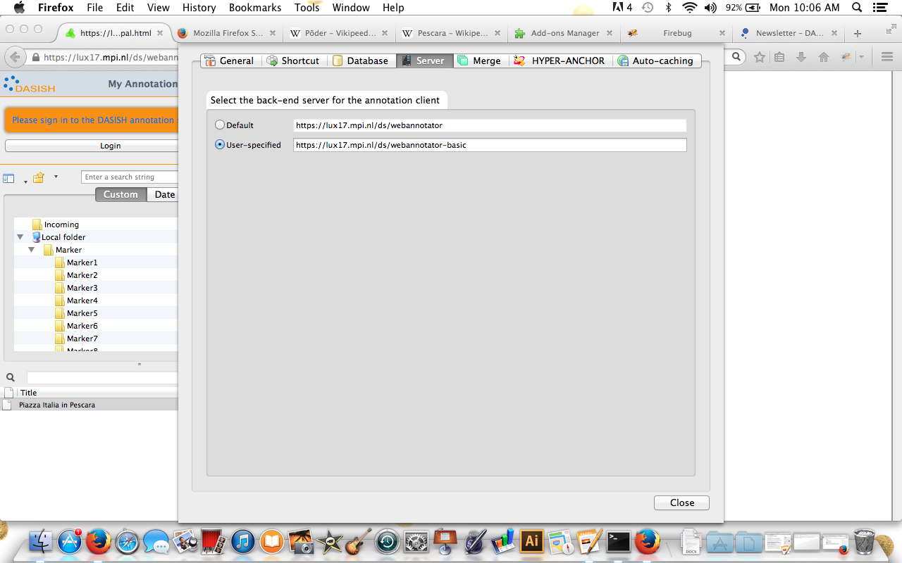

Annotations created on other clients or by other users are all listed in the **Incoming** folder, in the left side box. DASISH website is the default webpage. Browse the page you are interested in and where are the annotations you want to see. The full list of annotations will appear and they can be ordered by title or date. Please note, it is not possible to see the author of the annotations.

To see annotations from the other users, click on the annotation you want to see from the full list. It will appear on the webpage in light yellow.

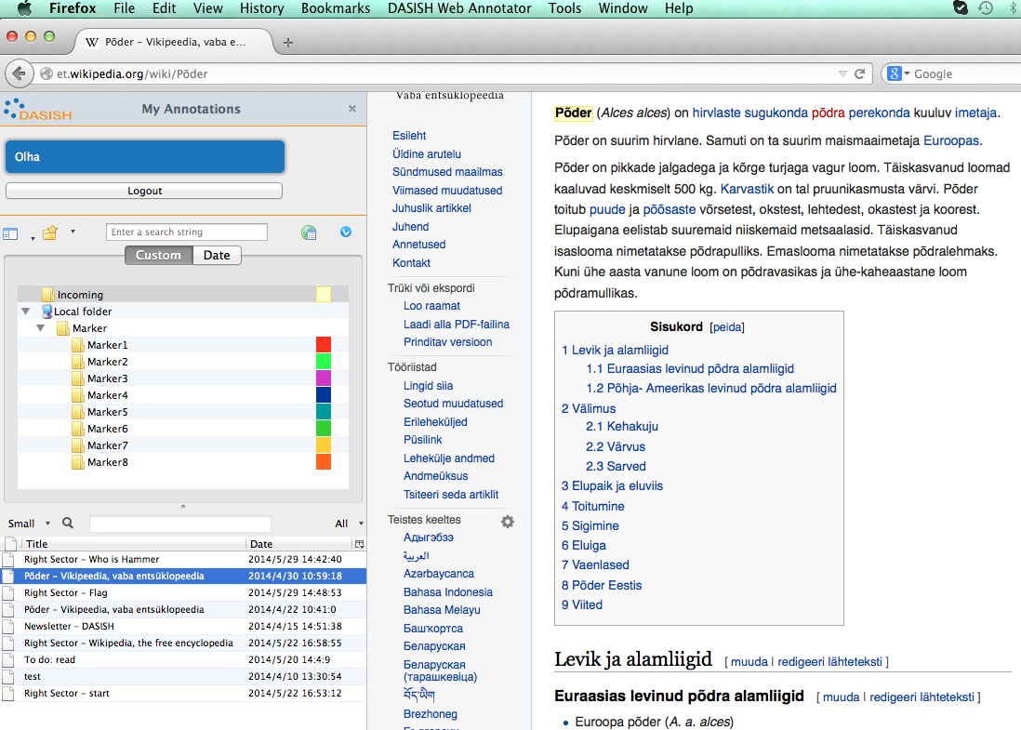

To see the user’s own annotations, (s)he can also go to the **Marker** folder and click on the colour used to make the annotation.

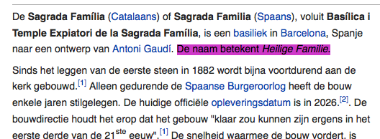

If one or more annotations do not appear after clicking on them and also after refreshing the page, it means that the client cannot resolve the annotated fragment. The most probable reason for this is that the webpage has been changed since it was annotated.

However, one of the main features of DWAN is that it is still possible to see the annotations even if the webpage has changed by viewing the cached representations. To do this, point the mouse to the annotation in question and right-click. In the pop-up menu select "*Cached representations*" and click "*open remote cache*" in the sub-menu. If you compare this example cached representation with the current webpage, you will be able to see the annotations.

To make an annotation, the user goes to the webpage (s)he want to annotate, selects a text fragment with the mouse, right clicks and chooses the marker colour (s)he would like to use from the menu.

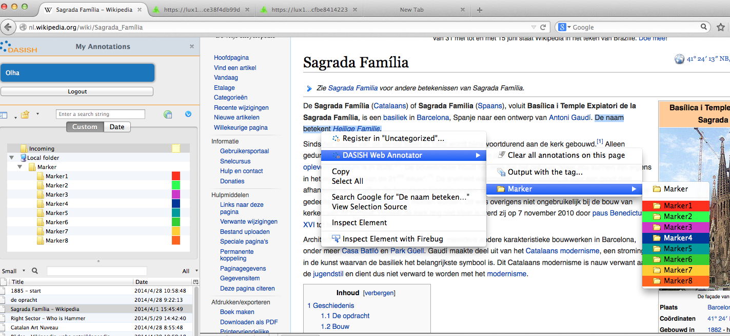

Nest, one needs to select the colour by left-clicking the mouse, and fill in the fields in the pop-up text-box to make the annotation. One assigns a distinctive title to the annotation and write a clear short description in the annotation box. To save the annotation, one clicks “ok” after filling in the form in the pop-up text box and it will show on the webpage.

To update the annotation, one picks it up in the list, right clicks and selects “Properties” in the menu. The form for editing will appear where by selecting tabs “Brief Overview” or “Annotation” one can edit the title and the text body respectively.

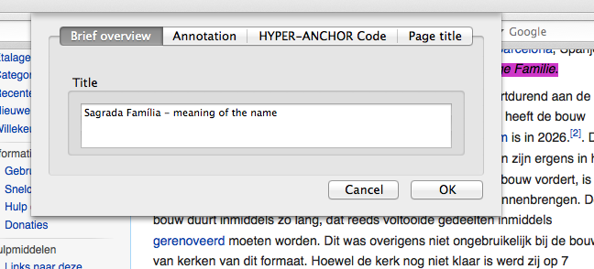

While it is not possible to delete other users’ annotations, the user can delete his/hers.

One finds the annotation to delete in the Local Folder, then right clicks on it and select Delete.

When an annotation is created by DWAN client all registered users except the creator (“owner”) get *read* access. The owner has *write* access and can change the rights of other users. Additional html forms are produced by the backend server upon the request from the client, filling which allows the owner to reassign the rights for a particular user and an annotation, or change the public access mode for a given annotation.

Users with advanced technical skills can also examine the relationship between the Backend and the Frontend directly by installing Firebug, another Firefox add-on. This is particularly useful to analyse DWAN in situations where it does not seem to behave properly. To install Firebug, go to Tools > Add-Ons > Search for Firebug and allow installation.

In cases where a clean reinstall of a Firefox add-on is needed, it is advisable to first remove the respective Firefox add-on via the Add-ons Manager that Firefox provides (about:addons) and then delete any add-on related directories contained within the Firefox profile directory of the Firefox profile that is used (e.g. "DWAN" or "WiredMarker" directories). Please note that there might be different profiles, and thus different profile folders on your machine.

Mac OS X: ~/Library/Application Support/Firefox/Profiles/[profile folder

name]

For Windows please cf. <http://kb.mozillazine.org/Profile_folder_-_Firefox>.

1. The redirection to these forms must be implemented in frontend, though. See <https://github.com/DASISH/dwan-backend/issues/9> and  <https://github.com/DASISH/dwan-client-wiredmarker/issues/22> [↑](#footnote-ref-1)
2. Hopefully this can be fixed in the frontend. See: <https://github.com/DASISH/dwan-client-wiredmarker/issues/16> [↑](#footnote-ref-2)
3. The current front-end is not able to present the annotations on xml's properly (as Olof has suggested), but they do exist in a good shape on the backend.  See <https://github.com/DASISH/dwan-client-wiredmarker/issues/18>.   If fixing it, is problematic, a jsp page for "advanced users", where an annotation on an annotation can be made or obtained, could be added. <https://github.com/DASISH/dwan-backend/issues/10> [↑](#footnote-ref-3)
4. The Language Archive, Max Planck Institute for Psycholinguistics, <http://tla.mpi.nl/> [↑](#footnote-ref-4)
5. Recall, that a principal is ether a user or a group of users, and for the current version of DWAN user and principal are synonyms. Creating user's groups is the matter of the future work. [↑](#footnote-ref-5)
6. http://dublincore.org/documents/2010/10/11/dcmi-type-vocabulary [↑](#footnote-ref-6)
7. http://docs.spring.io/spring-framework/docs/current/spring-framework-reference/html/dao.html [↑](#footnote-ref-7)
8. Java Database Connectivity [↑](#footnote-ref-8)
9. Implemented, however testing is not completed and it is not used in the current DWAN frontend. [↑](#footnote-ref-9)
10. BITS Co., Ltd. <http://www.bits.cc> [↑](#footnote-ref-10)
11. Prof. Okubo [↑](#footnote-ref-11)
12. Update this part of the text if the bug is fixed. [↑](#footnote-ref-12)
13. Correct it if the problem is fixed. [↑](#footnote-ref-13)
14. Implementation to be added [↑](#footnote-ref-14)
15. <http://www.ahrc.ac.uk/Funding-Opportunities/Research-funding/Connected-Communities/Scoping-studies-and-reviews/Documents/Crowd%20Sourcing%20in%20the%20Humanities.pdf> [↑](#footnote-ref-15)
16. <http://www.ahrc.ac.uk/Funding-Opportunities/Research-funding/Connected-Communities/Scoping-studies-and-reviews/Documents/Crowd%20Sourcing%20in%20the%20Humanities.pdf> [↑](#footnote-ref-16)
17. Siiri (Tartu) can write on creating profile in windows. [↑](#footnote-ref-17)