## Current (DASSL) Schema

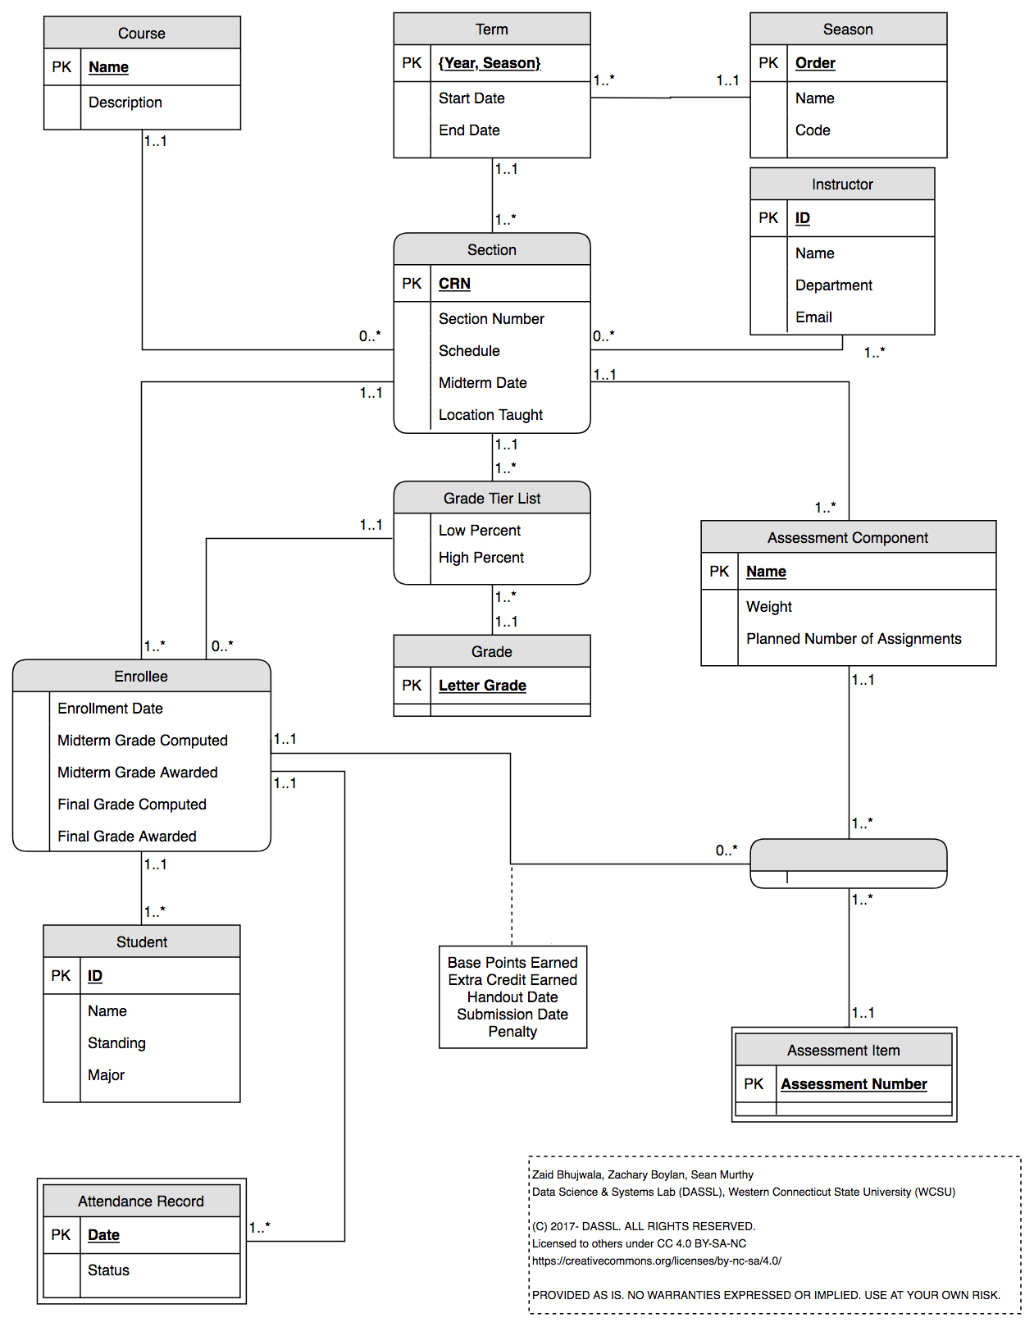

## New (Team Alpha) Schema

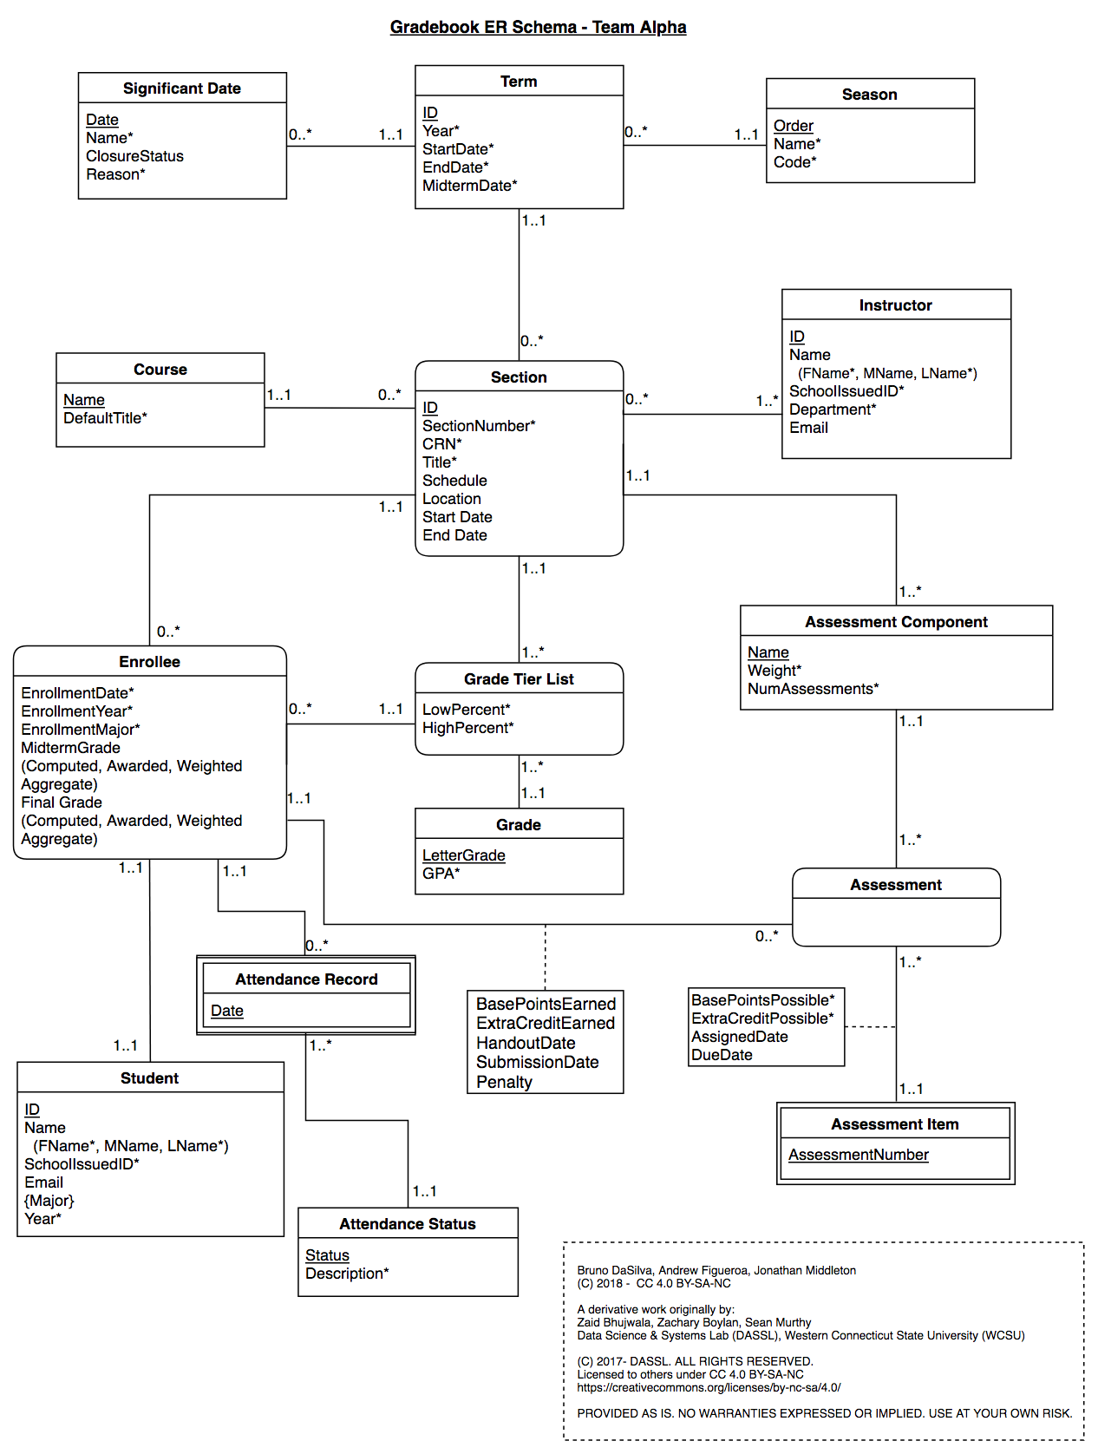

## Changes

### General changes:

* Formatting was adjusted to fit within the specifications of an ER diagram with UML syntax (without relationship names). Namely, any references to primary keys were removed
* Some relationship cardinalities were updated to match actual implementation (for example, a section is required to be related to 0..* students, not 1..* students)

### Specific changes:

See logical schema for a more detailed explanation on changes made, including an explanation of the three letter codes before each change. Some changes apply only to the style of the conceptual schema and not of the ER diagram (such as changed to primary keys)

* Course entity
  + MOD: Change Description entity to DefaultTitle
* Section entity
  + FIX: Change PK from CRN to ID
  + FIX: Add CRN as a non-key attribute
  + FIX: Add attributes Start Date and End Date
  + FIX: Remove Midterm Date (part of Term)
  + MOD: Add Title attribute
* Term entity
  + ALT: Add midterm attribute
  + FIX: Change PK from {Year, Season} to ID
  + FIX: Add Year attribute
* Relationship between Enrollee, Assessment Component, and Assessment Item
  + ALT: Give name to unnamed entity
  + ALT: Add relationship attributes between Assessment and Assessment Item
  + ALT: Add name to entity formed by tertiary relationship (Assessment).
* Entity Student
  + FIX: Change Name to composite attribute that includes full, middle, last name
  + FIX: Add School Issued ID attribute
  + FIX: Add Email attribute
  + ALT: Make Major a multi-valued attribute
* Entity Enrollee
  + FIX: Add Enrollment Major and Enrollment Year attributes
  + FIX: Add Midterm Weighted Aggregate and Final Weighted Aggregate attributes
  + ALT: Change grades into 2 composite attributes
* FIX: Add Entity Attendance Status
  + FIX: Add PK Status
  + FIX: Add attribute Description
* Entity Attendance Record
  + FIX: Remove status attribute (part of Attendance Status)
* Entity Grade
  + FIX: Add attribute GPA
* Entity Instructor
  + MOD: Add SchoolIssuedID attribute to instructor
  + FIX: Change name to a composite attribute containing full, middle, last name
* Entity SignificantDate
  + MOD: Add new entity based on functionality that will be added as a part of our project