Synthetic face generation

***WHAT IS YOUR ISSUE OF INTEREST?***

Synthetic face generation, is gaining a lot of attraction in current days.

*"The coolest idea in the last 20 years" - quoted by Yann LeCun*

Synthetic face generation has many applications like data augmentation for machine learning models, usage in anime or cartoons, creating social media influencers etc.

The technology behind this is GANs which is short for Generative Adversarial Networks.

Many firms and R&Ds started working on GANs extensively in recent days. Facebook is extensively working on this to use the new faces in the metaverse. An artificially

generated instagram influencer named Miquela Sousa got over a million followers on instagram before it was announced that she wasn't real.

*"Until my conversation with Nikola, it seemed like an indisputable fact that Miquela wasn’t real" - quoted by a reporter from "The Cut"*

The success stories of GANs reflects on the impact they make in society.

***WHY IS THIS ISSUE IMPORTANT TO YOU AND/OR OTHERS?***

In data science, it is very common to face issues like, the dataset is not big enough, the dataset is not diverse enough, amount of data present for one label

dominates amount of data present for another. We personally faced this issue while

creating a model for attendence system by face recognition. Face synthesis can be used as a data augmentation technique in such cases to create more data. Microsoft created a complete dataset with synthetic faces. When tesed on different models, the

performance was much better than models trained using normal dataset on test data. Microsoft says this is because of the diversity added in the dataset.

*"We demonstrate that it is possible to perform face-related computer vision in the wild using synthetic data alone." -quoted by Microsoft Content creators can use*

*this technique when they want images of so many people(in cases like metaverse) or when they have to use a face for some sensitive issue that could be uncomfortable for the person whose face is displayed. The same model can be used on anime images and reduce valuable efforts of anime character designers and artists to create new anime characters. This technique can also be used to create avatars.*

***WHAT QUESTIONS DO YOU HAVE IN YOUR MIND AND WOULD LIKE TO ANSWER?***

As explained above, synthetic face generation is a research topic that can be used in so many aspects. Our research finds out and stores the key features to be present in a face and creates new faces by keeping the key features constant and changing the other features. The actions that the model will be handling is,

Generate a new face

Distinguish whether a face is real or synthetic

As we are fairly new to GANs, we personally have many questions in mind. Some of them are,

What are the key performance indicators of the model.

Can we give some input parameters to the model so that we will get a particular type of face? (like a face of particular ethnicity)

Will the generated faces really be human indistinguishable?

Will the generated faces be computer indistinguishable?(i.e., Can we build a model other than discriminator which is trained along with generator to

distinguish between synthetic and real faces)

Are the generated faces usable in other models?

Can we induce a specific feature like smile into the faces by tweaking an input parameter?

Is it possible to generalize the model in such a way that we can input an image and the model can generate images in the context of input image?

***WHERE DO YOU GET THE DATA TO ANALYZE AND HELP ANSWER YOUR QUESTIONS?***

We obtained the dataset from the following source:

<http://mmlab.ie.cuhk.edu.hk/projects/CelebA.html>  
It is called the celebA dataset and contains over 200,000 face images along with different tags. The data is taken from a trusted source which is a Multimedia lab from The Chinese University of Hong Kong. The data contains over 38 different attributes namely

5_o_Clock_Shadow Arched_Eyebrows Attractive

Bags_Under_Eyes Bald

Bangs

Big_Lips Big_Nose

Black_Hair Blond_Hair Blurry

Brown_Hair

Bushy_Eyebrows Chubby

Double_Chin Eyeglasses Goatee

Gray_Hair

Heavy_Makeup

High_Cheekbones Male

Mouth_Slightly_Open Mustache

Narrow_Eyes No_Beard

Oval_Face Pale_Skin

Pointy_Nose

Receding_Hairline Rosy_Cheeks

Sideburns Smiling

Straight_Hair Wavy_Hair

Wearing_Earrings Wearing_Hat

Wearing_Lipstick Wearing_Necklace

***WHAT QUESTIONS DO YOU HAVE IN YOUR MIND AND WOULD LIKE TO ANSWER?***

Here, the unit of analysis is the location

***WHAT VARIABLES/MEASURES DO YOU PLAN TO USE IN YOUR ANALYSIS?***

The train data will contain face images as input data. The aim will be to make the images indistinguishable by a discriminator.

***WHAT KINDS OF TECHNIQUES/MODELS DO YOU PLAN TO USE?***

We will be using a GAN model. It contains number of 2d convolutions. Additionally, We will be using image processing techniques for preprocessing. A block diagram of how the model looks is shown below:-

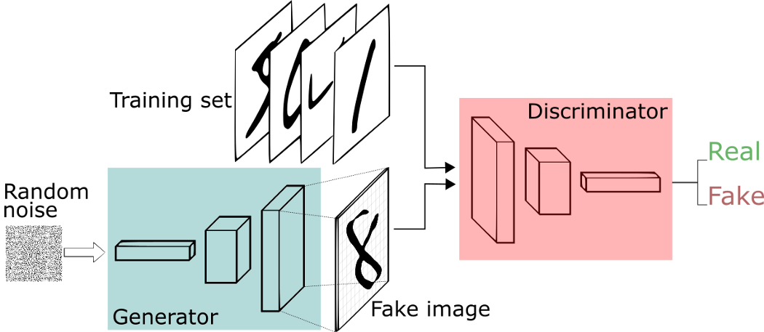

***HOW DO YOUPLAN TO DEVELOP/APPLY ML AND HOW DO YOU EVALUATE PERFORMANCE OF MODELS?***

We are planning to make use of google colaboratory which provides GPU and keras library to create convolution networks.

Unlike other networks, GANs are very difficult to evaluate as we are just producing new images which cannot be compared to any other. Some qualitative techniques for

evaluating GAN generator models are listed below:

Nearest Neighbors.

Rapid Scene Categorization.

Rating and Preference Judgment.

Evaluating Mode Drop and Mode Collapse.

Investigating and Visualizing the Internals of Networks

Although which method to use should be decided through deep analysis after the model creation according to the face quality that the model is producing.

***WHAT OUTCOMES DO YOU INTEND TO ACHIEVE?***

The project aims to create a model which can create faces which are indistinguishable by humans or machines. Through this project we intend to gain more insights about Machine learning tools, requirement analysis, more insights into convolution neural networks etc.