Hi Sprocket Central,
I hope this email finds you well.
I am writing to you today to provide an update on the Data Quality Assessment issues that we identified in the Sprocket Central Pty Ltd dataset.
Worksheet Name | Data Quality Issue | Action Taken
Transaction | Completeness & Relevancy | Removed blank values for columns "online order" and "brand". Converted the column for "product first_sold date" into a date/time format.
New Customer List | Completeness & Consistency | Removed blank and null values from columns "second name", "job title", and "industry". Corrected inconsistencies in the "gender" column by changing spelling errors and abbreviations to "M" for male and "F" for female. Removed the irrelevant variable consistency in the "gender" column.
Customer Demographic | Completeness, Consistency, and Relevancy | Removed blank and null values from columns "job site" and "job industry". Corrected inconsistencies in the "gender" column by changing spelling errors and abbreviations to "M" for males and "F" for females Removed the irrelevant field "default".

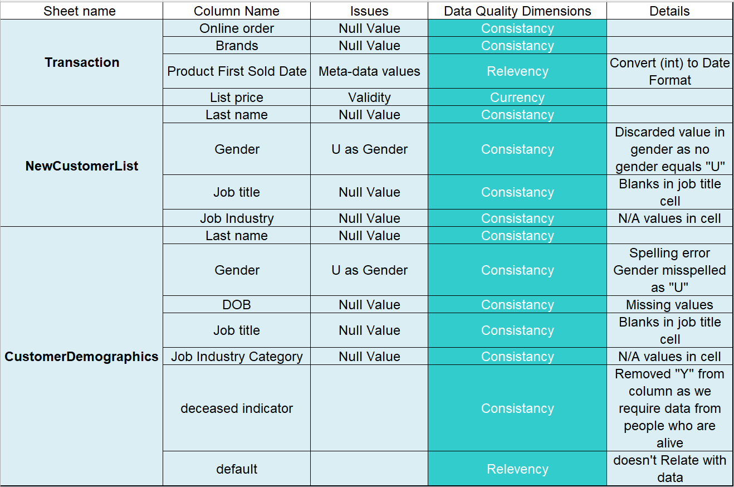
We will continue the data cleaning and data transformation process for modelling, and we will raise any questions or document any assumptions that we have along the way. We would also like to meet with the data SME to ensure that all our assumptions are in line with Sprocket Central Pvt Ltd's understanding.
Thank you for your time and consideration.
Best regards,
Muhammad Usman Khan
Junior Data Consultant

