1.

a/ service –status-all

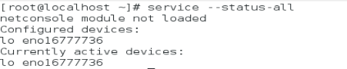

2.

a, b/ top

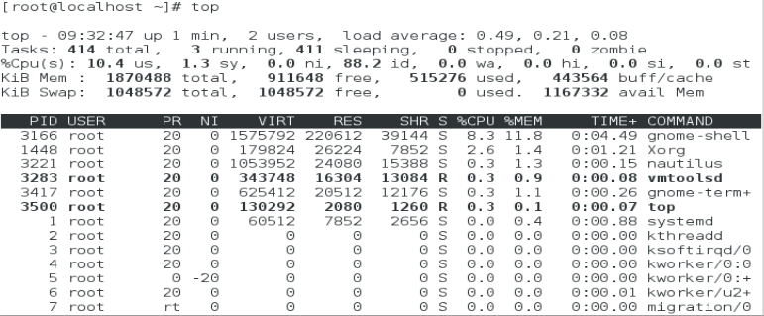

c/ press h

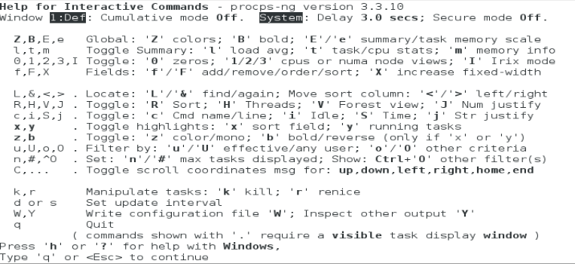

d/ press t

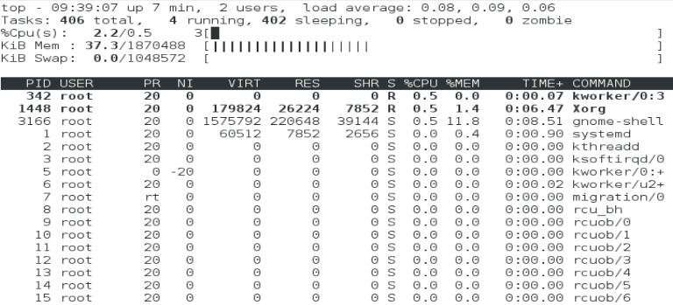

e/ press m

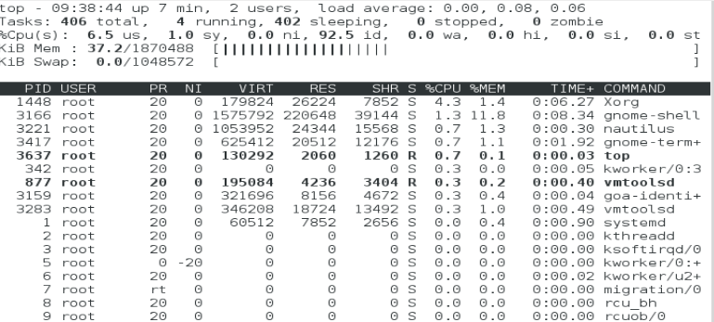

f/ press f

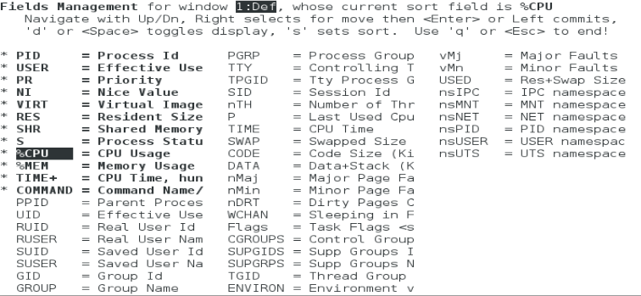

g/ press b then spacebar

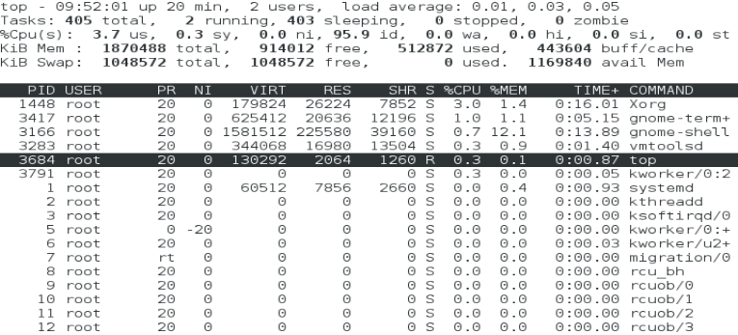

6.

a/ps



b/ps -ef |more

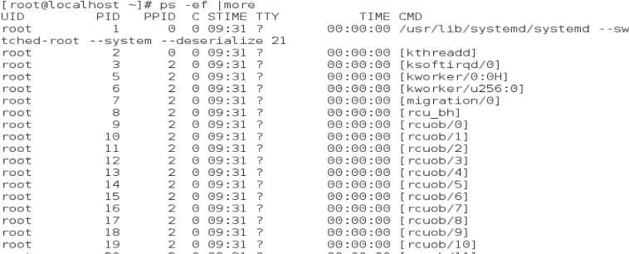

c/ user nam does atd run under is root



d, e/ ps -ef |less



f/ The status of the service is S



7.

a/ top

b/

NI shows the niceness of process ( is the nice value)

PR  is the process’s actual priority

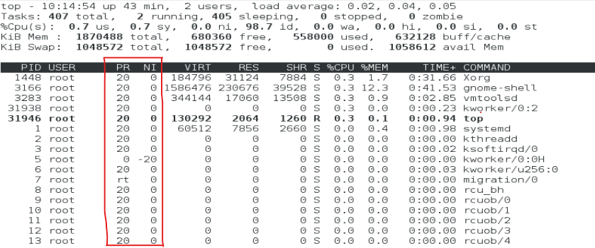

c/nice -n -20 top

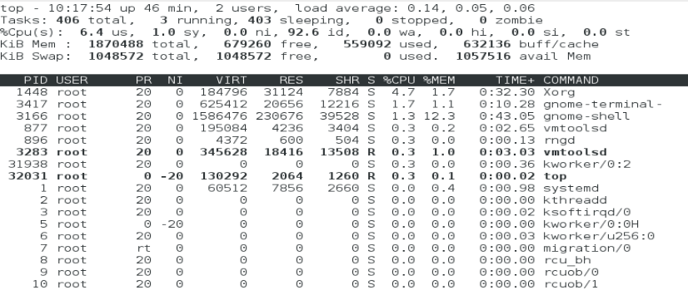

d/ renice 1 top_PID

renice 1 2

-PR is not change value, value of NI now is 1

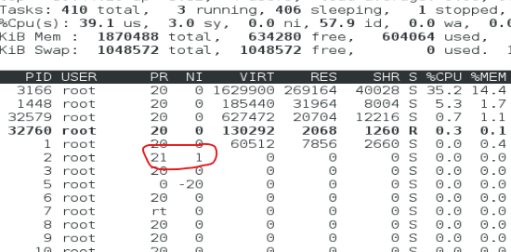

8.

a/ top

b/ Ctrl + z

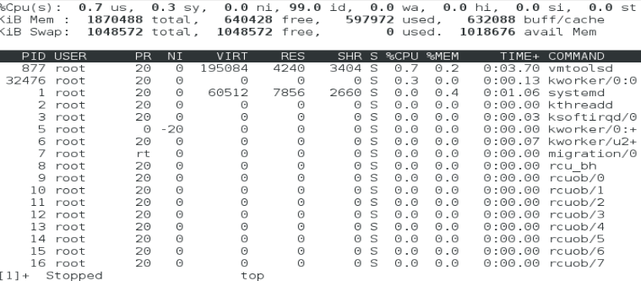

c/bg background_job_ID

bg %1



d/ Ctrl + C

e/ fg background_job_ID

fg %1

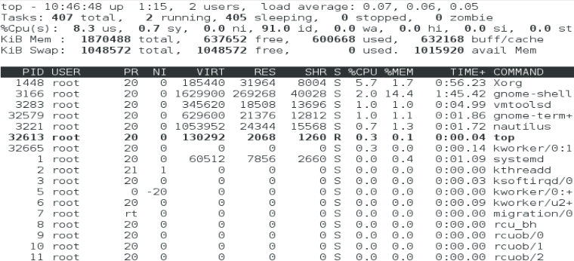

9.

a/top

b/ ps -e|grep top



d/ kill -sigterm top_PID

kill -signterm 1

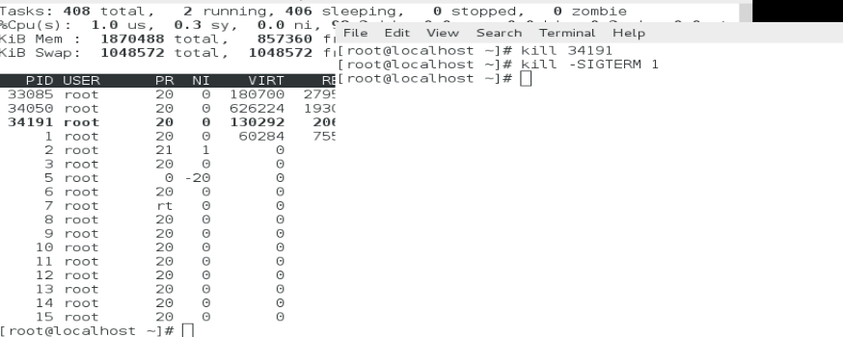

g/killall -15 top

