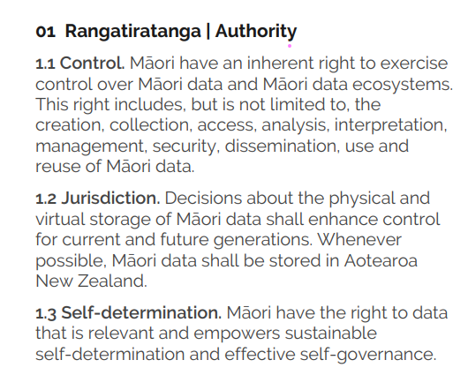

[**TMR+Māori+Data+Sovereignty+Principles+Oct+2018.pdf**](https://static1.squarespace.com/static/58e9b10f9de4bb8d1fb5ebbc/t/5bda208b4ae237cd89ee16e9/1541021836126/TMR+Ma%CC%84ori+Data+Sovereignty+Principles+Oct+2018.pdf)

**My critique**

**Moving from a full enumeration Census to an administrative-based model may undermine Māori Data Sovereignty by failing to capture key aspects of Māori identity (such as iwi affiliation, descent, and ethnicity)**

The shift from a full enumeration Census to an administrative-based model could violate Māori Data Sovereignty and Governance (MDS/G). This is especially true when considering the principle of rangatiratanga (self-determination), which states that Māori have full authority over the collection, definition, and usage of their data. Historically, while Census data allows Māori to freely categorize themselves based on their iwi affiliation, descent and ethnicity, administrative datasets put this freedom in jeopardy. These dimensions might not be consistently recorded or might be omitted completely. For example, if iwi affiliation is not fully captured, it fails to present Māori communities with a basis for planning, resource allocation and asserting tino rangatiratanga. Such risks could undermine trust in Stats NZ and while neglecting the needs of Māori.

To mitigate this risk, Stats NZ should consider Māori governance in designing the new Census model. This means cooperating with Māori iwi and organizations to ensure the priority and safeguard of the abovementioned identity markers, or even establishing a Māori department to supervise the decisions on administrative data use. In this way, Māori maintain control over the representations of their identities while simultaneously aligning with the MDS principles of rangatiratanga and control.To mitigate this risk, Stats NZ should embed Māori governance into the design of the new Census model. This could include co-developing standards with iwi and Māori organisations to ensure identity markers are retained and prioritised, and establishing a formal Māori governance group to oversee decisions on administrative data use. In this way, Māori voices shape how their identities are represented, maintaining alignment with MDS principles of rangatiratanga and control.

Word count (not including title): 196