**一、出版社：IEEE transactions** [**https://ieeexplore.ieee.org/Xplore/home.jsp**](https://ieeexplore.ieee.org/Xplore/home.jsp)

**期刊：**IEEE Transactions on Evolutionary Computation

**Submission Deadline: 31 January 31 2025**

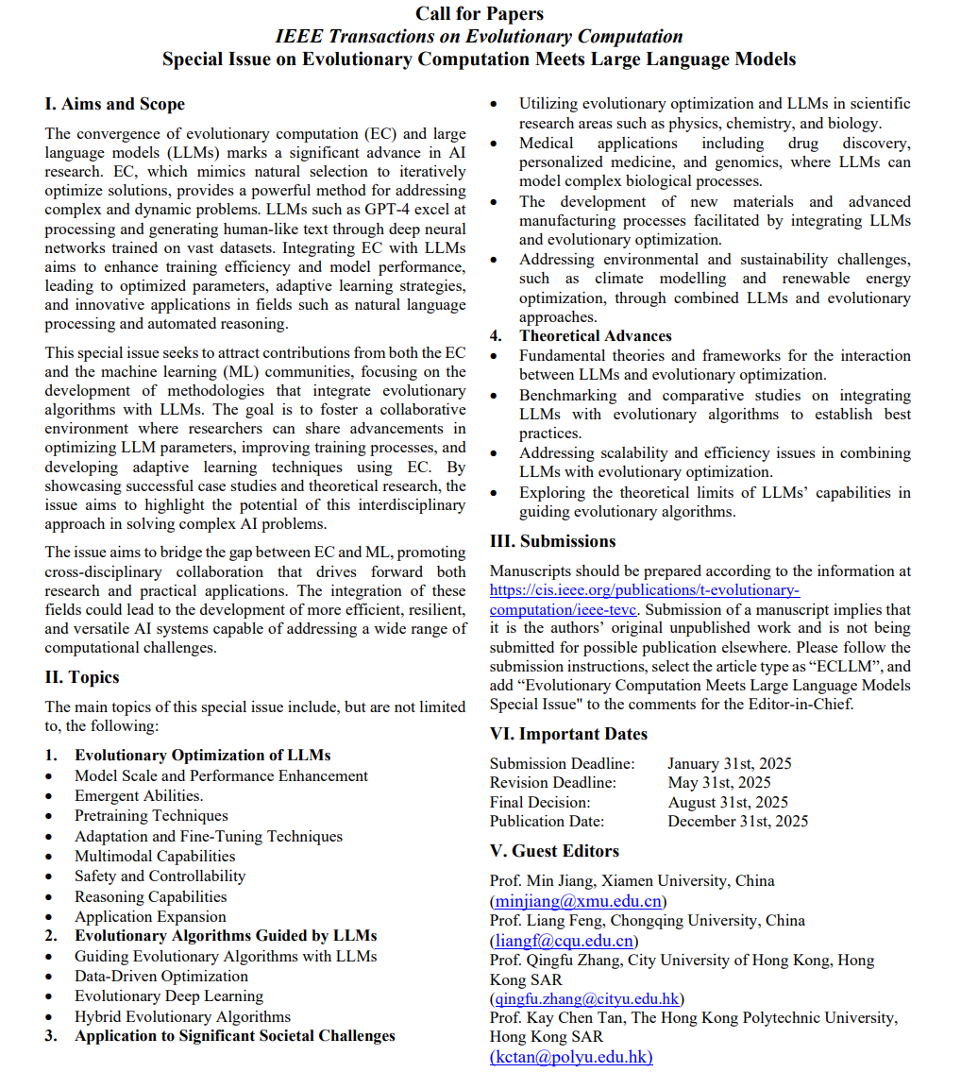

**期刊：**IEEE Transactions on Automation Science and Engineering

**Apr. 30, 2025, submission deadline**

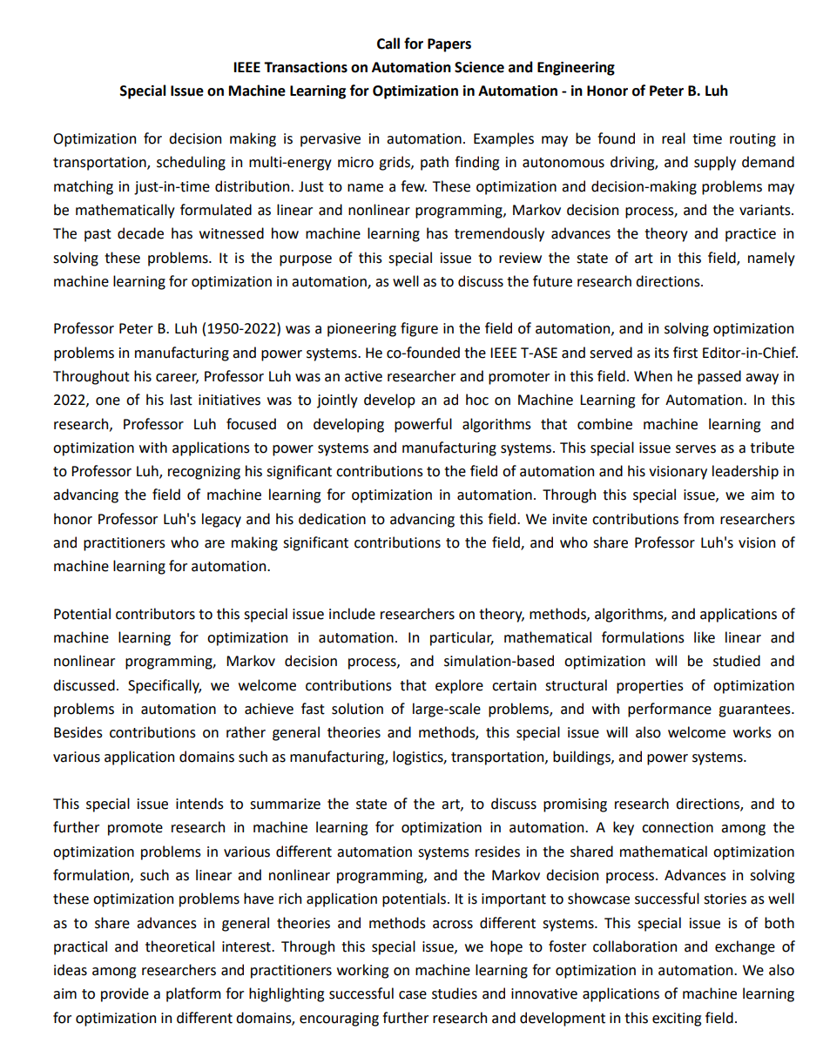

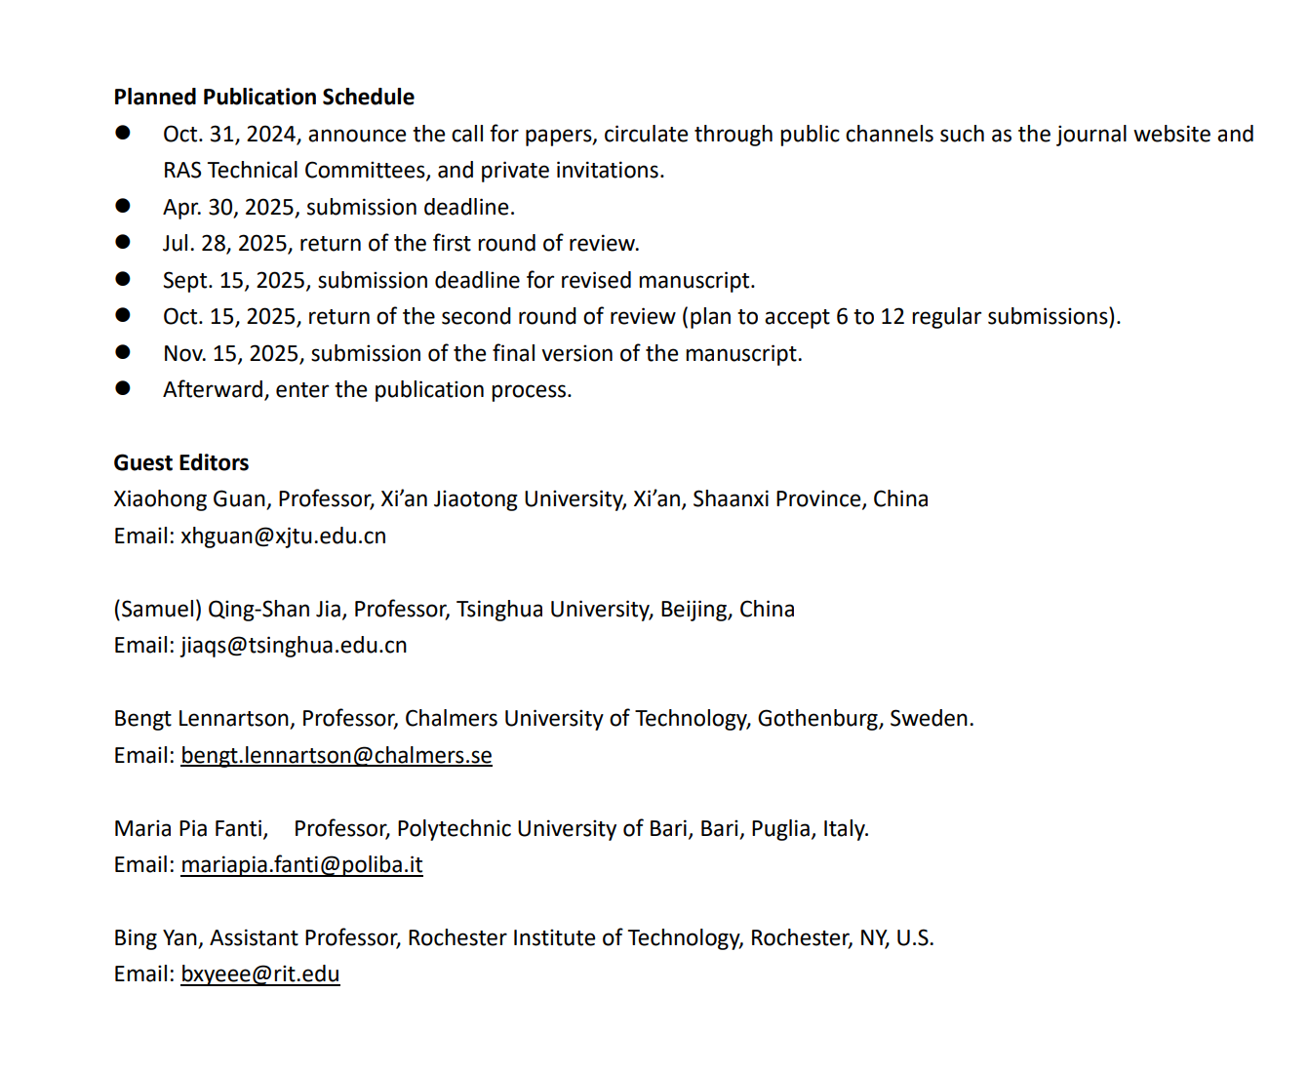

**期刊：**IEEE Transactions on Emerging Topics on Computational Intelligence

**Submission deadline: 31 December 2024**

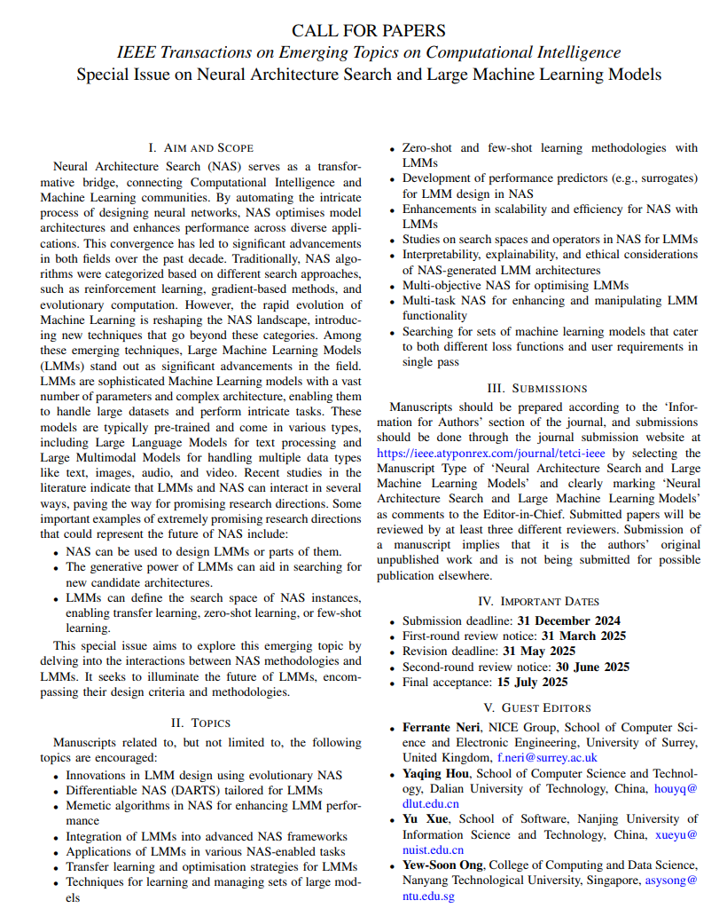

**二、出版社：Elservier 爱思唯尔** [**https://www.sciencedirect.com/**](https://www.sciencedirect.com/)

**期刊**：[Swarm and Evolutionary Computation](https://www.sciencedirect.com/journal/swarm-and-evolutionary-computation)

**Submission deadline: 31 December 2024**

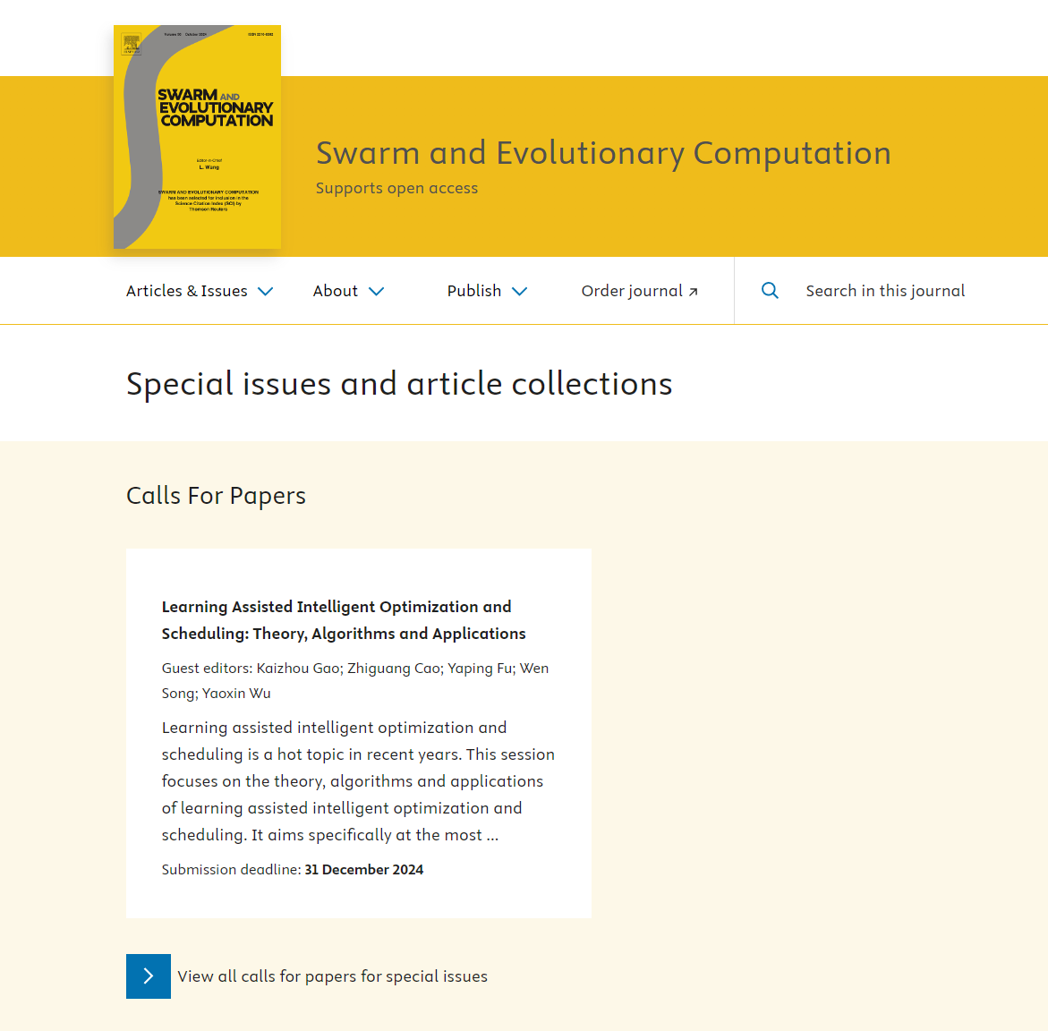

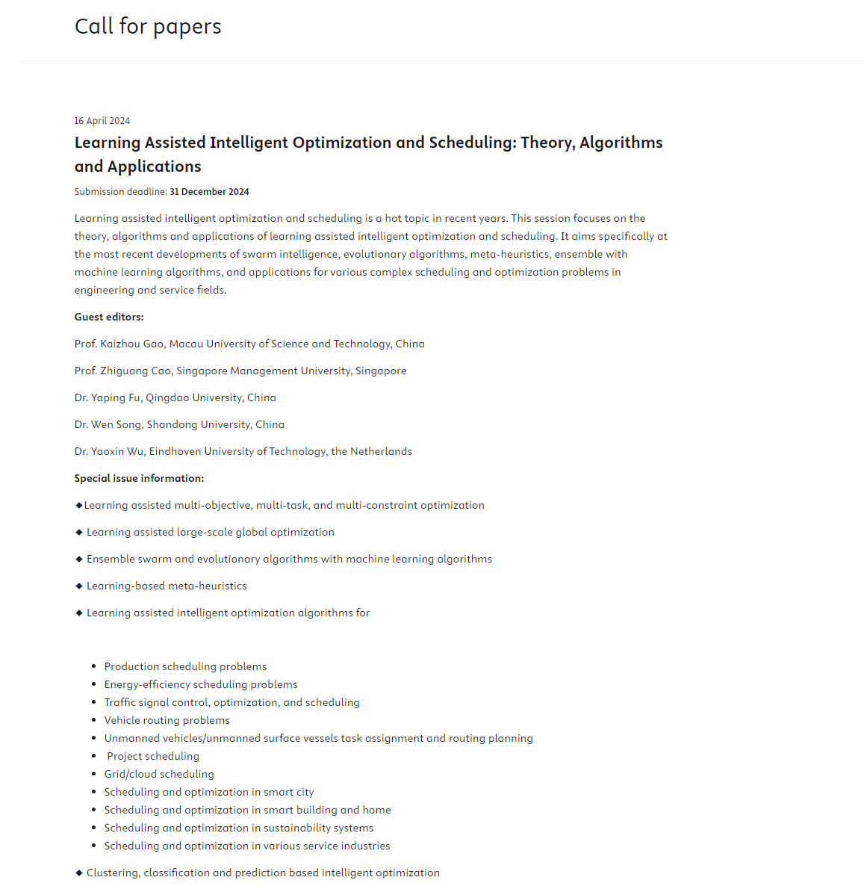

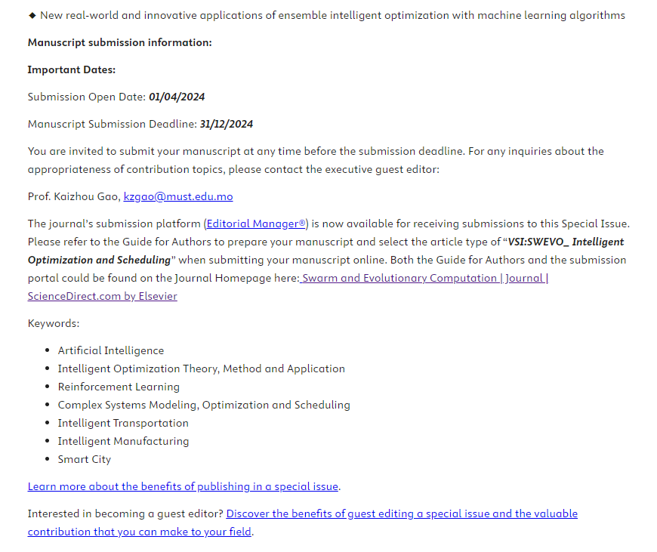

**期刊：Robotics and Computer-Integrated Manufacturing**

**Submission deadline: 30 June 2025**

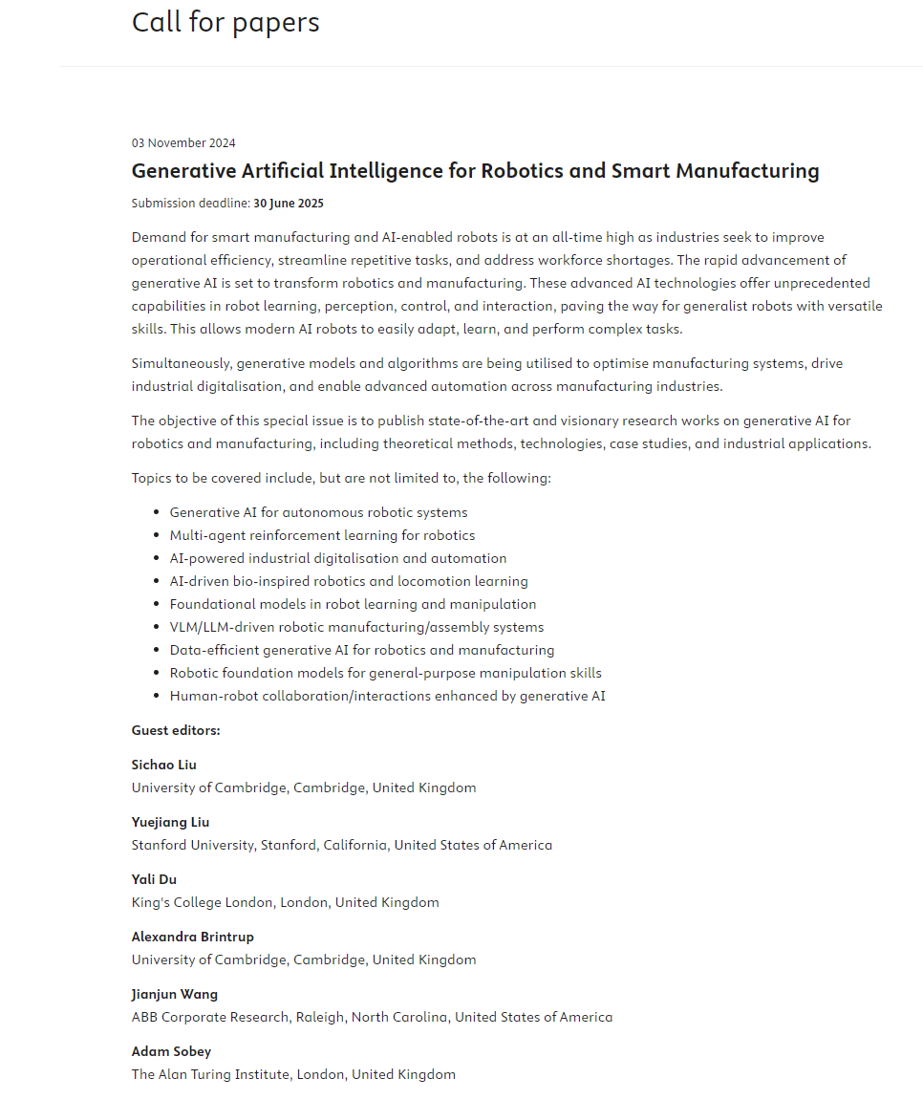

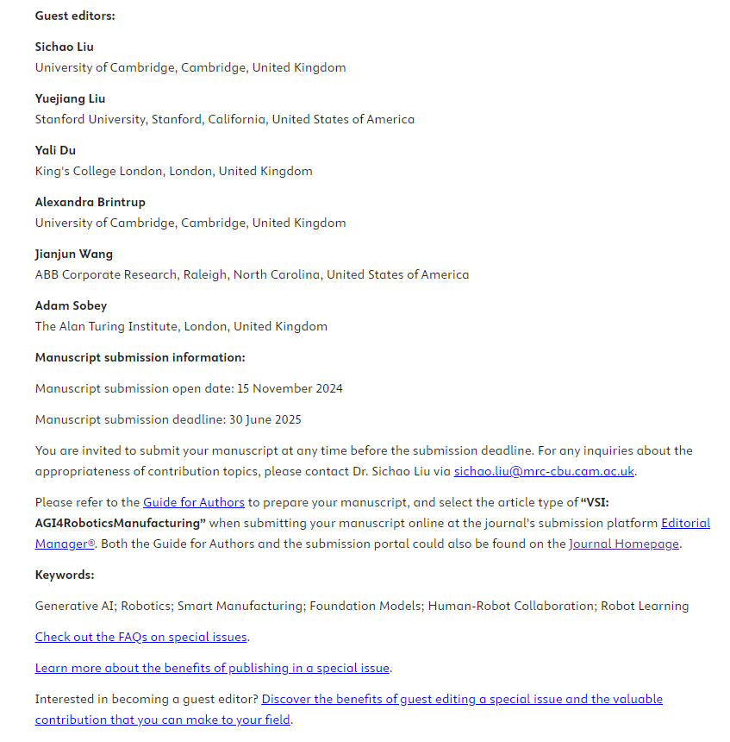

**期刊：Applied Mathematical Modelling**

**Submission deadline: 01 March 2025**

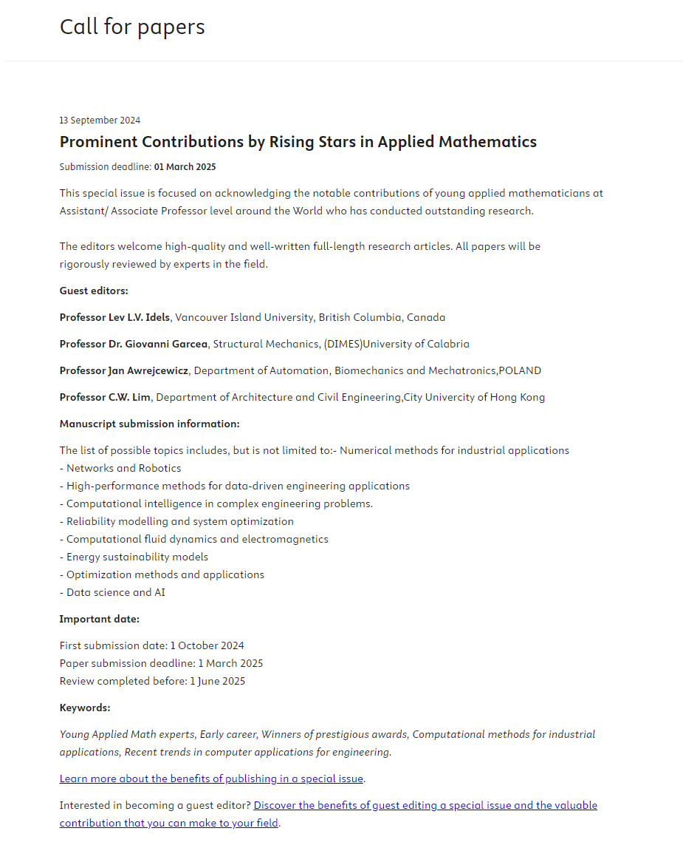

**期刊：Computers & Operations Research**

**Submission deadline: 31 December 2024**

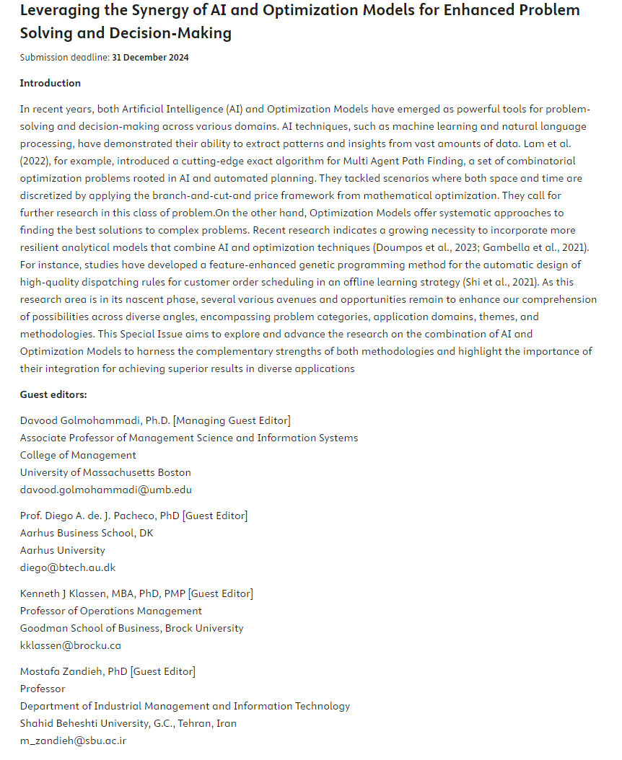

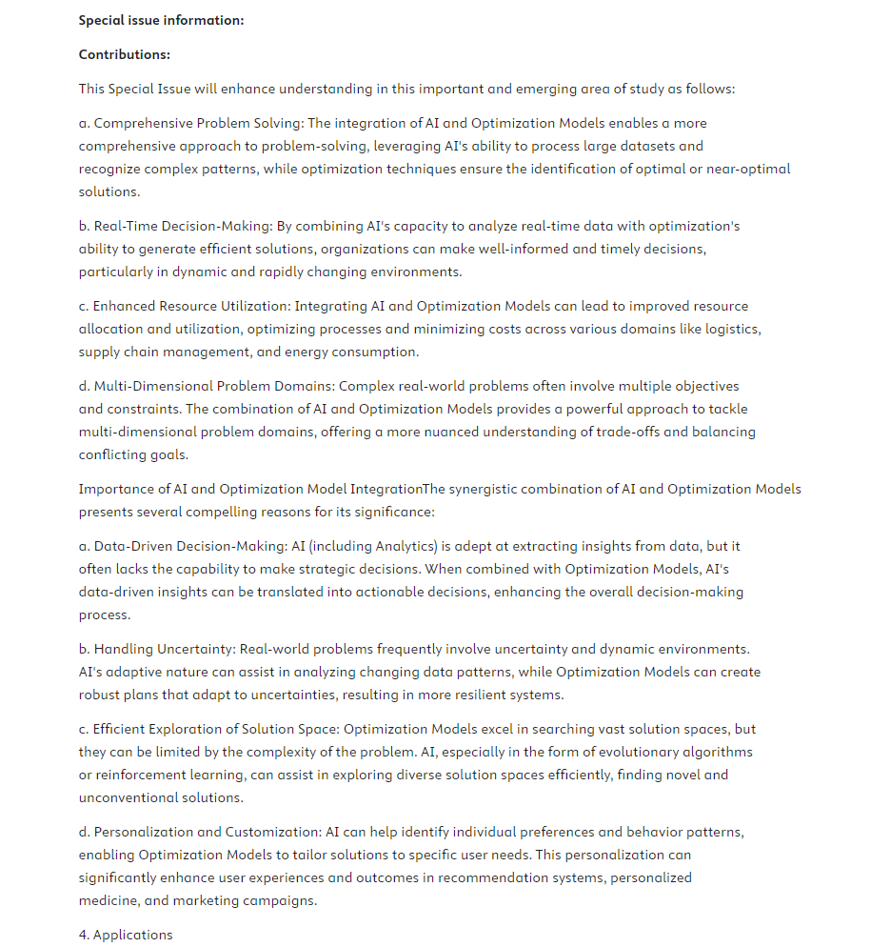

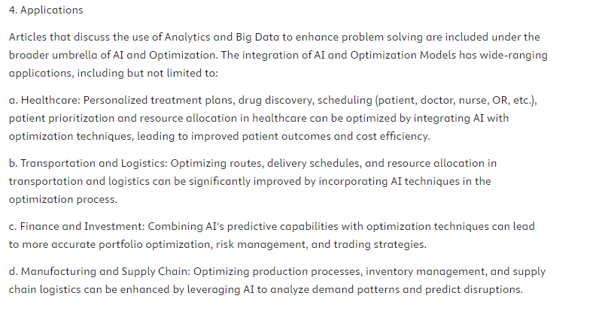

**期刊：Engineering Applications of Artificial Intelligence (EAAI)**

**Submission deadline: 30 November 2024**

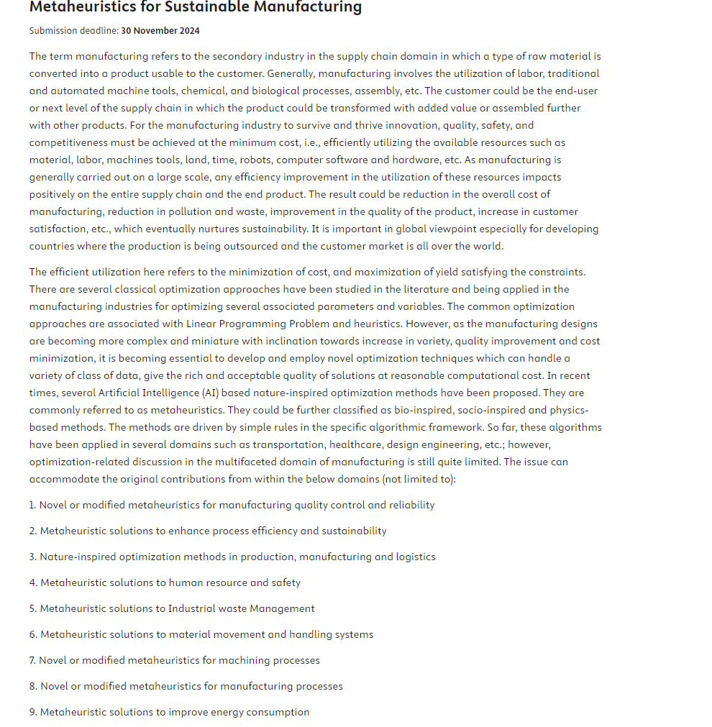



**期刊：European Journal of Operational Research (EJOR)**

**Submission deadline: 31 December 2024**

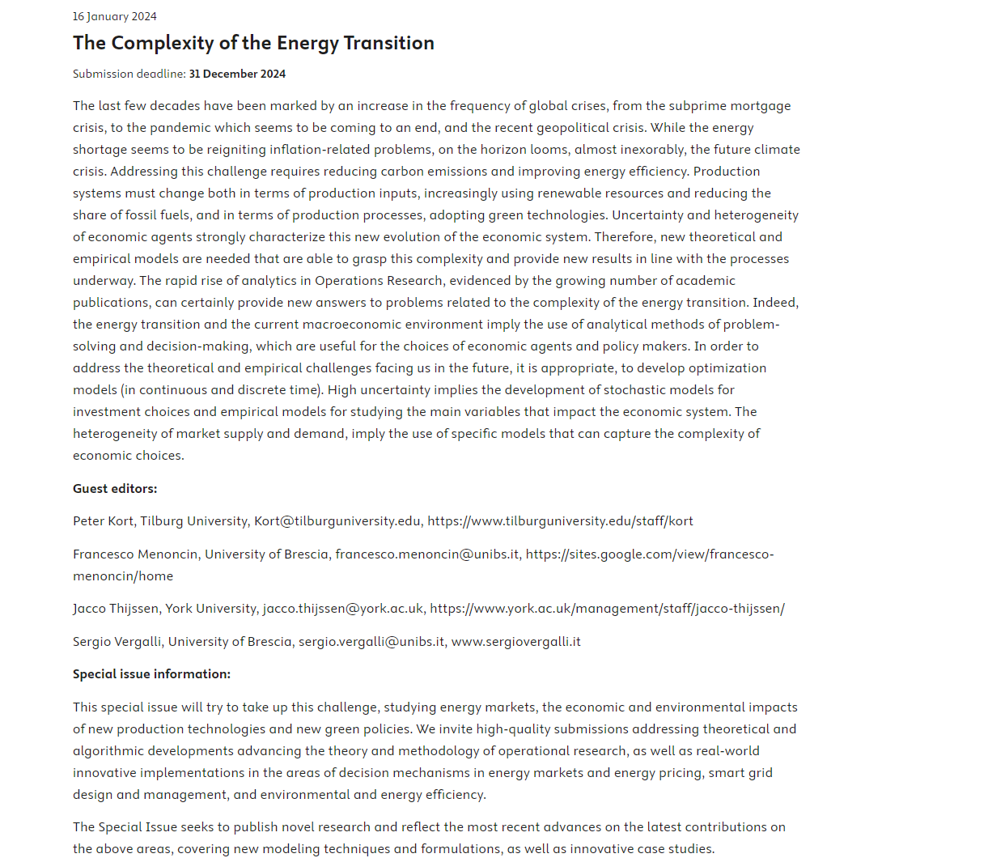

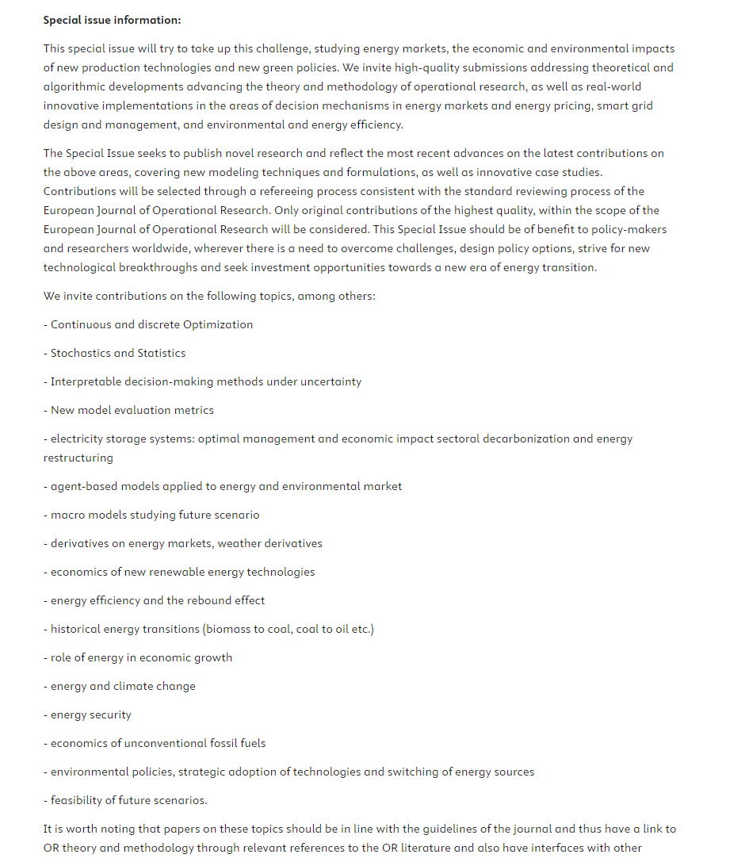

**期刊：Computers & Industrial Engineering (CAIE)**

**Submission deadline: 31 March 2025**

