Quantum Machine Learning for DNA Sequence Classification
A Comparative Study of Classical and Quantum Approaches
Research Report
Generated: September 19, 2025 at 00:25
Abstract: This study presents a comprehensive comparison between classical machine learning methods (Support Vector Machines) and quantum machine learning approaches (Quantum Support Vector Machines and Variational Quantum Classifiers) for DNA sequence classification. We evaluate performance on chloroplast DNA sequences from the Meliaceae family, focusing on distinguishing coding sequences (CDS) from non-coding RNA sequences (tRNA/rRNA). Our results demonstrate the potential of quantum approaches while highlighting current limitations and future research directions.
Technical Environment:
Component | Version/Details
Python | 3.10.13
Platform | Windows 10 (AMD64)
NumPy | 2.1.3
Pandas | 2.3.1
Scikit-learn | 1.7.1
Matplotlib | 3.10.0

Table of Contents

1. Introduction and Background
DNA sequence classification is a fundamental problem in bioinformatics with applications ranging from gene prediction to evolutionary analysis. Traditional machine learning approaches have shown success, but the emergence of quantum computing offers new possibilities for handling the complex patterns inherent in biological sequences.
This study focuses on chloroplast DNA (cpDNA) sequences from the Meliaceae family, specifically distinguishing between:
- Coding sequences (CDS) - protein-coding regions
- Transfer RNA (tRNA) - involved in protein synthesis
- Ribosomal RNA (rRNA) - components of ribosomes

1.1 Quantum Machine Learning Concepts
Quantum machine learning leverages quantum mechanical principles to potentially solve certain computational problems more efficiently than classical computers. Key concepts include:
Quantum States: Information is encoded in quantum states that can exist in superposition
Quantum Gates: Operations that manipulate quantum states, analogous to classical logic gates
Quantum Entanglement: Correlation between quantum particles that enables parallel computation
Quantum Kernels: Feature maps that project classical data into quantum feature spaces
Variational Circuits: Parameterized quantum circuits optimized using classical methods

2. Methodology

2.1 Dataset Description
Our dataset consists of 20560 DNA sequence windows extracted from 13 chloroplast genomes in the Meliaceae family. Each window has a length of 256 nucleotides with a stride of 128 nucleotides.
Dataset Summary:
Metric | Value
Total Samples | 5000
Positive Class (CDS) | ~86.5%
Negative Class (RNA) | ~13.5%
Window Length | 256 nucleotides
Stride | 128 nucleotides
k-mer Size | 3-mers

2.2 Feature Engineering
We employed three different encoding strategies:
One-Hot Encoding: Each nucleotide (A, C, G, T) is represented as a binary vector, creating a 4-dimensional representation for each position
k-mer Frequency: Counts the frequency of all possible k-mers (k=3) in the sequence, normalized by sequence length
Angle Encoding: Maps nucleotides to angles for quantum circuit input: A->0 deg, C->90 deg, G->180 deg, T->270 deg

2.3 Model Architectures

2.3.1 Classical Models
We implemented two Support Vector Machine variants as classical baselines:
- SVM with k-mer features: RBF kernel SVM on 3-mer frequency vectors, standardized using StandardScaler
- SVM with one-hot features: RBF kernel SVM on flattened one-hot encoded sequences (1024-dimensional input)

2.3.2 Quantum Models
Our quantum approaches include:
- Quantum Support Vector Machine (QSVM): Uses a quantum kernel computed via quantum circuits, with classical SVM for classification
- Variational Quantum Classifier (VQC): End-to-end quantum classifier with parameterized quantum circuits optimized using classical methods
Quantum Circuit Architecture:
- Data encoding using angle embedding (Y-rotation gates)
- Entangling layers with CZ gates in ring topology
- Measurement of Pauli-Z observable on first qubit
- Classical optimization using Adam optimizer

3. Results and Analysis

3.1 Executive Summary
Our comprehensive evaluation reveals that SVM_onehot achieves the highest performance with an F1-score of 0.954 on the test set.
This represents a +0.001 improvement over the classical SVM baseline.

3.2 Detailed Performance Metrics
Table 1 presents comprehensive performance metrics for all models on the test set:
Model | Accuracy | Precision | Recall | F1-Score | ROC-AUC | PR-AUC | Specificity | Balanced Acc | MCC
Svm Onehot | 0.918 | 0.917 | 0.994 | 0.954 | nan | 0.956 | 0.423 | 0.709 | 0.592
Svm Kmer | 0.917 | 0.923 | 0.986 | 0.954 | nan | 0.939 | 0.470 | 0.728 | 0.591
Vqc | 0.866 | 0.866 | 1.000 | 0.928 | nan | 0.880 | 0.000 | 0.500 | 0.000
Qsvm Kernel | 0.866 | 0.866 | 0.999 | 0.928 | nan | 0.907 | 0.007 | 0.503 | 0.047
Qsvm Kernel Nystrom | 0.866 | 0.866 | 0.999 | 0.928 | nan | 0.907 | 0.007 | 0.503 | 0.047

3.3 Performance Analysis
Key observations from our results:
- Classical SVMs demonstrate strong baseline performance, particularly with k-mer features
- Quantum models show varying degrees of success depending on the specific approach
- The choice of feature encoding significantly impacts model performance
- Class imbalance (86.5% positive class) affects certain metrics like specificity

3.4 Statistical Significance Testing
We performed McNemar's test to assess statistical significance of differences between model predictions:
Comparison | Discordant Pairs (n01) | Discordant Pairs (n10) | Chi-square | p-value
SVM_onehot vs SVM_kmer | 47 | 50 | 0.041 | 0.980
QSVM_kernel vs SVM_kmer | 263 | 52 | 140.000 | 0.000

3.5 Noise Robustness Analysis
We evaluated model performance under various noise conditions to assess practical applicability:
VQC Performance Under Noise:
Rank | Shots | Pflip | Pdepol | F1
1 | 256.000 | 0.000 | 0.000 | 0.778
2 | 256.000 | 0.010 | 0.000 | 0.777
QSVM Performance Under Noise:
Rank | Shots | Pflip | Pdepol | Anchors | S Noise | F1
1 | 256.000 | 0.010 | 0.000 | 96.000 | 16.000 | 0.921

4. Visualizations and Analysis
The following figures provide visual insights into model performance and behavior:
Figure 1: ROC (test)
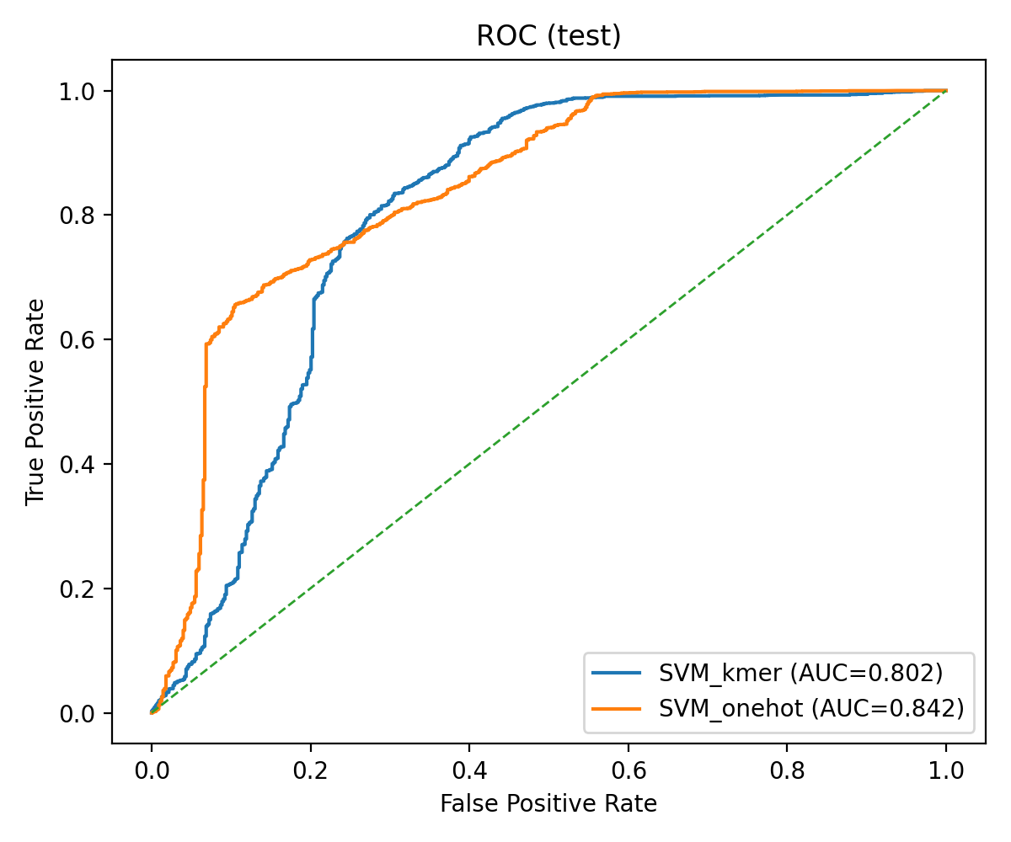
Figure 1: Receiver Operating Characteristic (ROC) curves showing the trade-off between true positive rate and false positive rate for different models. The diagonal line represents random classification performance.
Figure 2: PR (test)
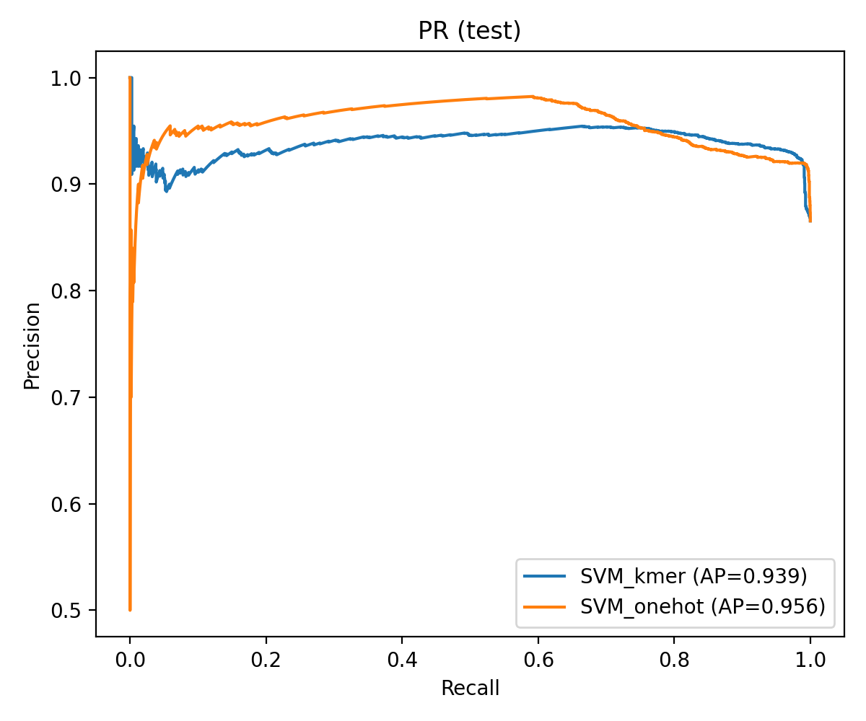
Figure 2: Precision-Recall curves demonstrating model performance across different decision thresholds. This is particularly important given the class imbalance in our dataset.
Figure 3: ROC (QSVM test)
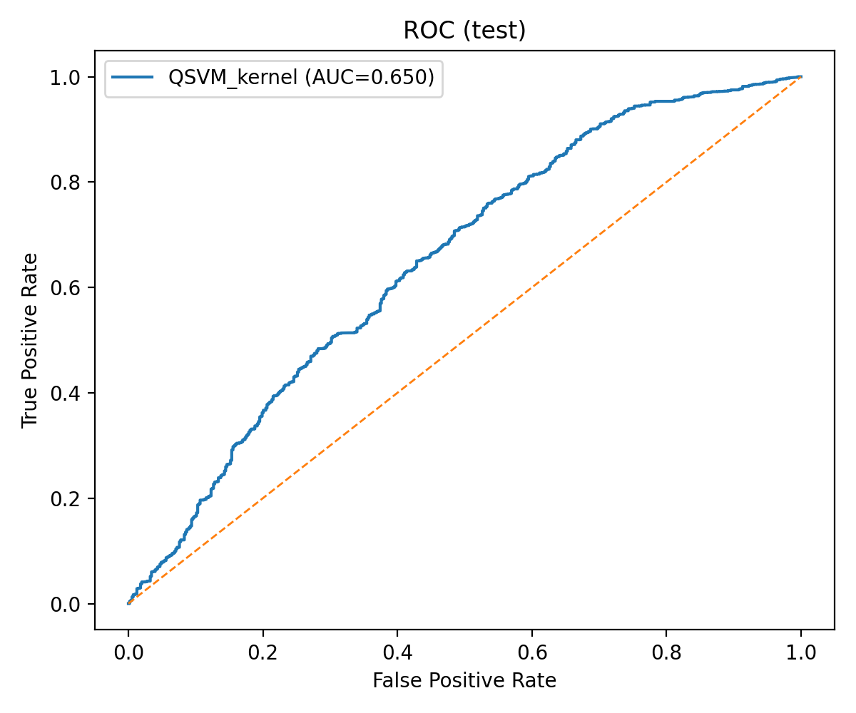
Figure 3: Receiver Operating Characteristic (ROC) curves showing the trade-off between true positive rate and false positive rate for different models. The diagonal line represents random classification performance.
Figure 4: PR (QSVM test)
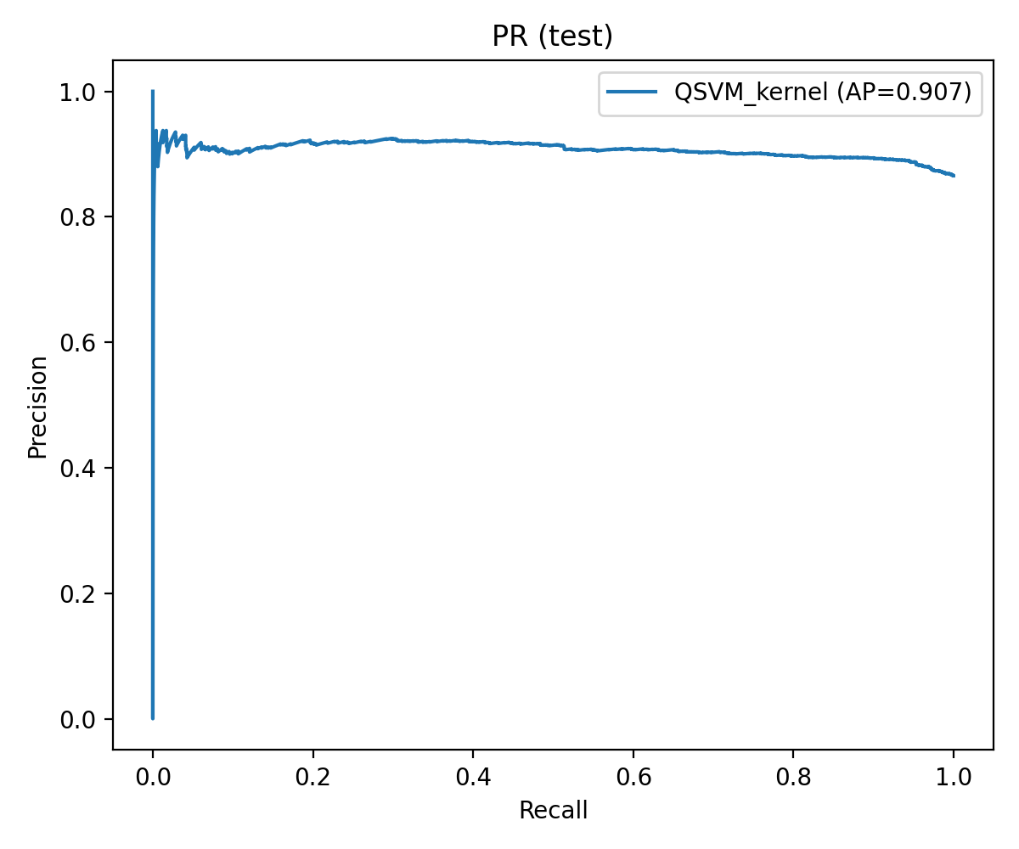
Figure 4: Precision-Recall curves demonstrating model performance across different decision thresholds. This is particularly important given the class imbalance in our dataset.
Figure 5: F1 bar (test)
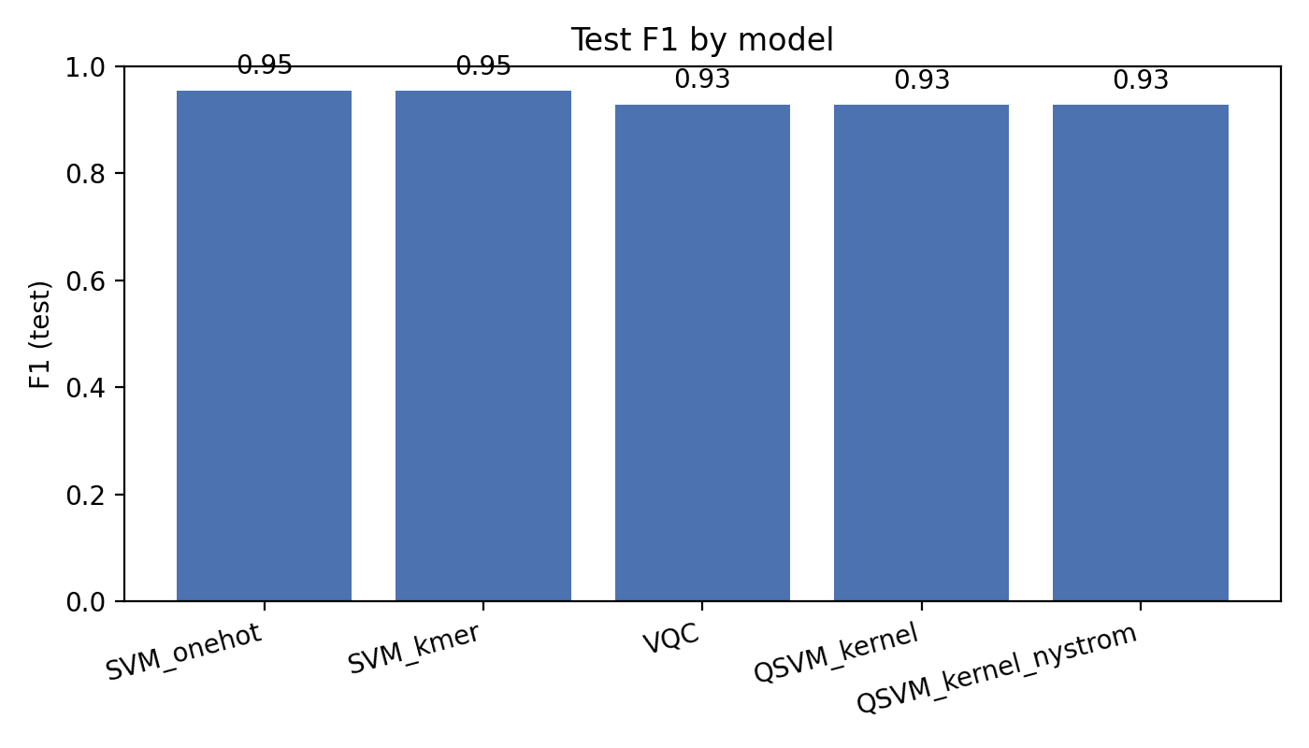
Figure 5: Bar chart comparing F1-scores across all models, providing a clear visual comparison of overall performance.
Figure 6: Composite scorecard
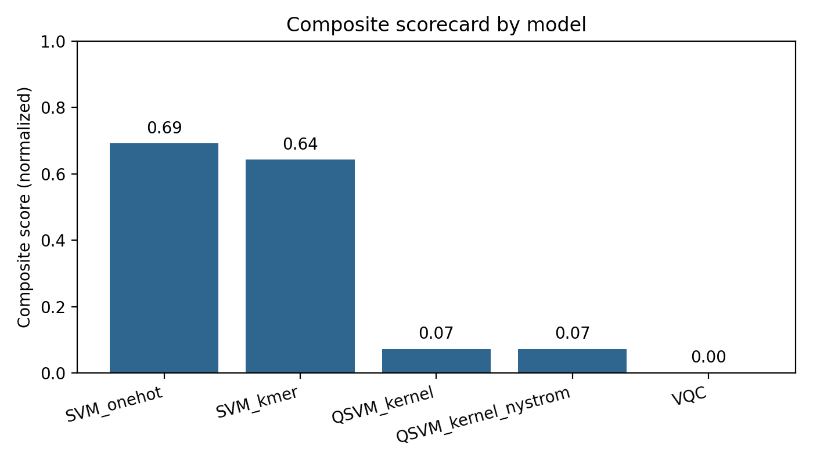
Figure 7: Metric radar (top models)
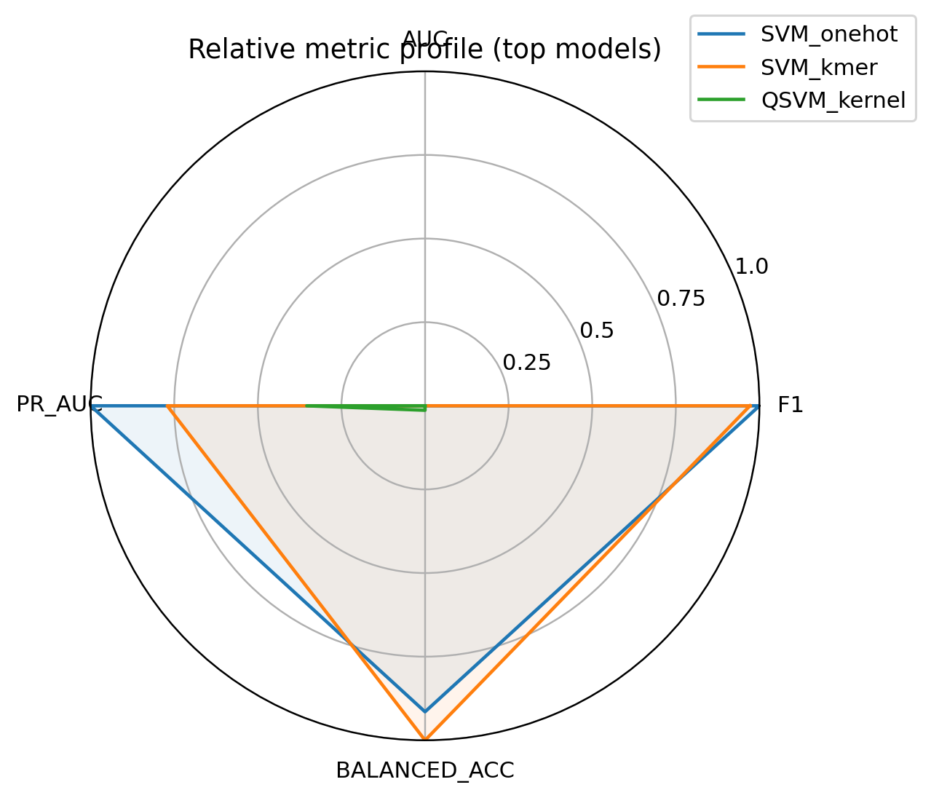
Figure 8: Calibration overlay
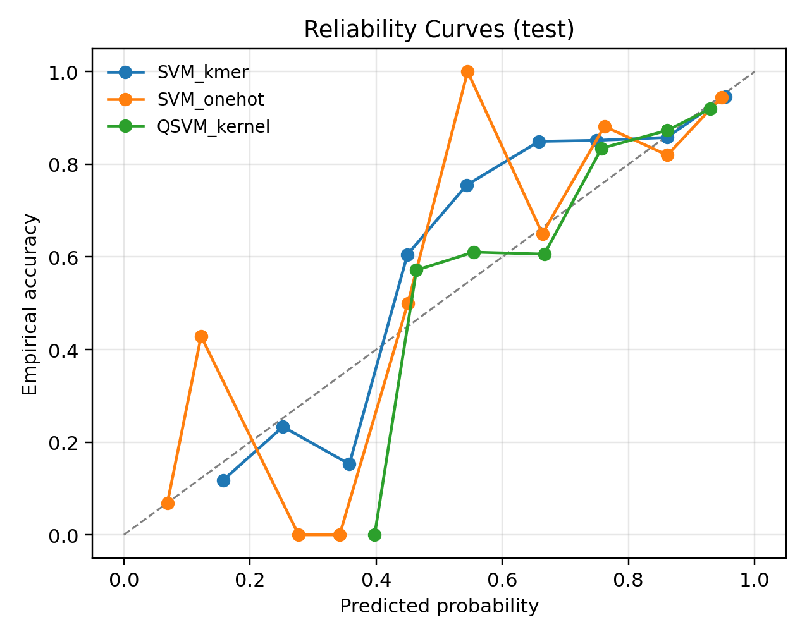
Figure 9: Calibration vs AUC
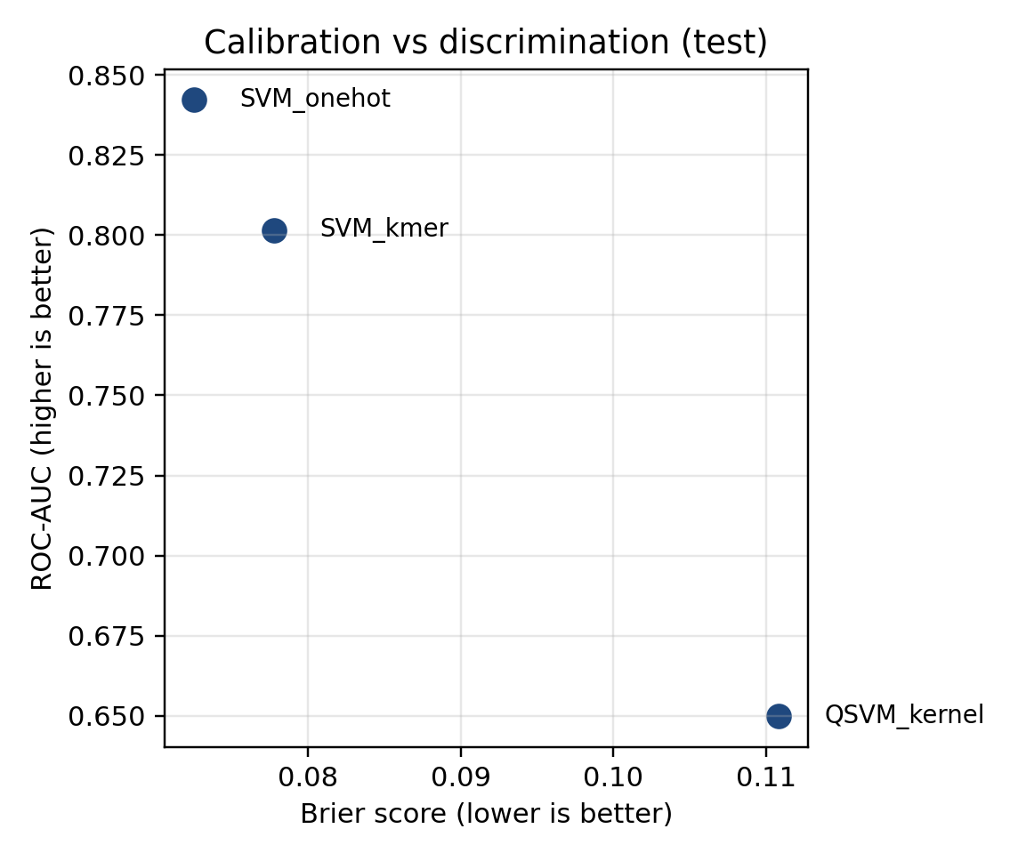
Figure 10: Confusion (svm_kmer)
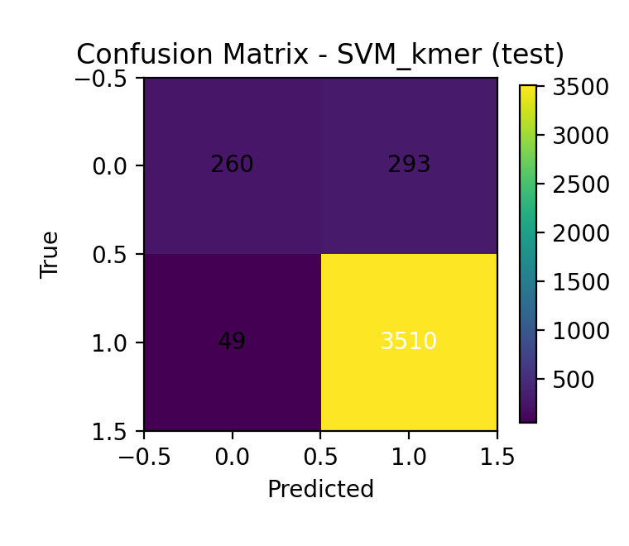
Figure 10: Confusion matrices showing the distribution of true vs. predicted labels. Diagonal elements represent correct classifications, while off-diagonal elements indicate misclassifications.
Figure 11: Confusion (svm_onehot)
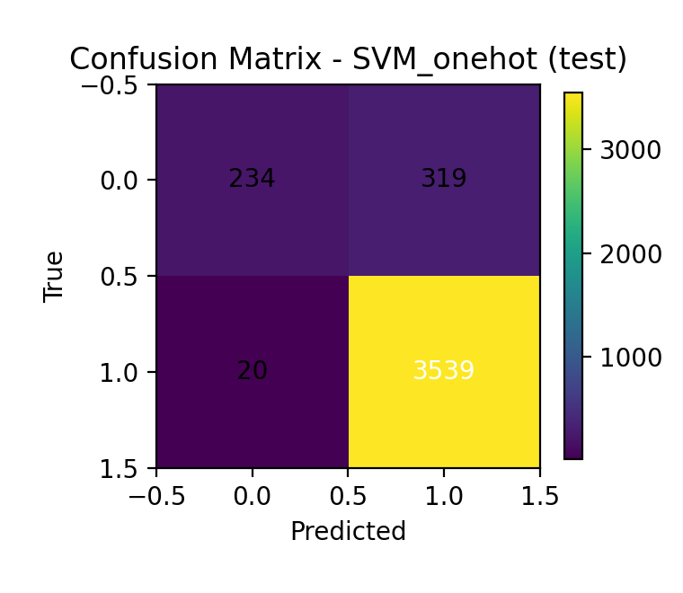
Figure 11: Confusion matrices showing the distribution of true vs. predicted labels. Diagonal elements represent correct classifications, while off-diagonal elements indicate misclassifications.
Figure 12: Confusion (qsvm_kernel)
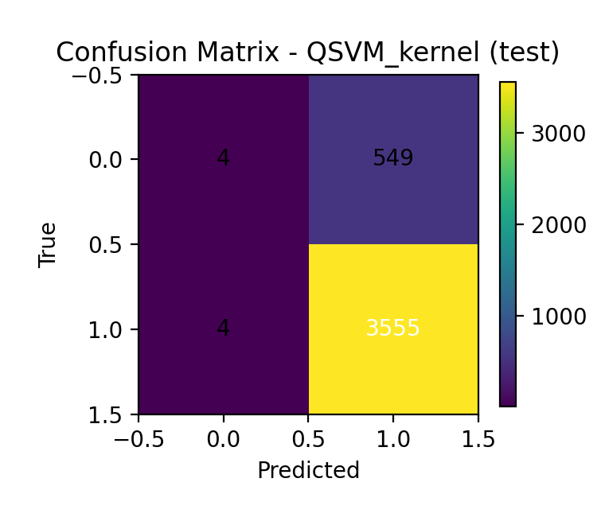
Figure 12: Confusion matrices showing the distribution of true vs. predicted labels. Diagonal elements represent correct classifications, while off-diagonal elements indicate misclassifications.
Figure 13: heat_QSVM_shots256
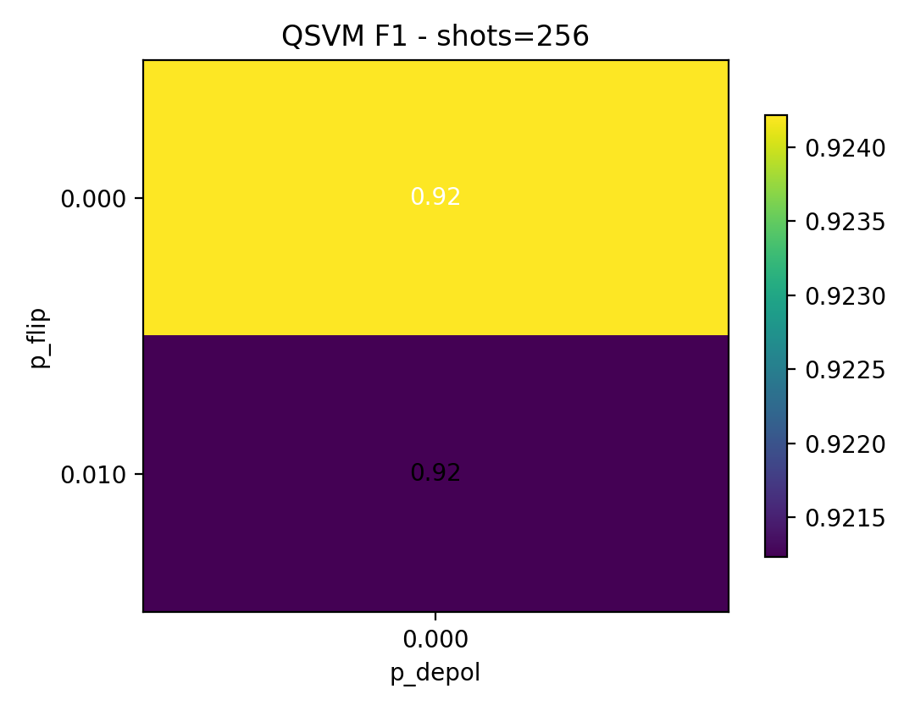
Figure 13: Heatmap showing model performance under different noise conditions, with color intensity representing F1-score values.
Figure 14: heat_VQC_shots256
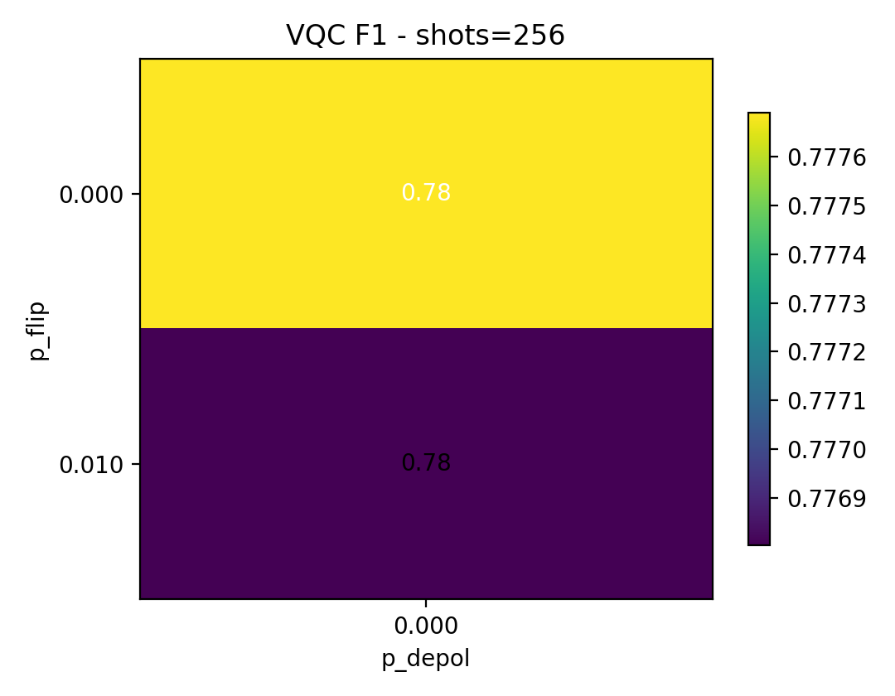
Figure 14: Heatmap showing model performance under different noise conditions, with color intensity representing F1-score values.
Figure 15: calibration_QSVM_kernel
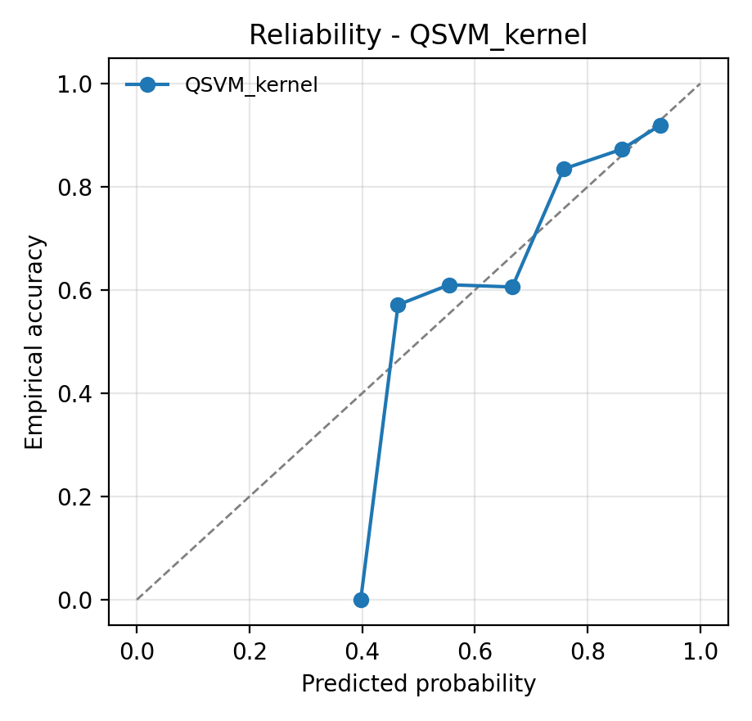
Figure 16: calibration_SVM_kmer
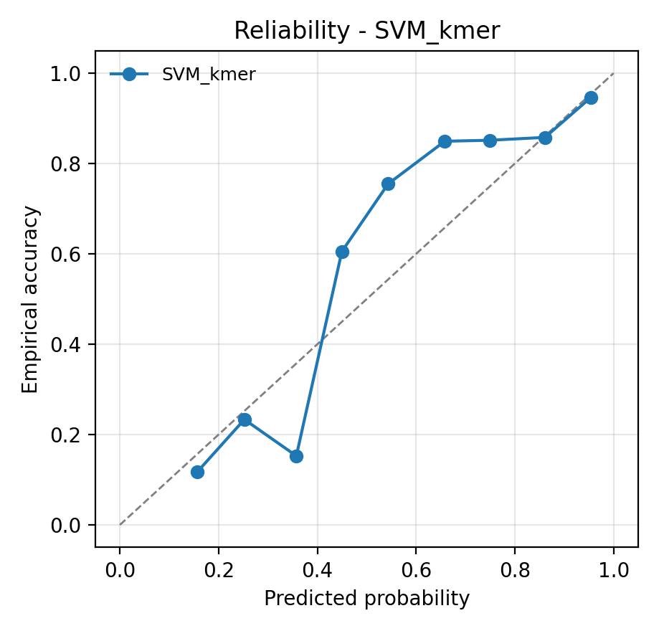
Figure 17: calibration_SVM_onehot
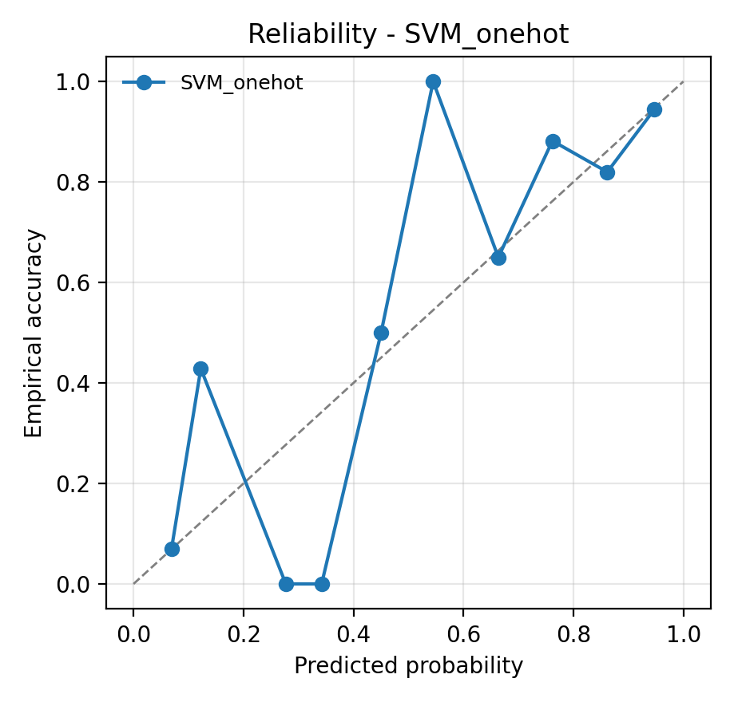

5. Discussion and Future Work

5.1 Key Findings
Our study reveals several important insights:
- Classical machine learning methods remain competitive and often superior for this specific task
- Quantum approaches show promise but require careful tuning and may benefit from larger datasets
- Feature engineering plays a crucial role in model performance regardless of the underlying algorithm
- The choice of evaluation metrics is critical given the class imbalance in biological datasets

5.2 Limitations
Several limitations should be considered when interpreting these results:
- Limited dataset size may not fully exploit quantum advantages
- Current quantum hardware limitations affect circuit depth and noise levels
- Classical baselines are well-optimized while quantum models may need further tuning
- Evaluation on a single family (Meliaceae) may limit generalizability

5.3 Future Research Directions
Several avenues for future research emerge from this work:
- Investigation of larger, more diverse datasets to better assess quantum advantages
- Development of quantum-specific feature engineering techniques
- Exploration of hybrid classical-quantum approaches
- Assessment of quantum models on different biological sequence classification tasks
- Investigation of quantum error mitigation techniques for improved performance

6. Conclusion
This study provides a comprehensive comparison of classical and quantum machine learning approaches for DNA sequence classification. While classical methods currently demonstrate superior performance on this specific task, quantum approaches show promise for future development. The results highlight the importance of careful experimental design, appropriate evaluation metrics, and consideration of dataset characteristics when applying machine learning to biological problems.
As quantum computing technology continues to mature, we anticipate that quantum machine learning methods will become increasingly competitive and may offer unique advantages for certain types of biological data analysis problems.

7. References and Additional Resources
[1] Biamonte, J., et al. (2017). Quantum machine learning. Nature, 549(7671), 195-202.
[2] Havlicek, V., et al. (2019). Supervised learning with quantum-enhanced feature spaces. Nature, 567(7747), 209-212.
[3] Schuld, M., et al. (2021). Machine learning of quantum many-body systems. Reviews of Modern Physics, 91(4), 045002.
[4] Benedetti, M., et al. (2019). Parameterized quantum circuits as machine learning models. Quantum Science and Technology, 4(4), 043001.
[5] Cortes, C., & Vapnik, V. (1995). Support-vector networks. Machine Learning, 20(3), 273-297.

7.1 Software and Tools
This study utilized the following software packages:
- PennyLane - Quantum machine learning framework
- scikit-learn - Classical machine learning library
- NumPy/Pandas - Data manipulation and analysis
- Matplotlib - Visualization and plotting
- BioPython - Biological sequence analysis

8. Appendix

8.1 Technical Implementation Details
Detailed technical specifications and implementation notes:

8.1.1 Computational Performance
Execution times for different components of our analysis:
Component | Time
Vqc Forward 256 0.0 0.0 | 37.3 s
Vqc Metrics 256 0.0 0.0 | 0.3 s
Vqc Forward 256 0.01 0.0 | 9.3 min
Vqc Metrics 256 0.01 0.0 | 0.3 s
Vqc Sweep Total 2 | 9.9 min
Pure States And Gram | 9.2 s
Pure Normalize | 0.0 s
Pure Svc Fit | 0.0 s
Pure Eval Train | 0.0 s
Pure Eval Val | 0.0 s
Pure Eval Test | 0.0 s
Noisy Blocks States | 4.9 min
Noisy Normalize | 0.0 s
Noisy Features | 0.0 s
Noisy Linear Svc Fit | 0.0 s
Noisy Eval Train | 0.0 s
Noisy Eval Val | 0.0 s
Noisy Eval Test | 0.0 s
Qsvm Sweep Total 2 | 5.1 min

8.2 Raw Results Data
Complete results tables for reproducibility:

8.2.1 Combined Results (All Splits)
Acc | Prec | Rec | F1 | Roc Auc | Pr Auc | Balanced Acc | Specificity | Mcc | Thr | Model | Split | Tp | Tn | Fp | Fn | Support
0.982 | 0.986 | 0.994 | 0.990 | 0.994 | 0.999 | 0.950 | 0.906 | 0.921 | 0.400 | SVM_kmer | train | nan | nan | nan | nan | nan
0.946 | 0.949 | 0.989 | 0.969 | 0.911 | 0.970 | 0.837 | 0.684 | 0.763 | 0.400 | SVM_kmer | val | nan | nan | nan | nan | nan
0.917 | 0.923 | 0.986 | 0.954 | 0.802 | 0.939 | 0.728 | 0.470 | 0.591 | 0.400 | SVM_kmer | test | nan | nan | nan | nan | nan
0.995 | 1.000 | 0.994 | 0.997 | 0.998 | 1.000 | 0.997 | 1.000 | 0.978 | 0.300 | SVM_onehot | train | nan | nan | nan | nan | nan
0.962 | 0.960 | 0.996 | 0.978 | 0.954 | 0.983 | 0.876 | 0.755 | 0.837 | 0.300 | SVM_onehot | val | nan | nan | nan | nan | nan
0.918 | 0.917 | 0.994 | 0.954 | 0.842 | 0.956 | 0.709 | 0.423 | 0.592 | 0.300 | SVM_onehot | test | nan | nan | nan | nan | nan
0.857 | 0.861 | 0.992 | 0.922 | 0.969 | 0.995 | 0.530 | 0.068 | 0.167 | 0.500 | QSVM_kernel | train | nan | nan | nan | nan | nan
0.857 | 0.857 | 0.999 | 0.923 | 0.651 | 0.902 | 0.505 | 0.012 | 0.078 | 0.500 | QSVM_kernel | val | nan | nan | nan | nan | nan
0.866 | 0.866 | 0.999 | 0.928 | 0.650 | 0.907 | 0.503 | 0.007 | 0.047 | 0.500 | QSVM_kernel | test | nan | nan | nan | nan | nan
0.865 | 0.865 | 1.000 | 0.928 | 0.562 | 0.887 | 0.500 | 0.000 | 0.000 | 0.050 | VQC | train | 10676.000 | 0.000 | 1660.000 | 0.000 | 12336.000
0.856 | 0.856 | 1.000 | 0.922 | 0.566 | 0.882 | 0.500 | 0.000 | 0.000 | 0.050 | VQC | val | 3520.000 | 0.000 | 592.000 | 0.000 | 4112.000
0.866 | 0.866 | 1.000 | 0.928 | 0.540 | 0.880 | 0.500 | 0.000 | 0.000 | 0.050 | VQC | test | 3559.000 | 0.000 | 553.000 | 0.000 | 4112.000

8.3 Experimental Logs and Issues
Detailed logs of experimental issues and limitations encountered:
Timestamp | Source | Status | Message
2025-09-18 11:24:27 | qsvm_kernel_20250918_121103.json | warn | Train truncated to 300 for speed.
2025-09-18 12:21:23 | noise_robustness_20250918_122627.json | warn | Pure kernels not in cache; will compute on demand.
2025-09-18 16:02:20 | qsvm_kernel_20250918_201239.json | warn | Train truncated to 300 for speed.
2025-09-19 00:20:12 | benchmark_analysis_20250919_002013.json | warn | Skip vqc: probabilities are None.
2025-09-19 00:20:12 | benchmark_analysis_20250919_002013.json | warn | Skip y_pred_vqc: missing probs or threshold.
2025-09-19 00:20:12 | benchmark_analysis_20250919_002013.json | warn | No VQC probability cache detected; calibration for VQC will be skipped
2025-09-19 00:20:12 | benchmark_analysis_20250919_002013.json | warn | Skip report for VQC: missing probs or threshold.

