

CAPSTONE PROJECT REPORT
Report 3 – Software Requirement Specification

– DaNang, September 2025 –
Table of Contents
I. Record of Changes 6
II. Software Requirement Specification 7
1. Product Overview 7
2. User Requirements 7
2.1 Actors 7
2.2 Use Cases 8
2.2.1 Diagram(s) 8
2.2.2 Descriptions 13
3. Functional Requirements 17
3.1 System Functional Overview 17
3.1.1 Screens Flow 17
3.1.2 Screen Descriptions 19
3.1.3 Screen Authorization 23
3.1.4 Non-Screen Functions 25
3.1.5 Entity Relationship Diagram 26
3.2 User Account Management 27
3.2.1 Login 27
3.2.2 Logout 29
3.2.3 Forgot Password 30
3.2.4 Change Password 31
3.2.5 Create User Accounts 33
3.2.6 View User Lists 36
3.2.7 Ban/Unban Users 37
3.2.8 Import Parent/Driver File 39
3.2.9 View personal profile 40
3.2.10 Edit personal profile 42
3.2.11 Upload user avatar 44
3.2.12 View driver’s information 46
3.3 Service Registration and Payment 48
3.3.1 Register for Shuttle Service 48
3.3.2 Select Pickup Point 50
3.3.3 Make payment 51
3.3.4 View Register History 53
3.3.5 View Payment History 55
3.3.6 View Parent's Register Request 57
3.3.7 Approve/Reject Parent's Register Request 58
3.3.8 View Driver's Request 60
3.3.9 Approve/Reject Driver's Request 61
3.4 Student Management 62
3.4.1 View Student List 62
3.4.2 View student detail 63
3.4.3 Add student 65
3.4.4 Update student 66
3.4.5 Delete student 67
3.4.6 Import student file 68
3.4.7 View Student’s Information 69
3.4.8 Update Student’s Information 71
3.4.9 Send absence report 72
3.4.10 Send leave/sick request 74
3.5 Vehicle Management 75
3.5.1 Create Vehicle 75
3.5.2 Update Vehicle 76
3.5.3 Delete Vehicle 77
3.5.4 View Vehicle List 78
3.5.5 Assign Driver 79
3.5.6 View Vehicle Detail 80
3.5.7 View Vehicle’s Information 81
3.6 Route Management 83
3.6.1 Create Route 83
3.6.2 Delete Route 84
3.6.3 View All Routes 85
3.6.4 View Route Detail 87
3.6.5 Update Route 88
3.7 Schedule Management 90
3.7.1 View All Schedule 90
3.7.2 Update Schedule 91
3.7.3 Create Schedule 93
3.7.4 Delete Schedule 94
3.7.5 View Schedule Detail 95
3.7.6 Add Exception Date 97
3.7.7 Delete Exception Date 99
3.7.8 Add Time Overrides 101
3.7.9 Update Time Overrides 103
3.7.10 DeleteTime Overrides 104
3.7.11 View Shuttle Schedule 105
3.8 Trip Management 107
3.8.1 View All Trip 107
3.8.2 View Trip Detail 110
3.8.3 Delete Trip 111
3.8.4 Create Trip 112
3.8.5 Update Trip 114
3.8.7 Confirm manual check-in 115
3.8.8 Confirm manual check-out 116
3.8.9 Handle absent student 118
3.8.10 View Trip’s History 120
3.9 Attendance Management 121
3.9.1 Take Attendance 121
3.9.2 Take Attendance Manually 122
3.9.3 View trip report 124
3.9.4 View Student List on Bus-Specific 126
3.10 Vehicle Status Monitoring 128
3.10.1 Track Vehicle Journey 128
3.10.2 Trace All Vehicle’s Trip 129
3.11 Notifications 131
3.11.1 View Parent's Notification 131
3.11.2 View DriverNotification 133
3.11.3 View Supervisor’s Notification 135
3.12 Pickup/Drop-off Address Management 137
3.12.1 Select/Search Location 137
3.13 Incident Reporting 139
3.13.1 Report Incidents 139
3.14 Reporting 141
3.14.1 View Revenue 141
3.14.2 Generate daily/monthly reports 142
3.14.3 View statistics 144
3.15 Audit Logs 146
3.15.1 View historical logs 146
3.15.2 Export logs to file 147
3.16 School System Configuration 149
3.16.1 View School Information 149
3.16.2 Update School Information 151
3.16.3 Update school’s logo/images 153
3.16.4 Update school’s location 154
3.16.5 Create unit price 155
3.16.6 Update unit price 157
3.16.7 Delete unit price 158
4. Non-Functional Requirements 160
4.1 External Interfaces 160
4.1.1 Database Interfaces 160
4.1.2 API Interfaces 160
4.1.3 Frontend Interfaces 160
4.1.4 External Service Interfaces 160
4.2 Quality Attributes 160
4.2.1 Usability 160
4.2.2 Reliability 161
4.2.3 Performance 161
5. Requirement Appendix 162
5.1 Business Rules 162
5.2 Common Requirements 167
5.3 Application Messages List 168
5.4 Other Requirements… 169

I. Record of Changes
Date | A*  M, D | In charge | Change Description
23/08/2025 | A | NhiPTK | Create the software requirement specification
23/08/2025 | A | NhiPTK, TrungNVT, NguyetNTT, HuyNLQ | Add the system’s entity relationship diagram
26/08/2025 | A | TrungNVT | Add the system’s context diagram
26/08/2025 | A | NguyetNTT | Add the system’s requirement appendix
26/08/2025 | A | HuyNLQ | Add the system’s overview use case diagram
10/10/2025 | M | HuyNLQ | Update UC and EDRD
29/10/2025 | M | NguyetNTT | Update screen flow
23/11/2025 | M | TrungNVT | Update description and design
*A - Added M - Modified D - Deleted

II. Software Requirement Specification

1. Product Overview
The School Bus Management System is a smart safety platform that connects parents, schools, and drivers in real time to ensure every child’s journey to school is safe and worry-free. With GPS tracking and AI-powered facial recognition, the system confirms each boarding and drop-off, instantly notifying parents and allowing them to follow the bus’s route until their child reaches school. By combining advanced technology with a deep commitment to student safety, the system not only prevents tragic incidents but also builds trust, transparency, and peace of mind for families every day.
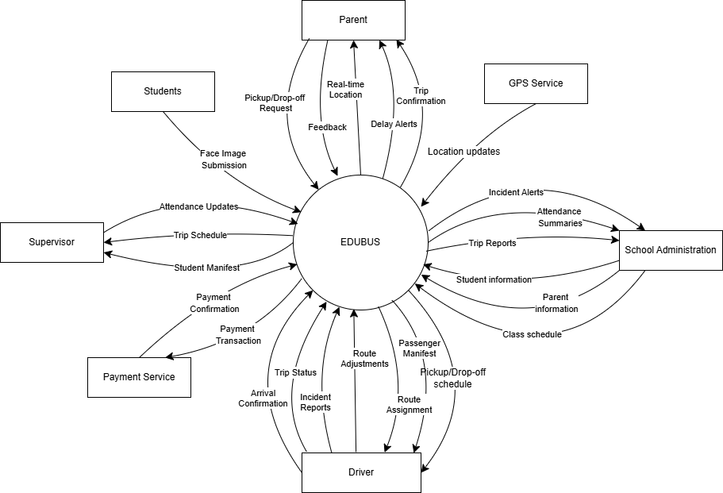
Figure 1: Context Diagram

2. User Requirements

2.1 Actors
# | Actor | Description
1 | Supervisor | Supervisor is a school staff member responsible for monitoring student safety and attendance during bus operations. They manage pickup and drop-off activities, check student presence, handle absences, and coordinate with drivers and administrators. Supervisors can view bus-specific student lists, record manual attendance, and receive trip-related updates to ensure safe and accurate transportation.
2 | Admin | Oversees and manages the entire shuttle operation, including creating bus schedules, assigning drivers, monitoring real-time trip progress, and reviewing attendance records to ensure safety and operational efficiency.
3 | Driver | Operates the school bus, starts and ends trips in the system, and uses the facial recognition device to confirm student boarding and drop-off, ensuring accurate attendance and timely notifications to parents.
4 | Parent | Receives instant notifications about trip status and their child’s boarding/drop-off events, and can track the bus’s live location through the mobile app, ensuring peace of mind and transparency throughout the journey.

2.2 Use Cases

2.2.1 Diagram(s)

2.2.1.1: Overall Use-Case
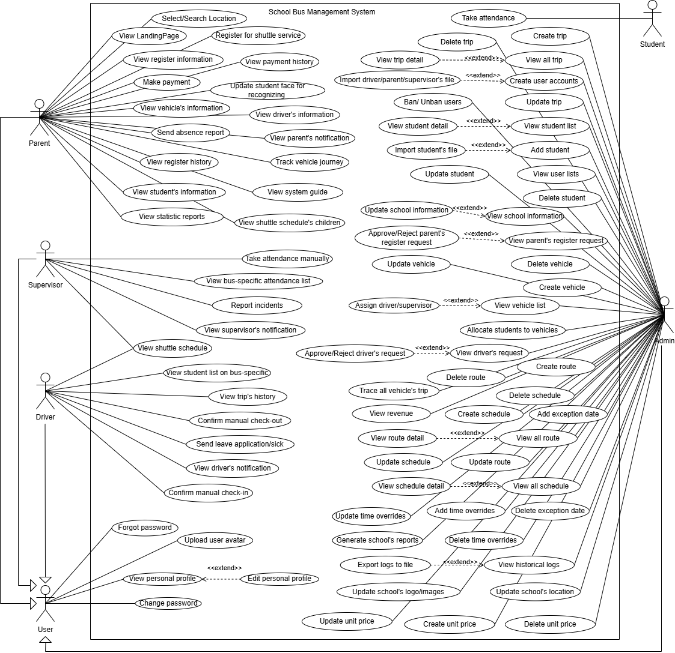
Figure 2: UseCase Overall

2.2.1.2: Authentication Use-Case
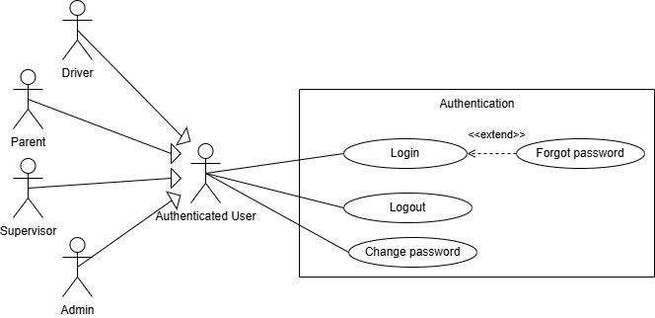
Figure 3: UseCase of Authentication

2.2.1.3: Supervisor Use-Case

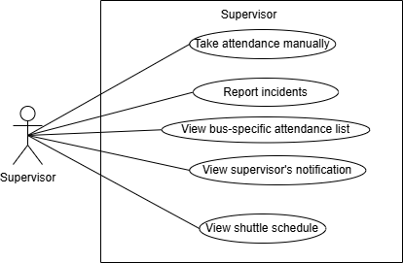
Figure 4: UseCase of Supervisor

2.2.1.4: Parent Use-Case

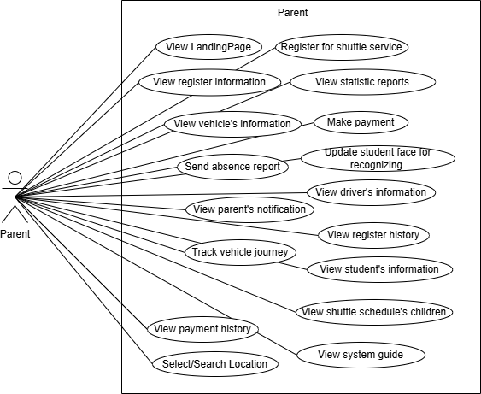
Figure 5: UseCase of Parent

2.2.1.5: Driver Use-Case

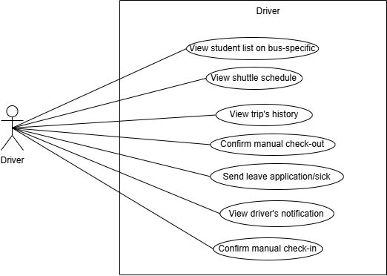
Figure 6: UseCase of Driver

2.2.1.6: Admin Use-Case
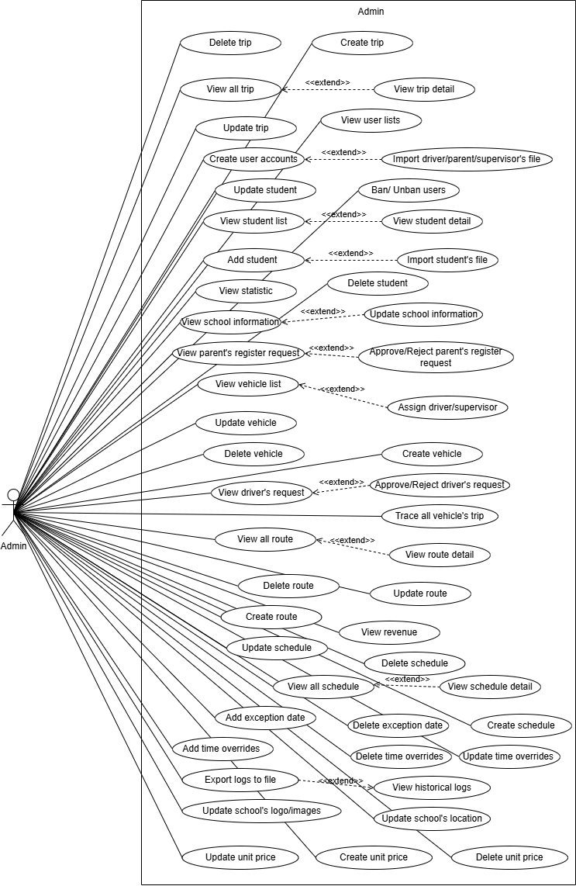
Figure 7: UseCase of Admin

2.2.2 Descriptions
ID | Use Case | Actors | Use Case Description
01 | Login | School Administrator, Driver, Parent, Supervisor | Allows users to access the system with their registered account, ensuring authentication and data security.
02 | Forgot Password | School Administrator, Driver, Parent, Supervisor | Helps users recover or reset their password when forgotten, via linked email or phone number.
03 | Change Password | School Administrator, Driver, Parent, Supervisor | Enables users to change their password at any time to enhance account security.
04 | Logout | School Administrator, Driver, Parent, Supervisor | Safely ends the user’s session and redirects them to the login screen, preventing further access without re-authentication.
05 | View personal profile | School Administrator, Driver, Parent, Supervisor | Allows users to view their complete personal information, including contact details and role-related data in the system.
06 | Edit personal profile | School Administrator, Driver, Parent, Supervisor | Allows users to update and modify their personal information to keep data accurate and up to date.
07 | Upload user avatar | School Administrator, Driver, Parent, Supervisor | Allows the users to upload or update a user's profile picture. The system stores the image and displays it in the user’s profile and relevant interface components for identification purposes.
08 | Create trip | Admin | Allows administrators to create a new trip with route and schedule details.
09 | View all trip | Admin | Displays the list of all trips managed in the system.
10 | View trip detail | Admin | Shows detailed information of a specific trip.
11 | Update trip | Admin | Enables editing of trip details such as schedule or assigned vehicle.
12 | Delete trip | Admin | Removes an existing trip from the system.
13 | Create user accounts | Admin | Allows creation of new driver and parent user accounts.
14 | Import driver/parent/supervisor's file | Admin | Supports bulk user creation by importing driver, supervisor and parent data files.
15 | View user lists | Admin | Displays all registered users in the system.
16 | Ban/Unban users | Admin | Restricts or restores user access to the system.
17 | View student list | Admin | Shows the list of all students.
18 | View student detail | Admin | Displays full details of a specific student.
19 | Add student | Admin | Allows administrators to add a new student.
20 | Import student’s file | Admin | Supports bulk student creation through file import.
21 | Update student | Admin | Updates student information such as class or contact details.
22 | Delete student | Admin | Removes a student’s record from the system.
23 | View school information | Admin | Displays general school details.
24 | Update school information | Admin | Allows modification of school-related information.
25 | View parent’s register request | Admin | Displays registration requests submitted by parents.
26 | Approve/Reject parent’s register request | Admin | Allows admin to approve or reject parent requests for student enrollment.
27 | View driver’s request | Admin | Shows requests submitted by drivers.
28 | Approve/Reject driver’s request | Admin | Enables admin to approve or reject driver-related requests.
29 | Create vehicle | Admin | Allows administrators to register a new vehicle.
30 | View vehicle list | Admin | Displays all vehicles registered in the system.
31 | Update vehicle | Admin | Enables modification of vehicle details such as license plates.
32 | Delete vehicle | Admin | Removes a vehicle record from the system.
33 | Assign driver/supervisor | Admin | Assigns a driver/supervisor to a specific vehicle.
34 | Trace all vehicle’s trip | Admin | Allows tracking of all trips made by vehicles.
35 | Create route | Admin | Allows administrators to define new bus routes.
36 | View all route | Admin | Displays the list of all routes.
37 | View route detail | Admin | Shows detailed information about a specific route.
38 | Update route | Admin | Enables editing of existing bus routes
39 | Delete route | Admin | Removes a bus route from the system.
40 | Create schedule | Admin | Allows administrators to define schedules for trips.
41 | View all schedule | Admin | Displays all existing schedules.
42 | View schedule detail | Admin | Provides detailed information about a specific schedule.
43 | Update schedule | Admin | Enables changes to schedule details
44 | Delete schedule | Admin | Removes an existing schedule from the system.
45 | Add exception date | Admin | Allows addition of special exception dates (holidays, events).
46 | Delete exception date | Admin | Removes an existing exception date
47 | Add time overrides | Admin | Allows adding custom time overrides to schedules.
48 | Update time overrides | Admin | Modifies existing time overrides.
49 | Delete time overrides | Admin | Deletes an existing time override.
50 | View statistic | Admin | Provides statistical reports of system usage.
51 | View revenue | Admin | Displays revenue reports related to transportation services.
52 | Export logs to file | Admin | Allows the admin to export system logs (e.g., attendance, trip records, activities) into downloadable files such as Excel or PDF for auditing, reporting, and data analysis.
53 | View historical logs | Admin | Enables the administrator to access the system’s historical activity logs. Logs include user actions, updates, configurations, and operational events, providing traceability for auditing, compliance, and troubleshooting.
54 | Update school's logo/images | Admin | Allows the administrator to update the school's branding elements such as logo or banner images. These assets are displayed on dashboards, login pages, and reports to personalize the system for the school.
55 | Update school's location | Admin | Enables the administrator to modify the school's official location details (address, coordinates). This information is used for route planning, distance calculation, and accurate trip scheduling.
56 | Update unit price | Admin | Enables the administrator to change the existing unit price configuration. This may include updating the price amount, type, or applicable conditions. Updated prices apply to future billing cycles or registrations.
57 | Create unit price | Admin | Allows the administrator to define a new unit price for the transportation service (e.g., per month, per route, per student). The created unit price becomes available for billing, invoicing, and registration processing.
58 | Delete unit price | Admin | Allows the administrator to remove a previously created unit price from the system. Deleted prices are no longer available for new transactions but may still be referenced in historical invoices or reports.
59 | Confirm manual check-in | Driver | Confirms the beginning of a scheduled trip.
60 | Confirm manual check-out | Driver | Marks the completion of a trip in the system.
61 | View trip’s history | Driver | Displays past trips taken by the driver.
62 | View driver’s notification | Driver | Displays system notifications specific to the driver.
63 | Send leave application/sick | Driver | Allows drivers to submit leave or sick requests.
64 | View student list on bus-specific | Driver | Allows drivers to view the student list for their assigned bus, including names, grades, locations, and attendance status.
65 | Report incidents | Supervisor | Allows supervisors to report trip incidents with details and optional photos in real time for timely handling.
66 | View shuttle schedule | Driver, Supervisor | Shows the assigned bus schedule to the driver/supervisor.
67 | View bus-specific attendance list | Supervisor | Displays the attendance list for a specific bus.
68 | Take attendance manually | Supervisor | Allows supervisors to mark attendance for students manually.
69 | View supervisor's notification | Supervisor | Displays system notifications specific to the supervisor.
70 | Make payment | Parent | Allows parents to make payments for transportation services.
71 | View shuttle schedule's children | Parent | Displays the shuttle schedule assigned to their child.
72 | View vehicle’s information | Parent | Provides details about the vehicle transporting their child.
73 | View student’s information | Parent | Displays their child’s registered information.
74 | View payment history | Parent | Allows parents to view their payment history, including past transactions, amounts, dates, and statuses, for better tracking of their shuttle service fees.
75 | View register history | Parent | Displays historical records of registration.
76 | View register information | Parent | Shows details of the parent’s registration request.
77 | View parent’s notification | Parent | Displays notifications sent to parents.
78 | View driver’s information | Parent | Provides information about the driver assigned to their child’s vehicle.
79 | View system guide | Parent | Displays instructions for using the system.
80 | Send absence report | Parent | Enables parents to submit complaints to the school administration.
81 | Track vehicle journey | Parent | Allows real-time tracking of the child’s vehicle.
82 | Update student face for recognizing | Parent | Allows parents to upload images of their children for identification.
83 | Register for shuttle service | Parent | Allows parents to register for the school bus service by providing necessary details.
84 | View Landing Page | Parent | Provides general information about the school bus service on the landing page.
85 | Take attendance | Student | Allows students to mark their attendance when boarding the bus.
86 | Select/Search Location | Parent | Allows parents to search for and select a pickup or drop-off location when registering for the shuttle service, ensuring accurate address selection.
87 | View statistic reports | Parent | Allows parents to view statistical reports related to their child’s shuttle usage, such as trip counts, attendance summaries, and monthly service activity.

3. Functional Requirements

3.1 System Functional Overview

3.1.1 Screens Flow

3.1.1.1 Screens Flow of Supervisor
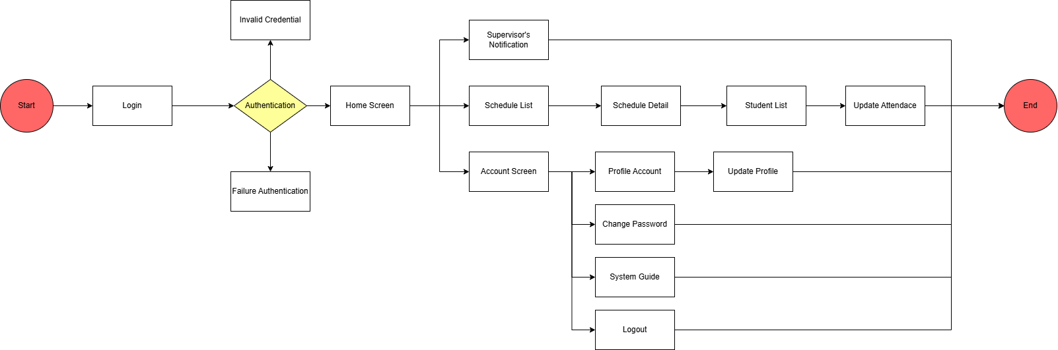
Figure 8: Screen Flow of Supervisor

3.1.1.2 Screens Flow of Parent
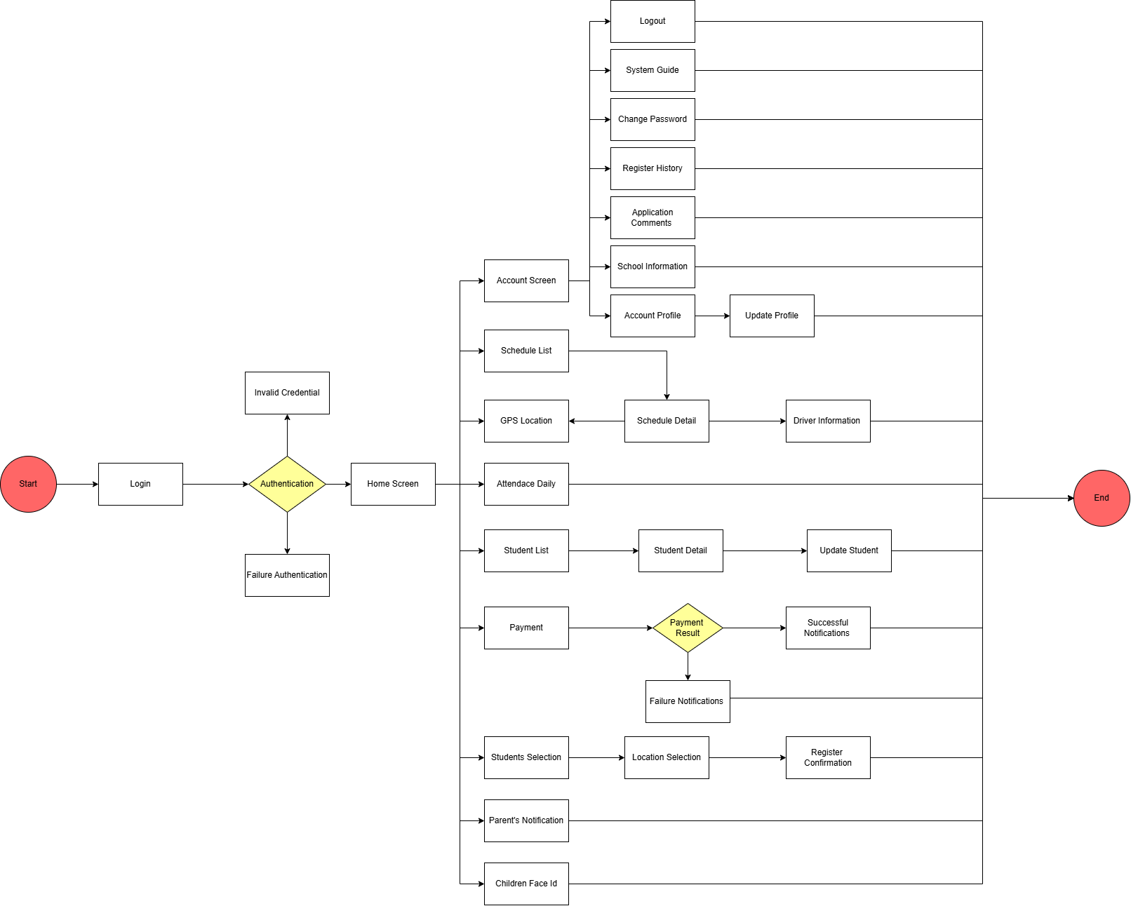
Figure 9: Screen Flow of Parent

3.1.1.3 Screens Flow of Driver

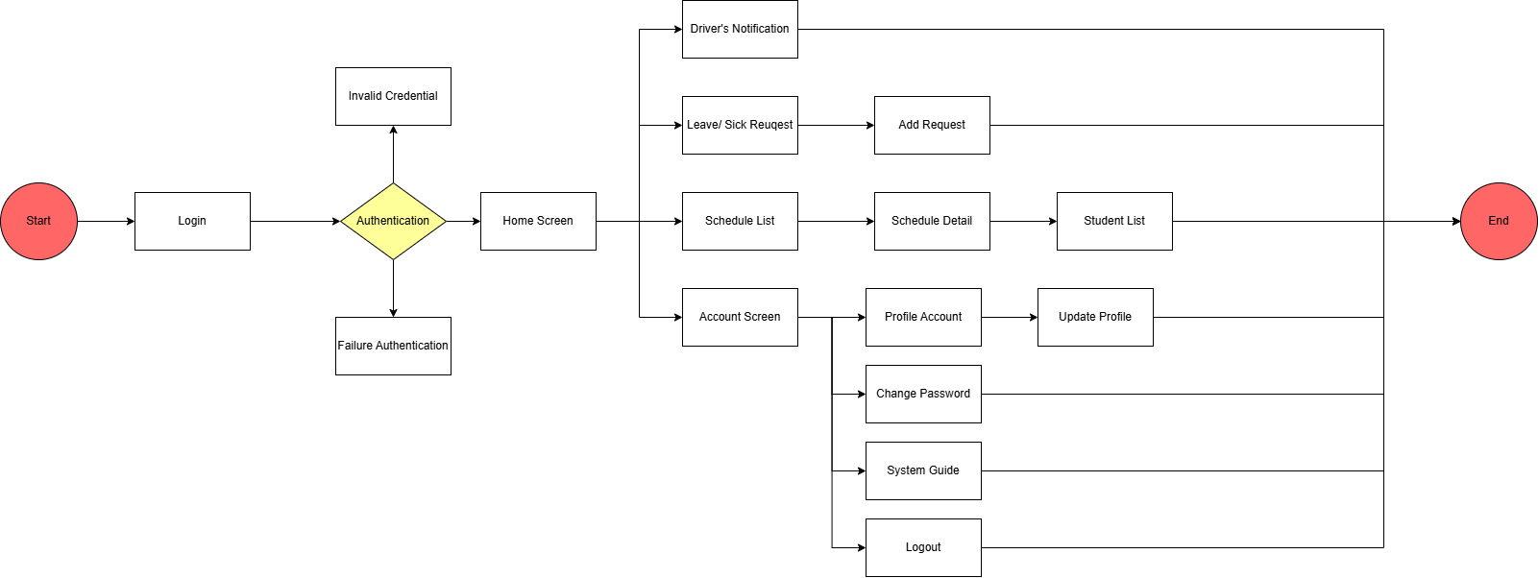
Figure 10: Screen Flow of Driver

3.1.1.4 Screens Flow of Admin
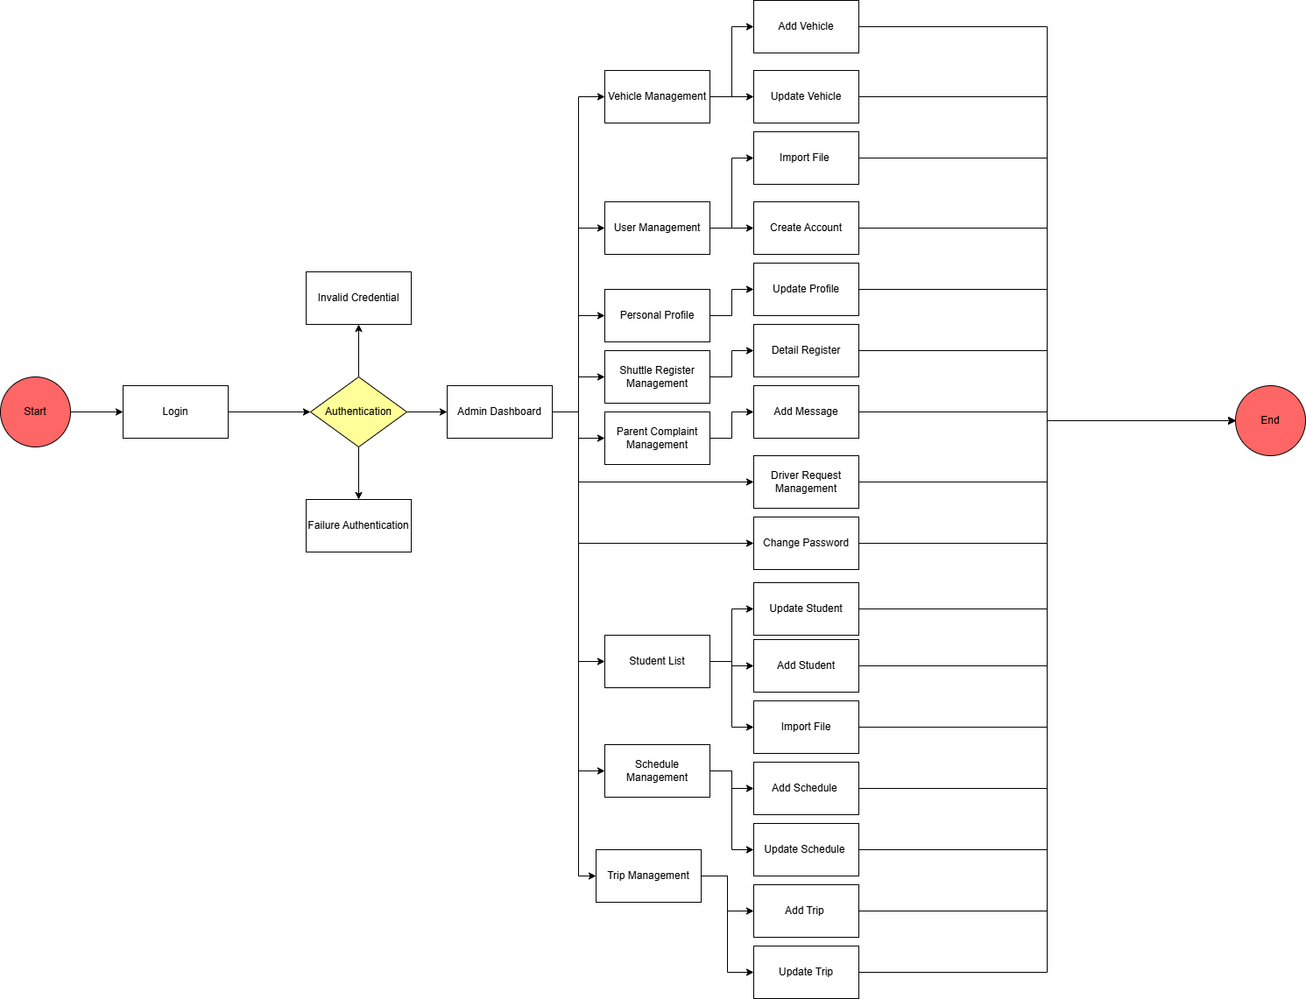
Figure 11: Screen Flow of Admin

3.1.2 Screen Descriptions
# | Feature | Screen | Description
1 | User Account Management | Login | Screen that allows users (Parent, Driver, Admin) to enter their registered email/phone and password to access the system.
2 | User Account Management | Logout | Screen that enables users to securely sign out of their account, ending the current session.
3 | User Account Management | Forgot Password | Screen that helps users recover or reset their password when forgotten, via linked email or phone number.
4 | User Account Management | Change Password | Screen where logged-in users can update their existing password to a new one for security.
5 | User Account Management | Invalid Credential | Displays an error message when incorrect login credentials are entered.
6 | User Account Management | Failure Authentication | Informs users of authentication failure due to system or account issues.
7 | User Account Management | Authentication | Intermediate screen that validates user credentials during the login process.
8 | User Account Management | Create Account | Screen that allows Admin to create new user accounts for parents, drivers, supervisors, or other admins.
9 | User Account Management | User Management | Admin screen to view, search, and manage all user accounts in the system, including ban/unban functionality.
10 | User Account Management | Personal Profile | Screen where users can view their personal information and profile details.
11 | User Account Management | Profile Account | Screen displaying user's account information including avatar, name, email, phone number, and role.
12 | User Account Management | Update Profile | Screen that allows users to edit and update their personal profile information and upload avatar.
13 | User Account Management | Account Screen | Main account hub screen showing profile overview and navigation to account-related functions.
14 | User Account Management | Import File | Screen that enables Admin to bulk import driver or parent data via file upload (Excel/CSV).
15 | User Account Management | System Guide | Help screen providing user manuals, tutorials, and guidance on how to use the system.
16 | Service Registration & Payment | Shuttle Register Management | Admin screen to view all parent registration requests and manage their approval/rejection status.
17 | Service Registration & Payment | Detail Register | Screen displaying detailed information of a specific parent's shuttle service registration request.
18 | Service Registration & Payment | Register History | Parent screen showing history of all their shuttle service registration requests with status.
19 | Service Registration & Payment | Register Confirmation | Screen where parent confirms their shuttle service registration details before final submission.
20 | Service Registration & Payment | Payment | Screen that allows parents to make payment for shuttle service using various payment methods.
21 | Service Registration & Payment | Payment Result | Screen displaying the outcome of payment transaction with success/failure status.
22 | Service Registration & Payment | Successful Notifications | Screen showing successful payment confirmation with invoice details.
23 | Service Registration & Payment | Failure Notifications | Screen informing parent that payment transaction has failed with reason and retry option.
24 | Service Registration & Payment | Application Comments | Screen where parents can view admin's comments or feedback on their registration application.
25 | Student Management | Student List | Screen displaying list of all students with filtering and search capabilities, accessible by Parent, Admin, Supervisor, and Driver with different views.
26 | Student Management | Student Detail | Parent screen showing detailed information of their specific child including academic and shuttle data.
27 | Student Management | Add Student | Admin screen for adding new student records to the system with all required information.
28 | Student Management | Update Student | Screen allowing Admin or Parent to edit and update student information and details.
29 | Student Management | Import File | Admin screen to bulk import student data from Excel/CSV file.
30 | Student Management | Students Selection | Parent screen for selecting which of their children to register for shuttle service.
31 | Student Management | Children Face Id | Screen for updating and managing a student's facial recognition profile for automated attendance.
32 | Vehicle Management | Vehicle Management | Admin screen displaying list of all vehicles with management capabilities.
33 | Vehicle Management | Add Vehicle | Screen allowing Admin to register new vehicle with details like license plate, capacity, and condition.
34 | Vehicle Management | Update Vehicle | Admin screen for editing existing vehicle information and status.
35 | Vehicle Management | Import File | Admin screen to bulk import vehicle data from file.
36 | Route Management | Create Route | Route management is integrated into schedule and trip creation workflows.
37 | Schedule Management | Schedule List | Screen showing list of all shuttle schedules, accessible by Parent, Driver, and Supervisor to view relevant schedules.
38 | Schedule Management | Schedule Detail | Screen displaying detailed information of a specific schedule including route, time, and assigned resources.
39 | Schedule Management | Schedule Management | Admin screen for viewing and managing all shuttle schedules in the system.
40 | Schedule Management | Add Schedule | Admin screen to create a new shuttle schedule with route, time, and resource assignments.
41 | Schedule Management | Update Schedule | Admin screen for editing existing schedule details including exception dates and time overrides.
42 | Trip Management | Trip Management | Admin screen displaying list of all trips with filtering and management options.
43 | Trip Management | Add Trip | Admin screen to create a new trip instance for a specific route and date.
44 | Trip Management | Update Trip | Admin/Driver screen for editing trip details or status.
45 | Attendance Management | Update Attendance | Supervisor screen for manually taking or updating student attendance on the bus.
46 | Attendance Management | Attendance Daily | Parent screen showing daily attendance records of their children with check-in/check-out times.
47 | Vehicle Status Monitoring | GPS Location | Real-time map screen showing current location of the shuttle bus, accessible by parents to track their child's journey.
48 | Notifications | Supervisor's Notification | Screen displaying notifications specific to supervisors including attendance alerts and schedule updates.
49 | Notifications | Driver's Notification | Screen showing notifications for drivers including trip assignments, schedule changes, and alerts.
50 | Notifications | Parent's Notification | Screen displaying notifications for parents about their children, payments, schedule changes, and announcements.
51 | Pickup/Drop-off Address Management | Location Selection | Parent screen for selecting or updating pickup and drop-off locations for their children.
52 | Incident Reporting | Leave/Sick Request | Driver screen to submit leave or sick day requests to admin.
53 | Incident Reporting | Add Request | Screen for driver to create and submit a new leave/sick request with date and reason.
54 | Incident Reporting | Driver Request Management | Admin screen to view and manage all driver leave/sick requests with approve/reject options.
55 | Incident Reporting | Parent Complaint Management | Admin screen to view and handle parent complaints or concerns with response tracking.
56 | Incident Reporting | Add Message | Screen allowing Admin to add response messages to parent complaints or driver requests.
57 | Reporting | Admin Dashboard | Main admin dashboard screen showing key metrics, statistics, and overview of system operations.
58 | Reporting | Revenue & Statistics Dashboard | Revenue reports and system statistics are displayed within the Admin Dashboard.
59 | Audit Logs | Logs history | Audit log functionality may be integrated within admin panels or as export features.
60 | School System Configuration | School Information | Screen displaying school's basic information including name, address, contact details, and logo.
61 | School System Configuration | School information settings | School configuration including unit prices and location updates are managed through admin settings.
62 | Navigation/Common | Home Screen | Main landing page after login showing dashboard overview and quick access to key functions, customized per user role.
63 | Navigation/Common | Driver Information | Parent screen showing assigned driver's information including name, photo, contact, and rating.

3.1.3 Screen Authorization
Screen | Supervisor | Parent | Driver | Admin
Login | X | X | X | X
Logout | X | X | X | X
Forgot Password | X | X | X | X
Change Password | X | X | X | X
Invalid Credential | X | X | X | X
Failure Authentication | X | X | X | X
Authentication | X | X | X | X
Create Account |  |  |  | X
User Management |  |  |  | X
Personal Profile | X | X | X | X
Profile Account | X | X | X | X
Update Profile | X | X | X | X
Account Screen | X | X | X
Import File |  |  |  | X
System Guide | X | X | X
Shuttle Register Management |  |  |  | X
Detail Register |  |  |  | X
Register History |  | X
Register Confirmation |  | X
Payment |  | X
Payment Result |  | X
Successful Notifications |  | X
Failure Notifications |  | X
Application Comments |  | X
Student List | X | X | X | X
Student Detail | X | X | X | X
Add Student |  |  |  | X
Update Student |  |  |  | X
Import File |  |  |  | X
Students Selection |  | X
Children Face Id |  | X
Vehicle Management |  |  |  | X
Add Vehicle |  |  |  | X
Update Vehicle |  |  |  | X
Import File |  |  |  | X
Create Route |  |  |  | X
Schedule List |  |  |  | X
Schedule Detail |  |  |  | X
Schedule Management |  |  |  | X
Add Schedule |  |  |  | X
Update Schedule |  |  |  | X
Trip Management |  |  |  | X
Add Trip |  |  |  | X
Update Trip |  |  |  | X
Update Attendance | X
Attendance Daily | X
GPS Location |  | X | X | X
Supervisor's Notification | X
Driver's Notification |  |  | X
Parent's Notification |  | X
Location Selection |  | X
Leave/Sick Request |  |  | X
Add Request |  |  | X
Driver Request Management |  |  |  | X
Parent Complaint Management |  |  |  | X
Add Message |  | X
Admin Dashboard |  |  |  | X
Revenue & Statistics Dashboard |  |  |  | X
Logs history |  |  |  | X
School Information |  |  |  | X
School information settings |  |  |  | X
Home Screen | X | X | X
Driver Information |  | X

3.1.4 Non-Screen Functions
# | Feature | System Function | Description
1 | User Account Management | Password Reset Email | Background service that sends reset password emails when users request it.
2 | Service Registration & Payment | Email Verification Service | API that sends verification emails to guests before registration.
3 | Student Management | Student Import Processor | Background job that processes Excel files uploaded by Admin for student creation.
4 | Student Management | Student Allocation Scheduler | Service that allocates students to vehicles based on routes and capacity.
5 | Vehicle Management | Vehicle GPS Tracker | API that updates bus GPS location periodically
6 | Route Management | Route Optimization Engine | Service that suggests optimized routes based on pickup/drop-off points.
7 | Trip Management | Trip Start/End Notifier | Service that sends notifications when a driver starts/ends a trip.
8 | User Account Management | Bulk User Import Processor | Background job that processes Excel files for bulk user creation (drivers/parents).

3.1.5 Entity Relationship Diagram
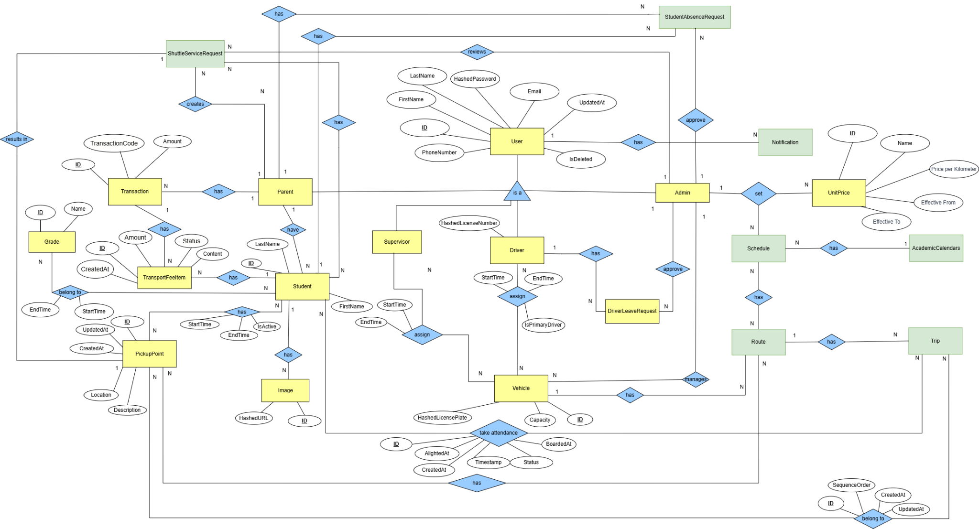
Figure 12: ERD
Entities Description
# | Entity | Description
1 | UserAccount | Represents a system user account (used by Parent, Driver, Supervisor, Admin). Stores personal details, email, phone number, password hash, and account status.
2 | Parent | Represents a parent or guardian responsible for one or more students. Manages student profiles, submits pickup point requests, and handles payment transactions.
3 | Driver | Represents a bus driver. Contains license information, assigned vehicles, working time ranges, and leave requests.
4 | Supervisor | Represents a bus supervisor/attendant. Monitors students during trips, manages attendance, and handles student absence requests.
5 | Admin | Represents the system administrator. Manages routes, unit prices, academic calendars, schedules, approvals, and notifications.
6 | Student | Represents a student who uses the school bus service. Linked to Grade, PickupPoint, Parent, and Image. Used for attendance and trip assignments.
7 | Grade | Represents the academic grade/class of a student. Used to categorize students by education level (e.g., Grade 6, Grade 7).
8 | Image | Represents system-stored images such as student photos or user avatars, saved with a secure URL.
9 | PickupPoint | Represents pickup/drop-off locations for students. Includes location, description, and active time periods.
10 | ShuttleServiceRequest | Represents a parent's request to add/change a student's pickup point. Requires admin review and approval.
11 | StudentAbsenceRequest | Represents a parent's request to report a student's absence on a specific date or trip. Reviewed by supervisors.
12 | DriverLeaveRequest | Represents a driver's request for leave during a specific period. Must be checked and approved by the admin.
13 | Vehicle | Represents a school bus vehicle. Includes license plate, capacity, operational status, and assigned driver/supervisor.
14 | TransportFeeItem | Represents a calculated fee item for a student, based on Route distance, UnitPrice, or billing cycle.
15 | Transaction | Represents payment transactions made by parents. Includes amount, payment code, status, and timestamps.
16 | Notification | Represents system notifications sent to various users. Includes message content, type, status, and recipient.
17 | UnitPrice | Represents pricing rules used to calculate transport fees. Includes price per kilometer and effective date range.
18 | AcademicCalendars | Represents the academic calendar defining valid operational periods for routes and schedules.
19 | Schedule | Represents a scheduled plan linking vehicle, route, driver, and supervisor for a specific period.
20 | Route | Represents a bus route that consists of multiple pickup points and is linked to multiple trips.
21 | Trip | Represents an individual trip executed by a vehicle along a route at a specific time. Includes timestamps and status.

3.2 User Account Management

3.2.1 Login
Function trigger: User navigates to the login page and submits email and password.
Function description:
Actors: Admin, Parent, Driver,Supervisor
Purpose: Allow users to authenticate and gain access to the system.
Data Processing:
1. Validate input fields (email format, non-empty password).
2. Verify credentials against stored user records.
3. If correct, create authenticated session/token.
Screen layout:
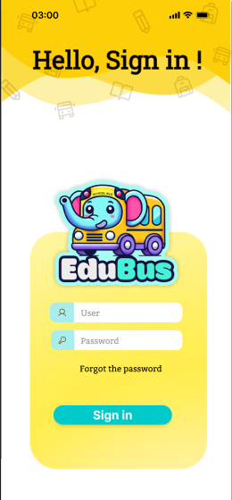
Figure 13: Login as a parent/driver

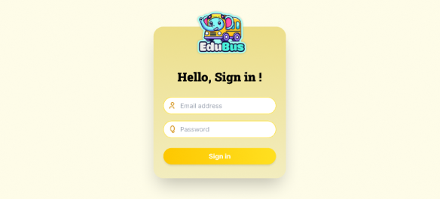
Figure 14:Login as an admin
Function Details:
Validation:
● Email/username must exist in the system.
● Passwords must match the stored password hash.
● Accounts must not be locked, suspended, or deleted.
Business Rules:
● Users must provide valid credentials to log in
● Once verified, the contract becomes read-only
● Rejected contracts require technician to resubmit or re-sign
Functionalities
Normal case:
1. The user enters the correct email/username and password.
2. System authenticates and creates session/token.
3. The user is redirected to the dashboard with the message "Login successful."
Abnormal case:
1. If email/username not found: System shows error ("Account does not exist.")
2. If password is incorrect: System shows error ("Incorrect password.")
3. If account is locked/suspended: System shows error ("Account has been locked, please try again later.")

3.2.2 Logout
Function trigger: Authenticated user clicks on the logout button.
Function description:
Actors: Admin, Parent, Driver
Purpose: Allow users to securely terminate their active session.
Data Processing:
1. Invalidate the current session or authentication token.
2. Clear user-related cached data.
3. Redirect the user to the login page or landing page.
Screen layout:


Figure 15: Logout
Function Details:
Validation:
● Users must have an active session.
Business Rules:
● Once logged out, the session/token cannot be reused
● Users must re-enter credentials to access the system again.
Functionalities
Normal case:
1. The user clicks logout.
2. System terminates the session.
3. The user is redirected to the login page with the message "Logout successful."
Abnormal case:
1. If no active session is found: System shows error ("No active session found.")

3.2.3 Forgot Password
Function trigger: User clicks “Forgot password” on the login page and submits registered email.
Function description:
Actors: Admin, Parent, Driver
Purpose: Allow users to reset their password securely when they forget it.
Data Processing:
1. Validate email format and check if it exists in the system.
2. Generate password reset token and expiration time.
3. Send a reset link to the user’s email.
Screen layout:
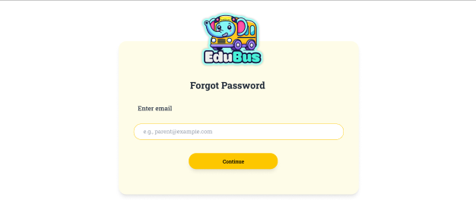
Figure 16:Forgot Password
Function Details:
Validation:
● Email must be in the correct format.
● Email must exist in the system.
● Reset tokens must be valid and not expired.
Business Rules:
● Users must reset password within the token validity period.
● Password reset request is logged for auditing.
Functionalities
Normal case:
1. The user enters a registered email.
2. The system generates a reset link and sends it to the email.
3. The user receives an email with the message "Password reset link has been sent."
Abnormal case:
1. If email not found: System shows error ("Email does not exist.")
2. If reset token expired: System shows error ("Reset link expired, please request again.")
3. If system cannot send email: System shows error ("Failed to send reset link.")

3.2.4 Change Password
Function trigger: Authenticated user navigates to the change password page and submits current password along with a new password.
Function description:
Actors: Admin, Parent, Driver
Purpose: Allow users who are logged in to update their password securely.
Data Processing:
1. Verify current password.
2. Validate new password and confirmation.
3. Update password hash upon success.
Screen layout:
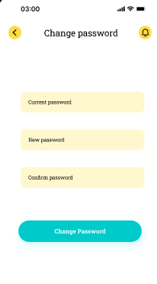
Figure 17:Change Password for mobile
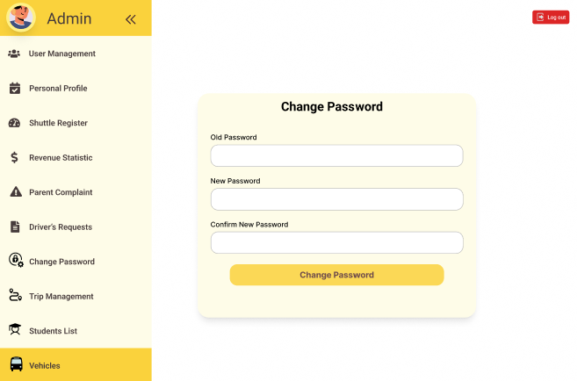
Figure 18:Change Password for web

Function Details:
Validation:
● The current password must match the stored password.
● New password and confirmation must match.
● The new password must meet complexity requirements.
Business Rules:
● Password change requires the user to be authenticated.
● Password is securely hashed before storage.
● Users may be required to re-login after password change.

Functionalities
Normal case:
1. The user provides the correct current password and valid new password.
2. System updates the password hash.
3. The system displays "Password changed successfully."
Abnormal case:
1. If current password incorrect: System shows error ("Current password is incorrect.")
2. If new passwords do not match: System shows error ("New password and confirmation do not match.")
3. If new password not strong enough: System shows error ("New password does not meet complexity requirements.")

3.2.5 Create User Accounts
Function trigger: Admin clicks on the "Create User Account" button in the User Management page.
Function description:
Actors: Admin
Purpose: Allow administrators to create new user accounts for parents, drivers, and other system users with appropriate roles and permissions.
Data Processing:
1. Validate user information (name, email, phone, role)
2. Check for duplicate email addresses
3. Generate unique username and temporary password
4. Assign appropriate role and permissions
5. Save user data to database
6. Send account creation notification
Screen layout:
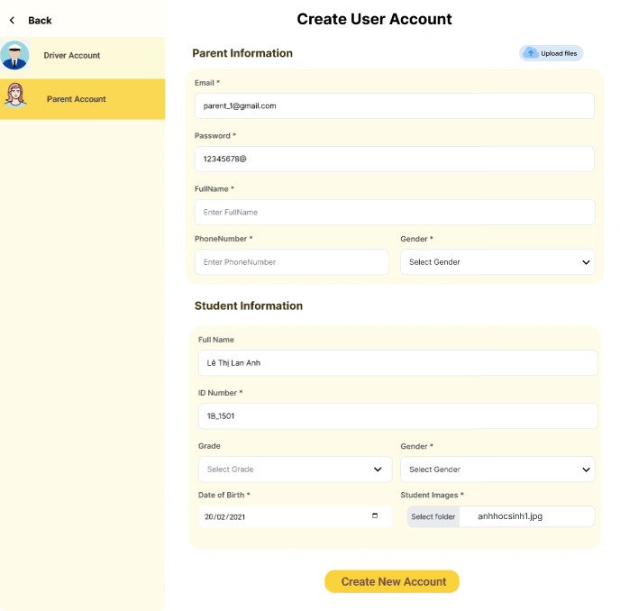
Figure 19 Create User Accounts
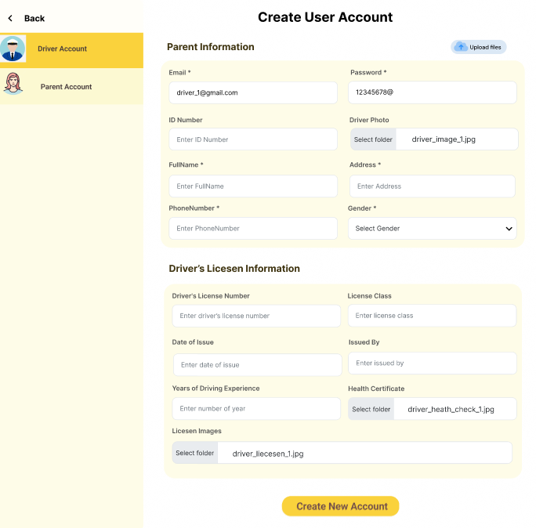
Figure 20: Create User Accounts
Function Details:
Validation:
● Email is required and must be unique
● Email must be in valid format
Business Rules:
● Username is auto-generated based on email
● Email addresses must be unique within the system
Functionalities
Normal case:
1. Admin fills in user information
2. Admin selects user type and role
3. System validates all data
4. System generates username and temporary password
5. User account is created successfully
6. Account creation notification is sent
Abnormal case:
1. If invalid email format: System shows error "Invalid email format"
2. If email already exists: System shows error "Email address already exists"

3.2.6 View User Lists
Function trigger: Admin navigates to the User Management page or clicks "View Users" menu item.
Function description:
Actors: Admin
Purpose: Display a comprehensive list of all users in the system with filtering, sorting, and search capabilities.
Data Processing:
1. Retrieve all users from database
2. Apply search filters if provided
3. Sort users based on selected criteria
4. Paginate results for performance
5. Calculate user statistics and activity status
6. Format data for display
Screen layout:
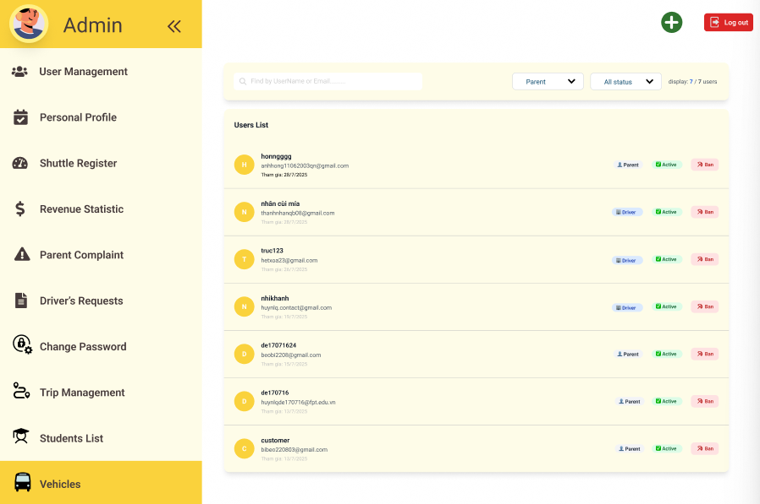
Figure 21 :View User Lists

Function Details:
Validation:
● User must be authenticated Admin
● Sort criteria must be valid
Business Rules:
● Users are sorted by creation date (newest first) by default
● All users are displayed regardless of status
Functionalities
Normal case:
1. Admin navigates to User Management page
2. System loads all users with pagination
3. System displays user statistics
4. Admin can search, filter, and sort users
5. Admin can view user details by clicking "View"
6. Admin can edit users by clicking "Edit"
Abnormal case:
1. If search returns no results: System shows message "No users match your search criteria"
2. If no users found: System shows message "No users found"

3.2.7 Ban/Unban Users

Function trigger: Admin clicks on the "Ban" or "Unban" button for a specific user in the User Management page.
Function description:
Actors: Admin
Purpose: Allow administrators to ban users from accessing the system or unban previously banned users.
Data Processing:
1. Validate admin permissions
2. Check user status and current ban status
3. Record ban/unban reason and timestamp
4. Update user status in database
5. Send notification to affected user
6. Log ban/unban activity for audit
Screen layout:
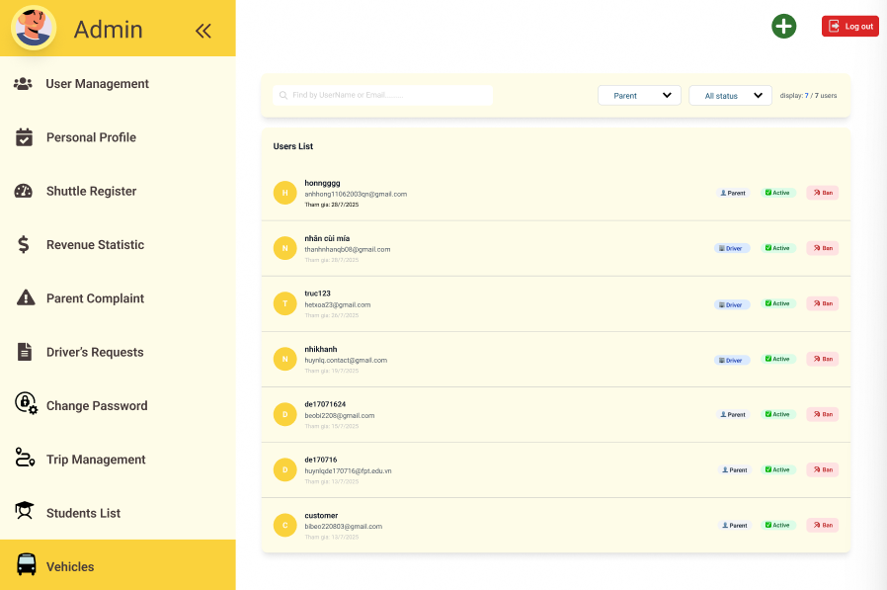
Figure 22:Ban/Unban Users
Function Details:
Validation:
● User must be authenticated Admin
● Target user must exist
Business Rules:
● Ban reason must be documented
● Banned users lose all system access
Functionalities
Normal case:
1. Admin clicks "Ban" button for a user
2. System shows ban confirmation dialog
3. Admin selects ban reason and adds notes
4. Admin confirms ban action
5. System updates user status to "Banned"
6. System logs ban activity
7. User is notified via email
8. Admin is redirected to user list with message "User banned successfully"
Abnormal case:
1. If trying to ban already banned user: System shows error "User is already banned"
2. If user not found: System shows error "User not found"

3.2.8 Import Parent/Driver File

Function trigger: Admin clicks on the "Import Users" button in the User Management page.
Function description:
Actors: Admin
Purpose: Allow administrators to import multiple parent or driver accounts from Excel/CSV files with validation and error handling.
Data Processing:
1. Validate file format and structure
2. Parse file data and validate each record
3. Check for duplicate email addresses
4. Generate usernames and temporary passwords
5. Save valid records to database
6. Generate import report with errors
Screen layout:
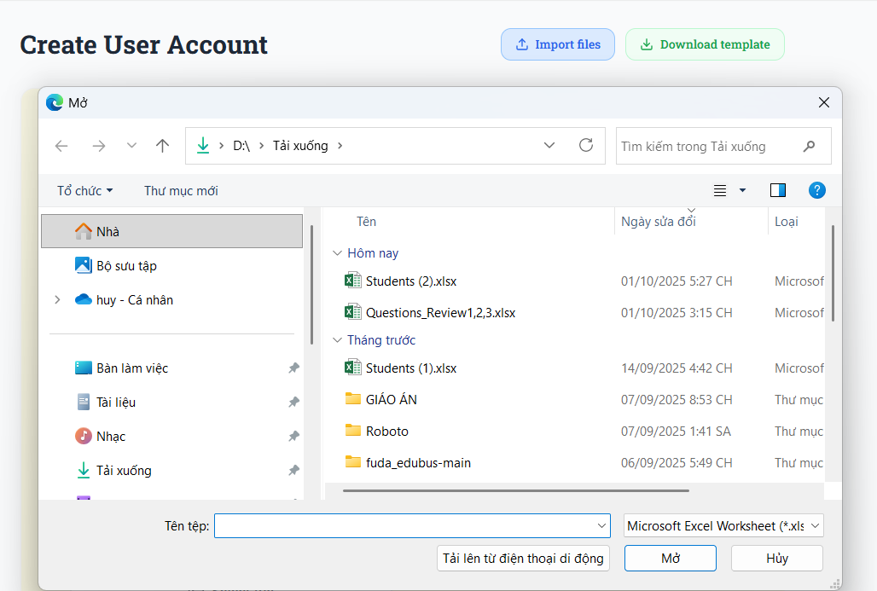
Figure 23: Import Parent/Driver File

Function Details:
Validation:
● Required columns must be present
● File must be in supported format (.xlsx, .xls, .csv)
Business Rules:
● Duplicate emails are skipped if option is enabled
● Email addresses must be unique
Functionalities
Normal case:
1. Admin clicks "Import Users" button
2. Admin selects import type (Parent or Driver)
3. Admin uploads file and configures settings
4. System validates file format and structure
5. System processes records and shows progress
6. System validates each record and checks for duplicates
7. Valid records are saved to database
8. System generates import report with results
9. Welcome emails are sent to new users
10. Admin is shown import results with error details
Abnormal case:
1. If file too large: System shows error "File size exceeds 10MB limit"
2. If file format is not supported: System shows error "Unsupported file format. Please use .xlsx, .xls, or .csv"

3.2.9 View personal profile

Function trigger: User clicks on the “Profile” icon/button from the navigation menu or header.
Function description:
Actors: All users (Admin, Parent, Driver, Supervisor)
Purpose:Allow users to view their own personal information stored in the system, including contact details, user role, and account status.The function displays read-only data and serves as the foundation for updating personal profile information.
Data Processing:
1. Retrieve authenticated user’s profile from the database
2. Load personal information (name, email, phone number, address)
3. Check for duplicate email addresses
4. Load avatar image
5. Display data in a structured and readable format
Screen layout:
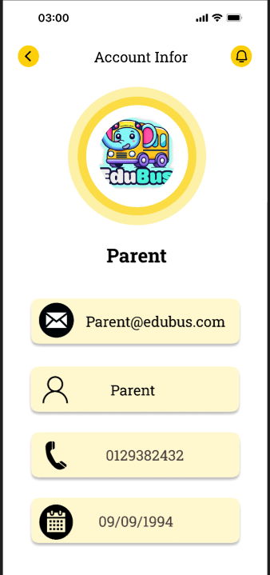
Figure 24: View personal profile

Function Details:
Validation:
● User must be authenticated
● User ID must exist in the system
● Access must match logged-in user (no cross-account access)
Business Rules:
● Users can view only their own profile
● Sensitive fields (password, system roles, permissions) must be hidden or masked
● Profile data must reflect the most recent saved information
Functionalities
Normal case:
1. User clicks on the “Profile” button
2. System verifies user authentication
3. System retrieves profile data from database
4. System loads avatar, name, role, contact information, and related details
5. The profile page is displayed with structured information
6. User can optionally navigate to Edit Personal Profile from this screen
Abnormal case:
1. If user session expired: System shows error “Session expired. Please log in again.”
2. If the user profile cannot be found: System shows error “Profile information not found.”

3.2.10 Edit personal profile

Function trigger: User clicks the “Edit Profile” button from the View Personal Profile screen.
Function description:
Actors: All users (Admin, Parent, Driver, Supervisor)
Purpose: Allow users to update their personal information such as name, phone number, address, and avatar (if supported). Changes must be validated before saving to ensure data consistency and accuracy.
Data Processing:
1. Retrieve existing user information from database
2. Validate modified fields (e.g., email format, phone number format)
3. Validate avatar file (if new image uploaded)
4. Update user information in database
5. Refresh user session cache (if required)
6. Log profile update event for audit purposes
Screen layout:
Figure 25: Edit personal profile

Function Details:
Validation:
● Required fields (e.g., Full Name, Phone Number) cannot be empty
● Phone number must follow valid format
● Email (if editable) must not duplicate existing accounts
● Avatar image must be in supported format (.jpg, .jpeg, .png)
● Avatar image must not exceed specified size limit (e.g., 5MB)
Business Rules:
● Users may only edit their own profile
● System must keep original profile image if user does not upload a new one
● Some fields are read-only based on user role (e.g., email or role cannot be edited by Parent/Driver)
● Every change must be recorded in audit logs
Functionalities
Normal case:
- User clicks “Edit Profile”
- System loads current profile information into editable form fields
- User updates fields such as name, phone number, address, or avatar
- User clicks “Save Changes”
- System validates all inputs
- If validation passes, system updates profile data in database
- System refreshes user session data (if required)
- Confirmation message displayed: “Profile updated successfully.”
- User is redirected back to View Personal Profile screen
Abnormal case:
- Invalid phone number format: System shows error “Invalid phone number format.”
- Avatar file too large: System shows “Image exceeds 5MB size limit.”
- Unsupported avatar format: System shows “Unsupported image format. Please upload a JPG or PNG.”
- Database update fails: System shows “Unable to save changes. Please try again later.”
- Missing required field: System highlights field and shows “This field is required.”

3.2.11 Upload user avatar

Function trigger: User clicks on the “Change Avatar” or avatar upload button in the Edit Personal Profile screen.
Function description:
Actors: All users (Admin, Parent, Driver, Supervisor)
Purpose: Allow users to upload or change their profile avatar image. The system must validate the uploaded file, replace the existing avatar, and save the new image securely in the server.
Data Processing:
- Load current user ID
- Validate uploaded file format and size
- Generate unique file name for the avatar
- Optimize image if required (compression/resize)
- Upload and store image in the server or cloud storage
- Update avatar path in user database record
- Remove old avatar if necessary
- Return updated avatar to UI for preview
Screen layout:
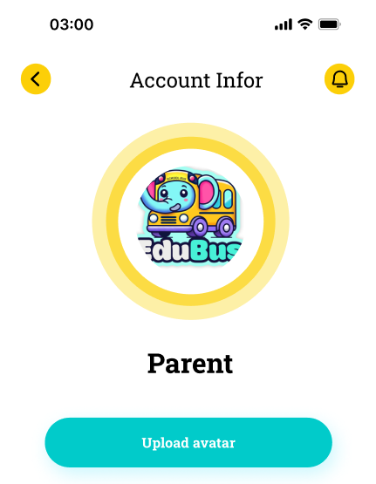
Figure 26: Upload user avatar

Function Details:
Validation:
● File must be in supported image formats: .jpg, .jpeg, .png
● Maximum file size: 5MB
● Minimum dimension requirement (optional): e.g., 200×200 px
● File cannot be corrupted or unreadable
Business Rules:
● Only the account owner can change their avatar
● Default avatar is used if none is uploaded
● Old avatar is deleted after new avatar is successfully stored
● Avatar file name must be unique to avoid conflicts
● System must ensure secure storage and prevent unauthorized access
Functionalities
Normal case:
- User clicks “Change Avatar”
- System opens file picker dialog
- User selects an image file
- System validates file format and size
- System uploads image to server
- System updates avatar path in database
- System refreshes the UI and displays the new avatar
- The system shows a confirmation message: “Avatar updated successfully.”
Abnormal case:
- File too large: System shows “Image exceeds 5MB limit.”
- Unsupported format: System shows “Unsupported image format. Please upload a JPG or PNG.”
- Upload failure due to network/server error: System shows “Unable to upload avatar. Please try again later.”
- File corrupted / unreadable: System shows “Invalid image file. Please choose another file.”
- User cancels upload: No changes applied; system keeps previous avatar

3.2.12 View driver’s information

Function trigger: Parent clicks on the “Driver Information” button from the shuttle service details page, trip detail page, or child’s route information.
Function description:
Actors: Parent
Purpose:Allow parents to view important details about the assigned driver responsible for transporting their child. The information includes driver identity, contact details, license information, and vehicle assignment to ensure transparency and trust.
Data Processing:
- Retrieve child’s assigned driver ID from the system
- Load driver profile data (name, avatar, phone number, email)
- Load driver’s license and certification details
- Load assigned vehicle information (plate number, model)
- Load historical rating or feedback (if supported)
- Display full driver information to parent
Screen layout:
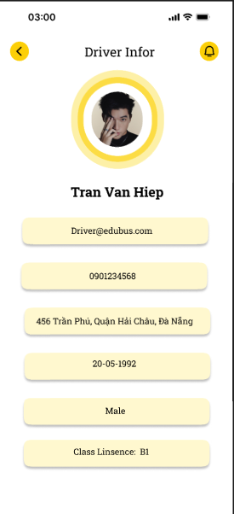
Figure 27: View driver’s information

Function Details:
Validation:
● Parent must be authenticated
● Parent must be associated with at least one student
● Student must have an assigned driver (active schedule/trip)
● Driver information must exist in the database
Business Rules:
● Parents may only view driver information for their own children’s assigned trips
● Sensitive driver data (e.g., personal documents, internal ratings) must not be exposed
● System must ensure that driver contact is shown only if permitted by policy
● If no driver is assigned, system must indicate status clearly
Functionalities
Normal case:
- Parent navigates to trip/route/shuttle service details
- Parent clicks “Driver Information”
- System retrieves driver ID linked to the child’s route or trip
- System loads driver profile, contact information, license details, and assigned vehicle
- Screen displays
- Parent reviews information
Abnormal case:
- No driver assigned: System shows “Driver not yet assigned for this trip/schedule.”
- Driver data missing: System shows “Driver information not available.”
- Network/server error: System shows “Unable to load driver information. Please try again later.”
- Parent not linked with the student: System shows “Access denied.”

3.3 Service Registration and Payment

3.3.1 Register for Shuttle Service
Function trigger: Parent clicks the “Register for Shuttle Service” button from the child profile page, shuttle service menu, or landing dashboard.
Function description:
Actors: Parent
Purpose: Allow parents to submit a registration request for their child to join the school shuttle service. The system collects route preferences, pickup/drop-off locations, time slots, and required student information before sending the request to admin for approval.
Data Processing:
- Retrieve parent and student information
- Get available shuttle routes, schedules, and vehicle capacity
- Validate registration eligibility (no duplicate active registration)
- Validate selected pickup/drop-off location
- Validate chosen schedule and time slot
- Save registration request to database
- Notify admin for approval
- Generate confirmation message for parent
Screen layout:
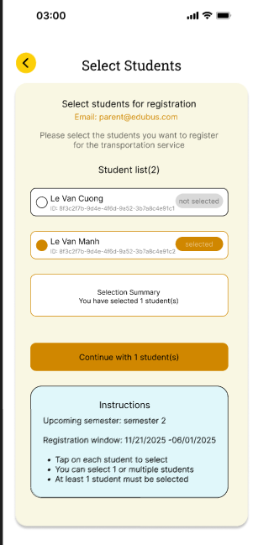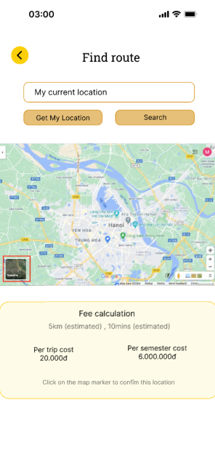
Figure 28: Register for Shuttle Service
Function Details:
Validation:
● Parent must have at least one student linked to their account
● Pick-up and drop-off locations must be valid and within service areas
● Chosen schedule must belong to an available route
● Student cannot already have an active or pending registration request
● Required fields must be filled (e.g., location, preferred schedule)

Business Rules:
● Only parents can register their own children
● Each child can only have one active or pending shuttle service registration
● Admin must approve or reject the request before it becomes active
● System must verify that vehicle capacity has not been exceeded (if real-time validation enabled)
● If relocation is requested later, parent must submit a new change request

Functionalities
Normal case:
1. Guests submit valid details.
2. System records the registration as pending
3. The system displays a confirmation message ("Registration submitted successfully, awaiting approval.").
Abnormal case:
1. If required fields are missing: System shows error ("Please complete all required fields.").

3.3.2 Select Pickup Point
Function trigger: Parent interacts with the map and selects a pickup point.
Function description:
Actors: Parent
Purpose: Allow parents to select the most convenient and valid pickup point for their child before registering for the shuttle service.
Data Processing:
- The system displays an interactive map showing all available pickup points belonging to active school routes.
- The parent selects a pickup point from the map.
- The system validates the pickup point and associates it with the student’s registration.
- The selection is saved and used for cost calculation and routing.
Screen layout:
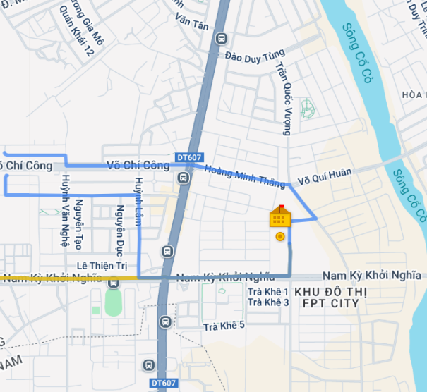
Figure 30: Select Pickup Point
Function Details:
Validation:
● Selected pickup points must be valid and active.
● Pickup points must belong to one of the school’s official routes.
Business Rules:
● Only active pickup points can be selected.
● Pickup points must be linked to a valid route used for shuttle operation.
● A student may be restricted to one pickup point per registration unless school rules allow changes.

Functionalities
Normal case:
- The parent selects a valid pickup point from the map.
- The system saves the selected pickup point successfully.
- The system updates related information such as cost calculation and estimated pickup time.
Abnormal case:
- If the selected point is invalid or inactive:
→ System shows error: "Pickup point not available."
- If route information cannot be loaded:
→ System shows error: "Route data unavailable."

3.3.3 Make payment
Function trigger: Parent proceeds to payment after registration approval.
Function description:
Actors:Parent
Purpose: Allow parents to pay for approved shuttle service registration.
Data Processing:
1. The parent selects the payment method.
2. The system processes payment through the payment gateway.
3. Payment status is recorded.
Screen layout:
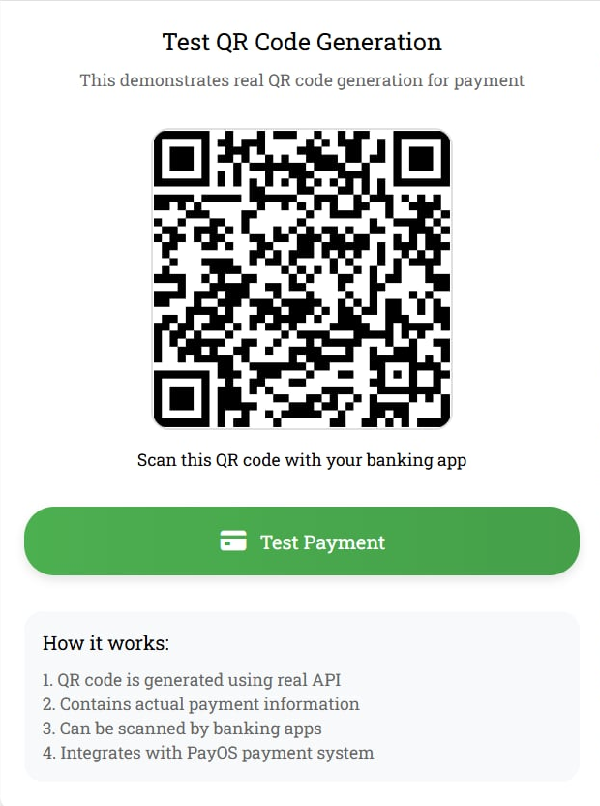
Figure 31: Payment
Function Details:
Validation:
● Only approved registrations can proceed to payment.
Business Rules:
● Only successful payments activate the service.
● Payment must be securely processed and recorded.

Functionalities
Normal case:
1. The parent selects a valid method and completes payment.
2. System records success and sends confirmation.
Abnormal case:
1. If payment fails: System shows error ("Payment failed, please try again.").

3.3.4 View Register History
Function trigger: Parent selects “Register History” from the menu or registration section.
Function description:
Actors: Parent
Purpose: Allow parents to view the complete history of shuttle service registrations, including past and current submissions, statuses, and related details.
Data Processing:
- The parent opens the “Register History” page.
- The system retrieves all registration records linked to the parent’s account and their child(ren).
- The system displays the list with key information such as date, selected pickup point, package type, status, and payment details (if applicable).
Screen layout:
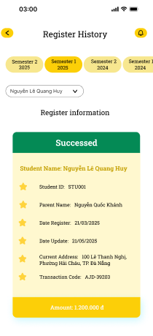
Figure 32: View Register History
Function Details:
Validation:
- Parents must be logged into the system.
- Parents must have at least one student linked to their account.
Business Rules:
- Registration history must include all submitted requests (approved, rejected, pending, cancelled).
- Data is sorted by the most recent submission date by default.
- Only parents can view their own registration history; no cross-account access allowed.
Functionalities
Normal case:
- Parents access the register history page.
- The system loads all historical registration records.
- The system displays the data clearly, including status and related details.
Abnormal case:
- If no registration records exist:
→ System displays message: "No registration history found."
- If the system fails to retrieve data:
→ System shows error: "Unable to load registration history."

3.3.5 View Payment History
Function trigger: Parent navigates to the “Payment History” section from the menu or payment page.
Function description:
Actors: Parent
Purpose: Allow parents to view the full history of payments made for shuttle bus services, including successful transactions, pending payments, failed attempts, and invoice details.
Data Processing:
- The parent opens the “Payment History” page.
- The system retrieves all payment records linked to the parent and their registered students.
- The system displays transaction details such as payment date, payment method, amount paid, service period, status, and invoice number.
- Parents may select a payment entry to view detailed information or download the invoice (if available).
Screen layout:
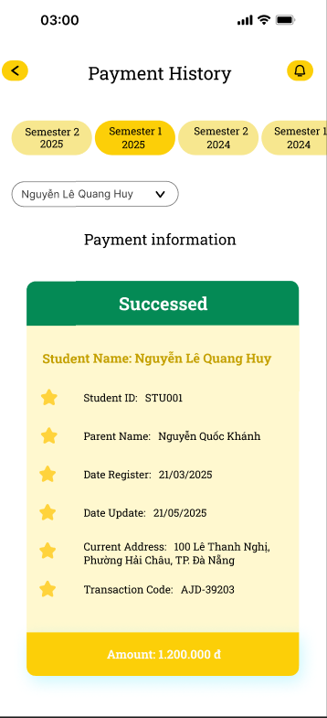
Figure 33: View Payment History
Function Details:
Validation:
- Parents must be logged in.
- Payment data must belong to the parent’s account.
Business Rules:
- Payment history includes all transaction types: successful, pending, failed, refunded (if supported).
- Records must be sorted by the most recent transaction date first.
- Only parents can access their own payment history.
- If the school uses multiple payment methods, the system must show the method used (e.g., bank transfer, e-wallet, credit card).

Functionalities
Normal case:
- The parent accesses the payment history page.
- The system retrieves and displays the complete list of payment records.
- Parents may click on a record to view details or invoice.
Abnormal case:
- If no payment records exist:
→ System displays message: "No payment history available."
- If data retrieval fails:
→ System shows error: "Unable to load payment history."
- If invoice data is missing for a specific record:
→ System shows message: "Invoice not available."

3.3.6 View Parent's Register Request
Function trigger: Admin clicks on "Parent Requests" menu item or navigates to the Parent Request Management page.
Function description:
Actors: Admin
Purpose: Display all parent registration requests with filtering, sorting, and detailed information for review and approval.
Data Processing:
1. Retrieve all parent registration requests from database
2. Apply status and date filters if provided
3. Sort requests by submission date (newest first)
4. Calculate request statistics and pending counts
5. Format request data for comprehensive display
Screen layout:
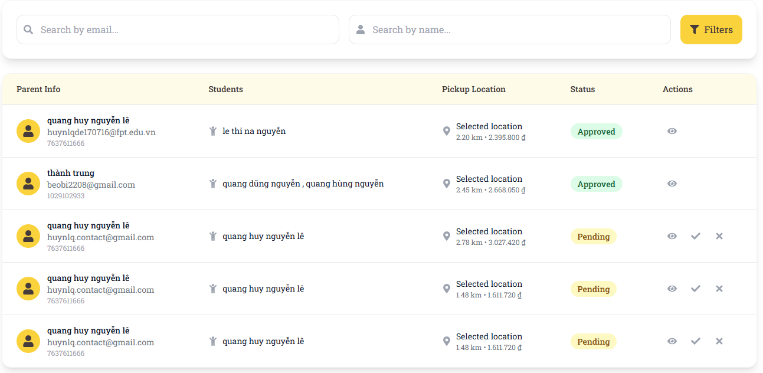
Figure 35:View Parent's Register Request

Function Details:
Validation:
● User must be authenticated Admin
● Search query must not exceed 100 characters
Business Rules:
● Requests are sorted by submission date (newest first) by default
● Only Admin can view parent registration requests
Functionalities
Normal case:
1. Admin navigates to Parent Request Management page
2. System loads all parent registration requests
3. System displays request statistics
4. Admin can search, filter, and sort requests
5. Admin can view detailed request information
6. Admin can approve or reject individual requests
7. Admin can perform bulk actions on multiple requests
Abnormal case:
1. If search returns no results: System shows message "No requests match your search criteria"
2. If no requests found: System shows message "No parent requests found"

3.3.7 Approve/Reject Parent's Register Request
Function trigger: Admin clicks on the "Approve" or "Reject" button for a specific parent registration request.
Function description:
Actors: Admin
Purpose: Allow administrators to approve or reject parent registration requests with detailed review and documentation.
Data Processing:
1. Load parent registration request details
2. Validate admin permissions and request status
3. Record approval/rejection decision and reason
4. Update request status in database
5. Send notification to parent about decision
Screen layout:
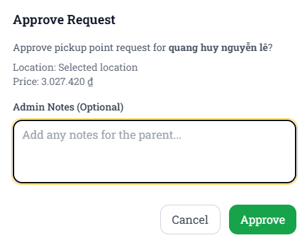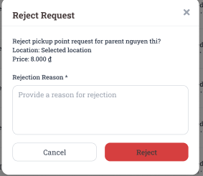
Figure 36:Approve/Reject Parent's Register Request
Function Details:
Validation:
● User must be authenticated Admin
● Request must exist and be in "Pending" status
Business Rules:
● Parent is notified of decision via email
● Only pending requests can be approved or rejected
Functionalities
Normal case:
1. Admin clicks "Approve" button for a pending request
2. System shows approval confirmation dialog
3. Admin reviews parent and student information
4. Admin adds approval notes if needed
5. Admin confirms approval action
6. System creates parent account and student record
7. System updates request status to "Approved"
8. Welcome email is sent to parent
9. Admin is redirected to request list with message "Parent request approved successfully"
Abnormal case:
1. If request already processed: System shows error "Request has already been processed"
2. If request not found: System shows error "Request not found"

3.3.8 View Driver's Request
Function trigger: Admin clicks on "Driver Leave Requests" menu item or navigates to the Driver Leave Request Management page.
Function description:
Actors: Admin
Purpose: Display all driver leave requests (sick leave, vacation, emergency) with filtering, sorting, and detailed information for review and approval.
Data Processing:
1. Retrieve all driver leave requests from database
2. Apply status and leave type filters if provided
3. Sort requests by submission date (newest first)
4. Calculate request statistics and pending counts
5. Format request data for comprehensive display
Screen layout:
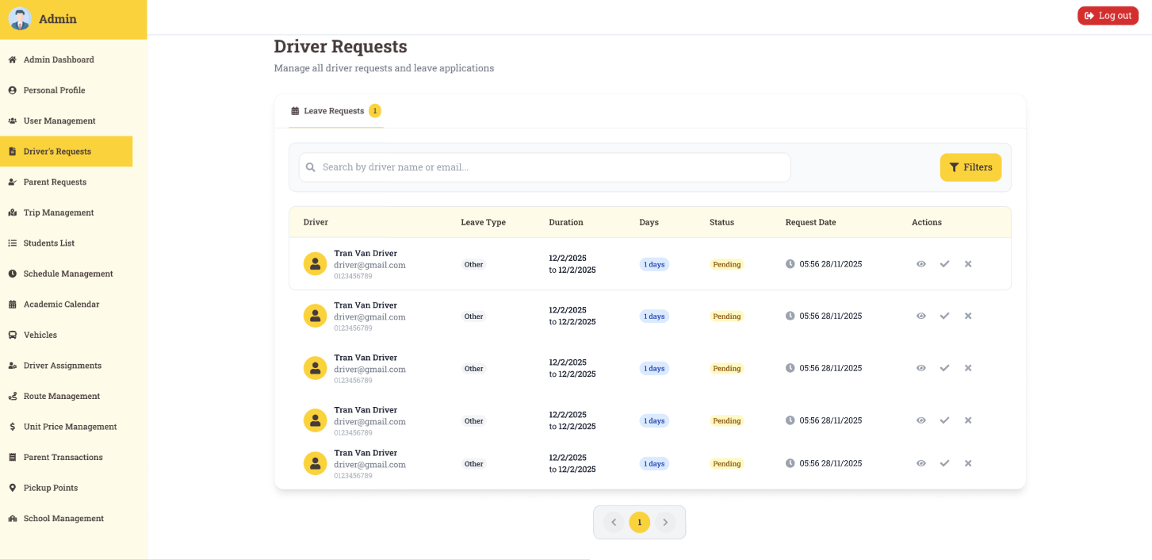
Figure 37: View Driver's Request
Function Details:
Validation:
● User must be authenticated Admin
● Search query must not exceed 100 characters
Business Rules:
● Requests are sorted by submission date (newest first) by default
● Search is case-insensitive and searches driver name, email, and leave type
Functionalities
Normal case:
1. Admin navigates to Driver Leave Request Management page
2. System loads all driver leave requests
3. System displays request statistics by leave type
4. Admin can search, filter, and sort requests
5. Admin can view detailed request information
6. Admin can approve or reject individual requests
7. Admin can perform bulk actions on multiple requests
Abnormal case:
1. If search returns no results: System shows message "No requests match your search criteria"
2. If no requests found: System shows message "No driver leave requests found"

3.3.9 Approve/Reject Driver's Request
Function trigger:Admin clicks on the "Approve" or "Reject" button for a specific driver leave request.
Function description:
Actors: Admin
Purpose: Allow administrators to approve or reject driver leave requests (sick leave, vacation, emergency) with detailed review and impact analysis.
Data Processing:
1. Load driver leave request details and supporting documents
2. Validate admin permissions and request status
3. Analyze impact on scheduled trips and routes
4. Record approval/rejection decision and reason
5. Update request status and notify affected parties
Screen layout:
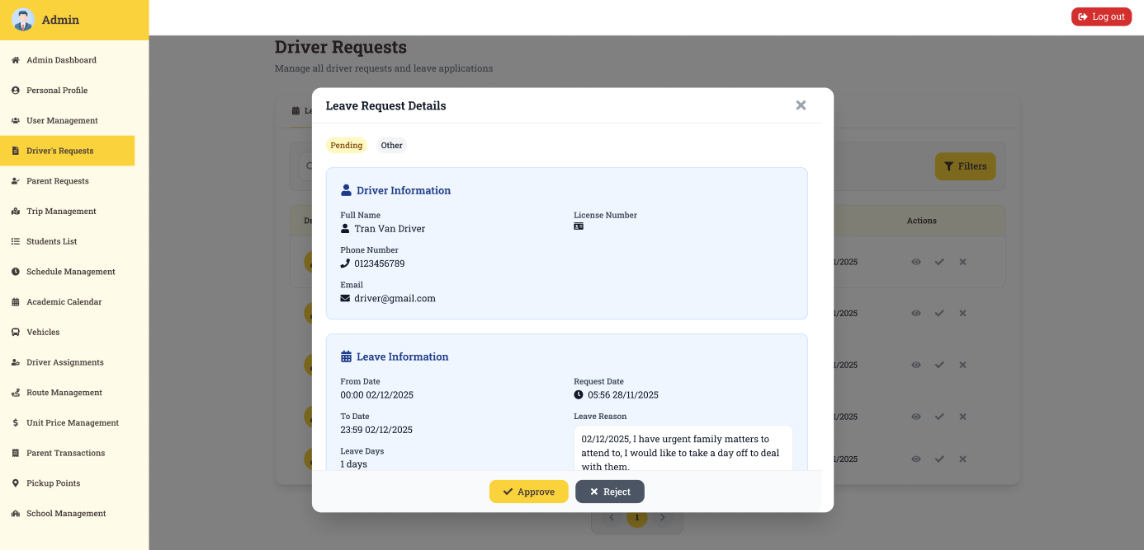
Figure 38: Approve/Reject Driver's Request
Function Details:
Validation:
● User must be authenticated Admin
● Request must exist and be in "Pending" status
Business Rules:
● Approval requires impact analysis on scheduled trips
● Only pending requests can be approved or rejected
Functionalities
Normal case:
1. Admin clicks "Approve" button for a pending leave request
2. System shows approval confirmation dialog with impact analysis
3. Admin reviews leave details and impact on trips
4. Admin adds approval notes if needed
5. Admin confirms approval action
6. System updates request status to "Approved"
7. System reschedules affected trips with alternative driver
8. Approval notification is sent to driver
9. Admin is redirected to request list with message "Leave request approved successfully"
Abnormal case:
1. If request already processed: System shows error "Leave request has already been processed"
2. If request not found: System shows error "Leave request not found"

3.4 Student Management

3.4.1 View Student List
Function trigger: Admin navigates to the “Student Management” page and selects “View student list.”
Function description:
Actors: Admin
Purpose: Allow admin to view and manage all students.
Data Processing:
1. Retrieve all student records from the database.
2. Display data in a tabular format with pagination and filters.
Screen layout:
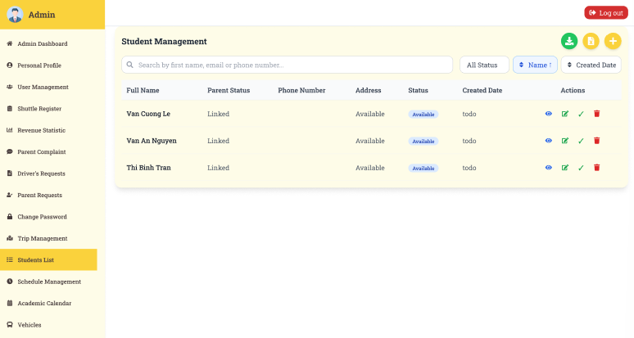
Figure 39: View Student List
Function Details:
Validation:
● Data must exist in the system.
Business Rules:
● Only the admin has sufficient permissions to view student data.
Functionalities
Normal case:
1. Admin selects “View student list.”
2. The system retrieves all students from the database.
3. The student list is displayed with filters and pagination.
4. Confirmation message is shown: “Student list loaded successfully.”
Abnormal case:
1. If database error occurs : Show error message (“Unable to fetch student list”).

3.4.2 View student detail
Function trigger: Admin selects a student from the list.
Function description:
Actors: Admin
Purpose: Provide detailed information for management and verification.
Data Processing:
1. Fetch student record based on student ID.
2. Display full details (personal info, guardian info, assigned vehicle, attendance history).
Screen layout:
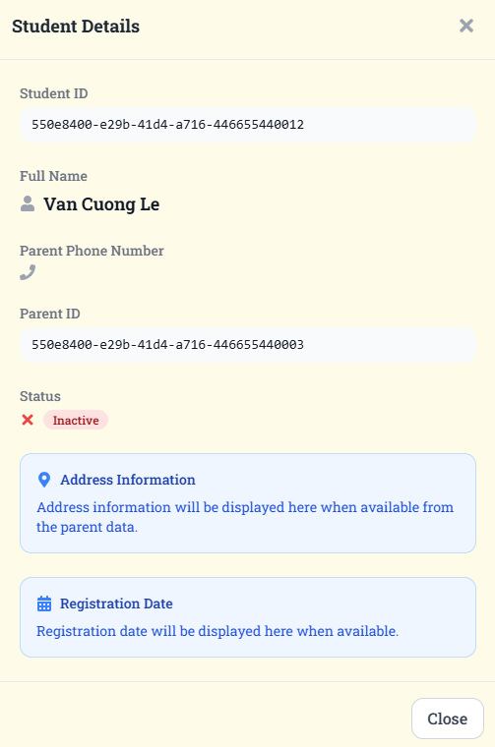
Figure 40: View student detail
Function Details:
Validation:
● Student ID must exist in the database.
Business Rules:
● Only the admin can view student data.
Functionalities
Normal case:
1. Admin clicks a student record.
2. System retrieves details of the selected student
3. The system displays a student profile.
Abnormal case:
1. If student is not found : Show error (“Student does not exist”).
2. If database query fails: System shows error: “Unable to fetch student details.”

3.4.3 Add student
Function trigger: Admin clicks “Add student”.
Function description:
Actors: Admin
Purpose: Allow admin to add one or multiple students.
Data Processing:
1. Validate input fields (Name, ID, Parent info, etc.).
2. Save student record(s) into the database.
Screen layout:
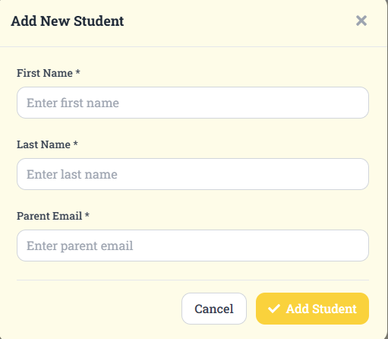
Figure 41: Add student
Function Details:
Validation:
● Mandatory fields cannot be empty.
● Student ID must be unique.
Business Rules:
● Students must be associated with a valid parent account.
Functionalities
Normal case:
1. Admin enters valid student information.
2. The system validates inputs.
3. The system stores new student records.
4. Confirmation message: “Student added successfully.”
Abnormal case:
1. Duplicate ID: Show error (“Student ID already exists”).
2. If required fields are missing: System shows error: “Please fill in all required fields.”

3.4.4 Update student
Function trigger: Admin selects a student and clicks “Update.”
Function description:
Actors: Admin
Purpose: Ensure student information remains up-to-date.
Data Processing:
1. Validate updated input.
2. Update student record in the database.
Screen layout:
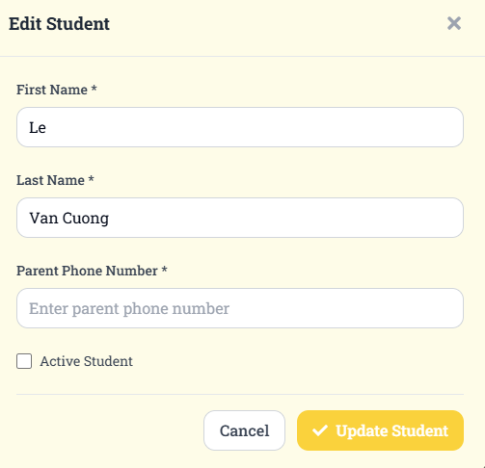
Figure 42:Update student

Function Details:
Validation:
● Students must exist in the system.
● Required fields cannot be empty.
Business Rules:
● Only authorized admins can update.
● Only existing students can be updated.
Functionalities
Normal case:
1. Admin selects student records.
2. Admin edits information and submits.
3. The system validates inputs and updates databases.
4. Confirmation message: “Student updated successfully.”
Abnormal case:
1. If a student does not exist: Show error (“Update failed, student not found”).

3.4.5 Delete student
Function trigger: Admin clicks “Delete” student they want to delete.
Function description:
Actors: Admin
Purpose: Manage data cleanup or remove inactive students.
Data Processing:
1. Verify student ID exists.
2. Inactive the student, data still remain.
Screen layout:
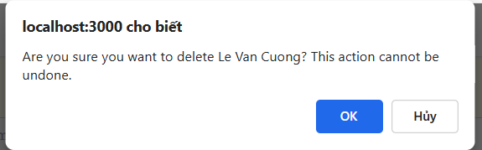
Figure 43:Delete student
Function Details:
Validation:
● Student ID must exist.
Business Rules:
● Deletion must not break relationships (e.g., attendance history retained separately).
Functionalities
Normal case:
1. Admin selects a student to delete.
2. System prompts for confirmation.
3. Admin confirms deletion.
4. The system removes student records.
5. Confirmation message: “Student deleted successfully.”
Abnormal case:
1. If linked to active records: Show error (“Cannot delete student with active assignments”).

3.4.6 Import student file
Function trigger: Admin uploads a file to import students.
Function description:
Actors: Admin
Purpose: Save time when adding multiple students.
Data Processing:
1. Validate file format and data structure.
2. Parse file and insert records.
Screen layout:
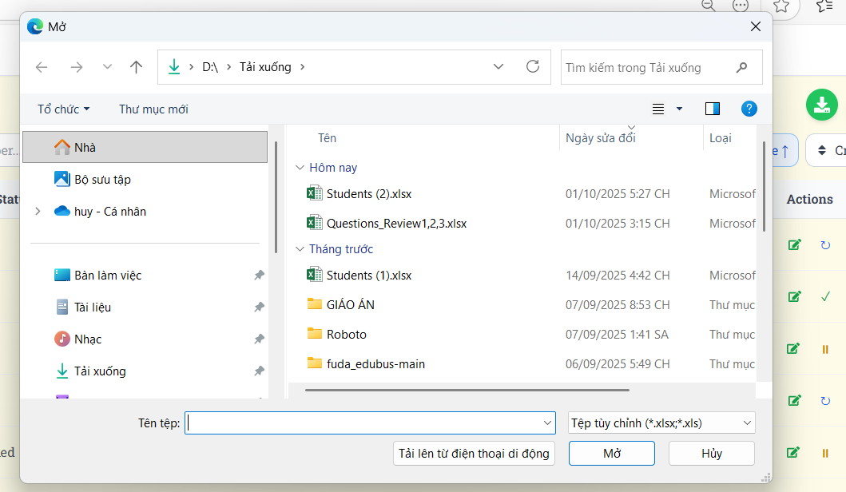
Figure 44:Import student file
Function Details:
Validation:
● File must follow template format.
● Student IDs must be unique.
Business Rules:
● Records with errors must not be imported.
Functionalities
Normal case:
1. Admin uploads a valid file.
2. The system validates file and parses data.
3. The system imports student records.
4. Confirmation message: “File imported successfully.”
Abnormal case:
1. Invalid file: Show error (“Invalid file format or data”).

3.4.7 View Student’s Information
Function trigger: Parent logs in and navigates to “My Child’s Profile.”
Function description:
Actors: Parent
Purpose: Allow parents to view their own child’s profile and assigned vehicle.
Data Processing:
1. Verify parent-child relationship.
2. Retrieve student data.
Screen layout:
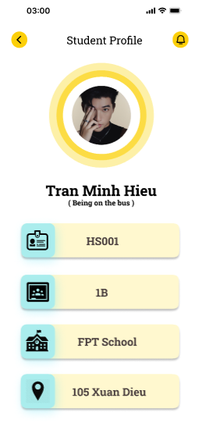
Figure 45:View Student’s Information
Function Details:
Validation:
● Parents must be linked to students.
● Parents must be registered to view students' information.
Business Rules:
● Parents can only view their own child’s profile.
Functionalities
Normal case:
1. Parent logs in.
2. The parent navigates to the student profile.
3. The system verifies relationships and displays student info.
Abnormal case:
1. If the parent is not linked: System shows error: “You are not authorized to view this student.”
2. If student record missing: System shows error: “Student information unavailable.”

3.4.8 Update Student’s Information
Function trigger: Parent selects “Edit student information” on their child’s profile.
Function description:
Actors: Parent
Purpose: Allow parents to update basic information about their child.
Data Processing:
1. Validate parent authorization.
2. Validate updated data.
3. Save changes to database.
Screen layout:
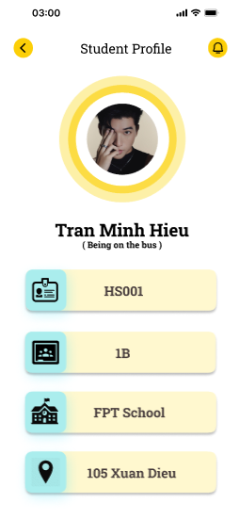
Figure 46:Update Student’s Information
Function Details:
Validation:
● Required fields must be filled.
● Data must follow a valid format.
Business Rules:
● Parents can update only their own child’s information.
Functionalities
Normal case:
1. Parents log in and navigate to their child’s profile.
2. Parent edits allowed fields and submits.
3. The system validates inputs and updates records.
4. Confirmation message: “Student information updated successfully.”
Abnormal case:
1. If the parent is not authorized: The system shows an error: “You cannot update this student’s information.”
2. If input invalid: System shows error: “Invalid data format.”

3.4.9 Send absence report
Function trigger: Parent clicks on "Complaints" menu item or "Submit Complaint" button in the Parent Dashboard.
Function description:
Actors: Parent
Purpose: Allow parents to submit complaints about bus service, driver behavior, schedule issues, or other concerns with detailed documentation.
Data Processing:
1. Validate parent authentication and permissions
2. Collect complaint details and supporting information
3. Categorize complaint by type and priority
4. Save complaint to database with timestamp
5. Send notification to admin about new complaint
Screen layout:
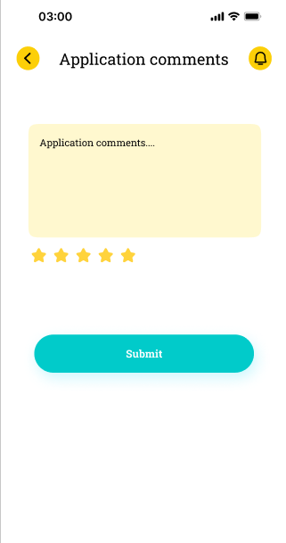
Figure 47:Send absence report
Function Details:
Validation:
● User must be authenticated Parent
● Complaint type is required
Business Rules:
● Only parents can submit complaints
● Complaints are automatically assigned reference numbers
Functionalities
Normal case:
1. Parent navigates to Submit Complaint page
2. Parent fills in complaint details and selects type
3. Parent provides detailed description and incident details
4. Parent uploads supporting documents if available
5. System validates all information
6. Complaint is submitted successfully
7. System generates complaint reference number
8. Admin is notified about new complaint
9. Parent receives confirmation with reference number
Abnormal case:
1. If description too short: System shows error "Description must be at least 50 characters"
2. If required fields missing: System shows error "Required fields are missing"

3.4.10 Send leave/sick request
Function trigger: Driver clicks on "Request Leave" button in the Driver Dashboard or selects "Submit Leave Request" from the menu.
Function description:
Actors: Driver
Purpose: Allow drivers to submit leave requests for sick leave, vacation, or emergency situations with supporting documentation.
Data Processing:
1. Validate driver authentication and permissions
2. Collect leave request details and supporting documents
3. Analyze impact on scheduled trips and routes
4. Save leave request to database with timestamp
5. Send notification to admin about new leave request
Screen layout:
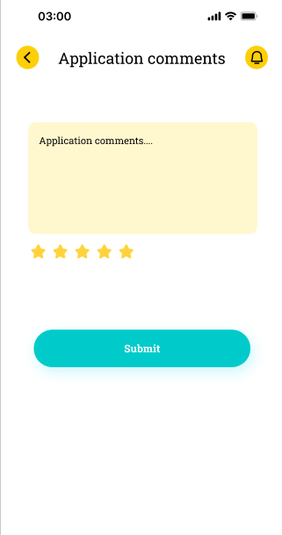
Figure 48:Send leave/sick request
Function Details:
Validation:
● User must be authenticated Driver
● Start date and end date are required
Business Rules:
● Leave requests are automatically analyzed for trip impact
● Only drivers can submit leave requests
Functionalities
Normal case:
1. Driver navigates to Submit Leave Request page
2. Driver selects leave type and priority
3. Driver specifies leave period and reason
4. Driver provides detailed description
5. Driver uploads supporting documents if available
6. System analyzes impact on scheduled trips
7. Driver reviews impact analysis and submits request
8. System generates leave request reference number
9. Admin is notified about new leave request
Abnormal case:
1. If description too short: System shows error "Description must be at least 30 characters"
2. If required fields missing: System shows error "Required fields are missing"

3.5 Vehicle Management

3.5.1 Create Vehicle
Function trigger: Admin navigates to the vehicle management page and clicks "Add Vehicle".
Function description:
Actors: Admin
Purpose: Allow admin to register a new vehicle into the system.
Data Processing:
1. Validate required input fields (license plate, capacity, model, etc.).
2. Store vehicle details in the database.
3. Assign default status (active/available).
Screen layout:
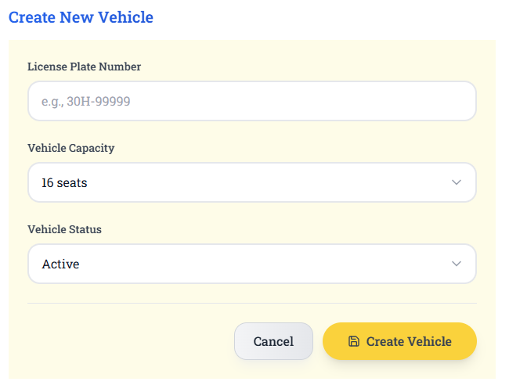
Figure 49:Create Vehicle
Function Details:
Validation:
● License plates must be unique in the system.
● Required fields cannot be empty.
Business Rules:
● Each vehicle must be uniquely identifiable by license plate.
● Only admins can create new vehicles.
Functionalities
Normal case:
1. Admin enters valid information.
2. The system saves the vehicle successfully.
3. The system shows the message "Vehicle created successfully."
Abnormal case:
1. If the license plate already exists → "Vehicle already registered."
2. If required fields are empty → "Please fill in all required fields."

3.5.2 Update Vehicle
Function trigger: Admin selects an existing vehicle and clicks "Edit".
Function description:
Actors: Admin
Purpose: Allow admin to modify vehicle information.
Data Processing:
1. Load current vehicle data from database.
2. Allow admin to modify fields.
3. Validate input.
4. Save changes to database.
Screen layout:
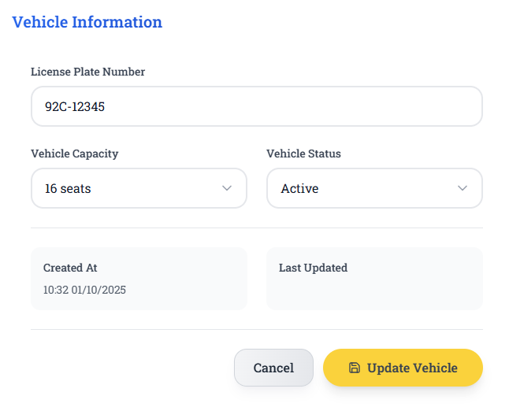
Figure 50: Update Vehicle
Function Details:
Validation:
● Required fields cannot be empty.
Business Rules:
● Only admins can update vehicle information.
Functionalities
Normal case:
1. Admin edits details.
2. System validates and saves.
3. Message "Vehicle updated successfully."
Abnormal case:
1. Invalid input → show error.
2. Attempt to update non-existent vehicle → show "Vehicle not found."

3.5.3 Delete Vehicle
Function trigger: Admin selects a vehicle and clicks "Delete".
Function description:
Actors: Admin
Purpose: Remove a vehicle from active use.
Data Processing:
1. Confirm delete action.
2. Check dependencies (assigned trips, schedules).
3. If safe, mark the vehicle as deleted/inactive in the database.
Screen layout:
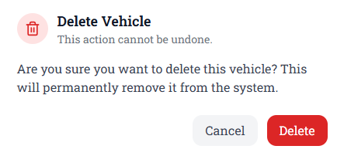
Figure 51:Delete Vehicle
Function Details:
Validation:
● If the vehicle is still assigned to a route, it cannot be deleted.
● Vehicles must exist.
Business Rules:
● Vehicle cannot be deleted if currently assigned to an active schedule.
● Only admins can delete.
Functionalities
Normal case:
1. Admin deletes unused vehicles.
2. The system removes records.
3. Success notification shown.
Abnormal case:
1. Vehicle assigned to active trip → error “Cannot delete vehicle in use.”

3.5.4 View Vehicle List
Function trigger: Admin opens vehicle management page.
Function description:
Actors: Admin
Purpose: Provide overview of all registered vehicles.
Data Processing:
1. Retrieve all vehicle records.
2. Display in table format.
Screen layout:
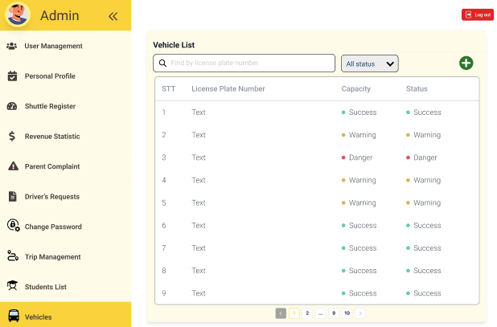
Figure 52:View Vehicle List
Function Details:
Validation:
● Data must exist in DB.
Business Rules:
● Pagination or search must be supported.
Functionalities
Normal case:
1. Admin views full vehicle list.
Abnormal case:
1. No vehicles available → “No data found.”

3.5.5 Assign Driver
Function trigger: Admin opens the vehicle list, and clicks the “Assign” button on a specific vehicle.
Function description:
Actors: Admin
Purpose: Ensure each vehicle is operated by exactly one driver.
Data Processing:
1. Admin clicks the “Assign” button for a vehicle.
2. The system opens an assignment dialog with a dropdown list of available drivers.
3. Admin selects a driver.
4. The system checks that the driver is not already assigned to another active vehicle.
5. The system saves the assignment to the database.
Screen layout:
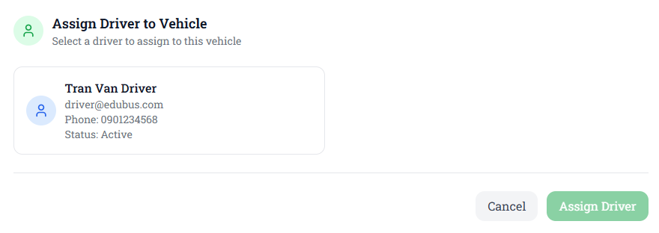
Figure 53:Assign Driver
Function Details:
Validation:
● Vehicles must exist in the system.
● The driver must exist and not already be assigned to another vehicle.
● Each vehicle can only have one active driver.
Business Rules:
● Only admins can perform this action.
● A driver can only be assigned to one active vehicle at a time.
● A vehicle must always have at most one driver.
Functionalities
Normal case:
1. Admin clicks “Assign” on a vehicle.
2. Selects a driver from the available list.
3. The system validates successfully.
4. Driver assigned to the vehicle.
5. Confirmation message shown: “Driver assigned successfully.”
Abnormal case:
1. Driver already assigned to another vehicle → system shows error “This driver is already assigned to another vehicle.”
2. Vehicle already has a driver → system shows error “This vehicle already has a driver assigned.”
3. Invalid vehicle or driver ID → system shows error “Invalid request.”

3.5.6 View Vehicle Detail
Function trigger: Admin clicks on a specific vehicle from the vehicle list (e.g., by pressing “View Detail”).
Function description:
Actors: Admin
Purpose: Provide complete vehicle profile.
Data Processing:
1. Retrieve vehicle records from DB.
2. Display details.
Screen layout:
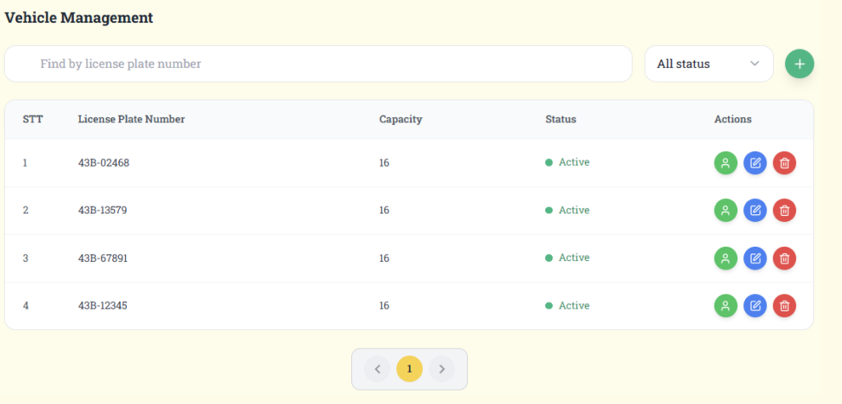
Figure 54:View Vehicle Detail
Function Details:
Validation:
● Vehicles must exist.
Business Rules:
● Only authorized users (Admin) can view.
Functionalities
Normal case:
1. Admin selects a vehicle.
2. The system retrieves and displays all vehicle details.
3. Admin can view the driver and schedule/trip info.
Abnormal case:
1. Vehicle ID not found → “Vehicle not found.”
2. Data retrieval error → “Unable to load vehicle details, please try again.”

3.5.7 View Vehicle’s Information
Function trigger: Parent navigates to their child’s profile and clicks “View Vehicle Info.”
Function description:
Actors: Parent
Purpose: Increase transparency and trust by letting parents know which vehicle is transporting their child.
Data Processing:
1. The system identifies the parent’s student.
2. Retrieve the vehicle assigned to that student.
3. Display key vehicle details.
Screen layout:
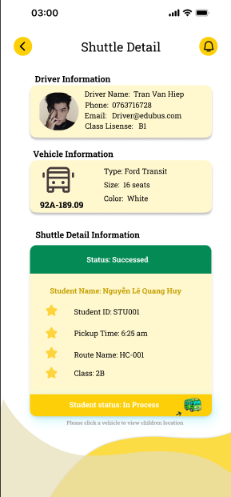
Figure 55:View Vehicle’s Information
Function Details:
Validation:
● Parents must have an active student registered.
● Students must be allocated to a vehicle.
Business Rules:
● EParent can only view vehicles linked to their children.
Functionalities
Normal case:
1. Parent clicks to view child’s bus info.
2. The system fetches and displays correct vehicle details.
Abnormal case:
1. No student registered under parent → “No student found.”
2. Student not assigned a vehicle → “No vehicle assigned to your child.”

3.6 Route Management

3.6.1 Create Route
Function trigger: Admin clicks on the "Create Route" button in the Route Management page.
Function description:
Actors: Admin
Purpose: Allow administrators to create new bus routes with pickup points, drop-off points, and route details.
Data Processing:
1. Validate route information (name, description, pickup points, drop-off points)
2. Check for duplicate route names
3. Validate pickup/drop-off point coordinates
4. Calculate estimated travel time and distance
5. Save route data to database
6. Generate unique route ID
Screen layout:
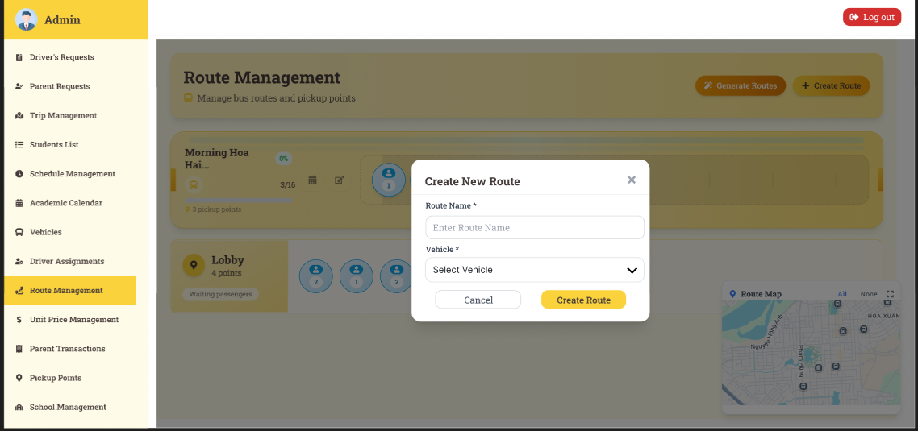
Figure 56:Create Route
Function Details:
Validation:
● Route name is required and must be unique
● At least one pickup point is required
Business Rules:
● Route names must be unique within the system
● Only Admin can create routes
Functionalities
Normal case:
1. Admin fills in route information
2. Admin adds pickup and drop-off points
3. System validates all data
4. System calculates distance and travel time
5. Route is created successfully
6. Admin is redirected to route list with message "Route created successfully"
Abnormal case:
1. If route name already exists: System shows error "Route name already exists"
2. If no pickup points added: System shows error "At least one pickup point is required"
3. If no drop-off points added: System shows error "At least one drop-off point is required"

3.6.2 Delete Route
Function trigger: Admin clicks on the "Delete" button for a specific route in the Route Management page.
Function description:
Actors: Admin
Purpose: Allow administrators to remove routes that are no longer needed or active.
Data Processing:
1. Check if route is currently assigned to any active trips
2. Check if route has any scheduled trips in the future
3. Validate admin permissions
4. Perform soft delete (mark as deleted, preserve data)
5. Update related schedules and trips status
6. Log deletion activity
Screen layout:
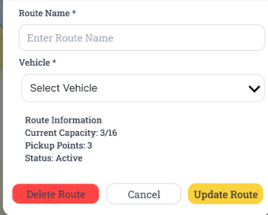
Figure 57:Delete Route
Function Details:
Validation:
● User must be authenticated Admin
● Route must not have active trips
● Route must exist and not already deleted
Business Rules:
● Routes with active trips cannot be deleted
● Routes with future scheduled trips will be marked as inactive instead of deleted
Functionalities
Normal case:
1. Admin clicks the delete button for a route.
2. System shows confirmation dialog with impact analysis
3. Admin confirms deletion
4. System checks for active trips and schedules
5. Route is soft-deleted successfully
6. Related schedules are updated
7. Admin is redirected to route list with message "Route deleted successfully"
Abnormal case:
1. If route has active trips: System shows error "Cannot delete route with active trips"
2. If route has future schedules: System shows warning "Route has future schedules. It will be marked as inactive instead"

3.6.3 View All Routes
Function trigger: Admin navigates to the Route Management page or clicks "View Routes" menu item.
Function description:
Actors: Admin
Purpose: Display a comprehensive list of all routes in the system with filtering, sorting, and search capabilities.
Data Processing:
1. Retrieve all active routes from database
2. Apply search filters if provided
3. Sort routes based on selected criteria
4. Paginate results for performance
5. Calculate route statistics (active trips, assigned vehicles)
6. Format data for display

Screen layout:
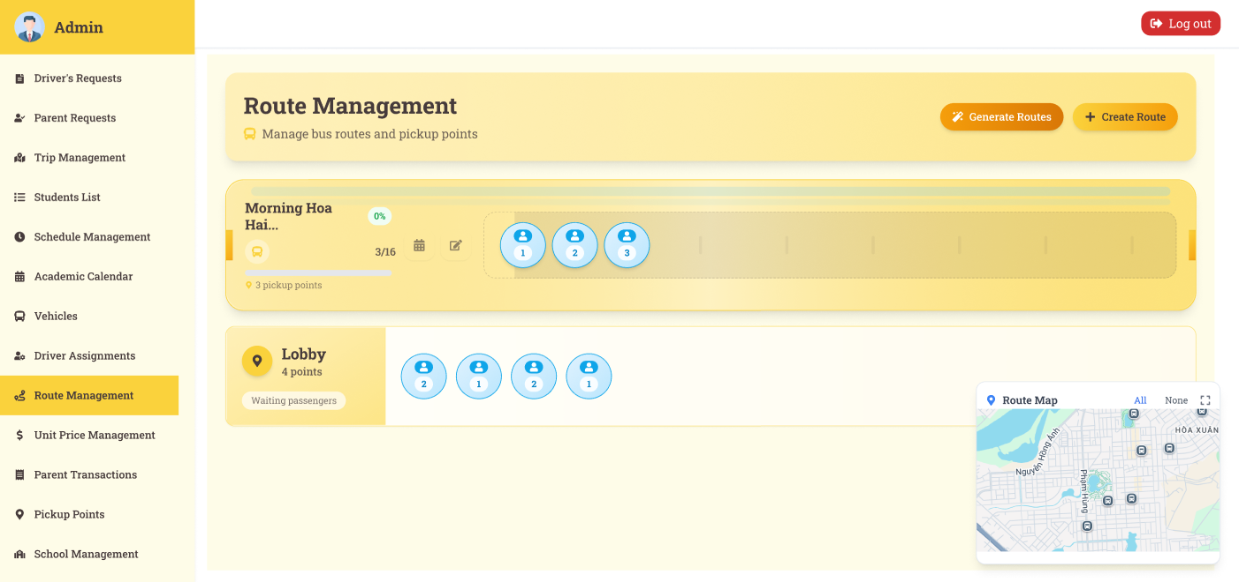
Figure 58:View All Routes
Function Details:
Validation:
● User must be authenticated Admin
● Sort criteria must be valid
Business Rules:
● Only active routes are displayed by default
● Search is case-insensitive and searches route name and description
Functionalities
Normal case:
1. Admin navigates to Route Management page
2. System loads all active routes with pagination
3. Admin can search, filter, and sort routes
4. Admin can view route details by clicking "View"
5. Admin can edit routes by clicking "Edit"
6. Admin can delete routes by clicking "Delete"
7. Admin can create new routes by clicking "Create New Route"
Abnormal case:
1. If no routes found: System shows message "No routes found"
2. If search returns no results: System shows message "No routes match your search criteria"

3.6.4 View Route Detail
Function trigger: Admin clicks on the "View" button for a specific route in the Route Management page.
Function description:
Actors: Admin
Purpose: Display comprehensive information about a specific route including all pickup/drop-off points, assigned vehicles, schedules, and statistics.
Data Processing:
1. Retrieve route details from database
2. Load all pickup and drop-off points
3. Get assigned vehicles and drivers
4. Calculate route statistics and metrics
5. Load related schedules and trips
6. Format data for detailed display

Screen layout:
Figure 59:View Route Detail
Function Details:
Validation:
● User must be authenticated Admin
● Route ID must be valid and exist
Business Rules:
● All route information is displayed in read-only mode
● Assigned vehicles and drivers are shown if available
Functionalities
Normal case:
1. Admin clicks "View" button for a route
2. System loads all route details
3. System displays comprehensive route information
4. System shows pickup and drop-off points
5. System displays assigned vehicles and drivers
6. System shows route statistics and metrics
7. Admin can navigate back, edit, or delete the route
Abnormal case:
1. If route not found: System shows error "Route not found"
2. If route is deleted: System shows error "Route has been deleted"

3.6.5 Update Route
Function trigger: Admin clicks on the "Edit" button for a specific route in the Route Management page or Route Detail page.
Function description:
Actors: Admin
Purpose: Allow administrators to modify existing route information including pickup points, drop-off points, and route details.
Data Processing:
1. Load existing route data for editing
2. Validate updated route information
3. Check for conflicts with existing routes
4. Validate pickup/drop-off point changes
5. Recalculate distance and travel time
6. Update route data in database
7. Update related schedules and trips if needed
Screen layout:
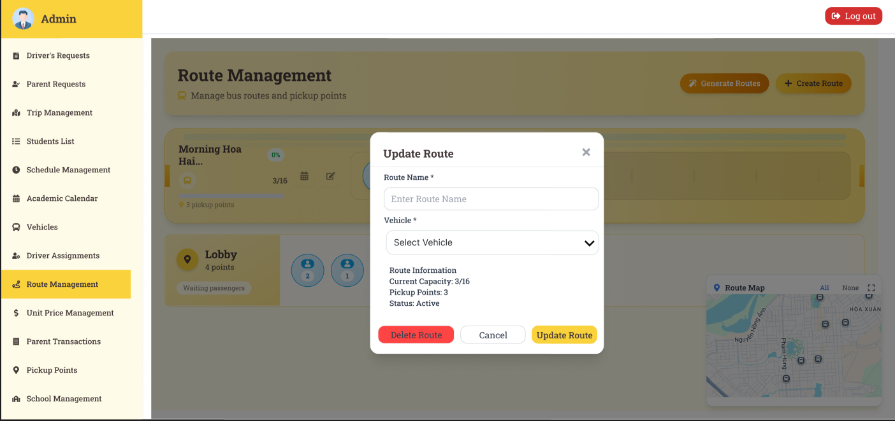
Figure 60:Update Route
Function Details:
Validation:
● User must be authenticated Admin
● Route name is required and must be unique (if changed)
● At least one pickup point is required
Business Rules:
● Route names must be unique within the system

● Changes to pickup/drop-off points may affect existing schedules
Functionalities
Normal case:
1. Admin clicks "Edit" button for a route
2. System loads existing route data in edit mode
3. Admin modifies route information
4. Admin adds, edits, or removes pickup/drop-off points
5. System validates all changes
6. System recalculates distance and travel time
7. Route is updated successfully
8. Related schedules are updated if needed
9. Admin is redirected to route list with message "Route updated successfully"
Abnormal case:
1. If route name already exists: System shows error "Route name already exists"
2. If no pickup points remain: System shows error "At least one pickup point is required"

3.7 Schedule Management

3.7.1 View All Schedule
Function trigger: Admin navigates to the Schedule Management page or clicks "View Schedules" menu item.
Function description:
Actors: Admin
Purpose: Display a comprehensive list of all schedules in the system with filtering, sorting, and search capabilities.
Data Processing:
1. Retrieve all active schedules from database
2. Apply search filters if provided
3. Sort schedules based on selected criteria
4. Paginate results for performance
5. Calculate schedule statistics (active trips, assigned routes)
6. Format data for display
Screen layout:
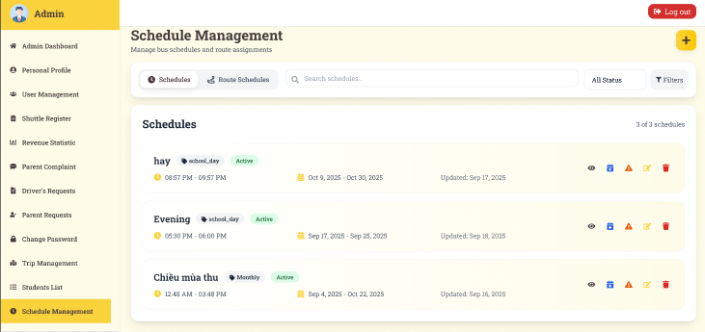
Figure 61: View All Schedule
Function Details:
Validation:
● User must be authenticated Admin
● Sort criteria must be valid
Business Rules:
● Only active schedules are displayed by default
● Schedules are sorted by creation date (newest first) by default
Functionalities
Normal case:
1. Admin navigates to Schedule Management page
2. System loads all active schedules with pagination
3. Admin can search, filter, and sort schedules
4. Admin can view schedule details by clicking "View"
5. Admin can edit schedules by clicking "Edit"
6. Admin can delete schedules by clicking "Delete"
7. Admin can create new schedules by clicking "Create New Schedule"
Abnormal case:
1. If no schedules found: System shows message "No schedules found"
2. If search returns no results: System shows message "No schedules match your search criteria"
3. If database error: System shows error "Failed to load schedules. Please refresh the page"

3.7.2 Update Schedule
Function trigger: Admin clicks on the "Edit" button for a specific schedule in the Schedule Management page or Schedule Detail page.
Function description:
Actors: Admin
Purpose: Allow administrators to modify existing schedule information including timing, routes, vehicles, and recurrence patterns.
Data Processing:
1. Load existing schedule data for editing
2. Validate updated schedule information
3. Check for conflicts with existing schedules
4. Validate timing and recurrence patterns
5. Update schedule data in database
6. Update related trips and notifications if needed
Screen layout:
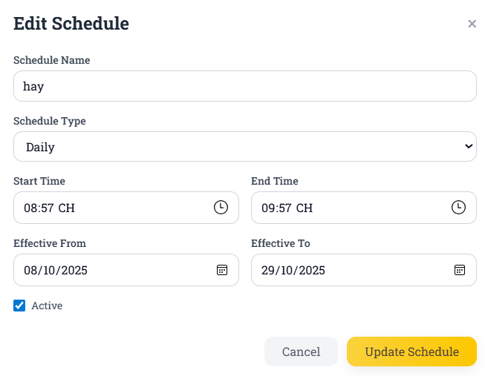
Figure 62: Update Schedule
Function Details:
Validation:
● User must be authenticated Admin
● Schedule name is required and must be unique (if changed)
Business Rules:
● Schedule names must be unique within the system
● Changes to timing may affect existing trips
Functionalities
Normal case:
1. Admin clicks "Edit" button for a schedule
2. System loads existing schedule data in edit mode
3. Admin modifies schedule information
4. Admin updates timing and recurrence patterns
5. System validates all changes
6. System recalculates duration and conflicts
7. Schedule is updated successfully
8. Related trips and notifications are updated if needed
9. Admin is redirected to schedule list with message "Schedule updated successfully"
Abnormal case:
1. If schedule name already exists: System shows error "Schedule name already exists"
2. If start time is after end time: System shows error "Start time must be before end time"
3. If no days selected: System shows error "At least one day must be selected"

3.7.3 Create Schedule
Function trigger: Admin clicks on the "Create New Schedule" button in the Schedule Management page.
Function description:
Actors: Admin
Purpose: Allow administrators to create new bus schedules with timing, routes, vehicles, drivers, and recurrence patterns.
Data Processing:
1. Validate schedule information (name, description, timing, route, vehicle, driver)
2. Check for duplicate schedule names
3. Validate timing and recurrence patterns
4. Check for conflicts with existing schedules
5. Calculate schedule duration and conflicts
6. Save schedule data to database
7. Generate unique schedule ID
Screen layout:
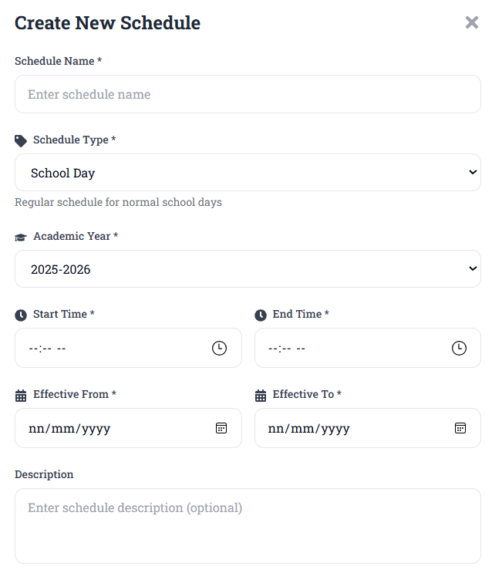
Figure 63:Create Schedule

Function Details:
Validation:
● Schedule name is required and must be unique
● Start time must be before end time
● At least one day of week must be selected
● Start date is required
Business Rules:
● Schedule names must be unique within the system
● Start time must be before end time
Functionalities
Normal case:
1. Admin fills in schedule information
2. Admin selects route, vehicle, and driver
3. Admin sets timing and recurrence patterns
4. System validates all data
5. Schedule is created successfully
6. Admin can delete schedules by clicking "Delete"
7. Admin is redirected to schedule list with message "Schedule created successfully"
Abnormal case:
1. If schedule name already exists: System shows error "Schedule name already exists"
2. If start time is after end time: System shows error "Start time must be before end time"
3. If no days selected: System shows error "At least one day must be selected"

3.7.4 Delete Schedule
Function trigger: Admin clicks on the "Delete" button for a specific schedule in the Schedule Management page.
Function description:
Actors: Admin
Purpose: Allow administrators to remove schedules that are no longer needed or active.
Data Processing:
1. Check if schedule is currently assigned to any active trips
2. Check if schedule has any scheduled trips in the future
3. Validate admin permissions
4. Perform soft delete (mark as deleted, preserve data)
5. Update related trips and notifications status
6. Log deletion activity
Screen layout:
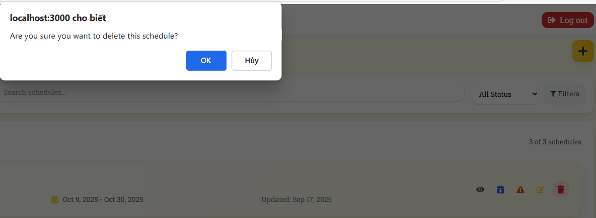
Figure 64: Delete Schedule
Function Details:
Validation:
● User must be authenticated Admin
● Schedule must exist and not already deleted
Business Rules:
● Schedules with future scheduled trips will be marked as inactive instead of deleted
● Deleted schedules are soft-deleted (marked as deleted, data preserved)
Functionalities
Normal case:
1. Admin clicks delete button for a schedule
2. System shows confirmation dialog with impact analysis
3. Admin confirms deletion
4. System checks for active trips and schedules
5. Schedule is soft-deleted successfully
6. Related trips and notifications are updated
7. Admin is redirected to schedule list with message "Schedule deleted successfully"
Abnormal case:
1. If schedule has active trips: System shows error "Cannot delete schedule with active trips"
2. If schedule has future scheduled trips: System shows warning "Schedule has future scheduled trips. It will be marked as inactive instead"
3. If the user is not Admin: System shows error "Access denied. Admin privileges required"

3.7.5 View Schedule Detail
Function trigger: Admin clicks on the "View" button for a specific schedule in the Schedule Management page.
Function description:
Actors: Admin
Purpose: Display comprehensive information about a specific schedule including timing, route, vehicle, driver, recurrence patterns, and statistics.
Data Processing:
1. Retrieve schedule details from database
2. Load assigned route, vehicle, and driver information
3. Calculate schedule statistics and metrics
4. Load related trips and notifications
5. Load exception dates and time overrides
6. Format data for detailed display
Screen layout:
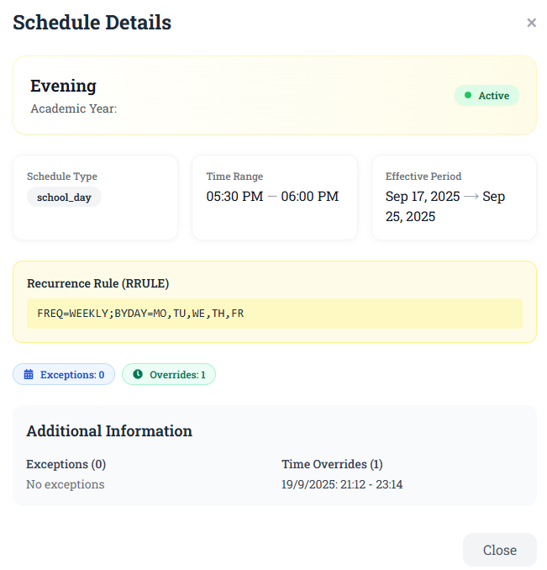
Figure 65: View Schedule Detail
Function Details:
Validation:
● User must be authenticated Admin
● Schedule ID must be valid and exist
● Schedule must not be deleted
Business Rules:
● All schedule information is displayed in read-only mode
● Assigned route, vehicle, and driver are shown if available
● Statistics are calculated in real-time
● Exception dates and time overrides are included
Functionalities
Normal case:
1. Admin clicks "View" button for a schedule
2. System loads all schedule details
3. System displays comprehensive schedule information
4. System shows route, vehicle, and driver information
5. System displays recurrence patterns and timing
6. System shows exception dates and time overrides
7. System displays schedule statistics and metrics
8. Admin can navigate back, edit, or delete the schedule
Abnormal case:
1. If schedule not found: System shows error "Schedule not found"
2. IIf schedule is deleted: System shows error "Schedule has been deleted"
3. If the user is not Admin: System shows error "Access denied. Admin privileges required"

3.7.6 Add Exception Date
Function trigger: Admin clicks on the "Add Exception Date" button in the Schedule Detail page.
Function description:
Actors: Admin
Purpose: Allow administrators to add specific dates when a schedule should not run (holidays, school breaks, etc.).
Data Processing:
1. Validate exception date information
2. Check for duplicate exception dates
3. Validate date is within schedule range
4. Save exception date to database
5. Update related trips and notifications
Screen layout:
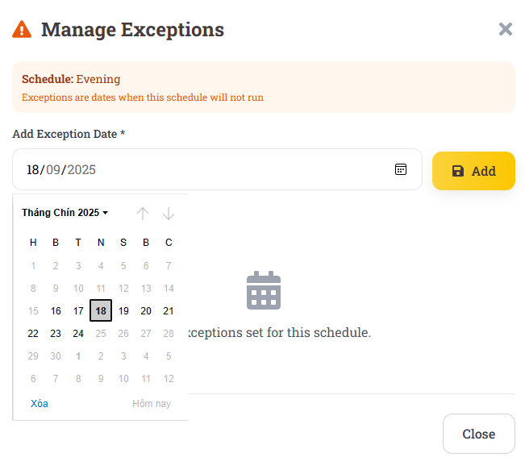
Figure 66:Add Exception Date

Function Details:
Validation:
● Exception date is required
● Date must not already be an exception date
● Date must be within schedule date range

Business Rules:
● Exception dates must be within the schedule's active period
● Duplicate exception dates are not allowed
● System automatically cancels trips on exception dates
Functionalities
Normal case:
1. Admin clicks "Add Exception Date" button
2. System shows exception date form
3. Admin fills in exception date and reason
4. System validates the exception date
5. System shows impact analysis
6. Admin confirms the addition
7. Exception date is added successfully
8. Related trips are cancelled and parents are notified
Abnormal case:
1. If date is outside schedule range: System shows error "Date must be within schedule date range"
2. If date already exists: System shows error "Exception date already exists"
3. If invalid date format: System shows error "Invalid date format"

3.7.7 Delete Exception Date
Function trigger: Admin clicks on the "Delete" button for a specific exception date in the Schedule Detail page.
Function description:
Actors: Admin
Purpose: Allow administrators to remove exception dates when they are no longer needed.
Data Processing:
1. Validate admin permissions
2. Check if exception date exists
3. Remove exception date from database
4. Restore cancelled trips for that date
5. Update related notifications
Screen layout:
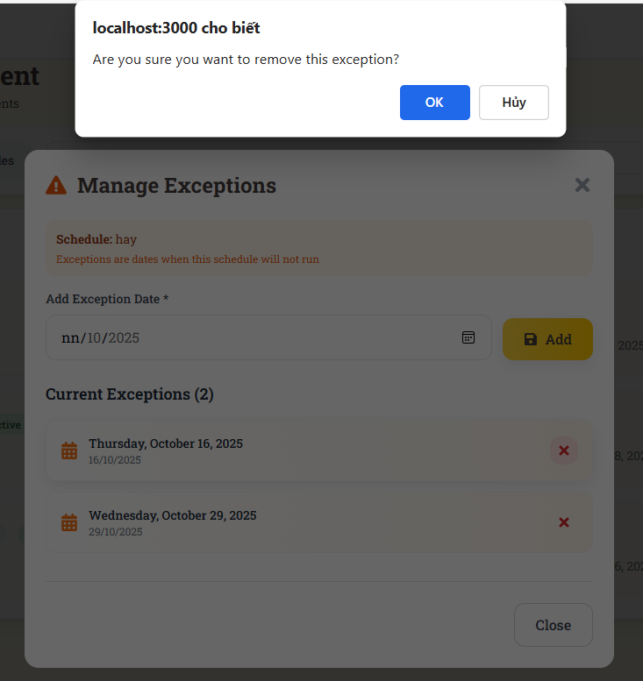
Figure 67:Send Contract
Function Details:
Validation:
● User must be authenticated Admin
● Exception date must exist
● Admin must confirm deletion action

Business Rules:
● Deletion restores cancelled trips for that date
● Parents are notified about schedule restoration
● Deletion is logged for audit purposes
Functionalities
Normal case:
1. Admin clicks delete button for an exception date
2. System shows confirmation dialog with impact analysis
3. Admin confirms deletion
4. Exception date is removed from database
5. Cancelled trips are restored for that date
6. Parents are notified about schedule restoration
7. Admin is redirected to schedule detail with message "Exception date deleted successfully"
Abnormal case:
1. If exception date not found: System shows error "Exception date not found"

2. If the user is not Admin: System shows error "Access denied. Admin privileges required"

3. If network error: System shows error "Failed to delete exception date. Please try again"

3.7.8 Add Time Overrides
Function trigger: Admin clicks on the "Add Time Override" button in the Schedule Detail page.
Function description:
Actors: Admin
Purpose: Allow administrators to override the default schedule timing for specific dates (early departure, late arrival, etc.).
Data Processing:
1. Validate time override information
2. Check for conflicts with existing overrides
3. Validate date is within schedule range
4. Calculate new duration and validate timing
5. Save time override to database
6. Update related trips and notifications
Screen layout:
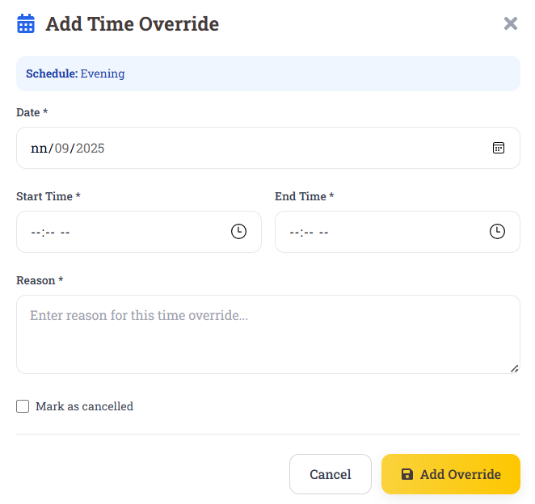
Figure 68 Add Time Overrides
Function Details:
Validation:
● Override date is required
● Date must be within schedule date range
● Start time must be before end time
Business Rules:
● Time overrides must be within the schedule's active period
● Duplicate time overrides for the same date are not allowed
● System automatically updates trips with new timing
Functionalities
Normal case:
1. Admin clicks "Add Time Override" button
2. System shows time override form
3. Admin fills in override date and timing
4. System validates the time override
5. System shows impact analysis
6. Admin confirms the addition
7. Time override is added successfully
8. Related trips are updated and parents are notified
Abnormal case:
1. If date is outside schedule range: System shows error "Date must be within schedule date range"
2. If time override already exists: System shows error "Time override already exists for this date"
3. If start time is after end time: System shows error "Start time must be before end time"

3.7.9 Update Time Overrides
Function trigger: Admin clicks on the "Edit" button for a specific time override in the Schedule Detail page.
Function description:
Actors: Admin
Purpose: Allow administrators to modify existing time overrides for specific dates.
Data Processing:
1. Load existing time override data for editing
2. Validate updated time override information
3. Check for conflicts with existing overrides
4. Calculate new duration and validate timing
5. Update time override data in database
6. Update related trips and notifications
Screen layout:
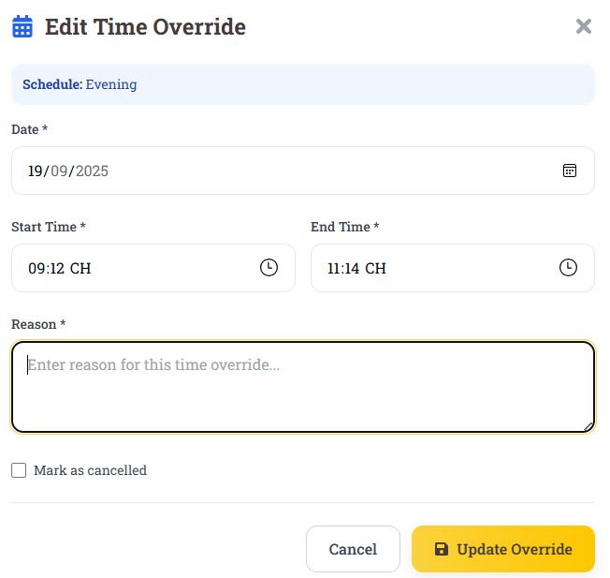
Figure 69:Update Time Overrides
Function Details:
Validation:
● User must be authenticated Admin
● Start time must be before end time
● Reason is required
Business Rules:
● Changes to timing affect existing trips
● System automatically recalculates duration
● Parents are notified about timing changes
Functionalities
Normal case:
1. Admin clicks "Edit" button for a time override
2. System loads existing time override data in edit mode
3. Admin modifies timing and reason information
4. System validates all changes
5. System recalculates duration
6. Time override is updated successfully
7. Related trips are updated and parents are notified
8. Admin is redirected to schedule detail with message "Time override updated successfully"
Abnormal case:
1. If start time is after end time: System shows error "Start time must be before end time"
2. If time override not found: System shows error "Time override not found"
3. If the user is not Admin: System shows error "Access denied. Admin privileges required"

3.7.10 DeleteTime Overrides
Function trigger: Admin clicks on the "Delete" button for a specific time override in the Schedule Detail page.
Function description:
Actors: Admin
Purpose: Allow administrators to remove time overrides when they are no longer needed.
Data Processing:
1. Validate admin permissions
2. Check if time override exists
3. Remove time override from database
4. Restore default timing for affected trips
5. Update related notifications
Screen layout:
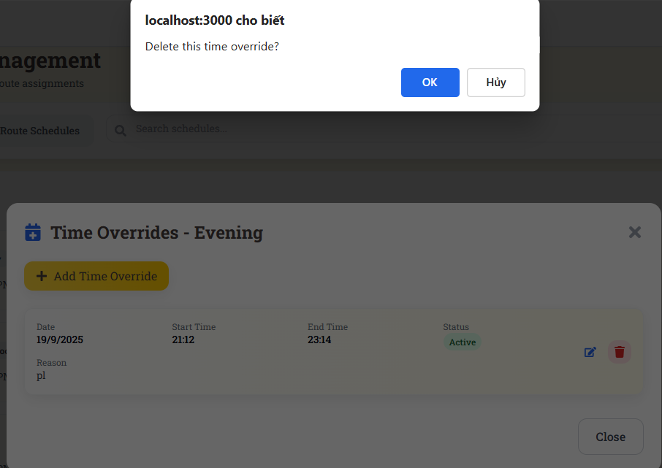
Figure 70: DeleteTime Overrides
Function Details:
Validation:
● Time override must exist
● Admin must confirm deletion action
Business Rules:
● Deletion restores default timing for affected trips
● Parents are notified about timing restoration
● Deletion is logged for audit purposes
Functionalities
Normal case:
1. Admin clicks delete button for a time override
2. System shows confirmation dialog with impact analysis
3. Admin confirms deletion
4. Time override is removed from database
5. Affected trips are restored to default timing
6. Parents are notified about timing restoration
7. Admin is redirected to schedule detail with message "Time override deleted successfully"
Abnormal case:
1. If time override not found: System shows error "Time override not found"
2. If the user is not Admin: System shows error "Access denied. Admin privileges required"

3.7.11 View Shuttle Schedule
Function trigger: Parent or Driver navigates to the "Shuttle Schedule" page or clicks "View Schedule" menu item.
Function description:
Actors: Parent, Driver
Purpose: Display relevant shuttle schedules for parents and drivers with filtering and search capabilities.
Data Processing:
1. Retrieve schedules based on user role and assignments
2. Apply user-specific filters (route, date range)
3. Sort schedules by date and time
4. Calculate real-time schedule status
5. Format data for user-friendly display
Screen layout:
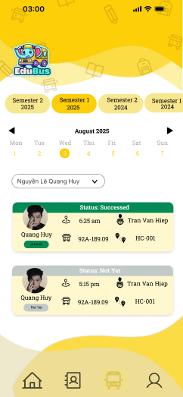
Figure 71: View Shuttle Schedule
Function Details:
Validation:
● User must be authenticated (Parent or Driver)
● User must have access to at least one schedule
● Date range must be valid
Business Rules:
● Schedules are displayed in chronological order
● Drivers see schedules for their assigned routes
● Parents see schedules for their children's routes
Functionalities
Normal case:
1. User navigates to Shuttle Schedule page
2. System loads relevant schedules based on user role
3. User can filter by date, route, or search
4. User can view schedule details
5. User can track bus location
6. Real-time updates are provided
Abnormal case:
1. IIf no schedules found: System shows message "No schedules available"
2. If user is not authenticated: System shows error "Please log in to view schedules"

3.8 Trip Management

3.8.1 View All Trip
Function trigger: Admin navigates to the Trip Management page or clicks "View Trips" menu item.
Function description:
Actors: Admin
Purpose: Display a comprehensive list of all trips in the system with filtering, sorting, and search capabilities.
Data Processing:
1. Retrieve all trips from database
2. Apply search filters if provided
3. Sort trips based on selected criteria
4. Paginate results for performance
5. Calculate trip statistics and real-time status
6. Format data for display
Screen layout:
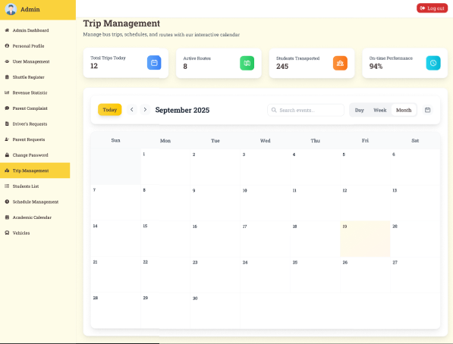
Figure 72: View All Trip
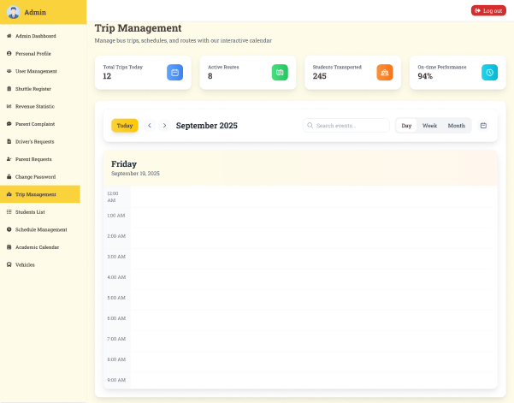
Figure 73:View All Trip

Function Details:
Validation:
● User must be authenticated Admin
● Sort criteria must be valid
Business Rules:
● Trips are sorted by date and time (newest first) by default
● All trips are displayed regardless of status
Functionalities
Normal case:
1. Admin navigates to Trip Management page
2. System loads all trips with pagination
3. Admin can search, filter, and sort trips
4. Admin can view trip details by clicking "View"
5. Admin can edit trips by clicking "Edit"
6. Admin can delete trips by clicking "Delete"
7. Admin can create new trips by clicking "Create New Trip"
Abnormal case:
1. If no trips found: System shows message "No trips found"
2. If search returns no results: System shows message "No trips match your search criteria"

3.8.2 View Trip Detail
Function trigger: Admin clicks on the "View" button for a specific trip in the Trip Management page.
Function description:
Actors: Admin
Purpose: Display comprehensive information about a specific trip including route, vehicle, driver, students, timing, and real-time status.
Data Processing:
1. Retrieve trip details from database
2. Load assigned route, vehicle, and driver information
3. Load student list and attendance information
4. Calculate trip statistics and real-time metrics
5. Load trip stops and progress information
6. Format data for detailed display
Screen layout:
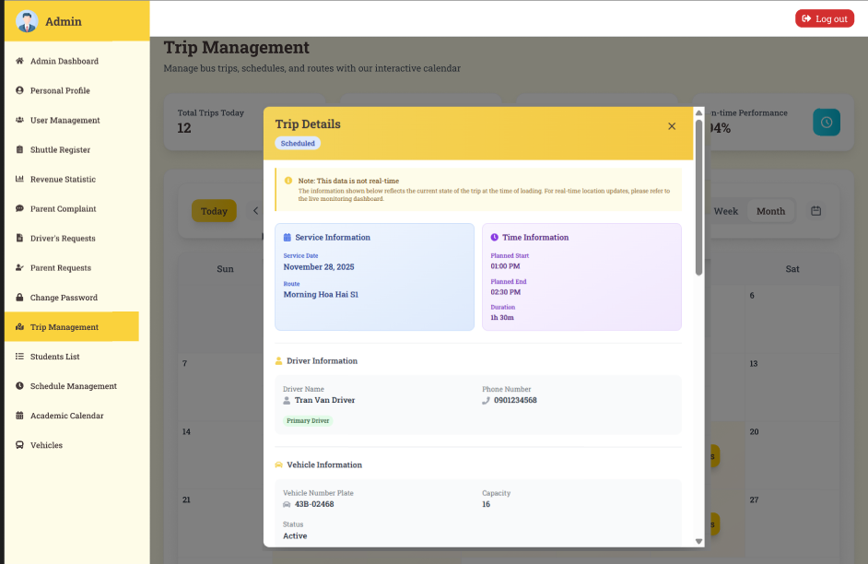
Figure 74:View Trip Detail
Function Details:
Validation:
● User must be authenticated Admin
● Trip ID must be valid and exist
Business Rules:
● Statistics are calculated in real-time
● All trip information is displayed in read-only mode
Functionalities
Normal case:
1. Admin clicks "View" button for a trip
2. System loads all trip details
3. System displays comprehensive trip information
4. System shows route, vehicle, and driver information
5. System displays trip progress and stops
6. System shows student information and attendance
7. System displays trip statistics and metrics
8. Admin can navigate back, edit, delete, or track the trip
Abnormal case:
1. If trip is deleted: System shows error "Trip has been deleted"
2. If trip not found: System shows error "Trip not found"

3.8.3 Delete Trip
Function trigger: Admin clicks on the "Delete" button for a specific trip in the Trip Management page.
Function description:
Actors: Admin
Purpose: Allow administrators to remove trips that are no longer needed or have been cancelled.
Data Processing:
1. Check if trip is currently active or in progress
2. Check if trip has any students assigned
3. Validate admin permissions
4. Perform soft delete (mark as deleted, preserve data)
5. Update related schedules and notifications
6. Log deletion activity
Screen layout:
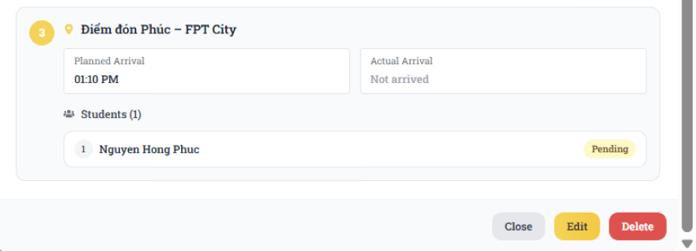
Figure 75: Delete Trip

Function Details:
Validation:
● User must be authenticated Admin
● Trip must exist and not already deleted
Business Rules:
● Active trips cannot be deleted
● Trips with assigned students will notify parents
Functionalities
Normal case:
1. Admin clicks delete button for a trip
2. System shows confirmation dialog with impact analysis
3. Admin confirms deletion
4. System checks for active status and assigned students
5. Trip is soft-deleted successfully
6. Related schedules and notifications are updated
7. Parents and driver are notified about trip cancellation
8. Admin is redirected to trip list with message "Trip deleted successfully"
Abnormal case:
1. If trip is active: System shows error "Cannot delete active trip"
2. If trip has students on board: System shows warning "Trip has students on board. Deletion will notify parents"

3.8.4 Create Trip
Function trigger: Admin clicks on the "Create New Trip" button in the Trip Management page.
Function description:
Actors: Admin
Purpose: Allow administrators to create new trips based on existing schedules or create ad-hoc trips.
Data Processing:
1. Validate trip information (schedule, route, vehicle, driver, date, time)
2. Check for conflicts with existing trips
3. Validate vehicle and driver availability
4. Calculate trip duration and estimated completion time
5. Save trip data to database
6. Generate unique trip ID
Screen layout:
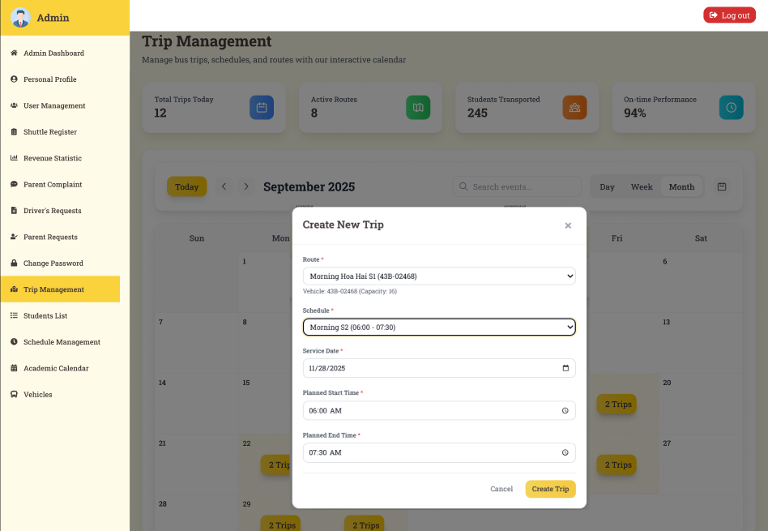
Figure 76:Create Trip
Function Details:
Validation:
● Schedule, route, vehicle, and driver must be selected
● Trip date and start time are required
Business Rules:
● Vehicle and driver availability must be checked
● Trips can be created from existing schedules or as ad-hoc trips
Functionalities
Normal case:
1. Admin fills in trip information
2. Admin selects schedule, route, vehicle, and driver
3. Admin sets trip date and timing
4. System validates all data and checks for conflicts
5. System calculates duration and estimated completion time
6. Trip is created successfully
7. Students are assigned based on selection
8. Admin is redirected to trip list with message "Trip created successfully"
Abnormal case:
1. If driver not available: System shows error "Selected driver is not available"
2. If vehicle not available: System shows error "Selected vehicle is not available"

3.8.5 Update Trip
Function trigger: Admin clicks on the "Edit" button for a specific trip in the Trip Management page or Trip Detail page.
Function description:
Actors: Admin
Purpose: Allow administrators to modify existing trip information including timing, vehicle, driver, and student assignments.
Data Processing:
1. Load existing trip data for editing
2. Validate updated trip information
3. Check for conflicts with existing trips
4. Validate vehicle and driver availability
5. Recalculate trip duration and timing
6. Update trip data in database
7. Update related notifications if needed
Screen layout:
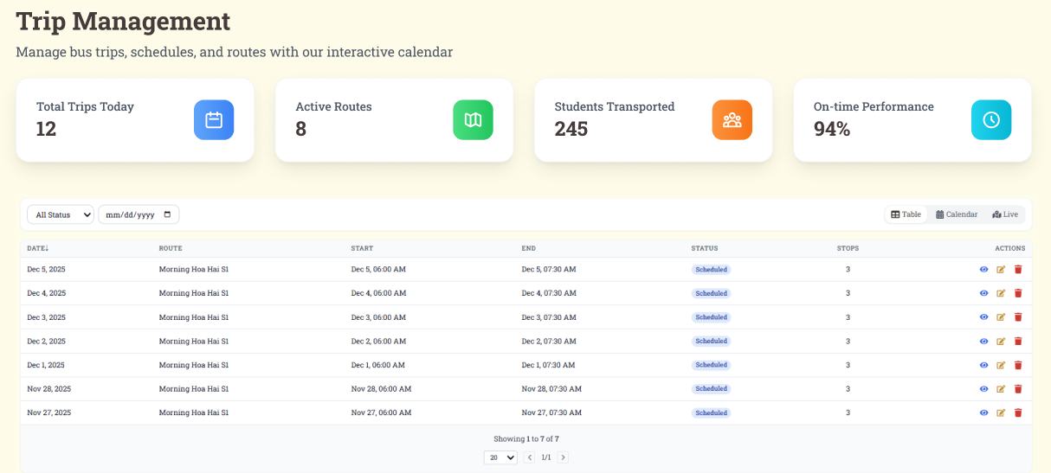
Figure 77:Update Trip

Function Details:
Validation:
● Trip must exist and not be deleted
● Start time must be before end time
Business Rules:
● Active trips cannot be edited
● Changes to timing may affect existing notifications
Functionalities
Normal case:
1. Admin clicks "Edit" button for a trip
2. System loads existing trip data in edit mode
3. Admin modifies trip information
4. Admin updates timing, vehicle, or driver assignments
5. System validates all changes
6. System recalculates duration and checks for conflicts
7. Trip is updated successfully
8. Related notifications are updated if needed
9. Admin is redirected to trip list with message "Trip updated successfully"
Abnormal case:
1. If trip is active: System shows error "Cannot edit active trip"
2. f vehicle not available: System shows error "Selected vehicle is not available"

3.8.7 Confirm manual check-in
Function trigger: Driver clicks on the "Start Trip" button for a scheduled trip in the Driver Dashboard.
Function description:
Actors: Driver
Purpose: Allow drivers to confirm the start of their assigned trips and begin real-time tracking.
Data Processing:
1. Validate driver permissions for the trip
2. Check trip status and timing
3. Initialize real-time tracking
4. Update trip status to "Active"
5. Send notifications to parents and admin
6. Log trip start activity
Screen layout:

Figure 78:Confirm manual check-in
Function Details:
Validation:
● Driver must be assigned to the trip
● Trip must be in "Scheduled" status
Business Rules:
● Only assigned drivers can start trips
● Trip status changes from "Scheduled" to "Active"
Functionalities
Normal case:
1. Driver clicks "Start Trip" button
2. System validates driver permissions and trip status
3. System shows pre-trip checklist and confirmation
4. Driver confirms trip start
5. System updates trip status to "Active"
6. System begins real-time tracking
7. Parents and admin are notified
8. Driver is redirected to trip tracking interface
Abnormal case:
1. If trip already started: System shows error "Trip has already been started"
2. If driver not assigned: System shows error "You are not assigned to this trip"

3.8.8 Confirm manual check-out
Function trigger: Driver clicks on the "End Trip" button for an active trip in the Driver Dashboard.
Function description:
Actors: Driver
Purpose: Allow drivers to confirm the completion of their trips and finalize trip data.
Data Processing:
1. Validate driver permissions for the trip
2. Check trip status and completion criteria
3. Calculate final trip statistics
4. Update trip status to "Completed"
5. Stop real-time tracking
6. Send completion notifications
Screen layout:
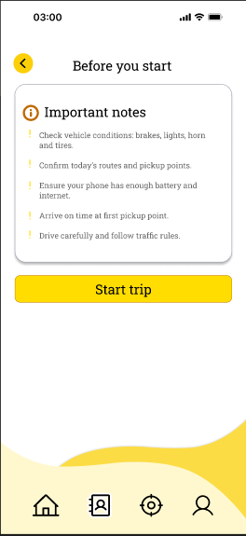
Figure 79:Confirm manual check-out
Function Details:
Validation:
● Schedule, route, vehicle, and driver must be selected
● Trip date and start time are required
Business Rules:
● Trip must be in "Active" status
● Driver must be assigned to the trip
Functionalities
Normal case:
1. Driver clicks "End Trip" button
2. System validates driver permissions and trip status
3. System shows trip summary and post-trip checklist
4. Driver confirms trip completion
5. System calculates final trip statistics
6. System updates trip status to "Completed"
7. System stops real-time tracking
8. Parents and admin are notified
Abnormal case:
1. If driver not assigned: System shows error "You are not assigned to this trip"
2. If trip not active: System shows error "Trip is not currently active"

3.8.9 Handle absent student
Function trigger: Supervisor identifies that a student assigned to the shuttle trip is absent during pickup or drop-off.
Function description:
Actors: Supervisor
Purpose: Allow supervisors to mark a student as absent, record the reason, and notify the parent and school in real time.
Data Processing:
- The supervisor opens the list of students assigned to the ongoing trip.
- The supervisor selects the student who is absent.
- Supervisor marks the absence and optionally enters a reason (e.g., sick, leave request, no-show).
- The system updates the attendance status and sends notifications to the parent and the school.
- The absence information is stored in the trip history and attendance log.
Screen layout:
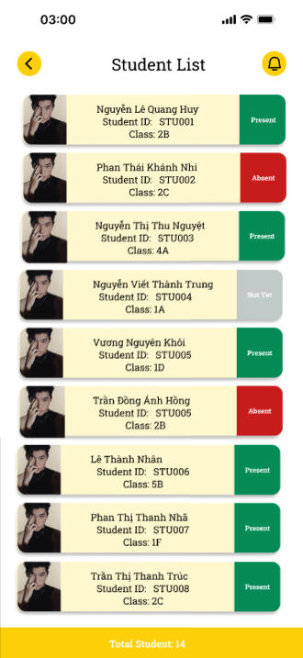
Figure 80: Handle absent student
Function Details:
Validation:
- Supervisor must be logged in.
- The student must belong to the current trip.
- The trip must be active (ongoing status) for absence marking.
Business Rules:
- Absence can only be recorded once per trip session (pickup or drop-off).
- Once marked absent, the student's status cannot be changed unless the system allows manual correction.
- Notifications must be sent immediately to the parent and school admin.
- All absence actions must be logged with timestamp and supervisor ID.
Functionalities
Normal case:
- Supervisor accesses the student list for the current trip.
- The supervisor selects the student and marks them as absent.
- The system saves the absence status.
- The system sends notifications to parents and school.
- Attendance record is updated in trip history.
Abnormal case:
- If the student is not linked to the trip:
→ System shows error: "Student not assigned to this trip."
- If the supervisor attempts to mark absence after the trip has ended:
→ System shows error: "Attendance cannot be updated. The trip is already completed."
- If notification sending fails:
→ System logs the issue and shows: "Absence recorded, but notification could not be delivered."

3.8.10 View Trip’s History
Function trigger: Driver clicks on "Trip History" menu item in the Driver Dashboard.
Function description:
Actors: Driver
Purpose: Display historical trip data for the driver including completed trips, statistics, and performance metrics.
Data Processing:
1. Retrieve driver's historical trip data
2. Apply date range and status filters
3. Calculate driver performance metrics
4. Sort trips by date and time
5. Paginate results for performance
6. Format data for display
Screen layout:

Figure 81: View Trip’s History
Function Details:
Validation:
● Date range must be valid
● Trips are sorted by date (newest first) by default
Business Rules:
● Rating data is included when available
● Performance metrics are calculated from completed trips
Functionalities
Normal case:
1. Driver navigates to Trip History page
2. System loads driver's historical trip data
3. System displays performance summary
4. Driver can filter by date range, status, or route
5. Driver can view detailed trip information
6. Driver can generate trip reports
7. Driver can export or print trip data
Abnormal case:
1. If no trips found: System shows message "No trip history found"
2. If search returns no results: System shows message "No trips match your search criteria"

3.9 Attendance Management

3.9.1 Take Attendance
Function trigger: A student checks in or checks out via face recognition, QR code scanning, or supervisor confirmation when boarding or leaving the shuttle bus.
Function description:
Actors: Student
Purpose: Record the student’s attendance for each shuttle trip session (pickup and drop-off) to ensure accurate tracking and safety.
Data Processing:
- The student approaches the bus and performs the required attendance action (face scan / QR code / supervisor marks attendance).
- The system verifies the student identity.
- The system records the check-in or check-out time.
- Attendance status is updated for the current trip session.
- Notifications are sent to parents if the school policy requires it.
Function Details:
Validation:
- Students must be assigned to the current trip.
- Attendance can only be taken during an active trip session.
- Student identification (face/QR) must match registered data.
Business Rules:
- Attendance is recorded separately for pick-up and drop-off.
- Each student can only check in or check out once for each session unless manual override is permitted.
- All attendance logs must include timestamp, location (optional), and verification method.
- Parents may receive notifications depending on configuration (e.g., “Your child has boarded the bus.”).
Functionalities
Normal case:
- Students present face/QR code.
- The system verifies identity successfully.
- Attendance is taken and saved.
- The system displays confirmation and (if enabled) sends parent notification.
Abnormal case:
- If student identity cannot be verified:
→ System shows error: "Unable to verify student identity."
- If student is not assigned to the trip:
→ System shows error: "Student not assigned to this trip."
- If attendance is attempted outside the allowed time:
→ System shows error: "Attendance not available at this time."
- If system fails to record attendance:
→ System shows: "Attendance could not be saved. Please try again."

3.9.2 Take Attendance Manually
Function trigger: Supervisor manually marks a student as present during pickup or drop-off when automatic attendance (face recognition/QR) is not available or fails.
Function description:
Actors: Supervisor
Purpose: Record the student’s attendance for each shuttle trip session (pickup and drop-off) to ensure accurate tracking and safety.
Data Processing:
- Supervisor opens the list of students assigned to the current trip session.
- The supervisor selects a student who needs manual attendance.
- The supervisor marks the student as Checked-in or Checked-out manually.
- The system records the attendance status along with supervisor ID, timestamp, and manual mark flag.
- The system triggers notifications to parents if enabled.
Screen layout:
Figure 82: Take Attendance Manually
Function Details:
Validation:
- Supervisor must be logged in.
- The student must belong to the current trip.
- Trip must be active (ongoing) for attendance to be recorded.
Business Rules:
- Manual attendance must be clearly distinguished from automatic attendance.
- Each student may only have one check-in and one check-out entry per session unless manual override is permitted.
- Manual attendance actions must be recorded in the system logs, including supervisor ID and timestamp.
- Parent notifications (if enabled) must indicate that the attendance was manually recorded.
Functionalities
Normal case:
- Supervisor accesses the student attendance list.
- The supervisor selects a student who cannot complete automatic attendance.
- Supervisor manually marks Present / Checked-in / Checked-out.
- The system saves the manual attendance record.
- Parents are notified (if required by school policy).
Abnormal case:
- If the student is not part of the current trip:
→ System shows error: "Student not assigned to this trip."
- If the trip has already ended:
→ System shows error: "Attendance cannot be updated. Trip completed."
- If the system fails to save the record:
→ System shows: "Manual attendance could not be recorded. Please try again."
- If supervisor attempts to mark attendance multiple times illegally:
→ System warns: "Attendance for this session has already been recorded."

3.9.3 View trip report
Function trigger: Parent opens the “Attendance Report” section from the menu or student profile page.
Function description:
Actors: Parent
Purpose: Allow parents to view a detailed report of their child’s attendance for the shuttle service, including daily check-ins, check-outs, absences, and any irregularities.
Data Processing:
- The parent selects the child/student whose attendance report they want to view.
- The system retrieves all attendance records for the selected student, including automatic and manual entries.
- The system calculates summary statistics, such as total attended sessions, total absences, and attendance rate.
- The system displays the detailed and summary attendance report to the parent.
Screen layout:
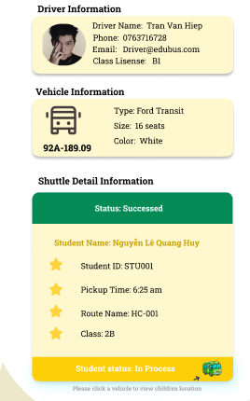
Figure 83: View trip report
Function Details:
Validation:
- Parents must be logged in.
- Students must be linked to the parent account.
- Attendance data must exist for the selected period.
Business Rules:
- Attendance report includes all sessions: pickup and drop-off.
- Absences and irregularities must be clearly flagged.
- Summary metrics (e.g., attendance percentage) must be calculated correctly.
- Parents can view reports for specific periods (daily, weekly, monthly, semester).
Functionalities
Normal case:
- The parent opens the attendance report section.
- The parent selects the student and desired reporting period.
- The system retrieves and displays detailed attendance records.
- The system provides summary statistics and flags any irregularities.
Abnormal case:
- If no attendance records exist for the student:
→ System shows message: "No attendance data available."
- If student is not linked to the parent account:
→ System shows error: "Access denied. Student not linked to your account."
- If system fails to load data:
→ System shows error: "Unable to retrieve attendance report. Please try again later."

3.9.4 View Student List on Bus-Specific
Function trigger: Supervisor or Driver opens the bus-specific student list for a scheduled trip.
Function description:
Actors: Supervisor, Driver
Purpose: Allow supervisors and drivers to view the list of students assigned to a specific bus trip, ensuring proper attendance, tracking, and management during shuttle operations.
Data Processing:
- Supervisor/Driver selects a bus and a scheduled trip.
- The system retrieves all students allocated to that bus for the selected trip.
- The system displays key student information such as name, grade, assigned pickup and drop-off points, and any special notes (e.g., special care, medical conditions).
- The list can be used for attendance checking, notifications, or reporting incidents.
Screen layout:
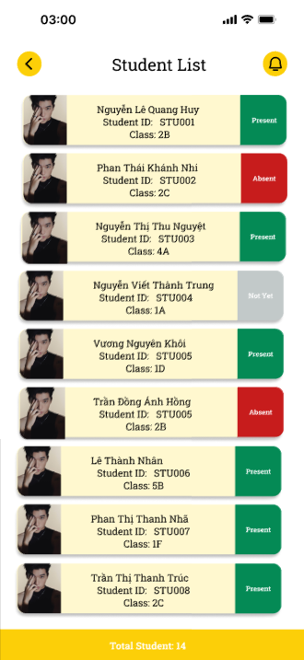
Figure 84: View Student List on Bus-Specific
Function Details:
Validation:
- Supervisor/Driver must be logged in.
- The bus and trip must exist and be active.
- Users must have permission to access the trip’s student list.
Business Rules:
- The list includes only students assigned to the specific bus and trip.
- Attendance and absence actions may be performed directly from the list.
- Any changes to the list must be logged with timestamp and user ID.
- Special notes (medical, pickup exceptions) must be highlighted for attention.
Functionalities
Normal case:
- Supervisor/Driver selects a bus and trip.
- The system retrieves and displays the list of assigned students.
- The system shows student details, pickup/drop-off points, and relevant notes.
- Supervisor/Driver uses the list for attendance and operational management.
Abnormal case:
- If no students are assigned to the bus:
→ System shows message: "No students assigned to this bus for the selected trip."
- If the bus or trip is invalid:
→ System shows error: "Bus or trip not found."
- If system fails to load data:
→ System shows error: "Unable to retrieve student list. Please try again later."

3.10 Vehicle Status Monitoring

3.10.1 Track Vehicle Journey
Function trigger: Parent opens “Track Vehicle” from app menu.
Function description:
Actors: Parent
Purpose: Help parents monitor their child’s bus route for safety and time management.
Data Processing:
1. Parent selects tracking.
2. The system verifies student-vehicle relationships.
3. Retrieve vehicle’s GPS location from driver app/device.
4. Display vehicle location on a live map, updating in intervals.

Screen layout:

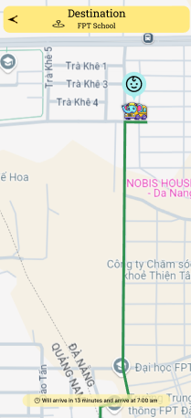
Figure 85: Track Vehicle Journey
Function Details:
Validation:
● The vehicle must exist and be assigned to the parent's child.
● GPS tracking must be enabled.
Business Rules:
● Only parents of the assigned student can access tracking.
● Tracking data is updated periodically.
Functionalities
Normal case:
1. Parent opens “Track Vehicle.”
2. System loads map with current bus location.
3. Position updates automatically as the bus moves.
Abnormal case:
1. GPS device not working → “Vehicle tracking unavailable at this time.”
2. Vehicle not on an active trip → “No active journey found.”

3.10.2 Trace All Vehicle’s Trip
Function trigger: Admin clicks on the "Trace All Vehicle Trips" button in the Trip Management page or navigates to the Vehicle Tracking page.
Function description:
Actors: Admin
Purpose: Display real-time tracking information for all vehicles and their current trips with location, status, and progress.
Data Processing:
1. Retrieve all active vehicles and their current trips
2. Get real-time location data for each vehicle
3. Calculate trip progress and estimated arrival times
4. Update vehicle status and trip information
5. Format data for map and list display
Screen layout:
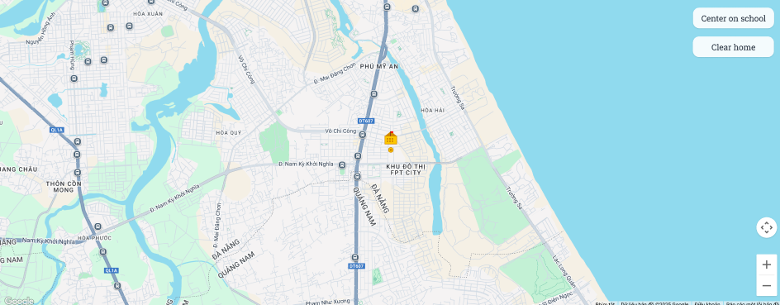
Figure 86:Trace All Vehicle’s Trip
Function Details:
Validation:
● Location data must be valid
● Vehicle data must be available
Business Rules:
● Only active vehicles are displayed by default
● Real-time location updates are provided
Functionalities
Normal case:
1. Admin navigates to Vehicle Trip Tracking page
2. System loads all active vehicles and their trips
3. System displays real-time location data on map
4. Admin can filter vehicles by status or trip type
5. Admin can track individual vehicles
6. Admin can view detailed trip information
7. System auto-refreshes data at configured intervals
Abnormal case:
1. If no vehicles found: System shows message "No vehicles available for tracking"
2. If location data unavailable: System shows warning "Location data temporarily unavailable"

3.11 Notifications

3.11.1 View Parent's Notification
Function trigger: Parent clicks on "Notifications" menu item or notification bell icon in the Parent Dashboard.
Function description:
Actors: Parent
Purpose: Display all notifications relevant to parents including trip updates, payment reminders, schedule changes, and system announcements.
Data Processing:
1. Retrieve parent's notifications from database
2. Filter notifications by relevance and priority
3. Sort notifications by date (newest first)
4. Mark notifications as read when viewed
5. Format notifications for mobile-friendly display
Screen layout:
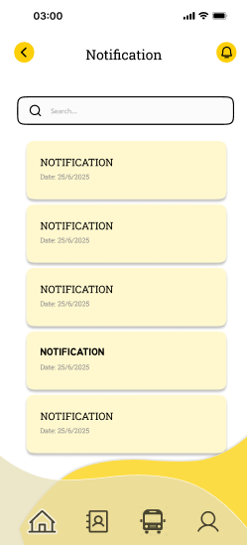
Figure 87:View Parent's Notification
Function Details:
Validation:
● User must be authenticated Parent
Business Rules:
● Unread notifications are highlighted
● Only parents can view their own notifications
Functionalities
Normal case:
1. Parent navigates to Notifications page
2. System loads parent's notifications
3. System displays notifications with unread count
4. Parent can filter notifications by type or status
5. Parent can mark notifications as read
6. Parent can take actions directly from notifications
7. Parent can access notification settings
Abnormal case:
1. If the user is not a Parent: System shows error "Access denied. Parent privileges required"
2. If no notifications found: System shows message "No notifications found"

3.11.2 View DriverNotification
Function trigger: Driver clicks on "Notifications" menu item or notification bell icon in the Driver Dashboard.
Function description:
Actors: Driver
Purpose: Display all notifications relevant to drivers including trip assignments, schedule changes, vehicle updates, and system announcements.
Data Processing:
1. Retrieve driver's notifications from database
2. Filter notifications by driver's assigned routes and trips
3. Sort notifications by date (newest first)
4. Mark notifications as read when viewed
5. Format notifications for mobile-friendly display
Screen layout:
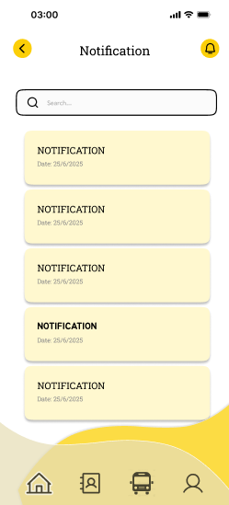
Figure 88:View Driver’s Notification
Function Details:
Validation:
● User must be authenticated Driver
Business Rules:
● Unread notifications are highlighted
● Only drivers can view their own notifications
Functionalities
Normal case:
1. Driver navigates to Notifications page
2. System loads driver's notifications
3. System displays notifications with unread count
4. Driver can filter notifications by type or status
5. Driver can mark notifications as read
6. Driver can take actions directly from notifications
7. Driver can access notification settings
Abnormal case:
1. If the user is not a Driver : System shows error "Access denied. Driver privileges required"
2. If no notifications found: System shows message "No notifications found"

3.11.3 View Supervisor’s Notification
Function trigger: Supervisor opens the notification section from the dashboard or menu.
Function description:
Actors: Supervisor
Purpose: Allow supervisors to view all notifications related to their assigned trips, students, or operational updates, ensuring timely awareness and response.
Data Processing:
- Supervisor navigates to the notification page.
- The system retrieves all notifications associated with the supervisor, including alerts about student absences, schedule changes, trip delays, or special instructions.
- Notifications are displayed in chronological order, with unread notifications highlighted.
- Supervisor can mark notifications as read or view details for more information.
Screen layout:
Figure 89:View Supervisor’s Notification
Function Details:
Validation:
- Supervisor must be logged in.
- Only notifications relevant to the supervisor’s assigned trips or role are displayed.
Business Rules:
- Notifications include trip updates, student attendance alerts, incident reports, or system messages.
- Notifications should be timestamped and indicate the sender/source.
- Supervisor can filter or search notifications based on date, type, or trip.
- Notifications must be marked as read after viewing to avoid repeated alerts.
Functionalities
Normal case:
- Supervisor opens the notification section.
- The system retrieves and displays all relevant notifications.
- The supervisor reads notifications and takes necessary action.
- The system marks notifications as read if viewed.
Abnormal case:
- If no notifications exist:
→ System displays message: "No notifications available."
- If the system fails to retrieve notifications:
→ System shows error: "Unable to load notifications. Please try again later."
- If supervisor attempts to access notifications for trips not assigned:
→ System shows error: "Access denied to notifications for this trip."

3.12 Pickup/Drop-off Address Management

3.12.1 Select/Search Location
Function trigger: Parent starts the shuttle service registration process.
Function description:
Actors: Parent
Purpose: Allow parents to search for and select a valid pickup/drop-off location during registration.
Data Processing:
- Parent enters keywords or browses the list of available locations.
- The system displays matching pickup/drop-off points.
- The parent selects a desired location for registration.
- The system stores the selected location as part of the registration request.

Screen layout:
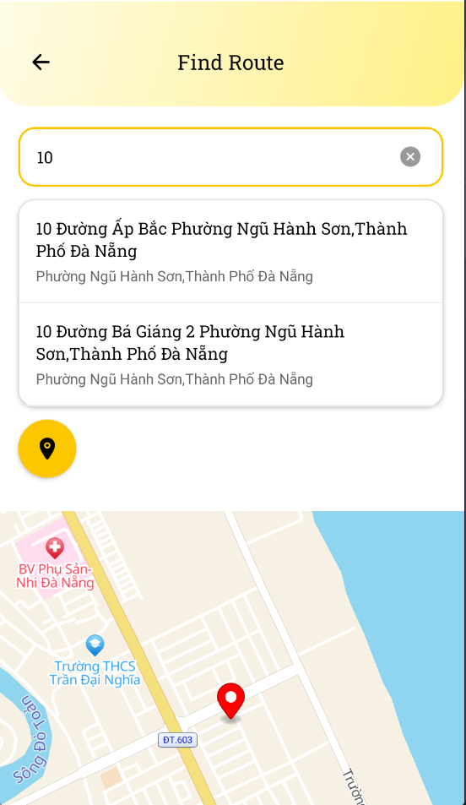
Figure 34: Select/Search Location
Function Details:
Validation:
● The selected location must exist in the system’s location list.
● Parents must choose exactly one pickup and/or drop-off location (depending on service type).
Business Rules:
● Only locations approved by the school can be selected.
● Invalid or unavailable locations cannot be used for registration.

Functionalities
Normal case:
- Parent searches for a location.
- The system displays valid results.
- The parent selects a location and continues registration.

Abnormal case:
- If no results found: System shows error ("No matching locations found.").
- If the parent tries to continue without selecting a location: System shows error ("Please select a location.").
- If the location becomes unavailable: System shows error ("Selected location is no longer available.").

3.13 Incident Reporting

3.13.1 Report Incidents
Function trigger:Driver observes or is informed of an incident during a shuttle trip and selects the option to report it in the system.
Function description:
Actors: Driver
Purpose: Allow drivers to report any incidents during shuttle operations, such as student misbehavior, vehicle issues, delays, or emergencies, to ensure proper documentation and timely action.
Data Processing:
- The driver opens the “Report Incidents” section during or after a trip.
- The driver selects the trip and bus related to the incident.
- The driver enters incident details, including type, description, time, and location.
- The system validates the input and saves the incident report.
- Notifications are sent to the supervisor, admin, and, if necessary, parents.
- Incident reports are logged in the system for future reference and follow-up actions.
Screen layout:
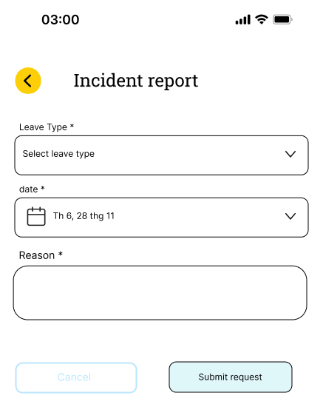
Figure 92: Report Incidents
Function Details:
Validation:
- The driver must be logged in.
- Trip must be active or within a valid reporting timeframe.
- Incident details (type, description, time) must be provided.
Business Rules:
- Incident reports must be timestamped and linked to the driver, bus, and trip.
- Incidents may include categories such as: student behavior, traffic/road issues, vehicle problems, or emergencies.
- Reports must trigger notifications to the appropriate parties.
- Drivers cannot submit duplicate incident reports for the same event.
Functionalities
Normal case:
- The driver opens the incident report interface.
- The driver selects the trip and bus.
- The driver enters incident details and submits the report.
- The system validates and saves the report.
- Notifications are sent to the supervisor/admin/parent as required.
- The system confirms successful submission to the driver.
Abnormal case:
- If required fields are missing:
→ System shows error: "Please fill in all required incident details."
- If trip is invalid or completed beyond allowed reporting time:
→ System shows error: "Incident cannot be reported for this trip."
- If the system fails to save the report:
→ System shows error: "Unable to submit incident report. Please try again."
- If notification delivery fails:
→ System logs the issue and displays: "Report submitted, but notifications could not be delivered."

3.14 Reporting

3.14.1 View Revenue
Function trigger: Admin clicks on the "Statistics" menu item and selects the "Revenue" tab.
Function description:
Actors: Admin
Purpose: Display comprehensive revenue statistics including monthly/yearly reports, payment trends, and financial analytics.
Data Processing:
1. Retrieve payment and revenue data from database
2. Calculate monthly and yearly revenue totals
3. Analyze payment trends and patterns
4. Generate revenue reports by service type
5. Format data for visual display and export
Screen layout:
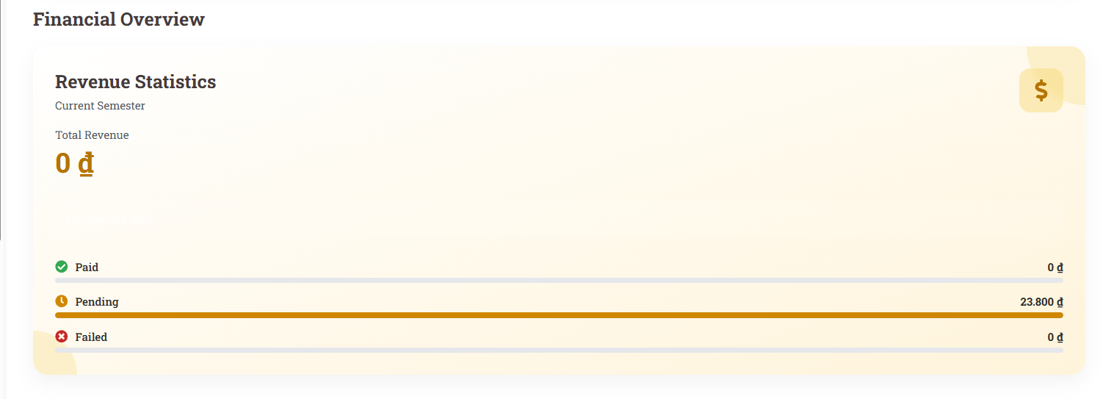
Figure 93:View Revenue
Function Details:
Validation:
● User must be authenticated Admin
● Date range must be valid
Business Rules:
● Only Admin can view revenue statistics
● Revenue data is calculated in real-time
Functionalities
Normal case:
1. Admin navigates to Revenue Statistics page
2. System loads revenue data for selected period
3. System displays comprehensive revenue overview
4. Admin can view revenue breakdown by service type
5. Admin can analyze payment method trends
6. Admin can export or print revenue reports
Abnormal case:
1. If the user is not Admin: System shows error "Access denied. Admin privileges required"
2. If no revenue data found: System shows message "No revenue data available for selected period"

3.14.2 Generate daily/monthly reports
Function trigger: Admin selects the option to generate attendance, trip, or payment reports for a specific day, week, or month from the reporting dashboard.
Function description:
Actors: Admin
Purpose: Allow administrators to generate detailed daily or monthly reports related to shuttle operations, including student attendance, trip completion, incidents, and payments, to support monitoring, decision-making, and record-keeping.
Data Processing:
- Admin selects report type (attendance, trip, payment, incident) and period (daily, monthly).
- The system retrieves relevant data from the database for the selected period.
- The system processes and compiles the data into a structured report format, including summaries, totals, and key metrics.
- The report is displayed on-screen and can be exported to file formats such as PDF or Excel.
- Generated reports are logged for auditing purposes.
Screen layout:
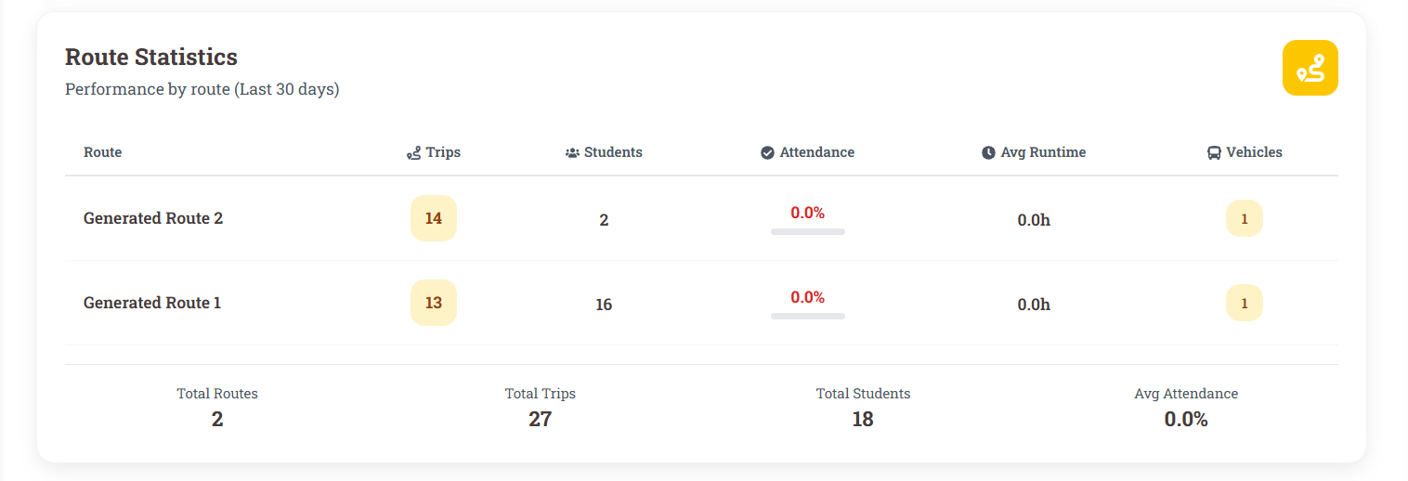
Figure 94:Generate daily/monthly reports
Function Details:
Validation:
- Admin must be logged in with report access privileges.
- Selected report type and period must be valid.
- The system must have sufficient data for the selected period.
Business Rules:
- Reports may include, but are not limited to:
  - Attendance summaries for each bus/trip or student.
  - Trip completion status and logs.
  - Incidents reported during trips.
  - Payment summaries and totals.
- Reports must display both detailed and summary information.
- Exported files should maintain data accuracy and formatting.
- Historical reports must be preserved for auditing.

Functionalities
Normal case:
- Admin selects report type and period.
- The system retrieves relevant data and generates the report.
- The system displays the report on-screen and provides options to export.
- Admin reviews and downloads the report if needed.
- The system logs the report generation activity.
Abnormal case:
- If selected period has no data:
→ System shows message: "No data available for the selected period."
- If invalid report type is selected:
→ System shows error: "Invalid report type selected."
- If system fails to generate report:
→ System shows error: "Unable to generate report. Please try again."
- If export fails:
→ System logs the issue and displays: "Report generated but export failed."

3.14.3 View statistics
Function trigger: Admin opens the “Statistics” section from the dashboard to review operational metrics and performance indicators.
Function description:
Actors: Admin
Purpose: Allow administrators to view aggregated statistics and key performance indicators (KPIs) related to shuttle operations, student attendance, trips, and payments for informed decision-making.
Data Processing:
- Admin selects the type of statistics to view (e.g., attendance rates, trip completion, vehicle utilization, payment collection).
- The system retrieves and aggregates relevant data from the database.
- The system calculates metrics such as totals, averages, percentages, and trends.
- Statistics are displayed in graphical (charts, graphs) and tabular formats.
- Admin may filter statistics by period (daily, weekly, monthly) or by bus, route, or school.
Screen layout:
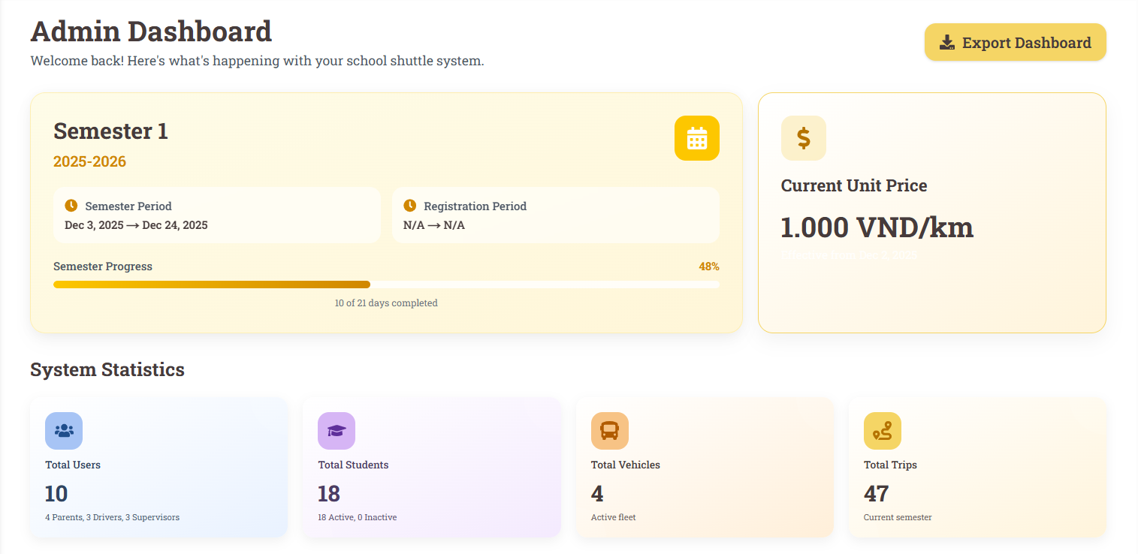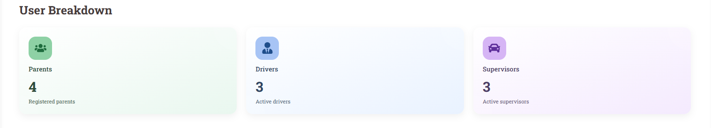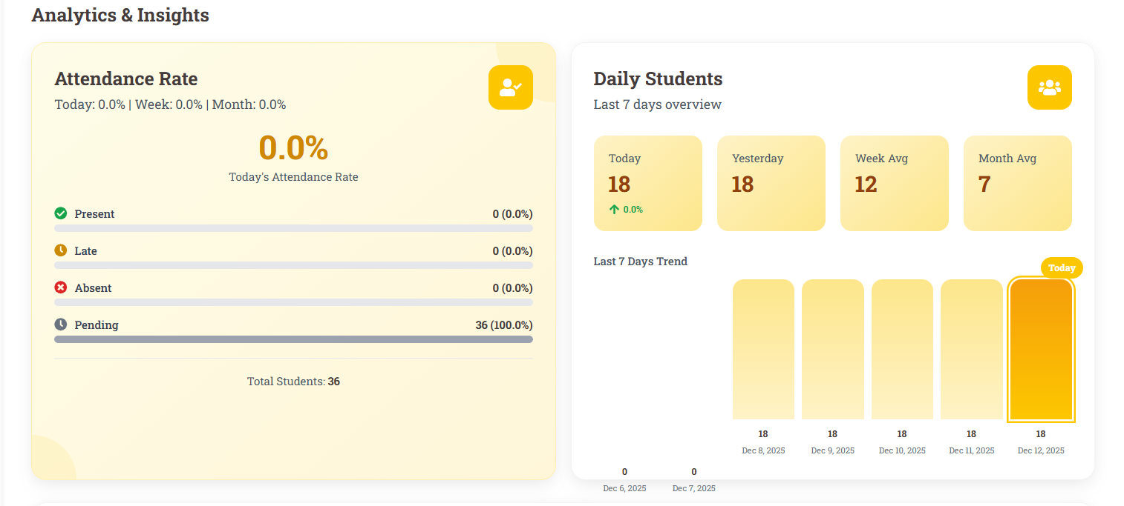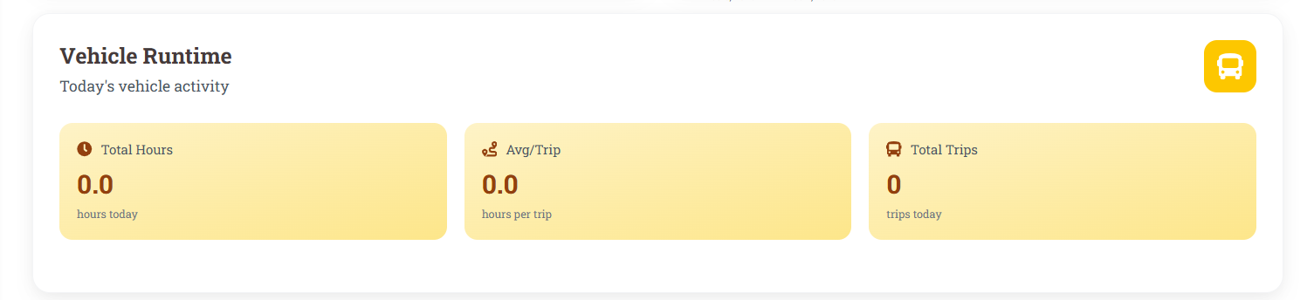
Figure 95: View statistics
Function Details:
Validation:
- Admin must be logged in.
- Selected statistical period and type must be valid.
- Data must exist for the selected filters.
Business Rules:
- Statistics must be accurate, aggregated from all relevant trips, students, and payments.
- The system must display both detailed and summary views.
- Graphs and charts must update dynamically based on filter selection.
- Historical data should be preserved for comparisons and trend analysis.

Functionalities
Normal case:
- Statistics must be accurate, aggregated from all relevant trips, students, and payments.
- The system must display both detailed and summary views.
- Graphs and charts must update dynamically based on filter selection.
- Historical data should be preserved for comparisons and trend analysis.
Abnormal case:
- If no data exists for the selected period or filters:
→ System shows message: "No data available for the selected period or criteria."
- If invalid filter or statistical type is selected:
→ System shows error: "Invalid selection. Please choose a valid statistics type and period."
- If system fails to retrieve or calculate data:
→ System shows error: "Unable to load statistics. Please try again later."

3.15 Audit Logs

3.15.1 View historical logs
Function trigger:Admin opens the “Historical Logs” section from the dashboard or system management menu to review past system activities.
Function description:
Actors: Admin
Purpose: Allow administrators to access detailed historical logs of system activities, including user actions, data changes, and operational events, for monitoring, auditing, and troubleshooting purposes.
Data Processing:
- Admin selects the date range or specific filters (e.g., user, action type, trip, student) for the logs.
- The system retrieves all relevant log entries from the database, including:
  - User actions (login, logout, create/update/delete records)
  - System events (errors, alerts, warnings)
  - Trip and attendance activities
  - Payment and transaction records
- Logs are displayed in chronological order with relevant details: user, action, target entity, timestamp, and result.
- Admin can search, filter, and sort the logs.
- Logs can be exported to files (CSV, PDF) for offline review or auditing.
Screen layout:
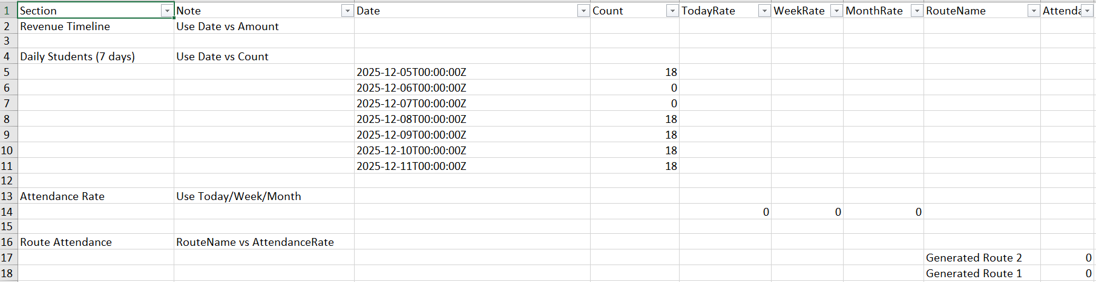
Figure 95:View historical logs
Function Details:
Validation:
- Admin must be logged in.
- Only authorized admins with log access privileges can view historical logs.
- Filters must be valid (e.g., date range, user, action type).
Business Rules:
- All system actions must be logged automatically.
- Logs must be immutable to prevent tampering.
- Historical logs must include sufficient detail for auditing: timestamp, user ID, action type, affected entity, result/status.
- Exported logs must retain original information and formatting.
- Logs must be preserved for a defined retention period according to school policy.
Functionalities
Normal case:
- Admin navigates to the Historical Logs section.
- Admin selects date range and filters.
- The system retrieves and displays log entries in chronological order.
- Admin can view details of each log entry.
- Admin may export logs to a file for further analysis.
Abnormal case:
- If no logs exist for the selected filters:
→ System shows message: "No logs available for the selected criteria."
- If filters are invalid or improperly formatted:
→ System shows error: "Invalid filter selection."
- If system fails to retrieve log data:
→ System shows error: "Unable to load historical logs. Please try again later."
- If export fails:
→ System logs the issue and displays: "Logs displayed, but export failed."

3.15.2 Export logs to file
Function trigger: Admin selects the option to export historical or operational logs to a file from the “Historical Logs” or reporting section.
Function description:
Actors: Admin
Purpose: Allow administrators to export system logs into file formats (e.g., CSV, PDF, Excel) for offline review, auditing, or record-keeping.
Data Processing:
- Admin navigates to the “Historical Logs” or “Logs” section.
- Admin selects filters such as date range, user, action type, trip, or student.
- Admin selects the export file format (CSV, PDF, Excel).
- The system validates the selected filters and retrieves the corresponding log entries.
- The system generates a file in the chosen format containing all selected log entries.
- Admin downloads the file for offline access or sharing.
Screen layout:
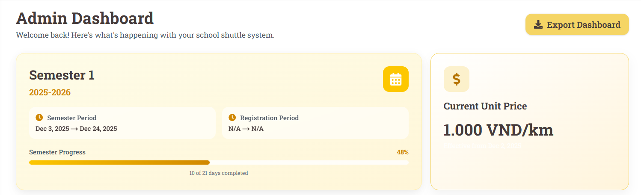
Figure 96:Export logs to file
Function Details:
Validation:
- Admin must be logged in and have export privileges.
- Selected filters must be valid (e.g., valid date range, user, action type).
- Only logs within the retention period can be exported.
Business Rules:
- Exported files must contain the same information as displayed in the system logs, including timestamp, user ID, action, target entity, and result/status.
- The system should prevent exporting excessively large datasets that may cause performance issues.
- Exported files must preserve data integrity and formatting.
- All export actions must be logged with admin ID, timestamp, and filters used.
Functionalities
Normal case:
- Admin selects the logs to export using filters.
- Admin chooses the file format (CSV, PDF, Excel).
- The system retrieves relevant log data and generates the file.
- Admin downloads the file successfully.
- System logs the export activity for auditing purposes.
Abnormal case:
- If selected filters return no logs:
→ System shows message: "No logs available for export with the selected criteria."
- If filters are invalid:
→ System shows error: "Invalid filter selection."
- If system fails to generate the file:
→ System shows error: "Unable to export logs. Please try again later."
- If download fails:
→ System shows error: "Export completed, but file download failed."

3.16 School System Configuration

3.16.1 View School Information
Function trigger: Admin navigates to the School Information page or clicks "View School Info" menu item.
Function description:
Actors: Admin
Purpose: Display comprehensive school information including contact details, academic policies, transportation settings, and system configuration.
Data Processing:
1. Retrieve school information from database
2. Load academic year and calendar information
3. Calculate transportation statistics
4. Load system configuration settings
5. Format data for comprehensive display
Screen layout:

Figure 97:View School Information

Function Details:
Validation:
● School information must exist in database
Business Rules:
● All information is displayed in real-time
● School information is displayed in read-only mode
Functionalities
Normal case:
1. Admin navigates to School Information page
2. System loads comprehensive school information
3. System displays basic information, academic details, and transportation settings
4. System shows system configuration and emergency contacts
5. Admin can edit information by clicking "Edit School Information"
Abnormal case:
1. If the user is not Admin: System shows error "Access denied. Admin privileges required"
2. If school information not found: System shows error "School information not found"

3.16.2 Update School Information
Function trigger: Admin clicks on the "Edit School Information" button in the School Information page.
Function description:
Actors: Admin
Purpose: Allow administrators to modify comprehensive school information including contact details, academic policies, transportation settings, and system configuration.
Data Processing:
1. Load existing school information for editing
2. Validate updated school information
3. Check for conflicts with existing data
4. Validate contact information and formats
5. Update school data in database
Screen layout:
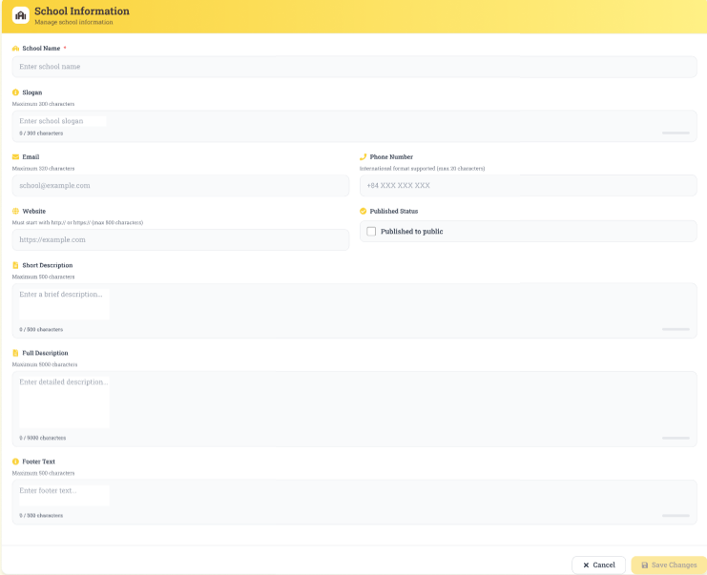
Figure 98: Update School Information
Function Details:
Validation:
● School name is required and must be unique
Business Rules:
● Changes to system configuration may require system restart
● School name and code must be unique within the system
Functionalities
Normal case:
1. Admin clicks "Edit School Information" button
2. System loads school information in edit mode
3. Admin modifies school information across all sections
4. System validates all changes
5. System checks for conflicts with existing data
6. School information is updated successfully
7. Changes are logged for audit purposes
8. Admin is redirected to school information page with message "School information updated successfully"
Abnormal case:
1. f school code already exists: System shows error "School code already exists"
2. If school name already exists: System shows error "School name already exists"

3.16.3 Update school’s logo/images
Function trigger: Admin selects the option to update school logos or images from the school profile or settings page.
Function description:
Actors: Admin
Purpose: Allow administrators to upload, replace, or manage school logos and images displayed in the system or on reports.
Data Processing:
- Admin navigates to the school profile or settings section.
- Admin selects “Update Logo/Image” and uploads a new file.
- The system validates the file type, size, and format.
- The system saves the new logo/images and replaces the previous version.
- The system displays confirmation and updates all relevant screens or documents.
Screen layout:
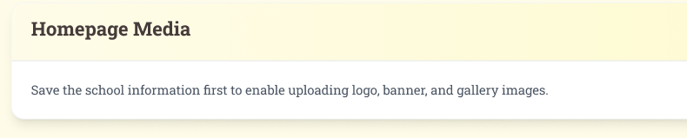
Figure 99: Update school’s logo/images
Function Details:
Validation:
- File format must be supported (e.g., PNG, JPG).
- File size must be within system limits.
- Admin must be logged in and authorized.
Business Rules:
- Only one logo is displayed per school.
- Images should maintain resolution and aspect ratio standards.
- All updates must be logged for auditing.
Functionalities
Normal case:
- Admin navigates to School Profile → Logo/Images.
- Admin clicks the “Update Logo/Image” button.
- The system opens a file selection dialog.
- Admin selects a valid file (PNG/JPG, <5MB) and clicks Upload.
- System validates file type and size.
- The system saves the new logo/image, replaces the old one, updates all relevant screens, and displays confirmation: “Logo updated successfully.”
- System logs the action with Admin ID, timestamp, and file name
Abnormal case:
- Admin selects an invalid file (wrong format or too large) → System displays error: “Invalid file type or size.”
- Admin is not logged in or lacks permission → System displays: “Access denied.”
- System fails to save the file → System displays: “Unable to update logo. Please try again.”

3.16.4 Update school’s location
Function trigger: Admin selects the option to update the school’s address or geographic location.
Function description:
Actors: Admin
Purpose: Ensure the school’s address and location are current for accurate route planning and notifications.
Data Processing:
- Admin opens the school profile section.
- Admin updates address fields or selects new coordinates on a map.
- The system validates the location.
- The system saves the updated location and propagates changes to dependent modules (routes, trips).
Screen layout:
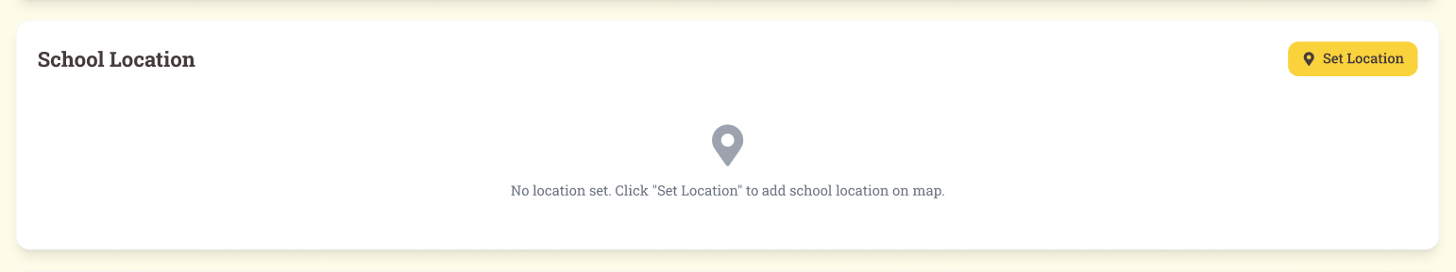
Figure 100: Update school’s location
Function Details:
Validation:
- Admin must be logged in and authorized.
- Location must be within valid geographic boundaries.
Business Rules:
- Changes affect route planning and cost calculations.
- All updates must be logged.
Functionalities
Normal case:
- Admin navigates to School Profile → Location.
- Admin edits address fields or selects a new location on the map.
- Admin clicks Save/Update.
- The system validates the new location against valid geographic boundaries.
- The system updates the school location, propagates changes to dependent modules (routes, trips), and displays confirmation: “School location updated successfully.”
- System logs the update with Admin ID, timestamp, and new coordinates/address.
Abnormal case:
- Admin enters invalid location → System displays: “Invalid location. Please select a valid area.”
- Admin is not logged in or lacks permission → System displays: “Access denied.”
- System fails to save location → System displays: “Unable to update school location. Please try again.”

3.16.5 Create unit price
Function trigger: Admin selects the option to create a new unit price for shuttle service.
Function description:
Actors: Admin
Purpose: Define pricing rules for school routes based on distance, pickup points, or other policies.
Data Processing:
Admin opens the pricing management section.
Admin enters details: route, distance range, price, effective period.
System validates input.
The system saves the new unit price to the database.
Screen layout:
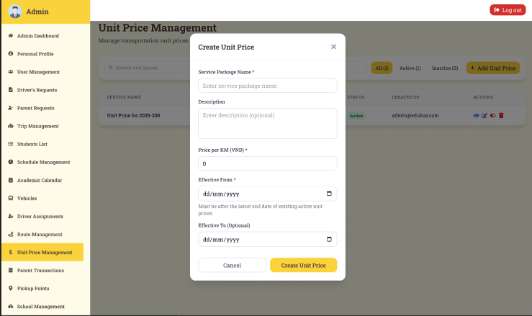
Figure 101: Update School Information
Function Details:
Validation:
- Admin must be logged in.
- Price must be numeric and greater than zero.
- Effective period must be valid.
Business Rules:
- Prices cannot overlap for the same route/distance period.
- All changes must be logged.
Functionalities
Normal case:
- Admin navigates to Pricing Management → Create Unit Price.
- Admin enters route, distance range, price, and effective period.
- Admin clicks Save/Create.
- System validates inputs (price numeric and >0, effective period valid).
- The system saves the new unit price to the database.
- The system displays confirmation: “Unit price created successfully.”
- The system logs the action with Admin ID, timestamp, and unit price details.
Abnormal case:
- Admin enters invalid data → System displays: “Invalid input. Please check the price or period.”
- Overlapping price rules for the same route/distance → System displays: “Unit price overlaps with existing entry.”
- Admin is not logged in or lacks permission → System displays: “Access denied.”
- System fails to save → System displays: “Unable to create unit price. Please try again.”

3.16.6 Update unit price
Function trigger: Admin selects the option to modify an existing unit price.
Function description:
Actors: Admin
Purpose:Update pricing rules for a route/distance to reflect policy or cost changes.
Data Processing:
- Admin selects the unit price to update.
- Admin modifies details: price, distance, effective period.
- System validates updates.
- The system saves changes and logs the update.
Screen layout:
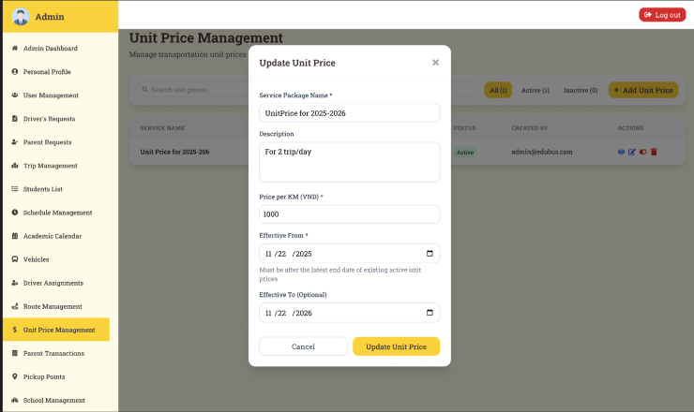
Figure 102: Update unit price
Function Details:
Validation:
- Admin must be logged in.
- Updated price and period must be valid.
Business Rules:
- Overlapping price rules are not allowed.
- All changes must be recorded for auditing.
Functionalities
Normal case:
- Admin navigates to Pricing Management → Update Unit Price.
- Admin selects the unit price to update.
- Admin modifies price, distance, or effective period.
- Admin clicks Save/Update.
- The system validates the updated information.
- The system saves changes, updates dependent calculations if necessary, and displays confirmation: “Unit price updated successfully.”
- The system logs the update with Admin ID, timestamp, and updated details.
Abnormal case:
- Admin enters invalid information → System displays: “Invalid input. Please check the price or period.”
- Overlapping price rules → System displays: “Update conflicts with existing unit price.”
- Admin is not logged in or lacks permission → System displays: “Access denied.”
- System fails to save → System displays: “Unable to update unit price. Please try again.”

3.16.7 Delete unit price
Function trigger: Admin selects the option to remove an existing unit price from the system.
Function description:
Actors: Admin
Purpose: Remove outdated or incorrect pricing rules to maintain accurate billing.
Data Processing:
- Admin selects the unit price to delete.
- System confirms deletion request.
- System deletes the entry and updates all dependent calculations (if necessary).
- System logs the deletion.
Screen layout:
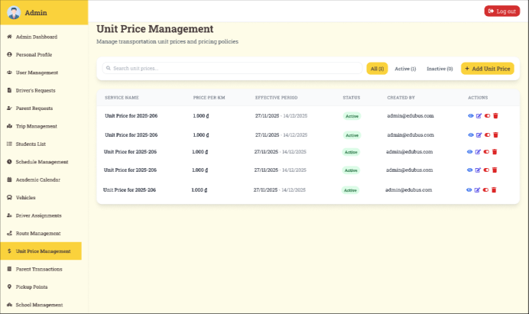
Figure 103: Delete unit price
Function Details:
Validation:
- Admin must be logged in.
- Unit price must exist.
- Deletion must not violate active trip/payment records.
Business Rules:
- Deleted prices cannot be used for new calculations.
- All deletions must be logged with timestamp and admin ID.
Functionalities
Normal case:
- Admin navigates to Pricing Management → Delete Unit Price.
- Admin selects the unit price to delete.
- The system asks for confirmation: “Are you sure you want to delete this unit price?”
- Admin confirms deletion.
- The system checks that the unit price is not linked to active trips or payments.
- The system deletes the entry and displays confirmation: “Unit price deleted successfully.”
- System logs the deletion with Admin ID, timestamp, and deleted price details.
Abnormal case:
- Admin tries to delete a unit price linked to active trips/payments → System displays: “Cannot delete. Unit price is used in active records.”
- Admin is not logged in or lacks permission → System displays: “Access denied.”
- System fails to delete → System displays: “Unable to delete unit price. Please try again.”

4. Non-Functional Requirements

4.1 External Interfaces

4.1.1 Database Interfaces
- The system shall use SQL Server as the primary relational database, supporting spatial data through Entity Framework Core with NetTopologySuite.
- The system shall implement automatic connection retry with up to 5 attempts and exponential backoff (maximum delay of 10 seconds).
- The system shall also use a document-oriented database (MongoDB) for OTP storage and real-time data. GUID serialization shall follow a standardized format.

4.1.2 API Interfaces
- The system shall expose a REST API developed in ASP.NET Core Web API (.NET 8.0).
- The API shall provide standardized Swagger/OpenAPI documentation.
- Authentication shall be based on JWT tokens with a 15-minute validity for access tokens and 7 days for refresh tokens.
- The API shall support CORS for web clients (e.g., localhost:3000, 3001, 4200, 8080).
- The system shall support real-time communication via SignalR Hub, integrated with JWT authentication and user group management.

4.1.3 Frontend Interfaces
- The Web Application shall be developed using Next.js (TypeScript), with API request timeouts not exceeding 10 seconds.
- The Mobile Application shall be developed using React Native (Expo) and shall support cross-platform deployment (iOS/Android/Web).
- All frontend applications shall be responsive and ensure consistent performance across multiple screen resolutions.

4.1.4 External Service Interfaces
- The system shall integrate with SMTP for email delivery (port 587, TLS). Email sending shall be processed in a queue, supporting a maximum of 5 emails per batch, 2-second intervals, and up to 10,000 queued emails.
- The system shall support import and export of student data via Excel files (.xlsx), with validation of required fields before import.

4.2 Quality Attributes

4.2.1 Usability
Training Requirements:
- Admin users shall become proficient with the dashboard within 30–60 minutes of training.
- Parent and driver users shall become proficient with basic operations within 15–30 minutes.
Task Completion Times:
- Login: < 5 seconds
- Import of 1,000 students: < 2 minutes
- Schedule creation: < 3 minutes
- Trip management: < 1 minute per trip
UI/UX Standards:
- The system shall follow a Soft UI design system with rounded corners and Roboto Slab typography.
- The color scheme shall use yellow/cream primary and background tones, with dark brown text.
- The system shall support real-time form validation, skeleton loading states, clear error messages, responsive design, and touch-friendly mobile interactions.

4.2.2 Reliability
- Availability: The system shall maintain at least 99.5% uptime.
- Health Monitoring: The system shall provide health check endpoints
- Database Failover: The system shall support dual databases (SQL Server + MongoDB) with retry and backoff mechanisms.
- MTBF (Mean Time Between Failures):
- API services: ≥ 7 days
- Database services: ≥ 10 days
- Email services: ≥ 3 day
- MTTR (Mean Time To Repair):
- Critical issues: < 2 hours
- Major issues: < 8 hours
- Minor issues: < 24 hours
- Data Accuracy:
- Input validation shall be enforced for all user data and file uploads.
- Excel imports shall require validation of mandatory fields.
- JWT tokens shall be securely generated and validated.
- Defect Rate:
- Critical: 0 per 1000 LOC
- Major: < 2 per KLOC
- Minor: < 5 per KLOC

4.2.3 Performance
Response Time Requirements:
- Authentication API: < 2 seconds
- Student CRUD operations: < 1 second
- Trip queries: < 2 seconds
- Excel import (1,000 records): < 30 seconds
- File upload: < 10 seconds
- Web page load: < 3 seconds
- Navigation between views: < 200ms
Throughput and Capacity:
- The system shall support at least 500 concurrent users.
- Each API endpoint shall process at least 50 requests per second.
- The database shall support at least 200 queries per second.
- The SignalR hub shall support at least 200 concurrent connections.
- The email service shall process at least 5 emails every 2 seconds.
- The system shall support a minimum of 5,000 registered users, 2,000 students, 500 daily trips, 100 active schedules, and 1,000 daily notifications.
- Storage capacity shall be at least 10GB, with a daily growth rate not exceeding 100MB.
Resource Utilization:
- API server memory usage shall not exceed 1GB RAM under normal load.
- CPU utilization shall not exceed 60% under normal load.
- Database connection pool utilization shall not exceed 70%.
Monitoring and Scalability:
- The system shall provide structured logging, error tracking, and database query monitoring.
- The architecture shall support scalability via repository pattern, service layers, background services, and token refresh mechanisms.

5. Requirement Appendix

5.1 Business Rules

ID | Rule Definition
BR-001 | A student can only be recorded once per boarding or alighting event on a single trip.
BR-002 | Facial recognition must meet a minimum confidence level (e.g., ≥ 85%) to be accepted.
BR-003 | Each attendance event must log the date, time, GPS location, bus ID, and route ID.
BR-004 | A push notification is sent to the parent immediately after a successful check-in/out.
BR-005 | If face recognition fails after 3 attempts, manual check-in by the driver is allowed and logged.
BR-006 | All facial-recognition attendance logs must be stored for at least 6 months.
BR-007 | Each student can have only one active biometric face profile at any given time.
BR-008 | If a face matches multiple student profiles, the check-in will be blocked and flagged for review.
BR-009 | Users must correctly enter their current password to proceed with changing it.
BR-010 | The new password must contain at least 8 characters.
BR-011 | New password must include at least one uppercase letter, one lowercase letter, one number, and one special character.
BR-012 | The new password must be different from the current password.
BR-013 | Users must enter the new password twice, and both entries must match.
BR-014 | The account will be temporarily locked after 5 consecutive incorrect password attempts (duration: e.g., 10 minutes).
BR-015 | All password change events must be logged with user ID and timestamp for audit purposes.
BR-016 | Users can only view their own personal profile, not others'.
BR-017 | Only specific fields are editable (e.g., name, phone number); critical system fields (e.g ..., email, address) are locked.
BR-018 | All input fields must be validated before saving (e.g., valid email format, phone number length).
BR-019 | Updated email must be unique in the system and not already in use by another user.
BR-020 | Any profile changes must be recorded with a timestamp and user ID for audit purposes.
BR-021 | A parent can register only one active shuttle service per student at a time.
BR-022 | The system must display or send a confirmation message/email after successful registration.
BR-023 | A shuttle registration is not considered active until the payment is completed.
BR-024 | The system calculates the fee based on route distance or zones and appropriate tax. configured by the school.
BR-025 | Only one active image is allowed per student; new uploads will replace the previous one.
BR-026 | Parents can only view shuttle schedules for their registered children.
BR-027 | Parents can temporarily disable pickup for a given day before a configurable cutoff time (e.g., 1 hour before route start).
BR-028 | Parents can view vehicle details (plate number, type) assigned to their student’s route.
BR-029 | Parents can view the name, contact, and photo of the assigned driver for safety assurance.
BR-030 | Parents can only file one complaint about the completed trip.
BR-031 | Notifications are sent based on events (e.g., student boarded, delay, no-show).
BR-032 | The system must keep a parent’s registration history for at least 12 months.
BR-033 | Parents can track the live location of the vehicle only during scheduled active routes.
BR-034 | The vehicle’s GPS data is refreshed every 30 seconds for display accuracy.
BR-035 | Relocation requests must be reviewed and approved by school admin before changes take effect.
BR-036 | Parents can only submit relocation requests for future shuttle trips
BR-037 | The system guide/help section must be accessible from the parent dashboard at all times.
BR-038 | Parents must fill in all required student information (name, birthdate, grade) before using shuttle services.
BR-039 | All edits to student data must pass validation checks (e.g., valid date of birth format).
BR-040 | Deleted student profiles are not permanently removed but flagged as inactive.
BR-041 | Parents cannot cancel or modify registrations for trips that have already occurred.
BR-042 | The system must show a refund policy before confirming shuttle payment.
BR-043 | The driver cannot confirm the trip ends before the last expected stop without an admin override.
BR-044 | Parents must verify email before accessing student registration.
BR-045 | Drivers can only view trip history and schedules for routes they are assigned to.
BR-046 | Drivers can only access trip history records for the past 30 calendar days.
BR-047 | Trip end confirmation is only allowed after all scheduled students are either checked in/out or marked absent.
BR-048 | Drivers can only view the status of leave or skip-stop requests submitted under their own account.
BR-049 | When a stop is skipped, an alert is immediately sent to the admin and dispatcher.
BR-050 | Leave requests must be submitted at least 12 hours before the next assigned trip, except in emergencies.
BR-051 | Drivers with pending or approved leave requests cannot be auto-assigned to new trips.
BR-052 | Manual student attendance entry must include a reason and be time-stamped.
BR-053 | Drivers can manually mark attendance no more than 3 times per trip to prevent abuse.
BR-054 | All route-related system notifications (e.g., parent cancel pickup) must be pushed in real-time to the driver's app.
BR-055 | Drivers must confirm receipt of critical alerts before proceeding (e.g., “route change”, “emergency”).
BR-056 | Drivers can view student boarding/alighting status only during active trips.
BR-057 | Past trip attendance summaries are viewable but not editable by drivers.
BR-058 | Every user account must have a unique and valid email address.
BR-059 | All user creation, updates, and bans must be logged with timestamp and admin ID.
BR-060 | Admin can search users by name, email, role, status, or registration date.
BR-061 | Admin is required to resolve or escalate complaints within 48 hours of submission.
BR-062 | Each student must have a system-generated unique identifier.
BR-063 | Deletion is blocked if the student is assigned to upcoming trips.
BR-064 | Revenue data is view-only and cannot be edited directly in the system.
BR-065 | Admin can filter revenue by time range, route, or vehicle for reporting purposes.
BR-066 | Each vehicle in the system must have a unique license plate number.
BR-067 | Vehicles assigned to active or future trips cannot be deleted.
BR-068 | Vehicle trip trace includes full logs of GPS coordinates, assigned driver, and route ID.
BR-069 | All charts and statistics must be based on the latest confirmed trip and attendance records.
BR-070 | Each trip must be assigned exactly one driver; overlapping assignments are not allowed.
BR-071 | Every approved or rejected driver request must include approver info and timestamp.
BR-072 | Admin can only assign drivers who are not on leave and have no overlapping schedules.
BR-073 | A vehicle cannot be scheduled for multiple trips that overlap in time.
BR-074 | Admin cannot edit or delete schedules once a trip has started.
BR-075 | A valid schedule must have a linked route and an assigned driver.
BR-076 | Each route must have a unique route code or name within the school.
BR-077 | Routes that are still tied to future schedules cannot be removed.
BR-078 | Route changes must be logged for audit tracking with editor and timestamp.
BR-079 | Students can only be allocated to vehicles if there are available seats.
BR-080 | A student may only be assigned to one active route at any given time.
BR-081 | Two routes cannot share the same start-end time with the same vehicle.
BR-082 | The driver must have uploaded and verified license info before being assigned.
BR-083 | Cannot assign more students to a vehicle than its maximum seating capacity.
BR-084 | Every schedule must define the departure and arrival time range.
BR-085 | Drivers with suspended accounts cannot be scheduled.

5.2 Common Requirements

ID | Rule Definition
CR-001 | The system must provide real-time GPS tracking accessible to parents, admins, and drivers.
CR-002 | The facial recognition system must achieve at least 95% accuracy in identifying students.
CR-003 | Push notifications must be sent to parents and admins for key events (e.g., boarding, alighting, delays).
CR-004 | The platform must support online payment integration for shuttle service reservations.
CR-005 | The application must support multiple languages to accommodate diverse school communities.
CR-006 | Vehicle schedules must be viewable and editable by admins with a 24-hour notice period.
CR-007 | The system must ensure data privacy by complying with local regulations (e.g., GDPR, if applicable).
CR-008 | The platform must ensure at least 95% system uptime and prevent unauthorized access or data leaks.
CR-009 | Payment transactions must use 256-bit encryption for security.
CR-010 | An audit trail must be maintained for all admin actions for a minimum of 2 years.
CR-011 | The system must implement role-based access control to restrict user permissions by roles.
CR-012 | The system must perform automated daily data backups stored securely for recovery.
CR-013 | The system must support responsive design across desktop, tablet, and mobile devices.
CR-014 | All pages must load in under 2 seconds under standard internet conditions.
CR-015 | The system must support cross-browser compatibility (Chrome, Firefox, Edge, Safari).
CR-16 | The system must support scheduled maintenance notifications and allow users to view system availability status.

5.3 Application Messages List
# | Message code | Message Type | Context | Content
1 | MSG01 | In line | Search result | No search results.
2 | MSG02 | In red, under the text box | Input-required fields | The * field is required.
3 | MSG03 | Toast message | Login failed | Incorrect username or password.
4 | MSG04 | Toast message | Register shuttle | Shuttle registration completed successfully.
5 | MSG05 | Toast message | Payment success | Payment completed successfully.
6 | MSG06 | Toast message | Payment fail | Payment failed. Please try again.
7 | MSG07 | Toast message | Upload student photo | Student photo uploaded successfully.
8 | MSG08 | Toast message | Face recognition success | Attendance recorded successfully.
9 | MSG09 | Toast message | Face recognition fail | Face not recognized. Please try again.
10 | MSG10 | Toast message | Manual attendance | Manual attendance recorded.
11 | MSG11 | Toast message | Schedule created | Shuttle schedule created successfully.
12 | MSG12 | Toast message | Schedule updated | Schedule updated successfully.
13 | MSG13 | Toast message | Driver assigned | Driver assigned to trip.
14 | MSG14 | Toast message | Report incident | Incident report submitted.
15 | MSG15 | Toast message | Submit complaint | Complaint sent successfully.
16 | MSG16 | Toast message | Password changed | Password updated successfully.
17 | MSG17 | Toast message | Password mismatch | New passwords do not match.
18 | MSG18 | Toast message | Max input length exceeded | Input exceeds maximum allowed length.

5.4 Other Requirements…

