

CAPSTONE PROJECT REPORT
Report 5 – Software Test Documentation

– DaNang, September 2025–
Table of Contents
I. Record of Changes 3
II. Testing Documentation 4
1. Scope of Testing 4
2. Test Strategy 4
2.1 Testing Types 4
2.2 Test Levels 4
2.3 Supporting Tools 5
3. Test Plan 5
3.1 Human Resources 5
3.2 Test Environment 5
3.3 Test Milestones 6
4. Test Cases 6
5. Test Reports 7
6. Test Units 9

I. Record of Changes
Date | A*  M, D | In charge | Change Description
22/10/2025 | A | NhiPTK, HuyNLQ, NguyetNTT, TrungNVT, KhoiVN | Add initial version
27/10/2025 | M | HuyNLQ | Update table of figures & tables
15/11/2025 | M | NguyetNTT, HuyNLQ | Update test cases
30/11/2025 | M | NguyetNTT, HuyNLQ | Update test cases
11/12/2025 | M | KhoiVN | Update test cases
14/12/2025 | M | NhiPTK, HuyNLQ, NguyetNTT, TrungNVT, KhoiVN | Latest update
*A - Added M - Modified D - Deleted

II. Testing Documentation

1. Scope of Testing
The scope of testing for our project includes testing all functions within the system and the user interface of the website. This means ensuring that all features are working as intended and that there are no issues or bugs that may affect the user experience. Additionally, security testing will also be conducted to identify any vulnerabilities or weaknesses in the system that could potentially be exploited by malicious actors. By conducting thorough testing across all aspects of the project, we can ensure that it is of the highest quality and meets the needs of all users.

2. Test Strategy
In this project, we only focus on functional testing, which verifies the software system in accordance with the requirements established during the requirement analysis stage.

2.1 Testing Types

Level | Purpose
Functional Testing | Test cases are created to test for bugs and quality of input and  examine the output without considering internal program structure.
User Interface Testing | Test for bugs and quality of user experience with developed UI system
Security Testing | Check all roles and permission of user when using this system

2.2 Test Levels

Type of Tests | Test Level
Type of Tests | Unit | Integration | System | Acceptance
Function testing | X | X | X | X
User interface testing |  |  | X | X
API testing | X | X

2.3 Supporting Tools

Purpose | Tool | Vendor/In-house | Version
Keep tracking detects | Excel | Microsoft
Test plan | Microsoft Word | Microsoft
Test case, test report | Microsoft Excel | Microsoft
Test Recoverage | VS Code (FE) / Visual Studio (BE) | Open Source / Microsoft | Lastest

3. Test Plan

3.1 Human Resources

Worker/Doer | Role | Specific Responsibilities/Comments
NhiPTK | Leader | Assign test task  Execute tests  Review test cases
HuyNLQ | Member | Execute tests  Review test cases
NguyetNTT | Member | Create test plan  Execute tests  Review test cases
TrungNVT | Member | Execute tests  Review test cases
KhoiVN | Member | Execute tests  Review test cases

3.2 Test Environment

Purpose | Tool | Provider | Version
View logs of web application | Chrome DevTools | Chrome
Test case management | Microsoft Excel | Microsoft
Manage API list and manual API testing | Postman | Postman
Backend | Visual Studio | Microsoft
Web application | Visual Studio Code | Microsoft

3.3 Test Milestones

Milestone Task | Start Date | End Date
Interaction 1: Testing planning for web application | 14/09 | 20/10
Create test plan | 15/09 | 01/10
Review test plan | 01/10 | 06/10
Create unit test | 14/09 | 13/10
Create test case | 14/09 | 20/10
Interaction 2: Execute tests for web applications | 21/10 | 29/10
Execute test for web applications | 21/10 | 29/10

4. Test Cases
Please refer to the following files for more details as they contain all written and completed test cases:
● Report5_Unit Test.xlsx
● Report5_Test Report.xlsx

5. Test Reports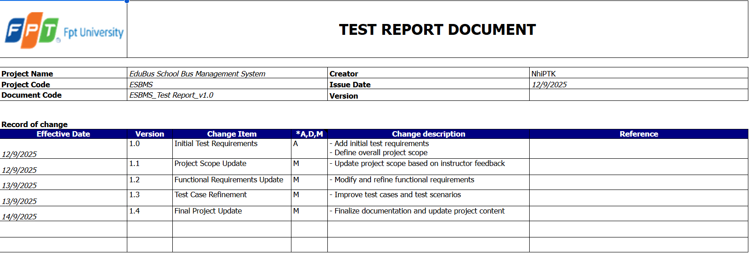
Figure 1. Report test Statics

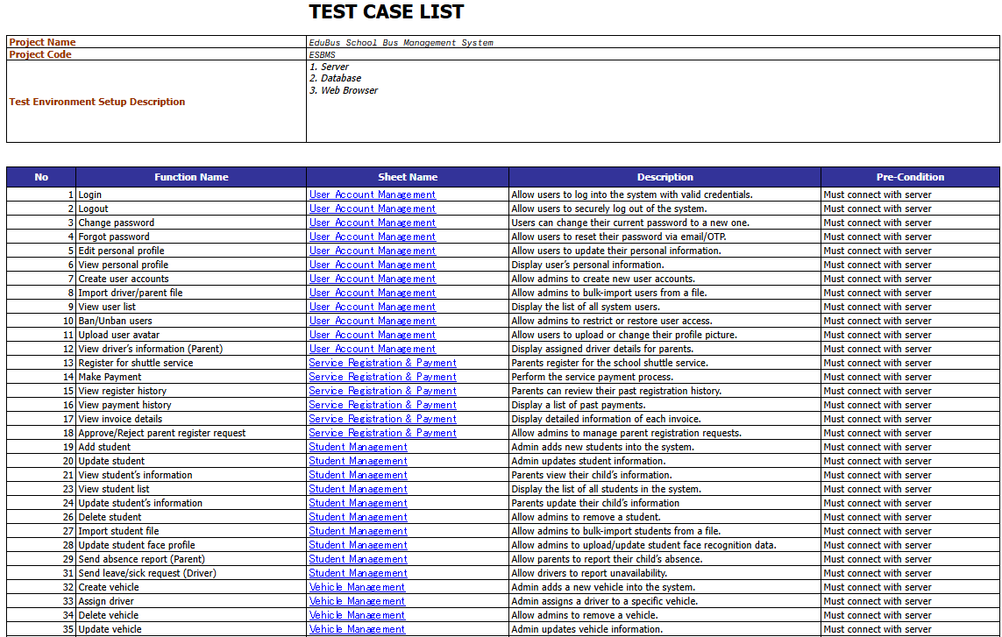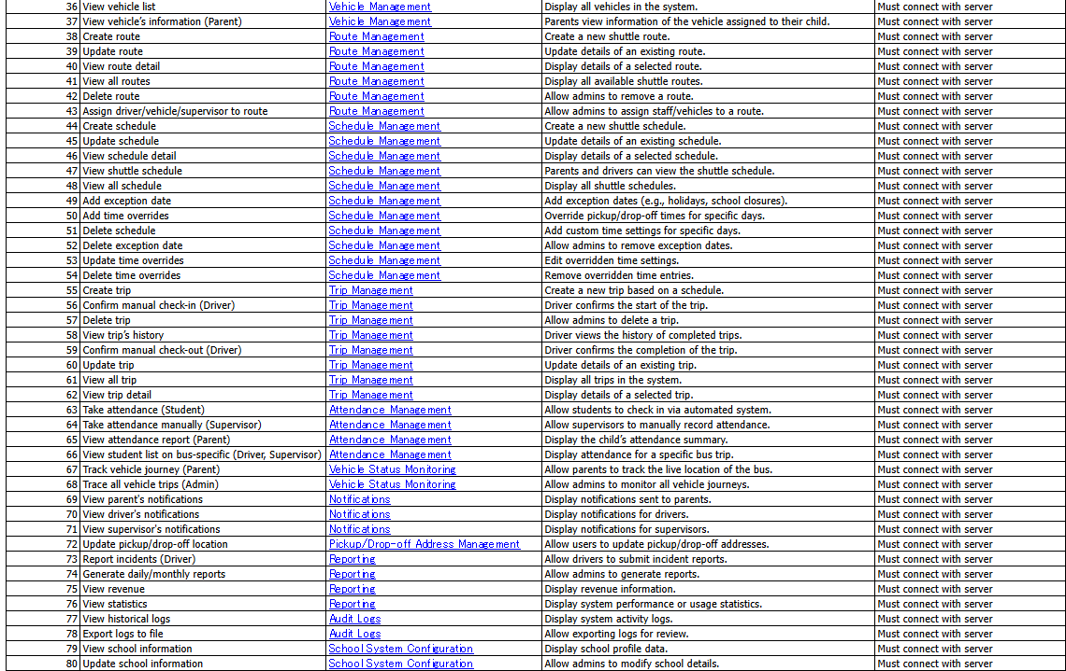
Figure 2. Report test Statics

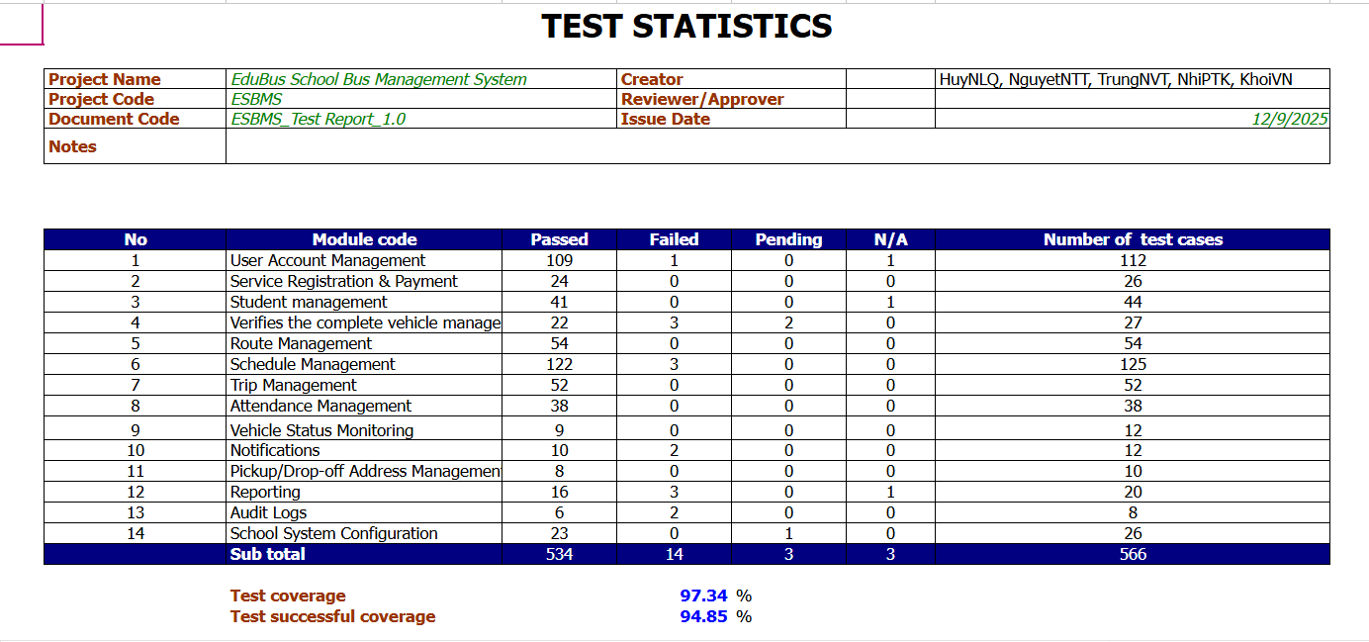
Figure 3. Report test Statics

6. Test Units
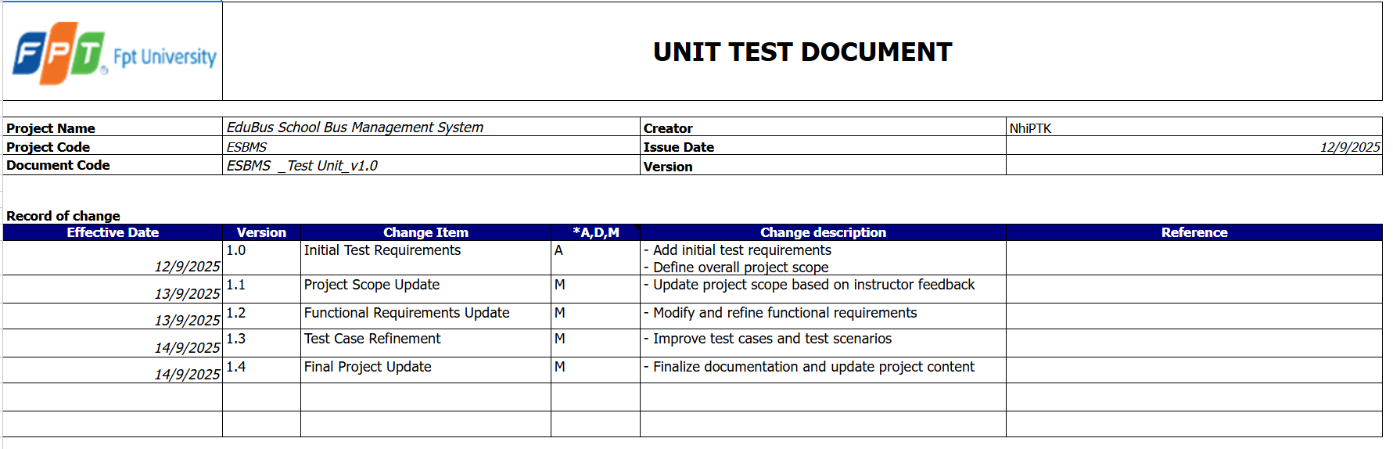
Figure 4. Unit test Statics

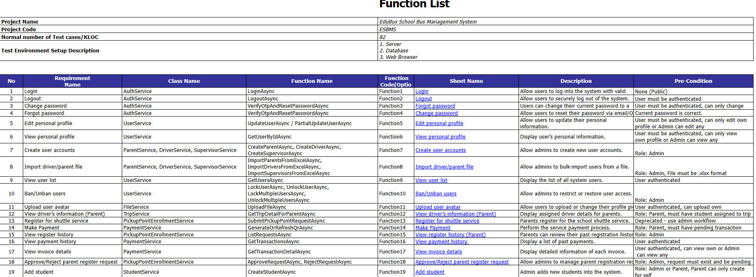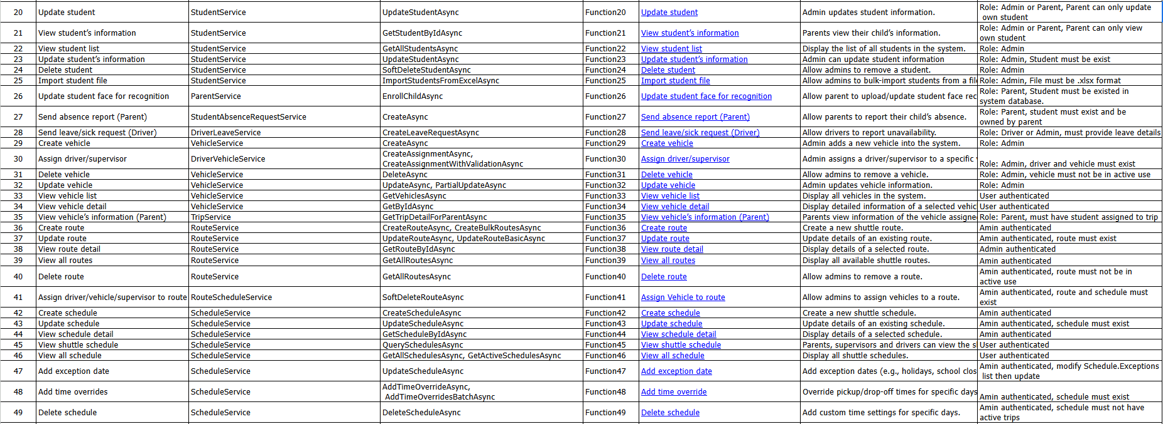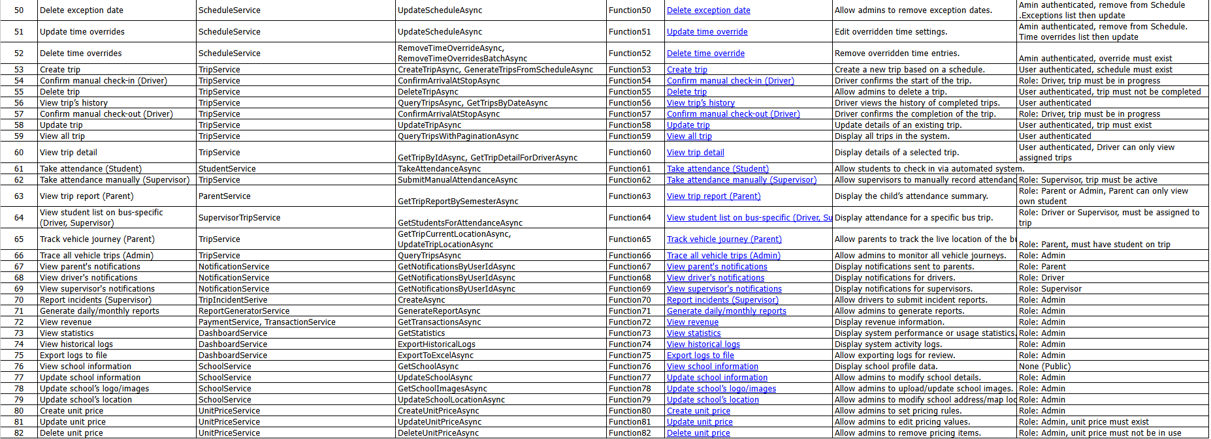
Figure 5. Unit test Statics

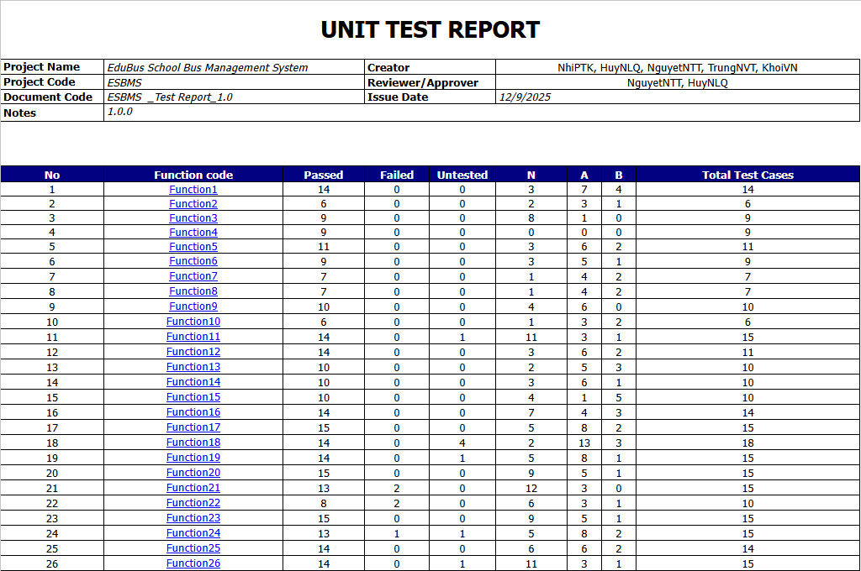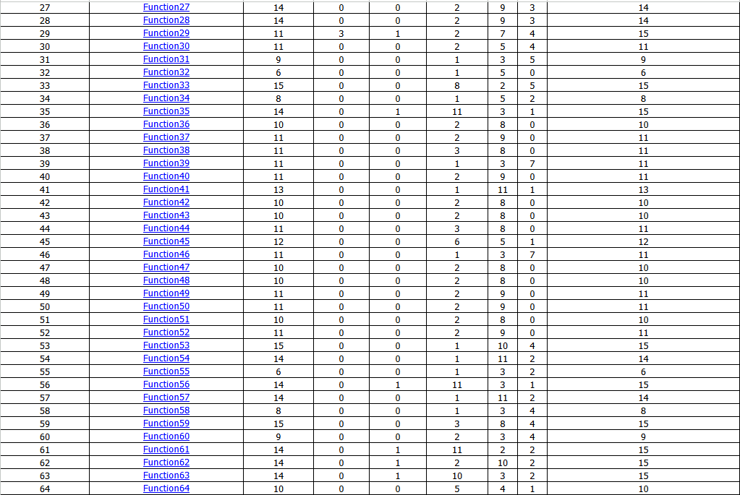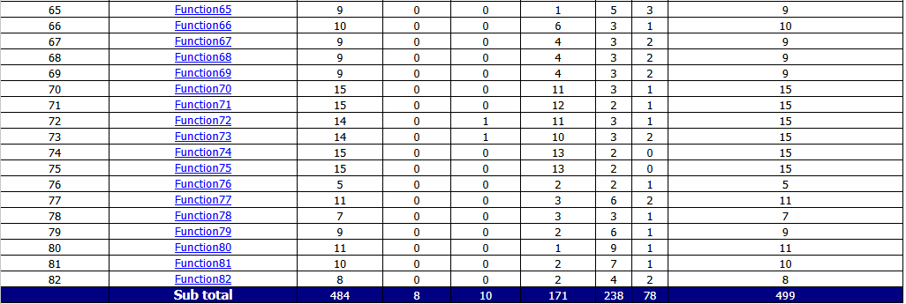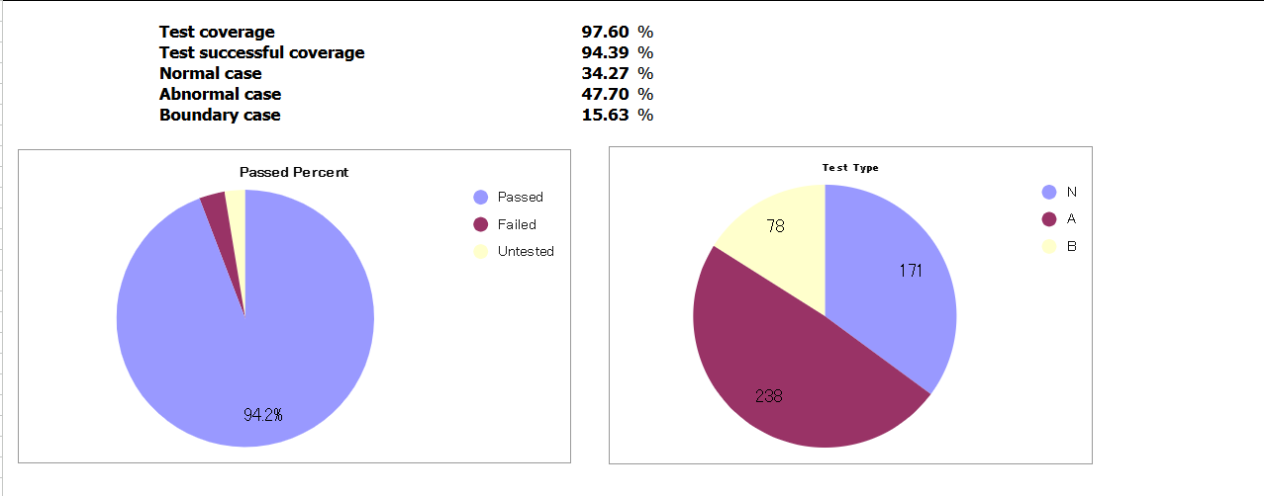
Figure 6. Unit test Statics

