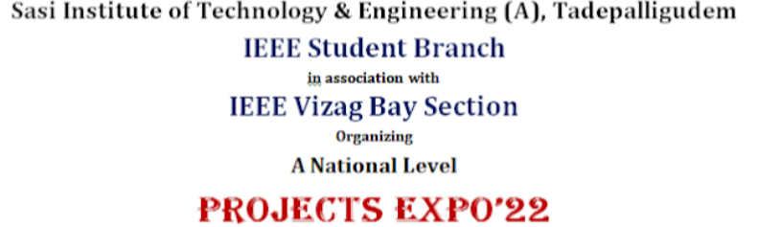

Project Id: **EXPO22SE064**

**BOOM LIFE**

Team Member 1 : TADI SUBHASH SAI SANDEEP REDDY

Team Member 2 : DATTI SAI KUMAR

Category : Smart Engineering

Problem Statement : Difficulty of choosing career path in education.

Department : CSE

Institute : Raghu Engineering College,Visakhapatnam

Contact Mail-id : [20981a4656@raghuenggcollege.in](mailto:20981a4656@raghuenggcollege.in) , 9441068764

**BRIEF DETAILS ABOUT THE PROJECT**

