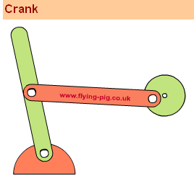
http://www.flying-pig.co.uk/mechanisms/pages/crank.html

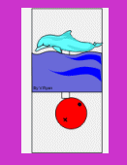 http://clc.esf.edu.hk/GroupHomepage.asp?GroupID=2492

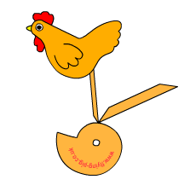 http://www.flying-pig.co.uk/mechanisms/pages/cam.html

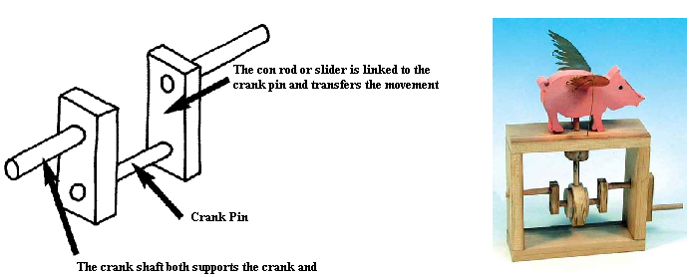
http://www.automata.co.uk/cranks.htm

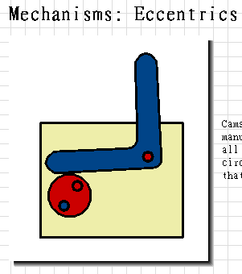
http://www.dtonline.org/apps/infopage/app?1&6&1&27&0&0

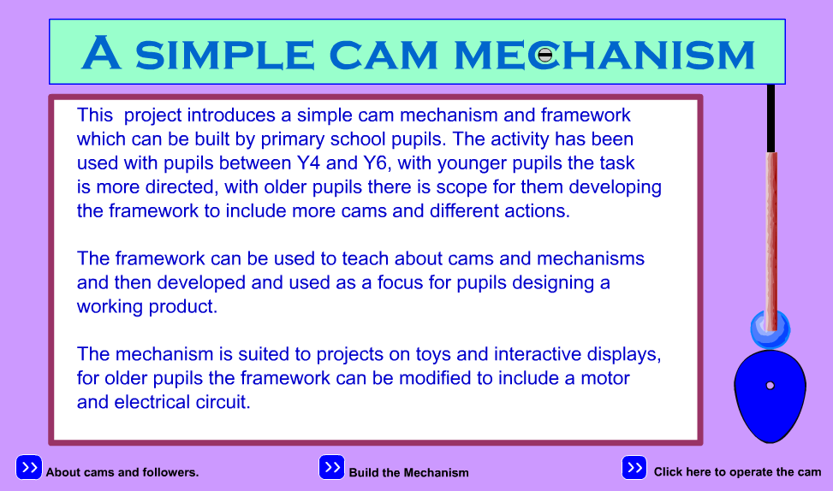
http://ngfl.northumberland.gov.uk/dt/cam/cam.html

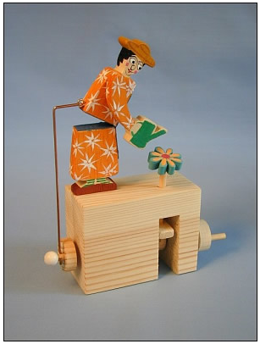
http://www.focuseducational.com/html/category.php/cid/7

