Course Report Project

Vaggelis Chasiotis - 20200101

21/03/2022

Course: CS230

Instructor: Dr. A. Astaras

**Outline**

* Project Description
* Menu Explanation
* Flowchart & Diagram
* References

**Project Description**

This project aims to create a menu with numerous options via which the user may read and alter baseball statistics acquired from a major league baseball team, notably the Boston Red Socks, by filtering and sorting. Furthermore, in addition to the base data in the file, the computer should be able to compute more valuable baseball statistics so that the user may obtain a better picture of the players’ performance throughout the year.

The menu should have at least 5 different options that go as follows:

1. Option 1 should read data from a file and display it on the screen as is (the data refers to the top 12 players of 2021 with the highest batting average).
2. Option 2 asks for user input of home runs that will be served as a threshold and will then display the players who have hit that number and above it.
3. Option 3 calculates two additional statistics, the home runs per game and the strikeouts per game and displays them on a new file
4. Option 4 allows the user to sort by any column, in the order they want (ascending or descending)
5. Option 5 is just an exit option

**Menu Explanation**

This is the interface of the Menu and its foundation is mainly done using arrays. This interface is going to appear every time the user finishes with using any of the options. It basically greats the user by providing the listed options, but there are some catches in the input in case a wrong character is typed on purpose or by mistake. Every option starts with a ‘thank you’ and a small description of what each option does in order to inform the user about what’s happening and then the menu appears once again.

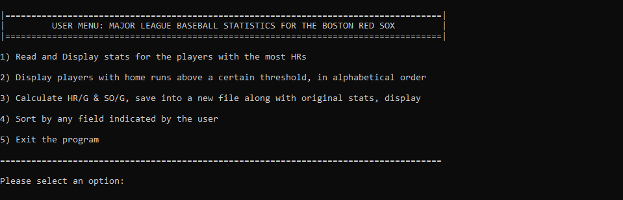

**Option 1:** This option is quite simple as the only requirement is to read data from a specific location and to just display them. so this is my personal layout preference.

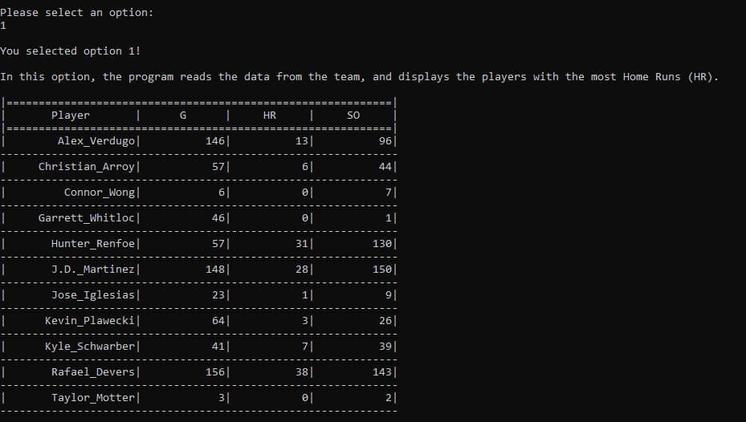

**Option 2:** For this option I just used the user’s input command and a catch in case he tries to put a different value than the one required, and the rest is just like in Option 1. In this case I used number 13 as a limit so it displays players with 13 and more homeruns.

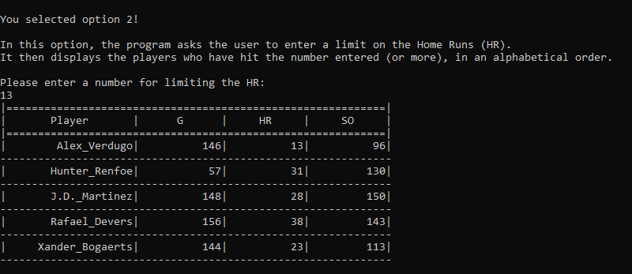

**Option 3:** For this option I just created two additional arrays for the columns that we need to create and since we need to display the data in a new file, I just included the ofstream and the rest of the commands required for this job. Finally I created a boolean type of variable which is going to play a role in the 4th Option mainly, basically as soon as the user does the option 3 it is activated to skip the condition in Option 4 and the rest of the explanation is going to be analyzed in there

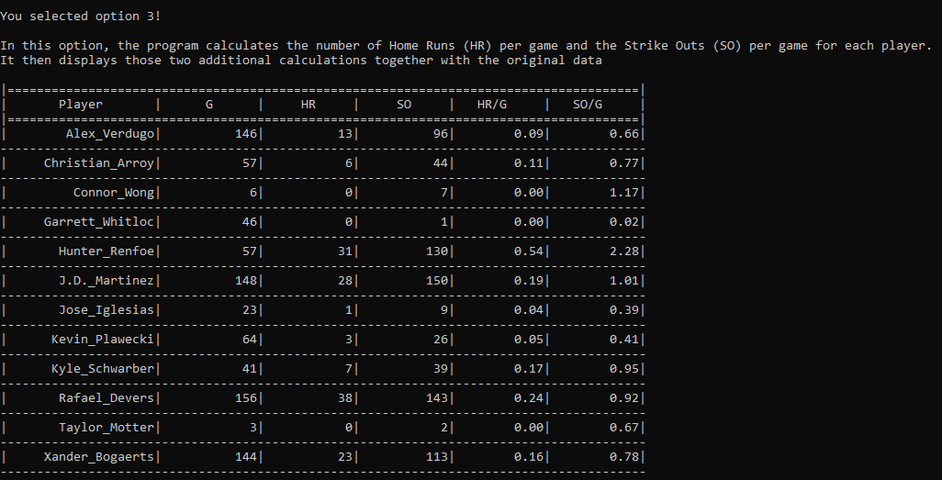

**Option 4:** In this Option, I initially created two variables for the user’s input since he has to choose both the column and the way to sort. Then, for the sorting part, I have created 2 bubble sort functions, the one sorting doubles and the other integers, which I then call in the main function to sort the input column. As for the way of sorting, descending is basically displaying them the way they are, while ascending is the reverse way, so I created a reverse function where it does exactly what I need for the ascending part. In this example I sorted the data on the 4th column, which is the strike outs, in descending order.

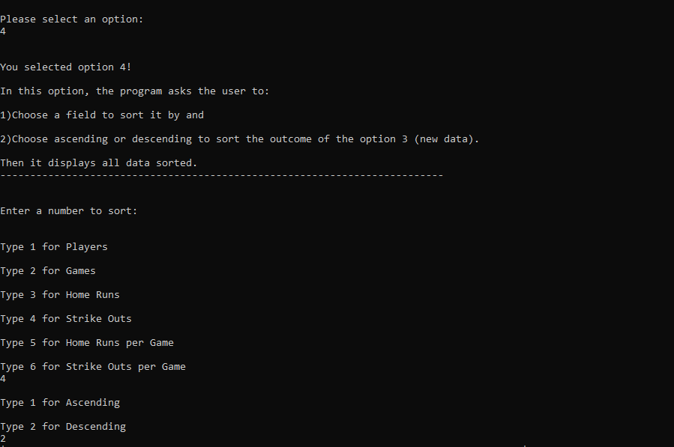

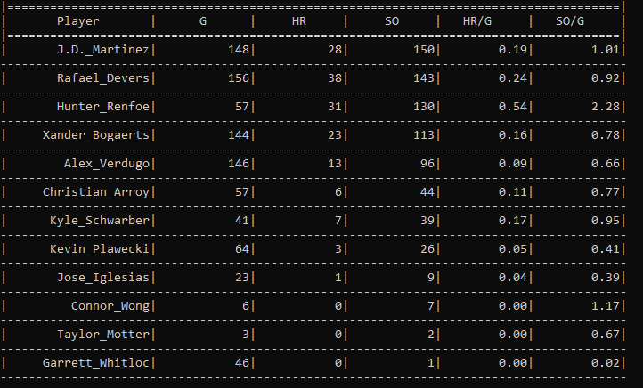

**Option 5:** 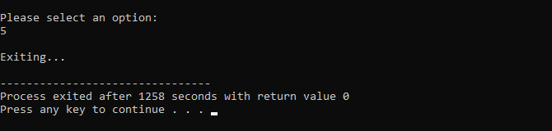

**Flowchart:**

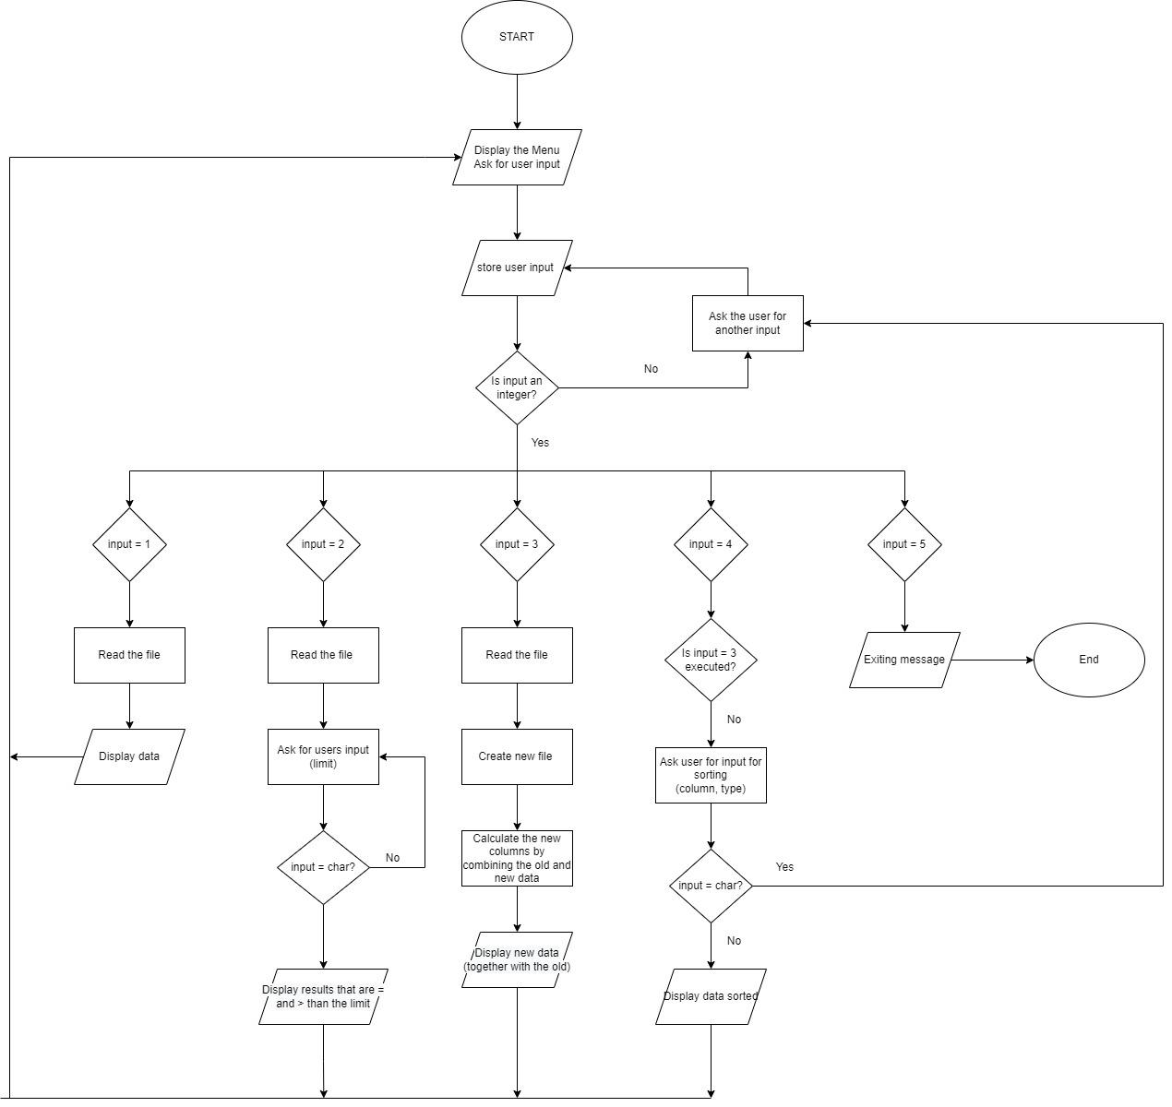

**Diagram:**

This diagram shows the data used in every question as well as the functions that are used in the 4th option.

