The collateral was created utilizing a directory structure based off C:\temp\FEM

The test harness file I/O nodes utilize this structure

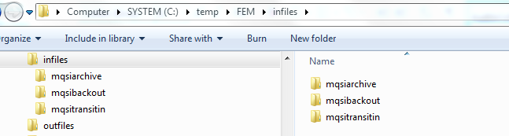

The trace nodes write to file and utilize this structure

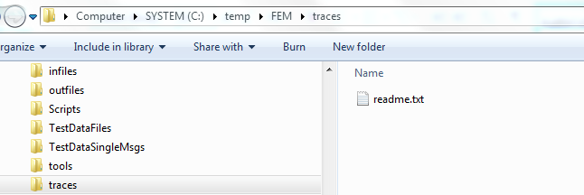

The TestDataFiles command files utilize this structure

